
Budapest University of Technology and Economics
Faculty of Electrical Engineering and Informatics
Department of Computer Science and Information Theory
Réka Szellmann

Adaptive market Beta calculation for hedging equity portfolios
External consultant
Zoltán Papp
BUDAPEST, 2020
Academic consultant
Judit Csima
BUDAPEST, 2020
Table of Contents

Összefoglaló 6
Abstract 7
1 Introduction 8
1.1 What is market Beta and hedging? 8
1.2 The main goal 9
1.3 Structure 9
1.4 The reason behind my decision 10
1.4.1 Some statistics about trading 10
2 S&P500 + SPY Data 12
2.1 Getting data 12
2.2 Cleaning data 12
2.3 Statistics of the data 15
2.3.1 Daily return 15
2.3.2 SPY (market) variance 17
2.3.3 S&P500 covariance of SPY 18
2.3.4 Best Beta error 19
2.3.5 Beta error with fix windows sizes 21
3 Follow the Leader 23
3.1 Conception 23
3.2 Summary 23
3.3 Implementation 24
3.3.1 Follow the Leader v.1. 24
3.3.2 Follow the Leader v.2. 26
3.4 Example from finance world 28
4 Random Forest 29
4.1 Conception 29
4.2 What is the model for? 29
4.3 Implementation 30
4.3.1 Gathering the label vector Y 31
4.3.2 Gathering the feature vector X 31
4.3.3 Preparation 31
4.3.4 Teaching 32
4.3.5 Validate 33
4.3.6 Result 35
5 Conclusion 51
5.1 Random Forest 51
5.2 Next Steps 53
6 Bibliography 54

Hallgatói nyilatkozat
Alulírott Szellmann Réka, szigorló hallgató kijelentem, hogy ezt a szakdolgozatot meg nem engedett segítség nélkül, saját magam készítettem, csak a megadott forrásokat (szakirodalom, eszközök stb.) használtam fel. Minden olyan részt, melyet szó szerint, vagy azonos értelemben, de átfogalmazva más forrásból átvettem, egyértelműen, a forrás megadásával megjelöltem.
Hozzájárulok, hogy a jelen munkám alapadatait (szerző(k), cím, angol és magyar nyelvű tartalmi kivonat, készítés éve, konzulens(ek) neve) a BME VIK nyilvánosan hozzáférhető elektronikus formában, a munka teljes szövegét pedig az egyetem belső hálózatán keresztül (vagy hitelesített felhasználók számára) közzétegye. Kijelentem, hogy a benyújtott munka és annak elektronikus verziója megegyezik. Dékáni engedéllyel titkosított diplomatervek esetén a dolgozat szövege csak 3 év eltelte után válik hozzáférhetővé.
Kelt: Budapest, 2020. 12. 16.
...…………………………………………….
Szellmann Réka

STUDENT DECLARATION
I, Réka Szellmann, the undersigned, hereby declare that the present BSc thesis work has been prepared by myself and without any unauthorized help or assistance. Only the specified sources (references, tools, etc.) were used. All parts taken from other sources word by word, or after rephrasing but with identical meaning, were unambiguously identified with explicit reference to the sources utilized.
I authorize the Faculty of Electrical Engineering and Informatics of the Budapest University of Technology and Economics to publish the principal data of the thesis work (author's name, title, abstracts in English and in a second language, year of preparation, supervisor's name, etc.) in a searchable, public, electronic and online database and to publish the full text of the thesis work on the internal network of the university (this may include access by authenticated outside users). I declare that the submitted hardcopy of the thesis work and its electronic version are identical.
Full text of thesis works classified upon the decision of the Dean will be published after a period of three years.
Budapest, 16 December 2020
...…………………………………………….
Réka Szellmann

Összefoglaló
A dolgozat célja különböző algoritmusok létrehozása és összehasonlítása, amelyeknek a segítségével hatékonyan meg lehet jósolni a kiválasztott papírok várható értékét a következő napra. A piacban megfigyelhető trendek torzíthatják az egyes papírok mozgásának vizsgálását, ennek kiküszöbölésére Hedge stratégiát lehet alkalmazni, ami ebben a dolgozatban a Market Beta formájában jelenik meg.
Ahhoz, hogy jobb becslést tudjak adni, több béta értéket is össze kell hasonlítani, amihez a csúszóablakos módszer lesz a segítségemre. A különböző ablakok pontosságának meghatározásához egy alapvető statisztikai módszerhez nyúlok: a Beta error (más néven másodfajú hiba) vizsgálatához.
Bevezetésképpen áttekintem, hogy mi a Beta error értéke, ha mindig a legjobb ablakot választom, illetve ha fix az ablakméret. Ezután implementálok két Follow the Leader alapú algoritmust és megnézem, hogy ezek hogyan teljesítenek az adatokon.
Végül a becsléshez több Random Forest algoritmust használok fel, amit a papírok különböző tulajdonságainak a segítségével tanítok be, majd összevetem az eredményeket és javaslok néhány ötletet a folyatatáshoz
A dolgozat során az S&P500 cégek részvényeinek az adatait, a piac követésére pedig az SPY indexet használom fel. A programozási nyelv Python, a környezet pedig a Jupyter Notebook.

Abstract
The goal of the paper is to create and compare algorithms which can be used to predict the selected instruments’ value for the next day.
Every stock market has a trend which can create a distortion in stocks. To avoid it I use a Hedge strategy, called market Beta.
To give a more accurate prediction I use the sliding windows method and compare different Beta values. The validity can be calculated by using a basic statistic test called Beta (or type II) error.
At first, I plot the errors with the best performing window for each day and with fix window sizes for all days. Then I talk about the Follow the Leader method and implement it in two ways. After I define the Random Forest algorithm and use different models taught by different aspects of the instruments. At the end I compare the results against each other and give some ideas for the next steps.
In the paper I use the stocks of S&P500 companies and SPY index for market. The programming language is Python, the environment is Jupyter Notebook.

Introduction
In this chapter I clarify the subject of the paper and why I selected it. To explain the definitions, I chose to use Investopedia which is one of the world's leading source of financial content on web.

What is market Beta and hedging?
Beta is a measure of the volatility - or systematic risk - of a security or portfolio compared to the market as a whole. It can help us to describe the movements of assets without the affection of the market’s popularity.
- Beta = 1.0: the instrument moves the same way as the market. This can be an index of market and the market.
- Beta > 1.0: The instrument’s movement is bigger than the markets.
- 0 < Beta < 1.0: The instrument’s movement is smaller than the markets.
- Beta < 0: The instrument moves the opposite way as the market. It doesn’t have a big probability, based on some opinion maybe gold can have this effect. However, there can be some artificially created paper to reduce the loss from market drop.
- Beta = 0: The instrument and the market are independent. This is only true for cash.
An upper bound can be the value 4 for beta and it’s a very rear number specially caused by unstable, young companies.
Generally, hedge is when we consider another asset’s (portfolio, market, instrument) value into calculation.
In this paper I intend to use hedging to neutralize the effects of the market on our stocks.

The main goal
The goal is to predict the selected stocks’ movement using market Beta with different algorithms, and to compare their results. To do that I need historical data from 2000 to 2020 which I get from Yahoo Finance and Quandl to oversee it. Beta error can be used to tell the accuracy of market Beta. To find the most capable data I use Sliding Window Technique with windows size 5, 10, 20, 50 and 60.
I use two aspects of the Follow the Leader Technique, then I teach a Random Forest Machine Learning algorithm with the 20 years data. I compare different models and then compare it to FTL.
Generally, the beta error can be acceptable under 10%.

Structure
- First of all, I talk about the data: how to get it from Yahoo, filter out and a few words about cleaning it. I show some basic statistics with DataFrame’s plot library.
- I show some statistics of beta error with the best and with fix sliding window sizes. After this I have principles for comparison.
- The next step is the idea and implementation of the Follow the Leader in two different aspects.
- In the last part I talk a little about Random Forest, then implement it with SciPy Toolkits, using different parameters and different properties for the feature vector.
- I compare the algorithms against each other and confirm the conclusion.

The reason behind my decision
Artificial Intelligence is one of the most popular fields nowadays, there are countless research and it still has a very large potential of developing. It can be applied for many financial problems with a huge success. Some trading company already uses Machine Learning to predict the prices, reduce risk and make faster orders.
In 2020 we are facing a bigger global crisis and because of that most of the instrument’s prices are drop down. In these times trading on market is very popular among people all over the world.

Some statistics about trading
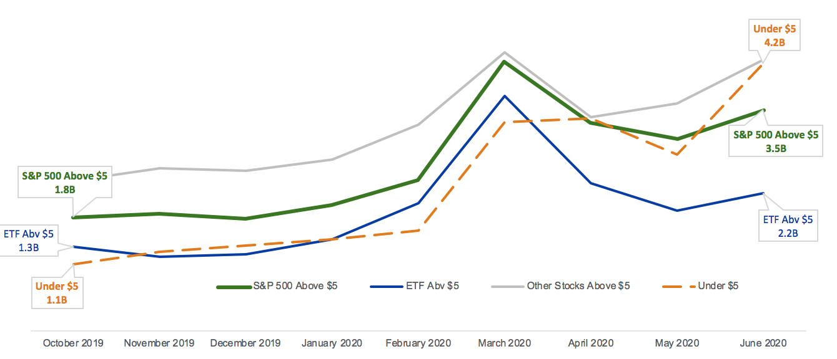
The trading volume has grown significantly around the two big global crises. This year it started around march when the market crashed.
1. US Equity Market Volume, October 2019 - June 2020

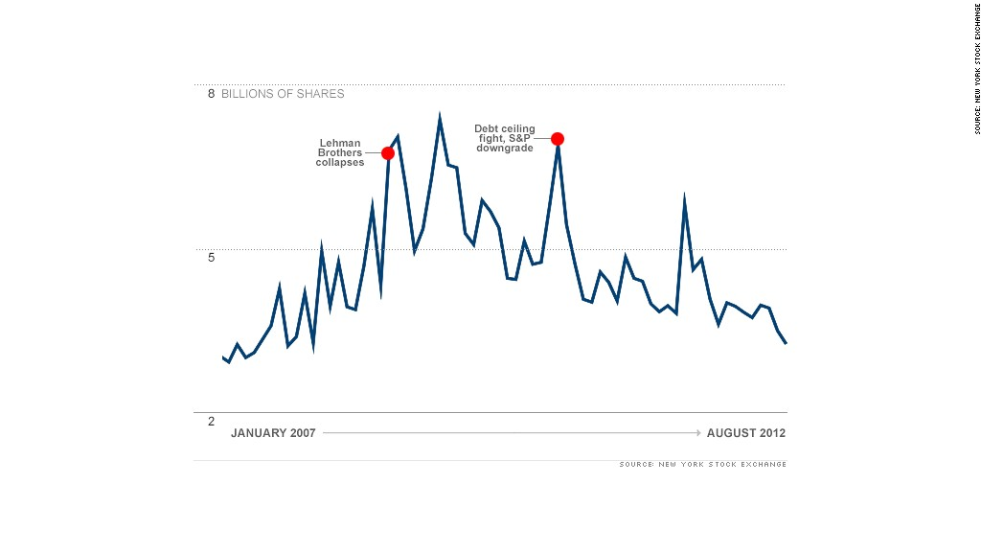
The trading spirit was lower between 2012 and 2020
2. NYSE trading volume between 2007 and 2012

S&P500 + SPY Data

Getting data
The main source of my data is yahoo.finance.com, Python has an API to make it easy to use. First, I get the list of actual S&P500 companies from Wikipedia, and turn data into pandas.DataFrame. I calculate the daily returns, and drop the other data:
daily_return_df['Daily Return'] = (daily_return_df['Close'] /
daily_return_df['Open']) – 1
daily_return_df.rename(columns = {'Daily Return': ticker}, inplace = True)
daily_return_df.drop(['Open', 'High', 'Low', 'Close', 'Close',
'Volume'], 1, inplace=True)
Then I join all daily return value into one DataFrame:
if main_daily_return_df.empty:
main_daily_return_df = daily_return_df
else:
main_daily_return_df = main_daily_return_df.
join(daily_return_df,how = 'outer')

Cleaning data
The zeroth step could be a scan for missing data, but I use data for 20 years, and some companies wasn’t even on stock in the early times, so I skip this.
I get the same data from Quandl also, so I can compare the suspicious results. I expect only zero or positive data, so I need to drop all columns smaller than 0 during the download (fortunately I didn’t have any).
for col in df.columns:
if col == 'ticker':
continue
negative = df.index[df[col] < 0].tolist()
if negative:
df.drop(negative)
print(negative)
After, I go through on data for all ticker. Zero values for daily return can be suspicious, so I check if I have different values in the Quandl data frame: if I have, I change all data of the instrument, otherwise I print out the ticker and date for further control.
zero_series_yahoo = daily_return_yahoo_df.index[daily_return_yahoo_df
['Daily Return'] == 0]
if not zero_series_yahoo.empty:
for date in zero_series_yahoo:
yahoo_daily = daily_return_yahoo_df['Daily Return'][date]
if date in quandl_df.index and quandl_df['Daily Return'][date] != 0
and not np.isnan(quandl_df['Daily Return'][date]):
yahoo_df.loc[date,'Open'] = quandl_df['open'][date]
yahoo_df.loc[date,'Close'] = quandl_df['close'][date]
yahoo_df.loc[date,'High'] = quandl_df['high'][date]
yahoo_df.loc[date,'Low'] = quandl_df['low'][date]
yahoo_df.loc[date,'Adj Close'] = quandl_df['adj_close'][date]
yahoo_df.loc[date,'Volume'] = quandl_df['volume'][date]
daily_return_yahoo_df.loc[date,'Daily Return'] =
quandl_df['Daily Return'][date]
change = True
print("{0} at {1}: changed from {1} to {2}".format(
ticker, date, yahoo_daily, quandl_df["Daily Return"][date]))
else:
print("{0} at {1}: is zero".format(ticker, date))
Another important verification is to check the return values if they are bigger than 40%. This can happen, but in my case it’s the 500 biggest company, so I expect them to be stable. I compare to Quandl this time too, and print out if it hasn’t got any changes:
big_diff = daily_return_yahoo_df.index[daily_return_yahoo_df['Daily Return'].
abs() > 0.4]
if not big_diff.empty:
for date in big_diff:
yahoo_daily = daily_return_yahoo_df['Daily Return'][date]
if date in quandl_df.index and np.abs(quandl_df['Daily Return'][date])
<= 0.4:
yahoo_df.loc[date,'Open'] = quandl_df['open'][date]
yahoo_df.loc[date,'Close'] = quandl_df['close'][date]
yahoo_df.loc[date,'High'] = quandl_df['high'][date]
yahoo_df.loc[date,'Low'] = quandl_df['low'][date]
yahoo_df.loc[date,'Adj Close'] = quandl_df['adj_close'][date]
yahoo_df.loc[date,'Volume'] = quandl_df['volume'][date]
daily_return_yahoo_df.loc[date,'Daily Return'] =
quandl_df['Daily Return'][date]
change = True
print("{0} at {1} changed from {2} to {3}".format(
ticker, date, yahoo_daily, quandl_df['Daily Return'][date]))
else:
print("{0} at {1} is fishy: {2}".format(ticker, date, yahoo_daily))
I cleaned most of my data based on two sources, but I still have some strange results, I compare them manually to the values of other websites, MarketWatch and investing.com .
I have lots of zero values for daily return, so I only check 5-8 dates for all tickers to see how this happened. My observation is that most of the zero values are right, or has a very small difference, so I won’t worry about them.
The big returns otherwise can modify my statistics sensibly, so I check all of them by hand, and modify their value if it has a big (>10%) difference. I found two occurrences:
if ticker == 'ROL':
yahoo_df.loc['2008-10-10','Open'] = 3.72
yahoo_df.loc['2008-10-10','Close'] = 4.56
yahoo_df.loc['2008-10-10','High'] = 4.79
yahoo_df.loc['2008-10-10','Low'] = 3.57
yahoo_df.loc['2008-10-10','Adj Close'] = 15.4
yahoo_df.loc['2008-10-10','Volume'] = 2010000
daily_return_yahoo_df.loc['2008-10-10','Daily Return'] =
yahoo_df['Close']['2008-10-10'] / yahoo_df['Open']['2008-10-10'] - 1
change = True

if ticker == 'AIG':
yahoo_df.loc['2008-09-16','Open'] = 31
yahoo_df.loc['2008-09-16','Close'] = 62.83
yahoo_df.loc['2008-09-16','High'] = 85.79
yahoo_df.loc['2008-09-16','Low'] = 20.94
yahoo_df.loc['2008-09-16','Volume'] = 61550000
daily_return_yahoo_df.loc['2008-09-16','Daily Return'] =
yahoo_df['Close']['2008-09-16'] / yahoo_df['Open']['2008-09-16'] - 1
change = True

I couldn’t download SPY from Quandl, so I downloaded manually in two parts, historical data without 2020, and the last 10 years.
I needed to change the date format for data from Nasdaq, but otherwise I used a similar method to check and change SPY prices.

Statistics of the data

Daily return
daily_return_without_SPY.plot(legend=False)
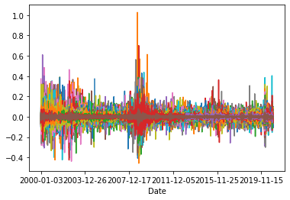
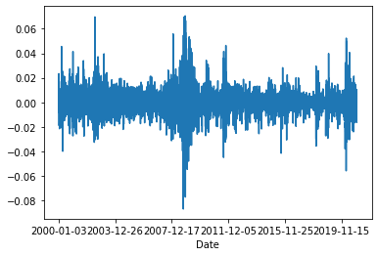
daily_return_without_SPY.mean(axis=1).plot(legend=False)
3. S&P500 Daily return's mean
4. S&P500 Daily return

We can see the maximum change is around 100%, the minimum is around -50%.
I want to check if I have the right connection between the stocks and the index:
import matplotlib.pyplot as plt
import seaborn as sns

sns.regplot(x = daily_return_df['SPY'].to_numpy(),
y = daily_return_without_SPY.mean(axis=1).to_numpy())
plt.xlabel("SPY Returns")
plt.ylabel("S&P500 Returns")
plt.title("S&P500 on SPY")
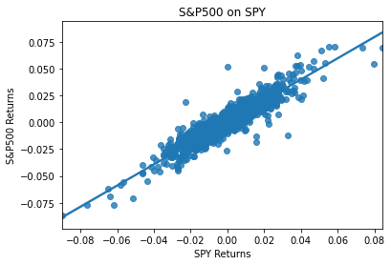
plt.show()
5. Regression model between the mean of S&P500 and SPY daily returns
As expected, the S&P500 stocks are correlated with the SPY market index.

SPY (market) variance
I calculate the market variance for all sliding window.
daily_return_df['SPY'].describe()
market_variance = daily_return_df['SPY'].var()
print("variance: {0}".format(market_variance))

count 5273.000000
mean 0.000039
std 0.010004
min -0.089906
25% -0.004272
50% 0.000510
75% 0.004665
max 0.084347
variance: 0.0001000733079563914
for window in [5, 10, 20, 40, 60]:
market_variance_roll = daily_return_df['SPY'].rolling(window).var()
plt.plot(market_variance_roll, label = "With rolling window {0}".
format(window))
plt.xlabel('Market Variance')
plt.ylabel('Volume')
plt.title("Market Variance with rolling window")
plt.legend()
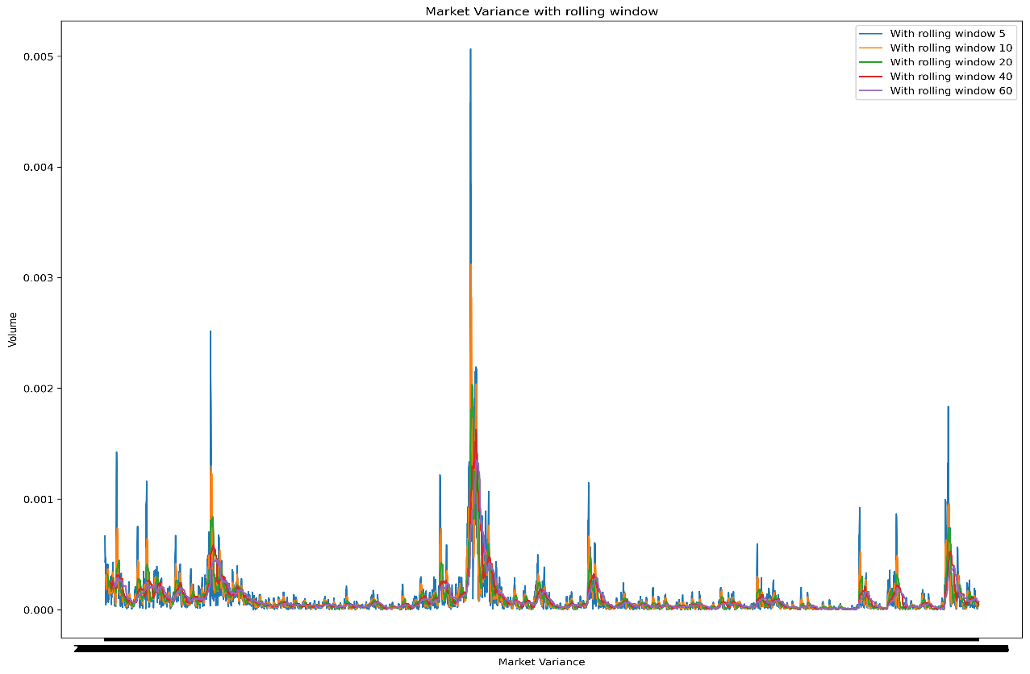
plt.show()
6. Market variance with rolling window

S&P500 covariance of SPY
I calculate the covariance between the S&P500 stocks and the market.
SP_covariance = pd.Series({symbol:
daily_return_df['SPY'].cov(daily_return_df[symbol])
for symbol in tickers
if symbol != 'SPY'})
SP_covariance.describe()

count 505.000000
mean 0.000096
std 0.000029
min 0.000015
25% 0.000074
50% 0.000095
75% 0.000114
max 0.000202

for window in [5,10,20,40,60]:
SP_covariance_rolling = daily_return_without_SPY.rolling(window).
cov(daily_return_df['SPY'])
plt.plot(SP_cov_df.mean(axis=1), label = "With rolling window {0}".
format(window))
plt.xlabel('Date')
plt.ylabel('Volume')
plt.title("S&P 500 covariance with rolling window")
plt.legend()
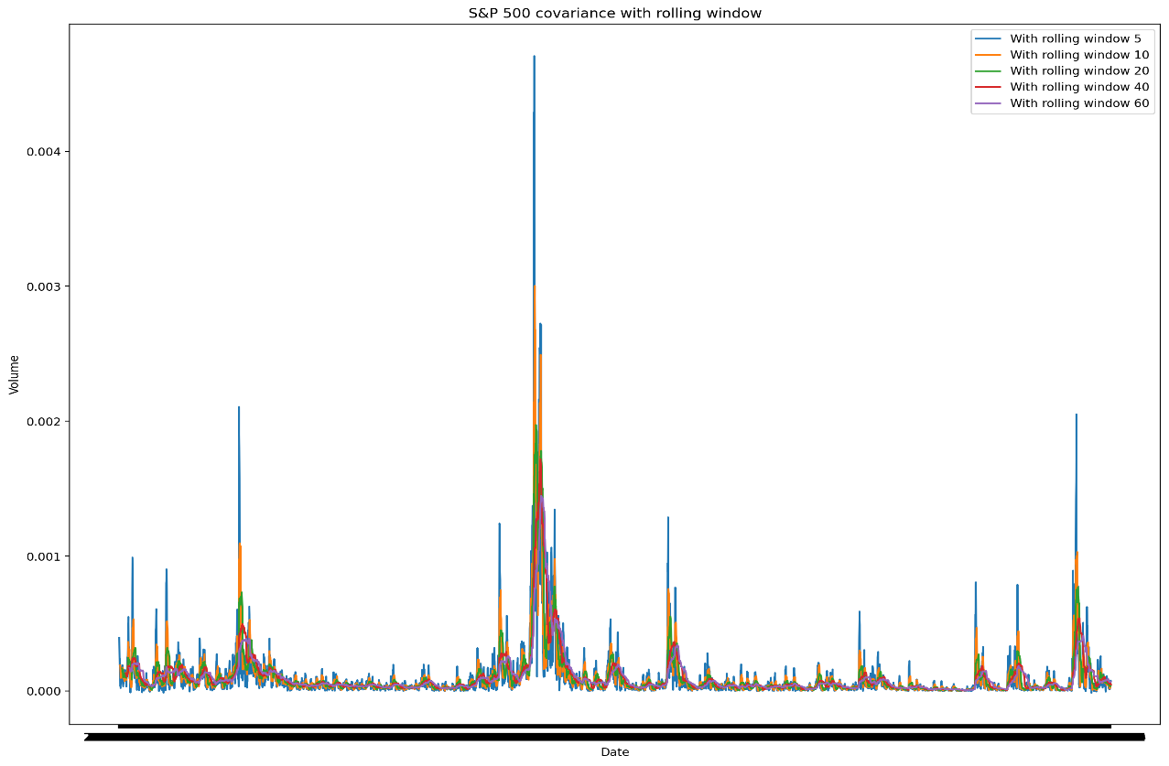
plt.show()
7. S&P500 covariance with rolling window
A smaller window has bigger variance and covariance as it doesn’t make the data as smooth as the one using more data. It’s more sensible for big differences.

Best Beta error
During calculations I use the parameter ‘min_periods’, to avoid having different number of NaN values all over the algorithms. This can ruin the comparison of the cumulative summa.
I have two approaches:
- Show the cumulative summa for all beta error of the tickers
- Show the cumulative summa for the mean of beta error of the tickers
The following two example can be a good base to compare against my algorithms.
First, I get the best beta error for every day and ticker:
def calc_beta(daily, window):
return daily.rolling(window = window, min_periods = 3).cov(daily['SPY']).
div(daily['SPY'].rolling(window = window, min_periods = 3).
var(), axis=0)
def calc_beta_error(daily, beta):
return (daily - beta.mul(daily['SPY'], axis=0)) ** 2

concat_df = None
for w in windows:
beta_df = calc_beta(daily_return_df, w)
beta_error_df = calc_beta_error(daily_return_df, beta_df)
beta_error_df.columns = beta_error_df.columns + "_{0}".format(w)
if concat_df is not None:
concat_df = pd.concat([concat_df, beta_error_df], axis=1)
else:
concat_df = beta_error_df

min_beta_error_df = pd.DataFrame()
for ticker in daily_return_df.columns:
prefix = ticker + '_'
head = []
for i in range(0,len(windows)):
head.append(prefix + str(windows[i]))
min_beta_error_df[ticker] = concat_df[head].min(axis=1)

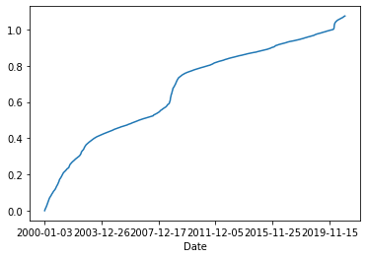
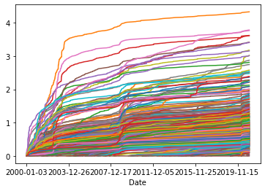
8. Beta error for the best window
9. Beta error’s mean for the best window

Testing
I need to test the algorithm to make sure I calculate the best window for every day.
I created two test set in Excel by deleting most of the columns and rows: test_daily_returns.csv. I only use 3 stocks and the SPY index.
I run through the algorithm, write the concatenated values and the beta error into two csv files:
concat_df.to_csv("test/best_window_concat.csv")
min_beta_error_df.to_csv("test/best_betas.csv")
I check in Excel if the beta errors are really the minimum values from the concatenated result.

Beta error with fix windows sizes
A calculate beta error with fix window sizes. This is the easiest solution with small flexibility, so I expect the worst results from this method.
I use two different views:
- the cumulative summa of all tickers on dates
- the cumulative summa of all tickers’ means on dates.
mean_cumsum_df = pd.DataFrame()

# Infinite window
beta_df = daily_return_df.expanding().cov(daily_return_df['SPY']).
div(daily_return_df['SPY'].
expanding().var(), axis=0)
beta_error_df = (daily_return_df - beta_df.mul(
daily_return_df['SPY'], axis=0)) ** 2
beta_error_df.cumsum().plot(legend=False)
mean_cumsum_df["fix sized window: inf"] = beta_error_df.mean(axis=1).
cumsum(axis=0)
for w in windows:
beta_error_df = calc_beta_error(daily_return_df, w)
beta_error_df.cumsum(axis=0).plot(legend=False)
mean_cumsum_df["Window: {0}".format(w)] = beta_error_df.mean(axis=1).
cumsum(axis=0)
mean_cumsum_df.plot()
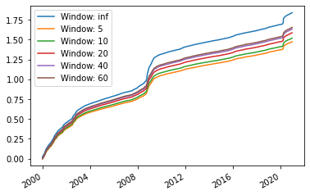
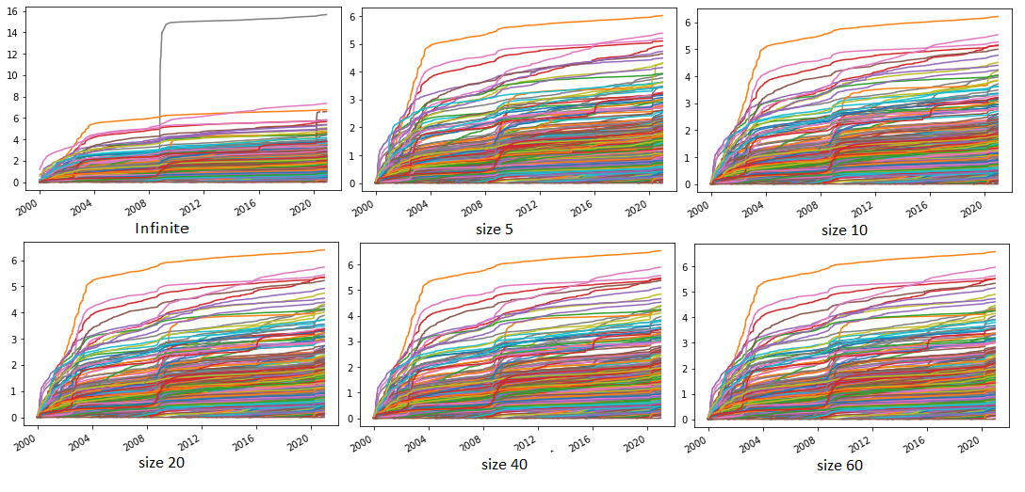
10. Beta error for S&P tickers' mean
11. Beta error for S&P tickers

12. Beta error for S&P tickers' mean

Follow the Leader

Conception
The idea of Follow the Leader method is very simple: it has a weight matrix where the performance of the options can be stored. Every iteration, it chooses the one with the best result so far and refresh the weights:
$$w_{t}=arg min_{w∈S}\sum_{i=1}^{t-1}{v_{i}\left(w\right)}$$
It is known to perform well when the loss functions are convex and positively curved.
A popular version is Follow the Regularised Leader, where we add a regularisation:
$$w_{t}=arg min_{w∈S}\sum_{i=1}^{t-1}{v_{i}\left(w\right)}+R\left(w\right)$$

Summary
I calculate the cumulative summa for previous days and use it as weights. Then I choose the smallest weight and use its window.
I use a more compact algorithm which is very similar to the one calculating the best windows.
I also implemented a more expanded algorithm, wherewith the main concept can be expressed better.

Implementation

Follow the Leader v.1.
I use the concatenation from chapter 2.3.4. After I go through all of the tickers and find the minimum window from the historical cumulative summa.
beta_error_df = pd.DataFrame()
for ticker in daily_return_df.columns:
prefix = ticker + '_'
head = []
for i in range(0,len(windows)):
head.append(prefix + str(windows[i]))
cumsum_min_cols = concat_df[head].cumsum(axis=0).
shift(1).idxmin(axis=1)
for date in concat_df.index:
if pd.isnull(cumsum_min_cols.loc[date]):
beta_error[ticker] = None
else:
beta_error_df.loc[date,ticker] = concat_df.
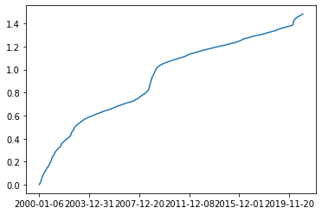
loc[date,cumsum_min_cols[date]]
13. Beta error’s mean with Follow the Leader v.1.

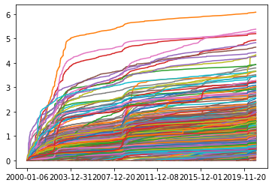
14. Beta error’s with Follow the Leader v.1. for all ticker

Testing
I write the results into csv files inside the loop:
concat_df[head].to_csv("test/FTL_concat_{0}.csv".format(ticker))
cumsum_min_cols.to_csv("test/FTL_cumsum_min_cols{0}.csv".format(ticker))
and outside:
min_beta_error_df.to_csv("test/FTL_min_beta_error.csv")
I check in Excel if the cumsum_min_cols chooses the minimum window from the concatenated values and saves the header. I check if the minimum beta error is really the value for header.

Follow the Leader v.2.
This version can be easily modified in two ways:
- The first iteration can be changed to any period (in this case the index dictionary needs to be recalculated)
- It can iterate through the tickers if we want to use different window size for each of them
This time I decided to go through on every year and use the same window for every ticker. In the loop I look for the best window based on the weight matrix, calculate the beta error and refresh the weights based on beta error:
FTL_beta_error_df = pd.DataFrame().reindex(columns = daily_return_df.columns)
W = pd.DataFrame(0.0, index=windows, columns=['error'])
daily_return_df.index = [pd.Timestamp(x) for x in daily_return_df.index]

for i in range(21):
year = 2000 + i
print(year)
date_indexes = [x for x in daily_return_df.index if x.year == year]
min_window = W.idxmin()['error']

daily = daily_return_df.loc[date_indexes,:]
act_beta_error_df = calc_beta_error(daily, min_window)
FTL_beta_error_df = pd.concat([FTL_beta_error_df, act_beta_error_df],
axis=0)
# refresh weights
W['error'][min_window] += act_beta_error_df.sum().sum()
for window in windows:
if window == min_window:
continue
beta_error_df = calc_beta_error(daily, window)
W['error'][window] += beta_error_df.sum().sum()

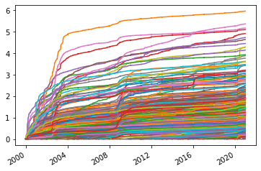
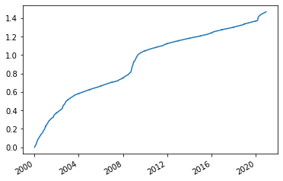
15. Beta error’s of Follow the Leader v.2. with yearly selected windows
16. Beta error’s mean of Follow the Leader v.2.
with yearly selected windows

Testing
I run the algorithm with the same test_daily_returns and save the parameters to a csv file again:
act_beta_error_df.to_csv("test/TFL2_beta_{0}.csv".format(year))
W.to_csv("test/W_after_{}.csv".format(year))

The initialization of the weights is 0, that means first I use the window 5.
I calculate the cumulative summa for all tickers in beta error 2000 sheet and check if the weights have the same values.
Next, I choose the smallest value from weights after 2000, it’s 5 also.
I calculate the cumulative summa again for all tickers in beta error 2001 sheet and check the weights for 5 again.
I repeat these steps once again to make sure everything is alright.

Example from finance world
- One of the practical usages of Follow the Leader conception is when we make orders based on the relations between instruments. For example, we know one ticker’s price will go up after another went down. This investment strategy needs experience and global knowledge.
- Another FTL strategy is simply copying the movements of another investor. It doesn’t require much experience, but following the top ranked investors have a big risk, we need to be aware of that.

Random Forest

Conception
Random forests are a combination of tree predictors such that each tree depends on the values of a random vector sampled independently and with the same distribution for all trees in the forest.
We can build one decision tree by providing different kind of information related to the problem and give it as input. Also, as it’s a supervised learning strategy, at teaching we need to give the expected output as result. The model will learn to map the given information during training.
At continues results the Random Forest takes the average of the tree’s estimations. If the result is discrete the majority vote will be the final result.

What is the model for?
I want to create a Random Forest model to predict the best window size for market beta from the given input. This is a regression problem, because the result set is based on numbers and not labels.
I want to mix the teach and test set somehow, so I build 10 models: the first 10 years is for the learning period, and the next year is for validity.
I will try the model with different properties of the stocks and compare them to the Follow the Leader. I try to make better predictions with changing the parameters of the Random Forest algorithm.

Implementation
I import the data and calculate beta error with the five window sizes. Volume, Low and High are just quantities, I need to divide or multiply them with the open or close price:
import pandas as pd

daily_return_df = pd.read_csv('sp500_joined_daily_returns_yahoo.csv')
daily_return_df.set_index('Date', inplace=True)

open_df = pd.read_csv('sp500_joined_open_yahoo.csv')
open_df.set_index('Date', inplace=True)

close_df = pd.read_csv('sp500_joined_close_yahoo.csv')
close_df.set_index('Date', inplace=True)

high_df = pd.read_csv('sp500_joined_high_yahoo.csv')
high_df.set_index('Date', inplace=True)
high_df = high_df.div(open_df)

low_df = pd.read_csv('sp500_joined_low_yahoo.csv')
low_df.set_index('Date', inplace=True)
low_df = low_df.div(open_df)

volume_df = pd.read_csv('sp500_joined_volume_yahoo.csv')
volume_df.set_index('Date', inplace=True)
volume_df = volume_df.mul(open_df)

windows = [5,10,20,40,60]

def calc_beta_error(daily,window):
beta = daily.rolling(window=window, min_periods=3).
cov(daily['SPY']).div(daily['SPY'].
rolling(window=window, min_periods=3).var(), axis=0)
return (daily - beta.mul(daily['SPY'], axis=0)) ** 2

all_beta_5_df = calc_beta_error(daily_return_df, 5)
all_beta_10_df = calc_beta_error(daily_return_df, 10)
all_beta_20_df = calc_beta_error(daily_return_df, 20)
all_beta_40_df = calc_beta_error(daily_return_df, 40)
all_beta_60_df = calc_beta_error(daily_return_df, 60)

Gathering the label vector Y
For step zero I need to create the Y vector to test the model’s results during learning. I use the best windows I calculate in chapter 2.3.4 and convert the data frames’ indices to date format:
daily_return_df.index = [pd.Timestamp(x) for x in daily_return_df.index]
min_windows_df.index = [pd.Timestamp(x) for x in min_windows_df.index]
volume_df.index = [pd.Timestamp(x) for x in volume_df.index]
high_df.index = [pd.Timestamp(x) for x in high_df.index]
low_df.index = [pd.Timestamp(x) for x in low_df.index]

all_beta_5_df.index = [pd.Timestamp(x) for x in all_beta_5_df.index]
all_beta_10_df.index = [pd.Timestamp(x) for x in all_beta_10_df.index]
all_beta_20_df.index = [pd.Timestamp(x) for x in all_beta_20_df.index]
all_beta_40_df.index = [pd.Timestamp(x) for x in all_beta_40_df.index]
all_beta_60_df.index = [pd.Timestamp(x) for x in all_beta_60_df.index]
I need to shift it because I want to use today’s X for the tomorrow’s Y. Also, I need to stack to use multilevel indexing here as well:
Y_sr = min_windows_df.shift(-1).stack()

Gathering the feature vector X
At first, I use different statistics with the daily return. I calculate the mean and the standard deviation with rolling window size 5 and 10. This will be the list of features:
X_df = pd.DataFrame({
"mean_5": daily_return_df.rolling(
window=5, min_periods=3).mean().stack(),
"std_5": daily_return_df.rolling(
window=5, min_periods=3).std().stack(),
"std_10": daily_return_df.rolling(
window=10, min_periods=3).std().stack(),
"mean_10": daily_return_df.rolling(
window=10, min_periods=3).mean().stack()})
X_df = X_df.dropna(axis = 0, how ='any')

Preparation
I have the X and Y, but they could differ from index size, because I dropped the rows with unknown data. To make the Random Forest work I need to find the common indices and keep only them:
print(Y_sr.shape, X_df.shape)
comm_indices = [x for x in X_df.index if x in Y_sr.index]
Y_sr = Y_sr.loc[comm_indices]
X_df = X_df.loc[comm_indices]
print(Y_sr.shape, X_df.shape)

To verify the process, I print out the shape of X and Y. The number of rows should be same for both.

Teaching
I use Scikits’s implementation for Random Forest algorithm.
I need 10 iterations to create the predictions from 2011 to 2020. After the loop, I’ll have 10 different models, which I have to concatenate to have all 10 years’ predictions in one DataFrame.
We can tell the RandomForestRegressor how many trees we want to use for the Forest, the parameter is n_estimators.
First, I use 10 estimators and everything else remains default. Later I try with different numbers.
I need to get the indices:
- The train set is 10 years data starting from 2000 - 2010, ending with 2009 - 2019
- The test set is the next year starting from 2001, ending with 2020

train_index_sr = [x for x in X_df.index if x[0] >=
pd.Timestamp('{0}-01-01'.format(test_year-11)) and
x[0] < pd.Timestamp('{0}-01-01'.format(test_year))]
test_index_sr = [x for x in X_df.index if x[0].year == test_year]

Get the data sets:
test_X_df = X_df.loc[test_index_sr]
train_X_df = X_df.loc[train_index_sr]
train_Y_sr = Y_sr.loc[train_index_sr]
test_y_sr = Y_sr.loc[test_index_sr]
After I prepared the data, fitting is just two lines:
from sklearn.ensemble import RandomForestRegressor
from sklearn import metrics
clf = RandomForestRegressor(n_estimators=10)
clf.fit(train_X_df, train_Y_sr)

Validate
I get the prediction from the trained model and change it, so I can calculate the beta error for the prototype.
First, I need to unstack it, and because every calculation is for the next day, I need to shift the results:
predicted_Y = pd.DataFrame(Y_pred, index = test_X_df.index).
unstack().shift(1)
I can have any numbers, because I used regression, so I need to round the predictions to my original 5 window sizes. To do that I find the closest window and round the value to it. The smallest and biggest window need to be checked separately:
prev_window = -windows[0]
for i in windows:
mask = (predicted_Y >= (prev_window + i)/2) & (predicted_Y <= i)
predicted_Y[mask] = i

predicted_Y[(predicted_Y >= prev_window) & (~mask) &
(predicted_Y <= i)] = abs(prev_window)
prev_window = i

predicted_Y[predicted_Y >= windows[-1]] = windows[-1]
predicted_Y = predicted_Y.droplevel(level=0, axis=1)
Then I summarize the beta error for all window sizes and append it in a list called models:
sum_beta_errors_df = pd.DataFrame()
sum_beta_errors_df.reset_index(drop = True)

sum_beta_errors_df = all_beta_5_df.loc[predicted_Y.index]
[predicted_Y.columns][predicted_Y==5]

sum_beta_errors_df = sum_beta_errors_df.add(
all_beta_10_df.loc[predicted_Y.index][predicted_Y.columns]
[predicted_Y==10], fill_value=0)

sum_beta_errors_df = sum_beta_errors_df.add(
all_beta_20_df.loc[predicted_Y.index][predicted_Y.columns]
[predicted_Y==20], fill_value=0)

sum_beta_errors_df = sum_beta_errors_df.add(
all_beta_40_df.loc[predicted_Y.index][predicted_Y.columns]
[predicted_Y==40], fill_value=0)

sum_beta_errors_df = sum_beta_errors_df.add(
all_beta_60_df.loc[predicted_Y.index][predicted_Y.columns]
[predicted_Y==60], fill_value=0)

models.append(sum_beta_errors_df)

There is just one step back: I have one model for all year, I need to summarize the beta errors to be comparable to the Follow the Leader. The predictions are starting from 2011:
summary = pd.DataFrame(0.0, index = daily_return_df.index
[daily_return_df.index.year > 2010],
columns = daily_return_df.columns)
for model in models:
summary = summary.add(model, fill_value = 0)
By repeating these steps with different features and parameters I can build various Random Forest algorithms.
I save the summarized result into a csv file, and the last model with pickles:
import pickle

summa.to_csv("RF_results/RF_r1.csv")
with open('RF_results/RF_r1', 'wb') as f:
pickle.dump(clf, f)

Scikit has a lot of tools to analyse the trained model. One of the most important features is to see which parameters appeared to be useful during the training. This property is called feature importance:
feature_list = ["mean_5", "std_5", "std_10", "mean_10"]
plt.barh(feature_list, clf.feature_importances_)
I should use the features with the biggest importance for learning.
Another important feature is the depth of trees the algorithm using. The estimators are accessible by the property called estimators_, it’s possible to iterate on them and see all the depths:
[estimator.tree_.max_depth for estimator in clf.estimators_]

Result

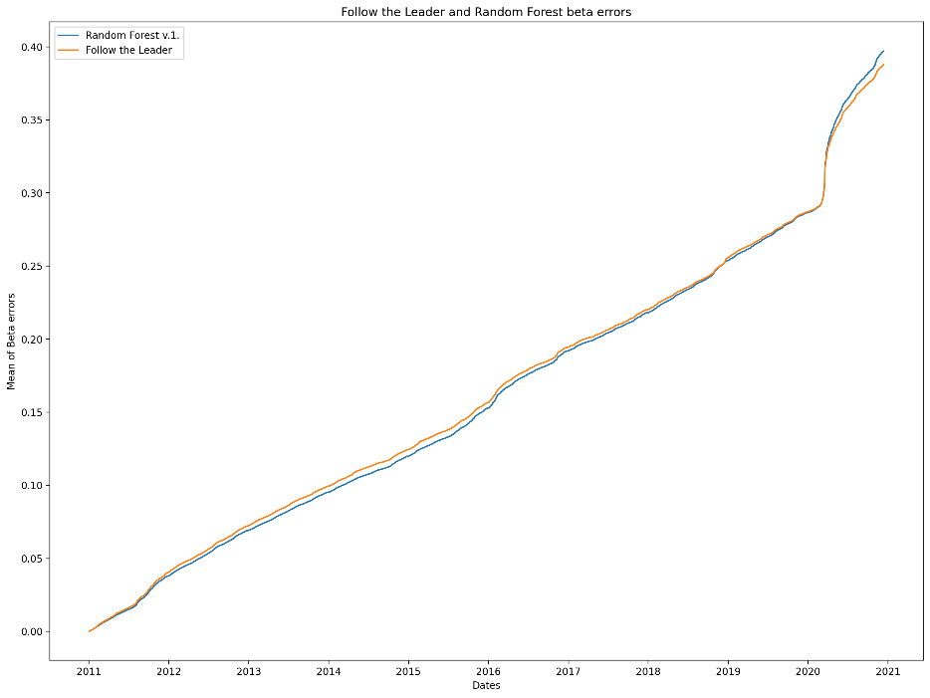
Version 1.
17. Random Forest v.1. vs. Follow the Leader
As we can see it hasn’t made a big development compared to the Follow the Leader, I need to tune the features and the parameters.
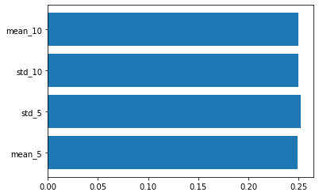
18. Feature importance of the Random Forest v.1.
They don’t have a big difference, so I try the algorithm with same features, but I set the parameter n_estimators to 100 and see how it can increase.

Version 2.
The feature set is the same from 4.3.2. The n_estimators is set to 100.
X_df = pd.DataFrame({
"mean_5": daily_return_df.rolling(
window=5, min_periods=3).mean().stack(),
"std_5": daily_return_df.rolling(
window=5, min_periods=3).std().stack(),
"std_10": daily_return_df.rolling(
window=10, min_periods=3).std().stack(),
"mean_10": daily_return_df.rolling(
window=10, min_periods=3).mean().stack()})
X_df = X_df.dropna(axis = 0, how ='any')
19. Random Forest v.2. vs. Follow the Leader
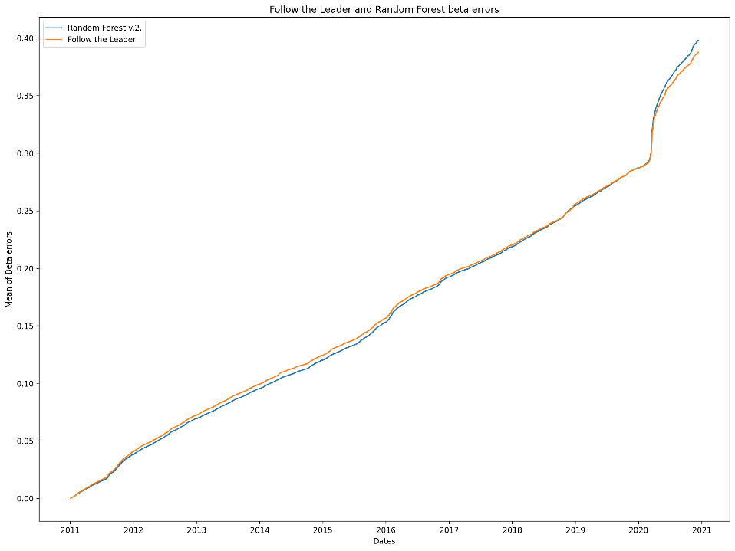

The result is not better with just changing the number of trees, I need to change the features.
20. Feature importance of the second Random Forest
The depths of the trees are around 100, so I try to cut it to half to be faster.

Version 3.
This time I try the beta error with the 5 rolling window sizes, the parameters: n_estimators=100, max_depth=2
X_df = pd.DataFrame({
"beta_5_mean": all_beta_5_df.stack(),
"beta_10_mean": all_beta_10_df.stack(),
"beta_20_mean": all_beta_20_df.stack(),
"beta_40_mean": all_beta_40_df.stack(),
"beta_60_mean": all_beta_60_df.stack(),
})
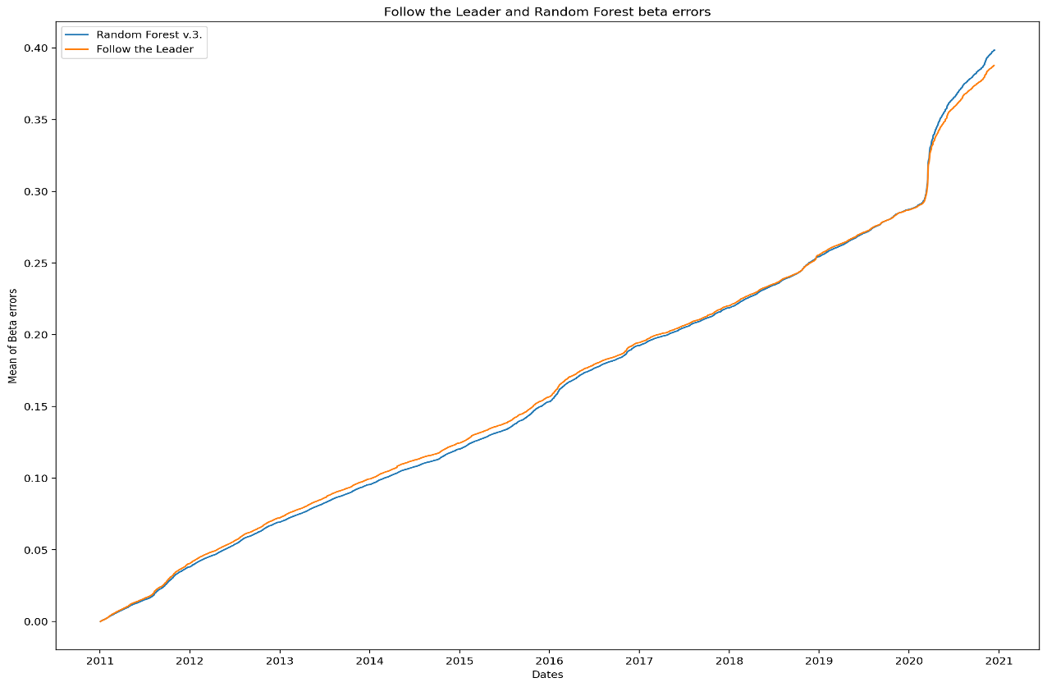

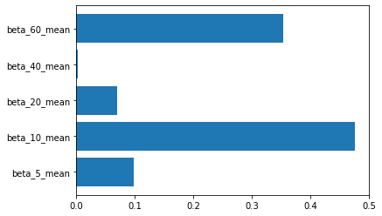
21. Random Forest v.3.

22. Feature importance of Random Forest v.3
This feature set has bigger differences, looks like I need to keep the rolling window 60 and 10 at least.
I try the same feature set and tree number with max_depth=15. The result is the same, but the features importance differs from the original:
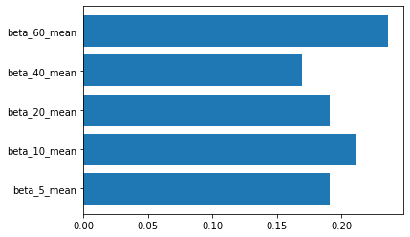
23. Random Forest v.3.2. feature importance
The two most important feature is still with rolling window 60 and 10, but the difference is not that big.

Version 4.

This time I use the previous 5 day’s beta error mean with n_estimators=100 and max_depth=2
X_df = pd.DataFrame({
"prev5_mean_be_5": all_beta_5_df.rolling(window=5, min_periods=3).mean().stack(),
"prev5_mean_be_20": all_beta_20_df.rolling(window=20, min_periods=3).mean().stack(),
"prev5_mean_be_40": all_beta_40_df.rolling(window=40, min_periods=3).mean().stack(),
"prev5_mean_be_60": all_beta_60_df.rolling(window=60, min_periods=3).mean().stack(),
"prev5_std_be_5": all_beta_5_df.rolling(window=5, min_periods=3).std().stack(),
"prev5_std_be_10": all_beta_10_df.rolling(window=10, min_periods=3).std().stack(),
"prev5_std_be_20": all_beta_20_df.rolling(window=20, min_periods=3).std().stack(),
"prev5_std_be_40": all_beta_40_df.rolling(window=40, min_periods=3).std().stack()
})
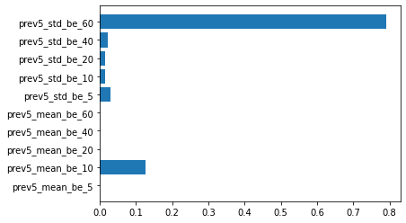
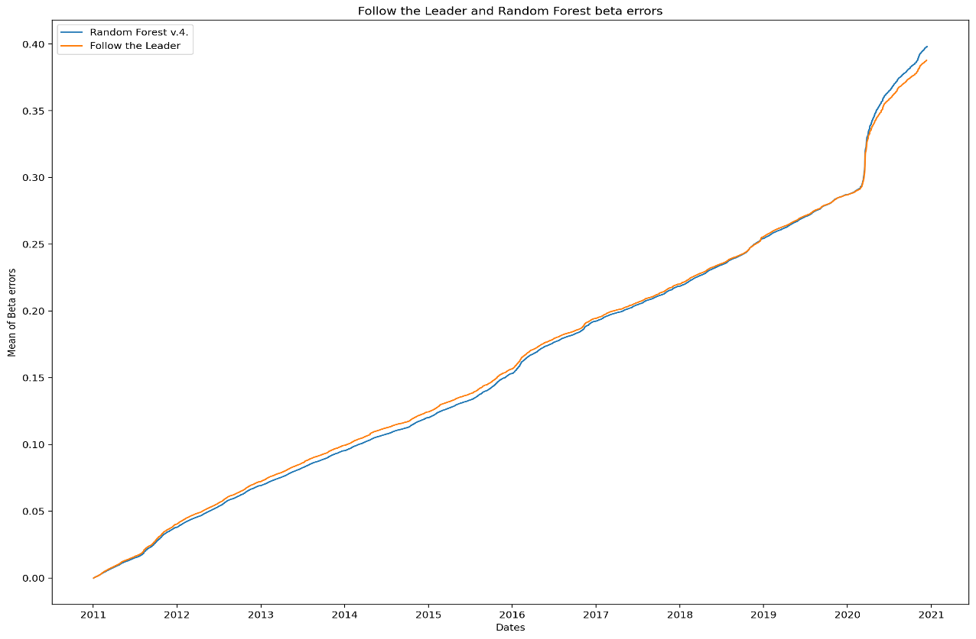
24. Random Forest v.4.
From this configuration the best feature is the standard division with rolling window 60, but I might use the mean with rolling window 10.
23. Feature importances of Random Forest v.4.

Version 5.
I want to select the best input features for daily return, so I go through of all windows with parameters: n_estimators=50, max_depth=2 max_features=8
X_df = pd.DataFrame({
"mean_5": daily_return_df.rolling(window=5, min_periods=3).
mean().stack(),
"mean_10": daily_return_df.rolling(window=10, min_periods=3).
mean().stack(),
"mean_20": daily_return_df.rolling(window=20, min_periods=3).
mean().stack(),
"mean_40": daily_return_df.rolling(window=40, min_periods=3).
mean().stack(),
"mean_60": daily_return_df.rolling(window=60, min_periods=3).
mean().stack(),
"std_5": daily_return_df.rolling(window=5, min_periods=3).
std().stack(),
"std_10": daily_return_df.rolling(window=10, min_periods=3).
std().stack(),
"std_20": daily_return_df.rolling(window=20, min_periods=3).
std().stack(),
"std_40": dail.y_return_df.rolling(window=40, min_periods=3).
std().stack(),
"std_60": daily_return_df.rolling(window=60, min_periods=3).
std().stack()
})
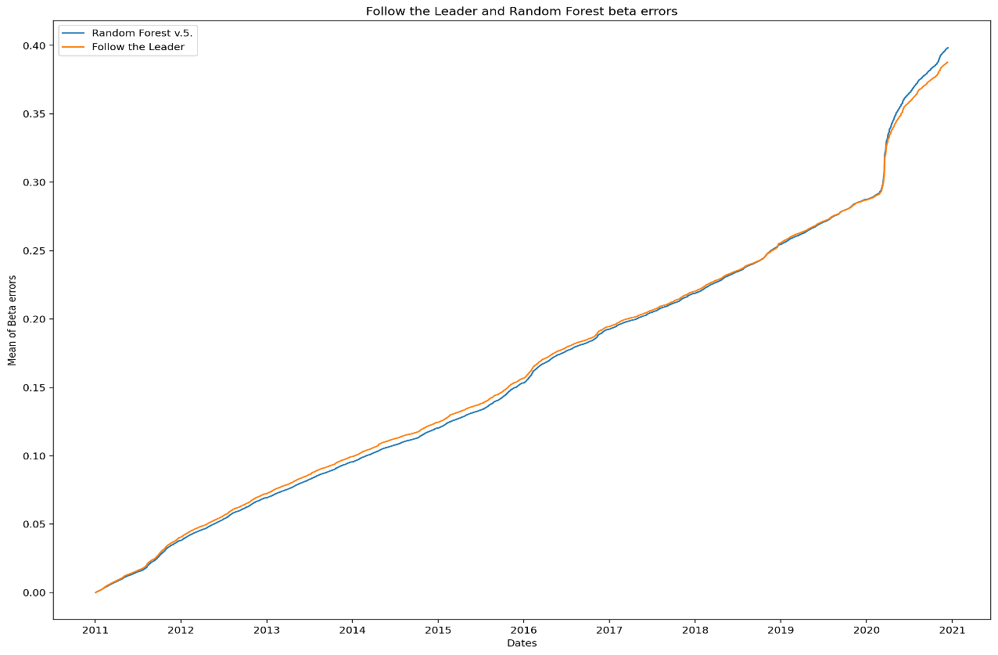
25. Random Forest v.5.

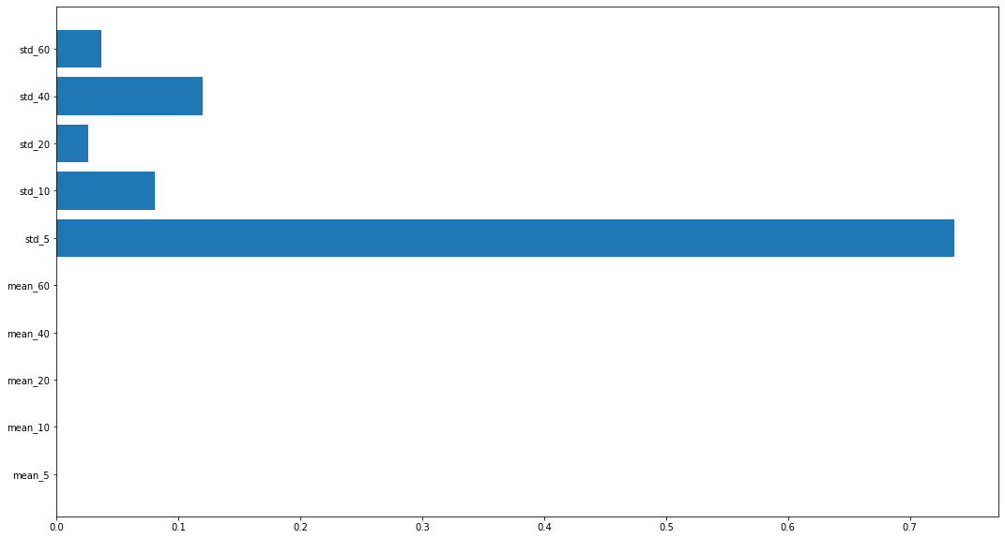
26. Random Forest v.5. feature importance
I try this version with 8 depths, the performance is very similar, but it looks like I might use two other features:
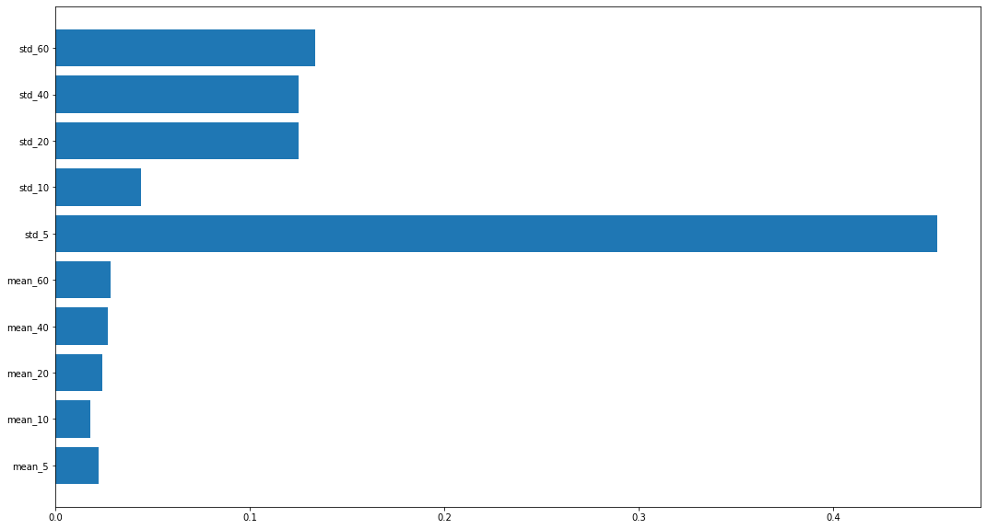
27. Random Forest v.5.2. feature importance
The standard deviation with rolling window 5 is the best conception here, but the 40, 20 and 60 window sizes are looking useful too.

Version 6.
I choose new features, the lowest price for every day. The parameters are set to n_estimators=50, max_depth=5, max_features=6
X_df = pd.DataFrame({
"low_5_mean": low_df.rolling(window=5, min_periods=3).mean().stack(),
"low_10_mean": low_df.rolling(window=10, min_periods=3).mean().stack(),
"low_20_mean": low_df.rolling(window=20, min_periods=3).mean().stack(),
"low_40_mean": low_df.rolling(window=40, min_periods=3).mean().stack(),
"low_60_mean": low_df.rolling(window=60, min_periods=3).mean().stack(),
"low_5_std": low_df.rolling(window=5, min_periods=3).std().stack(),
"low_10_std": low_df.rolling(window=10, min_periods=3).std().stack(),
"low_20_std": low_df.rolling(window=20, min_periods=3).std().stack(),
"low_40_std": low_df.rolling(window=40, min_periods=3).std().stack(),
"low_60_std": low_df.rolling(window=60, min_periods=3).std().stack()
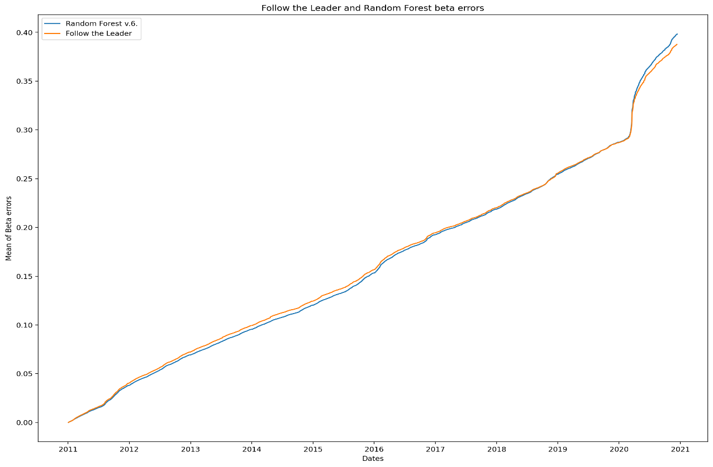
})
28. Random Forest v.6.

.

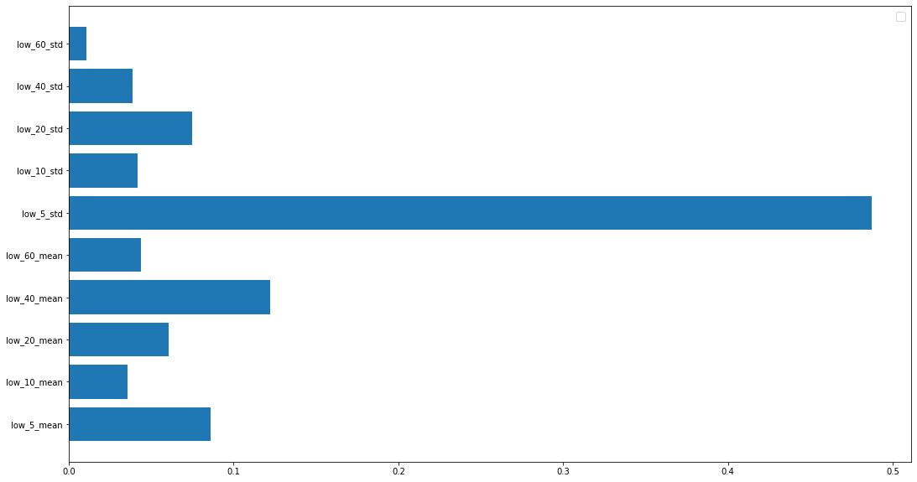
The standard deviation with rolling window 5 is the most important features.
29. Random Forest v.6. feature importance

Version 7.
I try the volume of papers. The parameters: n_estimators=100, max_depth=5, max_features=8

X_df = pd.DataFrame({
"volume_10_mean": volume_df.rolling(window=10, min_periods=3).
mean().stack(),
"volume_20_mean": volume_df.rolling(window=20, min_periods=3).
mean().stack(),
"volume_40_mean": volume_df.rolling(window=40, min_periods=3).
mean().stack(),
"volume_60_mean": volume_df.rolling(window=60, min_periods=3).
mean().stack(),
"volume_5_std": volume_df.rolling(window=5, min_periods=3).std().stack(),
"volume_10_std": volume_df.rolling(window=10, min_periods=3).std().stack(),
"volume_20_std": volume_df.rolling(window=20, min_periods=3).std().stack(),
"volume_40_std": volume_df.rolling(window=40, min_periods=3).std().stack(),
"volume_60_std": volume_df.rolling(window=60, min_periods=3).std().stack()
})
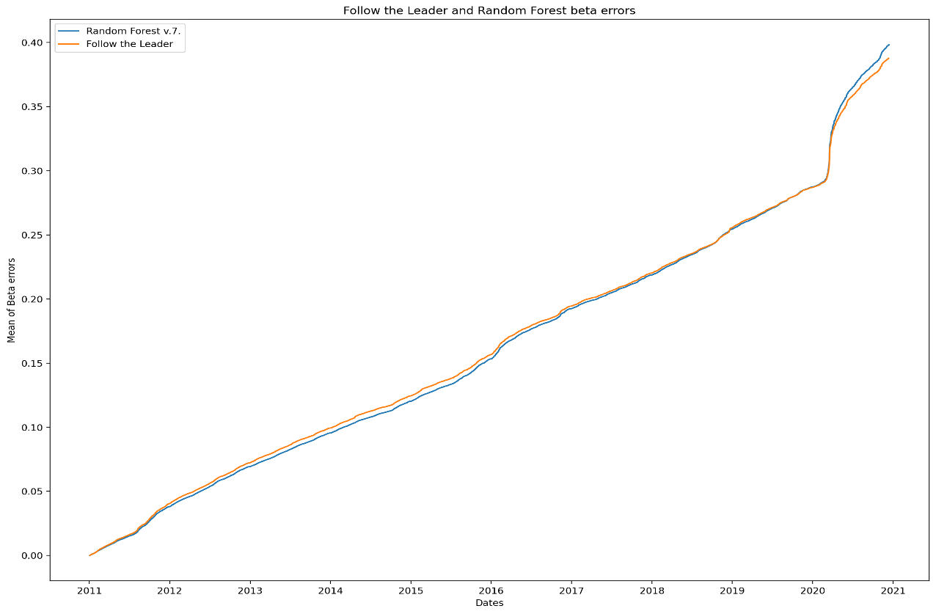
30. Random Forest v.7.
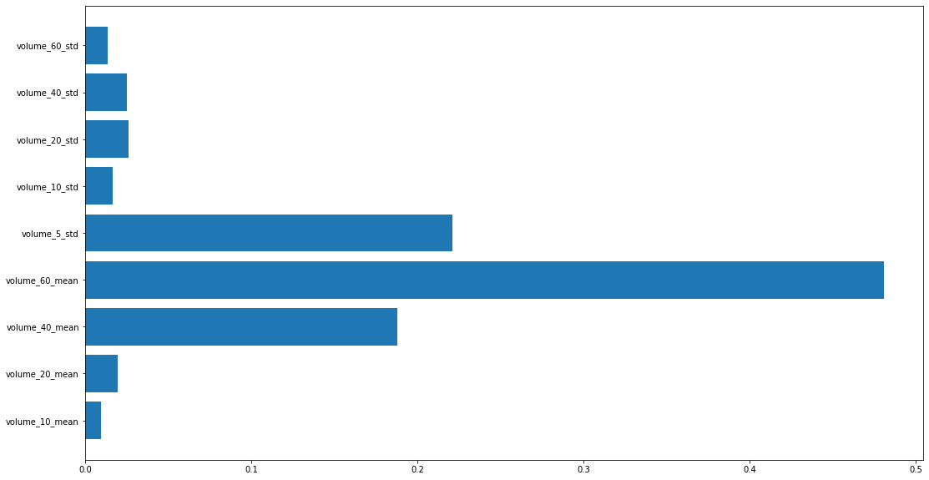
I might use the mean with 40 and 60 sizes, and the standard variation with size 5.
31. Random Forest v.7. feature importance

Version 8.
This time I try the highest price. Parameters: n_estimators=100, max_depth=5, max_features=6
X_df = pd.DataFrame({
"high_5_mean": high_df.rolling(window=5, min_periods=3).mean().stack(),
"high_10_mean": high_df.rolling(window=10, min_periods=3).mean().stack(),
"high_20_mean": high_df.rolling(window=20, min_periods=3).mean().stack(),
"high_40_mean": high_df.rolling(window=40, min_periods=3).mean().stack(),
"high_60_mean": high_df.rolling(window=60, min_periods=3).mean().stack(),
"high_5_std": high_df.rolling(window=5, min_periods=3).std().stack(),
"high_10_std": high_df.rolling(window=10, min_periods=3).std().stack(),
"high_20_std": high_df.rolling(window=20, min_periods=3).std().stack(),
"high_40_std": high_df.rolling(window=40, min_periods=3).std().stack(),
"high_60_std": high._df.rolling(window=60, min_periods=3).std().stack()
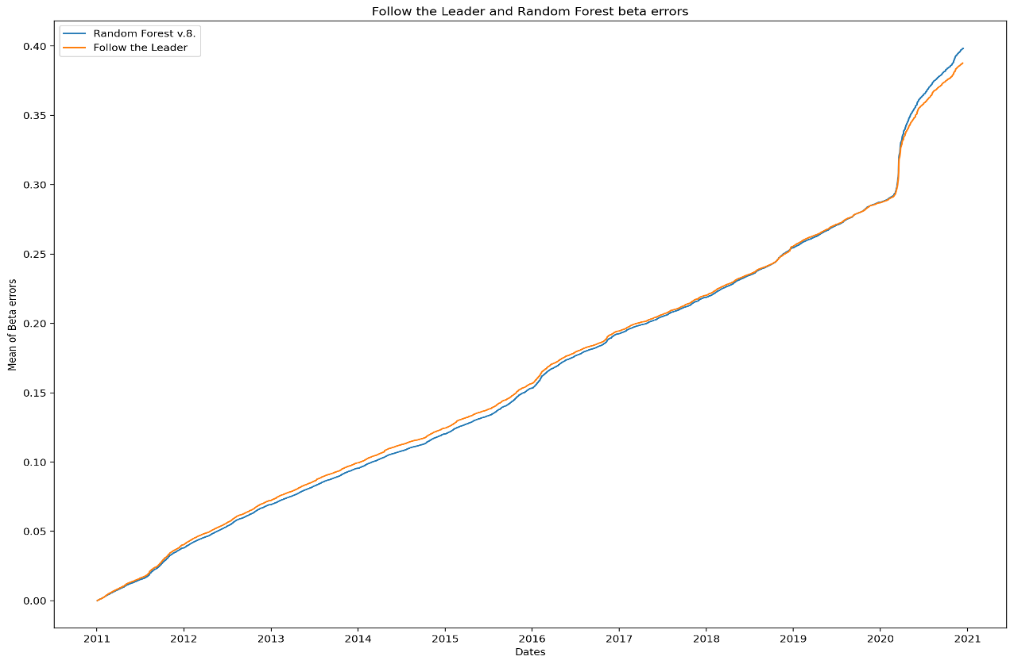
}).
32. Random Forest v.8.

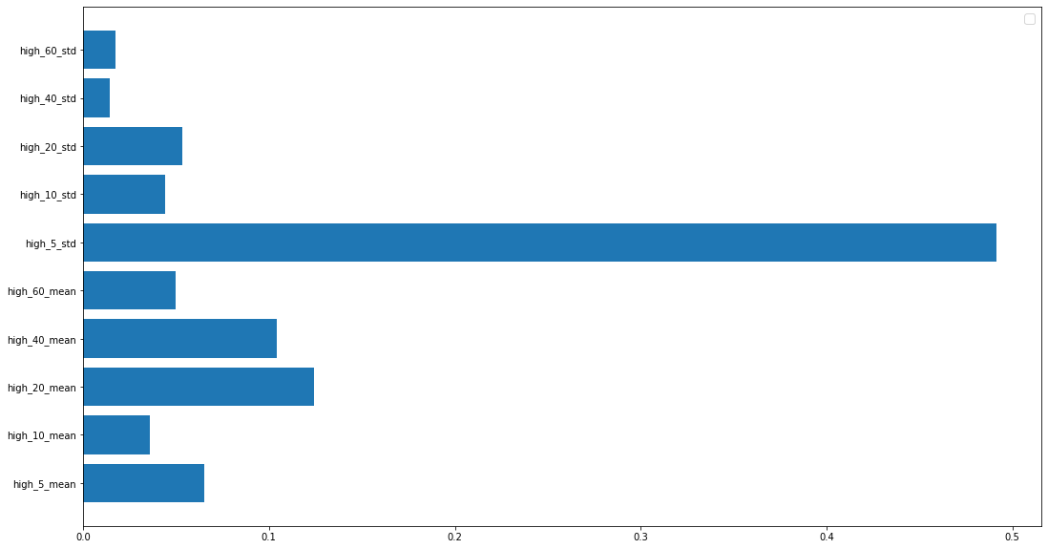
From the high prices I will use the standard deviation with rolling window 5.
33. Feature importance of Random Forest v.8.

Version 9.
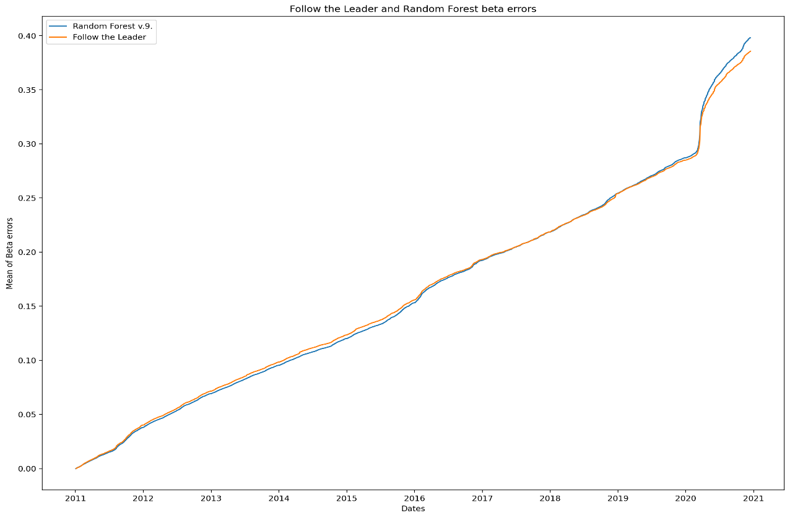
This time I try some statistic with the previous 10 days.

34. Random Forest v.9.
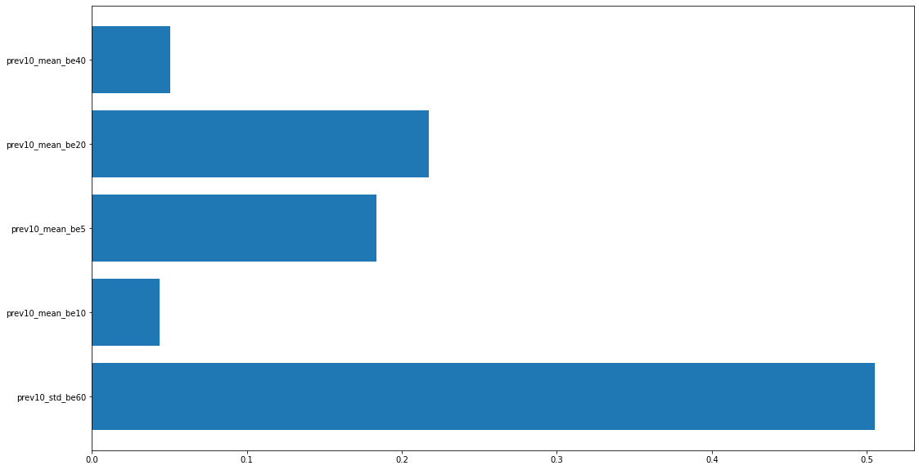
35. Feature importances of Follow the Leader v.9.
The best performing property is the standard deviation with rolling window 60, but the mean could also be good with 5 and 20 windows.
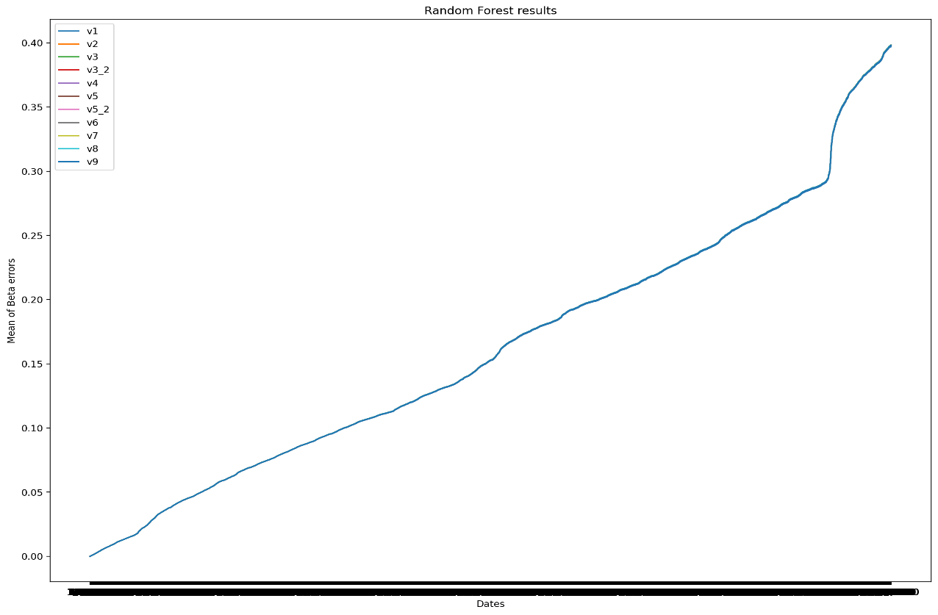
All Random Forest in one picture:
36. All Random Forest version

The models don’t have any difference, I checked the results before and after rounding to the 5 window sizes, and this is the reason. The algorithms don’t have enough differences with the five window sizes. I need to boost my algorithm to make a bigger change or use more window sizes. I try the best parameters from the models and add some new.

Final Result
I choose the best features from the previous models and add the beta error’s mean of the previous 20 days with rolling window 60 and 10.
The parameters: n_estimators=150, max_depth=28
X_df = pd.DataFrame({
"beta_10_mean": all_beta_10_df.stack(),
"beta_60_mean": all_beta_60_df.stack(),
"prev5_std_be_60": all_beta_60_df.
rolling(window=60,min_periods=3).
std().stack(),
"prev5_mean_be_10": all_beta_10_df.
rolling(window=10, min_periods=3).
mean().stack(),
"std_5": daily_return_df.rolling(window=5, min_periods=3).
std().stack(),
"std_40": daily_return_df.rolling(window=40, min_periods=3).
std().stack(),
"std_60": daily_return_df.rolling(window=60, min_periods=3).
std().stack(),
"low_5_std": low_df.rolling(window=5, min_periods=3).
std().stack(),
"low_40_mean": low_df.rolling(window=40, min_periods=3).
mean().stack(),
"volume_60_mean": volume_df.rolling(window=60, min_periods=3).
mean().stack(),
"volume_5_std": volume_df.rolling(window=5, min_periods=3).
std().stack(),
"high_5_std": high_df.rolling(window=5, min_periods=3)
.std().stack(),
"prev20_std_be60_20": all_beta_60_df.
rolling(window=20, min_periods=3).
std().stack(),
"prev20_mean_be10_20": all_beta_10_df.
rolling(window=20, min_periods=3).
mean().stack()

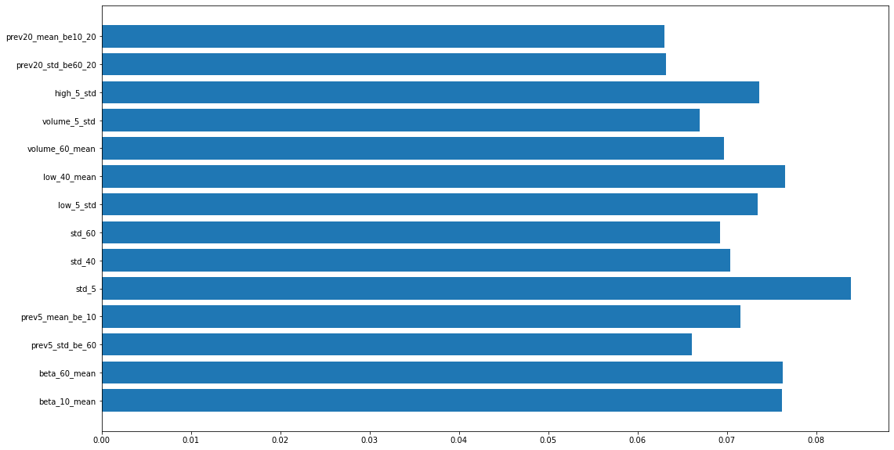
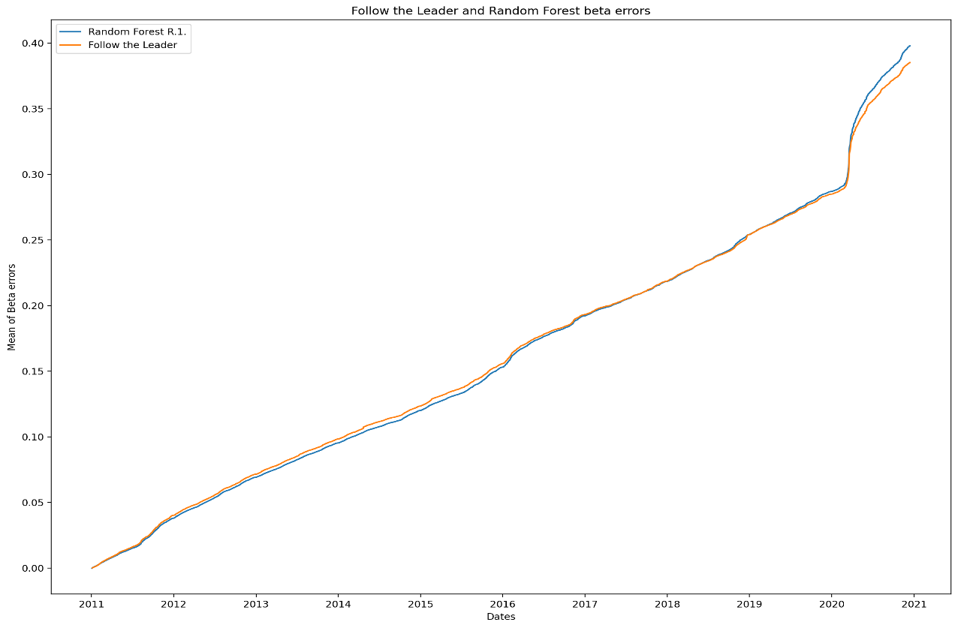
37. Random Forest final results’s important features
38. Random Forest final result vs. Follow the Reader

I selected the important features from the previous models, so here the utilization is similar.

Conclusion

Random Forest
I saved the results into csv files, I need to read and index them:
min_be = pd.read_csv('Results/Min_beta_error.csv')
min_be.set_index('Date', inplace=True)
min_be.index = [pd.Timestamp(x) for x in min_be.index]
min_be = min_be.loc[[x for x in min_be.index if x.year >= 2011]]

fix_5 = pd.read_csv('Results/fix_window_5.csv')
fix_5.set_index('Date', inplace=True)
fix_5.index = [pd.Timestamp(x) for x in fix_5.index]
fix_5 = fix_5.loc[[x for x in fix_5.index if x.year >= 2011]]

fix_10 = pd.read_csv('Results/fix_window_10.csv')
fix_10.set_index('Date', inplace=True)
fix_10.index = [pd.Timestamp(x) for x in fix_10.index]
fix_10 = fix_10.loc[[x for x in fix_10.index if x.year >= 2011]]

fix_20 = pd.read_csv('Results/fix_window_20.csv')
fix_20.set_index('Date', inplace=True)
fix_20.index = [pd.Timestamp(x) for x in fix_20.index]
fix_20 = fix_20.loc[[x for x in fix_20.index if x.year >= 2011]]

fix_40 = pd.read_csv('Results/fix_window_40.csv')
fix_40.set_index('Date', inplace=True)
fix_40.index = [pd.Timestamp(x) for x in fix_40.index]
fix_40 = fix_40.loc[[x for x in fix_40.index if x.year >= 2011]]

fix_60 = pd.read_csv('Results/fix_window_60.csv')
fix_60.set_index('Date', inplace=True)
fix_60.index = [pd.Timestamp(x) for x in fix_60.index]
fix_60 = fix_60.loc[[x for x in fix_60.index if x.year >= 2011]]

fix_inf = pd.read_csv('Results/infinite_windows.csv')
fix_inf.set_index('Date', inplace=True)
fix_inf.index = [pd.Timestamp(x) for x in fix_inf.index]
fix_inf = fix_inf.loc[[x for x in fix_inf.index if x.year >= 2011]]

FTL_v1 = pd.read_csv('Results/FTL_v1.csv')
FTL_v1.set_index('Date', inplace=True)
FTL_v1.index = [pd.Timestamp(x) for x in FTL_v1.index]
FTL_v1 = FTL_v1.loc[[x for x in FTL_v1.index if x.year >= 2011]]

FTL_v2 = pd.read_csv('Results/FTL_v2.csv')
FTL_v2.set_index('Date', inplace=True)
FTL_v2.index = [pd.Timestamp(x) for x in FTL_v2.index]
FTL_v2 = FTL_v2.loc[[x for x in FTL_v2.index if x.year >= 2011]]

RF_r1 = pd.read_csv('RF_results/RF_r1.csv')
RF_r1.set_index('Date', inplace=True)
RF_r1.index = [pd.Timestamp(x) for x in RF_r1.index]
I might have different number of days in the last year, but to plot everything in the same figure I need to restrict to the common indices.
I calculated everything in the same Notebook except the Random Forest, so compare it to another DataFrame should be enough:
comm_indices = [x for x in RF_r1.index if x in FTL_v2.index]

min_be = min_be.loc[comm_indices]
fix_5 = fix_5.loc[comm_indices]
fix_10 = fix_10.loc[comm_indices]
fix_20 = fix_20.loc[comm_indices]
fix_40 = fix_40.loc[comm_indices]
fix_60 = fix_60.loc[comm_indices]
FTL_v1 = FTL_v1.loc[comm_indices]
FTL_v2 = FTL_v2.loc[comm_indices]
RF_r1 = RF_r1.loc[comm_indices]
fix_inf = fix_inf.loc[comm_indices]

figure(num=None, figsize=(16, 12), dpi=200, facecolor='w', edgecolor='k')

plt.plot(min_be.mean(axis=1).cumsum(), label = "Minimum")
plt.plot(RF_r1.mean(axis=1).cumsum(), label = "Random Forest R.1.")
plt.plot(FTL_v1.mean(axis=1).cumsum(), label = "Follow the Leader")
plt.plot(FTL_v2.mean(axis=1).cumsum(), label = "Follow the Leader 2")
plt.plot(fix_5.mean(axis=1).cumsum(), label = "Fix window 5")
plt.plot(fix_10.mean(axis=1).cumsum(), label = "Fix window 10")
plt.plot(fix_20.mean(axis=1).cumsum(), label = "Fix window 20")
plt.plot(fix_40.mean(axis=1).cumsum(), label = "Fix window 40")
plt.plot(fix_60.mean(axis=1).cumsum(), label = "Fix window 60")
plt.plot(fix_inf.mean(axis=1).cumsum(), label = "Fix window infinite")

plt.xlabel('Dates')
plt.ylabel('Mean of Beta errors')
plt.title('All results')
plt.legend()
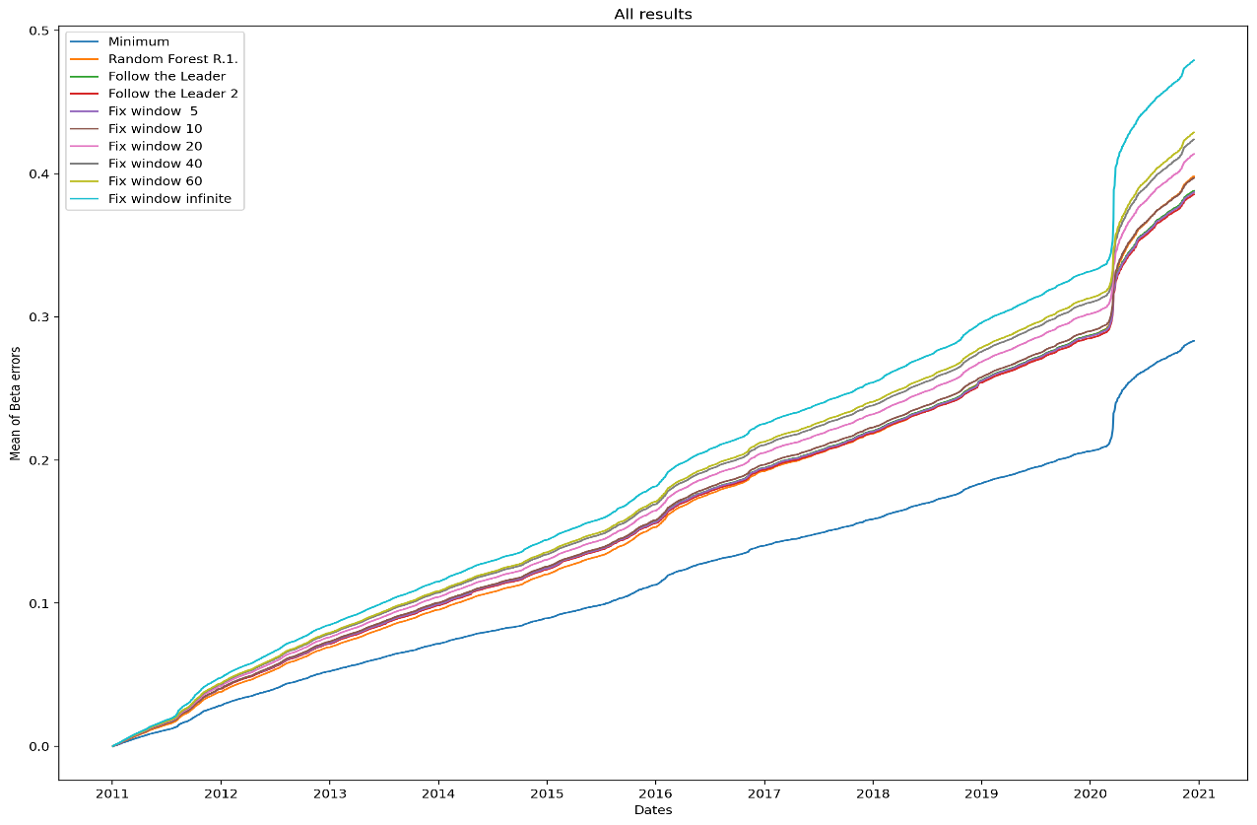
The theoretical minimum is the blue curve, this has the minimum windows if we know the beta errors and not just predict them. The worst result is the light blue curve, the fix window calculation used expanding.
39. All algorithms performance
The Random Forest is the best at the beginning, but then it becomes very similar to the Follow the Leader. The model can be boosted by adding more features and change different kind of parameters. After enough development it should give a better result at the end of the years too.
Choosing the daily return values as feature might signal the changes of the volatility or regime. If a regime starts, shorter window might be more useful. The mean value with different windows also could heighten the trend.

Next Steps
Using more machine learning algorithm can be a good direction, they might predict better. The suggested ones:
- Neural Network
- Gradient Boosting Machines

Bibliography
- Towards Data Science: Jose Manu: Calculate and Plot S&P 500 Daily Returns
Feb. 20, 2020
- Steven de Rooij, Tim van Erven, Peter D. Grünwald, Wouter M. Koolen: Follow the Leader If You Can, Hedge If You Must, Journal of Machine Learning Research 15 (2014) 1281-1316
Submitted 1/13; Revised 1/14; Published 4/14
- Wikipedia: Online machine learning, https://en.wikipedia.org/wiki/Online_machine_learning#Follow_the_leader_(FTL)
- Ruitong Huang, Tor Lattimore, András György, Csaba Szepesvári: Following the Leader and Fast Rates in Online Linear Prediction: Curved Constraint Sets and Other Regularities
Journal of Machine Learning Research 18 (2017) 1-31
Submitted 2/17; Revised 11/17; Published 12/17
- Google: H. Brendan McMahan, Gary Holt, D. Sculley, Michael Young, Dietmar Ebner, Julian Grady, Lan Nie, Todd Phillips, Eugene Davydov, Daniel Golovin, Sharat Chikkerur, Dan Liu, Martin Wattenberg, Arnar Mar Hrafnkelsson, Tom Boulos, Jeremy Kubica: Ad Click Prediction: a View from the Trenches
- Brendan McMahan, Alexandre Bykov: Follow-The-Regularized-Leader
CSE599s, Spring 2014, Online Learning
Lecture 3 - 04/08/2014
- Medium: Dhiraj Reddy: Factorization Machines and Follow The Regularized Leader for dummies
- Leo Breiman: RANDOM FORESTS
Berkeley, CA 94720
January 2001
- Medium: Will Koehrsen: Random Forest Simple Explanation
Dec. 27, 2017
- Tin Kam Ho: Random Decision Forest
web.archive
- Medium: Will Koehrsen: A Practical End-to-End Machine Learning Example
Dec. 27, 2017
- Towards Data Science: Jose Manu: Calculate and Plot S&P 500 Daily Returns
Feb. 20, 2020
- Towards Data Science: Will Koehrsen: Random Forest in Python
Dec 27, 2017
- Towards Data Science: Piotr Płoński:
The 3 Ways To Compute Feature Importance in the Random Forest
Jun 29, 2020
- Towards Data Science: Ravi Charan: How to Fit Random Forests Faster
Sept 7, 2020
- Sci-kit
- https://www.investopedia.com
- https://docs.python.org/3/
- https://pandas.pydata.org/
- https://www.quandl.com/

https://www.investopedia.com/terms/b/beta.asp
https://finance.yahoo.com/
https://www.quandl.com/
https://www.investopedia.com/terms/b/beta-risk.asp
https://www.nyse.com/data-insights/market-volume-and-off-exchange-trading
https://money.cnn.com/2012/08/22/investing/trading-volume/index.html
https://pypi.org/project/yahoo-finance/
https://pythonprogramming.net/sp500-company-list-python-programming-for-finance/
https://pythonprogramming.net/sp500-company-price-data-python-programming-for-finance/
https://www.marketwatch.com/tools/quotes/historical.asp
https://www.investing.com/equities/
https://www.investing.com/etfs/spdr-s-p-500-historical-data
https://www.nasdaq.com/market-activity/funds-and-etfs/spy/historical
https://pandas.pydata.org/pandas-docs/stable/reference/api/pandas.DataFrame.rolling.html
https://en.wikipedia.org/wiki/Online_machine_learning#Follow_the_leader_(FTL)
Journal of Machine Learning Research 18 (2017) 1-31
https://en.wikipedia.org/wiki/Online_machine_learning#Follow_the_regularised_leader_(FTRL)
https://www.marketwatch.com/story/following-the-leader-is-a-losing-strategy-2018-07-09
https://www.stat.berkeley.edu/~breiman/randomforest2001.pdf

