**The LANguage App**

**Lifecycle Architecture Review**

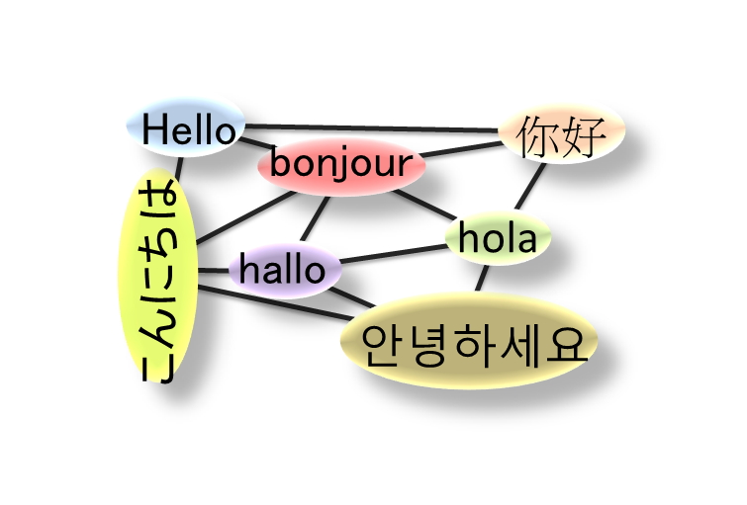

**Ayush Jha, Billy Savanh, Caleb Yang, Kevin Lin, Malia Steward, Yohanness Negash**

**Table of Contents**

Software Specification and Architecture

Software Services in MVP

Quiz Mini-game

Progress Report

Single-word Translation Tool

Software Services Out of MVP

Language Expansion

Pronunciation Services

Expanded Quiz Types

Enhanced Progress Reporting

Social Features

Risk and Risk Mitigation

Correct Single Word Translation

Dictionary API(s)

Uniqueness Compared to Other Competitors

Google Dictionary (Browser Extension)

Duolingo (Website / Mobile Application)

Implementation Time (Multiple Languages)

Schedule and Task Assignments

Team Structure

Existing Team Skills and Experience

Table 1: Roles Table

Table 2: Milestone Table

Table 3: Task Table

Test Plan Document

SFDPO

User Stories

Example User Story 1

Example User Story 2

Example User Story 3

CVA (Commonality Variability Analysis)

Table 4: CVA Table

### **Software Specification and Architecture**

The LANguage App is a supplemental language learning tool designed to help refresh or expand your vocabulary in a foreign language. As a minimally viable product, the tool will **provide three services** through a downloadable Chrome extension. LANguage **has a quiz mini-game** that will teach you words in foreign language derived from the words on the website that you’re viewing. LANguage also **has a progress report** page that tells the user what words they are good at and what words they need practice on. Finally, LANguage **can translate** single words from English to your target foreign language. Our minimally viable product will initially only offer translation and a quiz mini-game from English to German. We will look to expand our services and add new languages after reaching our minimally viable product.

#### Software Services in MVP

##### Quiz Mini-game

The **quiz mini-game** should provide a fun and interactive way for the user to learn vocabulary in the target language. Several words on the page the user is reading will be highlighted, indicating they can click on them to initiate a quiz. It **will appear in a tooltip** so that the experience is seamless for the user. It **will contain five words,** one of which is the correct translation of the English word into the foreign language. The goal of the quiz mini-game is to find the correct translation of the target word in the foreign language. The user can click any of the words to answer the quiz. If they answer correctly, they are congratulated and the quiz ends. Otherwise, the word will be removed from the list and they can try again. For each quiz currently on the page, **there will be an empty star** displayed. Whenever a quiz is finished, a star **will be filled in.** When all stars are filled in, the user knows they have completed all the quizzes on this page.

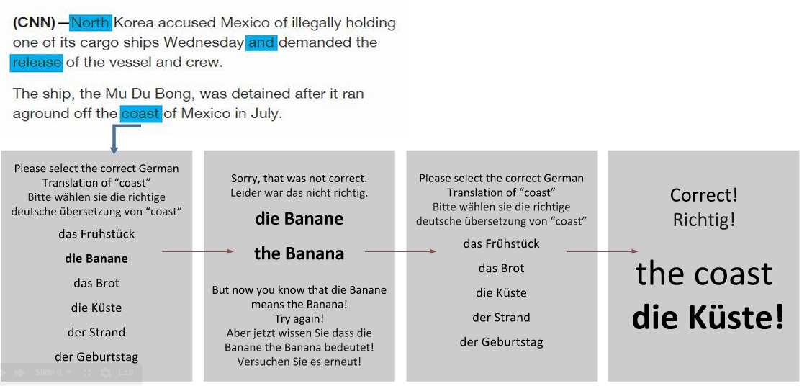

In order to accomplish this, the extension will first **use an HTML parser** to extract the text content from the web page. Then, words will be randomly sampled and **passed through the dictionary service** until it finds five that have known translations. Then, those five words **will be highlighted** using CSS styles. When the quiz is launched by clicking on a highlighted word, four words will be selected from a list of **common words** in the target foreign languageembedded in the extension. They will be displayed alongside the correct translation in the quiz, in a random order. When the user clicks on a word, check if it was the correct answer. If it was, **fill in a star** and record data about the quiz for the progress report. Otherwise, cross out the word and return to the multiple choice screen. In either case, after an answer is selected, display a screen showing the translated meaning of the selected word.

##### Progress Report

The progress report is the most important feature for the user to track their vocabulary learning through the LANguage app. The extension will display an icon in the **browser’s toolbar**, which will open the progress report page when clicked. For the MVP, the progress report page will consist of a list of words, alongside the number of **“perfect quizzes”** (got it right on the first try) out of total quizzes. They can use this list to see what words they are doing well with, and which words they struggle with and may need to practice.

Whenever a quiz is finished, it will **record** the word that was quizzed along with the number of attempts into the **browser’s local storage**. When the progress report is opened, the data will be loaded from local storage, and the list of words will be created **using HTML** and displayed to the user.

##### Single-word Translation Tool

The single-word translation tool is intended to give the user a resource to **practice vocabulary** outside of a quiz. It will translate a selected word from English to the target foreign language . This translation will be presented as a pop up after the user highlights a word.

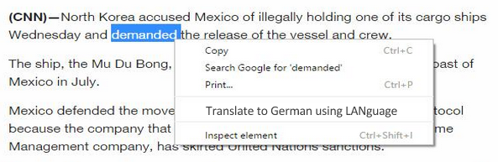

The translation tool will be written in **Javascript** and will require the use of an **external translation provider, and a tooltip library**. When the user highlights a word, the extension will use an **AJAX request** to get the translated word from the translation provider. Then, using the tooltip library, a tooltip will be displayed to the user containing the translated word.

#### Software Services Out of MVP

##### Language Expansion

Initially we will focus on English to German translations but we will look to expand to other languages.

##### Pronunciation Services

The single-word translation tool will be extended to include audio of the selected word being spoken.

##### Expanded Quiz Types

Right now, the quiz feature only focuses on matching the correct word to its synonym. Later, we can add different kinds of quiz features, each with their own progress tracking to help users learn other parts of their target language. Some possibilities are:

* Spelling quiz (select the word from the list that is spelled correctly)
* Fill-in-the-blank (choose the word that completes the given sentence)
* Time trial (the user has 5 seconds to choose the right answer)

##### Enhanced Progress Reporting

The progress report will include several more features to improve learning, such as the following:

* Average time spent on quizzes for specific words
* Graphs of vocabulary proficiency over time
* Progress based on word difficulty (“simple”, “common”, “difficult”)
* Custom quizzes based on words that the user is struggling with

##### Social Features

The user will be able to link their social accounts such as Facebook and Twitter to the LANguage app using a website. From there, they will be able to find friends and see their vocabulary progress, as well as compete with them in vocabulary quizzes.

#### Risk and Risk Mitigation

##### Correct Single Word Translation

A one word equivalent translation (for many languages) can be comprised of a context sensitive phrasing or have multiple context based meanings. For example a language such as Chinese will have word equivalences but the individual characters will have their own distinct meanings. This is an unavoidable inaccuracy in the process of translation.

To mitigate this risk, the developing team should pick a language already familiar (German) to them in order to establish a MVP that is as accurate as possible.

##### Dictionary API(s)

The project has Dictionary API(s) as an external dependency for the process of translation. Each Dictionary API will be the root of each language’s functionality, and any Dictionary inaccuracy will directly reflect on the MVP of this project.

To mitigate the risk, the developing team should use an external dictionary that is well known for its accuracy in single word translations.

##### Uniqueness Compared to Other Competitors

###### Google Dictionary (Browser Extension)

A Google Chrome browser extension called Google Dictionary shares some functionality with this project. In Google Dictionary, the user can find translations for a selected word of phrase. It translates between 12 different language. Google Dictionaries is different in how it also allows for “Google searches” of a selection (Google’s web crawlers as an external dependency).

Our product focuses on the language learning aspect of translating from your native language to your target foreign language. While Google Dictionaries does do simple single word translations, our minimally viable product **(MVP) will primarily use the quiz mini-game** to supplement language learning while having simple single word translations available to help in this regard.

###### Duolingo (Website / Mobile Application)

Duolingo is a language learning website / mobile application, which has a lesson structure. It shares a interactive quiz function, a continuous progress report, and a user word history system, with this project. It differs in their general purpose of teaching in order to crowdsource the translation of the internet.

The scope of Duolingo and LANguage as well as the delivery methods of Duolingo and LANguage differ greatly. **Duolingo** is a standalone product that is a **primary source for language learning**, while **LANguage** seeks to be a **secondary source of language** **learning** that will use the web pages that a user is already reading to supplement their vocabulary learning.

##### Implementation Time (Multiple Languages)

For a complete foreign language vocabulary learning product, multiple languages are required. This can take a long time depending on the complexity of the languages the developing team chooses to implement.

To mitigate the risk, the developing team should focus on implementing only one language for their minimally viable product and schedule in time to implement other languages after they complete the basic services of the product.

### **Schedule and Task Assignments**

#### Team Structure

##### Existing Team Skills and Experience

Team members in alphabetical order than our skills in order of most experience to least experience:

* **Ayush**: Python, Javascript/HTML, C#, Java, C++
* **Billy**: Java, C++, Python
* **Caleb**: C++, Java, Python, Objective-C
* **Kevin**: C++, Java
* **Malia**: Java, C++
* **Yohanness**: MySQL, MS SQL, Java, C++

Given the web based nature of our product, HTML and JavaScript knowledge are key to coding The LANguage App. Only one person on our team, Ayush, has had significant exposure to these languages. The rest of our team needs to set goals for learning HTML, and Javascript if they want to help build the frond-end of The LANguage App.

##### Table 1: Roles Table

|  |  |
| --- | --- |
| **Leader / Role** | **Person(s)** |
| Software Architect (**BIG**) | Caleb, Malia, Yohanness, Billy |
| Software Designer (**SMALL**) | Ayush, Kevin |
| Quality Assurance | Yohanness, Caleb |
| Communications Coordinator | Malia, Kevin |
| MVP (German) Consult | Billy, Caleb |
| UML Diagrammer | Kevin, Ayush |
| UI Designer | Billy, Yohanness, Malia |
| Writer | Billy, Ayush |

##### Table 2: Milestone Table

|  |  |
| --- | --- |
| **Type (Red = Done)** | **Milestone (COLOR Type)** |
| External | LCO |
| External | LCA |
| Internal | Development Environment |
| External | Zero-Feature Release |
| External | Alpha Release |
| External | Beta Release |
| External | Final Release |

##### Table 3: Task Table

|  |  |  |
| --- | --- | --- |
| **Due (Red = Done)** | **Task** | **Who(m) responsible** |
| 4/28/15 | Create GitHub Repository | Ayush |
| 4/28/15 | Add all team members to Repository | Ayush |
| 5/22/15 | Learn JavaScript | All (except Ayush) |
| 5/22/15 | Learn HTML | All (except Ayush) |
| TBD | Create Dev Account on Chrome Store | TBD |
| TBD | “Hello World” of Chrome extension | TBD |
| TBD | Tutorial write up/simulation | TBD |
| TBD | Word highlighter (5 words of page) | TBD |
| TBD | Quiz (window closes if clicked) | TBD |
| TBD | Progress report (blank page) | TBD |
| TBD | Barebones link to Dict API/Directory | TBD |
| TBD | Implement word highlighter | TBD |
| TBD | Implement quiz | TBD |
| TBD | Implement progress report | TBD |
| TBD | Polish extension | TBD |
| TBD | Publish | TBD |

### **Test Plan Document**

Our team will test LANguage using the SFDPO (Structure, Function, Data, Platform, Operations) methodology. LANguage’s three primary services will be thoroughly tested to ensure that each component communicates optimally with one another. We will also test the connectivity with the external dictionary and how well LANguage performs as a Chrome browser extension. Given the simplicity in LANguage’s design, these aspects will be sufficient to ensure a high quality product for our customers. Features that will not be tested are the software services not in MVP including: pronunciation, expanded languages, expanded quiz types, expanded progress reports, and social features. These features may be added in later releases of LANguage and will be tested then. The features we will be testing will be tested manually by quality assurance and tracked via an online document that the rest of our team can access. The main function that we need to test is to make sure that the browser extension, external dictionary, and browser local storage are linked together correctly. If we cannot get these components to link correctly by a certain date, our product will not have enough time to become completed. This constitutes our exit criteria.

#### SFDPO

##### Structure

* Ensure the browser extension, external dictionary, and the browser local storage are linked together correctly.
* For the single word translation service, verify that the extension communicates with the external dictionary correctly.
* For the game, verify that the extension parses a web page correctly.
* For the game, verify that user progress is stored correctly in local browser storage.
* For the game, verify that progress report can be load on to the browser extension.
* For the game, verify that words can be highlighted by the browser extension.

##### Function

* Make sure the translation tool retrieves a correct translation at least 90% of the time.
* Make sure we don’t crash on inappropriate input for the translation tool.
* Make sure our algorithms choose meaningful and appropriate words for the mini-game.
* Make sure all user interfaces function correctly.

##### Data

* Verify LANguage handles incoming words correctly for translation.
* Verify LANguage handles user selection during quiz mini-game correctly.
* Verify LANguage highlight words correctly after translation service.
* Verify LANguage stores user progress correctly in local browser storage.

##### Platform

* Make sure LANguage runs correctly on the Chrome browser.
* Make sure that LANguage uses the external dictionary correctly.

##### Operations

* Test translation feature.
* Test mini-game feature.
* See if user progress is being stored correctly.

#### User Stories

##### Example User Story 1

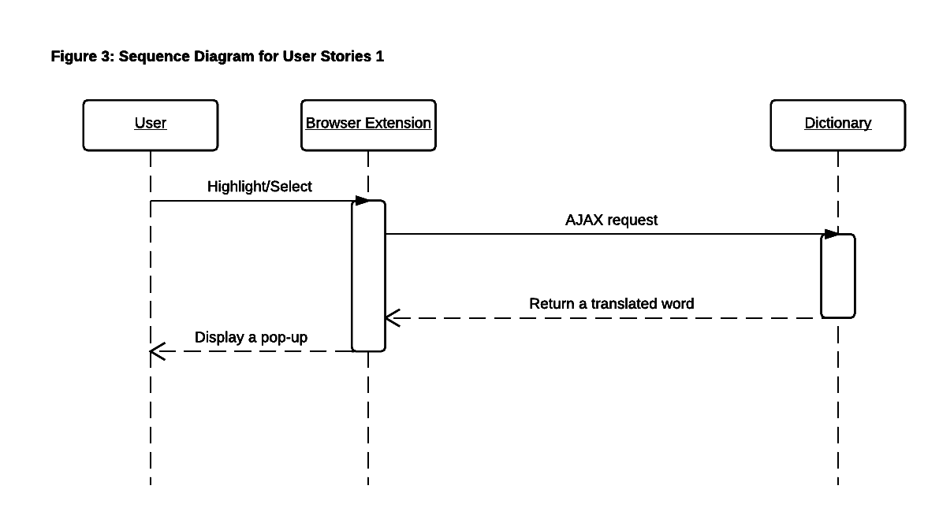**Goal:** User wants to translate a single word from their original language to their foreign language.

**Primary Actor:** The user.

**Pre-Condition:** The String they choose exists in the external dictionary of the foreign language.

**Successful Post-Condition:** A correct translation of the chosen word is retrieved and displayed.

**Unsuccessful Post-Condition:** The translation could not be found or an incorrect translation is found. It could also translate a the wrong word in document/ webpage

**Trigger:** The user highlights a word on the web page they are viewing.

##### Example User Story 2

**Goal:** User wants to play the quiz mini-game and store their progress.

**Primary Actor:** The user.

**Pre-Condition:** LANguage has determined some words with which a quiz mini-game can be played.

**Successful Post-Condition:** LANguage produces the correct translation of the target word as well as an appropriate choice of four other words in the foreign language. When the user selects an incorrect word, that word is removed from the list. This process repeats until the user selects the correct translation. The word they worked on is stored in their progress report.

**Unsuccessful Post-Condition:** LAnguage produces an incorrect translation of the target word or fails to produce an appropriate choice of four other words in the foreign language. The incorrect word is not removed from the list or incorrectly chosen as the correct word. The user’s progress is not stored in their progress report.

**Trigger:** The user selects a word from the web page they are viewing that has a quiz mini-game associated with it.

##### Example User Story 3

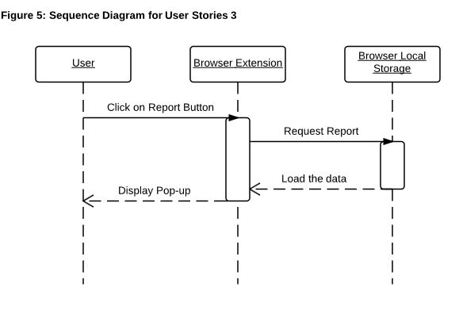

**Goal:** User wants to check and view their **history** of progress.

**Primary Actor:** The user.

**Pre-Condition:** Based on their results from the quizzes, the user will be able to view their progress.

**Successful Post-Condition:** The results will besaved to the memory where the user can access their results. If the user is curious how they are progressing, they will be able to check and verify what they should review more. LANguage will keep track of the scores from the user.

**Unsuccessful Post-Condition:** The user’s results have not been saved. Therefore, their history would not show up. There could also be a misrepresentation of their results, where the report would display an incorrect number of how many questions they got right from the mini-games.

**Trigger:** The user clicks the Progress Report button on the UI.

#### Table 4: CVA (Commonality/Variability Analysis) Table

|  |  |  |  |
| --- | --- | --- | --- |
| **Aspect** | **LANguage** | **Google Dictionary** | **DuoLingo** |
| Word selection | Included | Included | Included |
| Platform | Extension | Extension | Web/mobile app |
| # of languages | 1 | 12 | 9 |
| Interlingual | Not in MVP | Included | Included |
| Gamification | Included | Not included | Included |

#### User Interaction Sequence Diagram

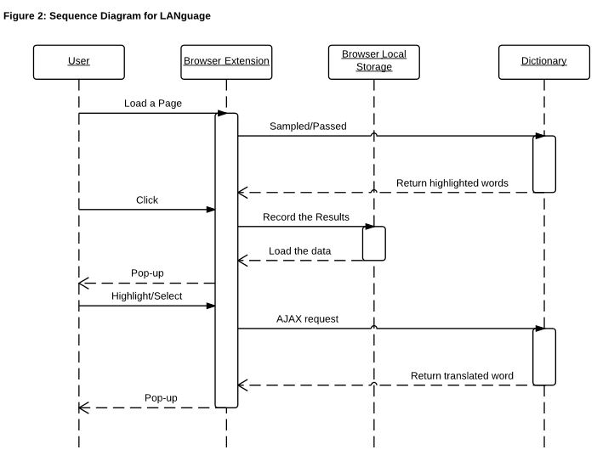

#### Data Flow Diagram

