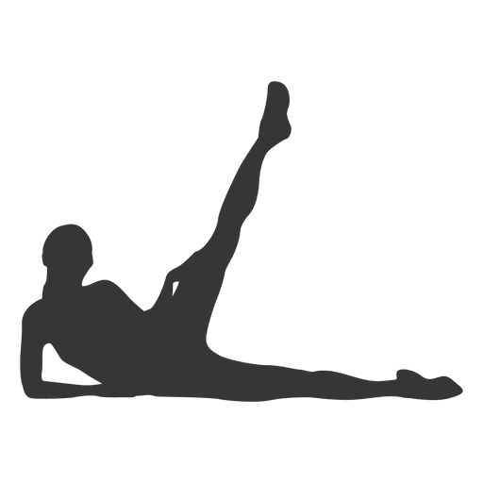
  - MOVE & STRETCH Mobility Tips for Office Workers

Refresh Your Body. Refocus Your Mind. Redefine Your Workday.

Sitting all day doesn’t have to mean stiffness and fatigue.
Discover quick, effective stretches you can do right at your desk to stay flexible, energized, and pain-free — all in just a few minutes a day.

