Project Structure

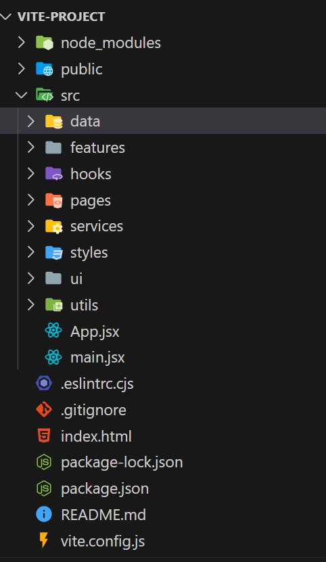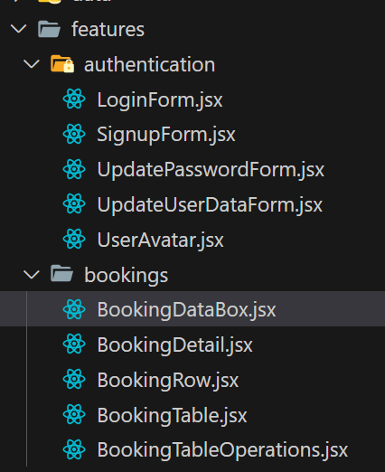

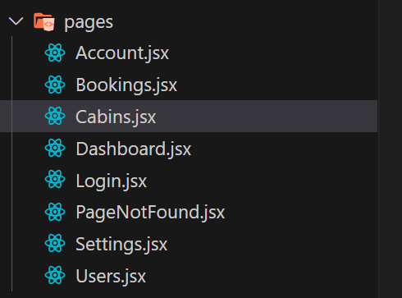

* For using styled components: npm install styled-components
* Build StyledComponents and apply styles
* Setup pages and routes (If not using api calls use normal method of routes)
* *function* App() {
* *return* (
* <>
* <GlobalStyles />
* <BrowserRouter>
* <Routes>
* <Route *element=*{<AppLayout />}>
* <Route *index* *element=*{<Navigate *replace* *to=*"dashboard" />} />
* <Route *path=*"dashboard" *element=*{<Dashboard />} />
* <Route *path=*"bookings" *element=*{<Bookings />} />
* </Route>
* </Routes>
* </BrowserRouter>
* </>
* );
* }

ui/AppLayout.jsx

*function* AppLayout() {

*return* (

        <div>

            hello

            <Outlet />

        </div>

    );

}

Now set up React query

