RPG Map Framework框架

Creative Spore

Support: creativespore@gmail.com

Web: http://www.creativespore.com

Unity Forums: user CreativeSpore

1Introduction.................................................................................................................................. 3

2DirectionalAnimationController ..............................................................................................3

2.1Creating a character with directional animation ........................................................ 6

3Prefabs .......................................................................................................................................... 8

3.1 Player ......................................................................................................................................... 8

3.2 PlayerTouch ............................................................................................................................... 8

3.3 Player Camera .......................................................................................................................... 8

3.4 Boat & Ballon ............................................................................................................................ 8

3.5 EnemyGen ................................................................................................................................. 8

3.6 ZombiePlay ................................................................................................................................ 8

3.7 Teleporter ........................................................................................................................... 8

4Autonomous Agents ......................................................................................................................9

5Path Finding ..................................................................................................................................9

6RPG Map Helper ............................................................................................................................9

7Legacy ............................................................................................................................................ 9

7.1Character Animation Editor (Legacy) ................................................................................. 9

1 Introduction介绍

This is the user manual for the Unity asset RPG Map Editor.

这是Unity资产RPG地图编辑器的用户手册。

This manual will teach you how to use all the framework included with

the asset.

本手册将教您如何使用资产中包含的所有框架。

This will also include some of the script found in the "Samples\Scripts"

这也将包括一些在“脚本”中发现的脚本。

folder. 文件夹

2 DirectionalAnimationController定向动画控制器

Manages the directional animations of the characters

管理字符的定向动画。

To create a directional animation controller navigate to

"Assets/Create/RpgMapEditor/Directional Animation Controller".

要创建定向动画控制器导航到

“资产/创建/ rpgmapeditor /定向动画控制器”。

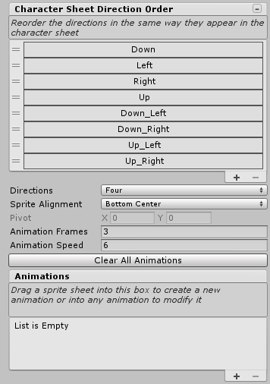

Before importing any sprite sheet by dragging it into the Animations drag

area, you have to setup the import settings:

在导入任何精灵表之前，将它拖动到动画拖动中

区域，您必须设置导入设置：

• Directions: the many directions have the sprite sheet.

说明：很多方向都有雪碧表。

• Sprite Alignment: the alignment of each frame crated for the

animation

• Animation Frames: number of frames per direction

• Animation Speed: frames per second

To add an animation, drag the sprite sheet texture to the drag are under

Animations header or directly over any other animation to modify it.

The sprite sheets should have the next format:

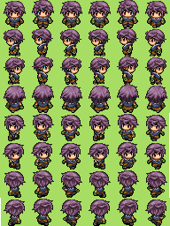

All the animations should have the same number of frames and be placed

in a row for each direction. Also, all frames should be placed in a grid

with cells of the same size (same size for all frames in the animation).

Sprite sheets with multiple character animations are allowed if they are

all placed together like in this example:

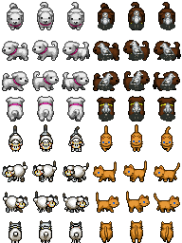

If the sprite sheets texture is set and Sprite Single and the frames are

separated and detected individually by the Sprite Editor while

automatically slicing the texture, the sprite will be sliced automatically

with no need of previously slicing the sprite sheet into multiple sprites.

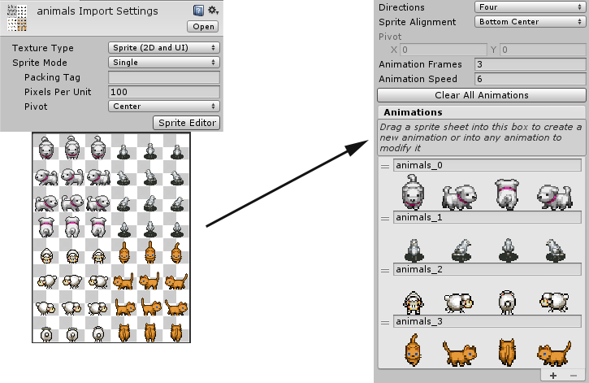

If the sprite sheet cannot be automatically sliced because some frames

have adjacent pixels or any other reason, you can change the sprite sheet

to be Sprite Multiple, and use the Sprite Editor to slice the sprite sheet

using the grid settings:

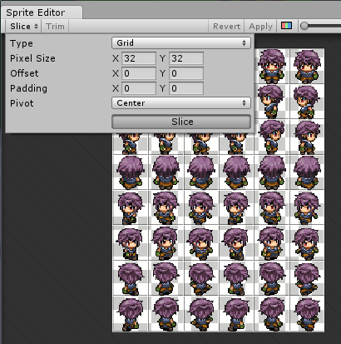

This way, when the sprite sheet is dragged, the frames are taken directly

from sliced frames.

2.1 Creating a character with directional animation

Once you have created a directional animation controller, you can use it

to create a character in the scene.

First, create a gameobject and attach a SpriteRenderer and a Directional

Animation component.

Select the Directional Animation Controller (Dir Anim Ctrl) and that's it.

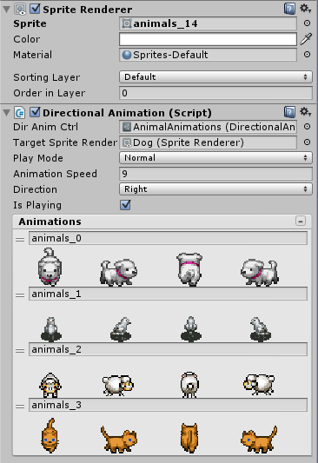

You can change some parameters and select the animation by clicking in

the animation list (to open the list, click the right button in the header of

the list):

• PlayMode:

◦ Normal: the animation is played in a forward loop.

◦ Reverse: the animation is played in a backward loop.

◦ Ping Pong: the animation is played in a loop from start to end,

then back and looping again.

• Animation Speed: the frames per second.

• Direction: the facing direction.

• Is Playing: if true, the animation will be animated, if false it will

show the first frame of the animation.

3 Prefabs

3.1 Player

Manages the control of the main character, allowing moving it in all

directions and shooting in 4 directions.

3.2 PlayerTouch

Manages the control of the main character but moving it by clicking over

the ground. If the clicked position is reached, it will find a way to move to

the destination.

This is used for controlling the player in a touch device.

3.3 Player Camera

Manages the control of the pixel perfect camera following the player.

3.4 Boat & Ballon

Manages the different vehicles included in the asset.

The player can drive any of them standing close and pressing Enter key.

3.5 EnemyGen

Manages an object generator to create a number of entities and create

more when they are destroyed.

This prefab is used to spawn enemies.

3.6 ZombiePlay

Manages an enemy with a simple AI using path finding to reach the

player.

Once reached, it's moving around him.

3.7 Teleporter

Manages a transition area to move the player to a destination scene and

target teleporter or other game object set by name.

4 Autonomous Agents

Manages the AI moving behaviour like steering, seeking, following a

path, etc,

Check "Scripts\AutonomousAgents\MovingBehaviour".

5 Path Finding

The path finding solution included with the asset can be found in the

"Script\MapPathFinding" folder and contains the following scripts:

• PathFinding: contains the basics of the path finding implementation

derived from the other scripts.

• MapPathFinding: contains the tile map specific implementation of

the path finding used by find a path in the tilemap having into

account the tile collisions.

• MapPathFindingBehaviour: is the Monobehaviour used by the

entities to find a path to a target tile or position and it's used as a

part of the enemy AI to reach the player.

6 RPG Map Helper

If you need help working with the tilemap by code, this will help you to

solve some of the common problems.

In the "Script\AutoTileMap" folder you can find an script file

RpgMapHelper.cs.

This class contains methods to help you getting or setting a tile from the

tilemap, trowing an special ray to check if a tile with collisions is in the

middle or modifying the fog of war, for example.

7 Legacy

7.1 Character Animation Editor (Legacy)

This is the old animation system replaced by the new

DirectionalAnimation.

The Character Animation Editor is an editor window opened through the

inspector view of a CharAnimationController.

You will be able to edit and create the character animation using an Editor

Window to make it easy to change parameters like animation speed or the

sprite pivot and create enemies, NPCs or the player faster and easier.

The new inspector of the CharAnimationController looks like this:

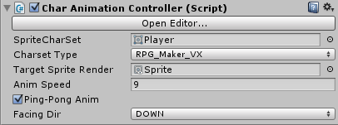

From the inspector, you can change some parameters of the animation

like the SpriteCharSet. It has to be an sprite with all frames of the

animation and should be a character sprite sheet compatible with RPG

Maker XP or VX characters like these ones:

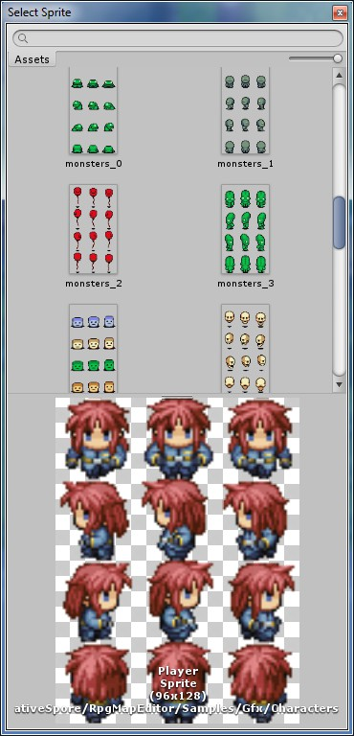 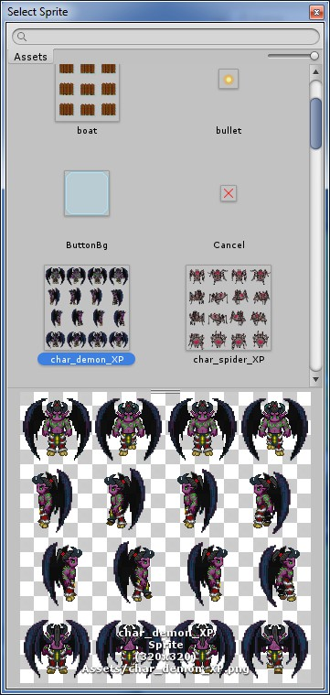

10/13

RPG Map Framework

If you change the SpriteCharSet remember to change also the Charset

Type to the right type of charset.

The Target Sprite Renderer will be the Sprite Renderer where the

animation will be rendered.

Anim Speed is the speed of the animation in frames per second.

Ping-Pong Anim change the order of animation frames. There are always

3 frames per walking animation: frame 0, 1 & 2. If Ping-Pong is activated,

the animation will be like 0,1,2,1,0 in a loop. Otherwise it will be

0,1,2,0,1,2. Some animations are thought to be played in ping-pong, some

are not.

Facing Dir will change the character facing direction.

You can changed most of the parameters here, in the inspector window,

but if you want to access more advanced parameters, you can access the

Character Animation Window by pressing the Open Editor… button.

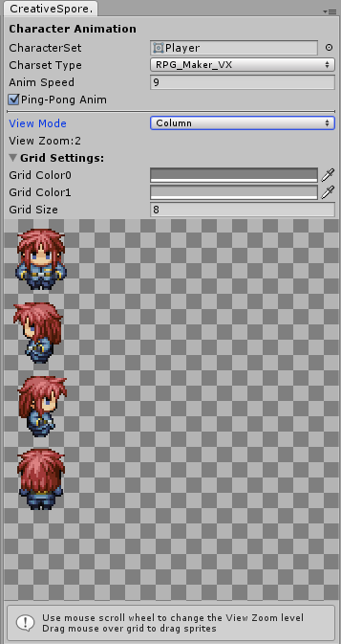 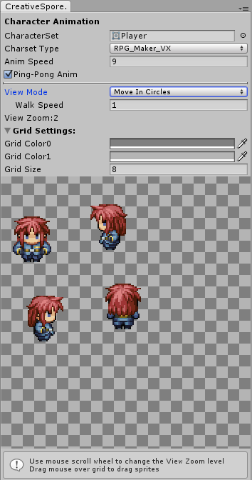

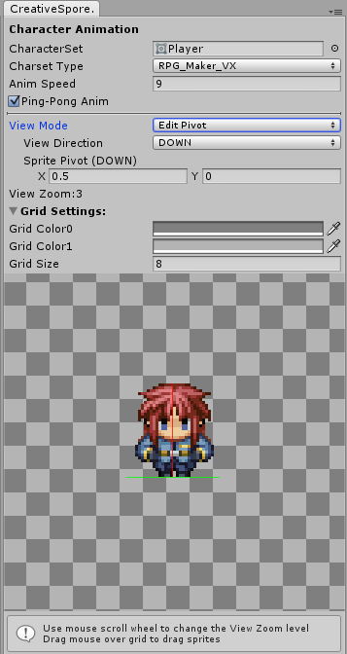 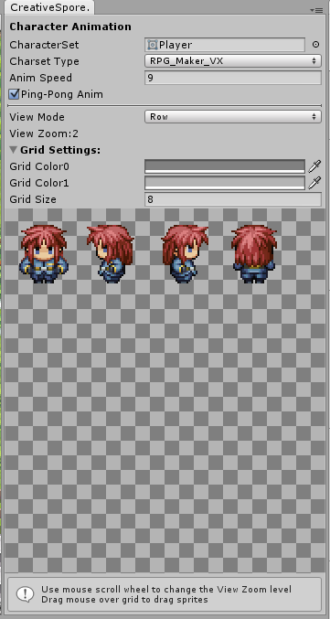

Here, you can change the View Mode to see the character animated in

different configurations.

One of the view modes, Edit Pivot, allow you to change the pivot of the

character for each direction. Most of the cases are good using the default

pivot (0.5, 0) but in some cases it’s useful to change the pivot.

You can change the grid options as well and drag the mouse over the grid

to move the character and use the mouse wheel to zoom in and out.