DIGITAL FUSION LABS
OpenMarket
A F R I C A
Where Africa's open markets meet verified commerce

The Business Plan, Market Analysis and System Architecture
for an AI-Powered Commerce Coordination Layer
A study of B2B commerce in Africa against the global and Western benchmark,
a competitive teardown of Omnibiz, OmniRetail, TradeDepot and Egatee,
and a complete commercial and engineering blueprint for Nigeria and Ghana.
BOROJI ADEBAYO-HOPEWELL
Digital Fusion Labs
First Edition · July 2026

OpenMarket Africa
The Business Plan, Market Analysis and System Architecture for an AI-Powered Commerce Coordination Layer
Copyright © 2026 Digital Fusion Labs. All rights reserved.
Author: Boroji Adebayo-Hopewell.
Published by Digital Fusion Labs. OpenMarket Africa™, Virtual Warehouse Ledger™ and SmartSubsidy™ are marks of Digital Fusion Labs. No part of this publication may be reproduced, distributed or transmitted in any form or by any means without the prior written permission of the publisher, except in the case of brief quotations embodied in critical reviews and certain other non-commercial uses permitted by copyright law.
This document contains confidential and proprietary information of Digital Fusion Labs. It is furnished for evaluation purposes only and may not be disclosed to any third party without prior written consent.
A note on the numbers
Every market statistic drawn from a public source is attributed in the text and catalogued in Appendix C. Every forward-looking figure — market sizing, GMV, take rates, credit economics, costs and the five-year model — is a modelled estimate constructed from labelled assumptions. Those assumptions are listed in full in Appendix A, with the basis for each stated explicitly, and that appendix is generated directly from the financial model so it cannot drift from the numbers in Part Three. Nothing here is a forecast in the legal sense. Where a figure is the author's judgement rather than a sourced fact, the text says so.
All monetary amounts are in United States dollars unless denominated in naira (₦) or cedi (GH₵). Naira is converted at the Federal Government of Nigeria's 2026 budget assumption of ₦1,400 to the dollar, depreciating 7% a year in the model; cedi at GH₵12.50, depreciating 5%.
Third-party marks
Omnibiz, OmniRetail, TradeDepot, Egatee, Wasoko, MaxAB, Copia, Alerzo, Sabi, MarketForce, Wabi, Zumi, Faire, Alibaba, Udaan, Moniepoint and all other product and company names referenced are the trademarks of their respective owners. Their inclusion is for comparative and analytical purposes and does not imply any affiliation with or endorsement by Digital Fusion Labs.

Contents
PART ONE · The Market 1
1 The Case in Brief 2
2 How Goods Actually Move 8
3 The Shakeout 11
4 Nigeria and Ghana in Close Detail 14
5 The Global Benchmark 16
6 Seven Structural Truths 19
PART TWO · The Competitive Field 21
7 OmniRetail: The Profitable One 22
8 TradeDepot and the Pivot to Finance 25
9 Egatee: The Corporate-Backed Entrant 26
10 The Failed Cohort 28
11 OpenMarket Africa Today: An Honest Teardown 30
12 The Capability Matrix 33
13 SWOT 35
14 The Position 39
PART THREE · The Business 41
15 The Theory of the Business 42
16 Sizing the Market 44
17 Where the Money Actually Is 47
18 Segments and the Ideal Participant 52
19 Product Strategy and the Value Ladder 54
20 Pricing Architecture 56
21 Go-To-Market 58
22 The Marketing Plan 60
23 The Human Distribution Layer 70
24 Partnerships and Distribution 77
25 Unit Economics and Hub Economics 78
26 The Five-Year Model 81
27 The Raise and the Use of Funds 85
28 The Moat 87
29 Risks 88
PART FOUR · The System 90
30 Architecture Principles 91
31 System Context 93
32 The Order and Settlement Flow 95
33 The Canonical Data Model 97
34 The Virtual Warehouse Ledger 99
35 The Intelligence Layer 100
36 API Specification 102
37 Non-Functional Requirements 104
38 Trust, Security and Regulatory Compliance 105
39 Infrastructure and the Cost Model 107
PART FIVE · Execution 109
40 Operating Model and Organisation 110
41 Roadmap 112
42 Instrumentation 114
43 The First Hundred Days 115
44 Closing Argument 117
Appendices 118
A Assumptions Register 118
B Financial Detail 122
C Source Catalogue 124
D Glossary 127

How to read this document
This is a dual-purpose document. Parts One through Three are written for an investor, a board member or a strategic partner: they establish what actually happened to B2B commerce in Africa over the last four years, dissect the surviving competitors, and set out the commercial plan with a financial model attached. Parts Four and Five are written for the people who have to build it. The two halves are joined because in a coordination business the architecture is the strategy: what OpenMarket can charge for is a direct function of what its settlement layer can be trusted to guarantee.
A reader with forty minutes should read Chapter 1, then Exhibits 1, 2, 5, 10 and 20, then Chapter 13 on SWOT and Chapter 29 on risk. A reader who intends to write a cheque should add Chapters 16, 17, 24 and 25, and then interrogate Appendix A, where the model's soft spots are on open display. A reader who intends to build should start at Chapter 30.
The document is written in prose rather than bullet points, deliberately. African B2B commerce is a subject where the interesting content lives in the qualifications — in why a company can raise $100 million, reach a hundred thousand retailers and still enter administration. Bullets flatten that. Where a list is genuinely the clearest form — a specification, a risk register, a set of API endpoints, a SWOT — the document uses one.

A word on what this business is not
OpenMarket Africa is not a B2B e-commerce company in the sense that Copia, Alerzo, Wasoko and Wabi were B2B e-commerce companies. It does not buy inventory, does not hold stock, does not operate warehouses and does not run a fleet. Those four cost lines are, on the published record, the proximate cause of nearly every failure in this sector, and Chapter 3 sets out that record in detail.
Nor is it a marketplace in the Western sense. Faire and Alibaba's 1688 aggregate supply that would otherwise be invisible to buyers. In Onitsha, Alaba, Mile 12 and Kejetia the supply is not invisible — it is physically present, socially organised, and already trading billions of dollars a year. What is missing is not discovery. What is missing is settlement integrity: a way for a merchant and a distributor who do not fully trust one another to transact at distance, with the money verified before the goods move and a ledger recording who owes what to whom.
OpenMarket sells that guarantee first, and everything else — routing, working capital, demand telemetry, and eventually the intelligence layer — is earned by having run the guarantee at volume. That sequencing is the argument of this entire document, and Chapter 17 shows why it is also where the money is.

PART ONE
The Market
Roughly a trillion dollars a year moves through African informal retail, and almost none of it is instrumented. This part establishes how those goods actually move, what happened to the companies that tried to change it, and why the failure was structural rather than operational.

1 The Case in Brief
Between 2021 and 2026, venture investors put well over half a billion dollars into digitising African informal retail. Four of the companies that took it have failed, three have abandoned commerce for something else, two have merged, and one is profitable. After all of it, 94% of Nigerian retailers still buy their stock the way they always did — in the open market, from a wholesaler they know. OpenMarket Africa is a bet that this is not a failure of demand but a failure of model.

The observation
Start with the number that should govern any strategy in this sector. In OmniRetail's own Nigerian FMCG research — the market leader's research, not a critic's — 94% of retailers source their stock from open markets, and 6% from online platforms. In the same study, 72% of those retailers say they would buy online. The demand is not absent. It is latent, and something in the offer has been failing to convert it for six years.
Set that beside the second number. Africa's informal retail channel comprises roughly 2.5 million small retailers turning over about $1 trillion a year and driving 70% of all food, beverage and personal care sales on the continent. In Nigeria, only 30% of FMCG reaches retailers directly from manufacturers; 70% moves through wholesale markets that nobody has instrumented. Logistics adds an estimated 75% to the cost of goods in sub-Saharan Africa.
And then the third. Every well-funded attempt to intermediate that channel by owning it has failed or retreated. Copia Global entered administration in 2023 after raising more than $100 million. MarketForce wound down its RejaReja commerce operation. Zumi shut down. Wabi, backed by Coca-Cola, exited Nigeria and Kenya. Alerzo went through repeated layoffs and warehouse closures. Wasoko and MaxAB merged to strip out duplicated infrastructure and have since made fintech their core, winding down e-commerce in Morocco outright. TradeDepot, having raised $110 million, pivoted to embedded finance. Sabi pivoted to traceability and export.
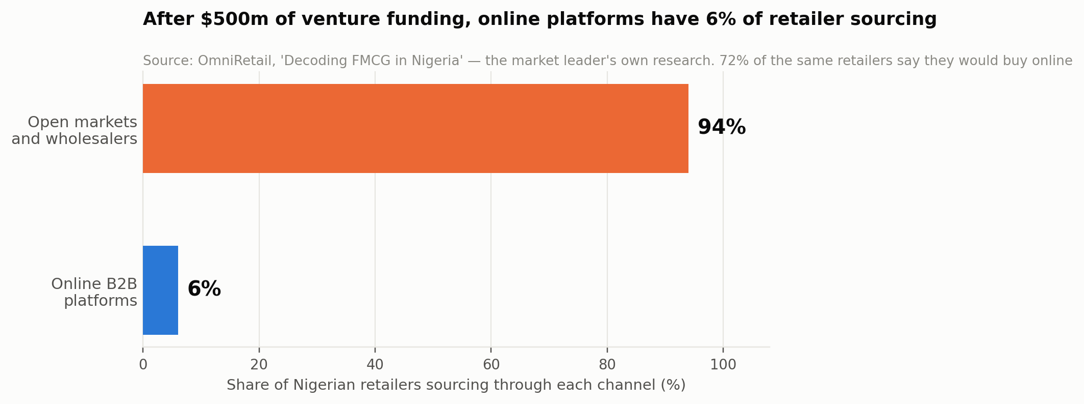
Exhibit 1. The market leader's own research on where Nigerian retailers actually buy.

The thesis
The common feature of every failure is not poor execution. It is that each company tried to replace the channel — to become the wholesaler, hold the stock, run the vans and sell to the retailer directly — in a channel whose margins cannot support the cost of doing so. FMCG distribution margins in this market run in the mid-single digits. Warehouses, fleets and inventory do not fit inside that, and the moment funding tightened in 2023 the arithmetic asserted itself. The Chari chief executive put it exactly: unprofitable growth at all costs turns into a death sentence the moment the funding market freezes.
India ran the same experiment at greater scale and reached the same conclusion. Udaan's revenue fell from roughly ₹9,900 crore in FY22 to ₹4,561 crore in FY25, and the analysis of why is worth quoting because it is the thesis of this document stated by someone else: marketplace plus logistics plus credit became burn, because wholesale trade is a low-margin business in which every operational layer stacks on top of already razor-thin margins. The lesson drawn was that successful B2B platforms must strengthen existing trade ecosystems rather than destroy them.
That is precisely what OpenMarket Africa does. The distributor keeps their stock, their shed and their customer relationships. The carrier keeps their vehicle, their liability and their insurance. The market union keeps its authority. OpenMarket supplies the one thing none of them can supply for themselves and none of them can build alone: a settlement guarantee. Payment is verified before any fulfilment instruction is issued; the ledger splits programmatically; the distributor receives 95% instantly and therefore carries no credit risk on the transaction. Everything else the platform eventually earns — routing, working capital, demand telemetry, and in Phase 2 the intelligence layer — is downstream of having run that guarantee at volume.
The one-sentence thesis
OpenMarket Africa does not replace Africa's open markets, own their inventory or drive their trucks. It supplies the settlement guarantee those markets cannot supply for themselves — and then monetises the transaction history that guarantee creates, through working capital and manufacturer demand intelligence that no participant in the channel can assemble alone.
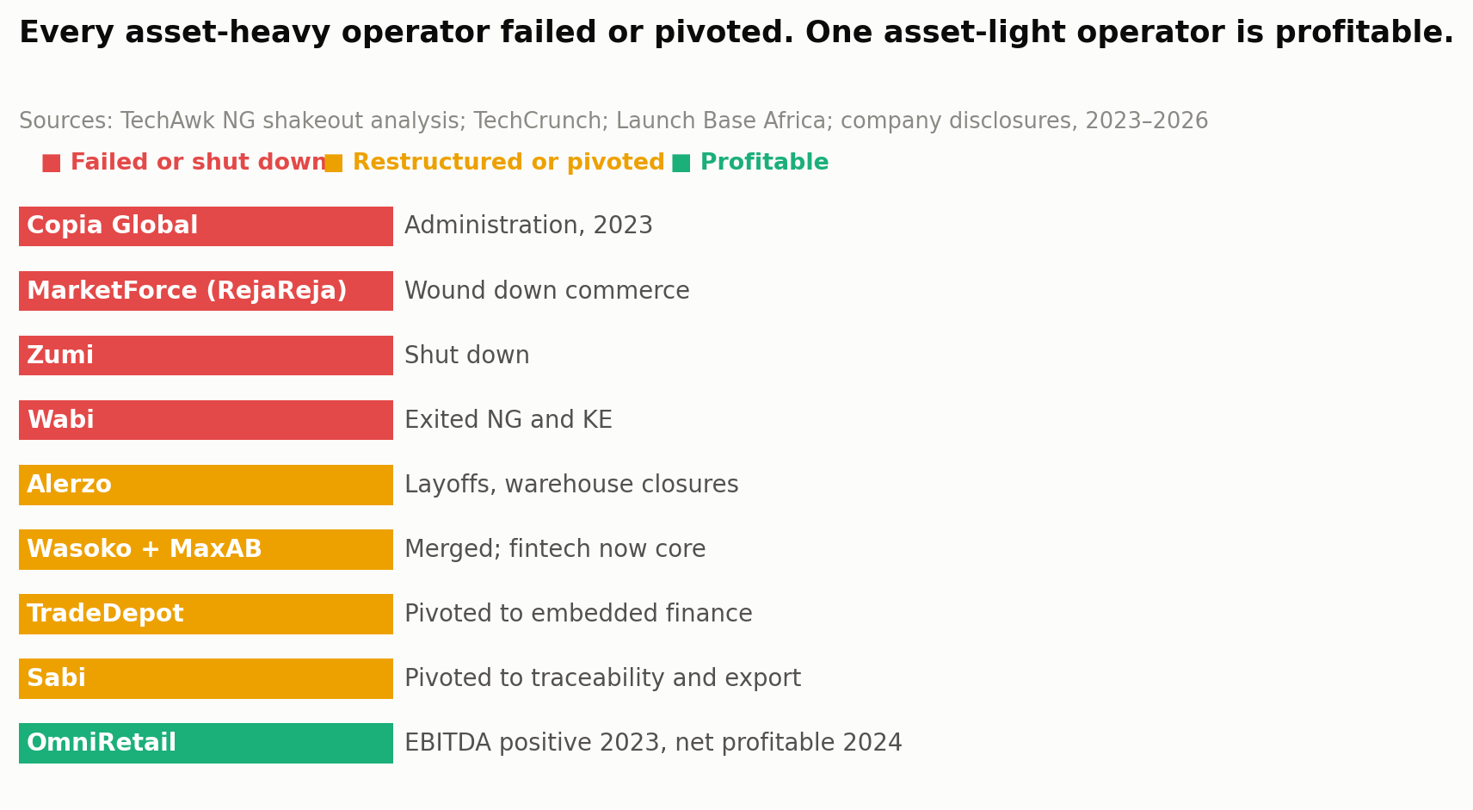
Exhibit 2. The published record of the African B2B commerce sector, 2023 to 2026.

Why the evidence points here and not elsewhere
This plan was asked to determine, from research rather than assertion, where the money in this business actually is. The answer is unusually well documented, and Chapter 17 sets it out in full. In summary: the take rate is the wedge, and embedded finance plus manufacturer data is the margin.
OmniRetail — the only profitable operator in the sector — reports 9% gross margins and 5% net contribution margins, achieved by becoming asset-light: sixteen decentralised hyperlocal warehouses rather than central ones, more than 3,000 partner logistics providers compensated on delivered value rather than daily rental, and a 3% supply-cost reduction against centralised models. It reached EBITDA positive in 2023 and net profitable in 2024 on ₦1.3 trillion (about $810 million) of 2024 transaction volume, having raised $38 million in total. Its embedded finance arm disburses ₦19 billion (about $12 million) a month at near-zero default.
MaxAB-Wasoko, after merging, stated the position even more plainly when it wound down Moroccan e-commerce: e-commerce is capital-intensive and low-margin, while fintech offers recurring revenue, better unit economics, and a higher ceiling for margin growth. Its Egyptian fintech operation turns over more than $180 million annually with 99%-plus repayment rates. TradeDepot's monthly effective BNPL rate is reported at close to 5%. And the size of the underlying pool is not in doubt: Nigeria's SME financing gap is $32.2 billion, and 75% of the merchants Moniepoint lends to are accessing formal credit for the first time.
OpenMarket has one structural advantage over every one of them in this. Because it verifies payment before fulfilment and records a programmatic ledger split on every order, it accumulates the cleanest possible record of who actually buys what, from whom, how often, and whether they pay — which is exactly the underwriting data the $32.2 billion gap exists for want of. It does so without buying a single carton.

The size of it
Chapter 16 builds the market bottom-up. Nigeria and Ghana together hold roughly 1,011,000 enumerated FMCG retail outlets — 745,000 in Nigeria on Nielsen's count and 266,322 in Ghana on the national FMCG census — of which the model treats about 617,000 as digitally reachable today. The seven launch hubs alone hold roughly 92,800 wholesale merchants with a downstream catchment of more than a million retail outlets. The addressable wholesale channel across the two countries is modelled at $22.4 billion of annual flow, against which the Year-5 base case takes $521 million of GMV — 2.3%.
At a Year-5 revenue capture of 4.64% of GMV, that is $24.15 million of revenue and $7.78 million of EBITDA, on a contribution margin of 3.65% of GMV — below OmniRetail's 5%, which is correct, because OpenMarket takes less per unit and carries no inventory risk whatsoever.
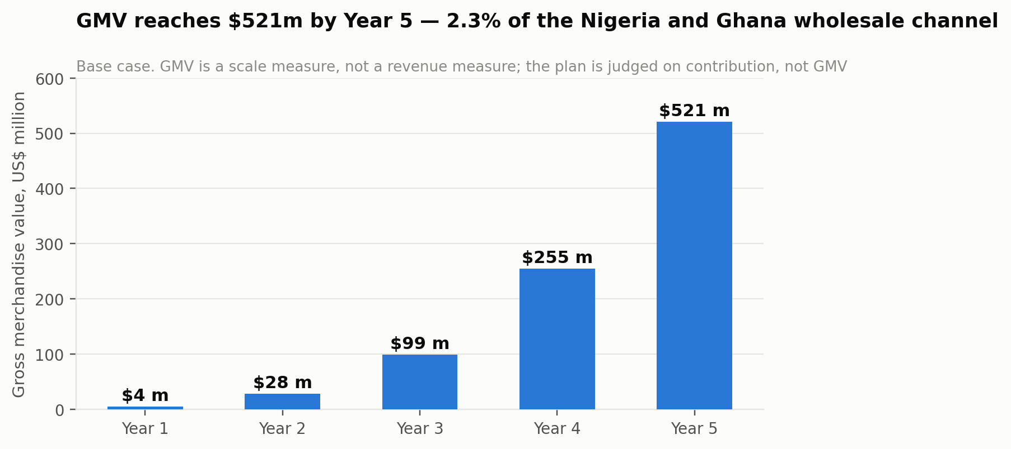
Exhibit 3. GMV build. A 2.3% share of the Nigeria and Ghana wholesale channel by Year 5.

The unit that matters
Merchant-level customer acquisition economics are the wrong lens for this business and the plan does not hide behind them: Year-1 LTV to CAC is 0.29, which is bad, and it is bad because the fixed cost of activating a market hub is being spread across the few thousand merchants who transact in its first year.
The right unit is the hub. A market hub costs approximately $46,000 to activate — four agents resident for six months, distributor onboarding incentives, market-association fees and launch events — plus about $2,600 a month in resident field cost thereafter. It ramps to roughly 18,300 transacting merchants by month 30. On that curve it pays back in month 12 and has returned $2.94 million of cumulative contribution by month 36. Sixteen hubs are live by Year 5.
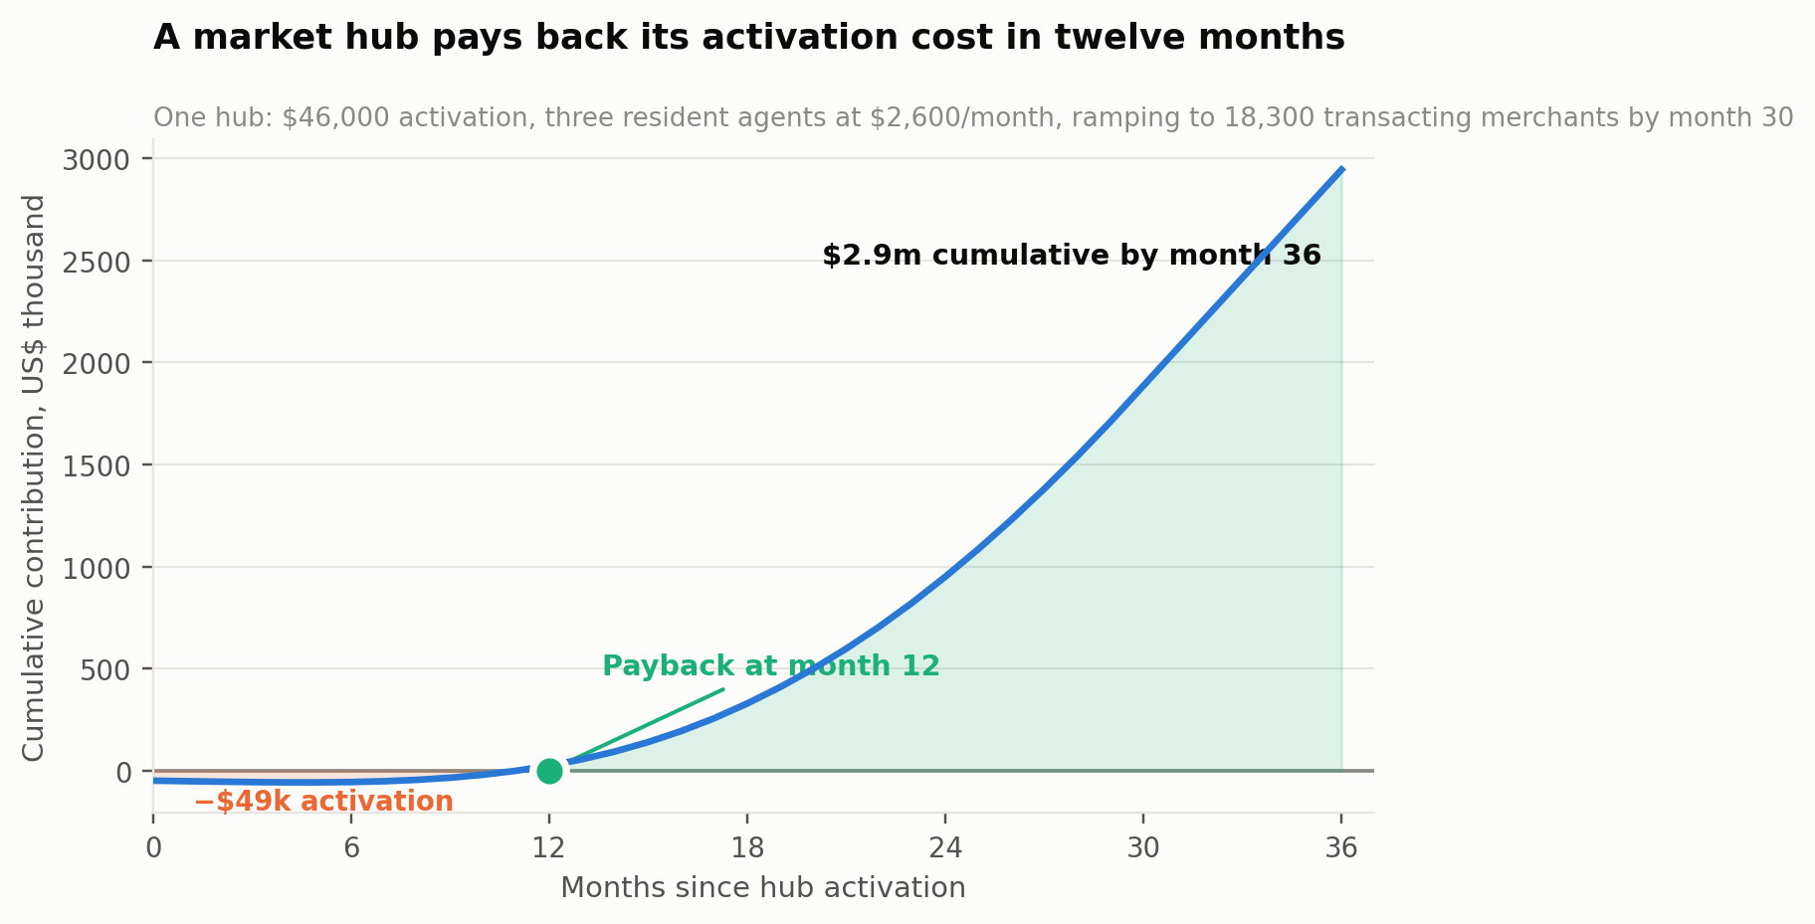
Exhibit 4. The economics that decide this business.

The ask
Digital Fusion Labs seeks $4.5 million in seed capital against $420,000 of founder and angel capital already deployed on the live platform at openmarket.africa. That funds thirty months of operation, through cumulative operating burn of $4.07 million across the first three years, to the point at which EBITDA crosses zero during Year 4. A separate, ring-fenced $16 million credit facility funds the working-capital book; it does not fund operations and is not part of the equity story.
The base case reaches $24.15 million of revenue and $7.78 million of EBITDA in Year 5. The bear case does not reach profitability at all — $12.66 million of revenue and an EBITDA loss of $3.09 million in Year 5, on a peak annual burn of $4.06 million — and the plan states that plainly rather than constructing a downside that conveniently survives. Chapter 29 sets out what would have to be true for the bear case to arrive, and Chapter 13 places it in a full SWOT.
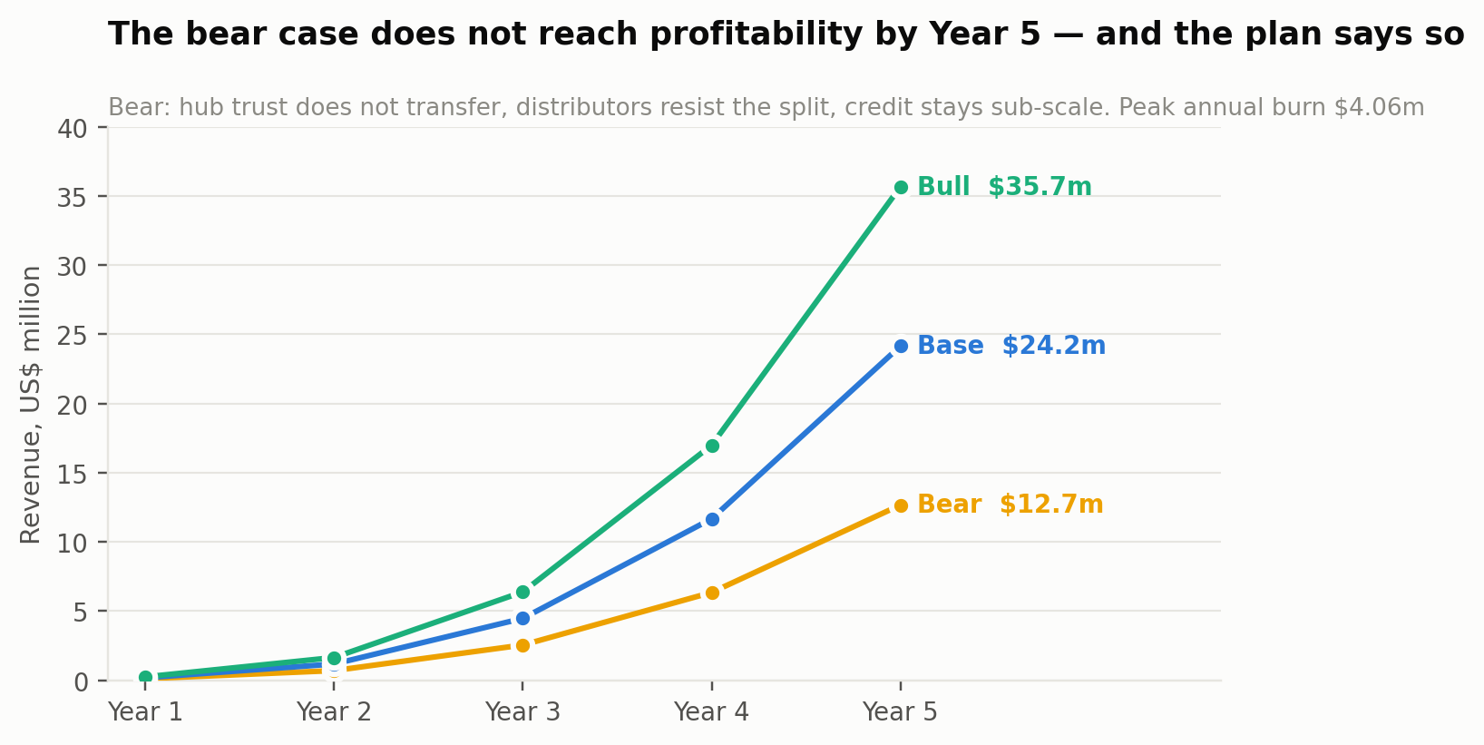
Exhibit 5. Three cases. The distance between them is a question about hub trust, not about market size.

2 How Goods Actually Move
Before any strategy, a description. The physical route a bag of rice or a carton of detergent takes from a Nigerian factory to a shop in Kano is not an inefficient version of a Western supply chain. It is a different system, with its own logic, and any plan that misreads it will fail the way its predecessors did.

The chain
A manufacturer sells to a key distributor, typically on terms and against a volume commitment. The key distributor sells onward to sub-distributors and to wholesalers, many of whom operate from a shed or a lock-up in a designated market. Those wholesalers sell to retailers — the kiosks, provision shops, table-tops and container stores that constitute the visible retail surface of the economy. Each tier takes a margin measured in single digits. The retailer, at the end, works on roughly 15%.

A note on who is who
Four participant classes appear throughout this document and it is worth fixing the terms once, because the trade uses several of them loosely. A manufacturer produces goods — Flour Mills, Unilever, Dangote and their peers. A distributor buys from the manufacturer and sells onward; this document uses the word to cover key distributors, sub-distributors and market wholesalers alike, because from the platform's point of view they perform the same function: they hold stock and they sell it to someone smaller. A retailer is the shop at the end of the chain — the kiosk, provision store, table-top or container shop that sells to the consumer.
Merchant is not a fifth class. It is the platform's term for a retailer who has an account on OpenMarket and transacts through it, and the two words are used interchangeably in this document: the market analysis says retailer because that is the language of the trade, and the financial model says merchant because that is the unit it counts. Where a number is attached — 218,000 merchants by Year 5, 6,400 distributors, 86 manufacturers — it refers to accounts on the platform, and there are three counted populations, not four.
Two further groups appear but are never counted as platform participants in the model: logistics partners, who are licensed carriers operating on verified lanes, and market connectors, the commissioned introducers of Chapter 23, who are paid on outcomes but hold no trading account.
Three features of this chain are usually described as defects and are in fact load-bearing. The first is that the market is a place, not a category. Onitsha Main Market is not an abstraction: it is a physical site with more than 20,000 merchants, annual trade exceeding $5 billion, roughly fifteen forty-foot containers and eight twenty-foot containers arriving daily, and a catchment that supplies south-eastern Nigeria plus Cameroon, Togo and Ghana. A retailer in Enugu does not search for a supplier; they travel to Onitsha, or they call someone who is there.
The second is that credit is relational and it is the actual product. A wholesaler who extends two weeks of credit to a retailer they have known for five years is not being informal; they are performing an underwriting function using information no credit bureau holds. Udaan's failure is instructive precisely here — the analysis concluded that blind algorithmic credit replaced relationship-based assessment, and that traditional distributors understand borrower context in a way platforms treating all overdue accounts identically simply do not.
The third is that the market union is a real institution. Access to a hub, adjudication of disputes, allocation of stalls and enforcement of norms run through associations with genuine authority. A platform that arrives without their consent is not disrupting a gatekeeper; it is attempting to operate in a jurisdiction while ignoring its government.
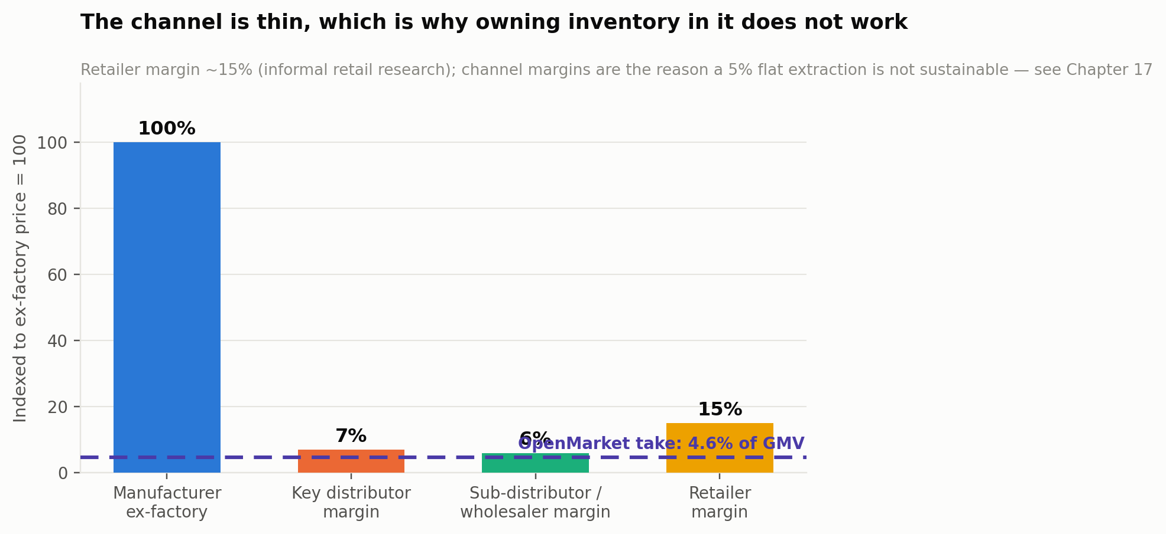
Exhibit 6. Indicative channel margins. The reason inventory-owning models cannot work here.

What is actually broken
Given all that, it is worth being precise about what genuinely fails, because that is the specification for the product.
Distance transactions do not work. A retailer who is not physically in the market cannot safely send money to a wholesaler they do not know well. The wholesaler cannot safely release goods to a buyer they cannot see. The entire trade is therefore constrained to the radius over which trust and travel are practical, which is the single largest suppressant of volume in the channel.
The distributor carries the credit risk and prices it into everything. Because informal credit is the norm, the wholesaler is effectively a lender who is not compensated as one. Bad debt, collection effort and the cash-conversion gap all sit on their balance sheet, and all of it is recovered through pricing and through refusing to serve buyers they do not know.
Nobody above the wholesaler can see anything. Manufacturers know what they sold to key distributors and essentially nothing after that. Nielsen's African work illustrates the consequence: in Lagos, 50% of laundry detergent sales are concentrated in 10% of the outlets that stock it — 10,000 of 100,000 — and roughly 80% of beverage sales happen in about 40% of the outlets carrying them. Manufacturers spend heavily on field forces to recover a fraction of this visibility.
Stockouts are chronic and expensive. Retailers typically carry 60 to 100 SKUs against a monthly turnover in the region of ₦250,000 to ₦500,000, and they run out of their fastest-moving items because procurement requires a trip, cash in hand, and a guess about demand.
The specification, derived from the diagnosis
Make distance transactions safe — verify payment before goods move, and split the ledger programmatically so neither side has to trust the other.
Take the credit risk off the distributor — pay them 95% instantly on verified payment, so they are a supplier again rather than an unpaid lender.
Give the tiers above the wholesaler sight — aggregate demand telemetry at cluster level, without exposing any individual merchant.
Then, and only then, lend — because after a year of verified settlement the platform knows which merchants actually pay, which is what the $32.2bn financing gap is short of.

3 The Shakeout
Between 2023 and 2026 the African B2B commerce sector went through a correction severe enough to be diagnostic. This chapter reads the record, because it is the closest thing this market has to a controlled experiment.

What happened
Copia Global entered administration in 2023 having raised more than $100 million, after failing to secure fresh funding. MarketForce wound down its RejaReja commerce operations when a funding round reportedly fell through. Zumi shut down after pivoting from fashion logistics to fintech without extending its runway far enough to stabilise. Wabi, backed by Coca-Cola, exited Nigeria and Kenya, its discount-heavy model unsustainable once expansion capital slowed.
Alerzo went through multiple rounds of layoffs and warehouse closures, and took a ₦5 billion loan from Moniepoint now characterised as a significant financial liability. Wasoko and MaxAB merged to strengthen margins and reduce duplicated infrastructure, then made fintech the core of the combined business, winding down e-commerce activity in Morocco in 2025. TradeDepot scaled back aggressive expansion and shifted toward embedded finance. Sabi pivoted away from pure FMCG distribution toward supply-chain traceability and export infrastructure.
The diagnosis offered by the sector's own analysts identifies three structural weaknesses: razor-thin FMCG wholesale margins that discount competition eroded further; asset-heavy operations — warehouses, fleets, inventory — creating high fixed costs; and macroeconomic volatility, particularly FX and inflation in Nigeria and Kenya.

The one that worked
Against that record, OmniRetail's outcome is the most informative data point in the sector. It reached EBITDA positive in 2023 and net profitable in 2024. Its 2024 transaction volume was ₦1.3 trillion, roughly $810 million, growing 35% in net merchandise volume and 40% in revenue. It serves more than 150,000 informal retailers across 12 cities in Nigeria, Ghana and Ivory Coast, working with 145 manufacturers, 5,800-plus distributors, and 1,100 vehicles managed by 85 local logistics partners. It raised $20 million in a Series A in 2025 co-led by Norfund and Timon Capital, for $38 million total across equity and debt.
What distinguishes it is not scale. Wasoko-MaxAB has 450,000 merchants and $230 million of funding. What distinguishes it is the operating model: partner distributors handle warehousing, third-party providers handle logistics and are compensated on a percentage of delivered product value rather than a daily rental, hyperlocal decentralised warehousing cuts supply cost roughly 3% against centralised models, and 65 brand partnerships supply rebates and incentives that lift gross margin to 9%.
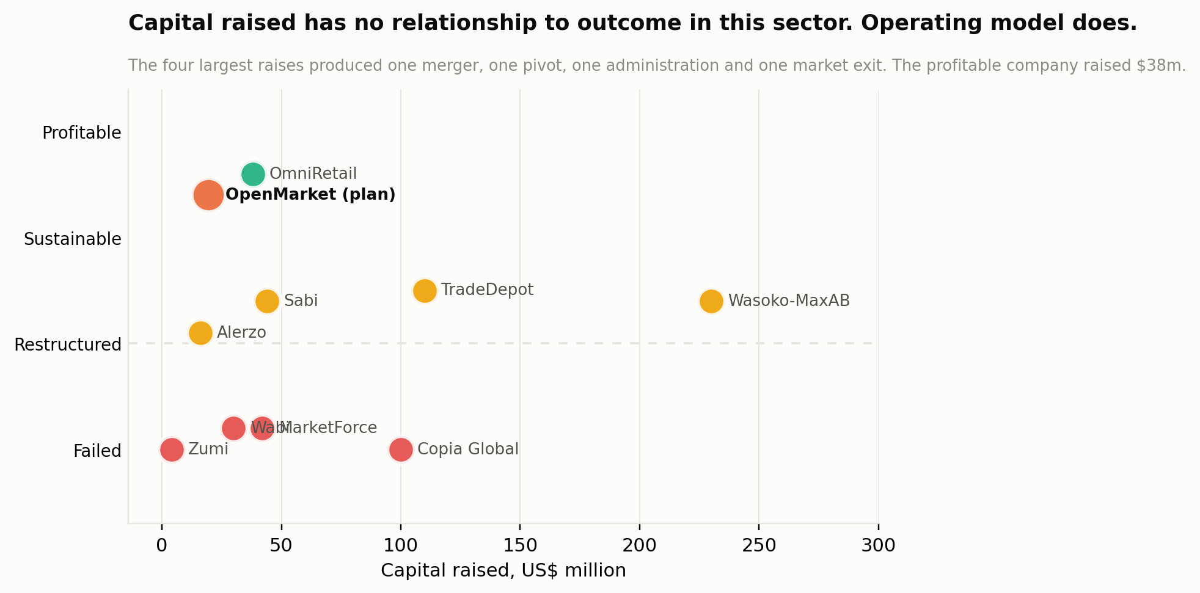
Exhibit 7. Capital raised against outcome. There is no relationship; the operating model explains everything.

The three conclusions this plan draws
First, asset ownership is the variable that predicts failure. Every company on the failed list owned inventory, warehouses or fleet. The profitable one owns none of them. This is not a small design preference; it is the finding that should govern the whole strategy, and it is why OpenMarket's architecture in Part Four contains no warehouse management system, no inventory ledger owned by the platform, and no fleet dispatch of its own.
Second, commerce is the wedge and finance is the business. Both survivors said so explicitly — MaxAB-Wasoko in describing why it moved to fintech, OmniRetail in attributing its 5% net contribution to embedded credit. A plan that models this business as a marketplace take rate alone is modelling the part that everyone agrees does not pay for itself.
Third, the failures were not caused by weak demand. 94% of retailers still buy in the open market and 72% say they would buy online. The demand was there throughout. What the sector proved is that you cannot profitably serve it by becoming the wholesaler. It did not prove that you cannot profitably serve it at all.
The uncomfortable question a serious investor will ask
If asset-light coordination is so clearly right, why has OmniRetail — profitable, funded, and already in Nigeria and Ghana — not simply done it?
The honest answer is that it has done part of it, and Chapter 7 gives it full credit. What it has not done is separate settlement from supply. OmniRetail still stands between the manufacturer and the retailer as a commercial counterparty. OpenMarket never becomes the counterparty at all: it verifies, splits and records, and the goods stay in a relationship that already exists. That is a smaller claim on the transaction and a much larger claim on the data, and Chapter 12 works through where the two models genuinely diverge.

4 Nigeria and Ghana in Close Detail
The plan launches in two countries simultaneously. The case for that is corridor logic rather than ambition, and it depends on specifics.

Nigeria
Nigeria has a population above 238 million with a median age of 18.1 years and 53.9% urban, and household FMCG spending exceeding $25 billion a year. Nielsen's African study enumerated 745,000 Nigerian retail outlets. Over 90% of retail sales run through traditional informal channels; modern retail comprises roughly 18,000 outlets nationally. There are approximately 39 million informal businesses, and informal retail accounts for about 44% of all informal enterprises.
The regional texture matters for sequencing. OmniRetail's research reports digital readiness at 82% in the South-West, 69% in the South-South and 40% in North Central, with monthly retailer purchase power ranging from ₦1.8m–₦3.5m in the South-West down to ₦0.8m–₦1.5m in the North-West and North-East. 78% of retailers already use POS devices and 74% say credit is important to them — the single most useful demand signal for the finance layer in Chapter 17.
The launch hubs are chosen on trade density rather than population. Onitsha Main Market — over 20,000 merchants, more than $5 billion of annual trade, supplying Cameroon, Togo and Ghana — is the anchor. Mile 12 is Lagos's foodstuff and produce distribution centre. Alaba International is West Africa's largest electricals hub. Balogun–Idumota on Lagos Island is the FMCG and general-goods complex. Ariaria in Aba is the manufacturing and leather cluster.

Ghana
Ghana's national FMCG enumeration identified 266,322 retail stores handling at least one FMCG product, of which 108,726 are grocery stores — 49,555 of those being kiosks and metal containers — plus 17,492 cosmetic and drug stores, 29,819 recreational outlets and 47,722 telco outlets. Accra holds 25% of national outlets and Kumasi 21%, which is an unusually concentrated distribution and makes a two-hub entry viable in a way it would not be in a more dispersed market.
Macroeconomically Ghana is the more stable of the two at present. AfDB reports GDP growth of 5.8% in 2025 with 5.0% projected for 2026, inflation down to 14.6% from 22.9%, the fiscal deficit narrowed to 2.4% of GDP, public debt down to 45.5% from 61%, a current account surplus of 4.4% of GDP and 5.7 months of import cover. For a business whose revenue is naira- and cedi-denominated and whose credit book is exposed to local rates, that matters.

Why twin-market rather than sequential
Three reasons, and one honest counter-argument.
The first is corridor trade. Onitsha's catchment explicitly includes Ghana and Togo. A settlement layer that works on one side of that corridor and not the other leaves the most valuable transactions — cross-border, high-value, highest-trust-deficit — unserved. The Phase-2 cross-border trade signals described in Chapter 35 are only possible if both ends are instrumented.
The second is concentration. Ghana's outlets are 46% concentrated in Accra and Kumasi. Two hub activations reach a large share of the national channel, which is a materially cheaper entry than Nigeria's fifth or sixth hub would be.
The third is competitive timing. OmniRetail already operates in Nigeria, Ghana and Ivory Coast. A Nigeria-only plan concedes the Ghanaian corridor to an incumbent that is profitable and expanding, and makes the eventual entry a displacement rather than a first-mover move.
The counter-argument, which the plan accepts, is that two countries in Year 1 doubles regulatory, payment-rail and field-management complexity for a company of twenty-two people. The mitigation is sequencing inside the twin-market commitment: Nigeria's Onitsha and Mile 12 activate in months 0–7, Ghana's Katamanto in months 10–13, and Kejetia not until Year 3. Ghana is a Year-1 commitment and a Year-2 operation.

5 The Global Benchmark
The comparison the brief calls for is not decorative. Global B2B commerce is what a solved version of this problem looks like, and the differences show which parts of the OpenMarket architecture are doing the load-bearing work.

Scale
Global B2B e-commerce was worth approximately $32.1 trillion in 2025, projected to reach $62.2 trillion by 2030 at a 14.5% compound rate. The United States alone accounted for about $10.1 trillion. Roughly 80% of B2B sales came through e-commerce channels in 2025, and 56% of US B2B revenue now comes from digital channels, up from 45% in 2023. Amazon Business, the largest single B2B marketplace, was projected at $83.1 billion for 2025; US B2B marketplace sales totalled about $378.7 billion.
Against those numbers, the Nigeria and Ghana wholesale channel that OpenMarket addresses — modelled at $22.4 billion of annual flow — is small. It is also, and this is the point, almost entirely undigitised, whereas the American figure describes a channel where the transition has largely already happened and the remaining opportunity is share-shift between platforms.
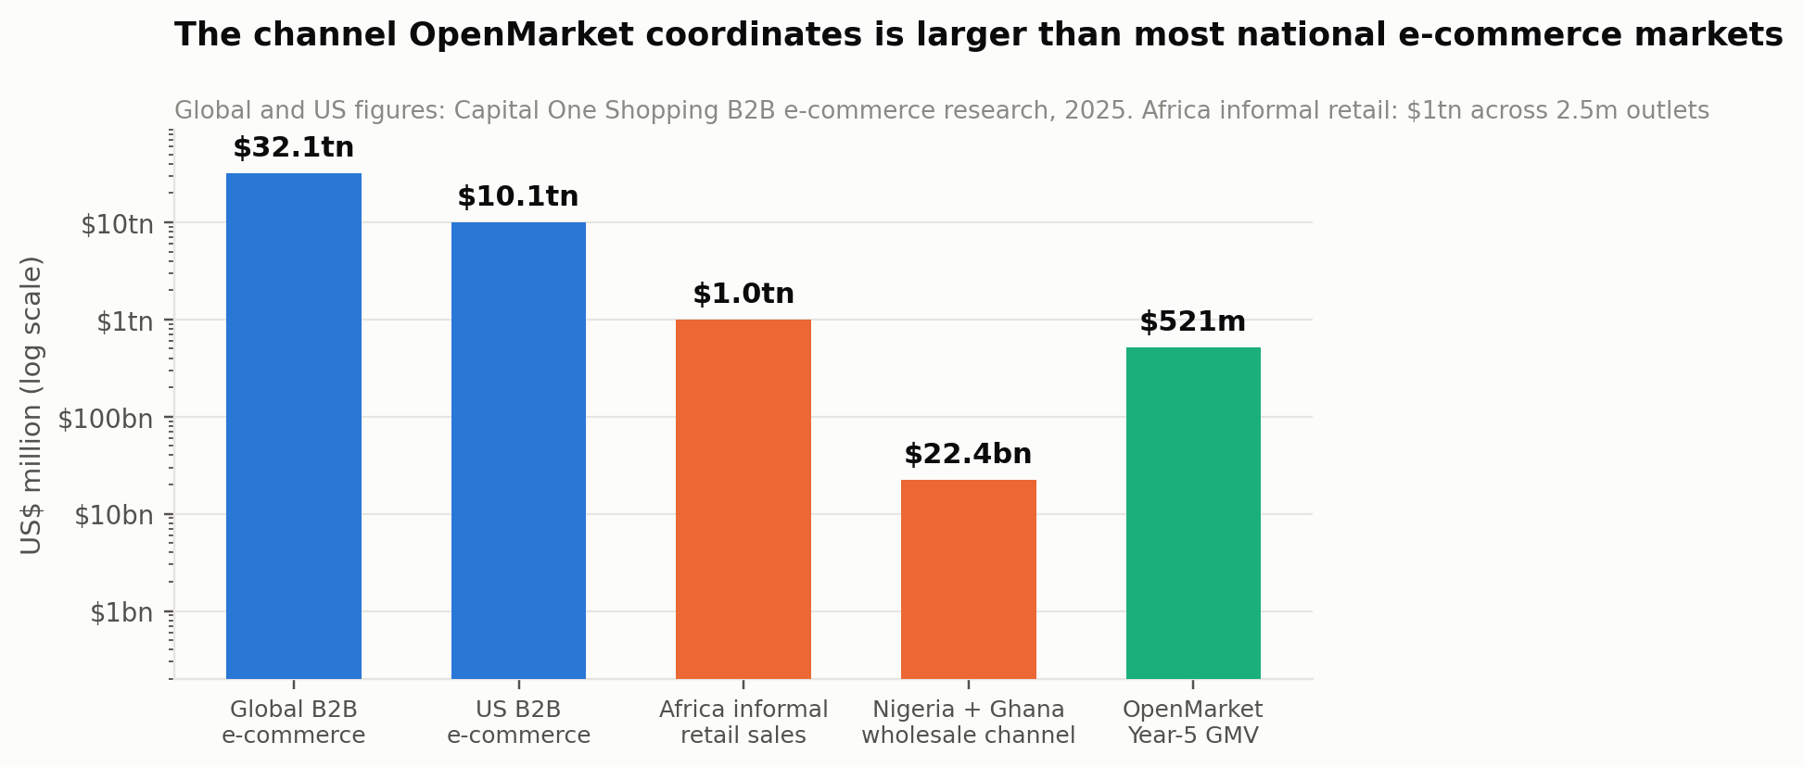
Exhibit 8. Scale comparison, logarithmic. The African opportunity is not size; it is that none of it is instrumented.

What the Western marketplaces prove and what they do not
Faire is the closest Western analogue to a wholesale coordination platform. It reached roughly $616 million of revenue in 2023, is annualising above $500 million with 40%-plus growth as of late 2025, projects around $3 billion of GMV, serves more than 800,000 retailers, and holds net dollar retention above 110%. Its effective take rate rose from about 16.5% to about 19% after a 2023 fee restructuring: a 15% base commission plus payment processing, with 0% on first-time Faire Direct orders.
Two things follow. The first is encouraging: a wholesale coordination marketplace can sustain a very high take rate, build durable retention, and reach billions in GMV without owning inventory — Faire's logistics offering moved more than five million shipments in 2025 without a captive fleet. The second is sobering: Faire's valuation fell from $12.6 billion in May 2022 to $5.2 billion at a November 2025 tender, on roughly 10x revenue. Even the best-executed version of this business has been repriced hard.
The critical caveat is that Faire's 19% take rate is not available in this market. Faire operates in giftware, home and specialty goods, where retailer gross margins routinely exceed 50%. FMCG in Nigeria runs on single-digit channel margins. Any plan that imports a Faire-like take rate into an African FMCG context is arithmetically incoherent, and Chapter 17 works through what rate is actually supportable.
Alibaba's 1688 is the other benchmark, and it is the one Egatee explicitly models itself on. Its relevance is structural rather than numerical: it demonstrates that a coordination layer over a physically-clustered, relationship-driven wholesale economy can reach enormous scale without the platform ever becoming the merchant. That is the closest structural precedent for what OpenMarket is attempting, and it happened in a country whose wholesale markets thirty years ago looked, by Egatee's own chief executive's account, very like Onitsha does now.

India, and the warning
Udaan is the most important negative benchmark because it ran the African playbook at Indian scale. Revenue fell from roughly ₹9,900 crore in FY22 to ₹5,609 crore in FY23, ₹5,707 crore in FY24 and ₹4,561 crore in FY25 — a 20% decline in the final year, with net losses improving 37% as the company retrenched. Fresh capital arrived in 2025 at around a $1.8 billion valuation, far below its peak.
The post-mortem identifies two failures that OpenMarket's design addresses directly. The first is that every operational layer — logistics, credit, sales acquisition, technology, discounting — stacked on top of margins too thin to carry them. The second is that blind algorithmic credit replaced relationship-based assessment: platforms treated all overdue accounts identically and missed the context that traditional distributors understand. OpenMarket's credit layer is built on verified settlement history within a hub where the platform has resident agents and an association relationship — which is a deliberately less scalable and considerably more accurate approach, and Chapter 35 explains the trade.
Dimension | United States / Faire | China / 1688 | Nigeria and Ghana
Channel margin available | Retailer gross margin often >50% | Mid, varies by category | Single-digit at each wholesale tier; ~15% retailer
Take rate supportable | ~19% effective (Faire) | Low single digits + ads | 2.4–2.6% net (Chapter 17)
Discovery problem | Real — supply is invisible to buyers | Partly | None — supply is physically present and known
Trust problem | Low — contract law and rating systems | Moderate | Dominant — constrains trade to travel radius
Payment rails | Card and ACH, percentage-priced | Alipay ecosystem | Bank transfer, flat-fee (NIP), near-free at B2B ticket sizes
Credit gap | Served by banks and BNPL | Served by platform and banks | $32.2bn unserved in Nigeria alone
Connectivity assumption | Always-on broadband | High | Intermittent; offline tolerance is mandatory
Logistics cost | ~5–8% of goods value | Low | Adds an estimated 75% to cost of goods in sub-Saharan Africa
Who owns fulfilment | Third-party, coordinated | Third-party | Existing distributors and licensed carriers
Table 1. The benchmark, dimension by dimension. Two rows — take rate and trust — determine the whole design.

6 Seven Structural Truths
Seven findings from the research that each change what a product built for this market has to do. They are the specification for Part Four.

One: the trust deficit, not the discovery deficit, is the binding constraint
Western marketplaces exist because buyers cannot find sellers. In Onitsha the seller is a hundred metres away and everyone knows who they are. What cannot happen is a transaction between people who are not in the same place. Settlement verification is therefore the product, not the plumbing beneath it, and it is why Chapter 32's order flow refuses to issue a fulfilment instruction before funds clear.

Two: owning assets in a single-digit-margin channel is fatal
This is the finding of the entire shakeout and it is not ambiguous. Four failures, four pivots, one merger, and the sole profitable operator is the asset-light one. The architecture in Part Four contains no warehouse, no inventory position and no fleet, and Chapter 28 argues that this constraint is the moat rather than a limitation.

Three: the distributor is a customer, not an obstacle
Every failed model treated the wholesaler as a margin layer to be removed. But the wholesaler holds the stock, the storage, the local knowledge and the customer relationships — and, critically, is the party currently absorbing the credit risk. Paying them 95% instantly on verified payment converts them from an incumbent defending territory into a beneficiary with a reason to recruit merchants onto the platform. That is the difference between a two-sided cold start and a distributor-led one.

Four: payment rails in Nigeria are structurally cheap at B2B ticket sizes
This is an under-appreciated technical advantage. Nigerian instant bank transfers are flat-fee with a low cap, not percentage-priced. On a ₦95,000 order that is a fraction of a percent, where a card-based model in a Western market would pay 1.5% to 3%. The model assumes a blended 0.25% payment cost, and at a 2.4% net take rate that difference is roughly a tenth of the entire contribution margin. It is one of the few places where the African context is cheaper rather than dearer.

Five: verified settlement history is the scarcest asset in African credit
Nigeria's SME financing gap is $32.2 billion, and 75% of merchants receiving credit through digital platforms are accessing formal credit for the first time. The reason is not unwillingness to lend; it is the absence of underwriting data. A platform that has verified a merchant's payments weekly for a year holds a better signal than any bureau in the market. OpenMarket generates that signal as a by-product of doing its primary job, which is why the finance layer costs almost nothing to originate.

Six: manufacturers are blind below the distributor tier and already pay to fix it
Only 30% of FMCG reaches retailers directly. Above the wholesaler, visibility ends. Manufacturers currently buy that visibility through field-force audits and panel research, both expensive and both stale. Cluster-level demand telemetry derived from settled orders is fresher, cheaper and continuous — and because it is aggregated, it can be sold upstream without exposing any individual merchant. Chapter 35 sets out the k-anonymity constraint that makes this defensible rather than extractive.

Seven: the market union is infrastructure
Access to a hub is granted, not taken. Associations adjudicate disputes, allocate space and enforce norms, and a platform operating without their endorsement is operating on sufferance. The plan treats association relationships as a first-order commercial asset — Chapter 24 makes them the leading partnership class and Chapter 22 makes association endorsement the highest-yield acquisition channel — and Chapter 29 lists gatekeeper refusal as a live risk with no cheap mitigation.
What the seven truths add up to
A Western marketplace ported into Onitsha fails on truths one, two, four and seven. An African B2B e-commerce company as built between 2019 and 2023 fails on truths two and three.
What is required is a settlement layer that assumes intermittent connectivity, leaves inventory and fulfilment with the people who already have them, treats the distributor as the first customer, monetises through finance and data rather than through margin extraction, and enters each market with its union's endorsement. That is a specification, and Part Four builds to it.

PART TWO
The Competitive Field
Four named comparators, one cohort of failures, an honest teardown of OpenMarket's own product, a capability matrix, a full SWOT, and the position that is actually available.

7 OmniRetail: The Profitable One
OmniRetail is the most important company in this sector and the most important comparison in this document. It is the only operator to have reached profitability, it is already in both of OpenMarket's launch markets, and it validates a large part of the thesis while occupying a materially different position.

The company
Founded in 2019, OmniRetail launched its retailer-facing product Omnibiz in 2020. The two names are frequently used interchangeably in press coverage; the group is OmniRetail and Omnibiz is its retailer app. It has raised $38 million across equity and debt, most recently a $20 million Series A in April 2025 co-led by Norfund and Timon Capital, with Ventures Platform, Aruwa Capital, Goodwell Investments via Alitheia, and — notably — Flour Mills of Nigeria, a manufacturer, on the cap table.
It reached EBITDA positive in 2023 and net profitable in 2024. Its 2024 transaction volume was ₦1.3 trillion, approximately $810 million, on 35% net merchandise volume growth and a 40% revenue increase. It serves more than 150,000 informal retailers across 12 cities in Nigeria, Ghana and Ivory Coast, with 145 manufacturers, 5,800-plus distributors and 1,100 vehicles managed by 85 local logistics partners. Its published site claims four countries, 150-plus brands, 160,000-plus retailers and 900-plus SKUs.

The model, and why it works
OmniRetail's product suite maps its position precisely. OmniBiz is the retailer ordering app with buy-now-pay-later. OmniHub is the distributor platform providing logistics network access and inventory management. OmniOne gives manufacturers real-time insight into distributor and retailer sales plus collateral-free credit. OmniPay is payments and credit, including zero-fee POS.
The economics are published and they are the benchmark for this entire document: 9% gross margins, 5% net contribution margins, or five cents of net contribution on every dollar transacted. The chief executive attributes profitability to becoming a value-chain player and bringing efficiencies into the chain rather than around it. The mechanisms are specific: sixteen decentralised hyperlocal warehouses in Lagos rather than centralised ones, cutting supply cost by about 3%; a logistics partner network of more than 3,000 compensated as a percentage of delivered product value rather than by daily rental, with an internal algorithm balancing van contents to optimise partner earnings; and 65 brand partnerships supplying rebates and incentives, with pharmaceuticals and beverages as the high-margin categories.
OmniPay processes around $95 million a month and disburses roughly ₦19 billion (about $12 million) a month in loans at a non-performing rate below 0.5%.

What OmniRetail proves for OpenMarket
Four things, and it is worth being generous about them because the plan depends on all four.
- Asset-light works in this market. The only profitable operator is the one that leaves warehousing with partner distributors and logistics with third parties. This is the central empirical support for OpenMarket's design.
- Embedded finance is where the contribution comes from. 5% net contribution on 9% gross margin, with credit explicitly cited as the mechanism, at near-zero default. Chapter 17's monetisation argument rests substantially on this evidence.
- Manufacturers will pay for visibility. OmniOne exists and Flour Mills invested in the company. The manufacturer-facing revenue line in Chapter 26 is not speculative.
- Nigeria and Ghana can be run together profitably. OmniRetail operates both plus Ivory Coast. The twin-market decision in Chapter 4 has a working precedent.

Where the two models genuinely diverge
The temptation is to describe OpenMarket as a better OmniRetail. It is not; it is a different layer, and the difference is worth stating precisely because it determines whether both can exist.
OmniRetail is a commercial counterparty. OpenMarket is not. OmniRetail sits in the transaction: it takes an order from a retailer, sources through its distributor and manufacturer relationships, earns a 9% gross margin on the goods, and carries the commercial relationship. Its distributors are suppliers to OmniRetail's network. OpenMarket never buys, never sells, and never becomes a party to the trade — it verifies the payment, splits the ledger, and records what happened between two parties who chose each other.
Three consequences follow. OpenMarket's revenue capture is less than half OmniRetail's — 4.64% of GMV at Year 5 against 9% gross margin — which is a genuine disadvantage and the plan does not pretend otherwise. But OpenMarket carries no stock risk, no category risk and no supplier concentration risk, and its cost of adding a category is zero because it never sourced the category in the first place. And critically, OpenMarket can operate inside the open market rather than adjacent to it: a wholesaler in Onitsha who would never become an OmniRetail supplier will accept instant settlement on their own existing customers.
OmniRetail's hub presence is partial; OpenMarket's is the entire premise. OmniRetail operates across 12 cities through a distributor network. It is not resident in Onitsha Main Market with agents and a union relationship. That is the territory OpenMarket is claiming, and it is territory that OmniRetail's model does not require it to hold.

The honest risk
OmniRetail could build the settlement layer. It has the distributor relationships, the capital, the profitability to fund it and the manufacturer credibility. If it decided to offer instant verified settlement to distributors outside its own supply network, it would be a formidable competitor with a two-year head start on density.
The plan's answer has three parts. The first is that doing so would cannibalise its own 9% gross margin business by giving distributors a way to transact without OmniRetail as counterparty — a classic incumbent's dilemma. The second is that hub residency is a field operation, not a software feature, and building it takes the same twelve to eighteen months regardless of balance sheet. The third is that this is precisely why Chapter 27 sizes the seed to reach seven hubs quickly rather than to build product depth slowly. Chapter 29 rates this risk medium-probability and high-impact, and it is the single competitive threat that should worry a reader most.

8 TradeDepot and the Pivot to Finance
TradeDepot raised the most capital of any Nigerian B2B commerce company and its trajectory is the clearest single illustration of where the value in this sector actually sits.

The record
TradeDepot raised $110 million in December 2021 — approximately $42 million of equity and $68 million of debt — led on equity by the International Finance Corporation, with Novastar Ventures, Sahel Capital, CDC Group, Endeavor Catalyst, Partech Africa and MSA Capital participating, and Arcadia Funds leading the debt. That followed a $10 million round in July 2020 co-led by Partech and IFC.
At the time of the raise it had grown from 40,000 to more than 100,000 merchants in eighteen months with GMV up fivefold, operating in 12 cities across Nigeria, Ghana and South Africa, against a stated target market of five million SMEs. Its model, as described then, was explicitly asset-owning: it owned warehouses and delivery fleets and shipped directly to merchants.
Its financial product, ShopTopUp, extends credit lines to retailers for consumer-goods purchases at a monthly effective interest rate of close to 5%, scored on purchase history and repayment performance, and was reported to produce a 200% increase in transaction volumes for participating store owners.
By 2026 the published assessment is that TradeDepot scaled back aggressive expansion and shifted toward embedded finance.

What this tells OpenMarket
The pricing benchmark for credit is established and OpenMarket prices below it. TradeDepot's roughly 5% monthly effective rate is the market reference. The model in Chapter 26 assumes a 46% gross annual yield — about 3.8% per 30-day cycle — deliberately beneath TradeDepot's rate, because OpenMarket's origination cost is lower and its underwriting data is better, and competing on price for the borrower is a defensible use of that advantage.
The sequencing lesson is the important one. TradeDepot built commerce first with owned assets, raised $110 million, then discovered that the finance layer was the business. OpenMarket's plan reaches the same destination by a cheaper route: it never builds the owned-asset commerce operation at all, and it arrives at the finance layer carrying settlement data rather than warehouses. That is the whole argument for why $4.5 million of seed is a credible number against TradeDepot's $110 million.
The debt structure is the template. TradeDepot's raise was 62% debt. Working-capital books are funded with debt, not equity, and Chapter 27 follows that structure explicitly with a ring-fenced $16 million facility that does not appear in the operating cash story.

9 Egatee: The Corporate-Backed Entrant
Egatee is the least discussed and most strategically interesting competitor, because it is not a venture-funded startup at all and it is pursuing a thesis adjacent to OpenMarket's from a completely different direction.

The company
Egatee was established in Africa in 2018 with Transsion Holdings — the handset manufacturer that dominates African mobile — and the Yiwu Market Group as principal shareholders, and launched formally in 2022 after four years of preparation. Its self-description is the African version of 1688, and its chief executive frames the African wholesale market as operating at the level China's did thirty years ago, drawing an explicit comparison to Yiwu's own clothing market in its early days.
It runs two models simultaneously. Self-operated, for short-shelf-life fast-moving goods such as food, grain and oil, where it purchases centrally and provides warehousing, logistics and delivery. Platform, for clothing, daily necessities and hardware, where it functions like 1688 — matching suppliers, distributors and retailers while providing logistics and payment.
Its scale as reported: 2024 transaction volume close to ¥1 billion; cross-border instant-messaging response rate and online payment usage both reaching 80% by early 2025; a target of 1.5 million platform merchants; and thousands of employees across Africa — roughly a hundred per country, with more than 1,000 in the Nigerian headquarters — of whom 90% are local. Its primary markets are Nigeria and Tanzania.
From mid-2024 it opened to Chinese merchants using what it calls yellow-page logic: African buyers post requirements first and Chinese suppliers respond, rather than suppliers listing and waiting. 20% of platform goods now come directly from China. It operates sample exhibition halls inside wholesale markets where goods remain merchant-owned until sold; the Dar es Salaam opening reportedly drew over 3,000 visitors in a day and signed 200 purchasing agents.

The strategic read
Egatee is the only competitor that has correctly identified the open market as the unit of organisation. Its sample halls sit physically inside wholesale markets. Its field force authenticates merchants door to door. Its 90%-local staffing is a deliberate trust strategy. On the positioning map in Chapter 12 it sits closer to OpenMarket than anyone else.
Where it diverges is direction of trade and depth of settlement. Egatee's strategic centre of gravity is the China–Africa corridor: its differentiated asset is access to Chinese supply, and the platform's purpose is substantially to route that supply into African markets. Its self-operated arm makes it an inventory owner in exactly the categories where the shakeout showed inventory ownership to be dangerous. And nothing in its published model offers instant verified settlement to a domestic distributor selling domestic goods to a domestic retailer — which is the transaction that constitutes the overwhelming majority of flow in Onitsha or Kejetia.
The honest assessment is that Egatee is a complement more often than a competitor, and that a serious plan should say so. A merchant importing electronics from Guangzhou through Egatee and restocking detergent from a wholesaler two sheds away through OpenMarket is a perfectly coherent merchant. The competitive overlap is real but partial, and the relationship most likely to create value is interoperability rather than displacement. Chapter 24 treats Egatee as a candidate corridor partner rather than a target.
The competitor that should worry a reader most is not the one that looks most similar
Egatee looks closest to OpenMarket on the positioning map and is the least dangerous, because its economics depend on Chinese supply access that OpenMarket is not competing for.
OmniRetail looks further away and is the most dangerous, because it is profitable, funded, present in both launch markets, and holds the distributor relationships that OpenMarket must build from scratch.

10 The Failed Cohort
Four companies that no longer operate, and four that operate as something other than what they set out to be. Their record is the evidence base for this plan's central design constraint, and it deserves to be read carefully rather than used as a rhetorical prop.
Company | Raised | Outcome | Published reason, and what it demonstrates
Copia Global | $100m+ | Administration, 2023 | Failed to secure fresh funding. Owned warehousing and last-mile delivery into rural Kenya. Demonstrates that the largest raise in the sector could not outrun the asset base it built.
MarketForce (RejaReja) | ~$42m | Commerce wound down | Funding round reportedly fell through. Had pivoted toward financial services for dukas before winding the commerce arm down; the fintech instinct was right and arrived too late.
Zumi | ~$4m | Shut down | Pivoted from fashion logistics to fintech but could not extend runway far enough to stabilise. Demonstrates that a correct pivot executed without runway is still a failure.
Wabi | Coca-Cola backed | Exited Nigeria and Kenya | Discount-heavy model became unsustainable once expansion capital slowed. Demonstrates that even corporate strategic backing does not survive negative contribution margins.
Alerzo | ~$16m | Restructured | Multiple layoffs and warehouse closures; a ₦5bn Moniepoint loan now described as a significant financial liability. Demonstrates how debt taken against an asset-heavy model compounds a downturn.
Wasoko + MaxAB | ~$230m combined | Merged; fintech core | Merged to strengthen margins and cut duplicated infrastructure; subsequently wound down Moroccan e-commerce, stating that e-commerce is capital-intensive and low-margin while fintech offers recurring revenue and better unit economics.
TradeDepot | $110m | Pivoted to finance | Scaled back expansion, shifted to embedded finance. See Chapter 8.
Sabi | ~$44m | Pivoted to traceability | Moved away from pure FMCG distribution toward supply-chain traceability and export infrastructure — a move up the value chain and out of the margin trap.
Table 2. The cohort. Funding figures are from company announcements and public databases; outcomes from press reporting, 2023–2026.

Reading it fairly
It would be dishonest to present this table as proof that OpenMarket will succeed. Several of these companies were well run, several were better capitalised than OpenMarket will ever be, and at least two — MarketForce and Zumi — identified the correct destination and simply ran out of time to reach it. Survivorship reasoning is a genuine hazard here, and a reader should apply the discount.
What the table does establish, and establishes strongly, is a negative finding: that no company in this sector has yet made inventory-owning, fleet-operating B2B distribution profitable in Africa, across a range of countries, capital structures, categories and management teams. When eight attempts with materially different execution converge on the same outcome, the explanation is more likely structural than operational.
And it establishes a positive finding, which is narrower but more useful: the two operators that moved fastest toward asset-light coordination plus embedded finance — OmniRetail and the merged MaxAB-Wasoko — are the two whose economics improved. OmniRetail reached profitability; MaxAB-Wasoko reports Egyptian fintech turnover above $180 million with 99%-plus repayment. Both said publicly that this is why.

11 OpenMarket Africa Today: An Honest Teardown
A plan that flatters the current product is worth nothing. This chapter assesses what exists at openmarket.africa as at July 2026, on the evidence of the live site, and states what is designed, what is asserted, and what is absent.

What the product asserts
The platform positions itself as B2B wholesale trade coordination infrastructure for African open markets, under the line Where Africa's open markets meet verified commerce, and is explicit about what it is not: not a consumer marketplace, not a logistics operator, not a factory catalogue. The order flow is stated as payment verification, then a programmatic ledger split, then distributor fulfilment, then optional partner logistics.
It addresses five participant classes. Retailers get offline-safe ordering on entry-level Android, verified payment checkout, and a shop stock ledger with reorder prompts. Distributors get a Virtual Warehouse Ledger, 95% instant payout on payment verification, and visibility of demand from verified retailers. Manufacturers get aggregated demand telemetry by geographic cluster with no individual merchant personally identifying information, SmartSubsidy campaign tools, and enterprise procurement lanes as density grows. Logistics partners operate on verified trade lanes, with the platform coordinating orders while carriers retain delivery liability and insurance. Affiliates and market connectors — the market-boy network — earn a 50% share of the settlement fee on the first settled order of any merchant or distributor they introduce, split with the platform and funded out of that order's channel rebate.
Twelve hubs across six countries are displayed — Ariaria, Onitsha, Alaba, Lagos Island and Mile 12 in Nigeria; Kejetia and Katamanto in Ghana; Asigamé in Togo; Addis Merkato in Ethiopia; Kariakoo in Tanzania; Gikomba in Kenya; Souk El Had in Morocco. AI-powered coordination is described as a Phase 2 development, with Phase 1 being human-trust infrastructure. Registration paths are separate per participant type. Contact is Lagos, Accra and Nairobi.

The strategic assessment
The positioning is not just right, it is unusually disciplined. The single most important sentence on the site is not a consumer marketplace — infrastructure for traders, and the second is payment verification is product design. Both refuse the framing that destroyed the previous generation of companies. The decision to state that carriers keep delivery liability, and that the platform does not operate a fleet, is a public commitment to the constraint that Chapter 28 argues is the moat. Very few early-stage companies are that clear about what they will not do.
Staging AI as Phase 2 is a strength and should be defended as one. In a market where every deck claims intelligence, saying that Phase 1 is human-trust infrastructure is a credibility signal. It is also correct engineering: the intelligence layer described in Chapter 35 is only possible on data the settlement layer generates, and building it first would mean building it on nothing. The plan therefore presents the sequencing as an argument rather than an apology.
The 5% split is the exposure, and it is arithmetic rather than strategy. Chapter 17 works through this in full. In summary: FMCG channel margins in this market are single-digit at each tier, and a permanent 5% extraction taken purely from distributor margin would consume most or all of a wholesaler's economics on the transaction. The model in this plan assumes roughly half of the gross split is returned to the channel as volume rebates and manufacturer-funded promotion, giving a net take of 2.4% rising to 2.6%. That is a material correction to the headline number and the plan states it openly rather than modelling revenue the channel cannot pay.
Twelve hubs across six countries is a claim the company cannot currently hold. Presenting Addis Merkato, Kariakoo, Gikomba and Souk El Had alongside Onitsha implies operational presence in Ethiopia, Tanzania, Kenya and Morocco. On the plan in this document, hubs one and two activate in Year 1 and there are sixteen by Year 5 — none of them in East or North Africa before Year 5 at the earliest. The site should distinguish between the hub map the company is building toward and the hubs where it can settle a transaction today, because the first merchant who signs up in Nairobi and cannot transact is a permanent loss of trust in a business whose entire product is trust.
There is no published proof and no pricing. No transaction counts, no settlement volumes, no distributor numbers, no time-to-payout figures, and no commercial terms beyond the 95% payout. For a pre-launch product that is defensible; sustained past launch it prevents self-serve distributor onboarding and forfeits the one category of evidence this business can produce that its competitors cannot — verified settlement performance. Chapter 42 makes median time-to-payout and settlement success rate published metrics for exactly this reason.

The build gap
Against the architecture in Part Four, the assessment is that the product has the right thesis, the right participant decomposition and a coherent order flow, and that the substantial engineering ahead is in settlement integrity and the Virtual Warehouse Ledger rather than in the interface. The load-bearing items between the current state and a defensible Year-1 product are:
- A double-entry, append-only settlement ledger with exactly-once posting and daily reconciliation to bank statements — Chapter 32. Nothing else in the product matters if this is wrong once.
- The Virtual Warehouse Ledger in production, with a confidence measure on every stock position, because routing a merchant to a distributor who does not actually have the goods is the fastest way to lose both.
- Genuine offline tolerance on entry-level Android: local outbox, conflict-free merge, and a state model the merchant can understand when the network is gone — Chapter 30.
- Hub residency in two markets with association agreements in place, which is a field programme rather than a software deliverable.
- A credit facility and a risk function before any lending, not after. Udaan's failure mode is the one to avoid by construction.
- Published settlement metrics, published commercial terms, and a hub map that distinguishes live from planned.
The honest summary
OpenMarket has the best-articulated strategy in this sector and the correct read of why its predecessors failed. What it does not yet have is a settled transaction.
The seed round exists to convert a well-designed thesis into two hubs where money actually moves, and the eighteen months after it are a field and settlement-engineering programme, not a product-marketing one.

12 The Capability Matrix
Nine capabilities, seven operators, and one column that constitutes the entire thesis.
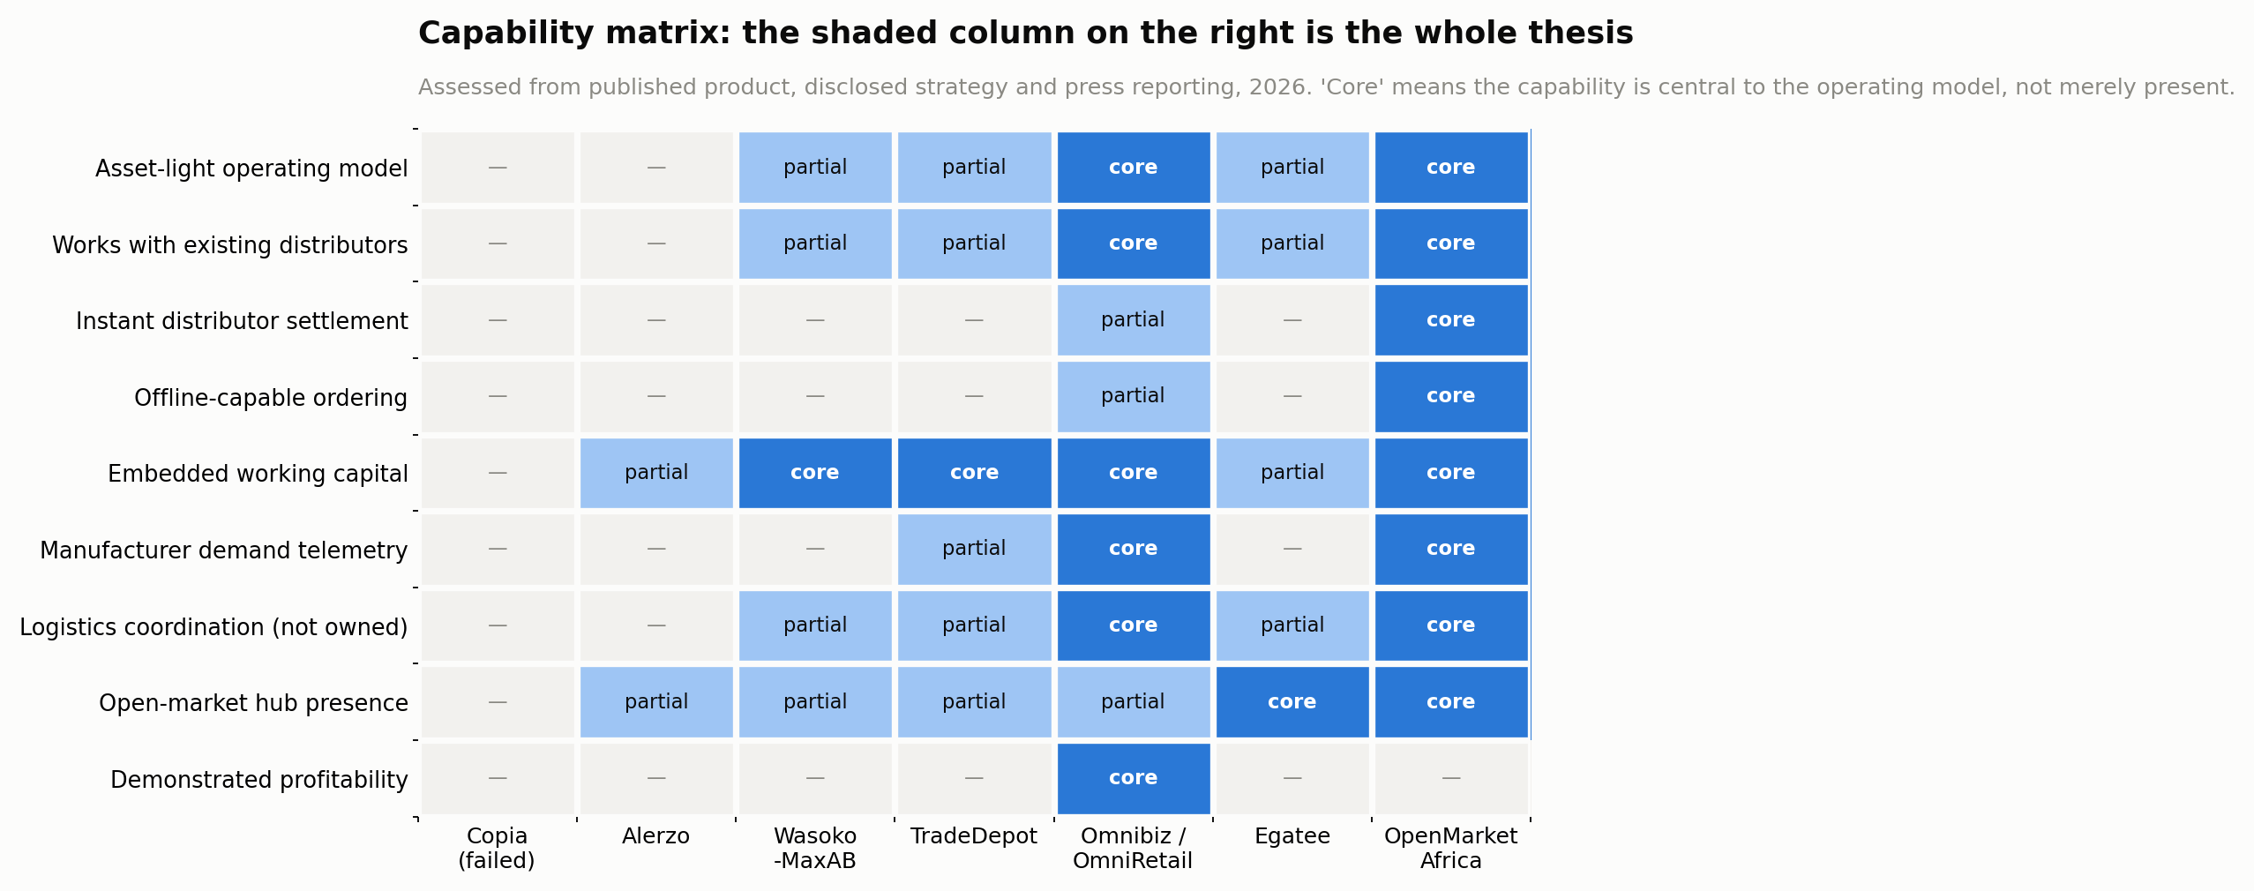
Exhibit 9. Capability matrix across the competitive field.
Capability | Why it decides outcomes | State of the field
Asset-light operating model | The single variable that separates every failure from the one profitable operator | Only OmniRetail and OpenMarket treat it as core; Wasoko-MaxAB and TradeDepot arrived at it after writing off assets
Works with existing distributors | Determines whether the incumbent channel is an ally or an opponent, and therefore the cost of entry | OmniRetail partners with distributors as suppliers; OpenMarket leaves them as principals in their own trades
Instant distributor settlement | Removes the wholesaler's credit risk, which is the actual reason they price defensively and refuse unknown buyers | Nobody offers it as a core primitive. This is the wedge.
Offline-capable ordering | Determines whether the product works in the markets where the trade physically happens | Largely absent; most competitors assume a connected session
Embedded working capital | Where the contribution margin comes from, on the published evidence of two operators | Widely adopted — the one capability where OpenMarket is a follower, not a leader
Manufacturer demand telemetry | A second revenue engine, and the reason a manufacturer becomes an ally rather than a channel-conflict risk | OmniRetail's OmniOne is the only mature example
Logistics coordination without ownership | Removes the fleet cost line that helped end Copia and Alerzo | OmniRetail's 85 partners and 1,100 vehicles is the model; OpenMarket goes further by never contracting the carrier itself
Open-market hub presence | Determines access to where 94% of sourcing actually occurs | Egatee's sample halls are the only serious precedent; OpenMarket's entire operating model is built on it
Demonstrated profitability | The only capability OpenMarket cannot claim | OmniRetail alone. This is the honest gap and Chapter 13 records it as a weakness.
Table 3. What each capability decides, and who holds it.
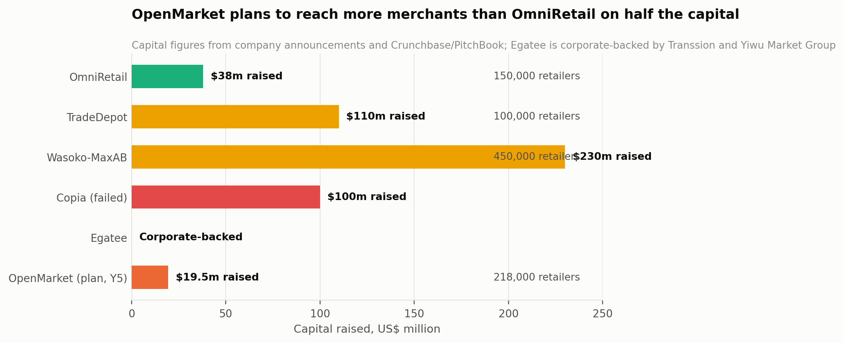
Exhibit 10. Capital raised against merchants reached. The plan targets more merchants than OmniRetail on roughly half its capital.

The claim, stated carefully
The matrix shows OpenMarket holding all but one capability as core. A sceptical reader should immediately note that this is trivially easy to claim for a company that has not yet processed a transaction, and hard to claim for companies that have had to make real trade-offs under real constraints. The matrix is a statement of design intent measured against competitors' demonstrated behaviour, and that asymmetry favours the author. It is presented with that caveat rather than without it.
The defensible version of the claim is narrower and still sufficient: instant distributor settlement, offline-capable ordering and open-market hub residency do not exist together anywhere in this field. Each exists somewhere in partial form. None of the seven operators has all three, and all three are required for the transaction that constitutes the bulk of flow in a Nigerian or Ghanaian open market — a domestic retailer buying domestic goods from a domestic wholesaler at a distance that makes physical trust impossible.

13 SWOT
Assessed against the published record of every comparable operator rather than against ambition. Each item below is either sourced in Part One or is a modelled output stated with its number.
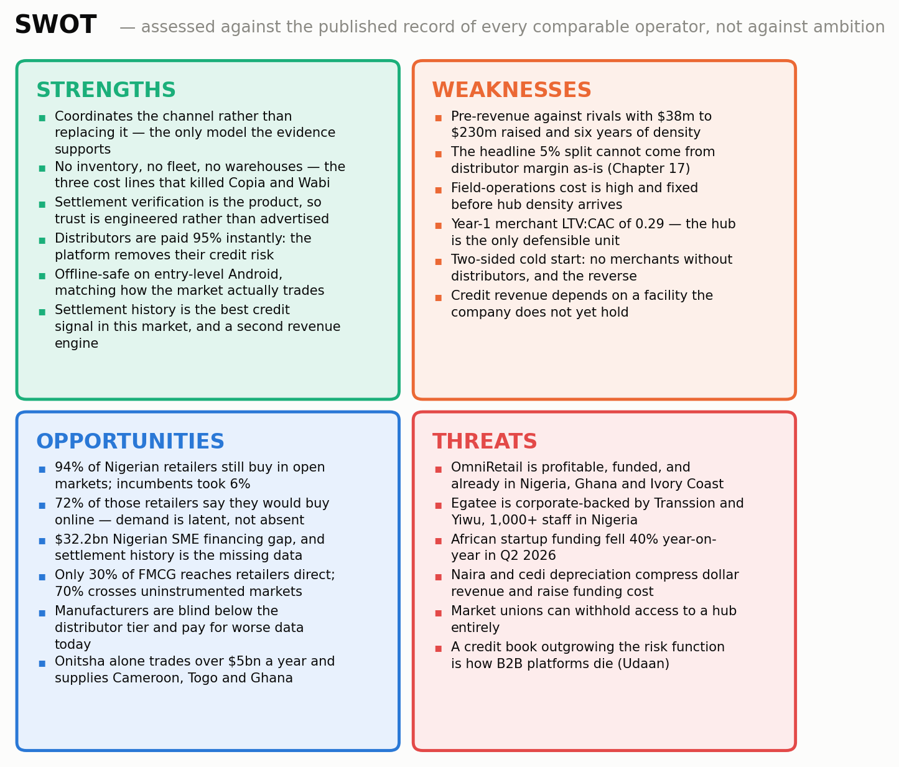
Exhibit 11. SWOT summary. Each quadrant is developed in the text below.

Strengths
The model is the one the evidence supports. This is the strongest single claim in the document and it is not the author's opinion: across eight comparable operators, asset ownership predicts failure and asset-light coordination plus embedded finance predicts survival. OpenMarket is designed to that finding from the first commit rather than arriving at it after writing off a warehouse estate.
Three cost lines are structurally absent. No inventory, no fleet, no warehouses. These are the lines that ended Copia, forced Alerzo's closures, drove Wabi out of two countries and prompted the Wasoko-MaxAB merger. Their absence is why Chapter 26 can model a business reaching sixteen hubs on $19.5 million of total equity.
Settlement verification is engineered, not marketed. Because no fulfilment instruction is issued before funds clear at the provider, trust is a property of the system rather than a claim about it. In a market where the trust deficit is the binding constraint, this is the product.
The distributor is made better off, not disintermediated. 95% instant payout removes the wholesaler's credit risk on the transaction. This converts the most powerful incumbent in the channel from an obstacle into a recruiter, and it is the mechanism by which the two-sided cold start in the weaknesses column is actually solved.
Offline tolerance matches how the market trades. Orders survive network drops with local state visibility on entry-level Android. Every competitor assuming a connected session is building for a market that exists in Lagos offices rather than in Onitsha sheds.
Settlement history is the scarcest asset in African credit, and it arrives free. Nigeria's $32.2 billion SME financing gap exists for want of underwriting data. OpenMarket generates the best available signal as a by-product of its primary function, which is why Chapter 25 can show credit origination at near-zero marginal cost.

Weaknesses
Pre-revenue against funded incumbents. OmniRetail has $38 million and profitability; Wasoko-MaxAB has $230 million and 450,000 merchants; TradeDepot has raised $110 million; Egatee has Transsion and Yiwu behind it and more than a thousand staff in Nigeria. OpenMarket has a live site and $420,000 deployed.
The headline 5% split does not survive contact with FMCG margins. Chapter 17 reduces it to a 2.4%–2.6% net take by returning roughly half to the channel. That is a 48% reduction in the platform's headline economics before a single order is processed, and any reader modelling this business at 5% of GMV is modelling a business the channel will not fund.
Field operations are expensive and the cost lands before the revenue. Thirty agents in Year 1 at $4,800 fully loaded each, against $178,000 of Year-1 revenue. Year-1 gross margin is 10%. This is the arithmetic of two hubs carrying a fixed field base and it is the least attractive year in the plan.
Merchant-level acquisition economics do not work in the early years. Year-1 LTV to CAC is 0.29 and payback exceeds five years. The hub cohort in Chapter 25 is the only defensible unit, and a reader who insists on merchant-level economics as the test will not fund this business.
The cold start is genuinely two-sided. Merchants will not use a platform with no distributors; distributors will not onboard for no merchants. The plan's answer is distributor-first sequencing funded by instant settlement, but it is an answer to a real problem rather than a reason the problem is not real.
Credit revenue depends on a facility that does not exist. The model assumes a $4 million tranche in Year 2 and $12 million in Year 3. No term sheet is in hand. If the facility is late, the finance line — 12% of Year-5 revenue and a much larger share of contribution — moves right.

Opportunities
94% of sourcing is still unaddressed after six years and half a billion dollars of competitor funding. The incumbents' combined penetration of retailer sourcing is 6%. This is not a mature market being contested; it is an unsolved one.
72% of those same retailers say they would buy online. The gap between 6% adoption and 72% stated willingness is the entire commercial opportunity, and it locates the failure in the offer rather than the demand.
A $32.2 billion financing gap with a data-shaped cause. 75% of merchants receiving digital credit are accessing formal credit for the first time. The constraint is underwriting information, which OpenMarket manufactures.
70% of FMCG crosses markets nobody has instrumented. Only 30% reaches retailers direct. The measurement layer over that 70% does not exist and manufacturers currently pay more for worse.
Manufacturers already buy inferior versions of what the telemetry layer produces. Field-force audits and panel research are expensive, periodic and stale. Nielsen's finding that 50% of Lagos detergent sales sit in 10% of stocking outlets is exactly the kind of insight a settled-order feed produces continuously.
The corridor is real. Onitsha supplies Cameroon, Togo and Ghana. A settlement layer instrumented at both ends of a corridor can price and route cross-border trade that is currently invisible, which is the Phase-2 optionality in Chapter 35.

Threats
OmniRetail. Profitable, funded, present in Nigeria and Ghana, holding distributor relationships and manufacturer credibility. If it chooses to offer open settlement it is the most serious threat in the field. Chapter 7 sets out why it may not, and Chapter 29 declines to treat that reasoning as a guarantee.
Egatee's balance sheet. Transsion and Yiwu backing, a thousand-plus Nigerian staff, sample halls already inside wholesale markets. Its direction of travel is different, but its ability to fund a domestic settlement product if it chose to is not in doubt.
The funding market. African startup funding fell 40% year on year in Q2 2026 to $260 million across 38 startups, against $1.64 billion for full-year 2025. This is a difficult environment in which to raise a seed round for a capital-intensive field operation, and the plan's sizing reflects that constraint rather than ignoring it.
Currency. Naira depreciation is modelled at 7% and cedi at 5%. Both compress dollar revenue and raise the local cost of funding the credit book. The natural hedges — a naira-denominated cost base and a naira-denominated facility — are partial rather than complete.
Gatekeepers. A market union that declines to endorse the platform can make a hub inaccessible. There is no cheap mitigation for this and Chapter 29 says so.
Credit outrunning risk. Udaan's post-mortem is unambiguous that algorithmic credit divorced from relationship context is how these platforms die. The plan's credit growth is fast, and the discipline that keeps it safe — resident agents, hub-level exposure caps, association recourse — is operational rather than technical, which makes it harder to guarantee.

What the SWOT implies for strategy
Reading the four quadrants together produces three instructions that run through the rest of this document. Convert the strengths into hub density before the threats can respond, because every strength listed is copyable in eighteen months and hub residency is the only one that takes longer to replicate than to describe. Fix the take rate honestly and early, because the weakness that most damages credibility is a headline number the channel cannot pay, and correcting it in Chapter 17 is cheaper than having a distributor correct it in month three. And treat the credit facility as a Year-1 milestone rather than a Year-2 assumption, because it converts the largest opportunity into revenue and the largest weakness into a solved problem simultaneously.

14 The Position
Positioning is a choice about which comparison the buyer makes. In a market where the previous generation of entrants is remembered as having failed, that choice is unusually consequential.
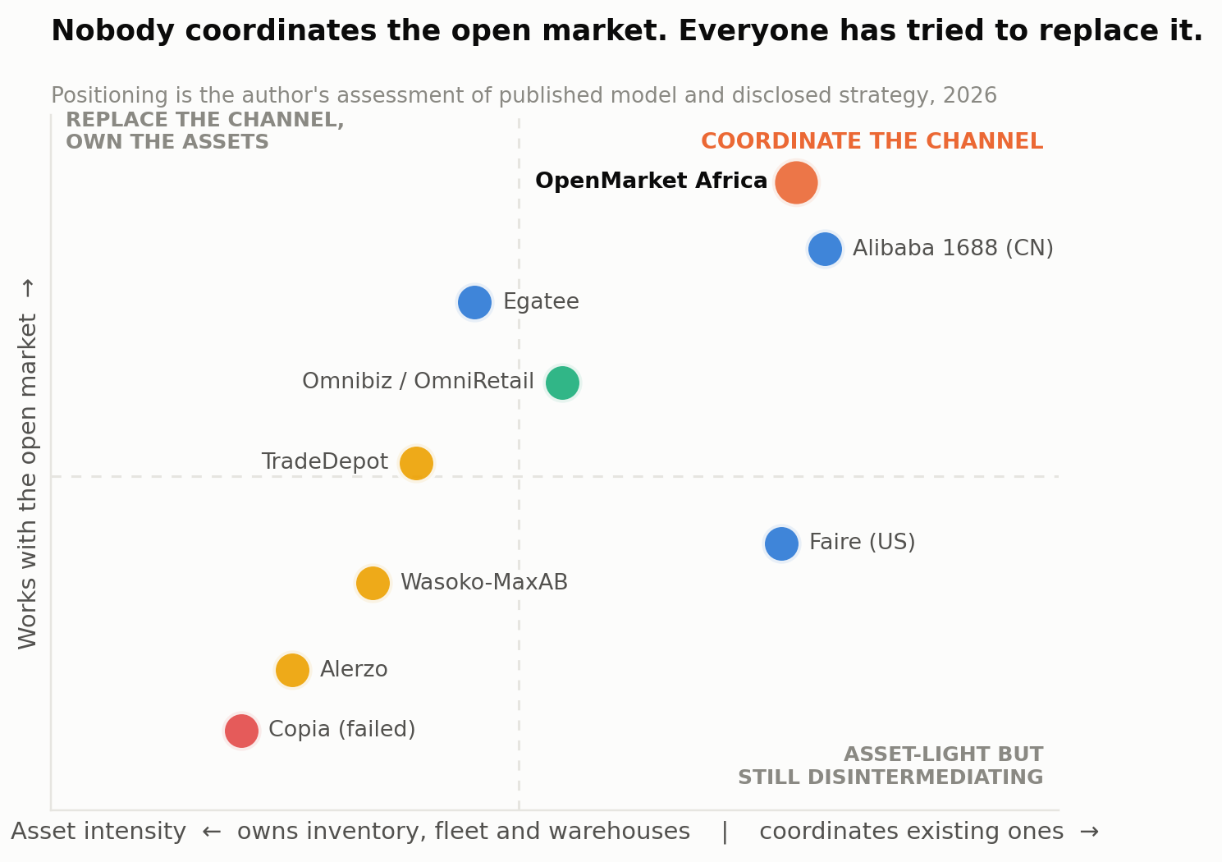
Exhibit 12. The competitive field on two axes: asset intensity and relationship to the open market.

The two wrong positions
The first wrong position is another B2B e-commerce platform. It is the obvious frame, it is what every distributor and market union will assume on first contact, and it is poisoned. Copia, Alerzo, Wabi and MarketForce were all B2B e-commerce platforms, and the wholesalers of Onitsha and Alaba watched at least some of them arrive, promise to change everything, and disappear. Adopting that frame means inheriting the scepticism without any of the capital.
The second wrong position is the AI platform for African trade. It is fashionable, it flatters the product, and it fails on contact with the customer. A wholesaler in Kejetia does not have an artificial intelligence problem. They have a problem where a buyer in Tamale wants three cartons but neither party will move first. Leading with intelligence also contradicts the company's own honest sequencing — Phase 1 is trust rails — and invites a comparison the product cannot yet win.

The right position
Stated in one sentence: OpenMarket is how a trader gets paid before the goods leave the shed, and how a shop buys from a wholesaler it has never met.
That position does four things. It describes a transaction rather than a technology, which is what the buyer actually understands. It puts the distributor's benefit first, which is correct sequencing for a distributor-led cold start. It makes the comparison set the customer's own alternatives — travelling to the market, extending informal credit, refusing the order — rather than a rival platform's feature list. And it is a claim only a settlement layer can make, which makes it unavailable to every aggregator and every inventory-owning competitor in the field.
The positioning statement
For wholesalers and retailers in Africa's open markets,
who cannot safely trade with anyone outside the radius they can physically reach,
OpenMarket Africa is trade coordination infrastructure
that verifies the buyer's payment before any goods move, pays the seller 95% instantly, and records the transaction so both sides can prove what happened.
Unlike B2B e-commerce platforms, which buy the goods, hold the stock and become the counterparty,
OpenMarket never owns a carton, never competes with the distributor, and is measured on one number: how much verified trade moves through the hub.

The three proof points
Settlement success rate. The proportion of initiated orders that reach verified payment and confirmed delivery without dispute. No aggregator can quote this because none of them settle. It should be published continuously from the first month, including when it is poor.
Median time to distributor payout. From payment verification to funds in the distributor's account. This is the number that decides whether a wholesaler recruits the next wholesaler, and it is the single most persuasive fact the company can hold.
Verified trade volume per hub. Not total GMV, which flatters and is easily inflated, but volume per live hub — which measures density, which is the thing that actually compounds. Chapter 42 makes all three Tier-1 metrics with named owners.

PART THREE
The Business
Sizing, the monetisation question answered from evidence, segments, product, pricing, go-to-market, marketing, partnerships, unit economics, the five-year model, the raise, the moat and the risks.

15 The Theory of the Business
Six claims. Each is stated so that it can be shown to be wrong, and each has a test with a date attached.
Claim one: the binding constraint is trust at distance, not discovery. If this is wrong — if merchants already transact happily outside their physical radius and simply lack a catalogue — then the settlement layer is expensive infrastructure solving a problem that does not exist. The evidence is that 94% of sourcing still happens in person in open markets while 72% of the same retailers say they would buy online. The test is early and unambiguous: the share of Year-1 orders placed with a distributor the merchant has not previously bought from in person. If that share is low, the product is a convenience layer over existing relationships rather than a trade expander, and the market is much smaller than modelled.
Claim two: distributors will accept a net take of 2.4% to 2.6% in exchange for instant settlement and zero credit risk. This is the pricing bet and Chapter 17 develops it. If the true acceptable rate is 1.2%, Year-5 revenue falls by roughly $6.8 million and the business does not reach the modelled EBITDA. The test is the first fifty distributor onboardings and specifically the rebate negotiation, not the headline signature.
Claim three: verified settlement history underwrites credit better than anything else available. If default rates come in at 8% rather than the modelled 2.1%, the net credit yield collapses from 19.9% to roughly 14%, and if they reach 15% the finance layer is loss-making. OmniRetail reports NPLs below 0.5% and MaxAB-Wasoko 99%-plus repayment, so the model's 2.1% is already several times more conservative than the observed market. The test is the Year-2 pilot book at 500 merchants.
Claim four: manufacturers will pay for cluster-level demand telemetry. Modelled at $18,000 rising to $46,000 per account, reaching $3.43 million — 14% of Year-5 revenue. OmniOne's existence and Flour Mills of Nigeria's investment in OmniRetail are the supporting evidence. The test is the first two paying manufacturer contracts in Year 1.
Claim five: the hub is a repeatable unit. The plan assumes a hub costs $46,000 to activate, pays back in month 12 and returns $2.94 million by month 36, and that this repeats sixteen times. If hub two performs like hub one but hub five does not — because Onitsha's density and union structure do not generalise — then the expansion case fails even if the first market works. The test is hub three, in Year 2, which is the first hub activated by a team rather than by the founders.
Claim six: Phase 1 earns Phase 2. The intelligence layer is worth building only if the settlement layer generates enough clean, dense transaction data to support it. If merchants transact once a month rather than 2.6 times, or if orders cluster in a handful of SKUs, the telemetry is too thin to sell and the routing engine has nothing to learn from. The test is order frequency and SKU dispersion at month 18.

What kind of business this is
OpenMarket is a payments and data business wearing commerce clothing. Its revenue is a percentage of flow it never owns, its margin comes from lending against a signal it manufactures, and its long-run asset is a transaction graph. The closest structural analogues are card networks and clearing houses rather than marketplaces: the value is in guaranteeing that a transaction happened, not in having sourced the goods.
That determines the failure mode. A marketplace fails by having the wrong assortment. A clearing layer fails by settling something incorrectly once, publicly, in a market where trust is the entire product. This is why Chapter 32 specifies a double-entry, append-only ledger with exactly-once posting and daily bank reconciliation, and why Chapter 37 makes settlement correctness the only service-level objective with a zero-tolerance threshold.

16 Sizing the Market
Built from enumerated outlets and named hubs upward, not from a percentage of GDP downward.

The method
Three layers. The hub layer counts the wholesale merchants physically present in the markets OpenMarket will activate, and their downstream retail catchment. The national layer counts enumerated FMCG outlets in Nigeria and Ghana and the wholesale channel flow through them. The continental layer scales to the informal retail sales pool for the expansion case. Every step is an assumption in Appendix A.

The hub layer
Hub | Merchants | Basis
Onitsha Main Market (NG) | 20,000 | >20,000 merchants; >$5bn annual trade; supplies SE Nigeria, Cameroon, Togo, Ghana
Alaba International (NG) | 14,500 | West Africa's largest electricals and electronics hub
Mile 12 (NG) | 9,800 | Lagos foodstuff and produce distribution centre
Lagos Island / Idumota (NG) | 16,200 | Balogun-Idumota FMCG and general goods complex
Ariaria, Aba (NG) | 12,400 | Manufacturing and leather goods cluster
Katamanto / Makola (GH) | 8,600 | Accra core trading district; Accra holds 25% of Ghana's FMCG outlets
Kejetia, Kumasi (GH) | 11,300 | Largest single market in West Africa by stall count; Kumasi holds 21% of Ghana outlets
Total, seven launch hubs | 92,800 | Downstream retail catchment of approximately 1,067,200 outlets at 11.5 retailers per wholesale merchant
Table 4. The launch hubs. Merchant counts are modelled from published trader estimates and outlet censuses.

The national layer
Nielsen's African FMCG study enumerated 745,000 Nigerian outlets. Ghana's national FMCG census identified 266,322 stores carrying at least one FMCG product. That is 1,011,322 enumerated outlets across the two markets, of which the model treats 61% — about 617,000 — as digitally reachable, on the basis of DataReportal's 45.5% Nigerian internet penetration adjusted upward for registered commercial outlets and OmniRetail's regional digital-readiness figures of 82% in the South-West and 40% in North Central.
The wholesale channel flow across the two countries is modelled at $22.4 billion a year: Nigeria's $25 billion of household FMCG spending at the 70% share that moves through wholesale markets rather than direct distribution, plus Ghana scaled by relative outlet count.
Layer | Measure | Note
Enumerated FMCG outlets, Nigeria + Ghana | 1,011,322 | Nielsen (NG) and national FMCG census (GH)
Digitally reachable outlets | 616,906 | 61% of enumerated
Launch-hub wholesale merchants | 92,800 | Seven hubs, Nigeria and Ghana
Wholesale channel flow (SAM basis) | $22.4bn / yr | NG household FMCG $25bn × 70% via wholesale, plus GH
Revenue pool at Year-5 capture of 4.64% | $1.04bn / yr | Serviceable revenue if the whole channel were coordinated
Africa informal retail sales | $1.0tn / yr | 2.5m retailers, 70% of food, beverage and personal care
TAM — African revenue pool | $19.5bn / yr | 42% FMCG share of informal sales, at 4.64% capture
SOM — Year 5 GMV | $520.9m | 2.33% of the Nigeria + Ghana channel
SOM — Year 5 revenue | $24.2m | 2.32% of the serviceable revenue pool
Table 5. Market sizing. The obtainable share is deliberately modest: 2.3% of one channel in two countries.

What would make this wrong
The sizing is most sensitive to three inputs and a sceptical reader should attack them in this order.
The $22.4 billion channel figure is built from Nigeria's $25 billion household FMCG spend, which is itself a published estimate, multiplied by a 70% wholesale share derived from the observation that only 30% of FMCG reaches retailers directly. If the true wholesale share is 50%, the channel falls to roughly $16 billion and the Year-5 share rises to 3.3% — still attainable, but the headroom for the expansion case narrows.
The 11.5 retailers per wholesale merchant multiplier drives the catchment figure and is a judgement with no published source. At 6.0 the launch catchment falls to roughly 557,000 outlets, which would not by itself break the plan — the model's merchant counts are built independently — but it would weaken the argument that seven hubs reach a meaningful share of the national channel.
The 218,000 Year-5 merchant count is benchmarked against OmniRetail reaching 150,000-plus in six years on an inventory-touching model. If the coordination model does not in fact acquire faster than the inventory model — if the binding constraint on merchant adoption is trust-building time rather than capital — then Year-5 merchants might be 120,000 and revenue roughly $13 million. That outcome sits between the base and bear cases in Chapter 26 and remains a viable business, though not a venture-scale one.
A reader who believes only the Nigerian hub layer should read this as a good $12-to-15-million-revenue business. The case for something larger rests on the continental TAM and on the Phase-2 intelligence layer, neither of which appears in any scenario in Chapter 26.

17 Where the Money Actually Is
This chapter answers the monetisation question from evidence rather than preference, and it corrects the platform's own headline number in the process.

The published evidence
Three operators have disclosed enough to settle the question.
OmniRetail reports 9% gross margins and 5% net contribution margins — five cents of net contribution per dollar transacted — reaching EBITDA positive in 2023 and net profitable in 2024. It attributes the contribution explicitly to embedded credit and to 65 brand partnerships supplying rebates. Its lending arm disburses about $12 million a month at sub-0.5% NPLs.
MaxAB-Wasoko, on winding down Moroccan e-commerce, stated that e-commerce is capital-intensive and low-margin while fintech offers recurring revenue, better unit economics and a higher ceiling for margin growth. Its Egyptian fintech turnover exceeds $180 million annually at 99%-plus repayment, and fintech services more than doubled year on year.
TradeDepot, having raised $110 million on an asset-owning commerce model, scaled back expansion and shifted toward embedded finance, running BNPL at a monthly effective rate near 5%.
Against that, Udaan ran marketplace plus logistics plus credit at Indian scale and found that the operational layers stacked on top of thin wholesale margins produced burn, with revenue falling from ₹9,900 crore to ₹4,561 crore across four years.
The answer, stated plainly
Take rate on GMV is the wedge, not the business. Every operator that tried to live on it either failed or pivoted. It buys the transaction relationship and it must be priced so the channel can afford it.
Embedded working capital is the margin. Two independent operators say so, both with near-perfect repayment, against a $32.2bn Nigerian financing gap whose binding constraint is underwriting data rather than capital appetite.
Manufacturer demand intelligence is the second margin and the strategic one. It is high-gross-margin, it makes the manufacturer an ally rather than a channel-conflict risk, and it is the only revenue line an aggregator structurally cannot copy.

The correction to the 5% split
The published OpenMarket model states that distributors receive a 95% instant payout, implying a 5% gross platform split. That number does not survive contact with FMCG channel economics and the plan says so rather than modelling revenue the channel will not pay.
Channel margins at each wholesale tier in this market are single-digit. A permanent 5% extraction taken purely from the distributor's margin on the transaction would consume the majority of their economics, and the rational distributor response is either to refuse the platform or to reprice the goods, which pushes the cost onto the retailer and suppresses the volume the whole model depends on.
The model therefore assumes that roughly half the gross split is returned to the channel — as distributor volume rebates, and as manufacturer-funded promotional support routed through SmartSubsidy. That gives a net take of 2.4% in Year 1 rising to 2.6% by Year 5. This mirrors exactly how OmniRetail reports 9% gross against 5% net, and it is the single most important correction in this document.
Two things follow. The distributor's effective cost of the platform is between 2.4% and 2.6% of order value, in exchange for instant settlement and the complete removal of credit risk on that order — which, against informal credit terms of two to four weeks with real bad-debt exposure, is a straightforwardly good trade. And the rebate is a commercial instrument rather than a leak: it is the mechanism by which volume is bought, manufacturers fund promotion, and the platform's pricing flexes by hub and category.
% of GMV | Year 1 | Year 2 | Year 3 | Year 4 | Year 5
Gross settlement split | 5.00% | 5.00% | 5.00% | 5.00% | 5.00%
Less: channel rebate and promotion | (2.60%) | (2.50%) | (2.40%) | (2.40%) | (2.40%)
Net settlement take | 2.40% | 2.50% | 2.60% | 2.60% | 2.60%
Plus: embedded finance | 0.10% | 0.21% | 0.34% | 0.47% | 0.57%
Plus: manufacturer telemetry | 1.21% | 1.09% | 0.97% | 0.80% | 0.66%
Plus: SmartSubsidy | 0.11% | 0.20% | 0.29% | 0.35% | 0.41%
Plus: logistics coordination | 0.18% | 0.25% | 0.31% | 0.36% | 0.40%
Total revenue capture | 4.00% | 4.24% | 4.51% | 4.58% | 4.64%
Contribution after cost of revenue | 0.40% | 1.98% | 2.88% | 3.36% | 3.65%
Table 6. Revenue capture as a percentage of GMV. The net take is what the channel actually pays.
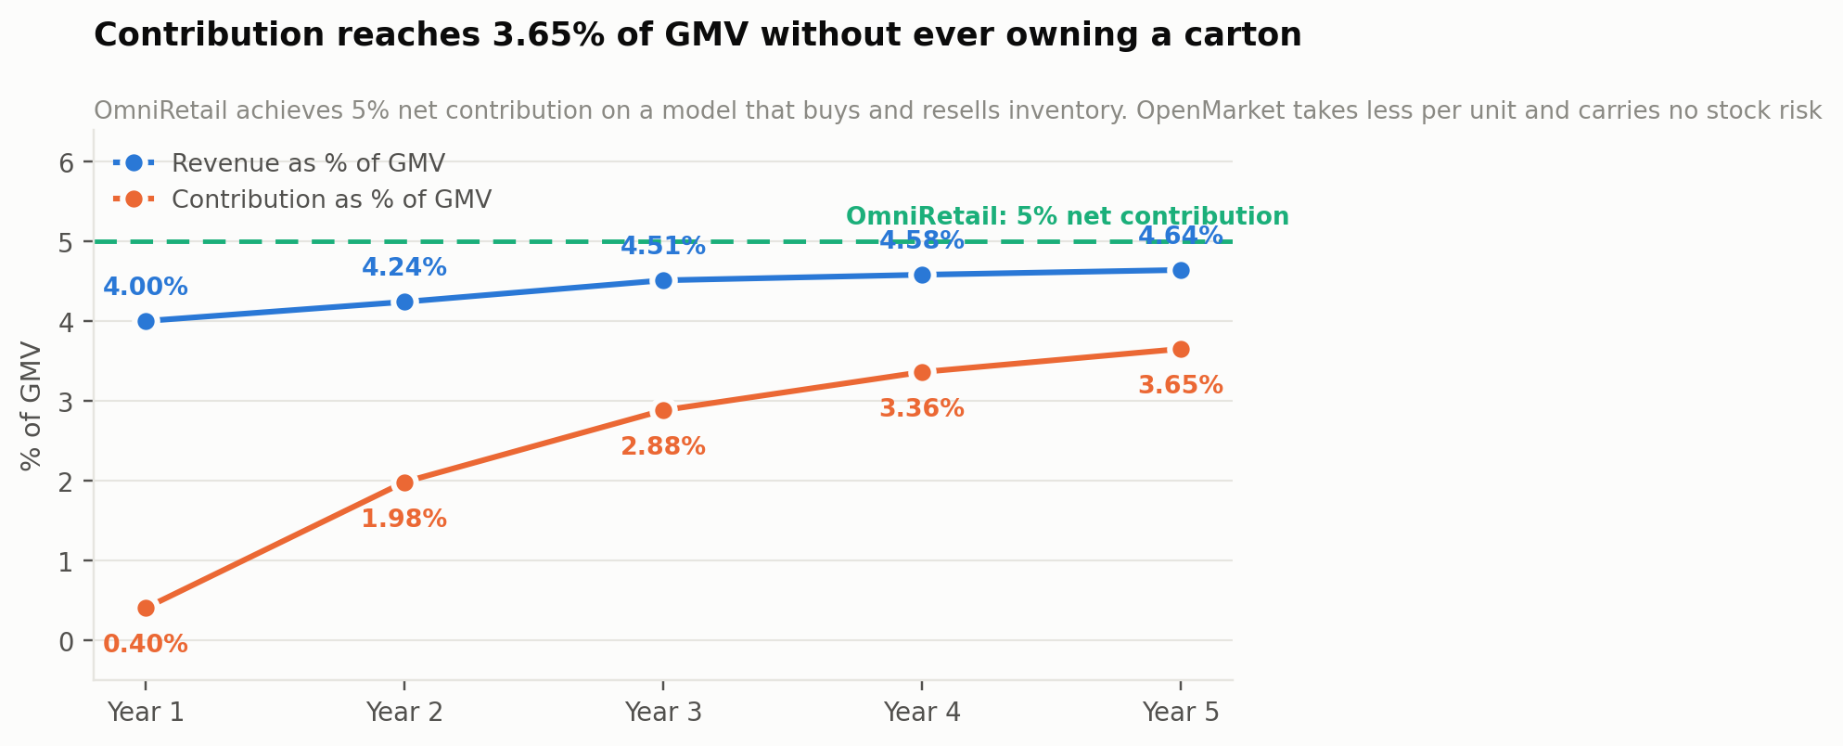
Exhibit 13. Revenue and contribution as a share of GMV, against OmniRetail's disclosed 5% net contribution.

The credit economics
The finance layer is modelled conservatively against every published benchmark. Gross yield of 46% a year — about 3.8% per 30-day cycle — sits deliberately below TradeDepot's reported ~5% monthly rate. Cost of funds is 24%, reflecting naira facility pricing for a development-finance-backed book. Credit losses are modelled at 2.1% a year, which is more than four times OmniRetail's disclosed sub-0.5% NPL rate and roughly double MaxAB-Wasoko's implied 1% or better. That produces a net yield of 19.9% on the average outstanding book.
Penetration rises from 6% of GMV financed in Year 1 to 35% by Year 5, against OmniRetail's roughly 18% implied penetration (₦19 billion monthly disbursement against ₦1.3 trillion of annual volume). Reaching 35% is therefore an aggressive assumption, and it is the input a sceptical reader should test hardest after the take rate.
The structural point is that origination costs almost nothing. The platform is not acquiring borrowers; it is offering credit to merchants whose payment behaviour it has already observed weekly for a year. That is why a $15 million book can be run by a nineteen-person credit and risk function, and it is why the finance line carries a much higher contribution margin than the settlement line.
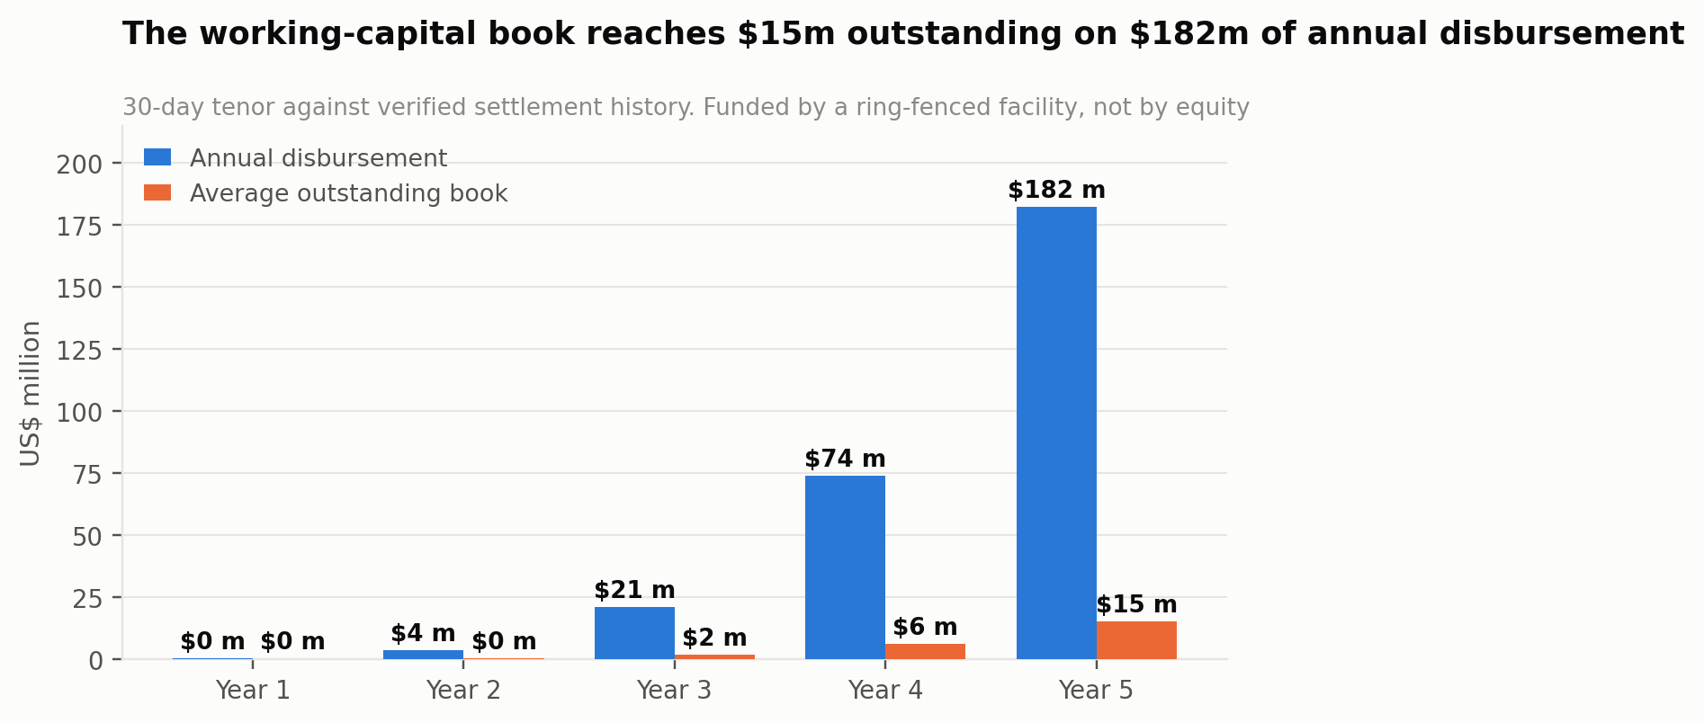
Exhibit 14. The working-capital book. Funded by a ring-fenced facility, never by equity.

Why manufacturer data is the strategic line
At $3.43 million it is 14% of Year-5 revenue — smaller than settlement, larger than finance. Its importance exceeds its size for three reasons. It is the highest-gross-margin line in the business, because the data is a by-product. It converts manufacturers from a channel-conflict risk into commercial allies, which is how a platform gets promotional funding rather than resistance. And it is the only line that an aggregator or a payments company cannot copy, because it requires settled, SKU-level, geographically-resolved transaction data that only a settlement layer generates.
The privacy constraint is what makes it defensible rather than extractive, and it is architectural rather than contractual: telemetry is aggregated to local-government-area clusters with a minimum cohort size, and no merchant identity is ever exposed upstream. Chapter 35 specifies the k-anonymity threshold and Chapter 38 places it in the regulatory frame.
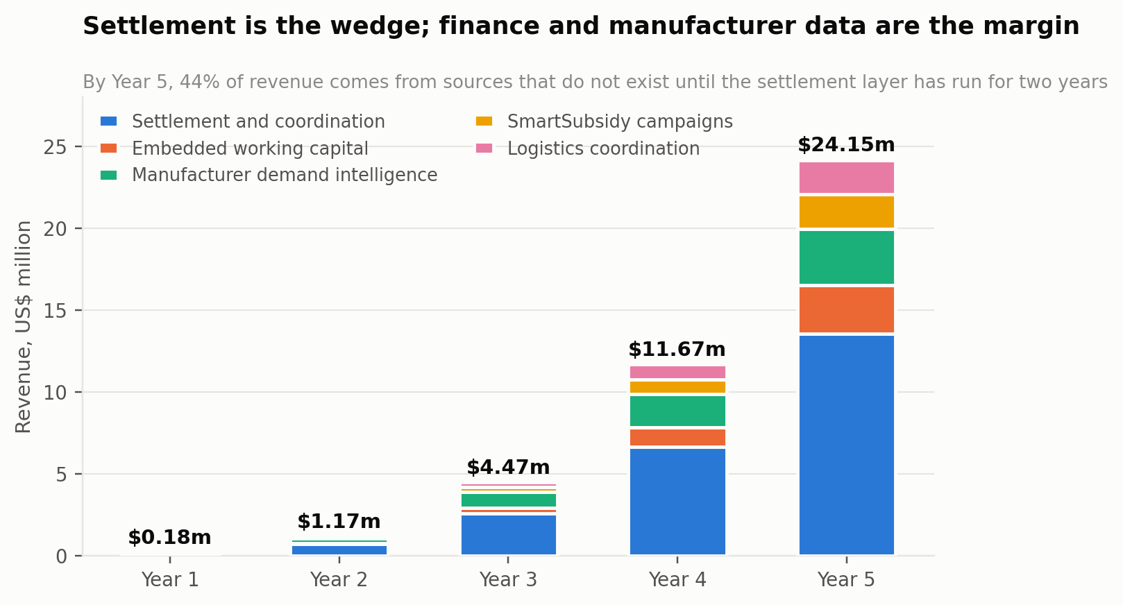
Exhibit 15. Revenue by line. Settlement is the wedge; finance and manufacturer data are the margin.

18 Segments and the Ideal Participant
Four participant classes with different problems, different economics and different acquisition costs. Only one of them is the customer that unlocks the others.

The distributor — the first customer
A wholesaler operating from a shed or lock-up in a designated market, holding stock, extending informal credit and serving retailers within a radius defined by trust. Their binding constraint is not demand; it is that they cannot safely sell to anyone they do not know, and that the credit they extend is unpriced and unrecovered.
OpenMarket's offer to them is the strongest in the plan: instant settlement at 95% of order value, and zero credit risk on the transaction. This is the segment that must be won first, because a market with distributors and no merchants is a soluble problem and a market with merchants and no distributors is not. The model builds from 140 distributors in Year 1 to 6,400 by Year 5, each supporting roughly 34 transacting merchants at Year-5 density.

The retail merchant — the volume
An open-market shop, kiosk, provision store or container retailer, typically 20 to 50 square metres, carrying 60 to 100 SKUs, turning over ₦250,000 to ₦500,000 a month, serving 100 to 150 households who shop about twice a week, and working on roughly 15% margin. Their constraints are stockouts on fast-movers, the cost and time of travelling to market, and working capital.
They are the volume segment — 218,000 by Year 5 — and individually they are worth very little: $84.66 of platform revenue in Year 1 rising to $141.25 by Year 5. They are acquired by agents and by distributors, not by marketing, and Chapter 25 explains why measuring them individually is the wrong lens.

The manufacturer — the margin
An FMCG or general-goods producer selling through key distributors and blind below that tier. Their constraint is that they cannot see secondary and tertiary sales, cannot verify whether promotional spend reached the shelf, and cannot tell which of the 745,000 Nigerian outlets actually carry them. They currently buy an inferior answer through field-force audits.
They buy cluster-level demand telemetry at a modelled $18,000 rising to $46,000 a year, and they fund SmartSubsidy campaigns at an 11% platform take. Eighty-six accounts by Year 5. This segment is sold by the founders and a small commercial team, not self-serve.

The carrier — the enabler
A licensed transport operator working defined trade lanes. OpenMarket does not employ them, contract for capacity, or take delivery liability — the carrier holds both liability and insurance. The platform presents them at checkout and takes a 0.8% coordination fee on orders that use one, rising to 50% attachment by Year 5. They are an enabler of trade at distance rather than a revenue engine, and treating them as a partner rather than a cost centre is what keeps the fleet off the balance sheet.
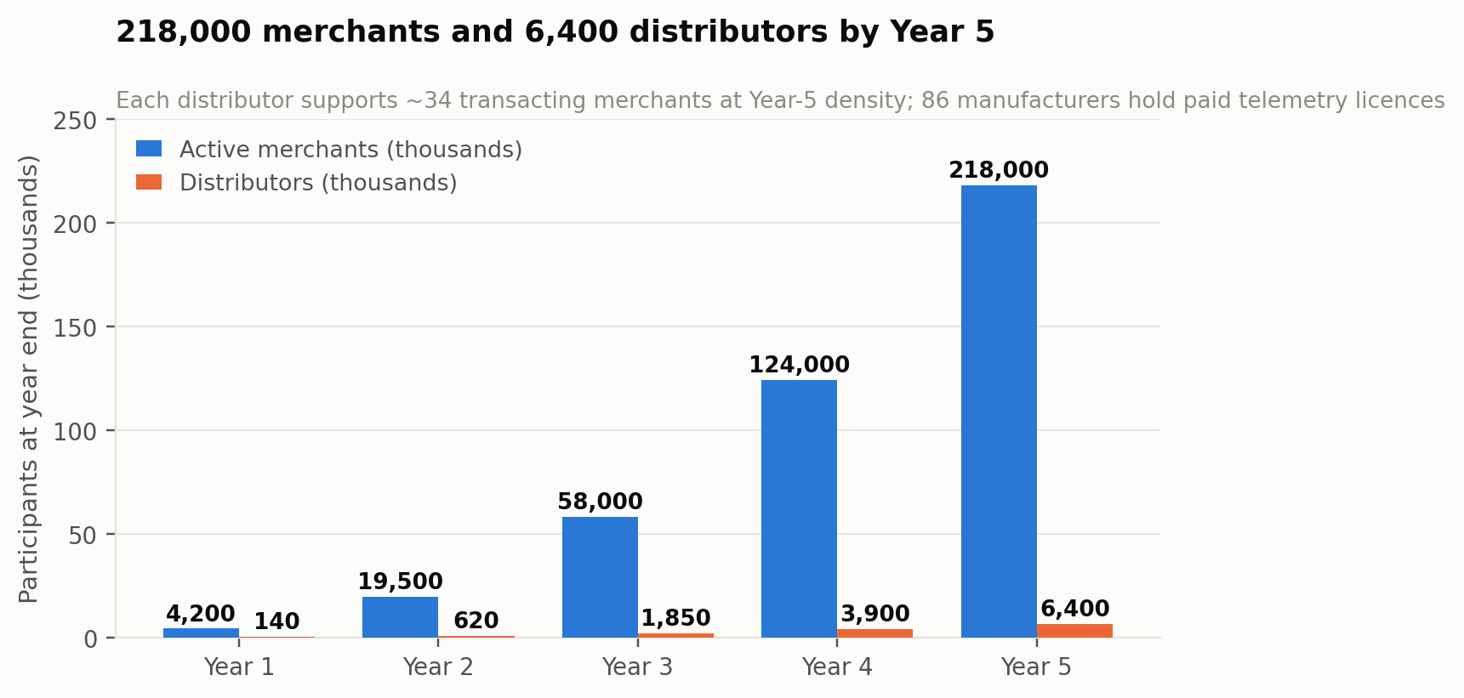
Exhibit 16. Network build across the three transacting participant classes.

The ideal hub, precisely
Because the hub is the unit, the ideal-customer profile is a market rather than a firm. The ideal OpenMarket hub has more than 8,000 wholesale merchants; a functioning, identifiable market association with real authority; a catchment extending at least 200 kilometres, so that distance transactions have obvious value; FMCG and general goods rather than a single specialised category; existing informal credit practice, which indicates both a real pain point and a population accustomed to terms; mobile money or bank transfer already in common use for large payments; and at least one competitor absent. Onitsha meets all seven. Mile 12 meets six. Kejetia meets six.

19 Product Strategy and the Value Ladder
Four rungs, and a strict rule that no rung is built before the one beneath it is carrying weight.

Rung one — verified settlement
The entire Phase-1 product. A merchant places an order; the platform verifies payment at the provider; only then is a fulfilment instruction issued; the ledger splits programmatically and the distributor receives 95% immediately. Nothing else in the product matters until this is correct every time, and the plan treats a single mis-settlement as a Sev-1 incident rather than a defect.
The free tier is a verified identity and a shop stock ledger — enough for a merchant to establish a record and receive reorder prompts without transacting. Its purpose is the top of the funnel: 11,500 free merchant registrations in Year 1 growing to 390,000 by Year 5, against 4,200 and 218,000 transacting.

Rung two — the Virtual Warehouse Ledger and routing
The distributor digitises stock they already hold, in place, without moving it. That is the VWL, and it is the mechanism by which a merchant can be routed to a wholesaler who genuinely has the goods. It is also the point at which the platform stops being a payment rail and starts being coordination infrastructure, because a routing decision requires knowing stock, price, distance and reliability simultaneously.
The commercial consequence is that the VWL is what makes the 2.4% take defensible: without it the platform is charging for a payment; with it the platform is charging for a matched, stocked, settled transaction.

Rung three — working capital
Offered only to merchants with verified settlement history on the platform, at a 30-day tenor matching the restock cycle. This rung is gated by data rather than by price: a merchant qualifies by having transacted, not by applying. It is the strongest retention mechanism in the product — a merchant with an active facility does not casually leave — and Chapter 25 shows it is where the contribution margin turns.

Rung four — manufacturer intelligence and SmartSubsidy
Cluster-level demand telemetry sold upstream, and manufacturer-funded promotion routed down through the network at an 11% platform take. This rung monetises the aggregate rather than the individual, and it is the reason the platform can afford to return half its gross split to the channel: the manufacturer funds a meaningful share of the rebate that makes the take rate acceptable to the distributor.

What OpenMarket deliberately does not build
Inventory. The finding of the entire shakeout. The platform never takes title, never holds stock and never appears in the chain of goods.
A fleet. Carriers hold their own vehicles, liability and insurance. The platform coordinates and takes a fee; it does not dispatch its own drivers, because the moment it does it acquires a fixed cost that scales with volume rather than with margin.
A consumer-facing surface. The site says so and it is right. Consumer commerce would put the platform in competition with the retailers it serves, and it is a different business with different economics.
Lending from its own balance sheet. Credit risk sits with partner lenders under a facility; OpenMarket originates, scores and services. Taking the risk directly would require capital, licensing and a completely different competence, and would subordinate a high-margin coordination business to a low-margin financial one.
Bypassing the market union. Technically possible, commercially fatal. The plan treats association endorsement as a precondition of hub activation rather than as a nice-to-have.

Product principles
- No fulfilment instruction before verified funds. The single non-negotiable rule. Every other feature can degrade; this one cannot.
- The distributor is never disadvantaged by the platform. If a change would reduce a distributor's economics, it does not ship. They are the segment that can end this business by declining to participate.
- Offline is the default assumption, not the edge case. Orders are built, queued and reconciled on a device that may not see the network for hours.
- Aggregate upward, never identify. No merchant identity crosses the tier boundary to a manufacturer, ever, at any price.
- Explain the money. Every participant can see, at any moment, what they are owed, what has been paid, and what fee was taken. Opacity in a settlement product is indistinguishable from theft.

20 Pricing Architecture
Five prices, each set against what the payer can actually afford rather than against what the platform would like.
Who pays | What for | Price | Why this number
Distributor | Verified settlement, instant 95% payout, VWL, demand visibility | 5.0% gross, ~2.4–2.6% net of rebate | Against single-digit channel margins; the effective cost is the net figure, in exchange for zero credit risk
Merchant | Ordering, stock ledger, reorder prompts, identity | Free | The merchant's contribution is volume and data. Charging them suppresses the flow everything else depends on.
Merchant (optional) | 30-day working capital | ~3.8% per cycle | Below TradeDepot's reported ~5% monthly effective rate; only offered on verified settlement history
Manufacturer | Cluster demand telemetry licence | $18,000 → $46,000 / yr | Priced below the cost of a single field-audit programme, which is the alternative they buy today
Manufacturer | SmartSubsidy campaign routing | 11% of subsidy value | A promotion fee, not a media fee; the manufacturer's spend reaches the shelf and is verifiable
Carrier / order | Logistics coordination at checkout | 0.8% of order value | A coordination fee on a lane the platform did not have to build; carrier keeps the delivery economics
Table 7. Who pays what, and the reason for each number.

The three pricing decisions that matter
The merchant is free, permanently. Every instinct in a subscription business argues for charging them, and it is wrong here. The merchant supplies the volume that makes the distributor's take worth paying and the manufacturer's telemetry worth buying. A ₦2,000 monthly fee would raise perhaps $300,000 by Year 5 and cost far more than that in suppressed transacting merchants. The merchant pays in data and in flow.
The rebate is a lever, not a leak. Modelling 2.6% of GMV returned to the channel looks like giving away half the revenue. It is the instrument that makes the platform acceptable to distributors, funds manufacturer promotion, and can be flexed by hub, by category and by cohort to buy density where density is worth buying. A plan that models 5% net has not thought about who pays it.
Credit is priced below the market and gated above it. Below TradeDepot's rate because origination costs less and the data is better; gated on verified settlement history because Udaan's failure was extending credit to people the platform did not actually know. Cheaper money to fewer, better-known borrowers is the correct trade in a market where the last generation lost money doing the reverse.

Currency
Prices are percentages, which makes the naira and cedi exposure structural rather than a pricing problem: revenue moves with local prices automatically. The exposure that remains is in dollar-denominated costs — cloud, inference, senior engineering — and in the credit book, where a 24% naira cost of funds against a 46% gross yield leaves a margin that a rate shock could compress. Chapter 29 rates this a high-probability, medium-impact risk with a partial hedge.

21 Go-To-Market
The sequence is distributor, then merchant, then manufacturer, and it is not negotiable — reversing it is how a two-sided cold start becomes a two-sided failure.

The hub activation playbook
Every hub follows the same seven-step sequence, and the plan's central operational claim is that this sequence is repeatable at $46,000 a time.
- Union first. Approach the market association before approaching a single trader. Explain the model, agree terms of presence, and secure a named contact. No activation begins without this.
- Anchor distributors. Recruit eight to twelve of the hub's most respected wholesalers. Their participation is the signal every subsequent trader reads. Onboard their stock into the VWL personally, with agents present.
- Prove settlement on their existing customers. The first hundred transactions should be between a distributor and retailers they already serve. The product's value here is instant payout and a clean record, not new demand.
- Then open distance trade. Only once settlement is visibly reliable does the platform introduce retailers the distributor has never met. This is the moment the market expands, and it must not come first.
- Agent-led merchant recruitment. Four resident agents working the catchment, onboarding retailers who already buy from the hub.
- Referral. Merchants who have settled successfully recruit others, with a one-month fee credit both sides.
- Density, then telemetry. Only when the hub carries enough settled volume for cluster aggregates to be statistically meaningful is manufacturer data sold from it.

Sequencing across hubs
Period | Hubs activated | Live at end | Focus
Months 0–7 | Onitsha, Mile 12 | 2 | Prove settlement integrity and the activation playbook. Founder-led.
Months 8–18 | Alaba, Idumota, Katamanto (Accra) | 5 | Prove the playbook is transferable, including across a border. First team-led activation.
Months 19–30 | Kejetia (Kumasi), Ariaria | 7 | Complete the seven flagship hubs. Credit at scale. First manufacturer telemetry sold.
Months 31–42 | Four secondary Nigerian hubs | 11 | Density in the catchments already served. Lower activation cost per hub.
Months 43–60 | Five further secondary hubs | 16 | Corridor coverage and cross-border trade signals.
Table 8. Hub sequencing. Ghana is a Year-1 commitment and a Year-2 operation.
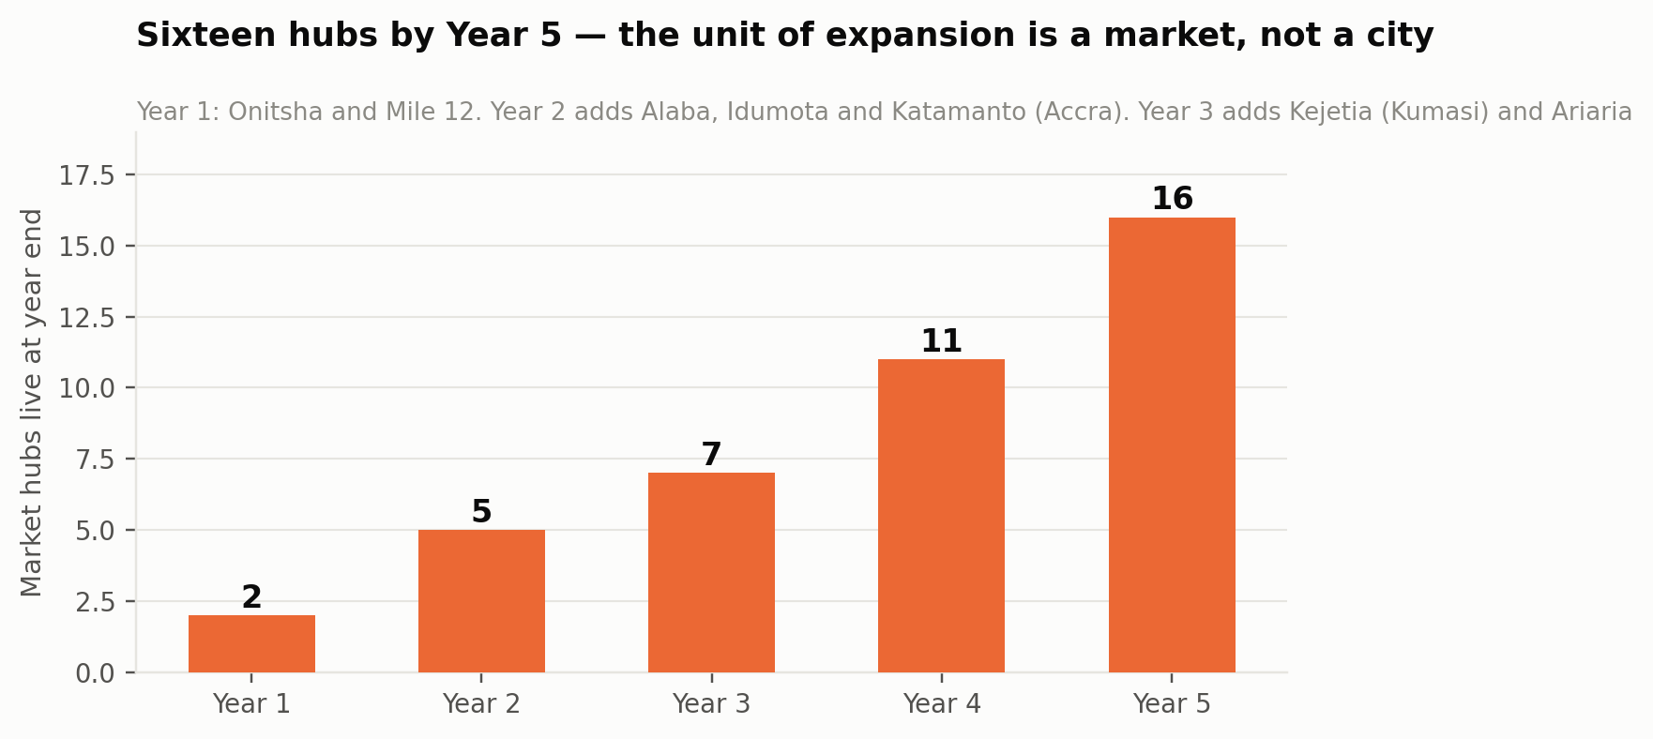
Exhibit 17. Hub rollout. The unit of expansion is a market, not a city or a country.

Why not faster
The obvious question is why sixteen hubs rather than forty, given that activation costs $46,000 and returns $2.94 million by month 36. The answer is that hub activation is constrained by trust-building capacity rather than by capital: it requires a union relationship, anchor distributors who vouch for the platform, and resident agents who are known in the market. Those are people-limited and reputation-limited, and a company that activates hubs faster than it can staff them credibly will fail in exactly the way its predecessors did, one bad settlement at a time.

22 The Marketing Plan
Chapter 21 set out which hubs OpenMarket activates and in what order. This chapter is the operating plan underneath it: three distinct acquisition motions, six channels with a budget that reconciles to the model, four honest definitions of acquisition cost, a trust-building programme that is unusual because the product is unusual, and the ten numbers marketing is held to.

Marketing in a trust business is a field programme
It is worth being blunt about what this function is, because importing a conventional software marketing plan here would waste most of the budget. OpenMarket's buyer is a wholesaler in a shed in Onitsha and a shop owner two hours away in Enugu. Neither reads a blog. Neither clicks a search advertisement. Both make decisions on the basis of what a person they respect told them, and what they watched happen to somebody else's money.
So the marketing organisation is a field organisation with a communications function attached, and the budget says so: 65% of Year-1 merchant-recruitment spend goes to three channels that involve a human being physically present in a market. No digital channel exceeds 18% of spend in any year of the plan. The single most effective marketing asset the company owns is a resident agent standing beside a distributor when ₦95,000 lands in their account before the goods have left the shed.

What marketing owns
Five numbers, and no others. Hubs activated on schedule, because the hub is the unit of everything. Distributors onboarded per hub, because they come first. Merchants transacting within thirty days of registration — registration alone is worthless and counting it is how a marketing function starts lying to itself. Cost per transacting merchant. And the second-order rate within thirty days, which is the only measure of whether the settlement promise actually landed.
Everything else — impressions, registrations, agent conversations, radio spots — is diagnostic. It is used to explain why one of the five numbers moved. It never appears in a board report as an achievement.

Three motions, not one
The most common structural error available to this business would be to run a single acquisition function. The three participant classes are bought in completely different ways, on completely different timescales, at costs that differ by three orders of magnitude.
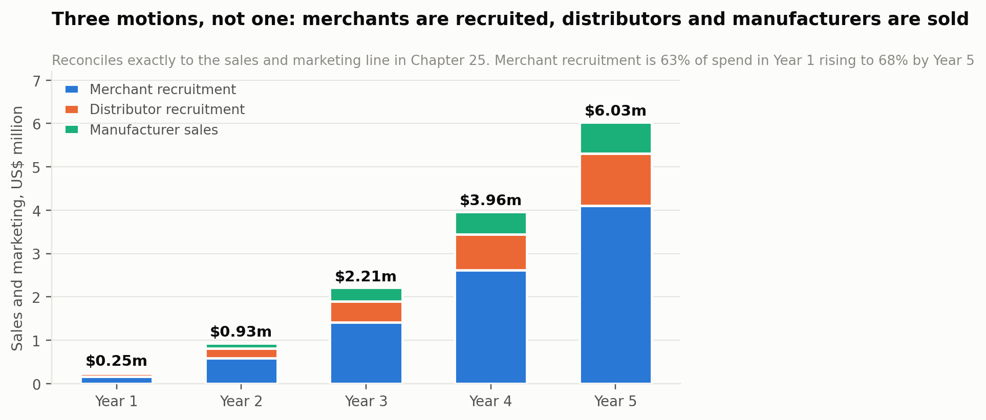
Exhibit 18. Sales and marketing decomposed by motion. Reconciles exactly to the model's S&M line.
Motion | How it is bought | Y1 spend | Y5 spend | Y1 cost each | Y5 cost each
Merchant recruitment | Field agents, distributors, referral | $160,083 | $4,098,401 | $29.05 | $28.21
Distributor recruitment | Relationship selling, founder-led early | $66,066 | $1,205,412 | $472 | $482
Manufacturer sales | Named-account enterprise sale | $27,951 | $723,247 | $4,658 | $31,446
Total sales and marketing |  | $254,100 | $6,027,060
Table 9. The three motions. A manufacturer costs 1,000 times more to acquire than a merchant, and is worth it.
Merchant recruitment takes 63% of Year-1 spend rising to 68%, at a cost per transacting merchant of $29.05 falling to $25.62 by Year 3. It is a volume motion run by agents and, increasingly, by distributors themselves.
Distributor recruitment takes 26% of Year-1 spend for 140 distributors, at $472 each. That looks expensive against a merchant at $29 until you observe that the average distributor at Year-5 density supports roughly 34 transacting merchants — so the effective cost per merchant acquired through a distributor relationship is under $14, and the distributor also brings stock, storage and local credibility. It is the best-value acquisition in the plan and it is the one that must happen first.
Manufacturer sales takes 11% rising to 12%, at $4,658 per account in Year 1 rising to $31,446 by Year 5 as the easy relationships are exhausted and the sale moves to larger, slower accounts. Against a $46,000 annual contract that is an eight-month payback on a multi-year relationship, and the account also funds SmartSubsidy promotion that subsidises merchant acquisition. Two contracts in Year 1 is a validation gate, not a revenue target.

The six merchant channels
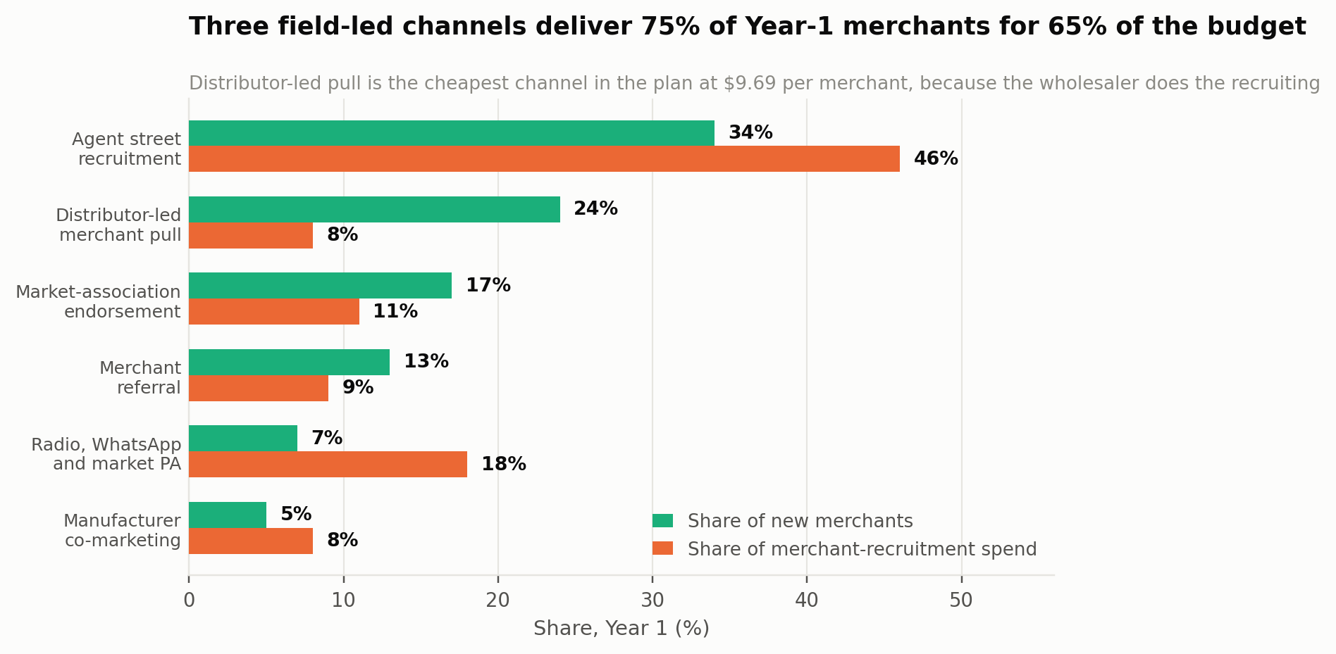
Exhibit 19. Year-1 merchant channel mix: share of new merchants against share of recruitment spend.
Channel | Y1 adds | Y1 spend | Y1 CAC | How it works
Agent street recruitment | 1,873 | $73,638 | $39.32 | Resident agents working a defined catchment, present when the first order settles. The person standing there when the money arrived is the marketing.
Distributor-led merchant pull | 1,322 | $12,807 | $9.69 | A wholesaler receiving instant settlement migrates their own existing customers, unpaid. The clearest evidence that distributor-first sequencing is correct.
Market-association endorsement | 937 | $17,609 | $18.79 | An announcement from the union executive at a general meeting carries a guarantee no advertisement can. Cost is relationship management, not media.
Merchant referral | 716 | $14,407 | $20.12 | One-month fee credit both sides, triggered after a successful settled order rather than at registration. The only channel whose cost falls as the base grows.
Radio, WhatsApp and market PA | 386 | $28,815 | $74.65 | Establishes legitimacy at hub level before agents arrive. Expensive per merchant, retained because it materially reduces agent cost per onboarding.
Manufacturer co-marketing | 276 | $12,807 | $46.40 | Largely manufacturer-funded. Matters mostly as a signal to the channel that brands endorse the platform.
Total merchant recruitment | 5,510 | $160,083 | $29.05
Table 10. The Year-1 merchant channel portfolio. Costs are recruitment spend only; hub activation is separate.

Agent street recruitment — 34% of merchants
Resident agents working a defined catchment inside and around a hub. They onboard merchants in person, walk them through a first order, and — critically — are present when that order settles. In a product whose entire claim is that money moves safely, the person standing there when the money arrived is the marketing, and no amount of media spend substitutes for it.
At $39.32 per merchant it is the most expensive of the three field-led channels and the only one that scales linearly with headcount. It is also the channel that seeds the other two: a market with no agent presence generates no referrals and no distributor pull.

Distributor-led merchant pull — 24% of merchants, at $9.69 each
The cheapest channel in the plan by a wide margin, and the strongest evidence that the distributor-first sequence in Chapter 21 is correct. A wholesaler receiving 95% instant settlement has a direct commercial interest in moving their existing customers onto the platform, and they do it without being paid to, because every migrated customer is one they no longer extend informal credit to.
Its share of merchants rises from 24% to 28% across the plan as the distributor base compounds. It cannot be forced: it only appears after a distributor has personally experienced reliable settlement, which is why it contributes nothing in a hub's first two months and a great deal by month nine.

Market-association endorsement — 17% of merchants
An announcement from the union executive at a general meeting reaches more qualified merchants in twenty minutes than a month of agent work, and carries an implicit guarantee no advertisement can buy. The cost — $18.79 per merchant — is relationship management, association fees and the time to prepare a quarterly settlement report for the executive, not media.
The operating discipline here matters more than the spend. The association relationship is owned by the market operations lead, is reviewed weekly, and is never delegated to an agent. A union that feels used will withdraw access, and Chapter 29 rates that a medium-probability, high-impact risk with no cheap mitigation.

Merchant referral — 13% rising to 21%
A one-month fee credit to both sides, triggered after a successful settled order rather than at registration, and surfaced at the moment of demonstrated value rather than on a dashboard on day one. It is the only channel whose cost per merchant falls as the business grows, because its capacity is a function of the installed base rather than of budget.
It is also the most honest leading indicator in the plan. If the referral rate does not develop as modelled, the problem is almost never the referral mechanic — it is that settlement is not producing outcomes a merchant considers worth telling a peer about. Chapter 42 treats a soft referral rate as a product signal, not a marketing one.

Radio, WhatsApp and market public address — 7% of merchants for 18% of spend
The worst channel by cost per merchant at $74.65, and retained deliberately. It does something the field-led channels cannot: it establishes that the platform exists and is legitimate at hub level before agents arrive, which materially reduces the number of conversations an agent needs to convert one merchant. Market PA announcements, local-language radio on the stations traders actually listen to, and WhatsApp broadcast into groups that already circulate trade information.
It is budgeted per hub activation rather than nationally, and it front-loads: roughly 60% of a hub's awareness spend falls in the eight weeks around activation.

Manufacturer co-marketing — 5% of merchants
Largely manufacturer-funded, and it matters mostly as a signal. When a brand a merchant already stocks puts its name beside OpenMarket at a market activation, it answers the only question the merchant is actually asking, which is whether this platform will still exist in six months.

Budget by channel and year
Merchant recruitment, US$ | Year 1 | Year 2 | Year 3 | Year 4 | Year 5
Agent street recruitment | $73,638 | $263,832 | $608,441 | $1,071,723 | $1,598,376
Distributor-led merchant pull | $12,807 | $46,903 | $127,348 | $235,256 | $409,840
Market-association endorsement | $17,609 | $64,492 | $155,648 | $287,535 | $450,824
Merchant referral | $14,407 | $58,629 | $155,648 | $313,675 | $532,792
Radio, WhatsApp and market PA | $28,815 | $105,533 | $254,696 | $496,652 | $778,696
Manufacturer co-marketing | $12,807 | $46,903 | $113,198 | $209,117 | $327,872
Merchant recruitment total | $160,083 | $586,293 | $1,414,979 | $2,613,958 | $4,098,401
Distributor recruitment | $66,066 | $223,350 | $486,399 | $831,714 | $1,205,412
Manufacturer sales | $27,951 | $120,981 | $309,527 | $514,870 | $723,247
Total sales and marketing | $254,100 | $930,624 | $2,210,904 | $3,960,542 | $6,027,060
Table 11. The full marketing budget. The bottom row is the sales and marketing line in Chapter 26, unchanged.
Two features of the allocation are deliberate. Field-led channels take 65% of merchant spend in Year 1 and 60% by Year 5 — the shift reflecting referral compounding rather than any loss of faith in agents. And awareness spend stays flat at 18–19% throughout, because it is tied to hub activations rather than to revenue, and there are more activations in later years.

Four definitions of acquisition cost
The model in Chapter 26 quotes a merchant CAC of $46.11 in Year 1 falling to $41.48. That figure is conservative by construction, and it is worth being explicit about why, because a reader comparing it to a software benchmark will otherwise draw the wrong conclusion.
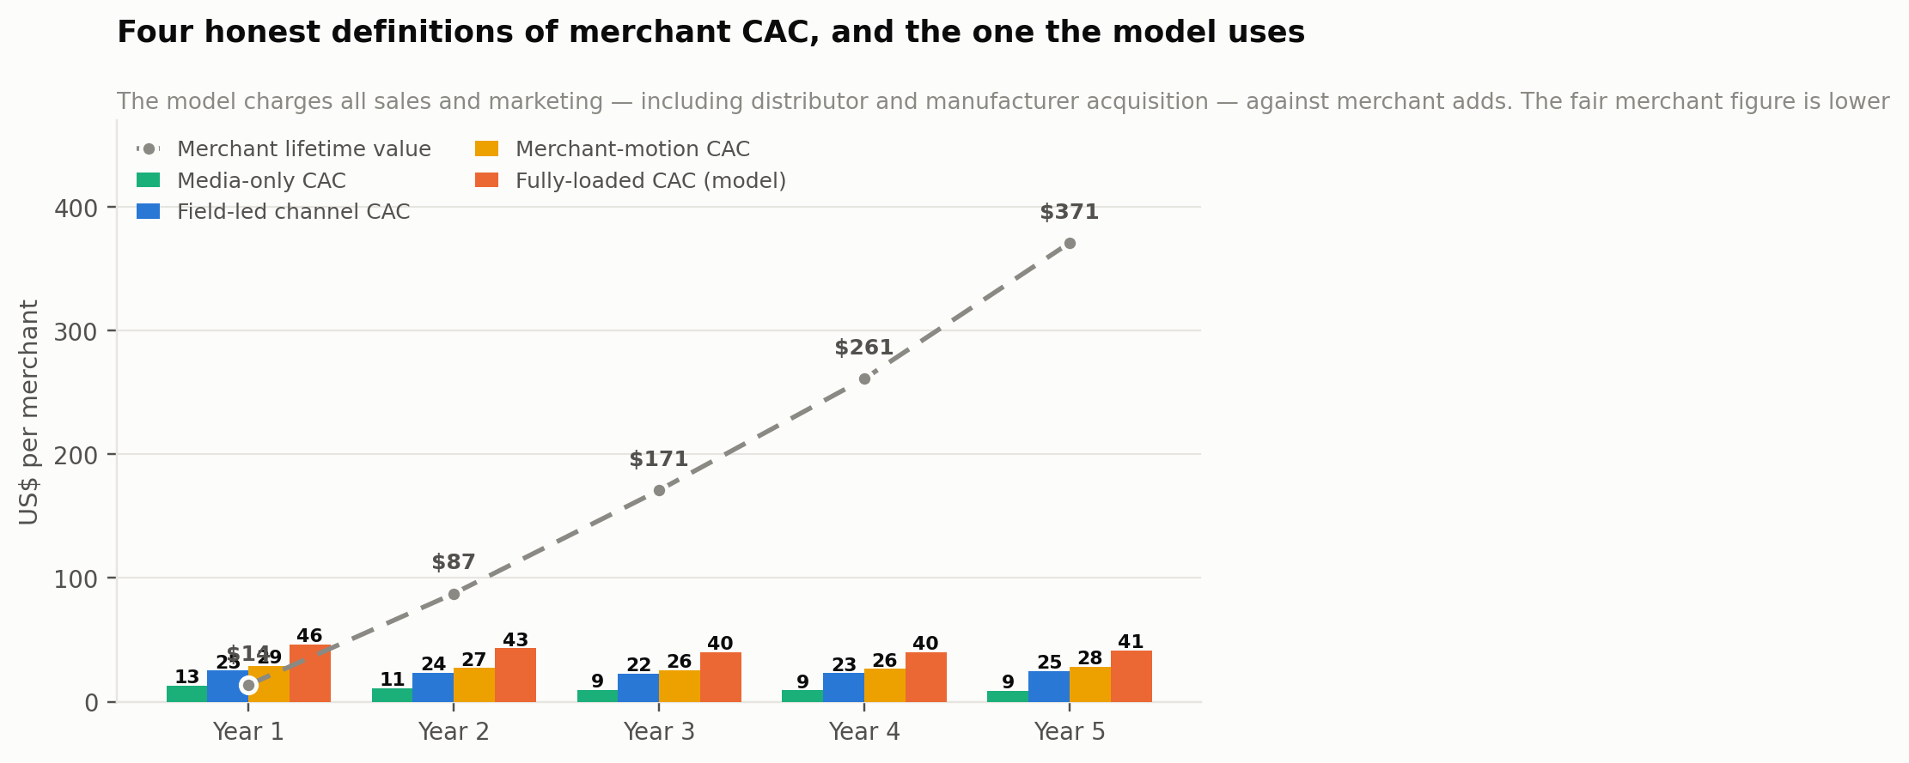
Exhibit 20. Four definitions of merchant acquisition cost against merchant lifetime value.
US$ per new transacting merchant | Year 1 | Year 2 | Year 3 | Year 4 | Year 5
Media-only CAC | $13.07 | $11.13 | $9.41 | $9.11 | $9.08
Field-led channel CAC | $25.18 | $23.52 | $22.41 | $23.07 | $24.89
Merchant-motion CAC | $29.05 | $27.20 | $25.62 | $26.47 | $28.21
Fully-loaded CAC (used in the model) | $46.12 | $43.17 | $40.02 | $40.10 | $41.48
Merchant lifetime value | $14 | $87 | $171 | $261 | $371
LTV : merchant-motion CAC | 0.47x | 3.21x | 6.67x | 9.86x | 13.15x
Field-led share of new merchants | 75% | 74% | 72% | 70% | 68%
Table 12. Acquisition cost, stated four ways. The model uses the least flattering.
Media-only CAC — the non-payroll budget divided by new merchants — is $13.07 in Year 1 falling to $9.08. It is the number a conventional marketing report would quote and it is close to meaningless here, because it excludes the agents who do most of the work.
Field-led channel CAC is $25.18, covering the three channels that deliver 75% of Year-1 merchants. This is the number that should be watched operationally, because it is the one management can actually influence week to week.
Merchant-motion CAC is $29.05 — all spend allocated to merchant recruitment, divided by merchants recruited. This is the fair figure: it charges merchants for merchant acquisition and nothing else.
Fully-loaded CAC is $46.12, and it is what Chapter 26 uses. It charges the entire sales and marketing line — including distributor recruitment and manufacturer enterprise sales — against merchant additions alone. That is not a fair attribution and the plan uses it anyway, because a reader should be given the harsher number and told that it is harsh, rather than the flattering one and left to discover the construction.
What this changes, and what it does not
On the fair merchant-motion basis, LTV to CAC is 0.47 in Year 1, crosses 3.0x in Year 2 at 3.21x, and reaches 13.15x by Year 5 — against 0.29, 2.02 and 8.94 on the fully-loaded basis the model uses.
It does not change the conclusion in Chapter 25: Year 1 is bad on every merchant-level definition, and the hub cohort remains the only unit that makes sense of this business. What it does establish is that the model's headline CAC is a deliberately conservative construction rather than a genuine measure of what a merchant costs.

The funnel, and the step that decides everything
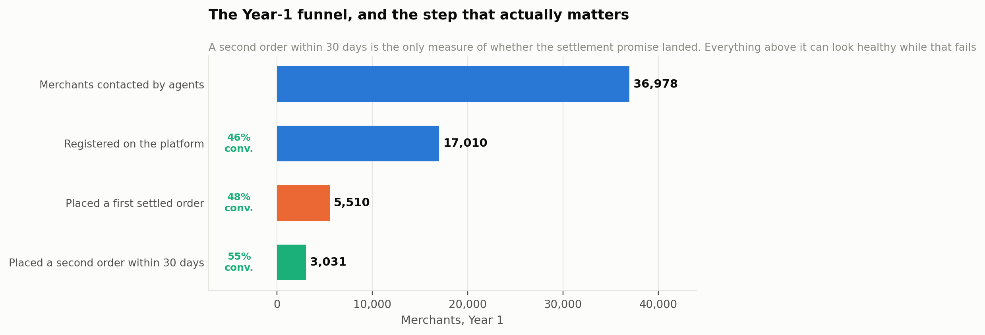
Exhibit 21. The Year-1 acquisition funnel.
Agents contact roughly 36,978 merchants in Year 1, of whom 17,010 register — a 46% conversion that reflects the fact that agents work inside markets where the platform has already been announced. Of those, 5,510 place a first settled order, a 48% step that is the true test of the proposition. And of those, the plan targets 55% placing a second order within thirty days.
That last step is the only one that matters. A merchant who settles once and does not return did not believe what happened, or was not served well enough to risk it twice. Every metric above it can look healthy while it fails, and if it fails the business does not work no matter how many registrations have been counted. It is a Tier-1 weekly metric in Chapter 42 with a named owner, and a soft reading escalates to product rather than to marketing.

The trust-building programme
This is the part of the plan with no equivalent in a conventional marketing function, and it exists because of a specific fact: traders in Onitsha, Alaba and Kejetia have watched B2B platforms arrive, promise to change everything, and disappear. Copia entered administration. MarketForce wound down. Wabi left. That scepticism is earned and it is the single largest obstacle to adoption — larger than price, larger than product.
Four instruments address it, and none of them is advertising.
Published performance. Settlement success rate, median time to distributor payout and verified trade volume per hub, published monthly — including in the months when the numbers are poor. A company with no track record cannot ask to be believed; it can only offer a figure and let people watch it over time. Publishing a bad month is what makes a good month credible.
The quarterly hub report to the association. Every market union receives verified trade volume in their own market — information no executive has ever previously had about the hub they govern. It costs nothing to produce, it is genuinely valuable to them, and it converts the association from a gatekeeper into a stakeholder.
The State of the Open Market report. Published annually from Year 2, using aggregated settlement data to describe how goods actually move through West African wholesale markets: volumes, corridors, price dispersion, seasonality. Given away. Its purpose is not lead capture but to make OpenMarket the organisation whose numbers get quoted when anyone discusses this channel — a position that cannot be bought and compounds indefinitely.
Demonstration over explanation. The standing instruction to every agent and every commercial hire is to settle one transaction in front of the sceptic rather than explain ten. For a distributor watching money land in their account before the cartons move, the demonstration is the argument.

Messaging
Audience | Their actual problem | The message, usable verbatim | Proof offered
Distributor | "I sell on trust and I carry the loss when trust fails" | You get paid 95% the moment the money clears, before the goods leave your shed. You carry no credit risk on the order. | Median time to payout, published continuously
Merchant | "I go to the market with cash, and I still run out of fast-movers" | Buy from a wholesaler you have never met. Your money does not move until the goods are confirmed. | Settlement success rate; the agent who was there
Market union | "Platforms come here, extract, and leave" | We do not buy or sell anything. Your traders keep their stock, their customers and their margin. We make sure they get paid. | The quarterly settlement report on their own hub
Manufacturer | "I cannot see anything below my key distributor" | See what actually sells, by cluster, by SKU, every week — and fund promotion you can verify reached the shelf. | Coverage and freshness of the telemetry feed
Carrier | "Half my problem is collecting on delivery" | The consignment is already paid for before you are dispatched. You keep the vehicle, the liability and the delivery economics. | Pre-paid consignment volume on your lanes
Table 13. The messaging matrix. Each line is written for an agent to use as written, not to paraphrase.

Brand and the asset inventory
The brand has one job: to make paid the first word a trader associates with the name. Everything in the identity system serves that. The settlement confirmation — the moment a distributor sees the money — is treated as the primary brand surface, and it is designed to be screenshot and forwarded, because that is how this market actually shares evidence.
The Year-1 asset inventory is deliberately small and complete rather than large and half-built: the messaging system and a tone guide in English, Igbo, Yoruba, Hausa and Twi; the settlement confirmation screen and its shareable form; a one-page distributor explainer that works as a WhatsApp forward; a market-association briefing pack and the quarterly report template; agent field materials including a printed order walkthrough for merchants who cannot yet use the app unaided; the public hub-performance page, which is a marketing asset disguised as a status page and is the most persuasive thing the company will publish; and the three briefs accompanying this plan.

The marketing dashboard
Measure | Year-1 target | Cadence | What a miss tells you
Hubs activated on schedule | 2 | Monthly | Union or anchor-distributor access, not marketing effort
Distributors onboarded per hub | 70 | Weekly | The 95% settlement offer is not landing, or the wrong distributors were approached first
Merchants contacted by agents | 36,978 | Weekly | Agent productivity or catchment definition
Registrations | 17,010 | Weekly | Awareness has not preceded the agent into the market
Registration to first settled order | 48% | Weekly | Onboarding friction, or a distributor with poor stock confidence in the routing set
Second order within 30 days | 55% | Weekly | The one that matters. Escalate to product, not to marketing
Merchant-motion CAC | $29.05 | Monthly | Mix has shifted toward paid awareness; check whether field-led channels stalled
Field-led share of new merchants | 75% | Monthly | The compounding engine is not compounding — a Tier-1 problem
Referral share of new merchants | 13% | Monthly | Almost always settlement quality, not the referral mechanic
Association meetings addressed | 6 | Quarterly | The relationship is cooling before the access does
Table 14. Ten lines, one owner each, reviewed alongside the weekly settlement review.

What marketing will never do
Never claim a hub is live before it can settle a transaction. The current site's twelve-hub map across six countries is the live instance of this risk and Chapter 11 flags it. In a trust business a merchant who registers and cannot transact is not a lapsed lead; they are an active detractor inside a market where everyone talks to everyone.
Never lead with AI. Phase 1 is trust rails and saying so is a credibility asset. The intelligence layer gets described when it exists and is measured, and not before.
Never promise the distributor more volume. Promise faster money and no credit risk, both of which the platform controls. Volume is a consequence, and promising it creates a claim that cannot be guaranteed to a party who will remember.
Never discount the take rate to win a hub. The rebate in Chapter 17 is the instrument for flexing price, and it is negotiated openly against volume. A quiet discount to one distributor becomes known across the market within a week and reprices every relationship in it.
Never buy a testimonial. Every trader quoted must be a real customer with a real settled transaction, named, and free to say what they actually think. This market can tell the difference, and the cost of being caught staging one is the hub.

23 The Human Distribution Layer
openmarket.africa describes Phase 1 as human-trust infrastructure. That phrase is usually read as a modest placeholder until the artificial intelligence arrives. It is not. In a market where 94% of trade still runs on relationships, the people OpenMarket puts into a hub are not a temporary bridge to an automated future — they are the distribution system, and this chapter specifies them as carefully as Part Four specifies the ledger.

Why software cannot be the distribution channel here
Every failed platform in Chapter 10 had a working application. Copia had one. Alerzo had one. Wabi had one. What none of them could buy with software was the thing a Nigerian wholesaler actually requires before sending goods to a stranger: someone they know, standing in front of them, whose reputation is attached to the outcome.
The evidence for this is not sentimental. The three channels in Chapter 22 that involve a human physically present in a market — agents, distributor-led pull and association endorsement — deliver 75% of Year-1 merchants for 65% of merchant-recruitment spend. Every purely broadcast channel is more expensive per merchant. Egatee reached the same conclusion independently and staffs roughly a hundred people per country, more than a thousand in Nigeria alone, at 90% local hiring, with sample halls physically inside wholesale markets.
So the plan treats the human layer as infrastructure with a capital budget, a productivity model, a career structure and a failure mode — not as a sales team.

The four human roles
Role | Employment | Paid for | What they actually do
Resident agent | Employed, hub-assigned | Salary plus settled-order bonus | Onboard and reconcile both sides onto the ledger: register the merchant or distributor, walk a first order to settlement in person, prompt VWL reconfirmation, and resolve the disputes that would otherwise reach an app screen
Hub lead | Employed, one per hub from month 6 | Salary plus hub-level contribution | Owns the association relationship, the anchor distributors, agent supervision and the hub's published performance numbers
Market connector | Commissioned, no retainer | 50% of the settlement fee on the first settled order of a referred merchant or distributor | Respected local traders, association officials' networks and existing market fixers who introduce merchants and wholesalers they already know. Paid only on an outcome
Association liaison | Not employed by OpenMarket | Nothing | The union's own named contact. Receives the quarterly hub report, adjudicates disputes, and is the reason the platform has permission to operate at all
Table 15. The four roles. Only two are on payroll, and the most important one is not employed by the company.
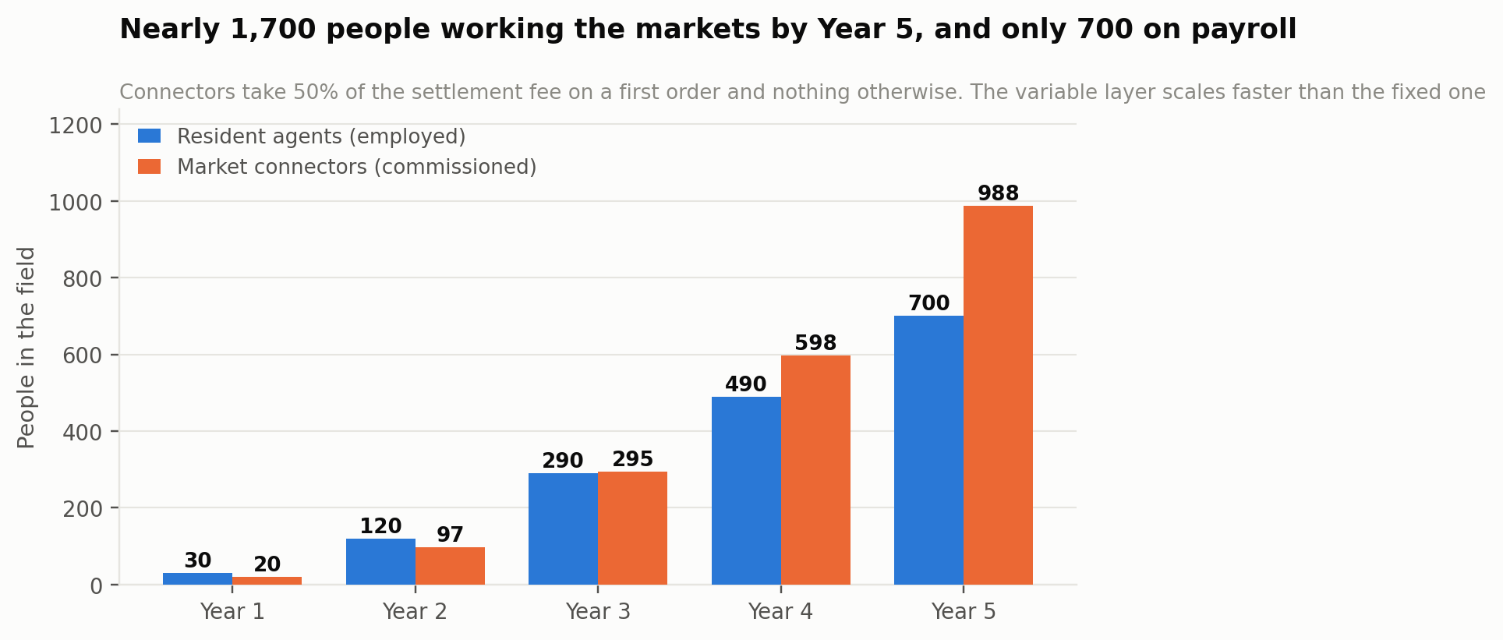
Exhibit 22. The field organisation. The commissioned layer grows faster than the employed one.

Agent economics
An agent costs $4,800 fully loaded in Year 1 — salary, commission, airtime, transport and a device — rising with 9% annual inflation. The plan runs 30 agents in Year 1 across two hubs and 700 by Year 5 across sixteen, which is roughly 15 agents per live hub at the start and 44 at maturity.
Per agent | Year 1 | Year 2 | Year 3 | Year 4 | Year 5
Agents in the field | 30 | 120 | 290 | 490 | 700
Agents per live hub | 15.0 | 24.0 | 41.4 | 44.5 | 43.8
Fully-loaded annual cost | $4,800 | $5,232 | $5,703 | $6,216 | $6,776
Merchants recruited per month | 5.20 | 4.94 | 4.92 | 4.87 | 4.67
Merchants supported | 140 | 162 | 200 | 253 | 311
Agent cost per merchant recruited | $49.97 | $57.37 | $62.78 | $69.13 | $78.58
GMV per agent | $148,200 | $230,355 | $342,126 | $519,765 | $744,073
Gross contribution per agent | $592 | $4,556 | $9,864 | $17,452 | $27,180
Table 16. Agent economics. Contribution per agent is the number that decides whether the field model works.
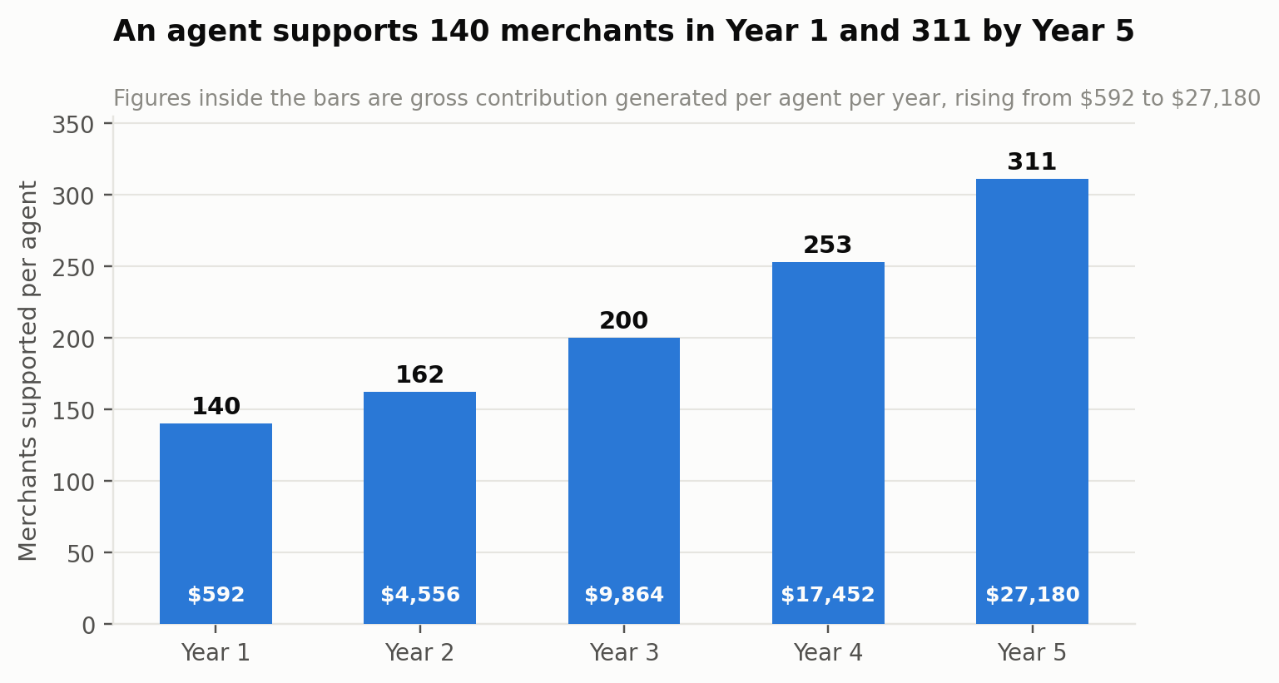
Exhibit 23. Agent load and the contribution each one generates.
Three readings matter. Recruitment productivity is deliberately flat at roughly 4.7 to 5.2 merchants a month per agent across the whole plan. It would be easy to model it rising and the plan does not, because the constraint is the number of conversations a person can have in a market in a day, and that does not improve with scale.
Support load rises steeply, from 140 merchants per agent to 311. This is where the product has to carry weight: an agent cannot personally serve 311 merchants, so the shop stock ledger, reorder prompts and self-service dispute flow must absorb the difference. If they do not, the plan needs roughly twice the agents by Year 5 and the cost base does not work. Chapter 42 makes support contacts per merchant a monitored metric for exactly this reason.
Contribution per agent rises 46-fold, from $592 in Year 1 to $27,180 by Year 5, against a fully-loaded cost rising from $4,800 to about $6,800. An agent is loss-making for roughly the first eighteen months of a hub's life and then becomes the most profitable unit in the company. That crossover is the same crossover as the hub payback in Chapter 25, viewed from a different angle, and it is why agents are placed by hub cohort rather than hired against a national plan.

Market connectors: the commissioned layer
The current site names affiliates and market connectors as a participant class earning platform-paid commissions on first settled orders. In practice this is the market-boy network — the respected traders, union officials' contacts and market fixers who already broker introductions for a fee, and who between them know every shop and every wholesaler in a hub by name. That mechanism deserves more prominence than a line item, because it is how the human layer scales without the payroll scaling with it.
The division of labour with the employed layer is precise and worth stating in one line, because getting it wrong is expensive. Connectors introduce. Agents onboard and reconcile. A connector's job ends when they have brought a merchant or a wholesaler to the table; the agent then registers them, walks the first order through to settlement, and reconciles both sides onto the ledger. Neither role can do the other's work — a connector has no access to the settlement flow, and an agent cannot manufacture the standing that makes a stranger's introduction credible.
Critically, connectors are paid for introducing distributors as well as retailers. A distributor introduction is worth many times a merchant one, and the network already knows exactly which wholesalers in a market are large, solvent and frustrated with cash handling. Pointing the commission at that knowledge is the cheapest distributor acquisition available to the company.

How the commission is calculated
Connectors are not paid a flat bounty. They are paid a 50% share of the settlement fee on the introduced party's first settled order, split with the platform — and that share is funded out of the channel rebate the platform would otherwise have returned on that single order. The arithmetic is the point:
- On every ordinary settled order, OpenMarket takes a 5.00pp gross settlement split, returns 2.60pp to the channel as rebate, and keeps 2.40pp net.
- On a connector-referred first order, the rebate is suspended and the same 5.00pp is split 50/50: 2.50pp to the connector, 2.50pp to the platform.
- The platform's net take on that order is therefore marginally higher than on an ordinary one. The connector layer is funded by the channel, not by margin, and costs the company nothing on a net basis.
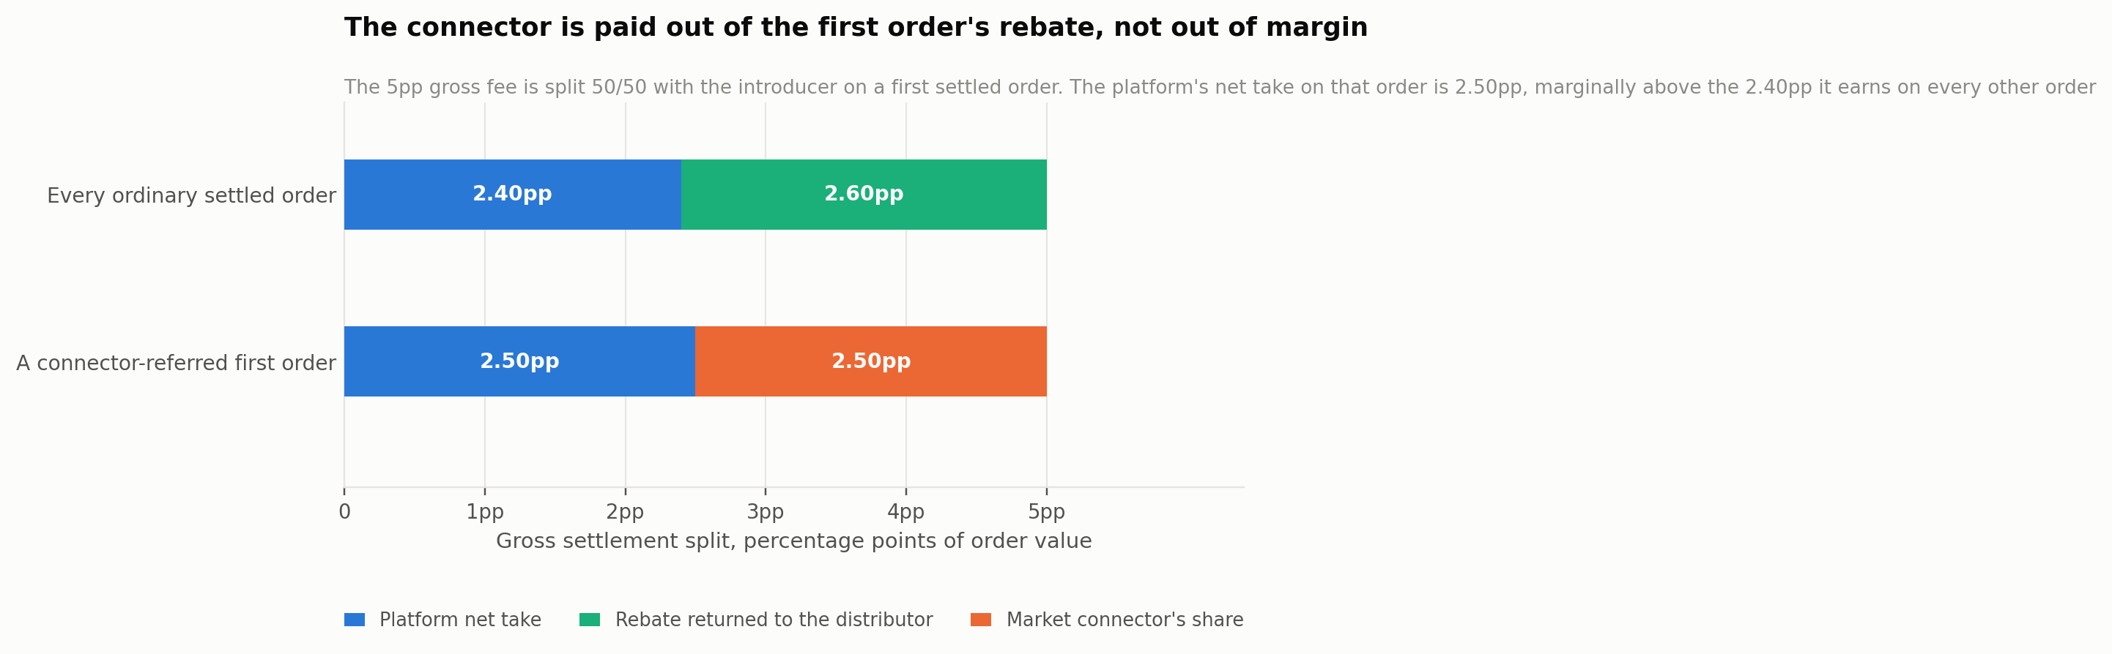
Exhibit 24. Where the connector's money comes from. The commission is a redirected rebate, not a marketing expense.
The one party who gives something up is the distributor, who forgoes the rebate on a single first order — around $1.76 on a merchant's opening basket. They accept it readily, because the connector has just delivered them a new buyer whose subsequent orders carry the full rebate.

What a connector actually earns
Market connectors | Year 1 | Year 2 | Year 3 | Year 4 | Year 5
Active connectors | 20 | 97 | 295 | 598 | 988
Merchants introduced | 364 | 1,738 | 5,303 | 10,755 | 17,785
Distributors introduced | 21 | 98 | 320 | 615 | 844
Payout per merchant | $1.80 | $1.84 | $1.88 | $1.93 | $1.98
Payout per distributor | $28.05 | $39.38 | $47.37 | $57.69 | $71.89
Average earnings per connector | $62 | $73 | $85 | $94 | $97
Total commission paid | $1,244 | $7,057 | $25,154 | $56,248 | $95,856
Table 17. The commissioned layer. A merchant introduction is pocket money; a distributor introduction is the prize.
Two numbers carry the design. A merchant introduction pays $1.80 in Year 1 and $1.98 by Year 5 — small, deliberately, because a retailer's opening basket is small. A distributor introduction pays $28.05 rising to $71.89, because the fee share on a wholesaler is calculated across their first thirty days of settled trade rather than a single retail basket. That ratio of roughly one to thirty-six is not an accident; it is the instruction the company is giving the network about what to go and find.
An average active connector introduces around eighteen merchants a year and earns $62 in Year 1 and $97 by Year 5. A connector who works it properly — thirty merchants and two wholesalers in a year — earns $203 at Year-5 rates. This is supplementary income layered on trade the person is already conducting, not a salary, and the plan does not pretend otherwise. Across the network it totals $1,244 in Year 1 rising to $95,856 by Year 5 — under two per cent of the sales and marketing line, for roughly 12% of Year-5 merchant acquisition.

The other incentives
Cash alone is a weak hold on people who are not employees, so the fee share sits inside a small structure of non-cash and deferred incentives:
- A performance step-up. A connector who lands more than twenty-five settled introductions in a quarter moves from a 50% to a 60% share for the following quarter. The plan models this as an effective blended share of 53%, and the extra ten points on the top tier come out of platform net rather than the rebate.
- Priority on working capital. Connectors with ten or more settled introductions get front-of-queue access to the platform's credit facility for their own trade. This costs nothing incremental — the facility already exists and these are, by construction, people whose commercial behaviour the platform can observe — and it is worth far more to a trader than the commission.
- Standing, published. A quarterly leaderboard shared with the market association. In a hub where reputation is the operating currency, being named to the union executive as the person who brought thirty traders onto a working settlement system is an incentive with no line in the budget.
- No exclusivity, no territory, no title. A connector can introduce to anyone, including competitors. The plan does not attempt to bind them, because attempting to and failing would cost the relationship that made them useful.
The temptation, looking at $1.80 against $49.97 for an agent-recruited merchant, will be to shift the mix hard toward connectors. The plan deliberately does not, for a reason worth stating plainly: a connector introduces, an agent guarantees. A connector who brings a merchant is not present when the first order settles, cannot walk them through a dispute, and has no reputational exposure if the platform fails them. Connectors are an amplifier on a market where agents have already established that settlement is real. Used as a substitute for that, they produce registrations that never transact — and, because the commission only pays on a settled order, they produce them at no cost to the company and no income to themselves, which is precisely the alignment the structure is designed to create.

Market associations as institutional infrastructure
The most important people in this distribution system are not employed by OpenMarket and never will be. A market union allocates stalls, adjudicates disputes, enforces norms and controls access. A platform operating in a hub without the union's endorsement is not disrupting a gatekeeper — it is operating in a jurisdiction while ignoring its government, and it will be removed.
The plan's terms with associations are deliberately unusual and are set out in Chapter 24: no fee to the union, no revenue share taken from members' trade, no exclusivity demanded, visible dispute-resolution rights over platform transactions in their market, and a quarterly report showing verified trade volume in their own hub — information no executive has previously had about the market they govern.
That last item is the asset. It costs nothing to produce, it is genuinely valuable, and it converts the association from a body that grants permission into a body with a reason to want the platform to succeed. The relationship is owned by the hub lead, reviewed weekly, and never delegated.

Recruiting and keeping the field organisation
Field roles in this market churn hard, and a plan that assumes otherwise is not serious. Three design choices address it.
Hire from the market, not into it. Agents are recruited from the hub's own trading community — traders' relatives, former shop assistants, association members' networks — because credibility in an open market is conferred by belonging to it and cannot be trained. Egatee's 90% local staffing is the same reasoning.
Pay on settled outcomes, not activity. An agent's variable compensation is tied to merchants who place a second order, not to registrations. This costs more per genuine merchant and eliminates the incentive to inflate a number that has no commercial value.
Build a visible ladder. Agent to senior agent to hub lead is a real progression with real pay steps, and hub leads are promoted from agents wherever possible. The company will need sixteen hub leads by Year 5 and the cheapest, fastest source of a person who can hold an association relationship is someone who has spent two years earning trust in that market.
The failure mode to watch
The specific way this layer breaks is scaling agents ahead of hub density. An agent placed in a market where distributors are not yet settling has nothing to demonstrate, no referrals to harvest and no reason for a merchant to trust them — and they churn out within a quarter, taking their credibility with them.
The sequencing rule is therefore absolute: union, then anchor distributors, then agents, then connectors. A hub that hires agents before it has eight settling distributors has bought a cost base and not a channel, and Chapter 43 makes that ordering a definition of done rather than a preference.

What this layer costs, in total
Adding it up: agent cost of $144,000 in Year 1 rising to roughly $4.8 million by Year 5, of which 65% sits in sales and marketing as acquisition and 35% in cost of revenue as ongoing support; connector commission of $1,244 rising to $95,856, funded out of first-order rebate rather than margin; hub activation of $46,000 per hub covering the first four agents for six months; and association costs carried within the hub's ongoing $2,600 a month. The human layer is, by a wide margin, the largest single thing this company spends money on — larger than engineering in every year of the plan.
That is the correct shape for this business and it is the clearest structural difference between OpenMarket and a conventional software company. The product is a ledger. The distribution system is people. Confusing the two in either direction is how this fails.

24 Partnerships and Distribution
A company of twenty-two people cannot reach a million outlets. Five partnership classes do most of the work, and the first of them is not optional.

Market associations and trade unions
The precondition rather than a channel. An association controls access, adjudicates disputes and confers legitimacy. The offer is straightforward: no fee to the union, a named liaison, visible dispute-resolution rights over platform transactions in their market, and a quarterly settlement report showing verified trade volume in their hub — which is information the executive has never previously had about their own market. In return: endorsement, presence, and the ability to address general meetings. Chapter 29 lists refusal as a risk with no cheap mitigation, which is precisely why this class is approached first and carefully.

Distributors as recruiters
Not a partnership in the conventional sense but the most productive distribution mechanism in the plan, delivering 24% of merchants for 8% of budget. A distributor receiving instant settlement has a direct commercial interest in migrating their existing customers, and does it without being paid to. The programme formalises this with onboarding support and a modest volume rebate tier.

Lenders and development finance institutions
The credit facility is a partnership, not a financing transaction. The plan requires $4 million in Year 2 and $12 million in Year 3, ring-fenced against the book. The lender receives verified settlement history as underwriting data, a first-loss structure, and exposure to a borrower population that is 75% first-time-formal-credit. OmniRetail's Series A included Norfund; MaxAB-Wasoko's book runs at 99%-plus repayment. The precedent for DFI participation in exactly this asset class is established.

Manufacturers
Both a customer and a channel. They buy telemetry and fund SmartSubsidy; they also lend credibility, co-market, and in at least one precedent invest — Flour Mills of Nigeria is on OmniRetail's cap table. The plan targets two paying manufacturer relationships in Year 1 as a validation gate rather than as revenue.

Carriers and corridor partners
Licensed transport operators presented at checkout, retaining liability and insurance. And, distinctly, corridor interoperability: Egatee moves Chinese supply into African markets and does not settle domestic wholesale trade. A merchant importing through one and restocking through the other is a coherent merchant, and Chapter 9 argues the relationship most likely to create value is interoperability rather than displacement.

25 Unit Economics and Hub Economics
Two lenses. One of them says this business does not work in its early years. The other says it works from month twelve. Both are computed here and the chapter explains which to trust.

The merchant lens
Per active merchant | Year 1 | Year 2 | Year 3 | Year 4 | Year 5
Revenue per merchant per year | $85 | $99 | $115 | $128 | $141
Gross margin | 10.0% | 46.6% | 63.9% | 73.3% | 78.8%
Monthly merchant churn | 5.2% | 4.4% | 3.6% | 3.0% | 2.5%
Lifetime value | $14 | $87 | $171 | $261 | $371
Cost per acquired merchant | $46 | $43 | $40 | $40 | $41
LTV : CAC | 0.29x | 2.02x | 4.27x | 6.51x | 8.94x
Payback | >5 yr | 11.2 mo | 6.5 mo | 5.1 mo | 4.5 mo
Contribution per order | $0.27 | $1.37 | $2.05 | $2.45 | $2.73
Table 18. Merchant-level economics. Year 1 and Year 2 do not clear any conventional threshold.
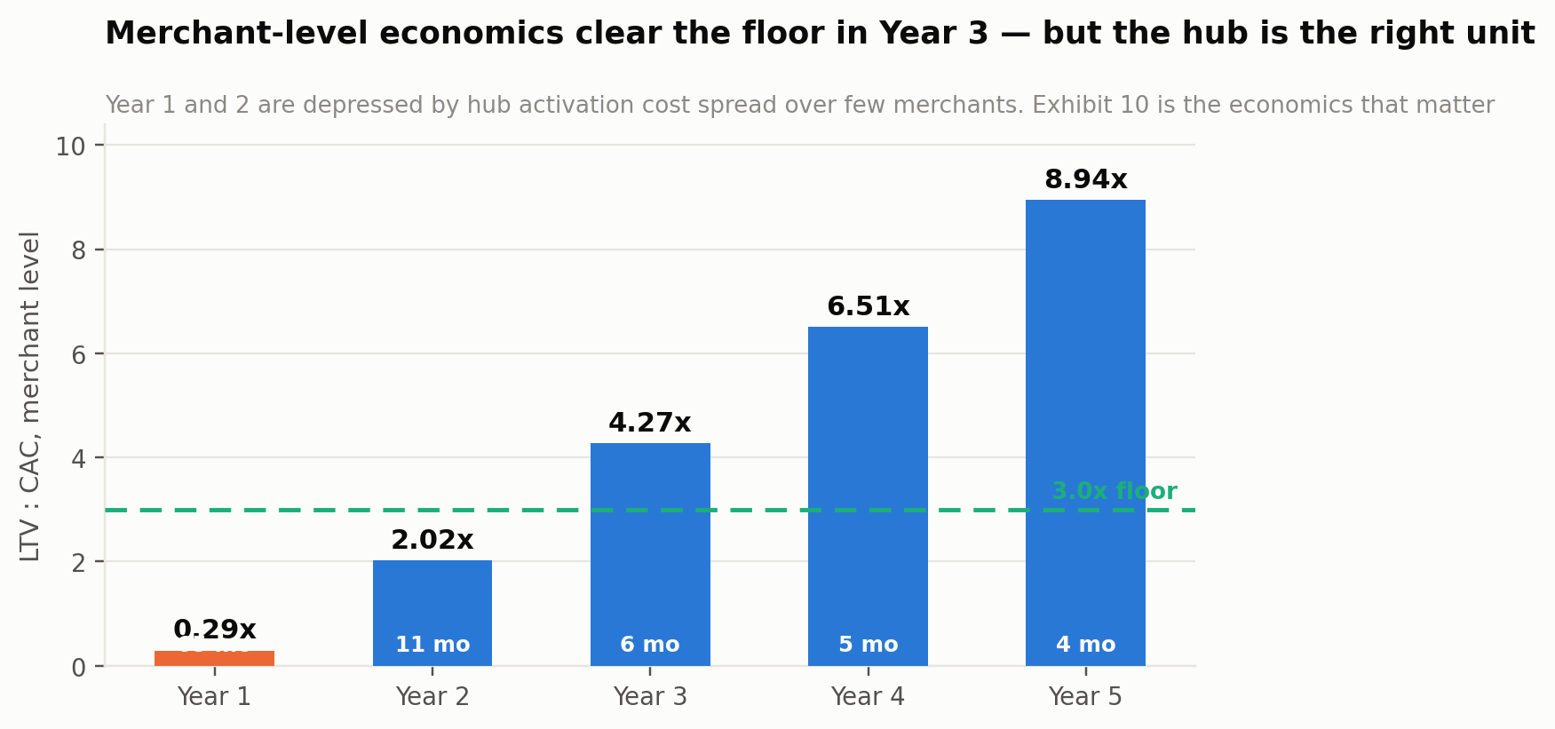
Exhibit 25. Merchant LTV to CAC. It clears the 3x floor in Year 3, not before.
These are poor numbers for two years and the plan does not dress them up. The cause is arithmetic: Year-1 gross margin is 10% because two hubs carry a fixed field-operations base of thirty agents plus infrastructure against $178,000 of revenue. Divide that thin margin by a 5.2% monthly churn rate and lifetime value is $14 against a $46 acquisition cost.
What changes it is density, not price. By Year 3, gross margin is 63.9% and the ratio is 4.27. By Year 5, at 78.8% margin and 2.5% monthly churn, it is 8.94. Every input in that improvement — margin, churn, revenue per merchant — is a function of how many merchants transact in a hub that has already been paid for.

The hub lens
A market hub costs $46,000 to activate: four agents resident for six months, distributor onboarding incentives, market-association fees, and launch events. Thereafter it carries about $2,600 a month in resident field cost — three agents and association costs. It ramps to roughly 490 transacting merchants by month 3, 2,090 by month 6, 6,030 by month 12, 14,850 by month 24 and 18,300 at maturity around month 30. Contribution per merchant per month rises from nil to about $9.78 as the finance and telemetry layers switch on.
On that curve the hub reaches cumulative break-even in month 12 and has generated $2.94 million of cumulative contribution by month 36, against a mature run-rate of roughly $2.12 million a year.
Exhibit 26. The hub cohort curve. This is the unit the plan should be judged on.
Month | Transacting merchants | Monthly contribution | Cumulative
Month 0 | 0 | $-2,600 | $-48,600
Month 6 | 2,090 | $1,538 | $-55,388
Month 12 | 6,030 | $25,017 | $24,878
Month 18 | 10,900 | $72,174 | $329,321
Month 24 | 14,850 | $127,189 | $950,389
Month 30 | 18,300 | $176,374 | $1,885,655
Month 36 | 18,300 | $176,374 | $2,943,899
Table 19. A single hub cohort, from activation. Payback in month 12.

Which lens to trust
A reader is entitled to be suspicious of a plan that presents a bad number and then argues for a different denominator. The defence is that the hub is not a convenient abstraction; it is the actual decision the company makes. Nobody at OpenMarket will ever decide to acquire a merchant. They will decide to activate Kejetia, and merchants will follow at a rate determined by agent count, association endorsement and distributor participation.
The honest reconciliation is that both lenses are true and they measure different things. The merchant lens says: this business is not viable at low density, ever. The hub lens says: density is purchasable at a known price with a known payback. The strategy that follows from holding both is the one in Chapter 21 — activate few hubs, activate them properly, and do not spread thin. Sixteen hubs in five years is a slow number chosen for this reason.
A cross-check supports the hub curve, and the hub ramp was calibrated against it rather than assumed independently: sixteen hubs at Year 5, at their respective maturities, imply roughly 218,000 transacting merchants and $17.1 million of contribution, against the 218,000 merchants and $19.0 million the aggregate model produces. The two build methods agree exactly on merchants and within 10% on contribution — the residual reflecting flagship hubs such as Onitsha, whose 20,000-merchant base exceeds the generic hub curve.

26 The Five-Year Model
The complete profit and loss, the cash curve, and three scenarios — one of which does not work.
US$ | Year 1 | Year 2 | Year 3 | Year 4 | Year 5
Gross merchandise value | 4,446,000 | 27,642,617 | 99,216,401 | 254,684,938 | 520,851,230
Settlement and coordination | 106,704 | 691,065 | 2,579,626 | 6,621,808 | 13,542,132
Embedded working capital | 4,363 | 58,777 | 340,788 | 1,208,044 | 2,981,695
Manufacturer demand intelligence | 54,000 | 300,000 | 960,000 | 2,028,000 | 3,427,000
SmartSubsidy campaigns | 4,891 | 54,732 | 283,759 | 896,491 | 2,119,865
Logistics coordination | 7,825 | 68,554 | 309,555 | 916,866 | 2,083,405
Total revenue | 177,783 | 1,173,128 | 4,473,728 | 11,671,209 | 24,154,096
Cost of revenue | (160,015) | (626,353) | (1,613,038) | (3,119,508) | (5,128,037)
Gross profit | 17,768 | 546,775 | 2,860,691 | 8,551,701 | 19,026,059
Research & development | (316,000) | (701,140) | (1,312,576) | (2,157,693) | (3,134,932)
Sales & marketing | (254,100) | (930,624) | (2,210,904) | (3,960,542) | (6,027,060)
General & administrative | (292,000) | (542,280) | (934,724) | (1,477,946) | (2,087,237)
Total operating expense | (862,100) | (2,174,044) | (4,458,204) | (7,596,180) | (11,249,229)
EBITDA | (844,332) | (1,627,269) | (1,597,513) | 955,521 | 7,776,830
EBITDA margin | -474.9% | -138.7% | -35.7% | 8.2% | 32.2%
Revenue as % of GMV | 4.00% | 4.24% | 4.51% | 4.58% | 4.64%
Contribution as % of GMV | 0.40% | 1.98% | 2.88% | 3.36% | 3.65%
Transacting merchants, year end | 4,200 | 19,500 | 58,000 | 124,000 | 218,000
Distributors, year end | 140 | 620 | 1,850 | 3,900 | 6,400
Manufacturer accounts, year end | 6 | 19 | 41 | 63 | 86
Orders settled | 65,520 | 398,160 | 1,395,000 | 3,494,400 | 6,976,800
Headcount | 22 | 51 | 94 | 147 | 200
Field agents | 30 | 120 | 290 | 490 | 700
Table 20. Base case, Years 1 to 5. Full assumption register at Appendix A.
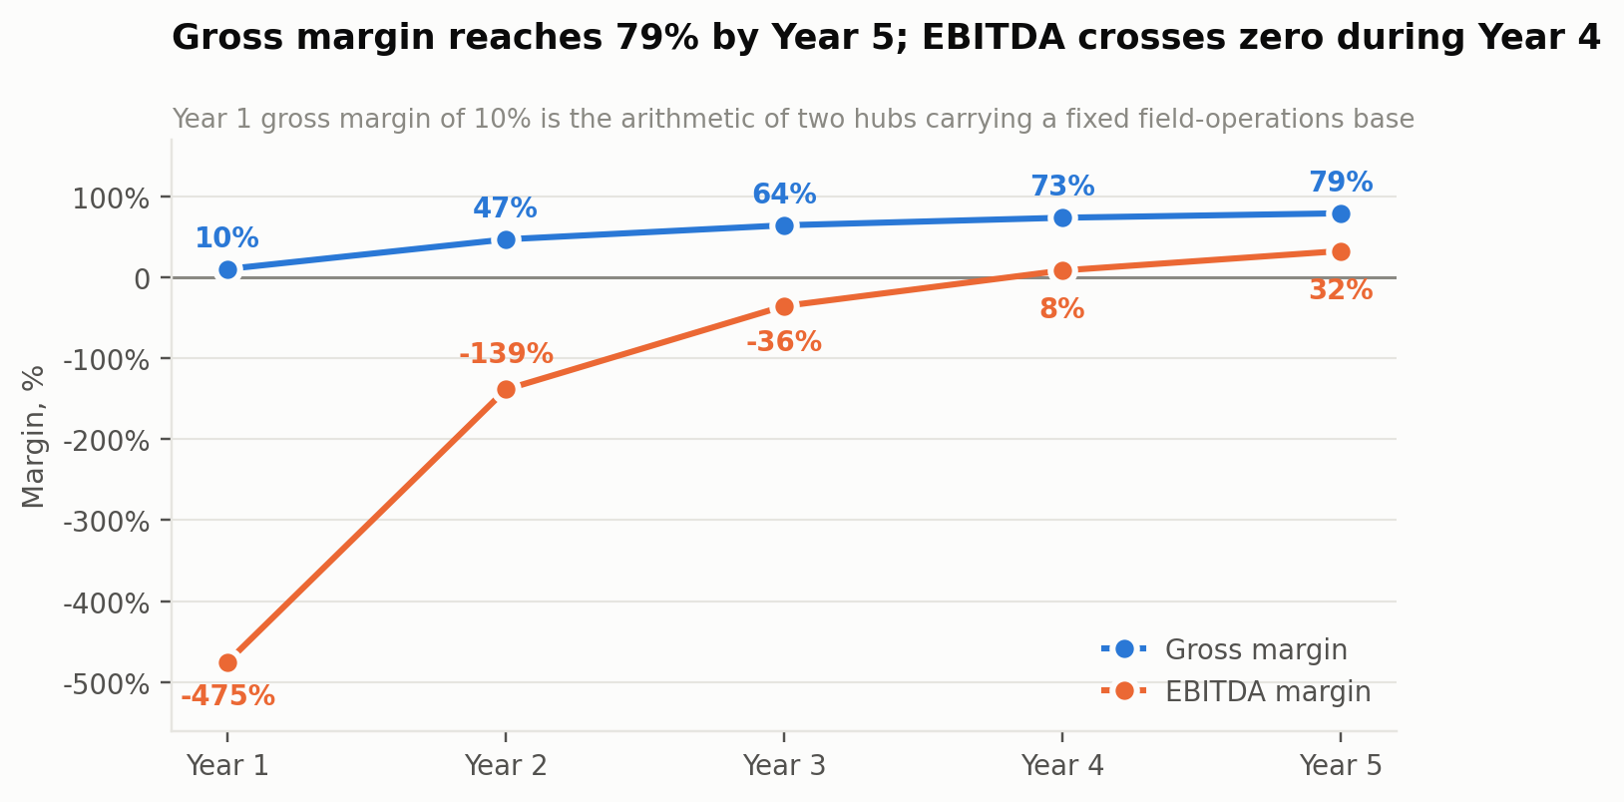
Exhibit 27. Margins. Year-1 gross margin of 10% is the arithmetic of two hubs carrying a fixed field base.

The cost base
Cost of revenue is payment processing at 0.25% of GMV, fixed infrastructure rising from $46,000 to $940,000, the Phase-2 intelligence layer from $14,000 to $552,000, 35% of field agent cost representing ongoing merchant support, and part of market operations payroll. The 0.25% payment cost deserves emphasis: because Nigerian instant transfers are flat-fee rather than percentage-priced, a $68 average order costs a fraction of a percent to settle where a Western card rail would take 1.5% to 3%. At a 2.4% net take that difference is roughly a tenth of the entire contribution margin.
Operating expense is predominantly people, at fully-loaded annual costs of $33,000 for engineering, $30,000 for data and intelligence, $14,000 for market operations, $26,000 for credit and risk, $19,000 for commercial and $27,000 for leadership, with 9% annual salary inflation. Field agents are $4,800 fully loaded, of which 65% is treated as acquisition cost in sales and marketing and 35% as ongoing support in cost of revenue.

Cash
US$ | Year 1 | Year 2 | Year 3 | Year 4 | Year 5
Equity raised | 4,500,000 | — | 15,000,000 | — | —
EBITDA | (844,332) | (1,627,269) | (1,597,513) | 955,521 | 7,776,830
Working capital movement | (17,784) | (110,570) | (396,866) | (1,018,740) | (2,083,405)
Closing operating cash | 4,057,884 | 2,320,045 | 15,325,666 | 15,262,447 | 20,955,872
Credit facility drawn (ring-fenced) | — | 4,000,000 | 12,000,000 | — | —
Table 21. Cash. The credit facility funds the book only and is excluded from operating cash.
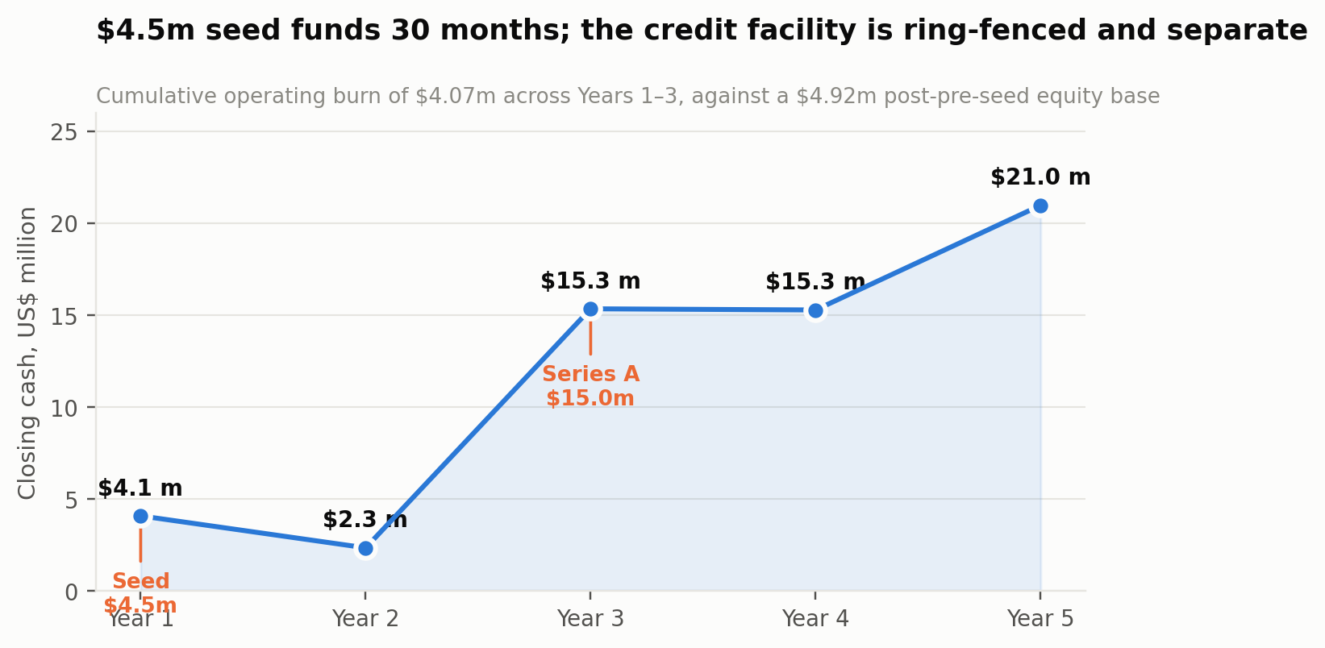
Exhibit 28. The cash curve. Cumulative operating burn of $4.07m across the first three years.

Scenarios
Scenario | Y5 GMV | Y5 revenue | Y5 EBITDA | Peak burn | Prob.
Bear | $270,842,640 | $12,662,344 | ($3,089,900) | ($4,063,480) | 30%
Base | $520,851,230 | $24,154,096 | $7,776,830 | ($1,627,269) | 50%
Bull | $739,608,747 | $35,668,065 | $18,743,905 | ($1,186,036) | 20%
Table 22. Scenario outcomes. Probabilities are the author's judgement, not a computed distribution.
The bear case does not work and the plan says so. If hub trust does not transfer beyond the first two markets, distributors resist the settlement split, and the credit book stays sub-scale, Year-5 revenue is $12.66 million against an EBITDA loss of $3.09 million, with a peak annual burn of $4.06 million. That is a company that has consumed its seed and its Series A and requires a third round to continue. It is not a survivable downside in the way a software business's bear case usually is, because the field-operations cost base cannot be cut as fast as revenue disappoints.
The bull case assumes two manufacturers adopt SmartSubsidy nationally in Year 2 and a development finance facility de-risks the credit book early, giving $739.6 million of GMV, $35.7 million of revenue and a 53% EBITDA margin.
A reader should weigh the bear case heavily. It is the reason Chapter 27 sizes the seed for thirty months rather than eighteen, the reason hub three is named as the critical test in Chapter 15, and the reason Chapter 29 places hub-trust transfer at the top of the risk register.

What the model excludes
No revenue from the Phase-2 intelligence layer beyond its cost. No cross-border corridor trade. No expansion beyond Nigeria and Ghana, despite twelve hubs across six countries appearing on the current site. No bond, insurance or e-procurement adjacencies. These are excluded because each requires a capability or a partnership that does not yet exist, and a model that counts unearned optionality is not a model.

27 The Raise and the Use of Funds
Two instruments: equity for the operation, and a ring-fenced facility for the book. Conflating them is how this sector's balance sheets went wrong.

The ask
$4.5 million in seed equity, against $420,000 of founder and angel capital already deployed on the live platform. That funds thirty months of operation through cumulative EBITDA losses of $4.07 million across the first three years, closing Year 1 at $4.06 million and Year 2 at $2.32 million of operating cash. A $15 million Series A is modelled in Year 3.
Separately, a ring-fenced credit facility of $16 million — $4 million in Year 2 and $12 million in Year 3 — funds the working-capital book. It is not operating capital, it does not appear in the operating cash line, and it should not be counted as dilution. TradeDepot's $110 million raise was 62% debt for exactly this reason.
Application | US$ | Share | What it buys
Hub activation — 5 hubs | 230,000 | 5% | Union agreements, anchor distributor onboarding, launch events at $46,000 per hub
Field operations | 1,120,000 | 25% | Resident agents across five hubs for the seed period — the largest single line, correctly
Engineering — settlement and VWL | 1,180,000 | 26% | The ledger, the payment verification loop, the Virtual Warehouse Ledger, offline-first mobile
Credit and risk function | 480,000 | 11% | Scoring, collections, the risk team that must exist before the first loan, and facility negotiation
Commercial and manufacturer sales | 520,000 | 12% | Distributor onboarding at scale, and the first manufacturer telemetry contracts
Infrastructure and inference | 320,000 | 7% | Cloud, data stores and the beginnings of the Phase-2 layer
G&A, regulatory and contingency | 650,000 | 14% | Two-country entity structure, NDPA and Ghana DPA compliance, audit, and genuine buffer
Total | 4,500,000 | 100%
Table 23. Use of the seed. Thirty per cent goes to field operations and hub activation, which is what this business actually is.

Milestones the seed buys
- Five hubs live and settling, with published settlement success rates and median time to distributor payout.
- 620 distributors onboarded with stock in the Virtual Warehouse Ledger, and 19,500 transacting merchants.
- $27.6m of settled GMV in Year 2, with contribution positive at 1.98% of GMV.
- A credit facility signed and a pilot book running at 500 merchants with measured loss performance — the validation gate for the largest revenue line in the plan.
- Two paying manufacturer telemetry contracts, proving the second margin engine.
- Hub three activated by a team rather than the founders, which is the single most important proof point for the expansion case.

28 The Moat
Four layers, honestly ranked, including one that is weaker than it appears.
Hub residency and union relationships — strong, and slow to copy. A competitor cannot buy a relationship with the Onitsha market executive, and cannot shortcut the eighteen months of visible reliable settlement that earns a union's endorsement. This is the only layer that takes longer to replicate than to describe, and it is why Chapter 21 sequences union-first.
Verified settlement history — strong and compounding. Every settled order adds to a record that cannot be reconstructed after the fact. A competitor beginning in 2029 cannot acquire OpenMarket's 2027 payment behaviour, which is precisely the data the credit layer underwrites against. The gap widens monotonically with time and is the reason the finance line is defensible.
The distributor relationship — moderate, and contestable. Instant settlement is a genuinely superior offer, but it is a commercial term rather than a technology, and a funded competitor could match it. What is harder to match is the VWL: a distributor who has digitised their stock positions in place has a switching cost, and one who has not is simply receiving a payment service.
Manufacturer telemetry — moderate, and dependent on density. Valuable and hard to copy while OpenMarket is the only party with cluster-resolved settled-order data in a given hub, and worth little in a hub without density. It is a consequence of the first two layers rather than an independent one, and presenting it otherwise would overstate the moat.

What would fill the moat in
OmniRetail opening settlement to non-network distributors. The material threat, assessed at medium probability and high impact. It would cannibalise its own 9% gross margin business, which is a real restraint but not a guarantee. The defence is speed to hub density, and it is the reason the seed is sized for five hubs rather than two.
A payments company moving up the stack. Moniepoint, Paystack or Flutterwave already hold merchant payment relationships at enormous scale and could add distributor settlement. The counter is that settlement is the easy half; the VWL, routing, hub residency and union relationships are the hard half, and none of it is a payments competence. This is nonetheless the threat that would arrive fastest if it arrived.
Commoditisation of instant settlement by regulation. Instant, cheap bank transfer is already the Nigerian norm and getting better. If the trust problem is solved at the rails level rather than the platform level, OpenMarket's wedge narrows. The response is that verified settlement is necessary but not sufficient — a merchant still needs to know which distributor has the stock, and a distributor still needs to know whether the buyer will pay next time — and both of those are graph problems rather than payment problems.

29 Risks
Ordered by expected damage. Each carries a mitigation and, where one exists, a leading indicator that would show the risk arriving before it becomes terminal.
Risk | Prob. | Impact | Mitigation | Leading indicator
Hub trust does not transfer beyond the founder-led hubs | Medium | Severe | Hub three is named as the critical test; playbook documented and measured from hub one; team-led activation attempted early while capital remains | Time to first 100 settled orders in hub three vs hubs one and two
A settlement error, publicly | Low | Severe | Double-entry append-only ledger, exactly-once posting, daily bank reconciliation, Sev-1 treatment, published success rate | Reconciliation breaks per 10,000 orders
Distributors reject the settlement split | Medium | Severe | Net take corrected to 2.4–2.6% in Chapter 17; rebate flexes by hub and category; instant payout is the compensating benefit | Rebate level required to close the first 50 distributors
Credit facility late or unavailable | Medium | High | DFI conversations opened in Year 1 as a named milestone; finance revenue deferred rather than assumed; book grows only with facility | Signed term sheet by month 15
Credit losses exceed the 2.1% model | Medium | High | Lending gated on verified settlement history only; hub-level exposure caps; resident agents and association recourse; pilot at 500 merchants first | Pilot cohort loss rate at day 60
OmniRetail opens settlement to non-network distributors | Medium | High | Speed to hub density; union exclusivity where obtainable; VWL switching cost | Competitor product announcements; distributor churn in live hubs
Market union withholds or withdraws access | Medium | High | Union-first sequencing; no fee extraction from the union; visible dispute rights; quarterly settlement reporting to the executive | Association meeting access; dispute escalation volume
Naira or cedi depreciation beyond model | High | Medium | Percentage-based pricing is a natural hedge on revenue; naira-denominated cost base; local-currency facility | Realised FX against the 7% and 5% assumptions
Payments company moves up the stack | Low–Medium | Medium | VWL, routing and hub residency are not payments competences; partner rather than compete where possible | Product announcements from Moniepoint, Paystack, Flutterwave
Funding market closes before Series A | Medium | Medium | Seed sized for 30 months; Year-3 EBITDA loss is only $1.6m; hub activation can be paused without unwinding assets | Sector funding run-rate; own pipeline conversion
Twin-market complexity overwhelms a 22-person team | Medium | Medium | Ghana is a Year-1 commitment and a Year-2 operation; Katamanto activates at month 10, Kejetia not until Year 3 | Nigerian hub metrics degrading as Ghana activates
Manufacturer telemetry does not sell at $18,000 | Low–Medium | Medium | Two contracts in Year 1 treated as a validation gate; priced below the field-audit alternative | Pipeline conversion by month 12
Table 24. Risk register. Probability and impact are the author's assessment.
The three risks that decide this
Hub transferability. If the model works in Onitsha because of Onitsha rather than because of the model, there is no expansion case and the business is a single-market operator. Hub three is the test and it happens in Year 2, while capital remains.
Settlement integrity. One public settlement failure in a product whose entire proposition is trust, inside a market where every trader talks to every other trader, is not a bug — it is the end of the hub.
The credit facility. It converts the largest opportunity in the plan into revenue and the largest weakness into a solved problem. Without it, the model loses its margin engine and becomes a thin coordination fee against a heavy field cost base.

PART FOUR
The System
The architecture and technical specification. In a settlement business the architecture is the product: what OpenMarket can charge for is a direct function of what its ledger can be trusted to guarantee.

30 Architecture Principles
Eight principles, each with a consequence. Every design decision in this part is an application of one of them.

One: no fulfilment instruction before verified funds
The single non-negotiable rule of the system. The platform does not tell a distributor to release goods until money is confirmed settled at the payment provider — not authorised, not initiated, settled. Every failure mode in the rest of the architecture is recoverable; this one is not, because it converts the platform from a guarantee into a promise, which is what the market already has and does not trust.

Two: the ledger is double-entry, append-only and exactly-once
Every movement of value is two entries. Nothing is updated in place; corrections are compensating entries with their own provenance. Every posting carries an idempotency key so that a retried webhook, a duplicated queue message or a merchant tapping twice cannot double-post. The ledger reconciles to bank statements daily, and a break is an incident rather than a ticket.

Three: the platform never takes title
There is no inventory table owned by OpenMarket, no stock position on the platform's balance sheet, and no code path that acquires goods. The Virtual Warehouse Ledger records what a distributor says they hold, with a confidence measure; it does not represent platform-owned stock. This is an architectural expression of the finding in Chapter 3 and it is enforced by the absence of the capability rather than by policy.

Four: offline is the default, not the exception
The merchant application assumes the network is absent. Orders are composed, queued and reconciled locally; state is legible to the merchant at every point — what is drafted, what is sent, what is confirmed, what is settled. A merchant standing in a shed with no signal must be able to tell, without ambiguity, whether their money has moved.

Five: aggregate upward, never identify
Data crossing a tier boundary is aggregated. Manufacturers receive cluster-level demand signals with a minimum cohort size and no merchant identity, ever, at any price. This is enforced in the telemetry service rather than in a contract, because a commercial pressure to relax it will arrive and the architecture must be the thing that refuses.

Six: deterministic where it concerns money, probabilistic where it concerns judgement
Ledger splits, rebate accruals, credit limits, fee calculations and payout amounts are computed in code with fixed-point arithmetic and are never produced by a model. Models are used for routing preference, stockout prediction, demand aggregation and fraud signals — decisions where being approximately right is useful and being occasionally wrong is survivable.

Seven: liability stays where it already sits
Carriers hold delivery liability and insurance. Lenders hold credit risk under a facility. Distributors hold their stock. The platform holds settlement correctness and nothing else. Every integration is designed so that this boundary is legible in the data model, not merely in the terms of service.

Eight: two countries, two regulators, one ledger
Nigerian and Ghanaian operations run on the same ledger with jurisdiction as a first-class field, separate settlement rails, separate regulatory reporting, and separate data-residency treatment. Retrofitting multi-jurisdiction into a single-country ledger is a rewrite, so it is present from the first schema.

31 System Context
The whole system in one picture, then the layers.
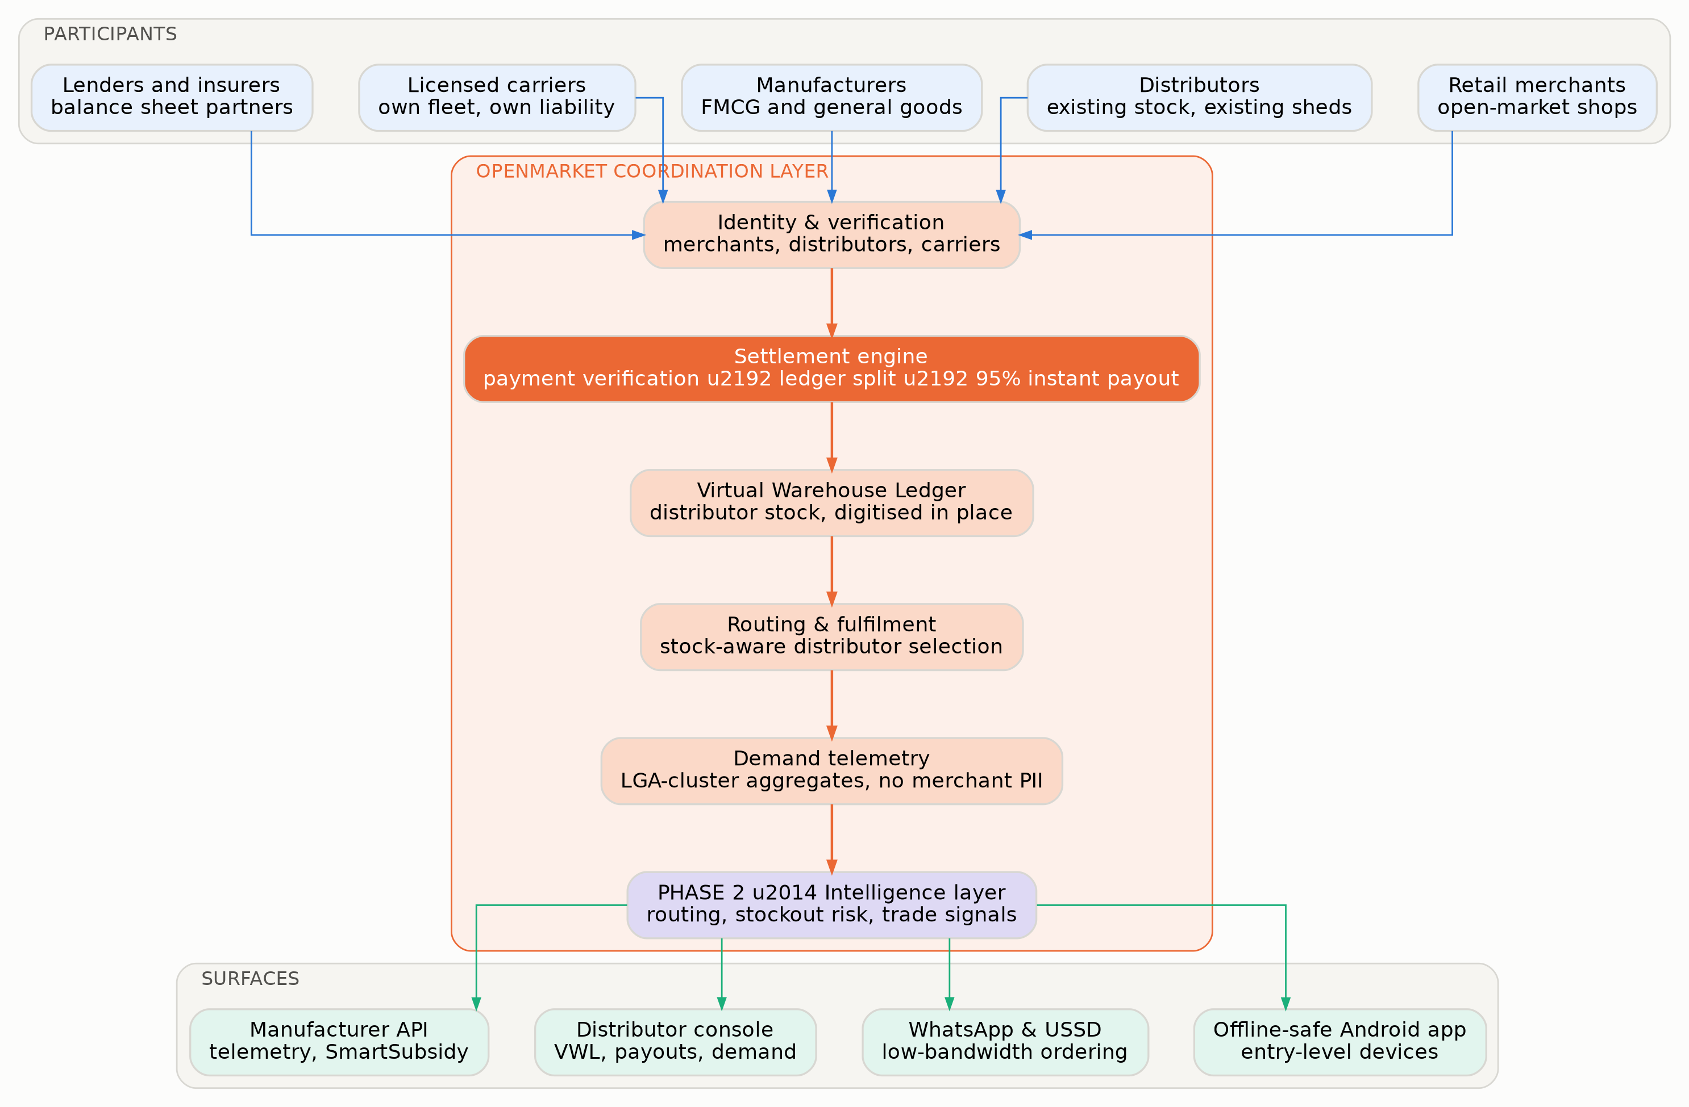
Exhibit 29. System context. Five participant classes, six coordination services, four surfaces.
Component | Responsibility | Key decision and rationale
Identity & verification | Phone-verified merchants, business-registered distributors, licensed carriers, with tiered transaction limits | Identity tier gates order value. A newly-verified merchant cannot place a ₦4m order; trust is earned in the data model.
Settlement engine | Payment verification, programmatic ledger split, 95% instant distributor payout, rebate accrual | The core. Exactly-once posting on a double-entry append-only ledger; daily bank reconciliation.
Virtual Warehouse Ledger | Distributor stock digitised in place, with reservation and a confidence measure | Never platform-owned. Confidence decays with time since last confirmation, which is what stops the router sending merchants to empty sheds.
Routing & fulfilment | Stock-aware distributor selection on price, distance, fill rate and history | Deterministic scoring in Phase 1; learned ranking in Phase 2. The scoring inputs are published to distributors so the market is legible.
Demand telemetry | Cluster-level aggregation of settled orders for manufacturers | k-anonymity enforced in the service, minimum cohort of 12 merchants per cluster-SKU-period.
Credit service | Limit engine on settlement history, disbursement against a partner facility, collections | Limits derive only from observed platform behaviour. No bureau data, no self-reported financials.
Intelligence layer (Phase 2) | Routing preference, stockout risk, credit limits, corridor signals | Deliberately deferred. It is trained on the data Phase 1 generates and cannot precede it.
Table 25. Component responsibilities and the decision behind each.

32 The Order and Settlement Flow
Three stages, and the boundary between stage one and stage two is where the entire business lives.
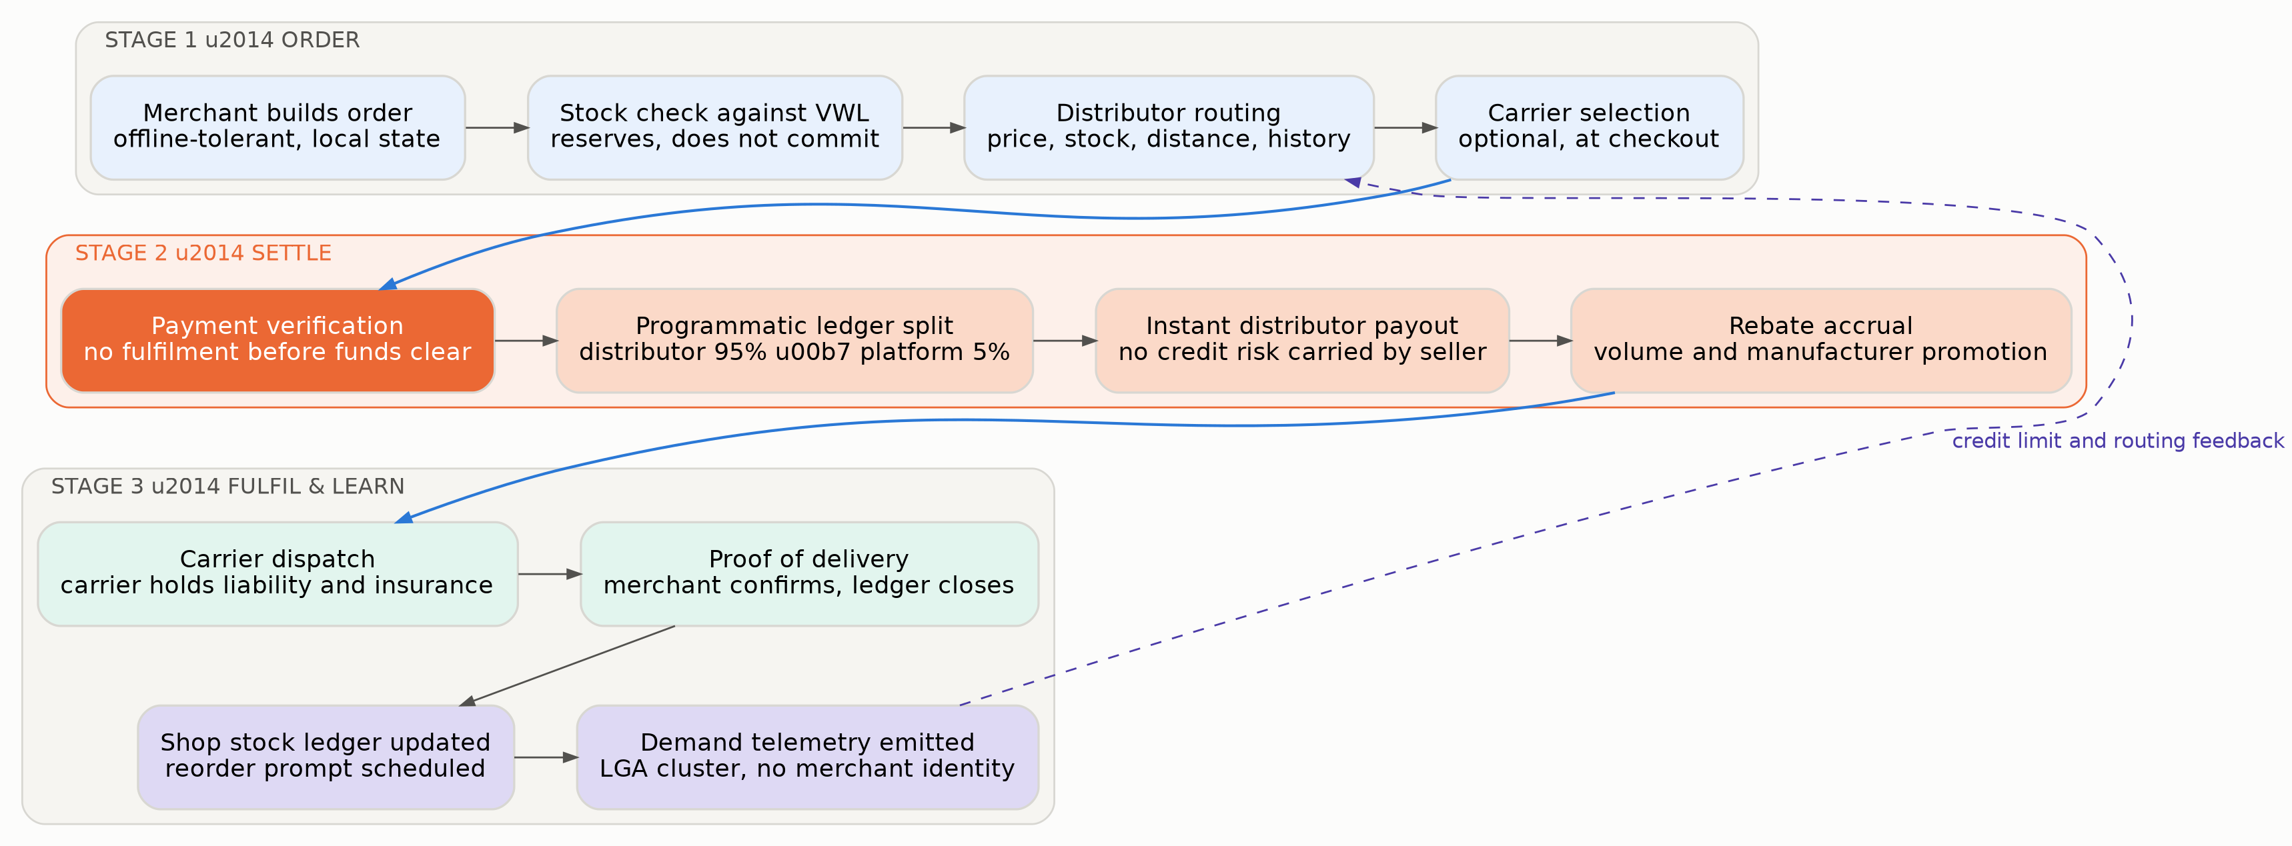
Exhibit 30. The order lifecycle: order, settle, fulfil and learn.

Stage one — order
The merchant composes an order in a local-first application. Line items are validated against a cached catalogue; the client holds an outbox of pending operations and a conflict-free replicated state so that composing an order offline, on a device that later syncs, produces exactly one order rather than none or two.
Stock is checked against the Virtual Warehouse Ledger and reserved, not committed. A reservation holds for a bounded window and releases automatically. This distinction matters: committing stock before payment would push risk onto the distributor, which is the opposite of the platform's promise.
Routing selects a distributor on a deterministic score over price, available stock, distance, historical fill rate and the merchant's own purchase history. A carrier may optionally be selected at checkout from licensed operators serving the lane.

Stage two — settle
Payment verification is the gate. The merchant pays by bank transfer, card or USSD; the settlement service confirms settled funds at the provider — settled, not authorised — before anything downstream occurs. Nigerian instant transfer is the primary rail because it is flat-fee and therefore near-free at B2B ticket sizes.
On confirmation the ledger split posts programmatically: distributor 95%, platform 5%, with rebate accrual recorded against the distributor's volume tier and any manufacturer-funded promotion applied. Instant payout is issued to the distributor. From their perspective the sequence is: a buyer they may never have met has paid, in full, before they moved a single carton.
// settlement posting — abridged, all amounts in minor units (kobo / pesewas)
BEGIN;
SELECT pg_advisory_xact_lock(hashtext(:order_id)); -- serialise per order
INSERT INTO ledger_entry (entry_id, order_id, account, direction, amount, idem_key)
VALUES
(:e1, :order_id, 'clearing:ngn', 'debit', :gross, :idem),
(:e2, :order_id, 'payable:distributor:'||:d,'credit', :dist, :idem),
(:e3, :order_id, 'revenue:platform_split', 'credit', :split, :idem),
(:e4, :order_id, 'liability:rebate_accrual','credit', :rebate,:idem)
ON CONFLICT (idem_key, account) DO NOTHING; -- exactly-once
-- invariant: sum(debits) = sum(credits) for this order, enforced by trigger
PERFORM assert_balanced(:order_id);
COMMIT;

Three properties of that posting are worth stating explicitly. It is balanced by assertion, not by convention — an unbalanced order cannot commit. It is idempotent by key, so a webhook delivered three times posts once. And the rebate is a liability at the moment of settlement, not a marketing accrual computed later, which means the distributor's entitlement is real and visible from the instant the order settles.

Stage three — fulfil and learn
The distributor releases goods; the carrier, if used, dispatches under their own liability and insurance; the merchant confirms receipt and the ledger closes the order. Proof of delivery is written to a write-once store. The merchant's shop stock ledger updates and a reorder prompt is scheduled from observed velocity.
Finally, a demand signal is emitted: local-government-area cluster, SKU, period, units and value, with a merchant count that must meet the k-anonymity floor before the record is materialised at all. Merchant identity does not travel with it and there is no path in the schema by which it could.
A feedback edge runs from settled outcomes back to routing preference and credit limits. This is the only place in Phase 1 where the system learns, and it is deliberately narrow: fill-rate and repayment observations adjust deterministic scores, rather than a model deciding who gets goods or money.

33 The Canonical Data Model
Seven entities. The privacy boundary and the liability boundary are both visible in the schema rather than only in the contracts.
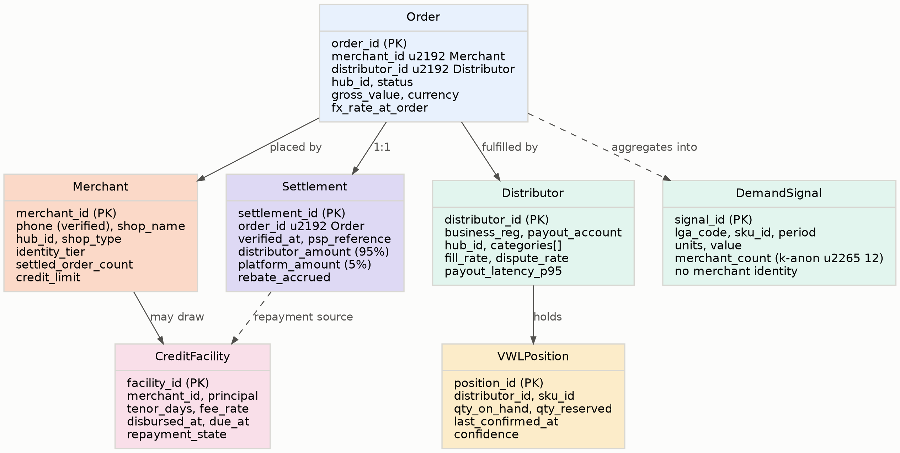
Exhibit 31. Core entities and relationships.
Entity or field | On | Why it exists
identity_tier | Merchant | Gates maximum order value by verification depth. Trust is a data-model property, not a policy document.
settled_order_count | Merchant | The only input to credit eligibility. A merchant qualifies by having transacted, not by applying.
fill_rate, dispute_rate | Distributor | Drives routing. Published to the distributor, so the market can see how it is being ranked.
payout_latency_p95 | Distributor | The platform's own performance against its central promise, measured per distributor rather than in aggregate.
qty_on_hand, qty_reserved, confidence | VWLPosition | Confidence decays with time since last confirmation. A stale position is routed around rather than trusted.
verified_at, psp_reference | Settlement | The evidential record that funds settled before fulfilment. This is what an auditor, a regulator or a disputing distributor is shown.
distributor_amount, platform_amount, rebate_accrued | Settlement | The split, recorded at the moment of settlement rather than computed later. Opacity here is indistinguishable from theft.
fx_rate_at_order | Order | Naira and cedi orders across a depreciating currency are not comparable over time without it, and neither telemetry nor credit limits would be stable.
merchant_count with k-anon floor | DemandSignal | The privacy boundary, enforced as a materialisation condition. A cluster below the floor produces no record at all.
jurisdiction | Order, Settlement, Merchant | Two countries, two regulators, one ledger. Present from the first schema because retrofitting it is a rewrite.
Table 26. The fields that carry the design decisions.
-- demand signal materialisation: privacy enforced in the write path
CREATE MATERIALIZED VIEW demand_signal AS
SELECT lga_code, sku_id, period,
SUM(units) AS units,
SUM(value_minor) AS value_minor,
COUNT(DISTINCT merchant_id) AS merchant_count
FROM settled_order_line
GROUP BY lga_code, sku_id, period
HAVING COUNT(DISTINCT merchant_id) >= 12; -- k-anonymity floor, non-negotiable

REVOKE ALL ON settled_order_line FROM telemetry_role;
GRANT SELECT ON demand_signal TO telemetry_role; -- no path to merchant identity

34 The Virtual Warehouse Ledger
The VWL is the least glamorous component in the system and the one most likely to determine whether the product works.

What it is
A distributor's existing stock, digitised where it already sits, without moving it into a platform warehouse or transferring title. A position records the SKU, quantity on hand, quantity currently reserved against pending orders, the time of last confirmation, and a confidence measure that decays as that timestamp ages.

Why confidence is the critical field
A routing engine that sends a merchant to a distributor who does not actually have the goods produces the worst outcome available to this system: the merchant has paid, the money has settled, and the distributor cannot fulfil. That failure is not a poor experience; it is a refund, a broken promise and, in a market where every trader talks, a hub-level reputational event.
The VWL therefore treats stock as a claim with a decaying half-life rather than a fact. A position confirmed an hour ago routes freely; a position last confirmed four days ago is either re-confirmed before routing, routed with a reduced share of demand, or excluded. Confirmation is cheap — a distributor tapping through a short list on their console, or an agent walking the shed — and the system is designed to make frequent light confirmation the path of least resistance rather than periodic heavy stocktakes.
Age of confirmation | Confidence | Routing behaviour
Under 6 hours | 0.95–1.00 | Routes freely up to full available quantity
6 to 24 hours | 0.80–0.95 | Routes freely; reconfirmation prompt issued to the distributor
1 to 3 days | 0.55–0.80 | Routes at reduced share; large orders require reconfirmation before payment is requested
3 to 7 days | 0.30–0.55 | Reconfirmation required before the position can be reserved at all
Over 7 days | Below 0.30 | Excluded from routing; distributor prompted; position flagged to the resident agent
Table 27. Confidence decay and its routing consequence. Thresholds are tuned per hub against observed fill rates.

Why the distributor participates
Digitising stock is work, and a distributor will not do it for the platform's benefit. Three things make it worth their while, in order of persuasiveness: positions with high confidence receive more routed demand, which is a direct commercial reward for maintenance; the VWL doubles as a stock record they have never had, in a business overwhelmingly run on memory and paper; and reservation prevents the specific and familiar irritation of promising the same cartons to two buyers.

35 The Intelligence Layer
Phase 2. Deferred deliberately, because it is trained on data that Phase 1 has to generate first — and saying so is a credibility asset rather than an admission.
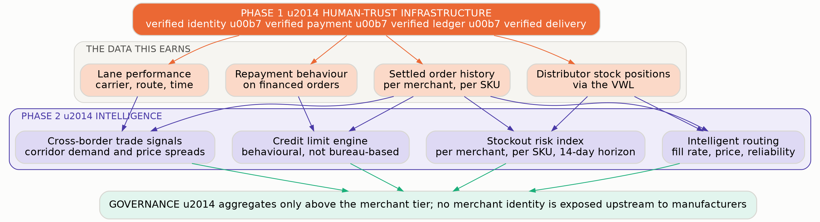
Exhibit 32. What Phase 1 earns, and what Phase 2 does with it.

The four capabilities
Intelligent routing. Phase 1 routes on a deterministic score. Phase 2 learns which distributor actually fulfils, for which SKU, into which cluster, at which time of week — including the effects that no rule captures, such as a wholesaler who is reliable on detergent and erratic on beverages. The measure is realised fill rate, not predicted rank.
Stockout risk index. Per merchant, per SKU, over a fourteen-day horizon, from observed reorder velocity and cluster demand. Its purpose is a reorder prompt that arrives before the shelf empties, which is the single most valuable thing the platform can tell a shop owner. It is also the feature most likely to raise order frequency, which is the input the whole GMV build rests on.
Credit limit engine. Behavioural rather than bureau-based: settled order history, payment punctuality, order-value stability, seasonality and hub-level exposure. Udaan's post-mortem is the design brief here — blind algorithmic credit that treated all overdue accounts identically failed against distributors who understood context. The engine therefore proposes limits; resident agents and hub exposure caps constrain them; and a merchant who falls behind is contacted by someone who knows the market rather than by an automated escalation.
Cross-border trade signals. Corridor demand and price spreads between instrumented hubs — Onitsha to Accra, Kejetia to Lomé. This is the capability that most justifies the twin-market decision in Chapter 4 and it is impossible without both ends settled.

The governance constraint
Everything above the merchant tier is aggregate. Manufacturers see clusters, never merchants; no upstream participant receives an identifier, a shop name or a location precise enough to re-identify. The floor is enforced as a materialisation condition in the telemetry pipeline, not as an access rule that could be relaxed under commercial pressure.
This is a genuine commercial cost. A manufacturer would pay considerably more for outlet-level data, and the plan is declining that revenue permanently. The reason is that the platform's entire value rests on merchants believing their trade is theirs; the first time a merchant learns that a manufacturer knows exactly what they stock, the settlement product loses the trust it is built on.

Cost discipline
The intelligence layer is modelled at $14,000 in Year 1 rising to $552,000 in Year 5 — roughly 2.3% of Year-5 revenue. It is kept there by routing narrow, high-volume tasks to small self-hosted models, computing aggregates in the warehouse rather than through inference, and reserving frontier-model calls for genuinely open-ended work. An intelligence layer that costs more than the settlement layer it sits on has misunderstood which one is the business.

36 API Specification
Three audiences: distributors integrating stock, manufacturers consuming telemetry, and lenders drawing against the facility.

Conventions
REST over HTTPS, JSON bodies, ISO 8601 UTC timestamps, ISO 4217 currencies, amounts in minor units as integers — never floating point for money — cursor pagination, and a mandatory `Idempotency-Key` header on every mutating call. Authentication is OAuth 2.0 client credentials scoped by participant. Every settlement-affecting response carries the ledger entry identifiers it produced.
Verb | Path | Consumer | Purpose
POST | /v1/orders | Merchant app | Create an order. Reserves VWL stock; returns a payment instruction. Idempotency-Key required.
GET | /v1/orders/{id} | All parties | Full order state with settlement, fulfilment and ledger references.
POST | /v1/settlements/verify | Internal / PSP webhook | Confirm settled funds and trigger the ledger split. Exactly-once by idempotency key.
GET | /v1/settlements/{id} | Distributor | The evidential record: verified_at, psp_reference, split amounts, rebate accrued.
PUT | /v1/vwl/positions | Distributor | Upsert stock positions in bulk. Sets last_confirmed_at and resets confidence.
POST | /v1/vwl/positions/confirm | Distributor | Lightweight reconfirmation of existing positions without restating quantities.
GET | /v1/routing/candidates | Merchant app | Ranked distributors for a basket, with the score components exposed.
GET | /v1/telemetry/demand | Manufacturer | Cluster demand signals by LGA, SKU and period. Returns nothing below the k-anonymity floor.
POST | /v1/subsidy/campaigns | Manufacturer | Create a SmartSubsidy campaign with targeting by cluster, SKU and merchant segment.
GET | /v1/subsidy/campaigns/{id}/effect | Manufacturer | Verified uplift: settled units against a matched control cluster.
POST | /v1/credit/limit-check | Internal | Proposed limit with the behavioural factors that produced it.
POST | /v1/credit/disbursements | Lender partner | Draw against the facility for a specific merchant and order.
POST | /v1/webhooks | Partners | Register endpoints. Events: order.settled, payout.completed, delivery.confirmed, position.stale, credit.repaid.
GET | /v1/hubs/{id}/metrics | Public | Settlement success rate, median time to payout, live status. Deliberately public — Chapter 14's proof points.
Table 28. Public API surface, version 1.
POST /v1/orders
Idempotency-Key: 8f14e45f-ea5c-4f2b-9c1d-3a7b21c9e004

201 Created
{
"order_id": "ord_01J8K...", "hub_id": "hub_onitsha", "jurisdiction": "NG",
"distributor_id": "dst_01J2...",
"gross_value_minor": 9500000, "currency": "NGN",
"routing": { "score": 0.87, "components": {
"price": 0.91, "stock_confidence": 0.96, "distance_km": 4.2,
"fill_rate_90d": 0.94, "prior_relationship": false } },
"vwl_reservation": { "expires_at": "2026-07-29T11:42:00Z" },
"payment": { "method": "bank_transfer", "reference": "OM-4471-9920",
"note": "No fulfilment instruction is issued until funds settle." },
"state": "awaiting_payment"
}

GET /v1/telemetry/demand?lga=NG-AN-ONI&period=2026-W30

200 OK
{
"cluster": "NG-AN-ONI", "period": "2026-W30",
"signals": [
{ "sku_id": "sku_deterg_1kg", "units": 18420, "value_minor": 92100000,
"merchant_count": 214, "wow_change": 0.061 },
{ "sku_id": "sku_oil_5l", "units": 6180, "value_minor": 74160000,
"merchant_count": 97, "wow_change": -0.023 }
],
"suppressed": [ { "sku_id": "sku_niche_2l", "reason": "below_k_anonymity_floor",
"floor": 12 } ]
}

37 Non-Functional Requirements
One of these has a zero-tolerance threshold. The rest are engineering targets.
Requirement | Objective | Rationale and measurement
Settlement correctness | Zero unreconciled breaks | The only zero-tolerance objective. Daily reconciliation to bank statements; any break is a Sev-1 with a written post-mortem.
Time to distributor payout | Median ≤ 4 min, p95 ≤ 20 min | From verified funds to money in the distributor's account. Published continuously — the proof point in Chapter 14.
Settlement success rate | ≥ 99.3% of initiated orders | Initiated to settled-and-confirmed without dispute. Published per hub.
Order capture, offline | 100% of composed orders survive network loss | Local outbox with conflict-free merge; verified by fault injection on a throttled device profile.
VWL freshness | ≥ 85% of routed positions confirmed within 24 h | Below this, routing accuracy degrades and fill rate follows.
Fill rate on routed orders | ≥ 96% | The merchant-facing consequence of VWL quality. Measured per distributor and published to them.
App cold start, entry-level Android | ≤ 3.5 s | Measured on a 2GB-RAM device profile over throttled 3G, not on a developer handset.
Payload per order session | ≤ 180 KB | Data is metered and expensive. This is a product constraint, not an optimisation.
API availability | 99.7% monthly | Excludes announced maintenance.
Telemetry k-anonymity | 100% enforcement, k ≥ 12 | Enforced at materialisation. A breach is a regulatory and reputational event, not a bug.
Credit decision latency | ≤ 2 s p95 | A limit check inside the order flow cannot be a perceptible pause.
RPO / RTO | 5 min / 2 h | Ledger point-in-time recovery; tested quarterly with a documented drill.
Table 29. Service-level objectives. Payout time and settlement success are published to customers.

38 Trust, Security and Regulatory Compliance
Seven layers, two jurisdictions, and one boundary the architecture is designed to defend against its own commercial interest.
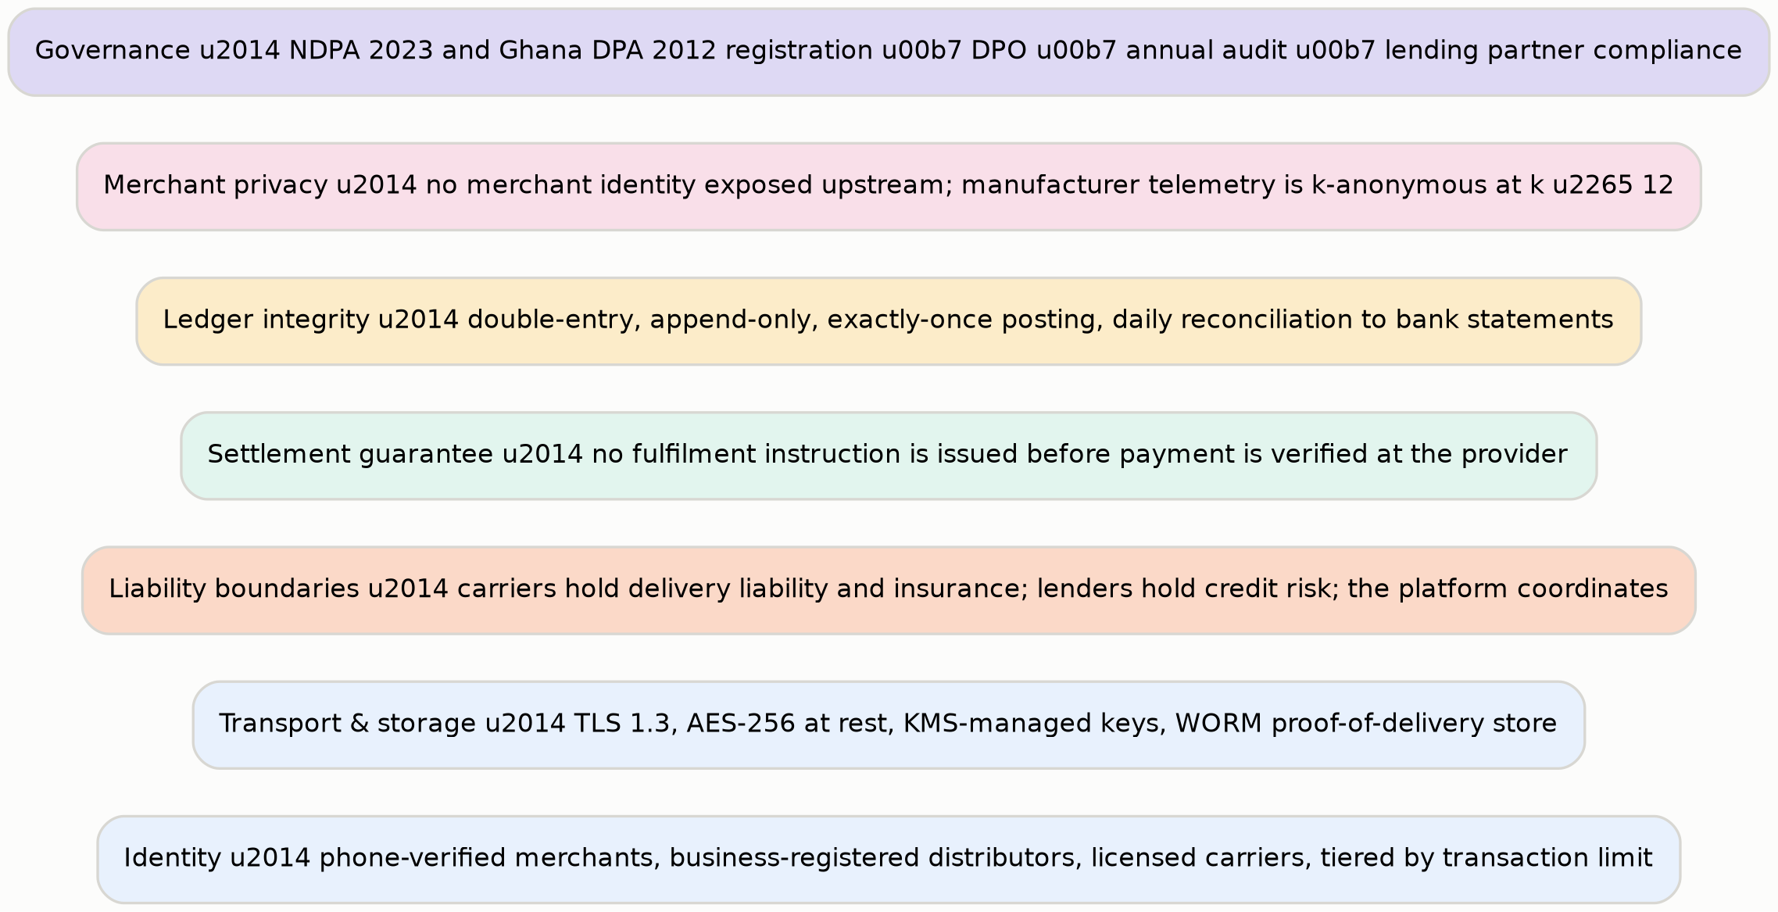
Exhibit 33. The trust and security stack.

Regulatory position
OpenMarket coordinates payments; it does not hold customer funds beyond the settlement moment, does not take deposits, and does not lend from its own balance sheet. The operating intent is to run settlement through licensed payment service providers and to originate credit for licensed lending partners under a facility, which keeps the company outside deposit-taking and lending licensure in both jurisdictions. Whether that structure holds is a matter for counsel in Lagos and Accra before the first naira moves, and Chapter 43 places the legal opinion in the first hundred days rather than later.
Data protection runs under Nigeria's Data Protection Act 2023 and Ghana's Data Protection Act 2012. Year-1 commitments are registration where thresholds are met, a named data protection officer, published privacy notices and lawful-basis registers for each jurisdiction, a records-of-processing register, a documented data-subject rights process, and an annual audit. Merchant data is processed under contract; telemetry is aggregated before it leaves the merchant tier.

The boundary that matters
The commercially valuable thing OpenMarket will be repeatedly asked to do is sell outlet-level data to manufacturers. It will be worth a great deal, the request will be reasonable-sounding, and it will arrive from a customer the company depends on. The architecture is built so that saying no is the default: the telemetry role has no grant on the underlying order table, and the aggregate view will not materialise a cluster below the anonymity floor. A future team under revenue pressure would have to make a deliberate, visible, reviewable schema change to cross that line.

The layers
- Identity. Phone-verified merchants, business-registered distributors, licensed carriers, with transaction limits tiered by verification depth.
- Transport and storage. TLS 1.3, AES-256 at rest, KMS-managed keys, write-once storage for proof of delivery and settlement evidence.
- Liability boundaries. Carriers hold delivery liability and insurance; lenders hold credit risk; the platform holds settlement correctness. Expressed in the data model, not only in the terms.
- Settlement guarantee. No fulfilment instruction before verified funds. Enforced in the state machine, not by convention.
- Ledger integrity. Double-entry, append-only, exactly-once posting, balance assertion at commit, daily reconciliation to bank statements.
- Merchant privacy. No merchant identity above the tier boundary; k-anonymity at k ≥ 12 enforced at materialisation.
- Governance. NDPA and Ghana DPA registration, named DPO, annual third-party audit, lending-partner compliance review, and a quarterly settlement report to each market association.

39 Infrastructure and the Cost Model
What runs where, and what it costs at each stage.
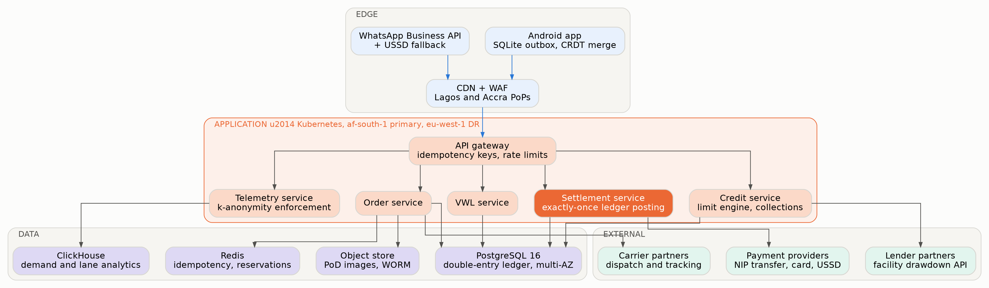
Exhibit 34. Deployment topology. Primary region in Africa; carriers, lenders and payment providers are external by design.
The edge is an offline-capable Android application with a local outbox and conflict-free merge, WhatsApp Business API and USSD as low-bandwidth alternatives, and a CDN with points of presence in Lagos and Accra. The application tier runs on Kubernetes in an African primary region with European disaster recovery, comprising the API gateway with idempotency and rate limiting, and the order, settlement, VWL, credit and telemetry services. The data tier is PostgreSQL 16 holding the double-entry ledger across multiple availability zones, Redis for idempotency keys and stock reservations, ClickHouse for demand and lane analytics, and write-once object storage for proof of delivery. Payment providers, lender partners and carriers are external integrations by deliberate design — each represents a liability that stays outside the platform.
Cost of revenue | Year 1 | Year 2 | Year 3 | Year 4 | Year 5
Payment processing (0.25% of GMV) | $11,115 | $69,107 | $248,041 | $636,712 | $1,302,128
Fixed infrastructure | $46,000 | $152,000 | $340,000 | $610,000 | $940,000
Intelligence layer (Phase 2) | $14,000 | $68,000 | $190,000 | $358,000 | $552,000
Field agent support (35% of agent cost) | $50,400 | $219,744 | $578,842 | $1,066,068 | $1,660,020
Market operations (allocated) | $38,500 | $117,502 | $256,155 | $448,728 | $673,889
Total cost of revenue | $160,015 | $626,353 | $1,613,038 | $3,119,508 | $5,128,037
Gross margin | 10.0% | 46.6% | 63.9% | 73.3% | 78.8%
Table 30. Cost of revenue. Components are rounded and may not sum exactly to the modelled total.
The cost line that decides the gross margin
Payment processing at 0.25% of GMV is the single most consequential number in the cost model, and it is a property of the Nigerian payment system rather than of the company. Instant bank transfers are flat-fee with a low cap, so a ₦95,000 order costs a fraction of a percent to settle.
A card-based equivalent at 1.5% to 3% would consume between 60% and 125% of the entire net take rate. Any version of this business that depends on card rails does not work, and the architecture treats bank transfer as the primary path for that reason rather than for convenience.

PART FIVE
Execution
The operating model, the build sequence, the instrumentation, the first hundred days, and the closing argument.

40 Operating Model and Organisation
Twenty-two people and thirty field agents in Year 1. The shape matters more than the size, because the wrong shape produces good software over an empty market.

Five functions, and the unusual one
Engineering, data and intelligence, commercial, and general administration are conventional. The fifth is market operations, and it is not a support function: it owns hub activation, association relationships, resident agents, distributor onboarding and VWL confirmation discipline. It is the function that manufactures density, which is the asset the business sells.
The second unusual choice is that credit and risk exists from Year 1, two people before there is a loan book, growing to nineteen by Year 5. Udaan's failure was extending credit faster than the risk function could understand it, and hiring risk after lending has begun is the specific mistake that produces that outcome.
Function | Y1 | Y3 | Y5 | Mandate
Engineering | 6 | 20 | 40 | Settlement ledger, VWL, offline mobile, API
Data & Intelligence | 2 | 10 | 22 | Telemetry pipeline, routing scores, Phase-2 layer
Market Operations | 5 | 28 | 62 | Hub activation, associations, agents, distributor onboarding
Credit & Risk | 2 | 9 | 19 | Limit engine, collections, facility relationship, loss performance
Commercial | 3 | 18 | 40 | Manufacturer sales, partner relationships, carrier network
G&A / Leadership | 4 | 9 | 17 | Two-country entity, regulatory, finance, people
Total staff | 22 | 94 | 200
Field agents (contracted) | 30 | 290 | 700 | Resident in hubs; 65% of cost is acquisition, 35% ongoing support
Table 31. Headcount plan. Market operations is the largest function by Year 5 and that is correct.

Operating cadence
A weekly settlement review is the company's central ritual: reconciliation breaks, median time to payout, settlement success rate by hub, and any dispute. It is the first meeting of the week because the thing a company reviews first is the thing it protects. A weekly hub review covers activation progress, VWL freshness, agent productivity and association contact. A fortnightly credit committee reviews the book, exposure by hub, and every account past due — attended by a resident agent from the affected hub, not only by analysts. And a monthly published hub report to each market association, showing verified trade volume in their market, whether or not the numbers flatter.

41 Roadmap
Trust rails, then coordination, then manufacturer layer, then intelligence. Reversing any two of those is how this fails.
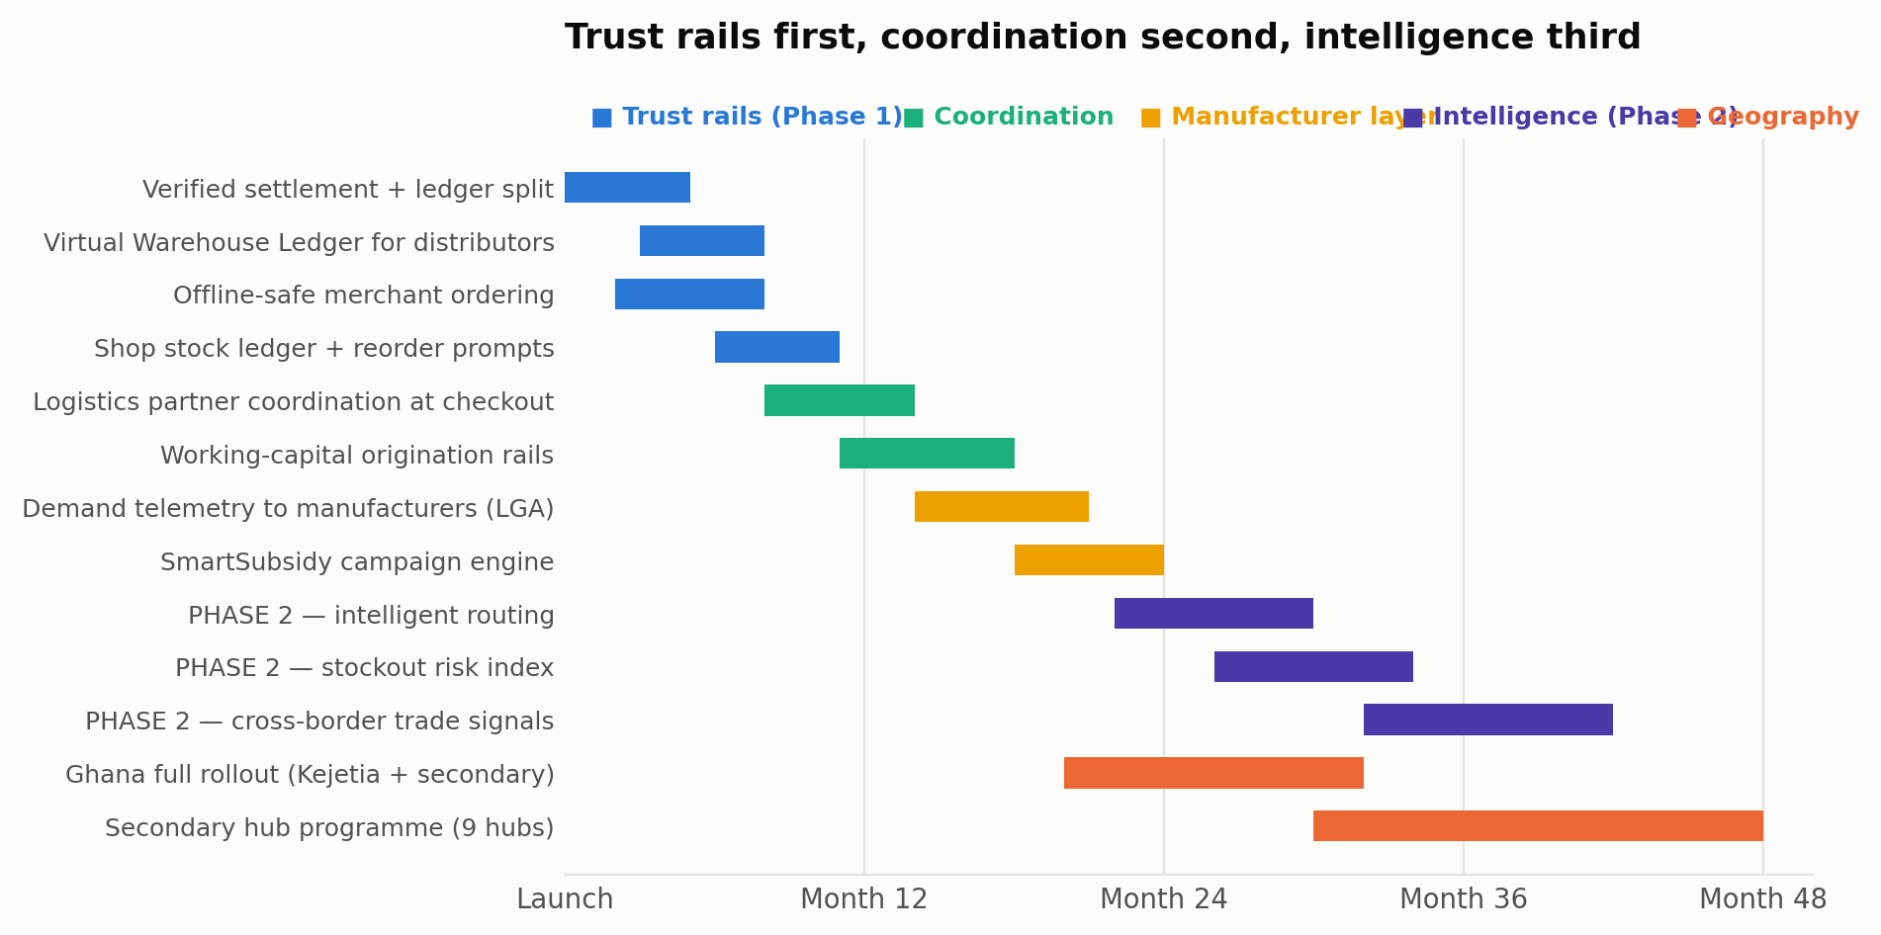
Exhibit 35. The four-year build sequence.
Months | Deliverable | Definition of done
0–5 | Verified settlement and ledger split | Double-entry append-only ledger reconciling to bank statements daily with zero unexplained breaks for 30 consecutive days
2–8 | Offline-safe merchant ordering | 100% of orders composed offline survive network loss, verified by fault injection on a 2GB Android profile
3–8 | Virtual Warehouse Ledger | ≥ 85% of routed positions confirmed within 24 hours; fill rate on routed orders ≥ 96%
6–11 | Shop stock ledger and reorder prompts | Reorder prompt precedes stockout for ≥ 60% of a merchant's top-5 SKUs
8–14 | Logistics coordination at checkout | Licensed carriers on 3 lanes per hub; carrier liability and insurance verified at onboarding
11–18 | Working-capital origination rails | Facility signed; pilot book of 500 merchants with measured 60-day loss performance
14–21 | Manufacturer demand telemetry | Two paying contracts; k-anonymity enforcement verified by external review
18–24 | SmartSubsidy campaign engine | Verified uplift measurable against a matched control cluster
20–32 | Ghana full rollout | Kejetia live; Ghanaian settlement rail and DPA compliance operating independently
22–30 | Phase 2 — intelligent routing | Realised fill rate improves ≥ 3 points against the deterministic baseline
26–34 | Phase 2 — stockout risk index | 14-day horizon precision measured against realised reorders on a held-out set
30–48 | Secondary hub programme | Nine hubs at reduced activation cost, each reaching payback within 14 months
32–42 | Phase 2 — cross-border trade signals | Corridor demand and price spreads published between two instrumented hubs
Table 32. Roadmap with explicit definitions of done. Every deliverable is measured, not declared.

The sequencing argument
A growth-led plan would ship the intelligence layer early because it is the thing that sounds most valuable. This plan puts it in months 22 to 42, for three reasons. It has nothing to learn from until settled orders exist at density. It cannot be sold to manufacturers until the telemetry underneath it is dense enough to be statistically meaningful. And most importantly, a coordination platform that offers intelligence before it offers reliable settlement is making a claim about sophistication to an audience that is asking a question about trust.

42 Instrumentation
Twelve numbers, three tiers, one owner each. Three of them are published to customers.
Tier | Metric | Year-1 target | Owner | Cadence
1 | Unreconciled settlement breaks | Zero | Engineering | Daily
1 | Median time to distributor payout — published | ≤ 4 min | Engineering | Daily
1 | Settlement success rate — published | ≥ 99.3% | Market operations | Weekly
1 | Second order within 30 days of first | ≥ 55% | Market operations | Weekly
1 | Hubs live and settling | 2 | Market operations | Monthly
2 | VWL positions confirmed within 24 h | ≥ 85% | Market operations | Weekly
2 | Fill rate on routed orders | ≥ 96% | Market operations | Weekly
2 | Distributors onboarded per hub | 70 | Commercial | Monthly
2 | Cost per transacting merchant | ≤ $46 | Market operations | Monthly
3 | Verified trade volume per hub — published | $2.2m | Market operations | Monthly
3 | Credit pilot 60-day loss rate | Baseline established | Credit & risk | Monthly
3 | Manufacturer contracts signed | 2 | Commercial | Quarterly
Table 33. The instrumentation set. Tier-1 metrics are reviewed in the weekly settlement meeting.
The metric that matters most is the cheapest to compute and the hardest to face. Second order within 30 days of first is the only number that measures whether the product's central promise actually landed. A merchant who settles once and never returns did not believe what happened, or was not served well enough to risk it again. Every other metric in the set can look healthy while that one is failing, and if it is failing the business does not work regardless of how many merchants have registered.
Three metrics are published to customers, and that decision is strategic rather than transparent for its own sake. Median time to payout, settlement success rate and verified trade volume per hub are the three things no aggregator can quote and no inventory-owning competitor measures. Publishing them monthly — including in the months when they disappoint — is how a company with no track record earns the right to be believed by a market that has watched four platforms arrive and leave.

43 The First Hundred Days
What happens between the round closing and the first board meeting.

Weeks one to four — the licence to operate
- Obtain written legal opinions in Lagos and Accra on the settlement and origination structure, before any money moves. This is the gating item for everything else.
- Open the Onitsha market association relationship, with a named executive contact and agreed terms of presence. No merchant is approached before this exists.
- Complete NDPA registration and appoint the data protection officer; begin the Ghana DPA process in parallel.
- Sign the primary Nigerian payment provider and confirm, in writing, the settled-funds webhook semantics the whole architecture depends on.
- Hire the market operations lead and the credit and risk lead. These are the first two hires and neither is negotiable.

Weeks five to eight — the ledger
- Ship the double-entry, append-only settlement ledger with exactly-once posting and balance assertion at commit.
- Stand up daily bank reconciliation and run it for thirty consecutive days before a single external transaction. A break during this window is a schedule event, not a defect to be logged.
- Onboard the first eight anchor distributors in Onitsha personally, with founders present, and load their stock into the VWL by hand.
- Ship offline order capture and verify it by fault injection on a 2GB Android device over a throttled connection, not on a developer handset.
- Recruit and place the first four resident agents in Onitsha.

Weeks nine to thirteen — the first hundred settled orders
- Settle the first hundred orders between anchor distributors and retailers they already serve in person. The product's value here is instant payout and a clean record, not new demand.
- Publish the first hub report: settlement success rate, median time to payout, verified trade volume. Publish it to the association and to the customers, including if it is poor.
- Only then open distance trade — retailers the distributor has never met — and measure the share of orders it represents. This is the test of Claim One in Chapter 15.
- Begin Mile 12 activation with the playbook documented from Onitsha rather than reinvented.
- Open credit facility conversations with two development finance institutions and one commercial lender.
- Open the first manufacturer telemetry conversation, on the basis of Onitsha density rather than a national promise.

What the first board meeting should see
Thirty days of clean reconciliation. A published settlement success rate and median time to payout. At least a hundred settled orders with a measured share placed with a distributor the merchant had not previously met in person. Two hubs in activation with an association agreement in each. Two credit facility conversations in progress. And a headcount below plan, because in a field business hiring behind plan in the first quarter is usually right and hiring ahead of it almost never is.

44 Closing Argument

Roughly a trillion dollars a year moves through African informal retail, and 94% of the Nigerian retailers who buy from it still do so the way they always have — in person, in an open market, from a wholesaler they know. Between 2019 and 2026 a generation of well-funded companies tried to change that by becoming the wholesaler: buying the stock, building the warehouses, running the vans and selling direct. Four of them no longer exist, three abandoned commerce for something else, two merged, and one — the only one that refused to own the assets — is profitable.
The evidence is not ambiguous and it is not the author's opinion. OmniRetail publishes 9% gross and 5% net contribution margins on an asset-light model with embedded credit. MaxAB-Wasoko said plainly, on exiting Moroccan e-commerce, that commerce is capital-intensive and low-margin while finance offers recurring revenue and better unit economics. TradeDepot raised $110 million on the asset-owning model and pivoted. Udaan ran the same experiment at Indian scale and concluded that platforms must strengthen existing trade ecosystems rather than destroy them.
What nobody has built is the thing that would actually let those ecosystems trade further than a person can walk: a settlement guarantee. A wholesaler in Onitsha will not release goods to a buyer in Enugu they cannot see, and the buyer will not send money to a seller they cannot hold to account. That single failure caps the market at the radius of physical trust, and it is a software problem — verify the payment, split the ledger, pay the seller instantly, record what happened — sitting underneath what everyone has mistaken for a logistics problem.
OpenMarket Africa builds that layer and nothing else. It owns no inventory, drives no trucks, holds no warehouse and never becomes a party to the trade. It earns the right to lend by watching who actually pays, and the right to sell demand intelligence by aggregating what actually sold — both of which are by-products of doing the first job properly. A market hub costs $46,000 to activate and returns $2.94 million of contribution by month 36. Sixteen hubs, two countries, five years, $19.5 million of equity.
The plan is honest about what could go wrong. The bear case in Chapter 26 does not reach profitability and says so. Year-one merchant economics are poor and Chapter 25 shows the numbers rather than hiding behind the hub. The headline 5% split has been corrected downward to what the channel can actually pay, because a revenue line the customer cannot afford is not a revenue line. And the single largest competitive threat — that OmniRetail simply does this itself — is assessed in Chapter 7 without the comfort of assuming it will not.
What is left, after those deductions, is a specific and testable proposition: that the constraint on African wholesale trade is trust at distance, that trust at distance is purchasable with verified settlement, and that whoever supplies it first in a market will hold a transaction record nobody can reconstruct afterwards. Onitsha is where that gets tested, and the test costs $46,000 and takes twelve months. That is the most a document of this kind can offer, and it is enough to act on.

Appendix A — Assumptions Register
Every modelled input, its value, and the basis on which it was set. Items marked as an assumption are the author's judgement; items citing a source are derived from it. This register is generated directly from the financial model, so it cannot drift from the numbers in Part Three.
Input | Value | Unit | Basis
fx ngn usd 2026 | 1,400 | NGN/USD | FGN 2026 Appropriation Bill macro assumption
fx ngn depreciation | 7.0% | ratio | Assumption: managed float, trailing average moderated
fx ghs usd 2026 | 12.5 | GHS/USD | Assumption: Bank of Ghana rate, post-stabilisation
fx ghs depreciation | 5.0% | ratio | Assumption: inflation down to 14.6% (AfDB), disinflation path
africa informal retailers | 2,500,000 | outlets | How we made it in Africa / DFS Lab: 2.5m small retailers driving 70% of food, beverage and personal care sales
africa informal retail sales usd | 1,000,000,000,000 | USD/yr | Same source: ~$1 trillion of annual sales through the informal retail channel
ng fmcg outlets | 745,000 | outlets | Nielsen Africa FMCG study: 745,000 Nigerian outlets enumerated
gh fmcg outlets | 266,322 | outlets | Ghana FMCG Retail Market Report, national enumeration of FMCG-carrying stores
ng fmcg household spend usd | 25,000,000,000 | USD/yr | OmniRetail 'Decoding FMCG in Nigeria': $25bn+ household FMCG spend
share fmcg via wholesale markets | 70.0% | ratio | Only 30% of FMCG is sold direct to retailers; 70% moves through wholesale markets
retailers sourcing from open markets | 94.0% | ratio | OmniRetail Nigeria FMCG report: 94% of retailers source from open markets vs 6% from online platforms
launch hub merchant base | 92,800 | merchants | Assumption: merchant counts per hub, scaled from published trader estimates and outlet censuses
retailers served per hub merchant | 11.5x | x | Assumption: each hub wholesaler supplies ~11-12 downstream retail outlets in its catchment
digitally reachable share | 61.0% | ratio | DataReportal Digital 2026 Nigeria: 45.5% internet penetration; OmniRetail reports 82% digital readiness in the South-West, 40% in North Central
y5 active merchants | 218,000 | merchants | Assumption: benchmarked against OmniRetail's 150,000+ retailers reached in six years on an inventory-touching model
orders per merchant per month y1 | 2.6 | orders | Assumption: informal retailers restock 2-3x monthly; BFA Global shopkeeper research
aov ngn y1 | 95,000 | NGN | Assumption: ~₦95,000 per restock against reported monthly purchase power of ₦0.8m-₦3.5m by region
gross settlement split | 5.0% | ratio | openmarket.africa published model: distributors receive 95% instant payout
rebate returned to channel y1 | 2.6% | ratio | Assumption: share of GMV returned as distributor volume rebates and manufacturer-funded promotion
finance penetration y5 | 35.0% | ratio | Assumption: benchmarked on OmniRetail Omnipay (₦19bn/month against ₦1.3tn annual volume) and MaxAB-Wasoko Egypt
credit tenor days | 30 | days | Assumption: single restock cycle, matching retailer cash conversion
credit gross yield annual | 46.0% | ratio | TradeDepot reports a ~5% monthly effective rate; plan models 3.8%/cycle to stay below it
cost of funds annual | 24.0% | ratio | Assumption: Nigerian naira debt facility pricing for a DFI-backed book
credit loss annual | 2.1% | ratio | OmniRetail reports NPLs below 0.5% and MaxAB-Wasoko 99%+ repayment; plan models 2.1% for prudence
manufacturer acv y5 usd | 46,000 | USD/yr | Assumption: LGA-level demand telemetry licence; priced below the cost of a single field-audit programme
smartsubsidy take rate | 11.0% | ratio | Assumption: platform fee on manufacturer-funded promotion routed through the network
logistics coordination fee | 0.8% | ratio | Assumption: platform fee on coordinated logistics; carriers keep delivery liability and insurance
payment processing cost | 0.3% | ratio | Assumption: Nigerian NIP transfers are flat-fee (₦50 cap), so B2B order sizes make processing near-free; blended with card
phase2 inference spend y5 | 566,000 | USD | Assumption: intelligence layer inference and training cost once demand telemetry is live
field agent share to acquisition | 65.0% | ratio | Assumption: activation agents recruit and onboard merchants (S&M); the balance is ongoing merchant support (COGS)
field agent fully loaded usd | 4,800 | USD/yr | Assumption: Lagos/Accra market activation agent, fully loaded incl. commission and airtime
salary inflation | 9.0% | ratio | Assumption: Nigerian and Ghanaian tech and field salary inflation, USD-denominated
merchant monthly churn y1 | 5.2% | ratio | Assumption: informal retail is high-churn; improves as credit and ledger create switching cost
hub activation cost usd | 46,000 | USD | Assumption: 4 agents for 6 months, distributor onboarding incentives, market-association fees and launch events
hubs live y5 | 16 | hubs | Assumption: 7 flagship hubs plus 9 secondary hubs across Nigeria and Ghana
mature hub active merchants | 18,300 | merchants | Assumption: active transacting merchants in a hub catchment at maturity (month 30+), calibrated so the bottom-up hub build reconciles with the aggregate merchant and contribution model
hub merchant ramp month 12 | 6,030 | merchants | Assumption: merchants transacting in a hub catchment 12 months after activation
contribution per merchant per month mature | 9.78 | USD | Assumption: settlement, finance, subsidy and logistics contribution per active merchant at hub maturity
hub ongoing field cost monthly | 2,600 | USD/month | Assumption: 3 resident agents plus market-association costs per live hub after activation
pre seed raised usd | 420,000 | USD | Assumption: founder and angel capital already deployed on the live platform
seed round usd | 4,500,000 | USD | Ask: seed round at close of Year 1; a field-operations business costs more to start than pure software
series a usd | 15,000,000 | USD | Assumption: Series A in Year 3 on proven contribution margin
credit facility usd | 16,000,000 | USD | Assumption: ring-fenced debt facility for the working-capital book; does not fund operations
ng gh addressable channel gmv usd | 22,400,000,000 | USD/yr | Nigeria $25bn household FMCG spend x 70% via wholesale markets, plus Ghana scaled by outlet count
africa fmcg share of informal sales | 42.0% | ratio | Assumption: FMCG and fast-moving general goods share of the $1tn informal retail sales pool
Table 34. The complete assumption register, generated from the model.

Appendix B — Financial Detail

Hub cohort, month by month
Month | Merchants | Monthly contribution | Cumulative
0 | 0 | $-2,600 | $-48,600
3 | 490 | $-2,115 | $-55,645
6 | 2,090 | $1,538 | $-55,388
9 | 3,940 | $10,323 | $-34,272
12 | 6,030 | $25,017 | $24,878
15 | 8,470 | $45,848 | $140,356
18 | 10,900 | $72,174 | $329,321
21 | 12,990 | $98,722 | $598,066
24 | 14,850 | $127,189 | $950,389
27 | 16,700 | $152,042 | $1,381,235
30 | 18,300 | $176,374 | $1,885,655
33 | 18,300 | $176,374 | $2,414,777
36 | 18,300 | $176,374 | $2,943,899
Table 35. Single-hub cohort at three-month intervals. Cumulative break-even in month 12.

Credit book
US$ | Year 1 | Year 2 | Year 3 | Year 4 | Year 5
Share of GMV financed | 6% | 13% | 21% | 29% | 35%
Average outstanding book | $21,925 | $295,359 | $1,712,502 | $6,070,572 | $14,983,392
Annual disbursement | $266,760 | $3,593,540 | $20,835,444 | $73,858,632 | $182,297,931
Net yield on book | 19.9% | 19.9% | 19.9% | 19.9% | 19.9%
Finance revenue | $4,363 | $58,777 | $340,788 | $1,208,044 | $2,981,695
Facility drawn | — | $4,000,000 | $12,000,000 | — | —
Table 36. The working-capital book. Net yield is 46% gross less 24% cost of funds less 2.1% credit loss.

Scenario detail
Scenario | Year 1 | Year 2 | Year 3 | Year 4 | Year 5
Bear — revenue | $111k | $697k | $2,546k | $6,347k | $12,662k
Bear — EBITDA | ($906k) | ($2,070k) | ($3,406k) | ($4,063k) | ($3,090k)
Base — revenue | $178k | $1,173k | $4,474k | $11,671k | $24,154k
Base — EBITDA | ($844k) | ($1,627k) | ($1,598k) | $956k | $7,777k
Bull — revenue | $244k | $1,643k | $6,388k | $16,988k | $35,668k
Bull — EBITDA | ($783k) | ($1,186k) | $212k | $6,005k | $18,744k
Table 37. Scenario traces. The bear case does not reach profitability within the plan period.

Appendix C — Source Catalogue
The sources on which this document's factual claims rest. Modelled and judgement-based figures are identified in Appendix A and are not listed here.

Market structure and scale
- How we made it in Africa, The case for investing in the digitalisation of Africa's informal retail supply chains — 2.5 million small retailers; ~$1 trillion of annual sales; $2.6 trillion contribution to nominal GDP; 70% of food, beverage and personal care sales; logistics adds 75% to the cost of goods in sub-Saharan Africa; only 30% of FMCG sold direct to retailers, 70% via wholesale markets; Nigerian retailer baseline of 20–50 m², 60–100 SKUs, ₦250,000–₦500,000 monthly turnover, ~15% margin, 100–150 households served.
- OmniRetail, Decoding FMCG in Nigeria — $25bn+ household FMCG spend; 238m population; median age 18.1; 94% of retailers source from open markets against 6% from online platforms; 72% willing to buy online; 74% consider credit important; 78% use POS; digital readiness 82% South-West, 69% South-South, 40% North Central; monthly purchase power ₦0.8m–₦3.5m by region.
- Nielsen Africa FMCG study, via Optimetriks — 745,000 Nigerian outlets enumerated; over 90% of sales through traditional informal outlets in Ghana, Cameroon and Nigeria; 50% of Lagos laundry detergent sales concentrated in 10% of stocking outlets; 80% of beverage sales in ~40% of outlets carrying them.
- Ghana's FMCG Retail Market Report — 266,322 retail stores carrying at least one FMCG product; Accra 25% and Kumasi 21% of national outlets; 108,726 grocery stores of which 49,555 are kiosks and metal containers; 17,492 cosmetic and drug stores; 10,082 wholesalers and semi-wholesalers.
- Grokipedia, Main Market, Onitsha — over 20,000 merchants; annual trade exceeding $5 billion; approximately fifteen 40-foot and eight 20-foot containers daily; catchment covering south-eastern Nigeria, Cameroon, Togo and Ghana; over half a million indirect jobs.
- FieldAssist, Decoding Nigeria's FMCG open market sector and Expanding digital footprint in Nigeria's FMCG traditional trade — 90% of retail through informal channels; FMCG sector at $30.53bn; informal retail 44% of informal businesses; Lagos 16% of the informal market base.
- Moniepoint 2025 Informal Economy Report — over 39 million informal businesses in Nigeria; 79% saw operating costs rise; 65% saw revenue rise but only 47% saw profit rise; 40% employ labour.
- DataReportal, Digital 2026: Nigeria — 45.5% internet penetration; 165m mobile connections; median mobile download 44.96 Mbps.

Competitors and the shakeout
- TechCrunch, What African B2B e-commerce startups can learn from OmniRetail's profitable run (March 2024) — 9% gross margins; 5% net contribution; EBIT breakeven; $0.05 net contribution per $1 transacted; OmniPay $95m monthly volume and $4m monthly disbursement at sub-0.5% NPL; 16 hyperlocal warehouses; 3,000+ logistics partners; 3% supply cost reduction; 65 brand partnerships; 144,000 registered retailers; $124m annual NMV.
- TechCrunch, OmniRetail shakes up Africa's B2B e-commerce market with $20m Series A (April 2025) — $20m Series A co-led by Norfund and Timon Capital, with Ventures Platform, Aruwa Capital, Goodwell via Alitheia and Flour Mills of Nigeria; $38m total raised; 150,000+ retailers across 12 cities; 145 manufacturers; 5,800+ distributors; 1,100 vehicles via 85 partners; Nigeria, Ghana, Ivory Coast; EBITDA positive 2023, net profitable 2024; ₦1.3tn (~$810m) 2024 transaction volume; 35% NMV and 40% revenue growth; Omnipay ₦19bn (~$12m) monthly at near-zero default.
- TechAwk NG, Africa's B2B e-commerce shakeout (February 2026) — Copia Global administration 2023 after raising $100m+; MarketForce wound down RejaReja; Zumi shut down; Wabi exited Nigeria and Kenya; Alerzo layoffs, warehouse closures and a ₦5bn Moniepoint loan; Wasoko-MaxAB merger; TradeDepot pivot to embedded finance; Sabi pivot to traceability and export; three named structural causes.
- TechCrunch, TradeDepot raises $110m from IFC, Novastar (December 2021) — $110m total, ~$42m equity and ~$68m debt; IFC lead with Novastar, Sahel, CDC, Endeavor Catalyst, Partech Africa, MSA Capital; Arcadia Funds on debt; 100,000+ merchants, up from 40,000 in 18 months; 5x GMV growth; 12 cities across Nigeria, Ghana and South Africa; ShopTopUp monthly effective rate near 5%.
- Launch Base Africa, MaxAB-Wasoko winds down e-commerce in Morocco as fintech becomes core (July 2025) — e-commerce described as capital-intensive and low-margin against fintech's recurring revenue and better unit economics; Egypt fintech turnover above $180m; $20m of working-capital loans at 99%+ repayment; 450,000 merchants; $230m total funding.
- 36Kr Overseas Pioneers, Egatee — established 2018 with Transsion Holdings and Yiwu Market Group as principal shareholders; launched 2022; self-operated and platform models; 2024 transaction volume close to ¥1bn; 20% of goods direct from China; cross-border IM response and online payment usage at 80% by early 2025; target of 1.5m platform merchants; ~100 staff per country and 1,000+ in Nigeria; 90% local staffing; sample halls, Dar es Salaam opening with 3,000+ visitors and 200 purchasing agents signed.
- Vanik, Why Udaan struggled — revenue from ~₹9,900 crore (FY22) to ₹5,609 crore (FY23), ₹5,707 crore (FY24) and ₹4,561 crore (FY25); 2025 capital at ~$1.8bn valuation; marketplace plus logistics plus credit equals burn; blind algorithmic credit versus relationship-based assessment; strengthen rather than destroy existing trade ecosystems.
- openmarket.africa — the live platform as at July 2026: positioning, order flow, five participant classes, Virtual Warehouse Ledger, 95% instant payout, offline-safe ordering, demand telemetry with no merchant PII, SmartSubsidy, twelve hub map across six countries, AI coordination stated as Phase 2.

Global benchmark and finance
- Capital One Shopping, B2B eCommerce Statistics (2025) — global B2B e-commerce $32.1tn in 2025 rising to $62.2tn by 2030 at 14.5% CAGR; US $10.1tn; ~80% of B2B sales through e-commerce channels; 56% of US B2B revenue digital, up from 45% in 2023; Amazon Business projected $83.1bn for 2025; US B2B marketplace sales $378.7bn.
- Sacra, Faire — $616m revenue in 2023, 73% growth on $355m in 2022; annualising above $500m at 40%+ growth as of Q3 2025; ~$3bn 2025 GMV; 800,000+ retailers; NDR above 110%; effective take rate from ~16.5% to ~19%; valuation $5.2bn (November 2025) against $12.6bn (May 2022); $1.7bn raised.
- BusinessDay Nigeria, Moniepoint's $700m lending push barely dented Nigeria's $32bn SME credit gap — $32.2bn financing gap; $700m disbursed; 75% of merchants accessing formal credit for the first time; MSMEs ~86% of employment and over 60% of the informal economy's GDP contribution.
- African Development Bank, Ghana Economic Outlook — GDP growth 5.8% (2025), 5.0% projected (2026); inflation down to 14.6% from 22.9%; deficit 2.4% of GDP; public debt 45.5% of GDP; current account surplus 4.4%; reserves 5.7 months of import cover.
- Disrupt Africa — African tech startups raised $260m in Q2 2026 across 38 startups, down 40% on $427m in Q2 2025; Q1 2026 $382m across 40 startups; 2025 full year $1.64bn.
- Federal Government of Nigeria, 2026 Appropriation Bill — ₦1,400 to the US dollar macro assumption.

Appendix D — Glossary
Term | Definition as used in this document
AOV | Average order value.
BNPL | Buy now, pay later — short-tenor credit extended at the point of purchase.
CAC | Customer acquisition cost.
Cluster | A local-government-area grouping used as the unit of demand aggregation for manufacturer telemetry.
Contribution margin | Revenue less cost of revenue, expressed here both in dollars and as a percentage of GMV.
DFI | Development finance institution.
Distributor | Any party that buys from a manufacturer or a larger distributor and sells onward to a smaller one or to a retailer. Used here to cover key distributors, sub-distributors and market wholesalers together, since all three perform the same function on the platform: they hold stock and sell it down the chain.
FMCG | Fast-moving consumer goods.
GMV | Gross merchandise value — the total value of goods transacted through the platform. A scale measure, not a revenue measure.
Hub | A physical open market in which OpenMarket has an association relationship, resident agents and onboarded distributors. The unit of expansion.
Hub activation | The one-off cost and programme of establishing a hub, modelled at $46,000.
Idempotency key | A client-supplied identifier ensuring a repeated request produces exactly one effect.
k-anonymity | The privacy property that no published aggregate represents fewer than k individuals; k ≥ 12 in this system.
LGA | Local government area — the Nigerian administrative unit used for demand clustering.
LTV | Lifetime value. Computed here on gross merchant churn, excluding expansion.
Manufacturer | A producer of goods, entering the platform for cluster-level demand telemetry and SmartSubsidy rather than to transact directly with retailers.
Merchant | A retailer holding a transacting account on OpenMarket. Not a separate tier of the trade — merchant and retailer denote the same party, the first from the platform's point of view and the second from the market's.
NIP | Nigeria Inter-Bank Settlement System instant payment — flat-fee bank transfer.
NMV | Net merchandise value — GMV net of returns and cancellations.
NPL | Non-performing loan.
Open market | A physical wholesale and retail trading site such as Onitsha Main Market or Kejetia.
PSP | Payment service provider.
Retailer | The shop at the end of the chain — kiosk, provision store, table-top or container store — selling to the consumer. Called a merchant once it holds a platform account.
SKU | Stock keeping unit.
SmartSubsidy | Manufacturer-funded promotion routed through the network at an 11% platform take.
Take rate | Platform revenue as a percentage of GMV. Distinguished throughout between gross (5.0%) and net of channel rebate (2.4–2.6%).
Traditional trade | Informal and independent retail, as distinct from modern or organised retail.
VWL | Virtual Warehouse Ledger — a distributor's existing stock digitised in place, with a confidence measure. Never platform-owned.
Wholesaler | A distributor trading from a stall, shed or lock-up inside an open market. Treated as a distributor throughout, and counted in the distributor population.
Table 38. Glossary.

Colophon
This document was prepared for Digital Fusion Labs by Boroji Adebayo-Hopewell in July 2026.
The financial model underlying Part Three is a single parameterised model from which every figure, table and exhibit in this document is generated. Appendix A is emitted directly from that model's assumption register, so the assumptions and the numbers they produce cannot diverge. The thirty-one exhibits were generated from the same model and from the sources catalogued in Appendix C, using a categorical palette validated for colour-vision-deficiency separation and surface contrast.
Market statistics are attributed at the point of use and catalogued in Appendix C. Forward-looking figures are modelled estimates constructed from the labelled assumptions in Appendix A and are not forecasts. Positioning assessments, probability weightings, the SWOT in Chapter 13 and any figure described as an estimate represent the author's judgement.
Copyright © 2026 Digital Fusion Labs. All rights reserved.

