Project Report

Design and Implementation of A Simple DNS System

Course: Internet Applications
Name: Yuan Yuchen (2017212758)
Qiao Nisha (2017212760)
Date: 2020-06-08

Category
Project Report 1
1. Overview 3
2. Requirements Analysis 3
3. Preliminary Design 4
3.1 Decomposition of functional modules 4
3.2 Relationship and interfaces between the modules 4
3.3 Overall flow chart 5
3.4 Design of data structures 6
4. Detailed Design 6
4.1 Client: 6
4.2 Local Server: 7
4.3 Other DNS Servers: 8
5. Results 9
5.1 A type: 9
5.2 CNAME type: 10
5.3 PTR type: 12
5.4 Get from cache 14
5.5 MX type: 15
5.6 Input with wrong type: 16
5.7 Query something which is not in the resource record: 17
6. Summary and Conclusion 18
Appendix: Source Codes 19

1. Overview
The requirements and targets of the project are introduced.
Requirement:
Understand the related knowledge of Domain Name System (DNS) protocol.
Complete a simple DNS system based on Linux command line operation and achieve the resolution of English domain name.
Target:
1. Achieve the resolution of English domain name.
2. Support at least 4 top level domains and at least 3 level domain name resolution. Program needs to implement a client and at least 6 DNS servers (including local DNS server).
3.Support three types of resource record query: A、MX、CNAME. As for MX, need to add the IP address in the additional section.
4. Use iterative resolution.
5. Transport layer protocol: TCP connection between client and local server; UDP connection between DNS servers.
6. Application layer protocol: all DNS messages used in the communication process must be able to be correctly resolved by Wireshark;
7. Files can be used to maintain data.
8. The program should run stably and supports error handling, such as invalid command, missing parameter, parameter error, query failure, etc.

2. Requirements Analysis
The requirements of the project are analyzed here, including:

  - Development Environment, such as OS and programming language
We develop the DNS system in Linux virtual machine and the programming language is C. We also use gcc compiler and gdb debugger. Then we use Wireshark as an analysis tool to grasp packets to check whether the format of the packets is correct.
Linux system information: | Linux version 4.4.0-31-generic
Protocol: | TCP between Client and Local server.  UDP between servers.  In application protocol: DNS

  - Functional requirements in details, including task decomposition and analysis
1. We need to achieve a client and 7 servers in total. They are a Local server, a Root server, a Nation server, an Edu server, a Gov server, a PTR server and an Other server.

Client: | 1. Deal with user input.  2. Produce query packet to local server and receive response packet from local server.  3. Display the query result to the user.
Local server: | 1. Deal with the query packet.  2. Check from cache.  3. Send query packet to other server.  4. Resolve the receive packet from other server and check the response type.  5. Check whether it need further query and if it needs, send to other server.  6. Get the final result and send to client.
Root: | Response to local server with the IP address of other server.
Nation: | Response to local server with the IP address of Edu and Gov server.
Other: | Response to local server with the IP address of website of which domain name in Other server.
Edu: | Response to local server with the IP address of website of which domain name in Edu server.
Gov: | Response to local server with the IP address of website of which domain name in Gov server.
PTR: | Response to local server with the domain name of website of which IP address in PTR server.
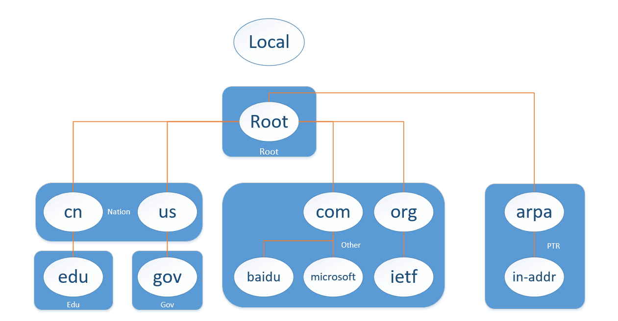
2. Client can communicate with Local server only. Client needs to send query to Local server and wit for response.
3. Local server can communicate with client and all the other server. It can deal with the request from client and then it need to resolve it to understand the query. If local server can find in cache, it will response to client with data in cache. If not, local server will forward the query packet to other server and deal with their response until get result.
4. When all other servers communicate with Local server through UDP connection, it can receive the DNS query message and check in its .txt files according to the query type. If it can search it in .txt files, update Resource Record and send right DNS response message back to Local server. If not, send DNS response message to Local server with no new RR.
If the query type is MX, set additional RR in DNS response message.
If the query type is PTR, send back with domain name.
If the query type is A, send back with IP address.
If the query type is CNAME, send back with its canonical name.
If the query type is NS, send back with the address of next level server.

3. Preliminary Design
Preliminary design includes:

3.1 Decomposition of functional modules
We divide the whole system into client, local server and other servers.

3.2 Relationship and interfaces between the modules

Client: | main() | display the user input interface
Client: | initSocket() | Initialize the TCP socket to connect with local server.
Client: | sendtoLocal() | Send the query packet to local server.
Client: | createMessage() | Create the query packet.
Client: | createQuery() | Create the query section using the user input.
Client: | createHeader() | Create the header section.
Client: | receiveFromLocal() | Receive the response packet from local server.
Client: | getMessage() | Divide the response packet into different parts and store header and query section into related structural array.
Client: | getRR() | Store answer section into struct RR.
Client: | getAddRR() | Store addition section into struct RR.
Client: | printResult() | Display the result to user.
Local Server: | main() | the entrance of the local server program
Local Server: | initSocket() | Initialize the TCP socket to connect with local server and UDP socket with other servers.
Local Server: | process() | A permanent loop to deal with client query.
Local Server: | receivefromClient() | Receive the query packet from local server
Local Server: | getMessage() | Divide the response packet into different parts and store header and query section into related structural array.
Local Server: | checkCache() | Check whether the query type has resource record in cache, if it has, add it in answer section.
Local Server: | checkSvr() | When it cannot find resource record in cache, it need to ask other servers for help.
Local Server: | sendtoOther() | Send the query packet to other server for help.
Local Server: | receivefromOther() | Get response packet from other server
Local Server: | getMessage() | Divide the response packet into different parts and store header and query section into related structural array.
Local Server: | getRR() | Store answer section into struct RR.
Local Server: | getAddRR() | Store addition section into struct RR
Local Server: | addRR() | Add the resource record to answer section
Local Server: | addCache() | Add the resource record to cache.
Local Server: | sendtoClient() | Send the response packet to client
Other DNS Servers: | initSocket() | Initialize the UDP socket with other servers and bind its address.
Other DNS Servers: | process() | A permanent loop to deal with Local server’s query.
Other DNS Servers: | setRR() | Match string between query.name and domain name in corresponding .txt files.
Other DNS Servers: | containString() | Compare if two strings has the same content.
Other DNS Servers: | addRR() | Add Resource Record into DNS response message in answer section.
 | setAddRR() | If the query type is MX, set additional RR in DNS response message.
 | sendtoSvr() | Send response DNS message to Local server.

3.3 Overall flow chart
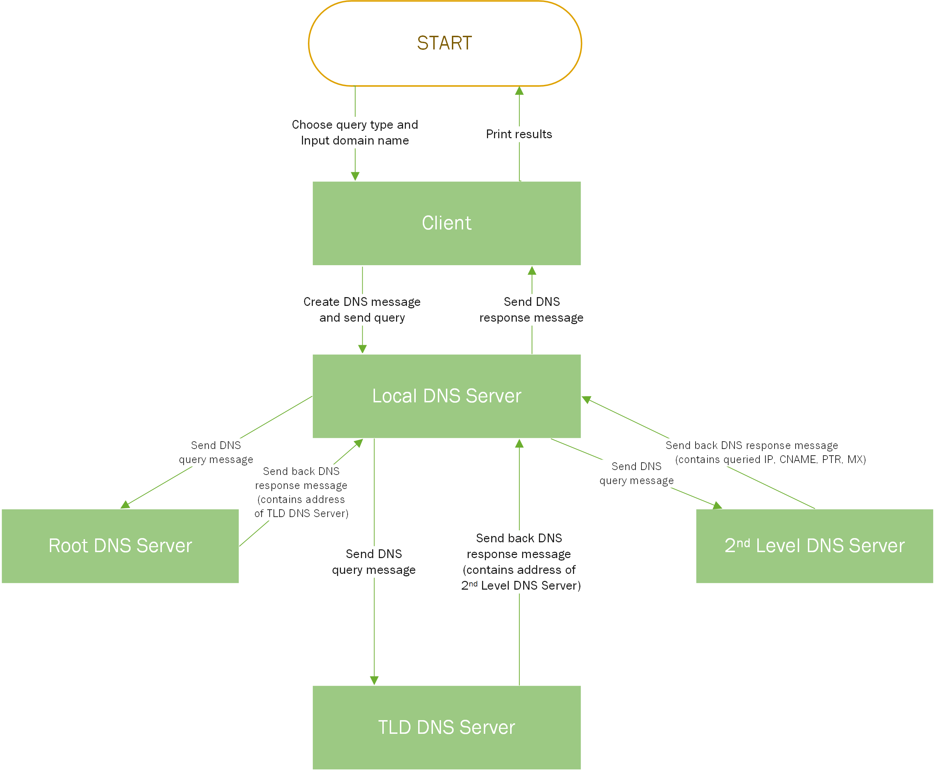

3.4 Design of data structures
We use structure to define DNS Header, DNS Query Section and DNS Resource Record (RR) Sections.
DNS Header | 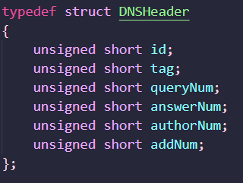
DNS Query | 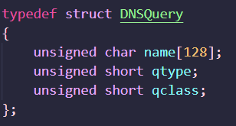
DNS Resource Record (RR) | 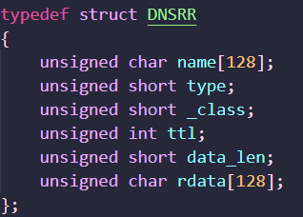

4. Detailed Design
Detailed design includes:
  - Design analysis of each module
  - Flow chart of each module

4.1 Client
The client is used to provide an interface for users to input data, then it collects data and process it to generate a packet. After finishing sending the query packet to the local server, the client waits to receive a response message. When it gets a response, it extracts information from the packet and shows it to the user.

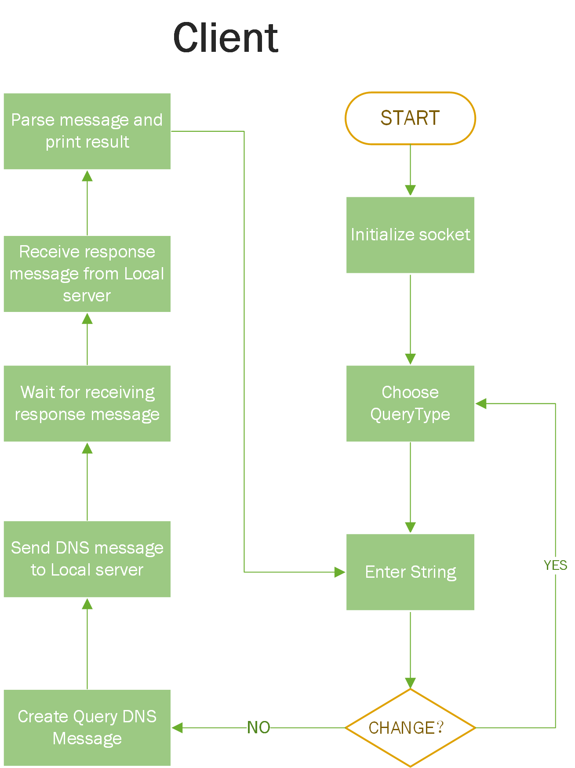

4.2 Local Server
It is listening port 53 to receive TCP packet from Client. After receiving a query, it converts receiving buffer to structure. First it will check cache to find whether there is the required data. If it can find, the local server will generate DNS response packet to client. If not, it will ask other name servers for result. When received from other name server, local server will check whether it is the final result. If not, ask the name server as the indication until get the result. Finally, it send the response to client.
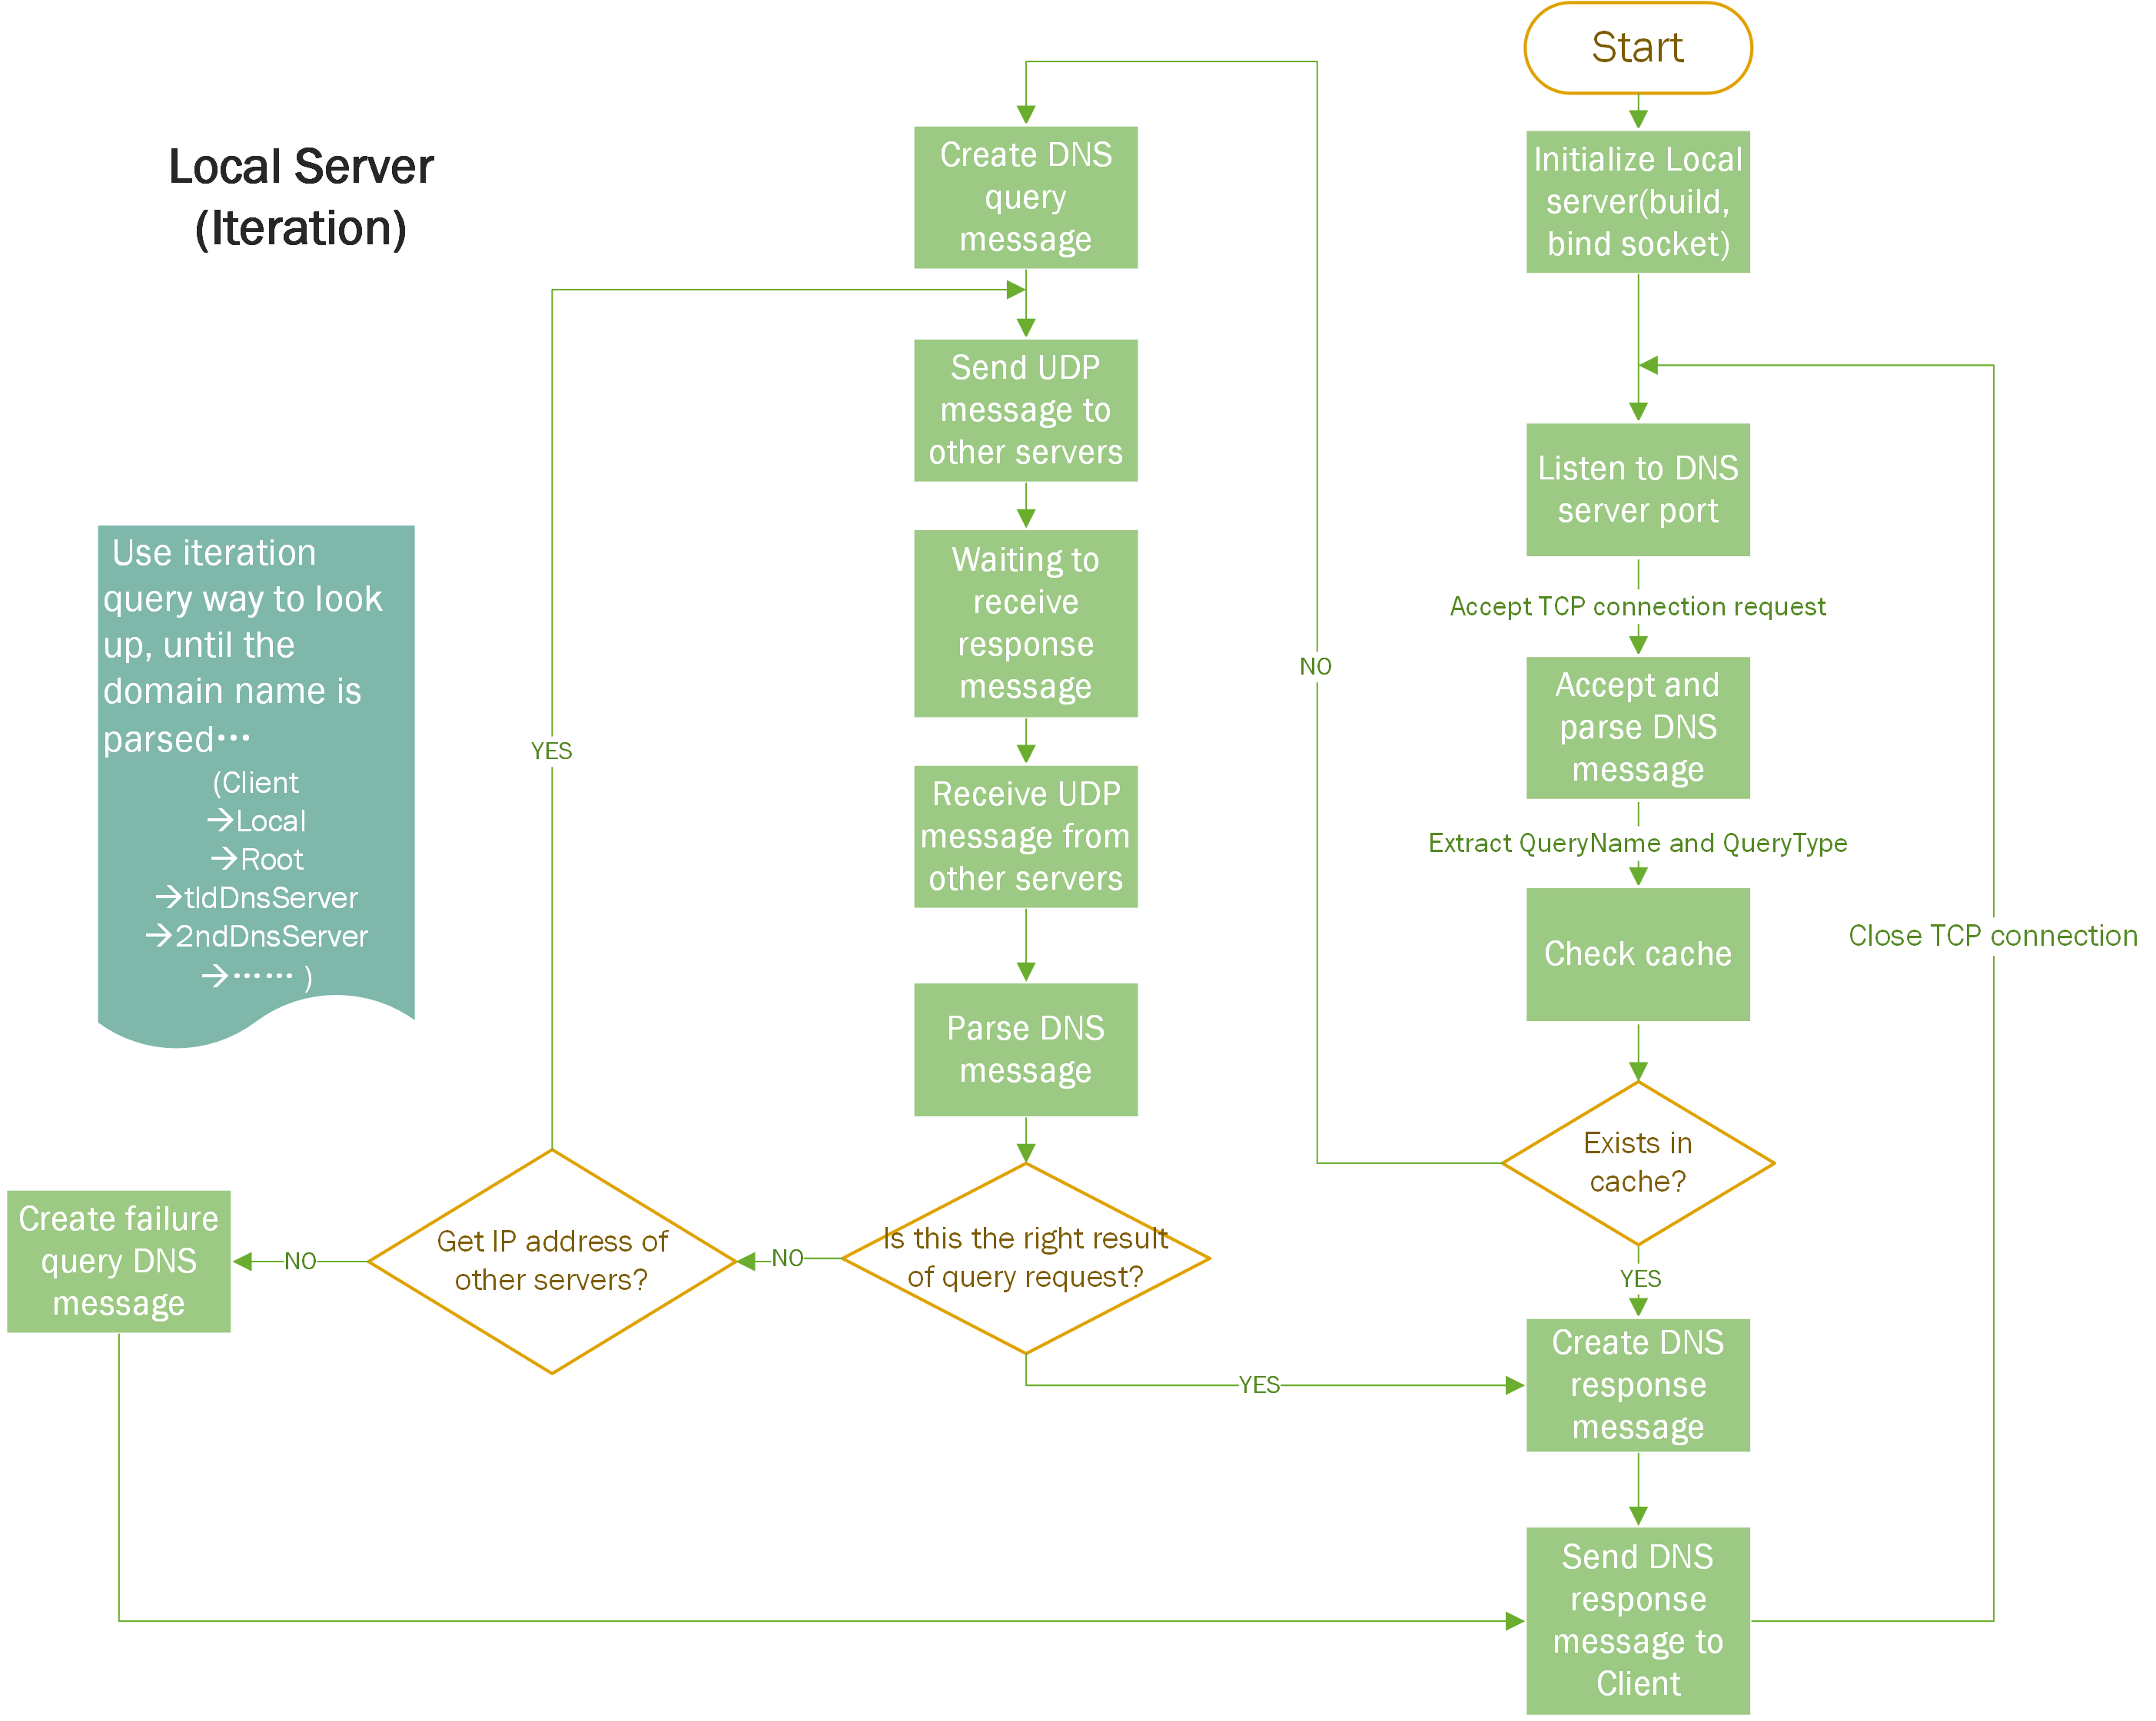

4.3 Other DNS Servers
Start with initialize its UDP socket, and bind its own address. Secondly, invoke receivefromServer() to receive the DNS query message. Thirdly, invoke getMessage() and getRR() in DNS.c to parse the DNS message header, query and RR part. Then, invoke setRR() to search Resource Record in its .txt files according to the query type. If it can fully match it in .txt files, update Resource Record and send right DNS response message back to Local server. If not, send DNS response message to Local server with no new RR, which is a query failed DNS message, if only part of domain name or IP address matches, create a response message for query in next level server.
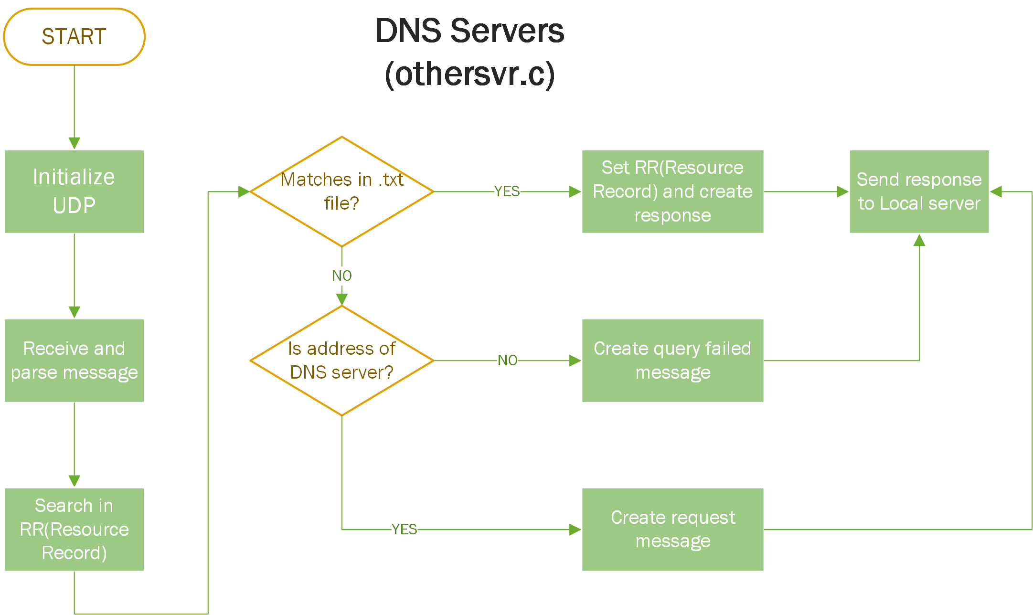

Results
Show the execution results with Screen Shot.

5.1 A type
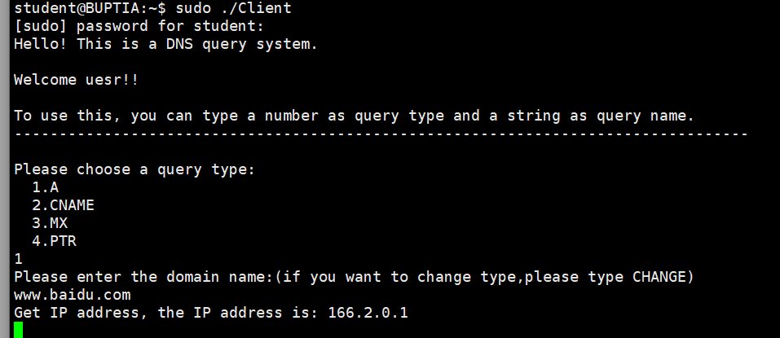
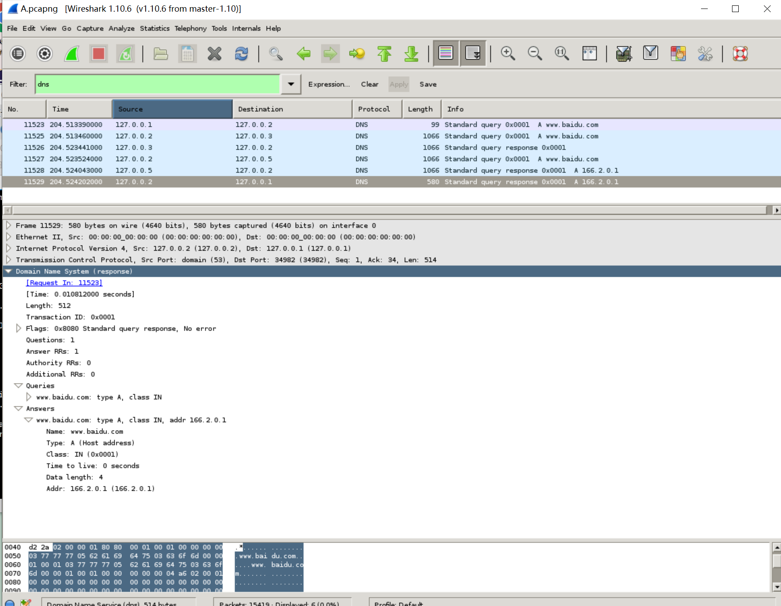

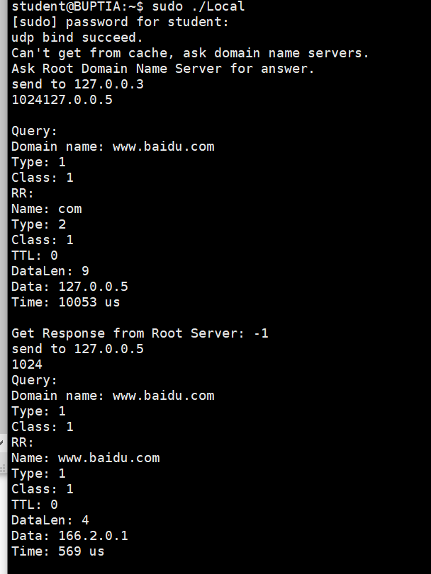

5.2 CNAME type
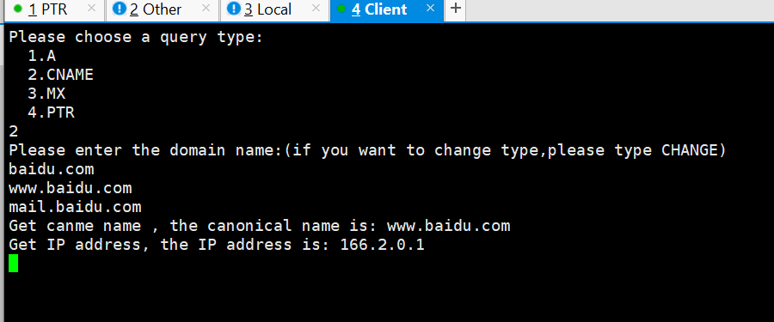
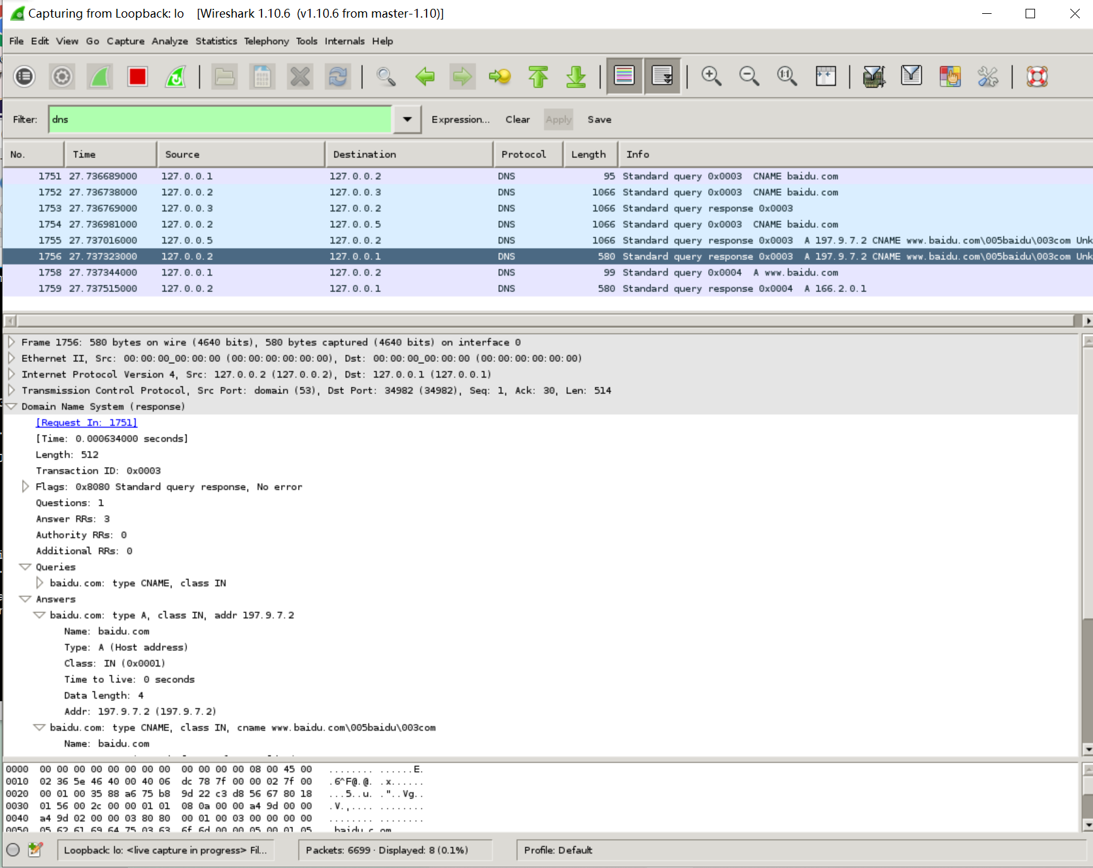
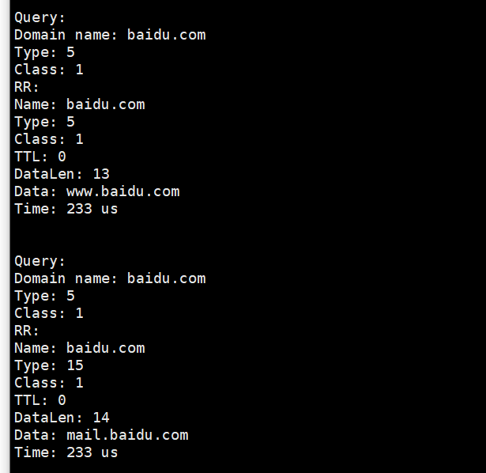

5.3 PTR type
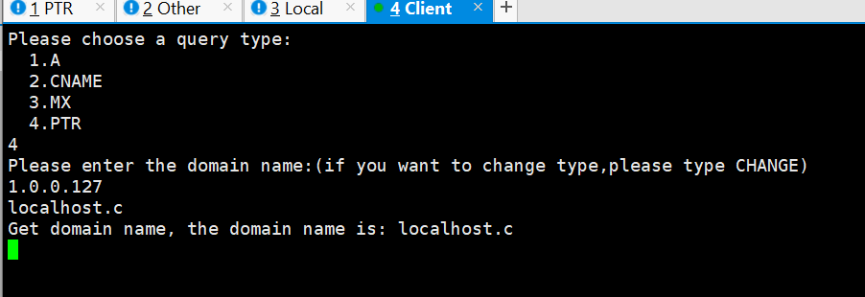
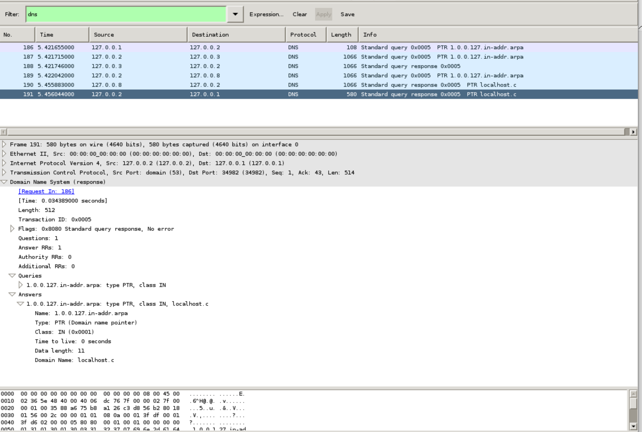

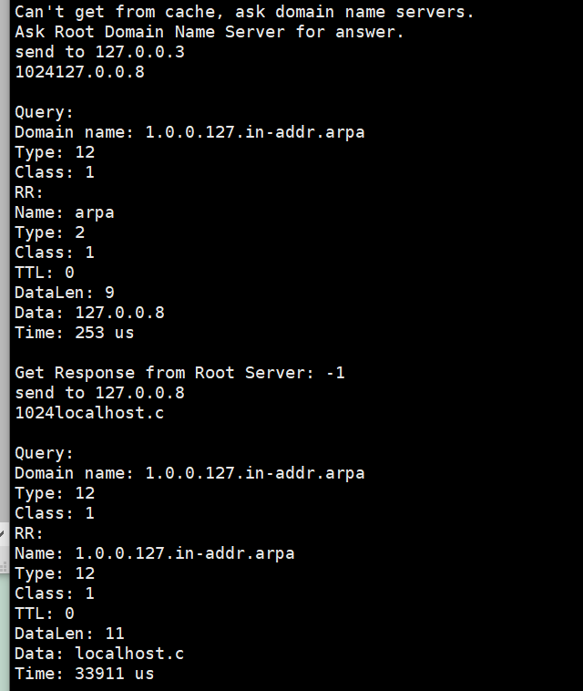

5.4 Get from cache
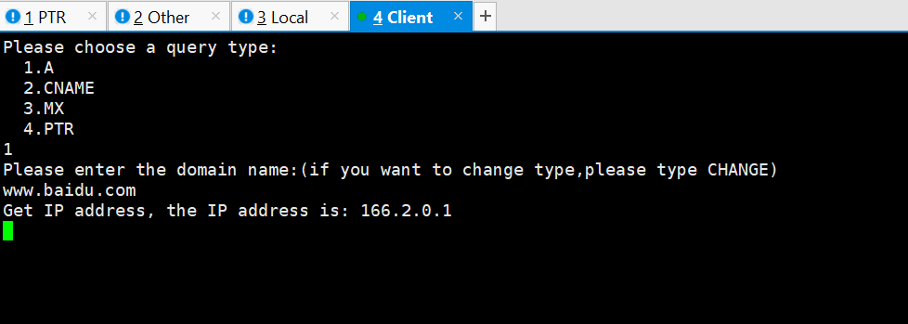
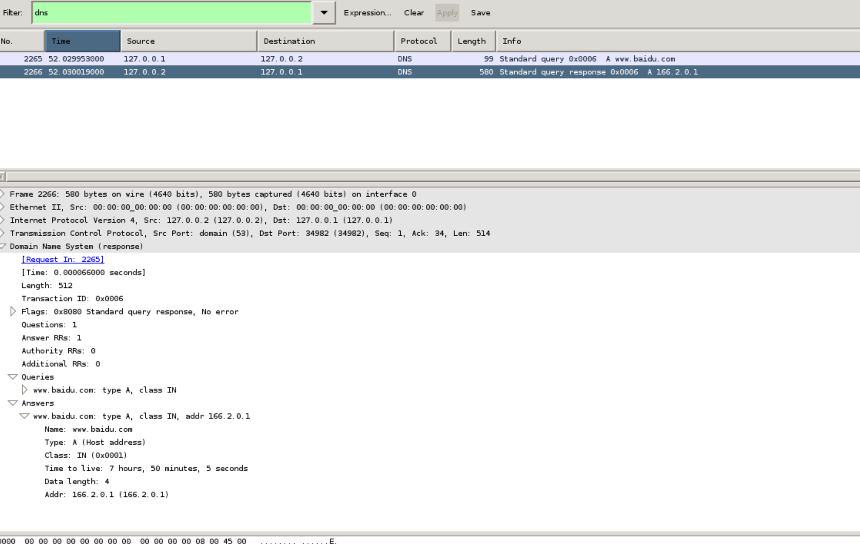
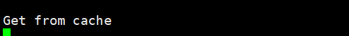

5.5 MX type
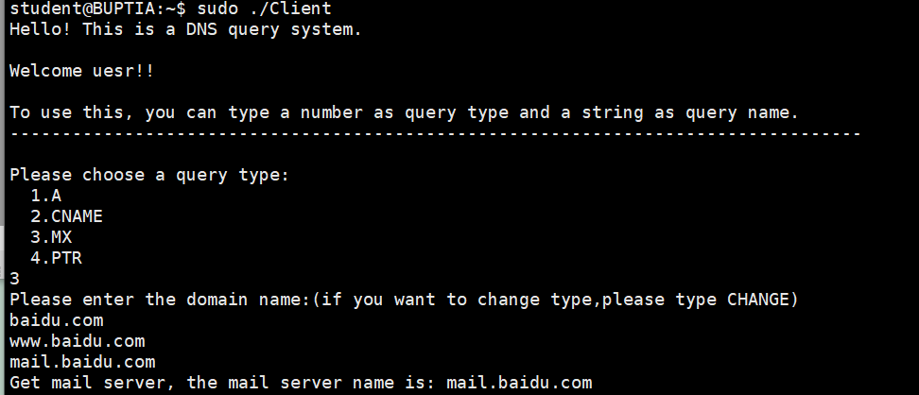
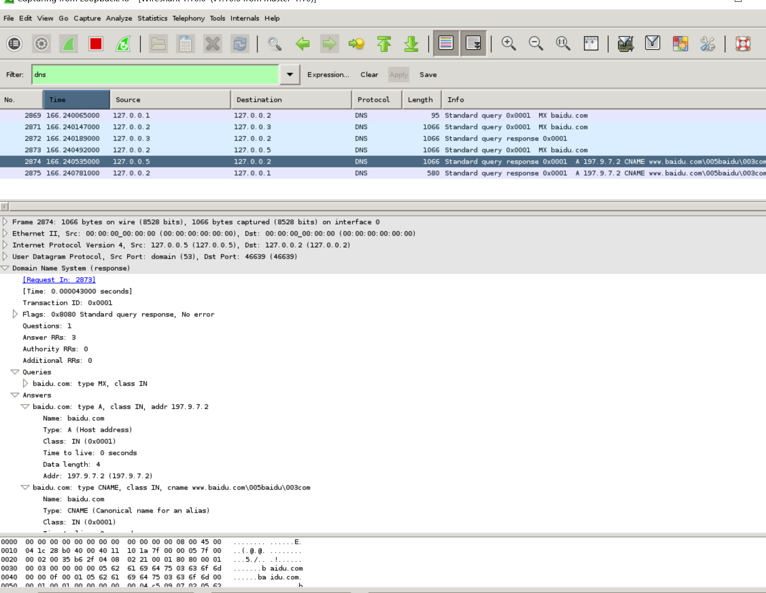
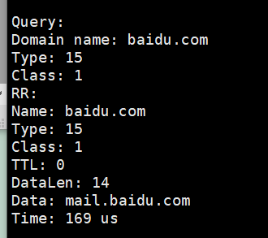

5.6 Input with wrong type
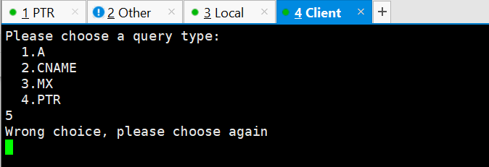

5.7 Query something which is not in the resource record
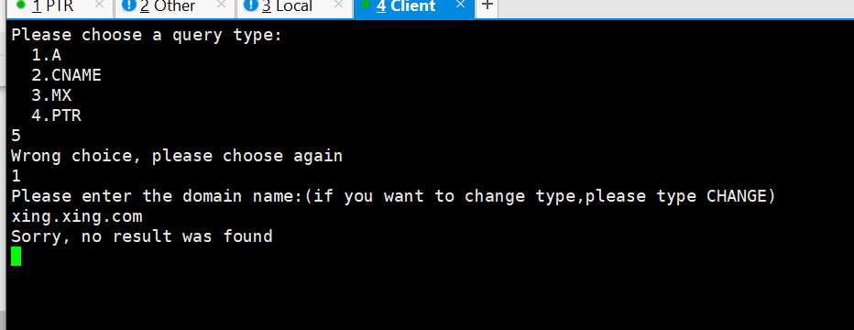
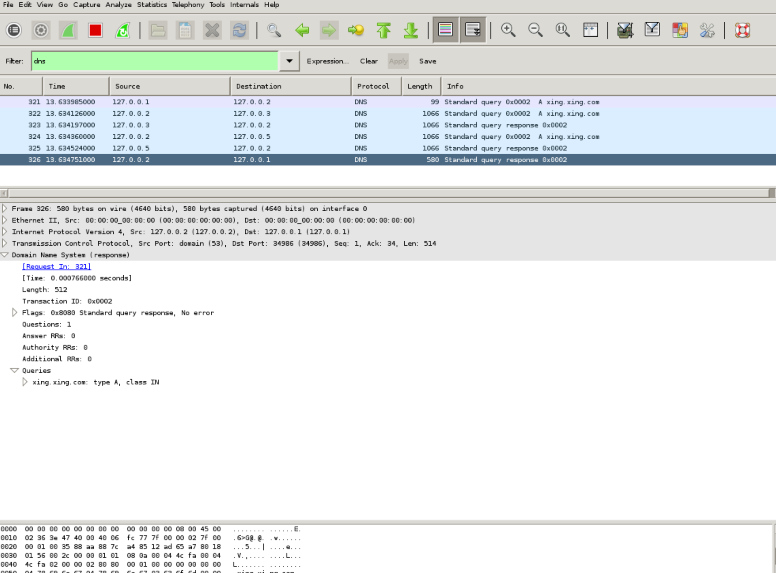
Cache file :
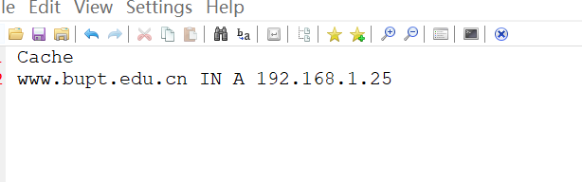

Summary and Conclusion
Specify how you divide jobs between team members and your jobs in the project. Self-evaluation of your work is given here, including future improvement.

Yuan Yuchen  (2017212758) | Mainly completes Client.c, Local.c and DNS.c.  Completed functions:  Communicate between client and server, including initiating sockets, sending and receiving packet, dealing with the query and response and etc.  Deal with the user input and display the query result in client.  Communicate with other server to get the query result in local server.  Get header, query section and resource record from packet (they will be used in all component, so we write them is a separate file—DNS.c)
Yuan Yuchen  (2017212758) | Self-evaluation: I think the total work I have done is good, but I can’t say how well it is. The basic functions are all completed. And Wireshark can resolve the packets correctly. But there are still some bugs I haven’t fixed yet and the system is not as robust as it could be. During the process, I learned how to understand the detailed work principle of DNS and also improve my practical skills. As for the future improvement, I want to improve the interface display to show the result more clearly and make the system cache more types of records. What’s more, we need to design the system with higher fault tolerance
Qiao Nisha  (2017212760) | Mainly completed Root.c, Nation.c, Other.c, Gov.c, Edu.c, PTR.c, othersvr.c servers.  Completed Client.c and DNS.c with Yuan Yuchen.  Debug and tests code in Oracle Virtual Box, Xshell, Xming and Wireshark together with Yuan Yuchen.  Completed functions:  receive and resolve query DNS message from Local server;  if part of domain name matches in corresponding .txt files in server, set RR (resource record) and create response DNS message to Local server;  if query type is MX, set additional RR in response DNS message;  send response DNS message to Local server.  Self-evaluation: Great. Although we didn’t learned about pointer and struct and struct array in C before, we can still master them in 2 weeks, which is a really, really amazing thing. Moreover, the most important thing is, I believe both of us will remember the structure of DNS message format till the end of our lives.  NO ONE KNOWS DNS BETTER THAN ME!!!

Appendix: Source Codes

