DEDICATION

THIS WORK IS DEDICATED
TO MY FAMILY

ACKNOWLEDGEMENTS
The accomplishment of this great project won’t have been a success without out the important contributions of a good number of people who gave me a huge support academically, professionally, financially and even spiritually. I then direct my appreciations to:
- Mr. Armand Claude ABANDA, the Resident Representative of AICS Cameroon for creating the Anglophone section offering the software engineering field and also for his encouragements and follow-ups. Also, for permitting us carry our internship at his institute AICS Cameroon.
- My Academic Supervisor Mrs. TCHOUTOUO ISABELLE for his time, advices, and follow-up throughout these periods.
- My Professional Supervisor Mr. TCHOUA NGATCHOU NANA Samory for his time, advices, and follow-up throughout these periods
- To my teachers (lecturers) for their words of encouragement, trust and time invested during this period.
- To my lovely family, my mum and dad must especially, thanking them for their continuous prayers, blessings, support (spiritual and financial support) and encouragements. A special thanks to my uncles and aunts.
- Mr. AGBOR ANDERSON for his time, advices, and follow-up throughout these periods.
- Mr. MESSIO for his time, advices, and follow-up throughout these periods.

SUMMARY
DEDICATION I
ACKNOWLEDGEMENTS II
SUMMARY III
LIST OF FIGURES V
LIST OF TABLES VII
LIST OF ABBREVIATIONS IX
ABSTRACT X
RESUME XII
GENERAL INTRODUCTION 14
PART I: 16
INSERTION PHASE 16
PART II: 30
TECHNICAL PHASE 30
PHASE I: EXISTING SYSTEM 31
PHASE II: SPECIFICATION BOOK 39
PHASE III : THE ANALYSIS PHASE 55
PHASE IV: THE CONCEPTION PHASE 95
PHASE V: THE DEPLOYMENT PHASE 111
PHASE VI: FUNCTIONAL TESTING 126
PHASE VII: USER GUIDE 135
PERSPECTIVE 144
GENERAL CONCLUSION 145
BIBLIOGRAPHY XI
WEBOGRAPHY XIII
ANNEXES XIV
TABLE OF CONTENT XV

LIST OF FIGURES
Figure 1: Organisation chart of INTERLINK 24
Figure 2: Localisation of INTERLINK 25
Figure 3: Gantt chart 49
Figure 4: Uml2.5 diagrams overview 61
Figure 5: Diagram of the 2TUP 64
Figure 6: Use case formalism 66
Figure 7: General use case of the system 68
Figure 8: Specific use case of manage users accounts (ADMIN) 69
Figure 9: Specific use case of manage appointment (DOCTOR) 69
Figure 10: Manage prescription specific use case (DOCTOR) 70
Figure 11: Manage pharmacy profile specific use case (PHARMACIST) 70
Figure 12: Manage inventory specific use case 71
Figure 13: Manage delivery specific use case 71
Figure 14: Communication diagram formalism 79
Figure 15: Communication diagram of authentication 81
Figure 16: Communication diagram create user 82
Figure 17: Communication diagram of make appointment 83
Figure 18: Sequence diagram formalism 84
Figure 19: Sequence diagram authentication 86
Figure 20: Sequence diagram create user 87
Figure 21: Sequence diagram of make appointment 88
Figure 22: Activity diagram formalism 89
Figure 23: Activity diagram authentication 92
Figure 24: Create user activity diagram 93
Figure 25: Activity diagram of make appointment 94
Figure 26: System physical architecture 99
Figure 27: MVC illustration diagram 100
Figure 28: Class diagram formalism 101
Figure 29: System class diagram 103
Figure 30: State machine formalism 104
Figure 31: Payment state machine 106
Figure 32: Payment state machine 107
Figure 33: Package diagram formalism 108
Figure 34:System package diagram 110
Figure 35: Formalism of the deployment diagram 115
Figure 36: System deployment diagram 117
Figure 37: Component diagram formalism 118
Figure 38: Component Diagram 120
Figure 39: Login Screen 130
Figure 40:Create Doctor account 131
Figure 41: Patient Dashboard 132
Figure 42: Unit test Register 133
Figure 43: Login unit test 134
Figure 44:Downloading pharmalink 140
Figure 45: Create Account 141
Figure 46: Login form 142
Figure 47: Services in the system 143

LIST OF TABLES
Tableau 1: Table of partners 20
Tableau 2: Hardware resource of INTERLINK 24
Tableau 3: Software resources of INTERLINK 25
Tableau 4: Criticism of the existing system 34
Tableau 5: Project planning 46
Tableau 6: Software resources needed 48
Tableau 7: Hardware resources needed source mercurial 2026 49
Tableau 8: Human resource needed 49
Tableau 9: Estimated cost table 49
Tableau 10: Table of participant 51
Tableau 11: Comparative study between UML and MERISE 60
Tableau 12: Component of use case diagram 65
Tableau 13: Authentication textual description 70
Tableau 14: Use case reschedule appointment 71
Tableau 15: Create prescription textual description 72
Tableau 16: Textual description create user account 73
Tableau 17: Textual description update pharmacy details 74
Tableau 18: Textual description add new stocks 75
Tableau 19 : Textual description accept Delivery 76
Tableau 20 : Component of communication diagram 79
Tableau 21:Components of a sequence diagram 84
Tableau 22: Component of an activity diagram 89
Tableau 23: Component of a class diagram 101
Tableau 24 : Component of state machine diagram 105
Tableau 25: Component package diagram 109
Tableau 26:Components of the deployment diagram 116
Tableau 27:Elements of the component diagram 119
Tableau 28:Materials used to develop our platform 121
Tableau 29: Software material used for the project 125

LIST OF ABBREVIATIONS
- 2TUP: Two Track Unified Process
- API: Application Programming Interface
- AICS: African Institute Of Computer Science
- CD-ROM: Compact Disk- Read Only Memory
- CRUD: Create Read Update Delete;
- DBMS: Database Management System
- ICT: Information And Communication Technology
- IOT: Internet Of Things
- SDLC: System Development Life Cycle

ABSTRACT
Humanity has evolved at an exponential rate over the past few centuries, driven by relentless innovations in technology that have profoundly changed the way we work, communicate, and interact with the world. In the field of healthcare, technology has become an indispensable force, reshaping how patients access medical services and how professionals deliver care. For this reason, the African Institute of Computer Sciences (AICS) is committed to making Cameroon a key player in the ICT revolution by offering students practical training through academic internships, giving them the opportunity to apply theoretical knowledge to real-world problems.
In line with these perspectives, we approached Interlink, which graciously hosted our internship and assigned us the theme: "Digital Health Ecosystem — Design and Implementation of a Connected Health Platform: Medication Tracking, Real-Time Patient-Doctor-Pharmacist Connection, Online Consultation, and Medicine Delivery with Chatbot." This theme gave birth to PharmaLink, an intelligent mobile healthcare delivery platform designed to bridge the gap between patients, doctors, pharmacists, and delivery drivers in Yaoundé, Cameroon. The application was developed using Flutter and Dart for the mobile frontend, Node.js with Express for the backend API, and PostgreSQL as the relational database, integrated with Google Maps for real-time delivery tracking, Gemini AI for the intelligent health chatbot, and Africa's Talking for SMS-based OTP verification, delivering a flexible, scalable, and secure healthcare solution that addresses the real needs of the Cameroonian population.
Keywords:
ARTIFICIAL INTELLIGENCE
HEALTHCARE DELIVERY
REAL-TIME TRACKING
MOBILE APPLICATION
CONNECTED HEALTH PLATFORM

RESUME
L'humanité a évolué à un rythme exponentiel au cours des derniers siècles, portée par des innovations technologiques incessantes qui ont profondément changé la façon dont nous travaillons, communiquons et interagissons avec le monde. Dans le domaine de la santé, la technologie est devenue une force indispensable, redessinant la manière dont les patients accèdent aux services médicaux et dont les professionnels dispensent les soins. C'est pourquoi l'Institut Africain des Sciences Informatiques (AICS) s'engage à faire du Cameroun un acteur clé de la révolution des TIC en offrant à ses étudiants des formations pratiques à travers des stages académiques, leur donnant l'opportunité d'appliquer leurs connaissances théoriques à des problèmes concrets.
Dans cette perspective, nous avons approché Interlink, qui nous a gracieusement accueillis pour notre stage et nous a assigné le thème : « Écosystème de Santé Numérique — Conception et Implémentation d'une Plateforme de Santé Connectée : Suivi des Médicaments, Connexion en Temps Réel Patient-Médecin-Pharmacien, Consultation en Ligne et Livraison de Médicaments avec Chatbot. » Ce thème a donné naissance à PharmaLink, une plateforme mobile intelligente de livraison de soins de santé conçue pour combler le fossé entre les patients, les médecins, les pharmaciens et les livreurs à Yaoundé, au Cameroun. L'application a été développée en utilisant Flutter et Dart pour le frontend mobile, Node.js avec Express pour l'API backend, et PostgreSQL comme base de données relationnelle, intégrée à Google Maps pour le suivi des livraisons en temps réel, à Gemini AI pour le chatbot de santé intelligent, et à Africa's Talking pour la vérification OTP par SMS, offrant ainsi une solution de santé flexible, évolutive et sécurisée qui répond aux besoins réels de la population camerounaise.
Mots-clés :
- INTELLIGENCE ARTIFICIELLE
- LIVRAISON DE SOINS DE SANTÉ
- SUIVI EN TEMPS RÉEL
- APPLICATION MOBILE
- PLATEFORME DE SANTÉ CONNECTÉE

GENERAL INTRODUCTION
In today's healthcare landscape, patients and healthcare providers face growing challenges in managing medication adherence, enabling real-time communication, and ensuring timely medicine delivery. Traditional healthcare systems often operate in silos, with fragmented communication between patients and pharmacists, limited tracking of medication schedules, and minimal personalized support for treatment adherence. These gaps can lead to medication non-compliance, delayed interventions, and reduced quality of care. To overcome these limitations, this project presents the design and implementation of a connected digital health ecosystem—an intelligent platform that integrates medication tracking, real-time patient-pharmacist connection, medicine delivery services, and an interactive chatbot for personalized assistance. The system seeks to combine healthcare efficiency with AI-driven support, offering real-time medication reminders, seamless communication channels, automated delivery coordination, and intelligent conversational assistance to enhance patient adherence and overall health outcomes. The project's analysis and design adopt the 2TUP (Two-Track Unified Process) methodology, emphasizing both business and system modeling for a comprehensive understanding of user needs and system functionalities. Using UML (Unified Modeling Language) diagrams—such as use case, class, sequence, and activity diagrams—the system is modeled to represent its behavior, user interactions, and data structures. This structured analytical approach establishes a solid foundation for subsequent design and implementation phases.
Project Phases:
- PART I: The Insertion phase: This book presents the company in which we spent our internship period and the integration of interns.
- PART II: Technical phase: which is composed of the following:
- PHASE I: Existing System: Here, we shall present the already present system in place, that is the one used for facilitating learning and management purposes.
- PHASE II: The specification book: In this book, we specify the needs of the user taking into consideration the time and cost of the project.
- PHASE III: Analysis book: Here, we present the analysis method chosen with the presentation of all the diagrams used for the analysis of this project.
- PHASE IV: Design phase: This presents the generic and detailed conception of the project to bring out real-world constituents, including the gamified interface and interactive learning pathways.
- PHASE V: Deployment phase: This phase will permit us to visualize the implementation process of the solution.
- PHASE VI: Test of functionalities: In this phase, we shall present to you the different functionalities or modules of our application (such as the dashboard, course generation, and progression tracking) and how they work.
- PHASE VII: User guide: which guides the user on how to install and use the application.

PART I:

INSERTION PHASE

Preamble

The insertion phase document presents the internship environment, the structure of the organization, the conditions in which the interns were received, as well as the project to be realized during the internship.

Overview

INTRODUCTION
- WELCOME AND INTEGRATION
- GENERAL PRESENTATION OF THE COMPANY
- ORGANISATION OF THE COMPANY
- GEOGRAPHICAL LOCATION
- COMPANY RESOURCES
- BRIEF PRESENTATION OF THE PROJECT THEME
CONCLUSION

INTRODUCTION
The insertion phase in a company is a period during which we discover our working environment, the staff of the company and other intense. Here, we will begin by discussing our first two weeks in the company, how we were welcomed and how we began adaptation to our internship environment, we will proceed by exploring the history of the company, discovering its missions, learning what its major activities are, and witnessing some of its key realizations. We will also get to understand how the company is structured administratively and functionally so that it operates effectively and accomplishes its goals. Furthermore, we will look at the hardware equipment used by the company, and the software resources used in its daily operations. We will then introduce our chosen theme for the internship period, briefly elaborate on it.
WELCOMING AND INTEGRATION

Welcome
Upon our arrival at INTERLINK, the reception was very simple. We were first taken to the meeting room, introduced to each team member, and then each of us introduced ourselves with our name, class, school, reason for being there, duration of the internship, and how we were admitted.
The Director then gave a welcome speech and instructed the intern coordinator to give us a full tour of the company. Finally, based on our academic fields, we were assigned to different departments

Integration
At first, adjusting was quite intense due to the workload and pressure of meeting tight deadlines. However, after three days, adaptation was achieved.

GENERAL PRESENTATION OF INTER-LINK

History
INTERLINK is a company specializing in software development, online presence management, digital marketing, tech consulting, systems maintenance, IT training and consultancy, network design and implementation, and surveillance camera installation.
It was founded in 2026 by Mr. TCHOUA NGATCHOU NANA SAMORY and Mr. BANGOUP Rufin, who had a futuristic vision for digital transformation in businesses. Today, INTERLINK supports and works with over 10 companies aiming to align with digital standards. Its headquarters is in Yaounde, with a branch office in Douala.

Mission
INTERLINK main mission is to promote digital transformation for individuals and businesses. Its objectives include:
Providing a new image of Africa (especially Cameroon) to the world by helping businesses move from analog to digital to improve performance.
Creating software, logos, flyers, websites, and network installations.
Offering quality training to company staff and individuals, believing every African should master digital tools.

Activities
INTERLINK is a key player in digital transformation across various business sectors. Its solutions include:
- System Integration: Helping companies adapt to digital tools.
- IT Strategy and Organization Consulting: Advising on IT service organization and strategies.
- Project Management: Supporting businesses throughout project execution.
- Communication & Digital Marketing: Handling online presence, including web design and content.
- Web & Mobile Application Development: Building websites and apps with attention to quality.

Achievements
- Design and implementation of a Travel Management System (TMS) for GHF SARL
- Network deployment and maintenance for SOCADEP, CWORTH ENERGY, and individuals
- Installation of surveillance systems at EMERIX COMPANY and private residences
- Design of logos and flyers for SMARTEKS, LA PETITE BAYAM,
FONDATION PAVI, and individuals
- Online presence management for LA PETITE BAYAM, SMARTEKS,
PENTIUM GSM, and others
- Creation of a professional training center with JPTEKS
- Maintenance of IT equipment for FONDATION PAVI and others.

Partners
INTERLINK as an economic enterprise has the following partners who greatly help in the development of their enterprise.
Tableau 1: Table of partners
PARTNERS
• SOCADEP 
• EMERIX. 
• JPTEKS
• PENTUIM GSM 

• FONDATION PAVI. 

ORGANIZATIONAL CHART OF INTERLINK
INTERLINK has several departments.

Administrative Organization
Interlink is administratively organized as follows:

Executive Leadership
This department is responsible for:
- Setting the company's vision, mission, and strategic direction
- Making high-level decisions about investments, partnerships, and growth
- Representing Interlink in key meetings with investors and government agencies
- Ensuring all departments align with the company's core values and objectives
- Overseeing the overall performance and sustainability of the organization

Software Engineering Department
This department is responsible for:
- Designing, developing, and maintaining all of Interlink's software products
- Implementing AI and machine learning solutions for company offerings
- Ensuring software security, scalability, and optimal performance
- Collaborating with other departments to understand technical requirements
- Staying updated with emerging technologies and industry best practices

Human Resources Department
This department is responsible for:
- Recruiting and onboarding top talent that aligns with Interlink's values
- Managing employee relations, welfare, and performance evaluations
- Developing training programs to enhance staff skills and capabilities
- Maintaining company culture and ensuring a positive work environment
- Handling compensation, benefits, and conflict resolution

Communication Department
This department is responsible for:
- Managing Interlink's public image and brand reputation
- Developing and executing marketing and PR strategies
- Handling all internal and external communications
- Managing social media platforms and digital content
- Organizing corporate events and press engagements

Department of Financial Affairs
This department is responsible for:
- Managing all financial operations and accounting
- Preparing budgets and financial forecasts
- Handling payroll, taxes, and financial reporting
- Ensuring compliance with financial regulations
- Managing investments and financial partnerships

Functional Organisation
The functional branch of Interlink is organized as follows:
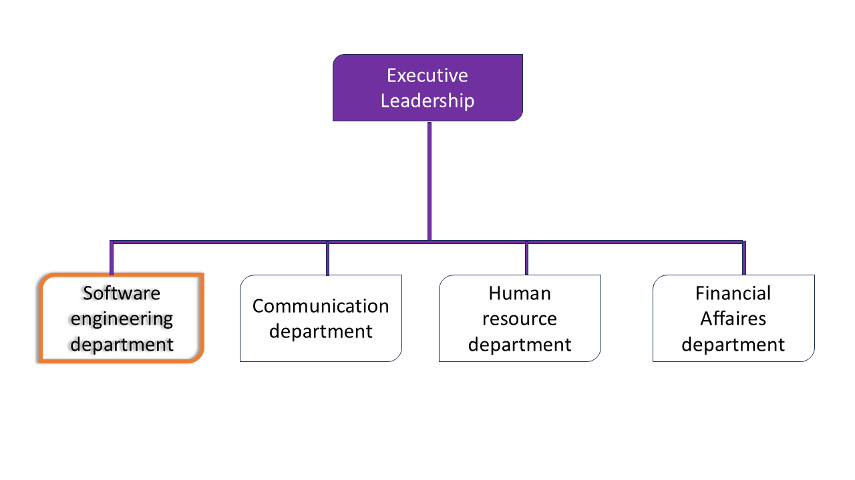
Figure 1: Organisation chart of INTERLINK

GEOGRAPHICAL LOCATION
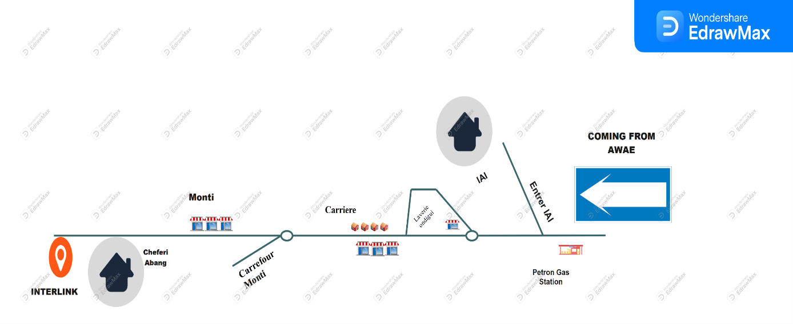

Figure 2: Localisation of INTERLINK

INTERLINK is located at Abang, 3 kilo meters from AWAE Escalier.

COMPANY RESOURCES

Hardware Resources
Tableau 2: Hardware resource of INTERLINK
N | Equipment | Characteristic | Quantity
1. | Computer sever |   Desktop HP | 03
2. | Laptop computer |   Laptop HP | 05
2. | Laptop computer |   Laptop Dell | 05
3. | Routers |   Cisco catalyst 1941 | 01  01
3. | Routers |   Tp-link (wifi) | 01  01
4. | Switch |   Switch cisco catalyst 24 ports | 01
5. | Optic fibre | Camtel | 01
6. | Modem | Modems MTN 4G 01  Modems Toplink 5G | 01  01
7. | Ethernet cable | Twisted pair CAT6 | 01

Software Resources
Tableau 3: Software resources of INTERLINK
N° | Software | Description
01 |   Office suite | Standard Office Suite for creating documents, spreadsheets, presentations, and other professional content.
02 |   Windows 11 | Operating System for computer.
03 |   WPS | Word Processing software.
04 |   Adobe suite | Professional Suite for image editing, illustration creation, video editing, and audio editing.
05 |   Canva | Online Graphic Design Platform for creating professional visuals, presentations, social media publications, etc.
06 |   Visual studio code | IDE (Integrated Development Environment), a free and open-source environment, very popular for web and mobile development.
07 |   Wamp | Local Web Development Environments, including Apache, MySQL, and PHP, for testing and deploying web applications locally before putting them online.
08 |   Cisco ISE | Authentication Management Tools (such as Active Directory) for managing authentications within information systems
09 |   ENSP of HUAWEI | Email Monitoring Software (such as Microsoft Exchange Monitor), a useful tool for monitoring and optimizing mail server operations
10 |   SolarWinds | Email Monitoring Software (such as Microsoft Exchange Monitor), a useful tool for monitoring and optimizing mail server operations
11 |   EVE NG | GNS3 (or other network simulation software), a software for simulating networks through clientless virtualization.
12 |   Eclipse | Open-source Integrated Development Environment (IDE)Used for software development in various languages, including:Java, C++, Python, PHP
 |   GitHub | Source Code Management Platform, used to store, share, and collaborate on software projects.

BRIEF PRESENTAION OF THE PROJECT THEME
When we started at INTERLINK, we wanted to propose a project that matches the company's goal of building modern software. We noticed that patients often struggle to keep up with their medications, reach a pharmacist in time, book doctor consultations, and get their medicines delivered without stress. We saw a chance to fix this by turning a fragmented healthcare experience into one connected, intelligent platform. This led us to our theme: "CONNECTED HEALTH PLATFORM."

This project is an application that helps patients manage their medications, connect in real time with pharmacists, consult doctors online, and order medicines for delivery — all guided by a smart chatbot. The system has four main parts:
- Admin Interface: Allows administrators to manage user accounts, verify pharmacists and doctors, oversee medicine inventory, and monitor platform activity.
- Patient Dashboard: Allows patients to upload prescriptions, set medication reminders, track their daily adherence streaks, book consultations, and order medicines for delivery.
- Pharmacy & Consultation Module: Manages the secure onboarding of pharmacists and doctors, enables real-time patient–pharmacist chat, and hosts online consultation sessions.
- AI Chatbot & Analytics: Features an intelligent chatbot that answers medication questions, offers basic symptom triage, and guides patients to the right professional. It also tracks adherence, sends refill alerts, and manages the patient's health history.
The goal of this platform is to make healthcare access easy, reduce missed doses and complications, and help patients live healthier lives through daily habits and continuous connection to care.

CONCLUSION
Upon completing our integration, we have gained a thorough understanding of the work environment in which we will be operating during our internship. We have acquainted ourselves with the structure's history, missions, responsibilities, organization, various resources, and organizational chart, enabling us to confidently proceed to the second part of the report, the specifications document.

PART II:

TECHNICAL PHASE

PHASE I: EXISTING SYSTEM

Preamble
The insertion phase helped us to establish a comprehensive understanding of the host organization. This phase emphasizes on the key characteristics, specificities, and objectives of the designated study subject.
Content Overview
INTRODUCTION
- THEME PRESENTATION
- STUDY OF THE EXISTING SYSTEM
- CRITICISM OF THE EXISTING SYSTEM
- PROBLEMATICS
- PROPOSED SOLUTION

CONCLUSION

INTRODUCTION
Before designing our Connected Health Platform, we must first understand how patients currently manage medications, reach pharmacists, consult doctors, and receive medicines. Studying existing systems reveals what works, what frustrates users, and where care breaks down. It also exposes real struggles — missed doses, delayed advice, and disconnected services. By examining these gaps, we can pinpoint exactly where today's healthcare experience fails. This analysis will shape the features our platform must provide — and how it can deliver care that is seamless, connected, and truly patient-centered.

THEME PRESENTATION
The project theme is centered on a recurring problem: patients find it difficult to manage their medications consistently, struggle to reach pharmacists and doctors in time, and often delay seeking care until their condition worsens — resulting in complications, stress, and poor health outcomes. Interlink was proposed as a solution: a connected health platform that unifies medication tracking, real-time patient–pharmacist communication, online consultations, medicine delivery, and an intelligent chatbot into one seamless experience — turning fragmented care into continuous, daily, patient-centered support.

STUDY OF EXISTING SYSTEM
The closest existing systems studied for this project are telehealth and digital pharmacy platforms such as MyTherapy, Medisafe, and Practo. MyTherapy and Medisafe focus on medication reminders and adherence tracking, while Practo connects patients to doctors for online consultations and medicine delivery.
Their core workflow is fragmented: Medisafe reminds patients to take pills but offers no real pharmacist connection; Practo enables consultations but lacks integrated adherence tracking or a continuous AI companion. Patients are forced to juggle multiple apps, each solving only one piece of the puzzle.
These systems also provide limited real-time interaction — chatbots are often generic, pharmacists are rarely reachable instantly, and delivery is disconnected from prescriptions. This confirms the gap Interlink fills: one connected platform where tracking, consultation, chat, delivery, and AI guidance work together seamlessly.

CRITICISM OF THE EXISTING SYSTEM
Tableau 4: Criticism of the existing system
Limitations | Solution | Critics
Medisafe sends medication reminders, but it does not connect the patient to a pharmacist when something goes wrong. | Pharmalink links each reminder to a real-time patient–pharmacist chat, so help is one tap away when a dose is missed or a reaction occurs. | Patients miss doses or experience side effects but have no one to ask, leading to confusion, self-medication, or dangerous delays.
Practo enables online consultations, but the experience ends when the call ends — no follow-up, no adherence tracking, no delivery link. | Pharmalink keeps care continuous: consultations feed directly into medication schedules, chatbot reminders, and follow-up check-ins. | Patients forget the doctor's advice, skip medications, and lose continuity of care between appointments.
Medicine delivery apps are separate from consultation and prescription apps. | Phamalink unifies consultation, prescription, ordering, delivery, and tracking into a single seamless workflow. | Patients juggle multiple platforms — one to consult, one to order, one to track — causing frustration and dropped treatments.
Existing chatbots give generic health answers not tied to the patient's own prescriptions or history. | Pharmalink’s AI chatbot is grounded in the patient's own prescriptions, history, and pharmacist input — delivering personalized, safe guidance. | Patients receive unsafe, irrelevant advice and lose trust in the tool.
Most platforms have no habit or reward system for adherence. | pharmalink uses adherence streaks, health points, and progress dashboards to make consistent medication a rewarding daily habit. | Patients lose motivation, especially for chronic conditions requiring long-term daily medication.
Admin oversight is minimal — fake pharmacies, unverified doctors, and counterfeit medicines slip through. | Pharmalink gives administrators full control to verify pharmacists, doctors, and inventory, ensuring trust and safety across the platform. | Patients risk their health by trusting unverified providers and products.

PROBLEMATICS
Given the above, the central problem this project addresses is: how can a single platform automatically transform a patient's own prescriptions, health records, and daily needs into a structured, connected, and habit-forming care routine — going beyond simple reminders?
This raises deeper questions:
- How can medication tracking, real-time pharmacist access, online consultations, and medicine delivery be unified without overwhelming the patient?
- How can an AI chatbot provide safe, personalized guidance grounded in each patient's own prescriptions and history?
- How can adherence be made rewarding enough to sustain long-term daily habits, especially for chronic conditions?
- How can administrators guarantee trust — verifying pharmacists, doctors, and medicines — while keeping the experience fast and seamless?
Answering these questions defines the design and implementation of Connected Health Platform.

PROPOSED SOLUTION
- Smart Prescription & Health Record Breakdown
To solve the problem of scattered and complex medical information, the platform uses AI to automatically extract text from prescriptions, lab results, and health documents. It then converts this raw data into clear, digestible insights — medication names, dosages, schedules, and warnings — so the patient never feels overwhelmed or confused about their treatment.
- Automatic Daily Care Roadmap
To build a truly structured routine, the system takes all the planning work away from the patient. When a prescription is uploaded, Interlink automatically calculates the full treatment schedule and maps out a precise day-by-day plan — which medicine to take, when, and for how long. The patient knows exactly what to do each day without having to think about it.
- Active Monitoring & Professional Connection
To go beyond simple reminders, the platform acts as an active health companion. It generates daily check-ins and symptom questions, and the patient must confirm their status before the next day's plan advances. If anything looks wrong, the system instantly connects the patient to a pharmacist or doctor through real-time chat — ensuring no concern goes unanswered.
- Integrated Health Calendar & Analytics
To help patients manage their health over time, the platform includes a built-in calendar and analytics view. This feature lets users track adherence streaks, visualize progress across the month, review past consultations, and monitor refill dates. Seeing a clear record of their health journey keeps them organized, accountable, and in control of their treatment.
- AI Chatbot & Medicine Delivery
To complete the circle of care, Phamalink includes an intelligent chatbot grounded in the patient's own prescriptions and history — answering medication questions, offering basic triage, and guiding patients to the right professional. When a refill or new medicine is needed, the patient can order directly through the platform and have it delivered to their door — closing the gap between advice and action.

CONCLUSION
This analysis shows that existing health platforms, such as Medisafe and Practo, can help patients manage reminders or consult doctors individually. However, they do not fully address the need for a consistent, connected, and engaging daily care experience. Patients still need motivation, clear treatment goals, progress tracking, real-time professional access, and convenient ways to act on their prescriptions. Therefore, Connected Health Platform aims to fill this gap by combining AI-powered health assistance allowing patients to manage their own medications through daily check-ins, adherence streaks, rewards, real-time pharmacist chat, online consultations, and medicine delivery — all in one seamless platform.

PHASE II: SPECIFICATION BOOK

Preamble
The insertion phase helped us to establish a comprehensive understanding of the host organization. This phase emphasizes on the key characteristics, specificities, and objectives of the designated study subject
Content Overview

INTRODUCTION

I.

CONTEXT AND JUSTIFICATION OF PROJECT

II.

PROJECT OBJECTIVES

III.

EXPRESSION OF NEEDS
-

IV.

PROJECT PLANNING

V.

ESTIMATED COST OF PROJECT

VI.

PROJECT CONSTRAINTS

VII.

DELIVERABLES

CONCLUSION

INTRODUCTION
The specification book is a crucial part in software engineering process. For this reason, care must be taken when elaborating this document in order for the solutions to clearly satisfy the client’s needs. This document permits us specify the expectations of the client(s), there by establishing a certain agreement between the client(s) and the person(s) to realize or develop the project. This specification book is to avoid inadequate production result

CONTEXT AND JUSTIFICATION

Context
The healthcare landscape in Cameroon and across Africa faces significant challenges in managing patient care, medication access, pharmacy services, and health communication. Manual processes for appointment booking, prescription management, and pharmacy operations result in errors, delays, and inconsistent access to quality care. Patients struggle to find available doctors and book timely consultations, often visiting multiple pharmacies in search of medications, while communication between doctors, patients, and pharmacists remains fragmented, leading to medication errors and poor health outcomes. Pharmacies still rely on outdated manual inventory systems, causing stockouts and losses from expired drugs, while patients with chronic conditions frequently miss doses due to the absence of refill reminders and adherence tracking. To address these issues, this study proposes the conception and implementation of PharmaLink, an Intelligent Connected Health Platform that centralizes patient, doctor, and pharmacy data, automates healthcare workflows, provides AI-driven analytics, and supports real-time communication between patients, doctors, and pharmacists. This system will streamline healthcare delivery, enhance decision making, and improve the overall healthcare experience in Cameroon and beyond.

Justification
Implementing an intelligent connected health platform is essential to improve efficiency, safety, and health outcomes for patients, doctors, and pharmacists alike. The proposed system will provide a centralized platform for patient records, prescription management, pharmacy operations, and medication adherence support. Key benefits include:
- Enhanced Data Management: Improved accuracy, security, and accessibility of patient, prescription, and pharmacy records.
- Improved Access to Care: Patients can find doctors, book appointments, and receive consultations without unnecessary delay.
- Reduced Medication Errors: Direct digital transmission of prescriptions from doctors to pharmacies eliminates transcription errors and duplicate prescriptions.
- Better Medication Adherence: Automated refill reminders and adherence tracking help patients with chronic conditions stay on treatment.
- Efficient Pharmacy Operations: Real-time inventory management reduces stockouts and expired-stock losses, and enables online order management.
- Reliable Delivery: Real-time tracking and coordination with delivery riders meet growing e-commerce expectations.
- Data-Driven Decision-Making: AI-driven analytics support doctors and pharmacists in making informed clinical and business decisions.

PROJECT OBJECTIVES

General Objectives
The general objective of this study is to design and implement PharmaLink, an Intelligent Connected Health Platform that centralizes patient, doctor, and pharmacy data, automates healthcare workflows, and supports real-time communication between all stakeholders. Specifically, the system aims to simplify appointment booking, digitize prescription management, support medication adherence, streamline pharmacy inventory and delivery operations, and provide AI-driven analytics, ultimately improving efficiency, safety, and the overall healthcare experience in Cameroon and beyond.

Specific Objectives
To achieve the general objective, the following specific objectives are targeted:
- Centralized Digital Platform: Develop an intuitive platform for managing patient, doctor, and pharmacy data accessible to all stakeholders.
- Appointment and Consultation Management: Enable patients to search for available doctors, book appointments, and receive consultations.
- Digital Prescription Management: Allow doctors to issue prescriptions electronically and transmit them directly to pharmacies.
- Medication Adherence Support: Provide reminders, adherence tracking, and a channel for patients to ask medication-related questions.
- Pharmacy Inventory and Order Management: Give pharmacies real-time inventory visibility and tools to manage online orders.
- Delivery Coordination: Provide real-time tracking and coordination between pharmacies, delivery riders, and patients.
- AI-Driven Analytics: Analyze patient and pharmacy data to support clinical decisions and business insights.
- Data Security: Ensure secure storage, role-based access, and protection of sensitive health information.
- Scalability: Design the system to handle a growing number of patients, doctors, and pharmacies.
Project Characteristics:
- Project Name: PharmaLink — Intelligent Connected Health Platform.
- Project Target: efficient patient care, prescription management, and pharmacy operations.
- Technical Specification: AI-driven analytics and automated healthcare workflows.

EXPRESSION OF NEEDS

Functional Needs
These are the requirements that a system must meet in order to fulfill its purpose, typically expressed in terms of system outputs, inputs, and behaviors. They are as follows:
- Super Admin
- Update application
- Admin
- Publish announcements
- Validate and manage doctor and pharmacy registrations
- Monitor overall platform activity
- Doctor
- Manage Availability
  - Create and update consultation schedules
  - Accept, reschedule, or decline appointment requests
- Manage Prescriptions
  - Issue digital prescriptions and send them directly to a pharmacy
  - View patient medical history and previous prescriptions
- Consultations
  - Conduct remote or in-person consultations
  - Update patient records after a consultation
- Pharmacist
- Manage Inventory
  - Add, update, and track medication stock in real time
  - Receive low-stock and expiry alerts
- Manage Orders
  - Receive and validate digital prescriptions
  - Process online orders and coordinate delivery
- Patient Consultation
  - Respond to patient questions about medications
  - Verify prescription authenticity
- Patient
- Search for available doctors and book appointments
- View and manage personal health records
- Receive digital prescriptions and locate pharmacies with medication in stock
- Set and receive medication reminders, and track adherence history
- Order medications online and track delivery in real time
- Delivery Rider
- View and accept assigned delivery orders
- Update delivery status in real time
- Confirm delivery completion with the patient

Non-Functional Needs
These specify the quality attributes of the software system. They judge the application based on requirements such as performance, usability, scalability, and portability that are critical to its success. Failing to meet the non-functional needs can result in the system not fulfilling users' needs:

- Usability
- User Interface (UI) Design: the system should have a user-friendly interface that is intuitive and easy to navigate, enhancing satisfaction and adoption among patients, doctors, and pharmacists.
- Performance
- Response Time: the system should respond to user actions (e.g., booking an appointment, searching for medication) within acceptable time limits, reducing user frustration.
- Scalability
- The system should handle an increasing number of patients, doctors, and pharmacies without significant degradation in performance, accommodating growth across regions.
- Reliability
- Availability: the system should be available and accessible to users with minimal downtime, ensuring continuous access to healthcare services.
- Security
- Data Protection: patient records, prescriptions, and pharmacy data should be securely stored and protected against unauthorized access or breaches.
- Authentication and Authorization: implement robust authentication (e.g., multi-factor authentication) and role-based access controls so users only access information relevant to their role.
- Maintainability
- Code Maintainability: the system should be modular and well-documented to support future updates and feature additions.

PROJECT PLANIFICATION

Chronogram of Activities
Tableau 5: Project planning
Phase | Objective | Output | Duration
Insertion | Collection of information on the healthcare context | Insertion report | 14 days
Existing System | Description of the existing system | Existing system report | 6 days
Specification | Define project scope, goals, and functional requirements | Specification book | 11 days
Analysis | Study of the existing system; use case and textual description; modelling | Analysis document | 15 days
Conception | Outline system architecture; design database schema; design user interface | Conception document | 10 days
Realization | Set up development environment; implement system and database | Realization document and source code | 21 days
Testing | Perform unit testing; test for performance | User testing report | 5 days
User Guide | User guide of the solution | User manual and guides | 5 days
Presentation | Realization of the PowerPoint and presentation of the work realized | PowerPoint | 5 days

Gantt Diagram
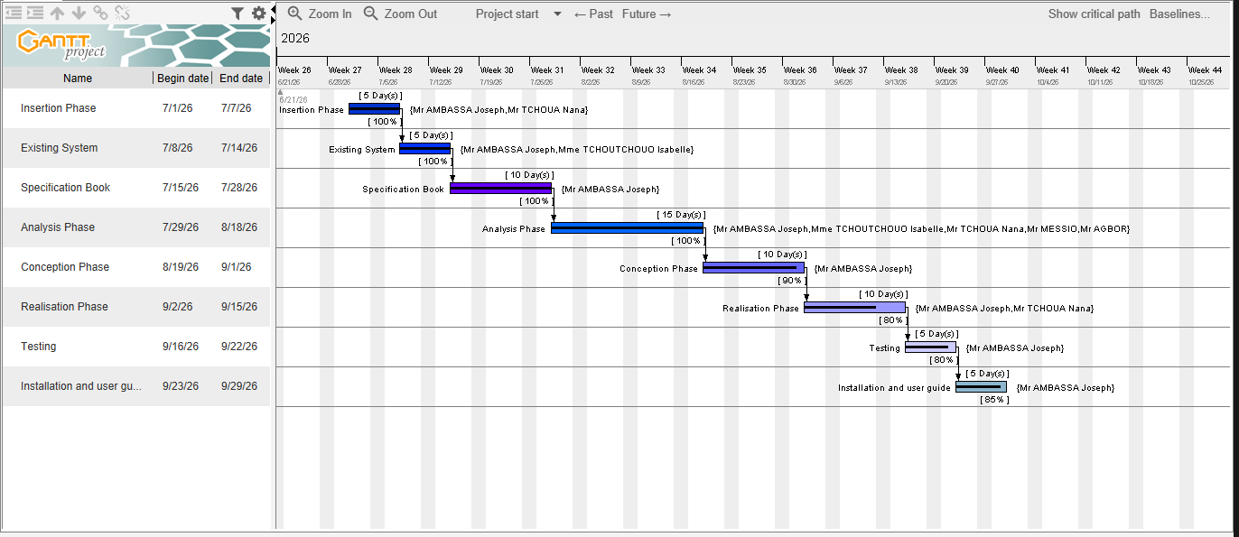
The Gantt project software stands as a highly effective instrument for illustrating the diverse tasks within a project, their respective dates and the precise sequence in which they are executed.
Figure 3: Gantt chart

PROJECT ESTIMATED COST

Software Resources
For the realization of this project, the following software applications will be needed:
Tableau 6: Software resources needed
Software Resource | Description | Quantity | Price (FCFA)/day | Total Price (FCFA)
Microsoft Windows 11 Pro (64 bits) | Operating System | 01 | 57 247 | 57 247
Microsoft Office 365 | Productivity suite (Word, Excel, Outlook) | 01 | 37 247 | 37 247
Visual Paradigm | Modeling tool | 01 | Freemium | Freemium
Figma | UI/UX design tool | 01 | Freemium | Freemium
Visual Studio Code | Front-end development environment | 01 | Freeware | Freeware
Node.js | Back-end development environment | 01 | Freeware | Freeware
POSTGRESQL | Database | 01 | Freeware | Freeware
Flutter | Front-end (mobile) development environment | 01 | Freeware | Freeware
Postman | API development, testing, and documentation | 01 | Premium | Premium
Google Chrome | Web browser | 01 | Freeware | Freeware
Total Cost of Software Resources (FCFA) |  |  |  | 94 494

Hardware Resources
Hardware Resource | Quantity | Price (FCFA)/day | Total Price (FCFA)
Laptop (16G RAM, SSD, Core i9, 3.5GHz) | 02 | 591 394 | 1 182 788
Modem (Camtel) | 01 | 50 000 | 50 000
Hard Disk Drive (500Gb) | 01 | 50 000 | 50 000
USB Key (16Gb) | 01 | 10 000 | 10 000
Internet Connection (MTN) | / | 126 500 | 126 500
Total Cost of Hardware Resources (FCFA) |  |  | 1 419 288

Tableau 7: Hardware resources needed source mercurial 2026

Human Resources
Tableau 8: Human resource needed
Human Resource | Quantity | Price (FCFA/day) | Duration | Total Price
Head of Project | 01 | 30 000 | 31 days | 930 000
Analyst | 01 | 25 000 | 21 days | 525 000
Developer | 01 | 20 000 | 30 days | 600 000
Tester | 01 | 10 000 | 10 days | 100 000
TOTAL |  |  |  | 2 155 000

Total Estimated Cost For The Project
Tableau 9: Estimated cost table
SOFTWARE RESOURCE | 94,495 FCFA
HARDWARE RESOURCE | 1,419,288 FCFA
HUMAN RESOURCE | 2,155,000 FCFA
Unexpected charges (10%)  (Total cost) * 10% | 1,200,000 FCFA
TOTAL COST | 4,868,782 FCFA

TOTAL :

4,868,782 FCFA

PROJECT CONSTRAINTS
To put in place this application, three main constraints must be respected:
- Budget Constraint: the fixed budget for the realization of this project must be strictly respected.
- Deadline Constraint: the realization of this system must respect the deadline attributed to it and should be completed within two (2) months, including meeting the fixed objectives of the project.
- Quality Constraint: after fixing the budget and deadline, the project must produce a flexible, standalone, and reusable application.

LIST OF PARTICIPANTS AND DELIVERABLES

List of Participants
The table below presents the different persons who took part in the accomplishment of this project.
Tableau 10: Table of participant
Names | Function | Role and Tasks
Mme TCHOUTOUO ISABELLE | Lecturer at AICS-  Cameroon  Software Engineer | Academic Supervisor
Mr TCHOUA NGATCHOU NANA SAMORY | Lecturer at AICS-Cameroon Software  Engineer | Professional Supervisor
AMBASSA JOSEPH JUNIOR | Student | Student at AICS Cameroon

Deliverables
This section presents the different elements that will be delivered at the end of this project:
- A CD-ROM / repository containing the web and mobile application;
- The installation guide and user manual of the application;
- PowerPoint presentation of the application.

CONCLUSION
This specification book has permitted us to present the general and specific objectives of the Pharmalink project, the project constraints, the functional and non-functional needs, the different resources of the project, and finally the project planning. The end of this document now enables us to easily move into drafting the analysis document, which will bring out the technical aspects of the project as a whole.

PHASE III : THE ANALYSIS PHASE

Preamble:
The Analysis Phase begins after the Specification Book. This section provides a detailed study of the learning problems identified in our context. It explains our solution using a software development process and a modeling language.
Content Overview
- METHODOLOGY
  - COMPARATIVE STUDY OF UML AND MERISE
  - COMPARATIVE STUDY OF UNIFIED PROCESS
- MODELING
- USE CASE DIAGRAM
- COMMUNICATION DIAGRAM
- SEQUENCE DIAGRAM
- ACTIVITY DIAGRAM
CONCLUSION
INTRODUCTION

INTRODUCTION
Analysis is the decomposition of a problem into its various elements for computer processing. Therefore, for the successful completion of a project, it is very important to carry out a good analysis in order to achieve the objectives specified in the specification book. The realization of a good project is mainly based on its analysis. Thus, a poorly analysed project cannot give good results.

PRESENTATION OF THE ANALYSIS METHODOLOGY

Comparative study OF UML and MERISE

Modeling With MERISE
MERISE stands for "Méthode d’Etude et de Réalisation Informatique pour des Systèmes d’Entreprise". It is a structured method used to design and build information systems for IT projects. It allows end users, managers, and IT professionals to work together in making decisions.
The main rule of the MERISE method is to separate the data from the system processes using several conceptual and physical models. Its core approach relies on three cycles: the decision cycle, the life cycle, and the abstraction cycle. These cycles treat data and processes equally. Separating data from processing helps the system last longer. This is because the structure of the data rarely needs to change, even when the system processes must be updated frequently.

Modeling with UML (2.5)
The Unified Modeling Language (UML) serves as a general-purpose and developmental modeling language within the broader field of software engineering. It is specifically intended to provide a highly standard and clear way to visually represent the overall design of our application.
The Unified Modeling Language was officially standardized in January of the year 1997 by the Object Management Group (OMG). This particular group is an American association that was initially created in 1989, and it constantly aims to promote and standardize the object-oriented programming model in all its various forms.
Furthermore, in the year 2005, UML was formally published by the International Organization for Standardization (ISO) as a fully approved global ISO standard. Since the year 2015, the UML framework has operated in its updated version 2.5. we will rely on this specific version, which consists of exactly fourteen unique diagrams that are strictly classified into two main categories: structural diagrams and behavioral diagrams.

Structural diagram
Structural diagram represents the static components of a system; they emphasize on what should be in the system we are modeling. They include:
- Class diagram
- Object diagram
- Package diagram
- Composite diagram
- Deployment diagram
- Component diagram
- Profile diagram

Behavioral diagram
The behavioral diagrams capture the dynamic state of a system, they emphasize on what should happen in the system we are modeling, they are:
- Use case diagram
- Activity diagram
- State machine diagram
- Sequence diagram
- Communication diagram
- Interaction overview diagram
- Timing diagram

UML 2.5 diagrams overview
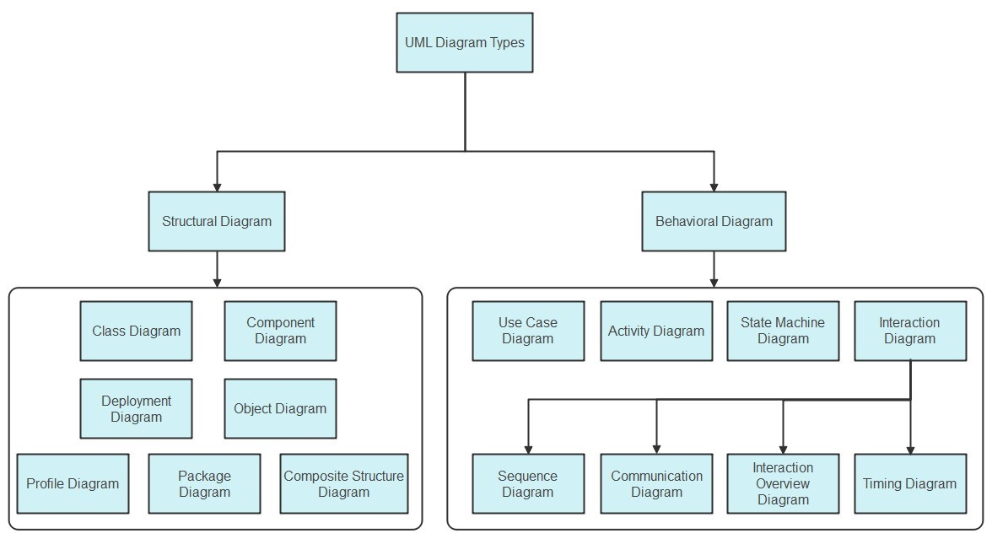

Source:
https://images.edrawsoft.com/articles/wha
t
-
i
s
-
uml/um
l
-
diagra
m
-
types.pn
g

Figure 4: Uml2.5 diagrams overview
It is important to remember that UML is only a modeling language. It is not a full method or a complete procedure. Therefore, to give our work a proper structure, we need to connect UML with a Unified Process. Doing this gives our design a clear methodology to follow.
A unified process is a general method used to develop software. This means it is always necessary to adjust the UP to match the specific needs of the project, the team, and the organization. Because of this, we will use the Two Track Unified Process during our entire project to build and implement our solution.

Comparative Study Of Unified Process
Tableau 11: Comparative study between UML and MERISE
MERISE UML
Méthode d’Etude et de Realization  Informatique pour les Systèmes d’Entreprise | Unified Modeling Language
Merise is a method of analysis | UML is modeling language
Merise is a systematic method of analysis and design for information systems i.e. it uses a system approach | UML is however not a method but rather an object-oriented language, uses the 2TUP approach to model a system
It is based on procedural approach | Based on object approach
Merise proposes to consider the real system from two points of view:  The Static view(data)  The Dynamic view(treatments)  Which means in Merise we have a separate study of data and treatments | UML offers a different approach from that of  MERISE in that it combines data and process

A process can be defined as an ordered sequence of steps that allows us to create software systems or improve an existing one. The main objective of software development is the production of quality software that responds to user needs within a specific timeframe and at a determined cost.

Unified Process
A unified Process is a process of development of software constructed on UML; it is iterative, incremental, centered on architecture, driven by use cases and requirements. Iteration is distinct sequence of activities with a basic plan and evaluation criterion that produces an internal or external output.
Either the content of an iteration is improved or the evolution of the system is evaluated by users.
• An increment is the difference between two released products at the end of two iterations. Each iteration that the group is capable of integrating the technical environment in order to develop a final product and give users the possibility of having tangible results.
• Centered on architecture the different models derived during the establishment of system must be reliable and coherent.
• Driven by use case and requirements enables the clear definition of a users’ needs and priorities respectively thereby minimizing the risk of project failure.

The Two Track Unified Process(2TUP)
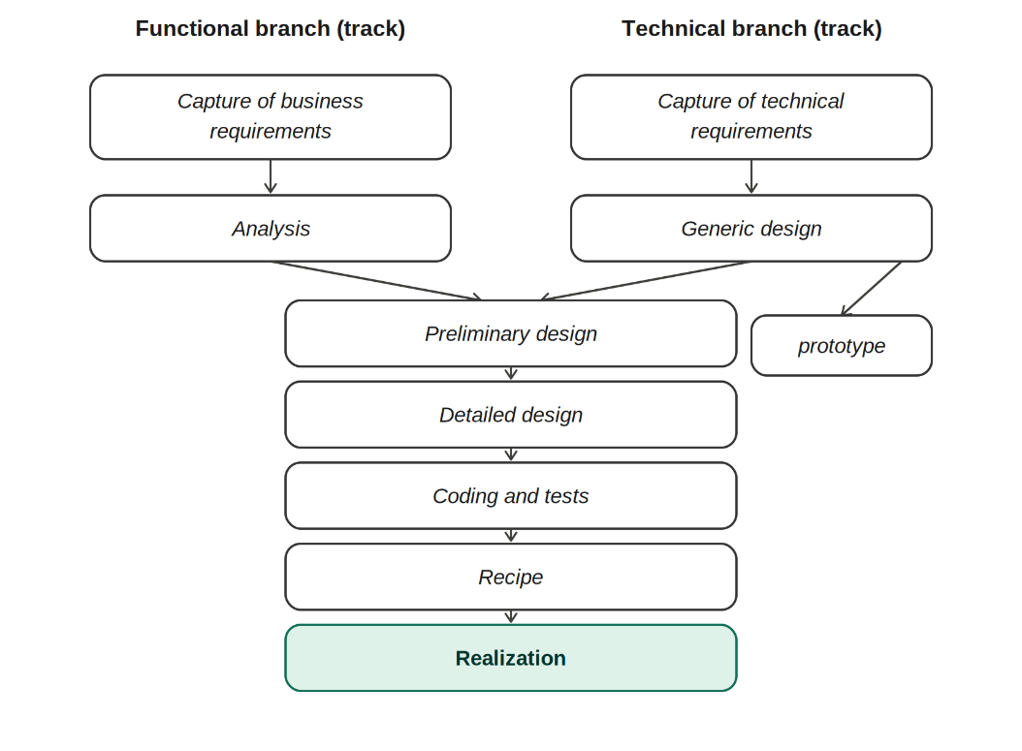
2TUP is a unified process which is belt on UML and has as objective to bring solution to constraints of functional and technical changes imposed on information systems by strengthening controls on development capacities. It proposes a Y-sharped development life cycle that separates the functional aspect from the technical aspects, and the merging of these two forms the implementation aspect. 2TUP distinguishes therefore two branches: the functional and technical
Figure 5: Diagram of the 2TUP
branches, the combination of the result of these two branches forms the third: the realization branch – where we realize our system. The diagram bellow illustrates the branches of 2TUP.

The left branch (functional branch)
It captures the functional needs of a system. This ensures the production of software that meets the needs/requirements of the user. The analysis here consists of studying precisely the functional specification in order to obtain an idea of what the system is going to realize and its result does not depend on any technology

The right branch (Technical branch)
The technical branch enumerates the technical needs and proposes a generic design validated by a prototype. The technical needs include constraints and choices related to the conception of the system, the tools and equipment as well as the integration constraint with the existing system condition. The different diagrams are shown in the tables below.

The middle branch (Realization or implementation branch)
In this branch, we study the preliminary conception, detailed conception, and documentation of the system. The realization branch supports the following:
Preliminary conception: This is the most sensitive step of 2TUP as it is the confluence of the functional and technical branch. It is completed when the deployment model, the operating model, the logical model, interphases and the software configuration model are defined.
Detailed conception: This is the detailed design of each feature of the system.
Coding and testing: This are the phase where we program the designed features and test the coded features.
The recipe: Also known as the deliverables is the validation phase of the functions of the developed system.

Justification of the method of analysis
As method of analysis, we chose the Unified Modeling Language associated with the 2TUP software development process / method. This choice was made as a result of the following criteria's:
- UML is the current standard for programming in an object-oriented language. For this reason, it is widely understood and well known making it easy for a new programmer to join the project and be productive from the very first day.
- UML diagrams allow teams to virtualize how a project is or will be working, and they can be used in any field, not just software engineering. The diagrams will allow teams to virtualize together how a system or a process will work or did work. It can provide new ideas for how teams have to collaborate to achieve the goal of the workflow process.
- 2TUP is centered around the creation and maintenance of a model, rather than the production of mountain documents.
- 2TUP is user oriented as it permits the development of software that responds to the needs of the users through the study of the user needs.
- 2TUP is iterative and incremental; hence it enables the project team to produce refined amelioration if necessary and easily integrate it in the already existing system.
- 2TUP by permitting the project team identify and test the key functionalities of the system limits the risk related to building the system.

MODELING OF THE SYSTEM

Use case diagram

Definition:
The use case diagram simply shows the functionalities of the system, their interdependency and how they can be linked with actors of the system. It also clearly defines the boundaries of the system.

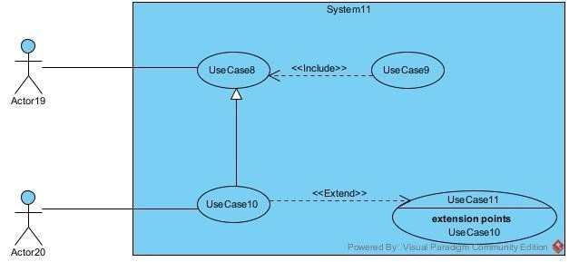
Formalism:
Figure 6: Use case formalism

Components of a Use Case Diagram
Tableau 12: Component of use case diagram
element | Description | Notation
Actor | An external entity, such as a user or another system, that interacts directly with the software to achieve a specific goa | 
Use case | A specific function or action that the system performs to provide a clear result for an actor. | 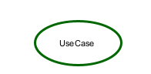
Generalization | A relationship indicating that one element (such as an actor or a use case) is a specialized version of a broader, general element, sharing its main purpose but adding specific variations. | 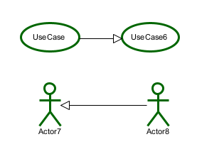
Association | A basic communication link that shows a direct interaction between an actor and a use case | 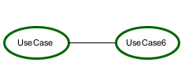
Include | A relationship indicating that a primary use case strictly requires the execution of another use case to function completely. | 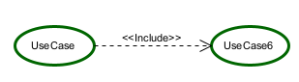
Extend | A relationship indicating that a primary use case may optionally add the behavior of another use case, but only under specific conditions | 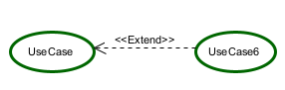


  - Graphical representation of use cases (General use case)
Figure 7: General use case of the system


Specific Use case of Manage users Accounts (ADMIN)
Figure 8: Specific use case of manage users accounts (ADMIN)

Specific use case of Manage appointment (Doctor)
Figure 9: Specific use case of manage appointment (DOCTOR)

Specific Use case of Manage prescription
Figure 10: Manage prescription specific use case (DOCTOR)

Specific Use case of manage profile (PHARMACIST)
Figure 11: Manage pharmacy profile specific use case (PHARMACIST)

Specific Use case of Manage Inventory specific (PHARMACIST)
Figure 12: Manage inventory specific use case

Specific Use case of manage Delivery (RIDER)
Figure 13: Manage delivery specific use case

TEXTUAL DESCRIPTION OF SOME USE CASES
Every use case is associated to a series of actions representing a given function. A use case is then an abstraction of a chain of executions. Implies an instance of a use case is known as a ‘’scenario” which is a series of steps undertaken to execute a specific use case.
The Textual description is a simple text that describes how a use case can be performed in a more precise and understandable way following a chronological order. We will present in the following lines the textual description of some use cases.

Use Case <Authentication>>
Tableau 13: Authentication textual description
Use Case « Authentication »
Actor | Doctors, patients, pharmacists, riders,
Objective | Be able to connect to the platform and perform task
Precondition | The actor must enter the url
Trigger | 1) User clicks on Authentication button.
Nominal scenario | System displays login form.  User fill and submit form.  Verifies form conformity  Send query to verify email  Send password to very if password match  system render users’ page.
Alternative Scenario (invalid credentials) | From step (3) above if form not correct system display error message  From step (4) if email not found system display error message  From step (6) if password not matched system display error message
Exception Scenario | From step (4) above if there is intern connection problem system display error message
Post-condition(s) | user landing page is displayed

Use Case <<Reschedule Appointment>>
Tableau 14: Use case reschedule appointment
Use Case « Reschedule Appointment »
Actor | Doctor
Objective | Be able to change the date/time of an existing appointment
Precondition | The Doctor is authenticated and has selected an existing appointment from the "Manage Appointment" interface
Trigger | 1) Doctor clicks on "Reschedule Appointment" button
Nominal scenario | 2) System displays the reschedule form with current appointment details  3) Doctor selects a new date and time  4) Doctor submits the form  5) System verifies form conformity  6) System sends query to check new slot availability  7) System sends query to update the appointment  8) System displays success message
Alternative Scenario (invalid data) | 9) From step (5) above, if the form is not correct, system displays error message  10) From step (6) above, if the selected slot is unavailable (conflict), system displays error message and prompts Doctor to choose another slot
Exception Scenario | 11) From step (5) above, if there is an internal connection problem, system displays error message  12) From step (7) above, if there is an internal connection problem (query fails to save), system displays error message and rolls back the change
Post-condition(s) | The appointment is rescheduled and updated in the system

Use Case <<Create Prescription>>
Tableau 15: Create prescription textual description
Use Case <<Create Prescription>>
Actor | Doctor
Objective | Be able to create a new prescription for a patient
Pre-condition(s) | The Doctor is authenticated and has accessed the "Manage Prescription" interface
Trigger | 1) Doctor clicks on "Create Prescription" button
Nominal scenario | 2) System displays create prescription form  3) Doctor fills in prescription details (patient, medication, dosage, duration, etc.) and submits form  4) System verifies form conformity  5) System sends query to verify if a similar/duplicate prescription exists  6) System sends query to save the prescription  7) System displays success message
Alternative Scenario (invalid data) | 8) From step (4) above, if the form is not correct, system displays error message  9) From step (5) above, if a duplicate prescription is found, system displays error message
Exception Scenario | 10) From step (4) above, if there is an internal connection problem, system displays error message  11) From step (6) above, if there is an internal connection problem, system displays error message
Post-condition(s) | Prescription is created and associated with the patient

Use Case <<Create user>>
Tableau 16: Textual description create user account
Use Case « create user »
Actor | Admin
Objective | Be able to create a user
Precondition | The actor must authenticate
Trigger | 1) User clicks on create user button.
Nominal scenario | System displays create form.  User fill and submit form.  Verifies form conformity  Send query to verify if course exist  Send query to save course  System displays success message.
Alternative Scenario (invalid credentials) | From step (3) above if form not correct system display error message  From step (4) if course found system display error message
Exception Scenario | From step (4) above if there is internconnection problem system display error message  From step (5) above if there is intern connection problem system display error message
Post-condition(s) | User is created

Use Case <<Update pharmacy details>>
Tableau 17: Textual description update pharmacy details
Use Case « Update Pharmacy details »
Actor | Pharmacist
Objective | Be able to update the pharmacy's profile information (address, contact details, etc.)
Precondition | The Pharmacist is authenticated and has accessed the "Manage Pharmacy Profile" interface
Trigger | 1) Pharmacist clicks on "Update Pharmacy Details" button
Nominal scenario | 2) System displays update form pre-filled with current pharmacy details  3) Pharmacist modifies fields and submits form  4) System verifies form conformity  5) System sends query to verify pharmacy details  6) System sends query to save updated details  7) System displays success message
Alternative Scenario (invalid data) | 8) From step (4) above, if the form is not correct, system displays error message  9) From step (5) above, if data conflict is found (e.g. duplicate registration number), system displays error message
Exception Scenario | 10) From step (4) above, if there is an internal connection problem, system displays error message  11) From step (6) above, if there is an internal connection problem, system displays error message
Post-condition(s) | Pharmacy profile details are updated in the system

Use Case <<Add new stocks>>
Tableau 18: Textual description add new stocks
Use Case « Add new stocks »
Actor | Pharmacist
Objective | Be able to add new stock items to the inventory
Precondition | The Pharmacist is authenticated and has accessed the "Manage Inventory" interface
Trigger | 1) Pharmacist clicks on "Add New Stock" button
Nominal scenario | 2) System displays add stock form  3) Pharmacist fills in stock details (product name, quantity, batch number, expiry date, supplier, etc.) and submits form  4) System verifies form conformity  5) System sends query to verify if the stock item already exists  6) System sends query to save the new stock  7) System displays success message
Alternative Scenario (invalid data) | 8) From step (4) above, if the form is not correct, system displays error message  9) From step (5) above, if the stock item already exists, system displays error message and suggests updating existing stock instead
Exception Scenario | 10) From step (4) above, if there is an internal connection problem, system displays error message  11) From step (6) above, if there is an internal connection problem, system displays error message
Post-condition(s) | New stock item is added to the inventory

Use Case <<Accept Delivery>>
Tableau 19 : Textual description accept Delivery
Use Case « Accept Delivery »
Actor | Rider
Objective | Be able to accept an assigned delivery
Precondition | The Rider is authenticated and has viewed the assigned deliveries in the "Manage Delivery" interface
Trigger | 1) Rider clicks on "Accept Delivery" button
Nominal scenario | 2) System displays delivery details for confirmation  3) Rider confirms acceptance  4) System verifies delivery is still available (not already accepted by another rider)  5) System sends query to update delivery status to "accepted" and assign it to the Rider  6) System displays success message
Alternative Scenario (invalid data) | 7) From step (4) above, if the delivery has already been accepted by another rider, system displays error message and removes it from the Rider's list  8) From step (4) above, if the delivery has been cancelled, system displays error message
Exception Scenario | 9) From step (4) above, if there is an internal connection problem, system displays error message  10) From step (5) above, if there is an internal connection problem, system displays error message
Post-condition(s) | Delivery is assigned to the Rider and marked as "accepted"

Communication diagram

Definition
The communication diagram is used to model the specific interaction between the participants of the system. It describes both the static and dynamic behavior of the system. It shows the chronological succession of the actions performed by an actor in order to realize an operation.

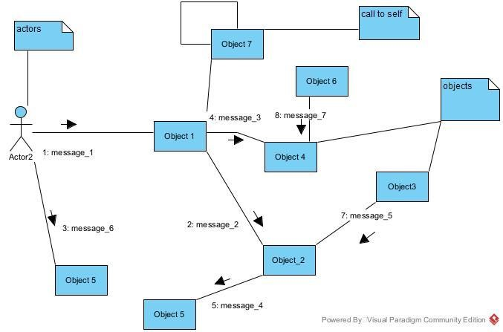
Formalism
Figure 14: Communication diagram formalism

2.3 Components of a Communication Diagram
Tableau 20 : Component of communication diagram
Element | Representation | Description
Object | 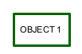 | An actor represents an individual participant in the interaction conversation.
link |  | It initiates an association it connects two objects together for them to communicate.
Actor |  | A role play by an entity that interacts with the subjects.
message | 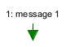 | Defines a particular communication between lifelines in an interaction.

Communication Diagram << Authentication>>
Figure 15: Communication diagram of authentication

Communication Diagram <<create user As Admin>>
Figure 16: Communication diagram create user

Communication Diagram <<Make appointment>>
Figure 17: Communication diagram of make appointment

Sequence diagram

Definition
A sequence diagram is a UML diagram that illustrates the sequence of messages between objects in an interaction. It consists of a group of objects that are presented by lifelines and the messages that they exchange over time during the interaction. These interactions are arranged from top to bottom following their order of occurrence.

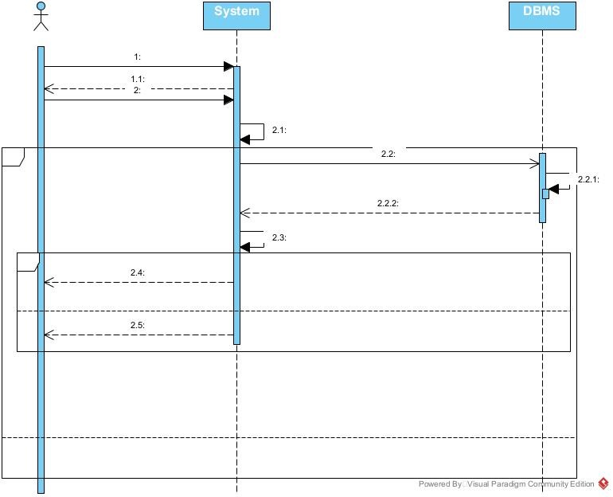
Formalism
Figure 18: Sequence diagram formalism

Components of a Sequence Diagram
Tableau 21:Components of a sequence diagram
Element | Description and main properties | Representation
Lifeline | They represent rows or obj instances that participates in sequence being modeled. | 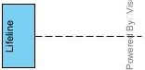  e
Synchronous  Message | A message that represented an invocation of an operation of the target lifeline | 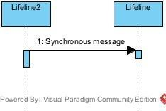
Self Message | Represents the execution  operation call on the same objec | t 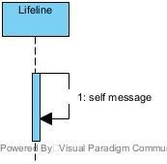
Destroy Message | It destroys a participant in the course of a process | 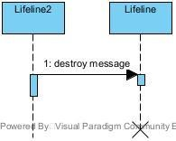
Return Message | Represents a response to a message | 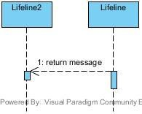

Sequence Diagram <<Authentication>>
Figure 19: Sequence diagram authentication

Sequence Diagram <<Create user>>
Figure 20: Sequence diagram create user

sequence Diagram <<make appointment>>
Figure 21: Sequence diagram of make appointment

Activity diagram

Definition
An activity diagram provides a view of the behavior of a system by describing a sequence of actions in the process. The activity diagram makes it possible to emphasize the processing and to graphically formalize the sequence of actors carried out in a use case.

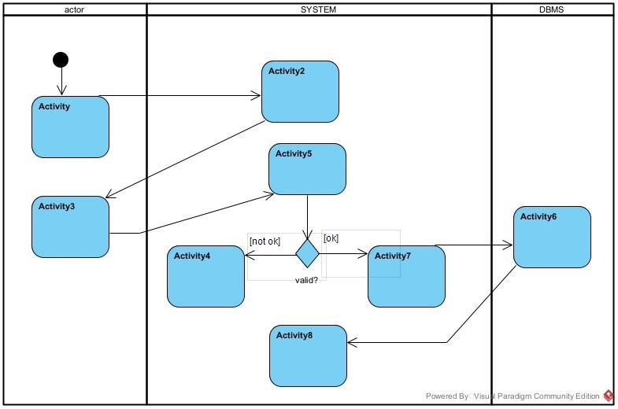
Formalism
Figure 22: Activity diagram formalism

Components of an Activity Diagram
Tableau 22: Component of an activity diagram
Elements | Representation | Description
Activity | 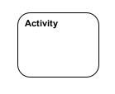 | Use to represent a set of actions.
Action | 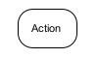 | Represent a task to be performed.
Activity edge |  | A directed connection between two activity nodes through which tokens may flow.
Initial node |  | Shows the beginning of an activity or set of actions.
Final node |  | Stops all controls and object flows in an activity.
Object node | 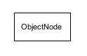 | Represents an object connected to a series of object flows.
Decision node | 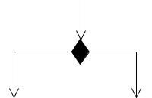 | Represents a test condition that slits an incoming activity edge into opposite outgoing activity edges.
Merge node | 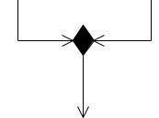 | Reunite different decision paths created using a decision node.
Fork node | 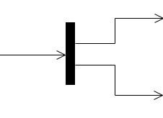 | Slits behavior into parallel or concurrent flows of activities (or actions)
Join node | 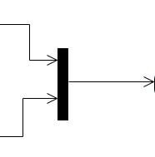 | Unites a set of parallel or concurrent flows of activities or actions.
Swimlane and partition | 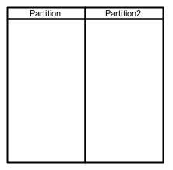 | A way of grouping activities performed by the same actor in an activity diagram or to group actions in the same thread.

Activity Diagram<< Authentication>>
Figure 23: Activity diagram authentication

Activity Diagram<< create user>>
Figure 24: Create user activity diagram

Activity Diagram<<make appointment >>
Figure 25: Activity diagram of make appointment

CONCLUSION
Having reached the end of our analysis, we were asked to illustrate the language and method used during this phase, present the different diagrams of the functional branch. we can then say that this analysis file has allowed us delimit the functional needs of the web application that will be designed and to have a detailed overview of the new system to be set up without notwithstanding we quickly dive into the conception phase

PHASE IV: THE CONCEPTION PHASE

Preamble
This section of the report will cover details of how we were welcomed in the company presentation, organization and brief introduction to our project.
Content Overview

INTRODUCTION

- CLASS DIAGRAM
- STATE MACHINE DIAGRAM.

- PACKAGE DIAGRAM

CONCLUSION

- CAPTURE OF THE TECHNICAL NEEDS

INTRODUCTION
The realization of an analysis file is very important for the advancement of the application; it guarantees the reliability of maintenance and use of a software. That said, after analyzing our system, we will move on to the design of our future system. To do this we will follow the steps of the technical branch of the 2TUP process, making the diagrams associated with these steps namely the class diagram and the state machine diagram.

CAPTURE OF TECHNICAL NEEDS

Physical architecture
The design of the database heavily relies on its underlying architecture. In this project, we utilized an n-tier architecture, a software design pattern that partitions the entire system into multiple, related but separate layers or tiers. This separation allows for greater flexibility, scalability, and maintainability, as each tier can be independently modified, altered, changed, or replaced without affecting the entire system.
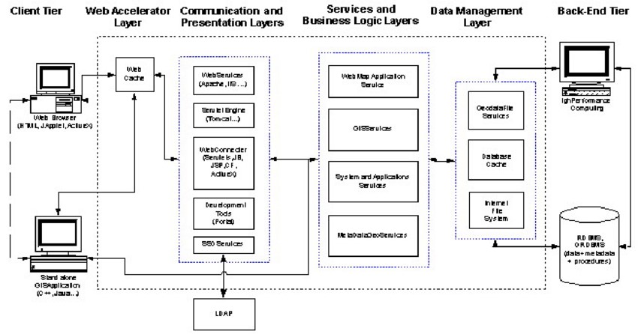
Figure 26: System physical architecture
Source: https://www.mindphp.com/images

Logical architecture
The application logic of our system is based on MVC design pattern which is a very practical way to organize the different classes in an application development project facilitating error detection, collaboration, and code reusability.
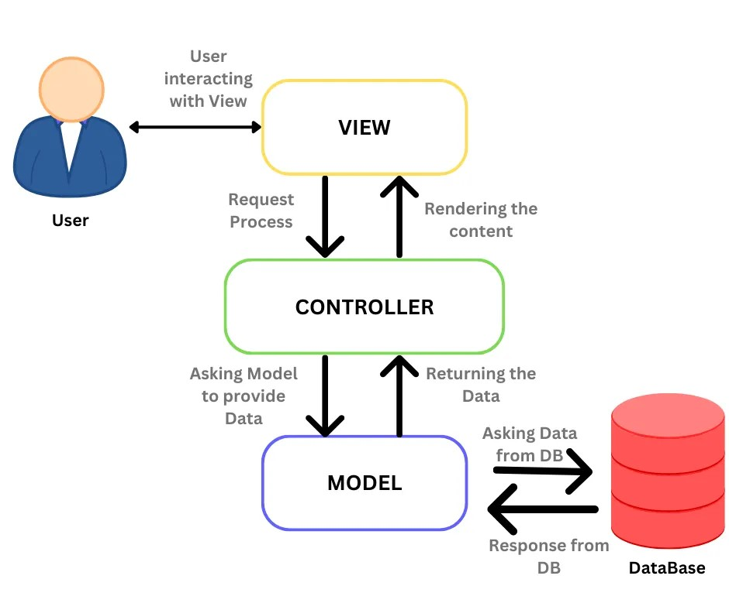
MVC (Model View Controller) design pattern is an architecture and a design method that organizes the human-machine interface (HMI), a view (user Interface) and a controller (Control Logic, event management, synchronization), each having a specific role in the interface. This design pattern allows you to organize your code well, its goal is to separate you code into three main parts and in separate files namely: Model, View, Controller
Figure 27: MVC illustration diagram
Source: https://www.mindphp.com/images/knowledge/IOT/ASP.NET-MVC.JPG

CLASS DIAGRAM

Definition
The class diagram expresses the static structure of the system in terms of classes and the relationships between those classes. The interest of the class diagram is to model the entities of the information system. The class diagram is used to represent all the finalized information that is managed by the domain. This information is being structured, that is, it has been grouped into classes.

Formalism
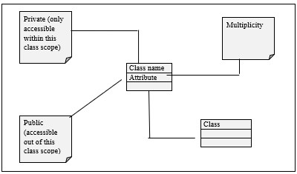
The diagram highlights possible relationships between these classes. A class is a set of elements of the same nature that can be uniquely identified. This diagram has several concepts: class, attribute, identifier, method, access modifier. (Public (+), protected (#), private (-), package (), derivative (/)), relationships and crossplicities. The table below shows the different components of a class.
Figure 28: Class diagram formalism

Components of a Class Diagram
Tableau 23: Component of a class diagram
Element | Description and main features | Representation
Class | Represents an entity within a system. It is an abstract representation or description of a set of objects in the applicatio domain | 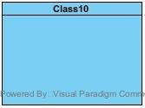
Generalization | Exist between two related classes where one is a specialized form of the other. | 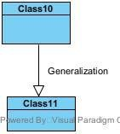
N-ary relation | It is a type of relationship used to model several classes | 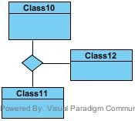
Composite Association | It is a type of association t represents a part-wh relationship in which one elem dies too when the other dies. It represented by a black diamond | 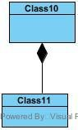  h o e

Graphical Representation of System Class Diagram
Figure 29: System class diagram

STATE MACHINE DIAGRAM

Definition
State diagrams are used to document the various modes (states) that a class can take, and the events that cause a state transition. Their role is to present the treatments (operations) that will manage the field studied. They define the sequence of class states, also known as the state chart diagram, which models the dynamic flow of control from the state of a particular object within a system.

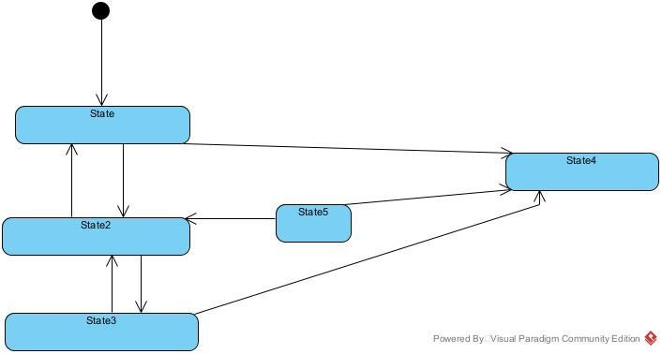
Formalism
Figure 30: State machine formalism

Components of a State Machine Diagram
Tableau 24 : Component of state machine diagram
Element | Description and features | Representation
Initial State | It represents the final or beginning of state and it is represented by a block filled circle | 
Final State | It represents the final state or end of a system. It is represented by a filled circle within another circle | 
Transition | it is a change of control from one state to another due to the occurrence of some events. It is represented by an arrow labelled with the event that causes it’s change of state. | 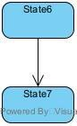
State Box | It depicts the condition or circumstances of particular object of a class at a specific point of time. | 

State Machine Diagrams

Course State machine diagram
Figure 31: Payment state machine

Validate account State machine
Figure 32: Payment state machine

PACKAGE DIAGRAM

Definition
They are structural diagrams used to show the organization and arrangement of various model elements in the form of a package. A package diagram is group of related UML elements such as diagrams, documents, classes, or even other packages. Package diagrams are commonly used to provide a visual organization of the architectural layout within any UML classifier such as software systems.

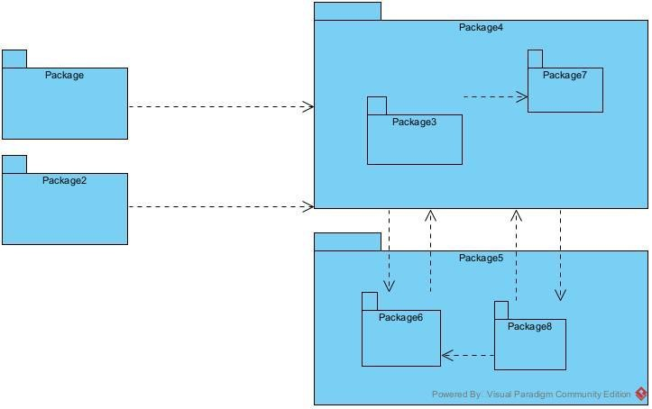
Formalism
Figure 33: Package diagram formalism

Component of package diagram
Tableau 25: Component package diagram
Element | Description and main features | Representation
Package | It is namespace used to group together logically related elements within a system. Each element contains within the package should be a packageable element and have a unique name | 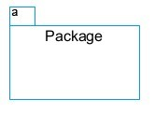
Package import | A relationship Indicate that, functionality has been imported from one package to another. | 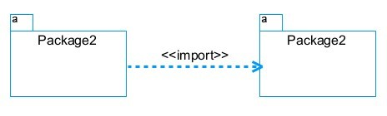
Package access | A relationship Indicates that one package requires assistance from the function of another package. | 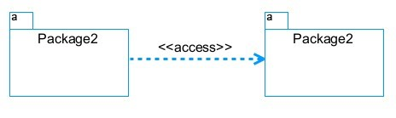
Package merge | It is a relationship which shows that, the functionality of two packages are combines to a single function. | 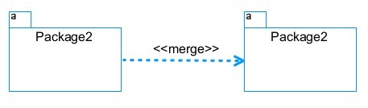

Package Diagram
Figure 34:System package diagram

CONCLUSION
In the conception phase, we set as objective to plane the different aspect of our system by showing how it will be structure and deployed within existing technical architectures. We began by taking into account the technical constraints for our system, after which we proceeded to identify the components of our system, how they are grouped together and how they should be deployed on appropriate deployment targets. We finished this phase by looking at interactions between the various aspects and actors of our system. The next phase of our report is the realization phase where we will look at aspects concerning the implementation of our system.

PHASE V: THE DEPLOYMENT PHASE

Preamble
This section of the report will cover details of how we were welcomed in the company presentation, organization and brief introduction to our project.
Content Overview
- TECHNICAL CHOICES
INTRODUCTION
- DEPLOYMENT DIAGRAM
- COMPONENT DIAGRAM.

CONCLUSION

INTRODUCTION
Here in the deployment phase, we will concentrate on building or implementing our solution, based on the different analysis and conception that we had carried out, which will help to facilitate our work, this phase is as critical as the previous phases. We are going to look at the relationship that exist between the entities of the entity relational diagram. Furthermore, we will see the choices of technologies used for the implementation of our system.

Deployment Diagram

Definition
Nodes are nothing but physical hardware used to deploy the application Deployment diagram is a structural diagram used to visualize the topology of the physical components of a system, where the software is deployed. They consist of nodes and their relationship. It is related to the component diagram because the components are deployedtup using the deployment diagram. A deployment diagrams

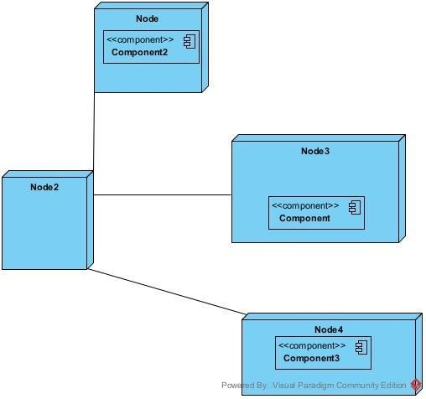
Formalism
Figure 35: Formalism of the deployment diagram

Component of the deployment diagram
Tableau 26:Components of the deployment diagram
Element | Representation | Description
Node | 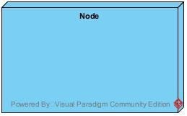 | It is a hardware used to deploy the application
Interface |  | Represents  declaration of a  set of coherent pub  features  and obligations
Component | 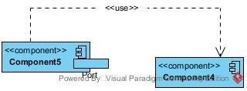 | It represents a modular part of a system that encapsulates its content and whose manifestation is replaceable within it environment.
Association | association | An association helps to connect two nodes together which permits them to communicate together

System deployment diagram of our system
Figure 36: System deployment diagram

Component Diagram

Definition
Component diagrams are utilized to model the physical structure of a system. You might ask, what exactly represents this physical structure? These are distinct elements like executables, code libraries, basic files, and documents that reside within a node. The component diagram does not explain system functionality; rather, it details the specific parts required to create those functions

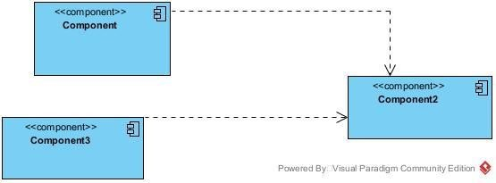
Formalism
Figure 37: Component diagram formalism

Elements of Component Diagram
Tableau 27:Elements of the component diagram
NAME | REPRESENTATION |  | DESCRIPTION
A component | 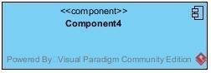 |  | A component is an abstract logical unit block of a system.it is represented as a rectangle with smaller rectangle in the upper right corner which saves as it icon for recognition.
Usage |  |  | A relationship in which one element requires another element for it’s full  implementation  operation
interface |  |  | An interface is a circle or a semicircle attached to a stick which looks like a lollipop. It describes groups of operations provided or required by components.
Instance  Specification | 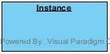 |  | It has the capability of being a deployment target in a deployment relationship

The component Diagram of Our System

Figure 38: Component Diagram

TECHNICAL CHOICES

Materials used for the development of our platform
Tableau 28:Materials used to develop our platform
Material | Quantity | Fonction | Image
Dell  LATITUDE  E7540 | 1 | The computer was used for the programming of the micro controller, the analysis, research, the design of the system architecture. This was the main component in this project. | 
HP computer | 1 | The computer was used for the development of the mobile application and web application | 
iPhone 11 pro max | 1 | Testing the mobile app functionalities and debugging. | 

Software used for the development of our project

Software | Role | Reason for use | Image
GitHub | It is a website and cloud service that helps developers store and manage their code. | Git allows developers to track changes, revert to previous versions, and maintain a history of modifications, ensuring that no work is lost and enabling easy recovery. | 
Chrome | Google Chrome is a fast, secure, and user-friendly web browser developed by Google.  Used to test our application UI. | Chrome is optimized for fast page loading and efficient resource management, providing a smooth browsing experience. | 
Flutter  Framework | A popular open-source framework for building natively compiled, crossplatform applications. Provides a widget-based approach for efficient rendering and state management | Promotes the creation of reusable components, which enhances code maintainability and allows for easier updates and testing. | 
GanttProject | GanttProject is a free, open-source project management tool that allows teams to plan and track projects using Gantt charts. | Allows users to assign tasks, set deadlines, and manage resources efficiently. Helps teams visualize project timelines. | 
MS Excel | MS Excel is a powerful spreadsheet application used for data organization, analysis, and visualization. Using to create charts after the | Provides a variety of charting and graphing options, helping users to present data in a visually appealing and easily  understandable format | 
MS PowerPoint | MS PowerPoint is a presentation software that allows users to create dynamic slideshows comprising text, images, videos, and animations.  Used to create slideshows presentations for application. | Its intuitive interface and templates make it easy for users to create professional presentations quickly, regardless of their technical skill level.
MS Word | MS Word is a widely used word processing application that allows users to create, edit, and format text documents.  Used in application report creation. | Offers extensive options for formatting text, images, and layouts, enabling the creation of professional quality documents. | 
MySQL | MySQL is a popular open-source relational database management  system | It is used to store and manage our data | 
Node.js | Node.js is an opensource and crossplatform JavaScript runtime environment. It is a popular tool for almost any kind of project! | It is used to build our backend, helping us to have a dynamic web application | 
OS  WINDOWS  10 | The operating system required to run the software is the one on which we have worked. | Windows 10 has a userfriendly interface that is familiar to many users, making it easy to navigate and use. | 
Visual  Paradigm | The software engineering workshop used for solution modelling. We utilized this tool for modelling the various diagrams of our system | . Supports multiple modelling languages and methodologies, making it suitable for various project requirements and enabling teams to adapt to different development processes. | 
Visual studio code | Visual Studio Code is a lightweight, open-source code editor developed by Microsoft, supporting multiple programming languages. Using for writing of application code. | . Combines tools for version control, debugging, and terminal access in one interface, improving efficiency and reducing the need for multiple applications. | 
Tableau 29:Software Resources Used

CONCLUSION
In our realization phase, we set as objective to plane the different aspect of our system by showing how it will be structure and deployed within existing technical architectures. We began by taking into account the technical constraints for our system, after which we proceeded to identify the components of our system, how they are grouped together and how they should be deployed on appropriate deployment targets. We finished this phase by looking at interactions between the various aspects and actors of our system. The next phase of our report is the realization phase where we will look at aspects concerning the implementation of our system.

PHASE VI: FUNCTIONAL TESTING

Preamble
This section of the report will cover details of how we were welcomed in the company presentation, organization and brief introduction to our project.
Content Overview

INTRODUCTION

- APPLICATION FUNCTIONNALITIES

TESTS SHOWCASES

CONCLUSION

INTRODUCTION
The test of functionalities phase helps us to know more about the solution we are building be it web or mobile. It provides the different functionalities or modules found in our application and how they are beneficial to the users. Hence, we are going to explore the different functionalities present in

APPLICATION FUNCTIONNALITIES
Authentication is the fundamental functionality of the systems that verifies the identity of users (Patient, Doctor, Pharmacy, Delivery driver, Admin). It ensures that only authorized individuals or entities can gain access to protected information or perform specific operations.

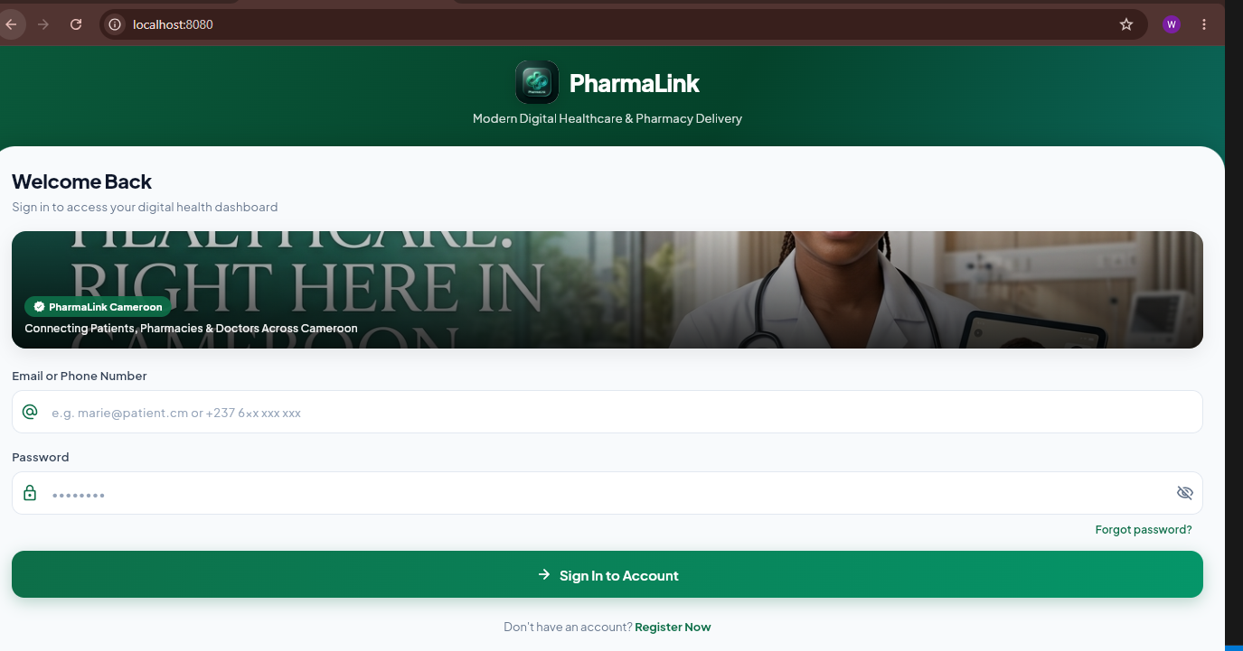
Authentication
Figure 39: Login Screen

Create Doctor Account
The Doctor Create Account form collects the doctor's full name, email, phone number, password, medical license number, specialty, and requires uploading a license document along with accepting a confidentiality clause before submitting for admin approval.
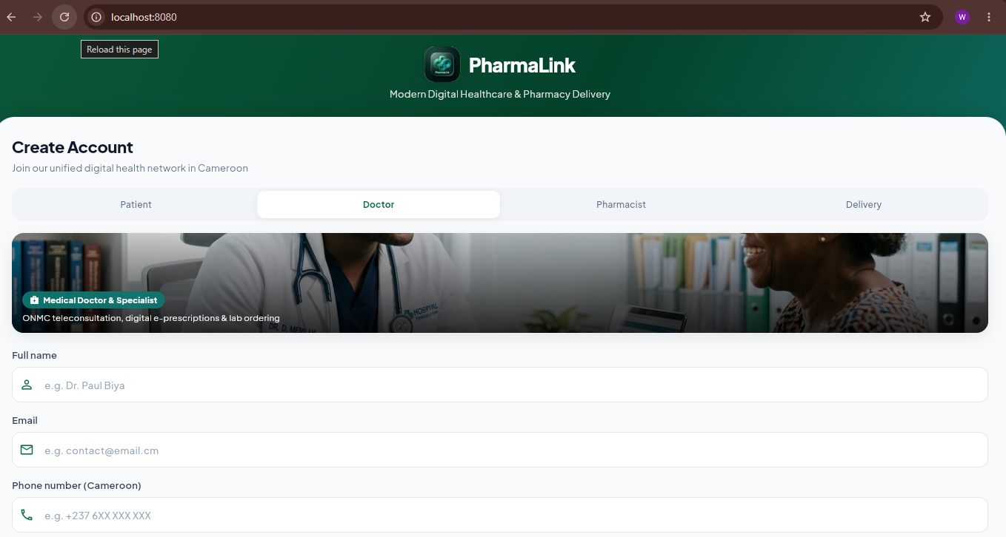
Figure 40:Create Doctor account

Patient Dashboard
The patient dashboard shows all the services the patients can get with respect to it needs.
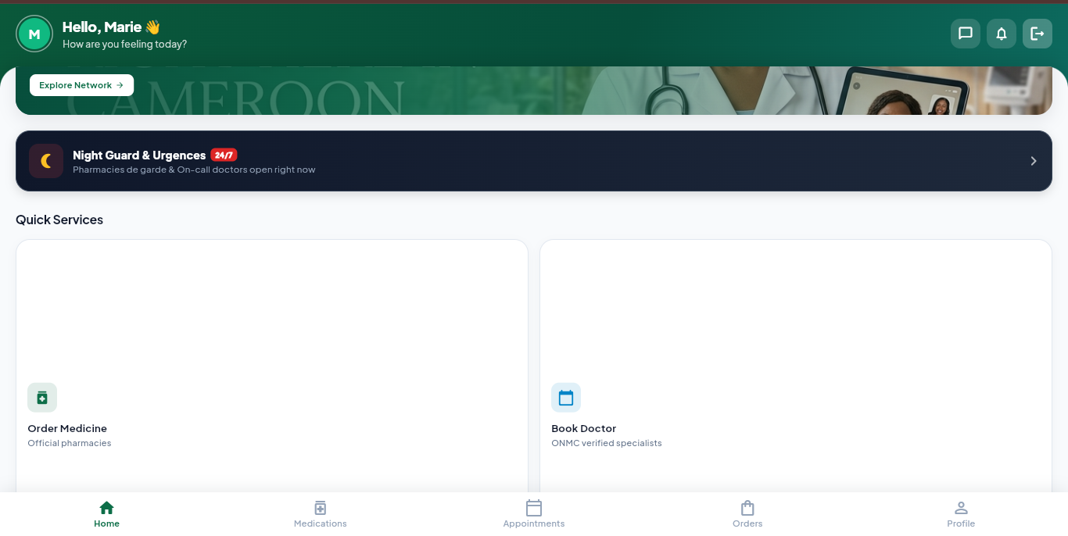
Figure 41: Patient Dashboard

TESTS SHOWCASES
Unit testing refers to testing a function individually, to ensure that it is working properly. Here are some unit test of our solution

Test of Authentication

Register
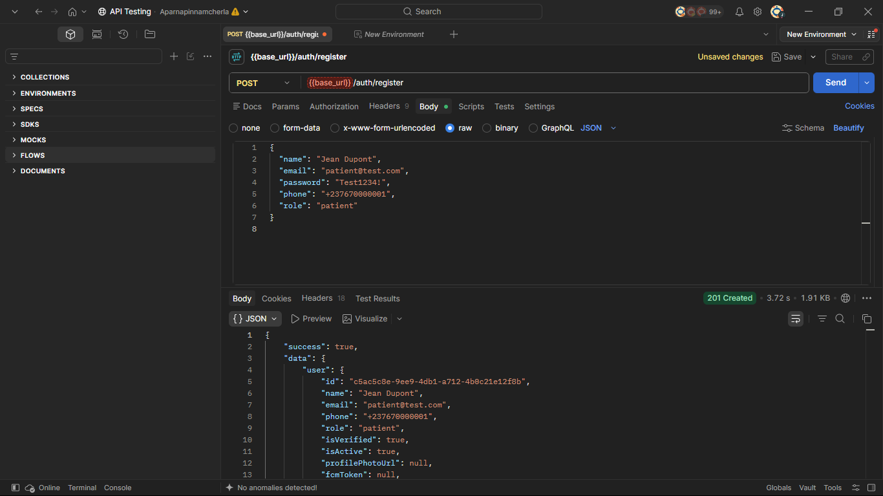
Figure 42: Unit test Register

Login
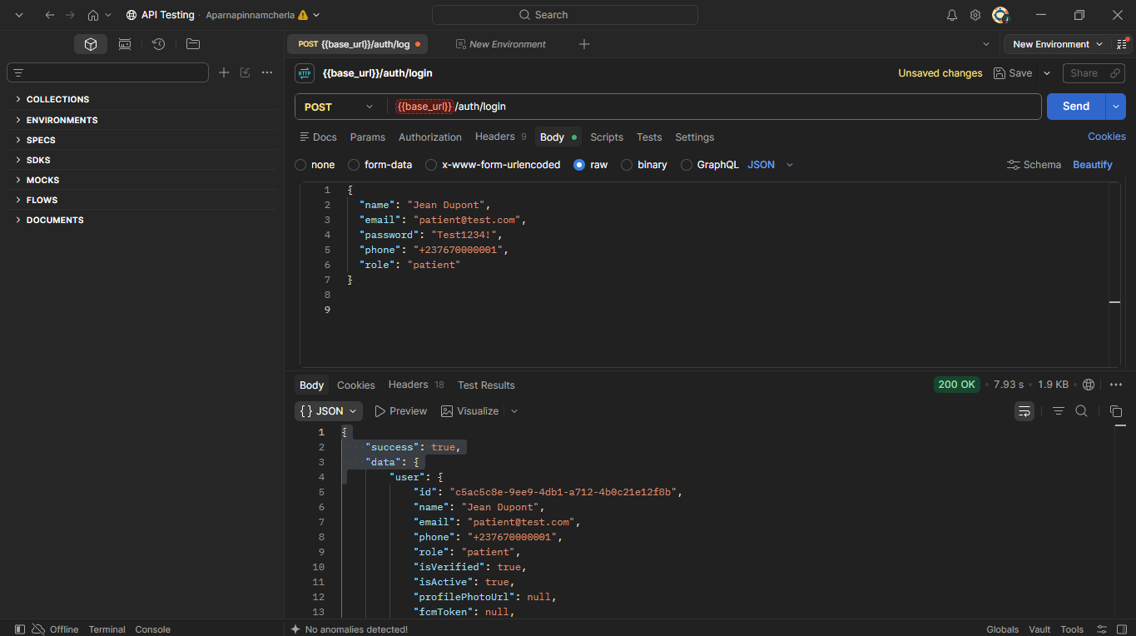
Figure 43: Login unit test

CONCLUSION
Testing is an integral part of the software development life cycle and is performed to verify the correctness, reliability, and robustness of the implemented functionality. the functionality and testing phase are therefore a critical stage in software development where the implemented features are validated, and any issues are identified and resolved.

PHASE VII: USER GUIDE

Preamble
A user guide explains how to use a software application in a language that a non- technical person can understand. Thus, it enables the user to easily use the application to familiarize with the software and discover all the its functionalities.

Content Overview

INTRODUCTION

- DESCRIPTION OF THE APPLICATION
- INSTALLATION GUIDE with SHOWCASES
CONCLUSION

INTRODUCTION
The user manual is the document established after the realization of an application, software, or platform. It informs on the question “how to use the software, the application, or the platform that you have in front of you?”. It is therefore crucial for us to offer the various users of our platform a guide allowing them to easily perform various operations on our platform.

DESCRIPTION OF THE APPLICATION
PharmaLink is an intelligent healthcare delivery platform built with Flutter (Dart) for a cross-platform mobile interface and Node.js + Express for a robust, scalable backend, with PostgreSQL as the database. The system is designed to streamline medication delivery, medical consultations, and pharmacy management within the Cameroonian healthcare community, specifically targeting Yaoundé.
This cross-platform mobile solution centralizes healthcare data, enabling patients, doctors, pharmacists, delivery drivers, and administrators to interact in real time. It provides:
    - Medication search and ordering system allowing patients to find, compare, and order medications from verified nearby pharmacies with both delivery and pickup options.
    - Intelligent AI-powered health assistant using Gemini AI to provide patients with personalized health guidance, medication information, and symptom-based recommendations and also automated appointment and order system.
    - Real-time delivery tracking system using Google Maps and Socket.io, enabling patients to monitor their order from the pharmacy to their doorstep with live driver location updates.
    - Secure telemedicine and consultation system allowing patients to book appointments with verified ONMC-approved doctors, receive digital prescriptions, and consult remotely via in-app chat.
    - Automated notification and reminder system to alert patients about medication schedules, appointment confirmations, order status updates, and prescription renewals via push notifications and SMS.

INSTALLATION GUIDE with SHOWCASES
To use the PharmaLink mobile application, you need a smartphone running Android 6.0 or higher, or iOS 12.0 or higher, along with a stable internet connection either via Wi-Fi or mobile data (3G/4G/5G). Follow the steps below to install and use PharmaLink:
Step 1 — Download the Application
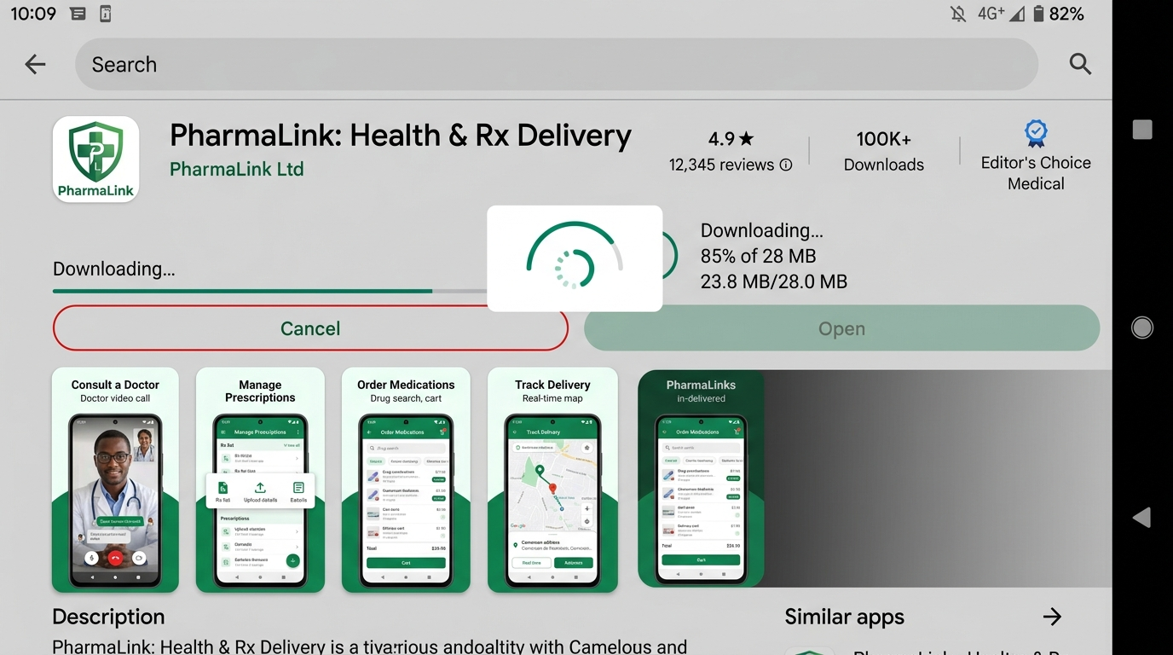
Open the Google Play Store on Android or the Apple App Store on iOS, type "PharmaLink" in the search bar, select the application from the results, and tap Install or Get to begin the download. Alternatively, if you have received the APK file directly, enable installation from unknown sources in your Android settings and open the APK file to install.
Figure 44:Downloading pharmalink

Step 2 — Launch the Application
Once installed, tap the PharmaLink icon on your home screen. The application will display the splash screen showing the PharmaLink logo and tagline "Your Health, Our Priority" for approximately 2 seconds before redirecting you to the login screen.

Step 3 — Create an Account
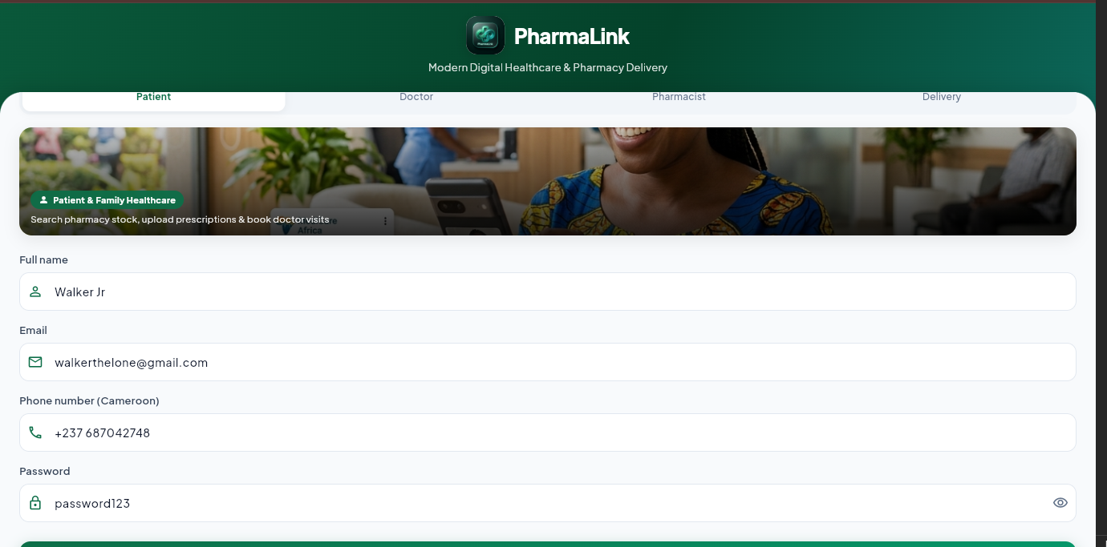
If you are a new user, tap "Don't have an account? Register" on the login screen. Select your role from the four available tabs — Patient, Doctor, Pharmacist, or Delivery — then fill in your full name, email address, phone number, and password. Doctors and pharmacists must additionally provide their license number and upload their official license document for admin verification. Tap Register to submit your account.
Figure 45: Create Account

Step 5 — Log In
Return to the login screen, enter your email address or phone number and your password, then tap Login. The application will automatically redirect you to the dashboard corresponding to your role — Patient Home, Doctor Dashboard, Pharmacist Dashboard, or Driver Dashboard.
Figure 46: Login form

Step 6 — Using the Application
Once logged in, patients can search for medications, place orders, book doctor appointments, track deliveries in real time, view prescriptions, set medication reminders, and chat with PharmaLink's AI health assistant. Doctors can manage appointments, write prescriptions, and view patient medical history. Pharmacists can manage their inventory, process orders, and view sales analytics. Delivery drivers can accept deliveries, navigate routes via Google Maps, confirm pickups and drop-offs, and track their earnings. All users can update their profile, view notifications, and contact support through the More tab at the bottom of the screen.
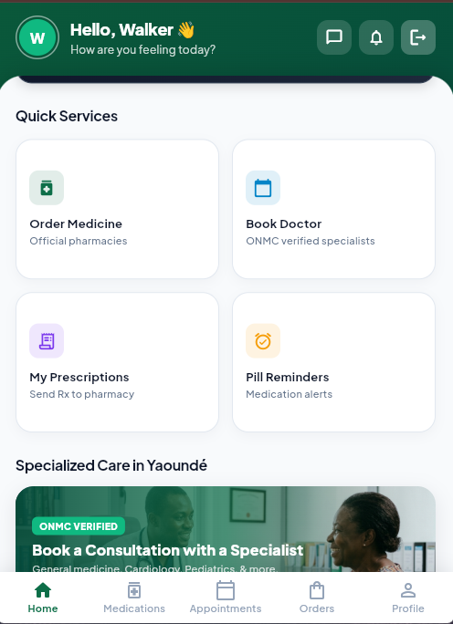
Figure 47: Services in the system

CONCLUSION

PERSPECTIVE
Here are the future perspectives for PharmaLink:
1. ONMC & ONPC API Integration
Develop a direct API connection with the Ordre National des Médecins du Cameroun and the Ordre National des Pharmaciens du Cameroun to automate license verification instead of relying on manual admin review.
2. Real Video Call for Telemedicine
Replace the current simulated video call interface with a fully functional WebRTC-based video consultation system, allowing patients and doctors to conduct real-time face-to-face medical consultations within the app.
3. Geographic Expansion
Extend PharmaLink beyond Yaoundé to other major Cameroonian cities such as Bafoussam, and Garoua, and eventually to neighboring CEMAC countries including Gabon, Congo, and Côte d'Ivoire, with multi-currency and multilingual support for both French and English.
7. Pharmacy Inventory Forecasting
Introduce a machine learning model that analyzes order history and seasonal trends to predict medication demand, helping pharmacies maintain optimal stock levels and reduce shortages.

GENERAL CONCLUSION
As we bring this project to a close, we take pride in the knowledge acquired, the challenges overcome, and the milestones achieved throughout its development. The journey of conceiving, analyzing, and designing PharmaLink — an intelligent healthcare delivery platform for medication ordering, medical consultation, and pharmacy management in Yaoundé, Cameroon — has been both intellectually stimulating and professionally rewarding. It has allowed us to apply theoretical concepts to practical scenarios, strengthening our understanding of software engineering principles, mobile development, and project management practices.
Guided by the structured phases of analysis and conception, we ensured coherence between user requirements and system functionalities across five distinct user roles: patient, doctor, pharmacist, delivery driver, and administrator. The use of UML (Unified Modeling Language) provided a rigorous framework for modeling system behavior, user interactions, and data flow through Package Diagrams, Deployment Diagrams, Component Diagrams, and Sequence Diagrams, thereby reinforcing the analytical precision of our design and ensuring every feature was architecturally grounded before implementation.
The implemented system, developed using Flutter and Dart for the cross-platform mobile frontend and Node.js with Express for the backend, integrates PostgreSQL as the primary database managed through Prisma ORM, Socket.io for real-time delivery tracking and messaging, and the Gemini AI API for an intelligent health assistant that provides patients with personalized medication guidance and health recommendations. It not only enhances the efficiency of pharmacy operations and medication delivery logistics but also promotes informed healthcare decision-making, transparent doctor-patient communication, secure prescription management, and verified professional accountability through ONMC and ONPC license verification for doctors and pharmacists respectively.
In conclusion, this project represents a meaningful contribution to the digital transformation of healthcare in Cameroon, demonstrating how modern technologies and structured software engineering methodologies can be combined to create intelligent, user-centered solutions that improve patient access to medication and bridge the gap between patients, medical professionals, and pharmacies. We are confident that, with further refinement and full deployment, PharmaLink will serve as a valuable tool for communities seeking innovation and excellence in accessible healthcare delivery

BIBLIOGRAPHY
Booch, G., Rumbaugh, J., & Jacobson, I. (2005). The Unified Modeling Language User Guide (2nd ed.). Addison-Wesley.
Jacobson, I., Christerson, M., Jonsson, P., & Övergaard, G. (1992). Object-Oriented Software Engineering: A Use Case Driven Approach. Addison-Wesley.
Jacobson, I. (1999). The Two-Track Unified Process (2TUP): Combining Business Modeling and System Modeling. Rational Software Corporation.
Sommerville, I. (2016). Software Engineering (10th ed.). Pearson Education Limited.
Pressman, R. S., & Maxim, B. R. (2020). Software Engineering: A Practitioner's Approach (9th ed.). McGraw-Hill Education.
Russell, S., & Norvig, P. (2021). Artificial Intelligence: A Modern Approach (4th ed.). Pearson.
Flanagan, D. (2020). JavaScript: The Definitive Guide (7th ed.). O'Reilly Media.
Tilkov, S., & Vinoski, S. (2010). Node.js: Using JavaScript to Build High-Performance Network Programs. IEEE Internet Computing, 14(6), 80–83.
Google LLC. (2024). Flutter Documentation. Retrieved from https://flutter.dev/docs
Google LLC. (2024). Dart Programming Language. Retrieved from https://dart.dev/guides
OpenJS Foundation. (2024). Node.js Documentation. Retrieved from https://nodejs.org/en/docs
PostgreSQL Global Development Group. (2024). PostgreSQL Documentation. Retrieved from https://www.postgresql.org/docs
Prisma. (2024). Prisma ORM Documentation. Retrieved from https://www.prisma.io/docs
Socket.io. (2024). Socket.io Documentation. Retrieved from https://socket.io/docs
Google LLC. (2024). Google Maps Platform Documentation. Retrieved from https://developers.google.com/maps/documentation
Google LLC. (2024). Gemini AI API Documentation. Retrieved from https://ai.google.dev/docs
Africa's Talking. (2024). Africa's Talking SMS API Documentation. Retrieved from https://africastalking.com/docs
ISO/IEC. (2011). ISO/IEC 19501: Information Technology — Open Distributed Processing — Unified Modeling Language (UML) Version 1.4.2. International Organization for Standardization.
République du Cameroun. (2010). Loi N° 2010/012 relative à la cybersécurité et à la cybercriminalité au Cameroun. Assemblée Nationale du Cameroun.

WEBOGRAPHY
Vue.js. (2024). Introduction to Vue.js. Retrieved from https://vuejs.org/guide/introduction.html
Node.js. (2024). About Node.js. Retrieved from https://nodejs.org/en/about/
MongoDB. (2024). MongoDB Manual. Retrieved from https://www.mongodb.com/docs/
W3Schools. (2024). JavaScript Tutorial. Retrieved from https://www.w3schools.com/js/
MDN Web Docs. (2024). Express: Node.js web application framework. Retrieved from https://developer.mozilla.org/en-US/docs/Learn/Server-side/Express_Nodejs
Stack Overflow. (2024). Vue.js, Node.js, and MongoDB development discussions. Retrieved from https://stackoverflow.com/
GeeksforGeeks. (2024). Introduction to UML Diagrams. Retrieved from https://www.geeksforgeeks.org/uml-diagrams/
Rational Software / IBM. (1999). Two-Track Unified Process (2TUP). Retrieved from https://www.ibm.com/docs/en/rational-soft-arch/
Mercurial SCM. (2024). Mercurial: Distributed Version Control. Retrieved from https://www.mercurial-scm.org/

ANNEXES

TABLE OF CONTENT
DEDICATION I
ACKNOWLEDGEMENTS II
SUMMARY III
LIST OF FIGURES IV
LIST OF TABLES VI
LIST OF ABBREVIATIONS VIII
ABSTRACT IX
RESUME X
GENERAL INTRODUCTION 1
PART I: 3
INSERTION PHASE 3
INTRODUCTION 5
I. WELCOMING AND INTERGRATION 6
1. WELCOME 6
2. INTEGRATION 6
II. GENERAL PRESENTATION OF INTER-LINK 6
1. HISTORY 6
1. MISSION 7
2. ACTIVITIES 7
3. ACHIEVEMENTS 7
4. PARTNERS 8
III. ORGANIZATIONAL CHART OF INTERLINK 9
I. Administrative Organization 9
1. Executive Leadership 9
2. Software Engineering Department 9
3. Human Resource Department 10
4. Communication Department 10
5. Department of Financial Affairs 10
II. Functional Organisation 11
IV. GEOGRAPHICAL LOCATION 11
V. COMPANY RESOURCES 12
1. Hardware Resource 12
2. Software Resources 13
VI. BRIEF PRESENTAION OF THE PROJECT THEME 15
CONCLUSION 16
PART II: 17
TECHNICAL PHASE 17
PHASE I: EXISTING SYSTEM 18
INTRODUCTION 20
I. THEME PRESENTATION 21
II. STUDY OF EXISTING SYSTEM 21
III. CRITICISM OF THE EXISTING SYSTEM 22
IV. PROBLEMATICS 23
V. PROPOSED SOLUTION 24
CONCLUSION 26
PHASE II: SPECIFICATION BOOK 27
INTRODUCTION 29
I. CONTEXT AND JUSTIFICATION 30
1. Context 30
2. Justification 30
II. PROJECT OBJECTIVES 31
1. GENERAL OBJECTIVES 31
2. SPECIFIC OBJECTIVES 31
III. EXPRESSION OF NEEDS 32
1. Functional Needs 32
2. Non-Functional Needs 33
IV. PROJECT PLANIFICATION 35
1. Chronogram of Activities 35
2. Gantt Diagram 36
V. PROJECT ESTIMATED COST 37
1. Software Resources 37
2. Hardware Resources 38
3. Human Resources 38
4. Total Estimated Cost For The Project 38
VI. PROJECT CONSTRAINTS 40
VII. LIST OF PARTICIPANTS AND DELIVERABLES 40
1. List of Participants 40
2. Deliverables 41
CONCLUSION 42
PHASE III : THE ANALYSIS PHASE 43
INTRODUCTION 45
1. PRESENTATION OF THE ANALYSIS METHODOLOGY 46
1.1 COMPARATIVE STUDY OF UML AND MERISE 46
1.2 COMPARATIVE STUDY OF UNIFIED PROCESS 49
a. UNIFIED PROCESS 50
b. THE TWO TRACK UNIFIED PROCESS(2TUP) 50
c. JUSTIFICATION OF THE METHOD OF ANALYSIS 52
2. MODELING OF THE SYSTEM 53
2.1 USE CASE DIAGRAM 53
2.2 COMMUNICATION DIAGRAM 67
2.3 SEQUENCE DIAGRAM 72
2.4 ACTIVITY DIAGRAM 77
CONCLUSION 83
PHASE IV: THE CONCEPTION PHASE 84
INTRODUCTION 86
I. CAPTURE OF TECHNICAL NEEDS 87
1. PHYSICAL ARCHITECTURE 87
2. LOGICAL ARCHITECTURE 88
II. RELATED UML DIAGRAMS 89
1. CLASS DIAGRAM 89
2. STATE MACHINE DIAGRAM 93
3. PACKAGE DIAGRAM 98
CONCLUSION 101
PHASE V: THE DEPLOYMENT PHASE 102
INTRODUCTION 104
I. PRELEMINARY CONCEPTION 105
1. Deployment diagram 105
2. Component Diagram 108
II. TECHNICAL CHOICES 111
1. Materials used for the development of our platform 111
2. Software used for the development of our project 111
CONCLUSION 112
PHASE VI: FUNCTIONAL TESTING 113
II. TESTS SHOWCASES 114
1. Test of Authentication 114
2. Test for Course Generation 114
INTRODUCTION 115
I. APPLICATION FUNCTIONNALITIES 116
II. TESTS SHOWCASES 116
1. Test of Authentication 116
2. Test for Course Generation 116
CONCLUSION 117
PHASE VII: USER GUIDE 118
INTRODUCTION 120
I. INSTALLATION OF THE APPLICATION 121
II. SHOWCASES 121
CONCLUSION 122
PERSPECTIVE 123
GENERAL CONCLUSION 124
BIBLIOGRAPHY XI
WEBOGRAPHY XII
VIDEOGRAPHY XIII
ANNEXES XIV
TABLE OF CONTENT XV

