PI
- User: bina
- password: binacam
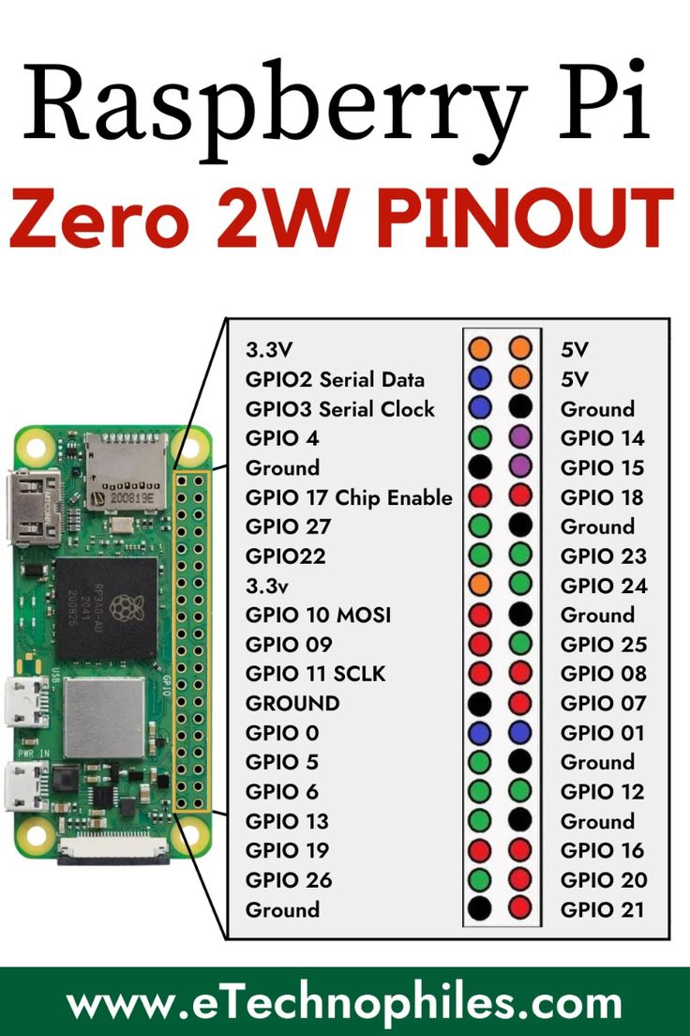
- http://<192.168.1.206>:8070/stream.mjpg

LEDs
- longer wire is positive
- Voltage: 3v
- Model: 0402 0603
TMC2209
- reduction ratio of 1:9.5
- stepping angle of 18 degrees
- Motor phase resistance: about 9.6 ohms
- @5V short circuit current: 0.49A
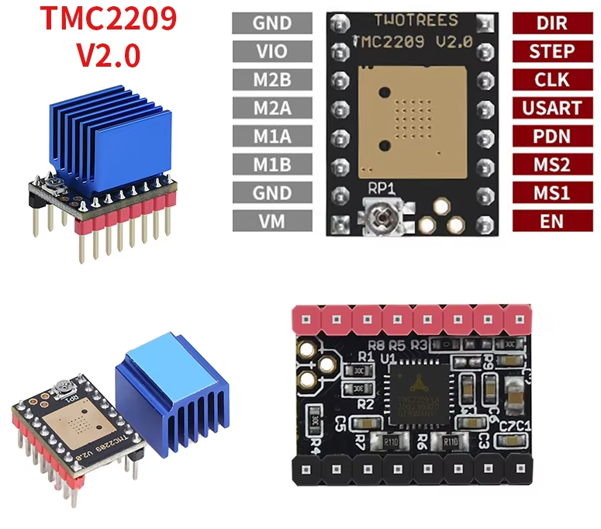
Motor Pinout
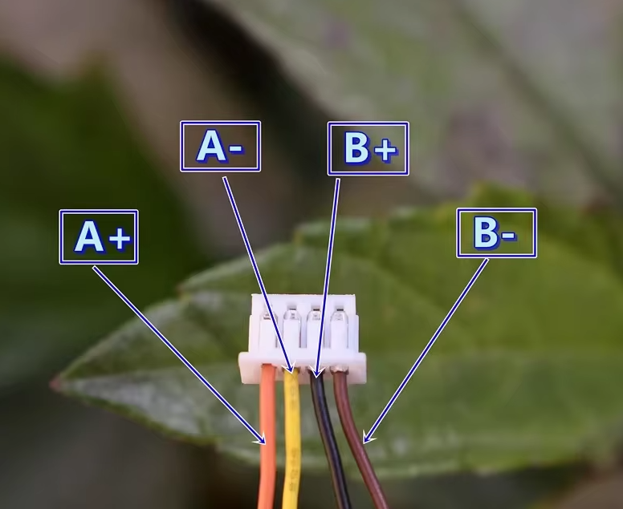
LED circuit
GPIO21 → 2x330Ω resistors → LED+ → LED- → common ground

Motor circuit
- Power (NOT FROM PI)
  - PI: MiniUSB port
  - Motor driver (NOT from rpi) VM
  - Shared ground

- Motor → TMC2209
  - A+ → M1A
  - A− → M1B
  - B+ → M2A
  - B− → M2B

- Pi → TMC2209
  - Power → VM
  - Pi 3.3v → VIO
  - Pi GND → GND
  - Power GND → GND
  - GPIO14 → 1kohm → USART
  - GPIO18 → STEP
  - GPIO23 → DIR
  - GPIO24 → EN

