Tutorial Postman

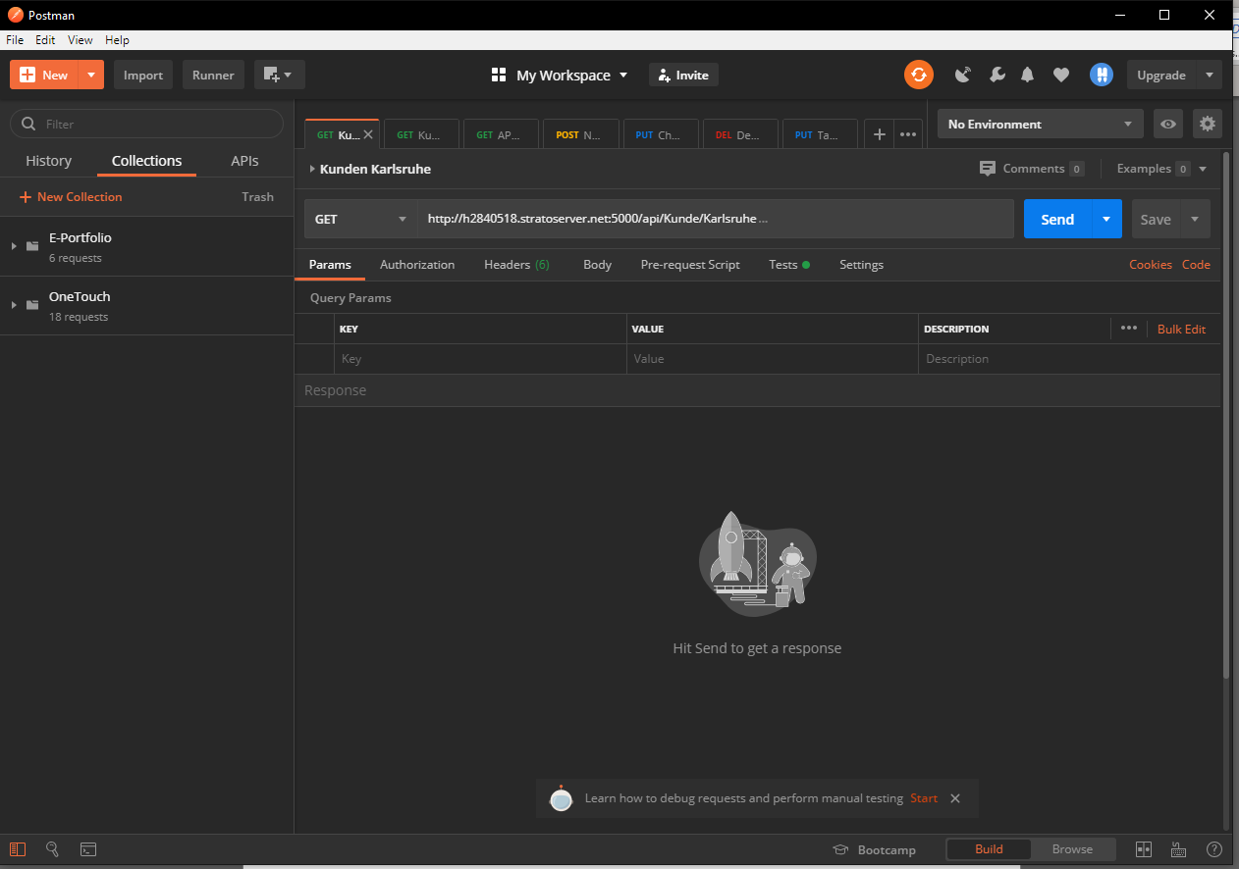

You can create new Requests or Collections on the orange NEW button.

The collections will be shown on the left side.

Requests can be send to the API with the blue Send button.

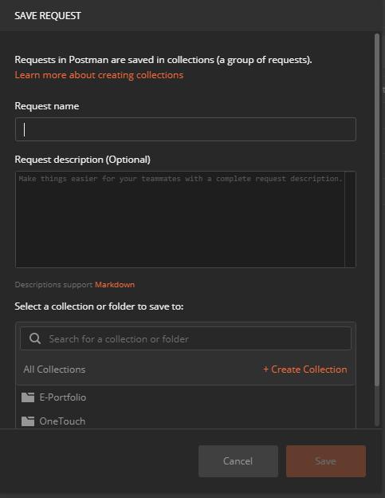

Just enter a Request name to Create a New Request.

You can group your Requests by using Collections.

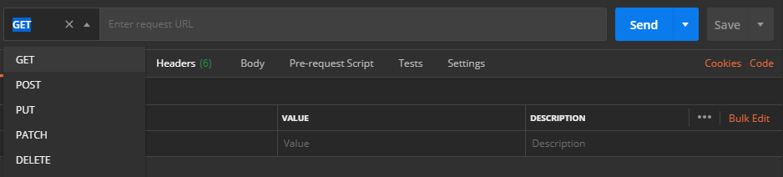

Choose the type of Request you would like to send and enter the URL of the API.

Most common are the:

* GET-Request: to get information from the API
* POST-Request: used to create new Data with the API
* PUT-Request: used to alter Data with the API
* DELETE-Request: used to delete Data with the API

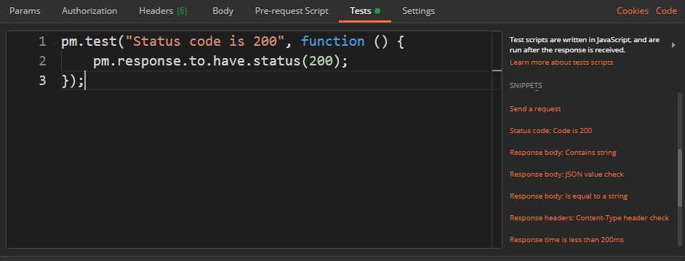

You can add tests to your Request by using the Tests Tab in the Request Overview.

Postman provides standard tests on the right side you can choose from.

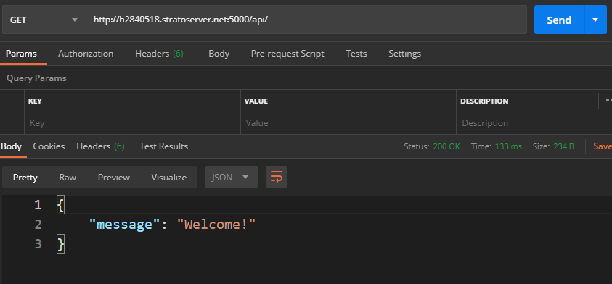

The answer of a Request will be shown below the URL.

There is also the http-Statuscode, the Roundtrip-Time and the Responsesize shown.

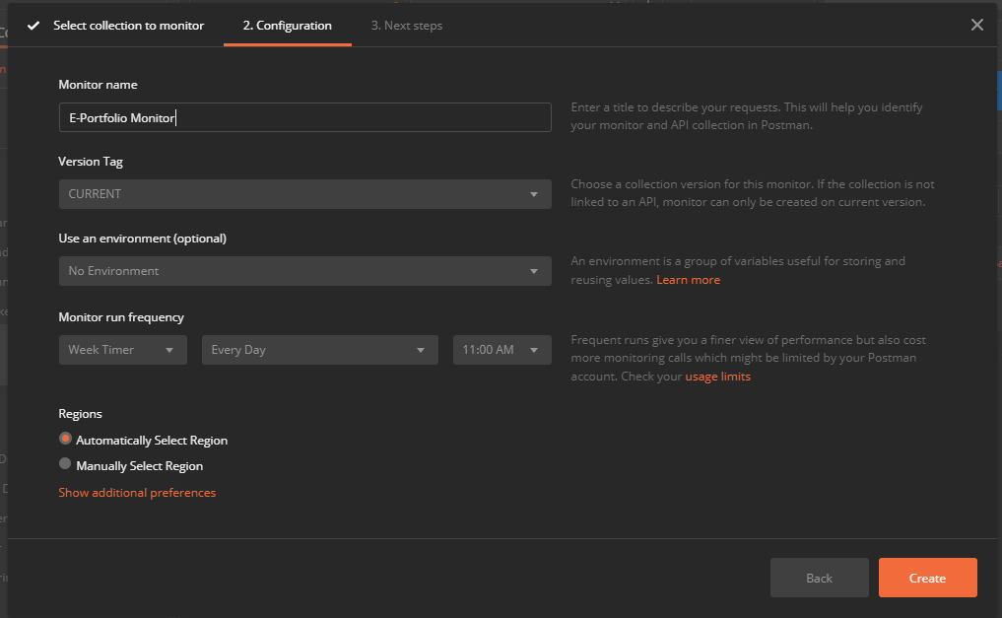

You can add automated monitors to the Collections you created.

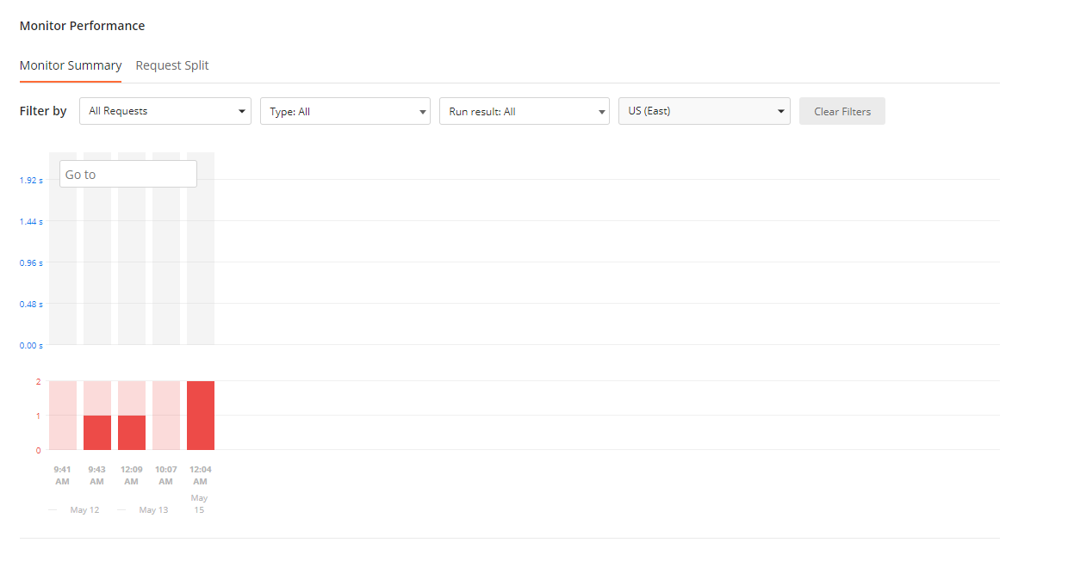

Monitors will be shown in the Browser.

They will run automatically as many times as you specify it.

Note that you have only 1000 Requests/Month in the free License.