**数据结构课程设计**

**班级：1615403**

**学号：161540205**

**姓名：张佳钰**

**指导老师：孙涵**

9.贪吃蛇小游戏

采用的数据结构：

静态数组 队列

算法思想：

通过js的setInterval函数 每隔一段时间执行一次函数 动态生成食物

food还有移动蛇身

移动蛇：

一个数组记录蛇身 不断地执行入队出队操作

源程序：

函数主要写在 snake.js中

/// <reference path="jquery.min.js" />

var width=0;

var height=0;

var hard=0;

var flag=parseInt(0);

var a;

var snake_head;

var snake_tail;

var snake_body;

var snake_direction;

var on_going=0;

var start;

var direction;

var visit;

var all_blank;

var food_num;

var all_food_num=10;//设置总的食物的数量

var food=new Array(all_food_num);

food.fill(-1);

var show;

var key=new Array();

console.log(a);

function init_visit(visit,flag)

{

visit=new Array();

for(var i=0;i<=(height+1);i++)

{

visit[i]=new Array();

for(var j=0;j<=(width+1);j++)

{

visit[i][j]=flag;

}

}

return visit;

}

function pick_start_point()

{

var flag=1;

var i=0;

flag=Math.floor(Math.random()*4);

var j;

var x,y;

y=Math.floor(Math.random()*(width-4))+4;

x=Math.floor(Math.random()*(height-4))+4;

start_point={x:x,y:y,direction:flag};

cur=start_point;

return start_point;

}

function point_to_count(i,j)

{

return (i-1)*(width)+j;

}

function get_food()

{

var y=Math.floor(Math.random()*(width))+1;

var x=Math.floor(Math.random()*(height))+1;

//console.log(width,height,x,y);

while((snake_body.findIndex(n=>n==point_to_count(x,y))!=-1)&&on_going==1)

{

y=Math.floor(Math.random()*(width))+1;

x=Math.floor(Math.random()*(height))+1;

}

return {x:x,y:y};

}

function show_place(num,type="normal")

{

if(type=="food")

{

$(`input[id=${num}]`).addClass("food");

$(`input[id=${num}]`).removeClass("default");

}

else if(type=="get_food")

{

$(`input[id=${num}]`).removeClass("food");

$(`input[id=${num}]`).addClass("walk");

}

else

{

$(`input[id=${num}]`).addClass("walk");

$(`input[id=${num}]`).removeClass("default");

}

}

function back_place(num,type="normal")

{

if(type=="food")

{

$(`input[id=${num}]`).removeClass("food");

$(`input[id=${num}]`).addClass("default");

}

else

{

$(`input[id=${num}]`).removeClass("walk");

$(`input[id=${num}]`).addClass("default");

}

}

function key_event()

{

var p;

var x=[-1,0,1,0];

var y=[0,1,0,-1];

console.log(snake_body);

show = setInterval(function(){

console.log('pp');

if(food_num<all_food_num)

{

var flag=-1;

for(var i=0;i<food_num;i++)

{

if(food[i]==-1)

{

flag=i;

break;

}

}

var new_food=get_food();

food.splice(flag,1,new_food);

console.log("ne_food");

console.log(new_food.x,new_food.y,point_to_count(new_food.x,new_food.y),visit[new_food.x][new_food.y]);

console.log(visit[new_food.x]);

for(var j=1;j<13;j++)

console.log(visit[j]);

visit[new_food.x][new_food.y]=1;

show_place(point_to_count(new_food.x,new_food.y),"food");

food_num++;

}

var new_x,new_y;

new_x=snake_head.x+x[snake_direction];

new_y=snake_head.y+y[snake_direction];

if(new_x<1||new_x>height||new_y<1||new_y>width)

{

alert("you lose!!");

clearInterval(show);

re_start();

}

else

{

console.log("visit: ",visit[new_x][new_y]);

if(snake_body.findIndex(x=>x==point_to_count(new_x,new_y))!=-1)

{

alert("lose");

clearInterval(show);

re_start();

}

else

{

console.log("vist : new direction: ",new_x,new_y,visit[new_x][new_y]);

var flag=-1;

for(var i=0;i<all_food_num;i++)

{

if(food[i]!=-1)

{

console.log("food",food[i]);

if(food[i].x==new_x&&food[i].y==new_y)

{

flag=i;

break;

}

}

}

if(flag!=-1)

{

food.splice(flag,1,-1);

console.log("all_blank: ",all_blank);

snake_body.push(point_to_count(new_x,new_y));

snake_head={x:new_x,y:new_y};

show_place(point_to_count(snake_head.x,snake_head.y),"get_food");

visit[snake_head.x][snake_head.y]=2;

console.log("get_food");

console.log("visit: ",new_x,new_y,visit[new_x][new_y]);

food_num--;

all_blank--;

}

else

{

snake_body.push(point_to_count(new_x,new_y));

snake_head={x:new_x,y:new_y};

var xx,yy;

console.log("back_place");

visit[new_x][new_y]=2;

//onsole.log("00000",snake_tail.x,snake_tail.y,visit[snake_tail.x][snake_tail.y]);

snake_tail=snake_body.shift();

console.log(snake_tail);

xx=Math.floor((snake_tail-1)/width)+1;

yy=snake_tail-width*(xx-1);

console.log("xx,yy",xx,yy);

//console.log("visit: ",new_x,new_y,visit[new_x][new_y]);

show_place(point_to_count(snake_head.x,snake_head.y));

back_place(snake_tail);

//console.log("00000",snake_tail.x,snake_tail.y,visit[snake_tail.x][snake_tail.y]);

visit[xx][yy]=0;

//console.log("00000",snake_tail.x,snake_tail.y,visit[snake_tail.x][snake_tail.y]);

}

for(var j=1;j<13;j++)

console.log(visit[j]);

}

}

}, 400*(all_blank/(height*width)));

document.onkeydown=function(event){

var e = event || window.event || arguments.callee.caller.arguments[0];

if(e)

{

visit=init_visit(visit,0);

visit[start.x][start.y]=1;

//var key=[37,39];

var weight=[-1,1];

console.log(e.keyCode);

for(var i=0;i<key.length;i++)

{

if(e.keyCode==key[i])

{

if(hard==1)

{

snake_direction=(weight[i]+snake_direction+4)%4;

}

else

{

snake_direction=i;

}

console.log("snake_direction: ",snake_direction);

return false;

break;

}

}

console.log(e.keyCode);

}

};

}

function make_matrix(w,h)

{

var text='';

var class_type;

var count=0;

height=h;

width=w;

visit=init_visit(visit,0);

console.log(visit);

console.log(height+1,width+2);

all_blank=height*width-1;

start=pick_start_point();

direction=start.direction;

snake_direction=start.direction;

snake_head={x:start.x,y:start.y};

snake_tail={x:start.x,y:start.y};

snake_body=new Array();

snake_body.push(point_to_count(snake_head.x,snake_head.y));

visit[start.x][start.y]=2;

console.log("start",visit,start.x,start.y);

console.log(start);

class_type="default";

for(var i=1;i<=height;i++)

{

for(var j=1;j<=width;j++)

{

//class_type= d[i][j]==0?"default":"block";

count++;

text+=`<input type="button" class="${class_type}" value="" name="${count}" id="${count}" onmousedown="check_bomb(this.id)">`;

}

text+=`</br>`;

}

//console.log(text);

$('#bg').append(text);

$(`input[id=${point_to_count(start.x,start.y)}]`).removeClass("default");

$(`input[id=${point_to_count(start.x,start.y)}]`).addClass("walk");

$('#re_start').show();

// $('#help').show();

$('#ask_height_width').hide();

}

function start_game()

{

if(on_going==0)

{

on_going=1;

food_num=0;

console.log(visit);

var h=$('#height').val();

var w=$('#width').val();

hard=parseInt($('#hard').val());

if(hard==0)

{

key=[38,39,40,37];

}

else

{

key=[37,39];

}

console.log(h,w);

w=parseInt(w);

h=parseInt(h);

console.log(w+1,h+2);

make_matrix(w,h);

key_event();

}

}

function re_start()

{

width=0;

height=0;

hard=0;

flag=parseInt(0);

snake_head='';

snake_tail='';

snake_body=new Array();

snake_direction=0;

on_going=0;

start=0;

direction=0;

visit=new Array();

all_blank=0;

food_num=0;

food=new Array(all_food_num);

food.fill(-1);

flag=0;

on_going=0;

$('#bg').empty();

clearInterval(show);

$('#re_start').hide();

$('#ask_height_width').show();

}

//打开方式 双击index.html(推荐 用 chrome 打开)

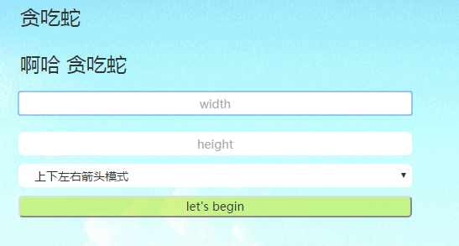

输入width height 选择模式 四键模式或者两键模式



点击 let’s begin

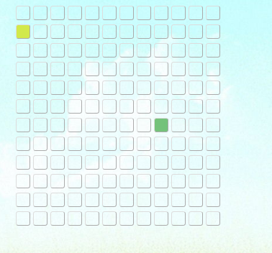

就开始了

Js代码行数

337

感想：

在写贪吃蛇的时候 发现自己好像就小时候玩过 决定打开7k7k小游戏玩一会 没一会就败了 但也差不多知道怎么写 然后就开始了 咦 好像还不难 效果也还行