**数据结构课程设计**

**班级：1615403**

**学号：161540205**

**姓名：张佳钰**

**指导老师：孙涵**

3、二叉树的应用 (必做)（二叉树）

[问题描述]

编程实现二叉树的建立，先序、中序、后序、层序遍历（递归和非递归方法），二叉树的高度，交换左右子树，统计叶子节点的数目，判断是否为完全二叉树。

[基本要求]

（1） 从文件中读入建树信息，树的节点数目不小于20个，树的高度不小于4。

（2） 采用二叉链表结构。

采用的数据结构：

二叉链表结构

算法思想：

二叉树的遍历

源程序：

#include<iostream>

#include<stack>

#include<fstream>

#include<queue>

using namespace std;

#define N 40

struct binary_tree{

int data;

binary_tree * left;

binary_tree * right;

binary_tree(int a = 0):data(a),left(NULL),right(NULL) {}

};

fstream f1,f2;

void CreateBiTree(binary_tree* &BT)

{

int ch;

if(!f1.eof())

{

f1>>ch;

cout<<ch<<" ";

if(ch==0) BT=NULL;

else{

BT=new binary_tree;

BT->data=ch;

// cout<<"left "<<ch<<endl;

CreateBiTree(BT->left);

// cout<<"right "<<ch<<endl;

CreateBiTree(BT->right);

}

}

}

void insert(binary_tree *cur,binary_tree * p)

{

if(cur->data>p->data)

{

if(cur->left==NULL)

{

cur->left=p;

}

else

{

insert(cur->left,p);

}

}else

{

if(cur->right==NULL)

{

cur->right=p;

}

else

{

insert(cur->right,p);

}

}

}

void bfs(binary_tree *root)

{

queue<binary_tree *> q;

q.push(root);

while(!q.empty())

{

binary_tree * p;

p=q.front();

q.pop();

cout<<p->data<<" ";

if(p->left!=NULL) q.push(p->left);

if(p->right!=NULL) q.push(p->right);

}

cout<<endl;

}

binary_tree* read_num(binary_tree * root)

{

int tmp;

binary_tree *p,*q;

root=NULL;

p=root;

int n=N;

while(n--)

{

tmp=rand()%10000;

if(n==N-1)

tmp=3000;

cout<<tmp<<endl;

q = new binary_tree;

q->data=tmp;

if(p!=NULL){

insert(root,q);

}

else{

root=q;

p=root;

}

}

return root;

}

void pre_read(binary_tree * root)

{

if(root!=NULL)

{

cout<<root->data<<" ";

pre_read(root->left);

pre_read(root->right);

}

}

void mid_read(binary_tree * root)

{

if(root!=NULL)

{

mid_read(root->left);

cout<<root->data<<" ";

mid_read(root->right);

}

}

void post_read(binary_tree * root)

{

if(root!=NULL)

{

post_read(root->left);

post_read(root->right);

cout<<root->data<<" ";

}

}

void mid_read_while(binary_tree *root)

{

binary_tree *p;

p=root;

stack<binary_tree*>q;

while(!q.empty()||p)

{

while(p)

{

q.push(p);

// f2<<p->data<<" ";

p=p->left;

}

// f2<<'0'<<" ";

p=q.top();

q.pop();

cout<<p->data<<" ";

p=p->right;

}

cout<<endl;

}

void pre_read_while(binary_tree *root)

{

binary_tree *p;

p=root;

stack<binary_tree*>q;

while(!q.empty()||p)

{

while(p)

{

cout<<p->data<<" ";

f2<<p->data<<" ";

q.push(p);

p=p->left;

}

f2<<'0'<<" ";

p=q.top();

q.pop();

p=p->right;

}

f2<<'0'<<" ";

cout<<endl;

}

void post_read_while(binary_tree *root)

{

binary_tree *p,*last;

p=root;

stack<binary_tree*>q;

last=NULL;

while(p)

{

q.push(p);

p=p->left;

}

while(!q.empty())

{

p=q.top();

q.pop();

if(p->right==NULL||p->right==last)

{

cout<<p->data<<" ";

last=p;

}

else

{

q.push(p);

p=p->right;

while(p)

{

q.push(p);

p=p->left;

}

}

}

cout<<endl;

}

int check_is_sorted(binary_tree *root)

{

binary_tree *p;

int last;

p=root;

int flag=0;

stack<binary_tree*>q;

while(!q.empty()||p)

{

while(p)

{

q.push(p);

p=p->left;

}

p=q.top();

q.pop();

if(!flag)

{

last=p->data;

flag=1;

}

// cout<<p->data<<" ";

if(p->data>=last)

{

last=p->data;

}

else

{

return 0;

}

p=p->right;

}

cout<<endl;

return 1;

}

int test_file()

{

binary_tree *root;

f1.open("bin3.txt",ios::in);

// f2.open("bin3.txt",ios::out);

root=read_num(root);

CreateBiTree(root);//两种模式

/* cout<<"bfs: "<<endl;

bfs(root);

cout<<"pre_read: "<<endl;

cout<<"post_read: "<<endl;

post_read_while(root);

*/ cout<<"mid_read: "<<endl;

mid_read_while(root);

// pre_read_while(root);

if(!check_is_sorted(root))

cout<<"this tree is not sorted"<<endl;

else

cout<<"this tree is sorted"<<endl;

// f2.close();

f1.close();

return 0;

}

void bin_h(binary_tree *root,int &max_height,int cur)

{

if(cur>max_height)

max_height=cur;

if(root->left)

{

bin_h(root->left,max_height,cur+1);

}

if(root->right)

{

bin_h(root->right,max_height,cur+1);

}

}

int bin_height(binary_tree *root)

{

int max_height=0;

bin_h(root,max_height,1);

return max_height;

}

void exchange(binary_tree *root)

{

if(root)

{

binary_tree *p;

p=root->left;

root->left=root->right;

root->right=p;

exchange(root->left);

exchange(root->right);

}

}

void exchange_bin_tree(binary_tree *root)

{

exchange(root);

}

void count_leave(binary_tree *root,int &count)

{

// cout<<root->data<<endl;

if(root->left)

{

count_leave(root->left,count);

}

if(root->right)

{

count_leave(root->right,count);

}

if(!root->left&&!root->right)

{

count++;

// cout<<endl<<root->data<<" ";

}

}

int count_leaves(binary_tree *root)

{

int count=0;

count_leave(root,count);

return count;

}

int main()

{

binary_tree *root;

f1.open("bin3.txt",ios::in);

cout<<"Create Tree :"<<endl;

CreateBiTree(root);

cout<<endl<<"Recurrene: "<<endl;

cout<<endl<<"pre_read:"<<endl;

pre_read(root);

cout<<endl<<"mid_read:"<<endl;

mid_read(root);

cout<<endl<<"pre_read:"<<endl;

post_read(root);

cout<<endl<<"non Recurrence: "<<endl;

cout<<endl<<"pre_read_while:"<<endl;

pre_read_while(root);

cout<<endl<<"mid_read_while:"<<endl;

mid_read_while(root);

cout<<endl<<"post_read_while:"<<endl;

post_read_while(root);

cout<<endl<<"binary_tree_height: "<<endl;

cout<<bin_height(root)<<endl;

cout<<endl<<"exchange_left_and_right_tree: "<<endl;

exchange_bin_tree(root);

cout<<endl<<"mid_read:"<<endl;

mid_read(root);

cout<<endl<<endl<<"count_binary_tree_leaves:"<<endl;

cout<<count_leaves(root)<<endl;

cout<<"check_if_the_tree_is_sorted: "<<endl;

if(!check_is_sorted(root))

cout<<"this tree is not sorted"<<endl;

else

cout<<"this tree is sorted"<<endl;

exchange_bin_tree(root);

if(!check_is_sorted(root))

cout<<"this tree is not sorted"<<endl;

else

cout<<"this tree is sorted"<<endl;

return 0;

}

测试数据：

bin3.txt

3000 1478 491 153 0 292 0 0 0 2995 1942 1726 1538 0 0 1869 0 0 2391 2382 0 0 0 0 8467 6334 5724 4464 3281 0 3902 0 0 5705 4827 4604 0 4771 0 0 5436 0 5447 0 5667 0 0 0 6299 0 0 6500 0 6962 6827 0 0 8145 7421 7035 0 0 0 0 9169 8716 0 0 9358 0 9961 9718 0 9895 9894 0 0 9912 0 0 0

测试结果：

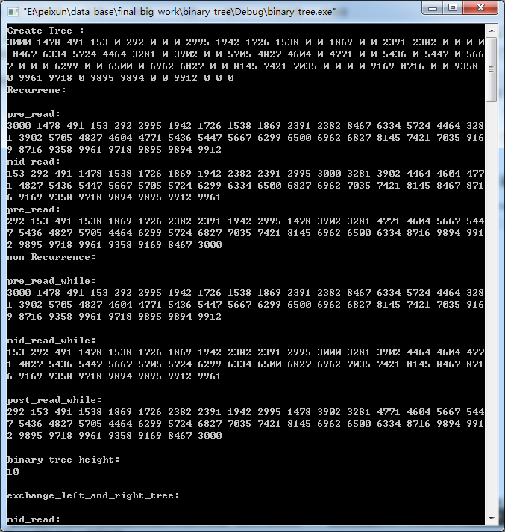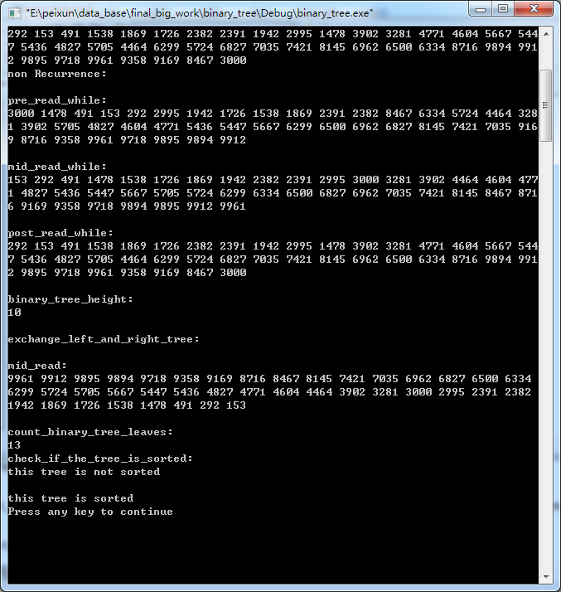

代码行数：375行