Instructions for Field Work in the Pollinator Experiment of the BetterGardens Project
NOTE: This is an unofficial translation. The original German version was used during data collection and field work. This translation is provided for reference only.
- Recording dates
Due to bad weather and an unusually cold spring, the plants are delayed and time for the experiment is running short, as many participants will be on holiday in July. Each group should therefore try to complete observations every three days between 13 June and 30 June. It is also possible to go into the field on consecutive days if the weather permits. The plants will remain in the field until at least the end of July. For motivated participants, there is therefore the possibility to join us in the field until the end of the experiment at the end of July.
- Observation periods
The observations take place between 9:00 a.m. and 6:00 p.m. (one hour less ;) (Table 1)! Within this time span, 9 capture windows are defined during which pollinators are captured. Nota bene: there are no longer any observation windows! This means that at least one person must be present throughout the entire day. During the capture windows, flower-visiting insects that are actually collecting nectar or pollen are captured. These are easy to recognize, as they stay on a flower for a longer period of time and can therefore be easily captured (no "short visits," but longer stays).

Table 1: Capture windows for pollinators during a field work day
Capture window | 9:00-10:00 | 10:00-11:00 | 11:00-12:00 | 12:00-13:00 | 13:00-14:00 | 14:00-15:00 | 15:00-  16:00 | 16:00-  17:00 | 17:00-  18:00

- Weather conditions for the observations
Favourable weather conditions concerning wind, temperature, and sunshine must prevail for the observations. Field work days should therefore only be scheduled for days with more or less sunny weather, at most a moderate breeze, and temperatures above 10°C.
Nevertheless, at the beginning of each capture window, the current weather conditions must be recorded on the observation sheet.
3.1 Wind
The best conditions are calm to light air. If there is wind, the wind speed may not exceed 4 Bft (according to the Beaufort wind scale: Bft 4 = branches move, loose paper is lifted from the ground). If the wind speed persists above 4 Bft (larger branches and trees move, wind clearly audible), discontinue capturing. See field work guide / observation sheet.
3.2 Temperature
The air temperature must be at least 10°C. The temperature does not need to be measured manually. Measuring probes are installed in each garden.
3.3 Sunshine
The sun must be shining for the most part during the observations. This means that field work days must be scheduled exclusively for days when good weather is forecast. Smaller or quickly passing cloud patches during the day are permitted and can be noted on the observation sheet. See field work guide / observation sheet.
3.4 Interruption or termination of field work due to bad weather
If weather conditions deteriorate significantly during the day, observations may be interrupted or completely terminated. This applies to persistently strong wind (Bft > 4), sustained heavy cloud cover, rain, or thunderstorms. Do not take any risks during thunderstorms!
Interruptions or terminations must be noted on the observation sheet. The reason for termination must also be recorded on the observation sheet.
After an interruption, observations can simply continue with the next time window if conditions allow. Interruptions due to heavy cloud cover can be used as breaks! Even if a day is not completed in full, the data collected prior to termination remain valuable and can be used for analysis!
- Work groups and selection of gardens
The work is carried out in groups of two or three people, who ideally remain together for the entire observation period. People with little or no field experience should form a group with an experienced person.
Each group conducts only one observation per garden. In each city district, only one garden may be surveyed. Apart from these restrictions, the gardens are assigned to the groups randomly.
The gardens are allocated to the groups by us one to two days before the planned observation. All gardens are located within the city of Zurich and are freely accessible. The garden owners will be informed by us in advance about each visit.
Important rule of conduct in the gardens: Always close the garden gates (children, dogs)!
- General work instructions
Insects are captured and observed exclusively on the pre-cultivated plants (see list below), which are placed in a central, unshaded location in the garden (approximately 10 pots in boxes). This is usually on the lawn.
In each garden, a "field kit" with all the necessary materials, including the field sheets and these instructions, is made available. Only personal equipment (net, sun hat, sunscreen, water, and picnic) must be brought along.
At the end of the day, all materials from the field kit must be placed back into the cool bag. The bag can be left in the garden; we will collect it later.
Only pollinating flower-visiting insects should be captured (e.g. no spiders, weevils, ants, or bugs). Flower-visiting insects are those that land on open flowers and actually collect nectar or pollen. These are easy to recognise, as they remain on a flower for a longer time and can therefore be easily captured (no “short visits,” but longer stays). Open flowers are those that are neither in bud nor wilting.
At around 11:00 a.m., the number of open flowers or inflorescences (the umbels for carrot) must be counted and recorded on the field form (Table 2; example sheet).
Table 2. Example sheet: how one counts flowers
Plant | Carrot  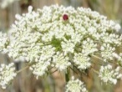 | Radish  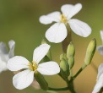 | Sainfoin  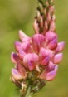 | Comfrey  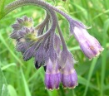
What to count? | Number of umbels | Number of individual flowers | Number of individual flowers | Number of individual flowers
E.g. | 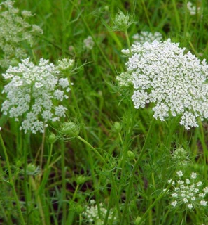 | 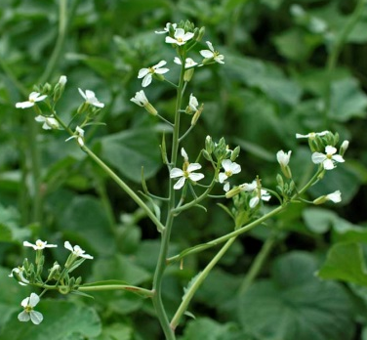 | 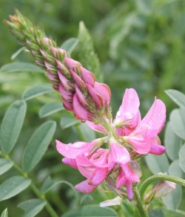 | 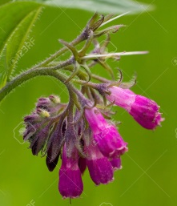
 | ≈ 3 open umbels | ≈ 13 open flowers | ≈ 7 open flowers | ≈ 7 open flowers

5.1 Instructions for CAPTURING
- All flower-visiting insects (including all honey bees) are to be captured.
- "Ordinary" flies (flies other than hoverflies), which often sit on the petals, do not need to be captured.
- Nectar robbers do not need to be captured. Nectar robbers, e.g. honey bees, gnaw into comfrey flowers from the side and leave characteristic holes. Record nectar robbing under “Observations” on the observation sheet.
- Bees that steal nectar from radish flowers from the side also do not need to be captured.
- Bugs, weevils, tiny black beetles (e.g. pollen beetles), spiders, ants, etc. do not need to be captured.
- Insects that could not be captured and escape must be recorded on the field form and assigned to a pollinator group (e.g. "hoverfly").
- Casting a shadow on the plants with your body must be avoided. This means that the plants must always be positioned between you and the sun.
- Insects are captured with the net or preferably with the capture jar with foam stopper (as practised during the excursion), without damaging the flowers. We have found that hoverflies are best captured with the capture jar and then transferred, under the net (to prevent escape), into the 8 ml glass vials. Bumblebees and bees can also be easily captured with the capture jar, as they are very focused on collecting nectar and pollen. Try out what works best for you!
- When an insect lands on an open flower, the net is gently placed over the plant. If the insect flies away, the net with the insect inside is lifted away from the plant and placed on the ground. The insect is then captured with an 8 ml glass vial and labelled with the tag corresponding to the plant on which it was captured. For each plant species, colour-coded labels are available and should be affixed to the vials immediately after capture:
  - Carrot: white label marked "Carrot".
  - Radish: grey-marked label marked "Radish".
  - Sainfoin: pink-marked label marked "Sainfoin".
  - Comfrey: violet-marked label marked "Comfrey".
- The vial is immediately placed into the prepared cool bag.
- At the latest, at the end of each capture window, all full vials are placed into a plastic bag on which the time window, date, and garden number are recorded.
- During the observation windows, the cool bag must be placed in the shade. It should only be opened when necessary. It contains four cooling elements.
- The inflorescences of wild carrot and oilseed radish must not be rubbed against each other (risk of pollination).
- Move calmly around the plants to avoid scaring off insects.

- Work attire
Observers should wear inconspicuous clothing (e.g. beige). Yellow clothing must not be worn. Strongly scented perfumes should not be used.
- Field materials
In each garden, a "field kit" with all necessary materials, including the field sheets and these instructions, is available. Only personal equipment (course materials, net, sun hat, sunscreen, water, and picnic) must be brought along.
Do not forget the nets! They have already been distributed and may be kept after the experiment if desired. Only the nets provided by us may be used.
Picnic and sufficient water must be brought along. The water bottle can be refilled in most gardens. A hat and sunscreen are very important for sun protection and must be brought along. Toilets: In most cases, you may ring the garden owner's doorbell. Otherwise, use public toilets (see map) or toilets in restaurants.

- Behaviour within the gardens
The experiment takes place in private gardens. Accordingly, you should move carefully in the garden (e.g. do not trample too many plants). The wishes of the garden owners must be respected.
Important rule of conduct in the gardens: Always close the garden gates (children, dogs)!
- Insurance
Insurance is the responsibility of the participants.
- Contact/Information
Most information will be provided by e-mail. Please check your mailbox regularly during the field season. If you have any questions, David Frey (XXX XXX XX XX) and Marco Moretti (XXX XXX XX XX) are available at any time. [Phone numbers have been removed now for privacy].
Morning field form:
Capture window | 9:00-10:00  Interrupted capturing (from - to):  …………………………………………………………………... |  |  |  | 10:00-11:00  Interrupted capturing (from - to):  …………………………………………………………………... |  |  |  | 11:00-12:00  Interrupted capturing (from - to):  …………………………………………………………………... |  |  |  | 12:00-13:00  Interrupted capturing (from - to):  …………………………………………………………………...
Wind speed  Tick! See field guide! | 0-1 | 2 | 3 | 4 | 0-1 | 2 | 3 | 4 | 0-1 | 2 | 3 | 4 | 0-1 | 2 | 3 | 4
Cloud cover  Tick! See field guide! | 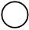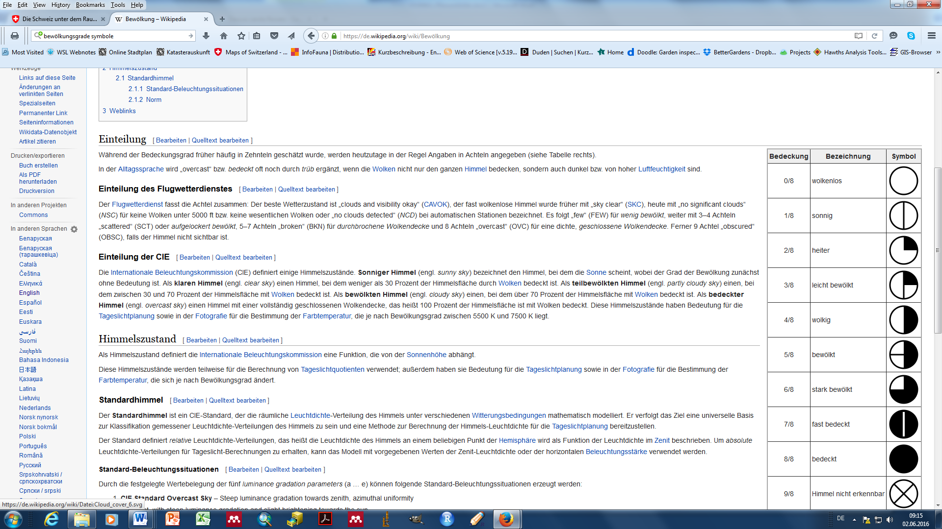
Escaped insect:  Write down which insect it was and on which plant it was observed (enter in the corresponding column).  Distinguish between:  - Wild bee  - Honeybee  - Bumblebee  - Wasp  - Hoverfly  - Jewel beetle  - Longhorn beetle  - False blister beetle  - Soldier beetle  - Scarab beetle | 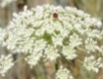  Carrot | 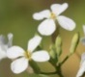  Radish | 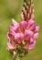  Sainfoin | Comfrey  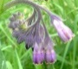 | Carrot | Radish | Sainfoin | Comfrey | Carrot | Radish | Sainfoin | Comfrey | Carrot | Radish | Sainfoin | Comfrey
Afternoon field form:
Capture window | 13:00-14:00  Interrupted capturing (from - to):  …………………………………………………………………... |  |  |  | 14:00-15:00  Interrupted capturing (from - to):  …………………………………………………………………... |  |  |  | 15:00-16:00  Interrupted capturing (from - to):  …………………………………………………………………... |  |  |  | 16:00-17:00  Interrupted capturing (from - to):  …………………………………………………………………...
Wind speed  Tick! See field guide! | 0-1 | 2 | 3 | 4 | 0-1 | 2 | 3 | 4 | 0-1 | 2 | 3 | 4 | 0-1 | 2 | 3 | 4
Cloud cover
Tick! See field guide!
Escaped insect:  Write down which insect it was and on which plant it was observed (enter in the corresponding column).  Distinguish between:  - Wild bee  - Honeybee  - Bumblebee  - Wasp  - Hoverfly  - Jewel beetle  - Longhorn beetle  - False blister beetle  - Soldier beetle  - Scarab beetle | Carrot | Radish | Sainfoin | Comfrey | Carrot | Radish | Sainfoin | Comfrey | Carrot | Radish | Sainfoin | Comfrey | Carrot | Radish | Sainfoin | Comfrey

Capture window | 17:00-18:00  Interrupted capturing (from - to):  …………………………………………………………………...
Wind speed  Tick! See field guide! | 0-1 | 2 | 3 | 4
Cloud cover
Tick! See field guide!
Escaped insect:  Write down which insect it was and on which plant it was observed (enter in the corresponding column).  Distinguish between:  - Wild bee  - Honeybee  - Bumblebee  - Wasp  - Hoverfly  - Jewel beetle  - Longhorn beetle  - False blister beetle  - Soldier beetle  - Scarab beetle | Carrot | Radish | Sainfoin | Comfrey
Number of open flowers: Count at ~11 a.m.! Do not count wilted flowers or buds!
Plant | Carrot | Radish | Sainfoin | Comfrey
What to  count? | Number of  umbels | Number of  individual counts | Number of  Individual counts | Number of  Individual counts
Count

Remarks/Observations:

These are valuable protocol sheets of a scientific study. In case of loss, please send to David Frey, Swiss Federal Institute for Forest, Snow and Landscape Research WSL, Zürcherstr. 111, 8903 Birmensdorf. david.frey@wsl.ch. Thank you!

Wind speed in Beaufort (Bft) Enter in the field protocol!

Source: https://de.wikipedia.org/wiki/Beaufortskala (adjusted, translated)
Wind speed  in Beaufort (Bft) | Description of wind speed | Effects on land | Experimental action
0 | Calm | no air movement, smoke rises vertically | ideal
1 | light air | barely noticeable, smoke drifts slightly, wind vanes unmoved | ideal
2 | light breeze | leaves rustle, wind felt on face | tolerable
3 | gentle breeze | leaves and thin branches move, flags extended | tolerable
4 | moderate breeze | branches move, loose paper lifted from the ground | tolerable
5 | fresh breeze | larger branches and trees move, wind clearly audible | discontinue
6 | strong wind | thick branches move, audible whistling in wires and telephone lines | discontinue
7 | near gale | trees sway, walking against the wind becomes difficult | discontinue

Cloud cover Enter in the field protocol!

Source: https://de.wikipedia.org/wiki/Bew%C3%B6lkung (translation ours)
Degree of cloud cover in eighths! e.g. 4/8 = half the sky covered.
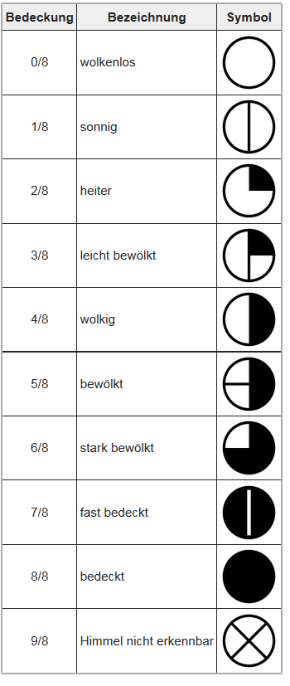
Symbol
Description
Coverage
sky obscured
almost overcast
heavily cloudy
mostly cloudy
partly cloudy
overcast
slightly cloudy
mostly clear
sunny
cloudless
ideal
tolerable
discontinue

