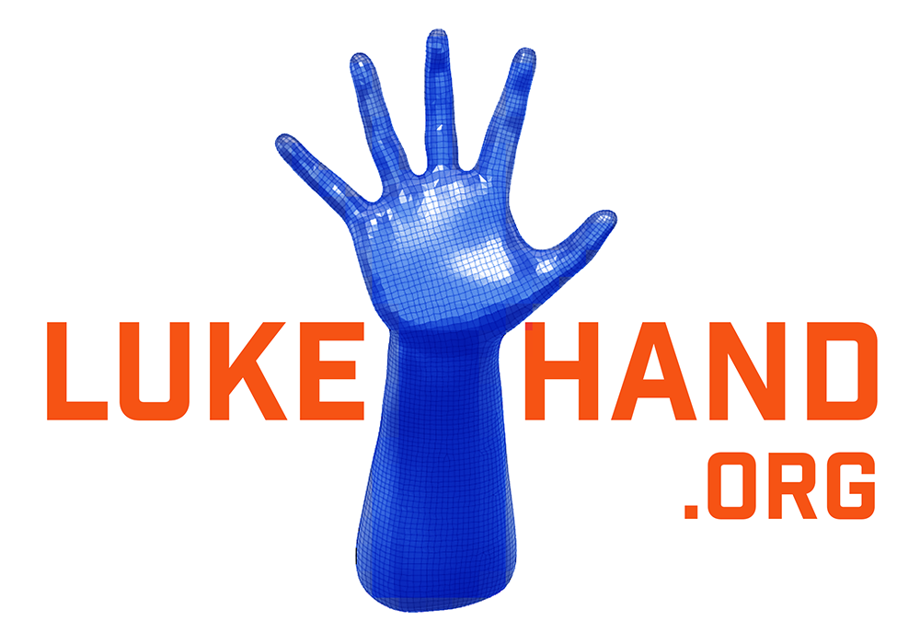

Control Software

ProposedControl SoftwarePrototypeWorkflow

Summary

The initial version of the software will be designed with Thalmic Lab’s Myo armband as the hardware device providing the EMG signals. A set of eight signals, each from the Myo’s EMG sensors, is recorded and processed at regular time intervals to determine hand gesture based on various distinct properties of these signals. In order to ensure the different gestures are uniquely identified each time, the signals will be parsed through Machine Learning algorithm(s) trained from prior gestures and non-gestures. The signals might have to be processed depending on the sampling rate and real time performance capabilities of the platform running the control software. For the initial prototype, the processing will be done on a computer. However, the software will eventually need to run on a processor embedded within the bionic arm. It is important to consider the flexibility of running the software on different platforms like Windows or Linux/ROS.

1. Data Collection

The first step is collecting the raw data signals from the Myo armband. From prior experience, sampling the signals at 100Hz did not require any filtering. However, sampling at 200Hz will be tested to see if better differentiation can be acquired. Both Finite Impulse Response (FIR) and Infinite Impulse Response (IIR) filters will be tested. FIR filters will be more powerful and will give more stable signals but they will require more processing power, hence a comparison of the two to determine the trade-off will have to be done. The signals will also have to be broken down into time windows with some overlap between them. The smallest time window will be determined by the shortest hand gesture the model will be trained to detect. The time overlap between the windows will be necessary in case a window encompasses only part of a gesture and the rest of the gesture would be in another time window were there no overlap.

1. Feature Extraction

Once the signal has been filtered, features that determine the nature of each signal will be calculated.

Several features that can distinguish a signal from another include but are not limited to:

* The Area Function: Area between the signal and the horizontal axis.
* Zero Crossings about the mean : A measure of how much the signal oscillates/frequency,
* Line Length: A discrete linear integration of the of the signal values.
* Energy of Signal: A function of squaring the signal values.

In general, the more distinguishing features that can be used, the more accurate the model will predict future signals. However, too many constraints can result in overfitting, a situation where the model will only work very well for one specific set of data.

1. Training & Prediction

Once the features are extracted, a supervised Machine Learning model will be trained to learn what each feature or combination of features represents in terms of hand gestures. In order to do so, the model has to be fed both actual gestures and non-gestures so that it can distinguish between “right” and “wrong”. The larger and more varied the training datasets, the better the performance of the model as it will be able to determine more well defined parameters that separate the gestures from each other. The algorithms will fall into two general categories; Regression and Classification. For starters, Classification will be used to determine pre-defined gestures whereas regression will be great for determine finer finger movements. The Myo armband alone will likely not be able to produce signals that can reflect individual finger joint angle.

Some Machine Learning models to be explored for classifying the signals are, Logistic Regression (linear), Support Vector Machines (SVM), K-NN, and neural networks. There are several Machine Learning tools at our disposal such as third party SVM and Logistic Regression libraries or Microsoft’s Cognitive Toolkit CNTK) and Google’s Tensorflow.

Once a model is created, the extracted features can then be parsed through the model which determined what types of gestures the features are associated with.

Future Steps

* Running porting the software for functionality on an embedded processor running ROS.
* Ability to listen to EMG data from different types of sensors other than the Myo.
* Determining exact finger joint angles in addition to general gestures.