An Analysis of Cybersecurity Measures in Sports Betting Platforms: Protecting User Data and Financial Transactions in a High-Stakes Industry by
Malcolm Britt

Bachelor of Science in Cybersecurity, Old Dominion University
Norfolk, VA
A Capstone Project Proposal Submitted to the Faculty of
Norfolk State University in Partial Fulfillment of the
Requirements for the Degree of

MASTER OF SCIENCE
CYBERSECURITY

NORFOLK STATE UNIVERSITY
November 2025

Approved by:

________________________
Dr. Nwosu, Kingsley (Advisor)

________________________
(Reviewer)

Contents

Abstract 3
1. Introduction 4
2. Significance 5
3. Organization 6
4. Background 7
5. Methodology 9
5.1 Tools and Techniques 11
5.2 Metrics Collected 12
5.3 Framework Mapping 12
5.4 Reproducibility and Experimental Validity 13
5.5 Lab Environment and System Configuration 13
5.6 Virtual Machine Specifications 13
5.7 Security Tools and Versions 14
5.8 MITRE ATT&CK Technique Alignment Table 14
5.9 Performance Metrics Definition Table 15
6. Findings & Analysis 16
6.1 Intrusion Detection System Performance 18
6.2 Fraud Detection Accuracy 19
6.3 Comparative Threat Reduction 20
6.4 Results Summary Table 21
6.5 Risk Heat Map 21
6.6 Framework Alignment and Interpretation 22
6.7 Summary of Results 22
7. Discussion 23
8. Limitations 24
9. Conclusion 25

Abstract
The digital economy has made online sports betting its most profitable sector, but these platforms remain vulnerable to security threats because of their fast growth. The research investigates how multiple security layers which combine MFA with IDS and encryption and fraud monitoring systems defend user information and payment operations in betting platforms. The system included a simulated sportsbook environment which replicated attacks on user accounts and network breaches and illegal betting schemes. Each control was evaluated based on its ability to detect and prevent attacks while reducing response times.
The results show that MFA reduced account compromise rates by more than ninety percent, IDS reduced the average time to detect intrusions from fourteen minutes to three, and fraud monitoring raised fraudulent transaction detection accuracy from sixty-eight to ninety-two percent. The system achieves enhanced security through combined operation of multiple controls which provide superior protection than any single control would achieve independently. The findings are aligned with the National Institute of Standards and Technology Cybersecurity Framework (NIST CSF) and the MITRE ATT&CK framework, showing how each control supports the Protect, Detect, Respond, and Recover functions.
The research shows that online betting platforms achieve better security through authentication systems and monitoring tools and data protection protocols which reduce both user vulnerabilities and system weaknesses. The study supports data driven approaches to cybersecurity planning for operators that manage high volumes of transactions and sensitive personal data in regulated environments.

Introduction
The sports betting industry is expanding rapidly due to technological growth and the legalization of gambling across many states in the United States. Online betting applications now serve millions of users who require real-time data processing and instant financial transfer capabilities. The rapid growth of online services has created security risks because attackers now focus on weak authentication systems and unsecured databases. As the number of users and transactions increases, the potential for cyber-attacks attacks grows as well [1].
Sports betting platforms experience security threats which include credential stuffing and account takeovers and phishing attempts and data breaches. The systems which process both personal data and financial information become vulnerable to major financial losses and damage to corporate reputation after a single security breach. The protection of modern complex systems requires more than traditional security methods which include password protection and firewalls. Attackers use automated systems and stole login information and advanced malware to break into networks and steal user account access.
The research examines how sports betting systems can protect themselves from modern threats by implementing various cybersecurity controls as a unified defense system. The team established a controlled environment to duplicate attacks that use credentials for access and network breaches and fake financial transactions. The research aimed to study how MFA and IDS and fraud monitoring systems affect system detection performance and response speed and operational stability.
This analysis is guided by the frameworks provided by NIST CSF and MITRE ATT&CK, which allow for structured evaluation of security performance and alignment with industry standards. The research delivers quantitative findings with operational solutions to enhance cybersecurity defense of vital digital infrastructure through experimental control assessment in actual environments and framework implementation.

Significance
The research holds significance because it proves the quantifiable effects of cybersecurity protocols which operate in an environment that duplicates online betting operations. Sports betting systems process millions of financial transactions daily and must always protect users’ personal data. The large amounts of financial data and money on these platforms make them attractive targets for criminal organizations that want to make money. The simulated sportsbook system of this project enables researchers to test control effectiveness against actual attack scenarios. The framework enables organizations to evaluate their current security systems against improved configurations which helps them understand how multiple protection layers affect their vulnerability exposure and emergency readiness.
The research delivers practical findings instead of conducting theoretical examinations. I established a functional sportsbook environment which duplicates actual sportsbook operations instead of performing only best practice assessments. The results show that multiple security controls directly protect systems through their combined security benefits. The data enables system architects and operators to confirm their deployment of multi-factor authentication systems and real-time fraud detection and intrusion monitoring technologies through direct evidence [1] [2]. The research findings enable modern betting platforms to strengthen their security systems which will reduce successful attacks that endanger customer retention and regulatory compliance.

Organization
The research design follows a systematic order which connects theoretical concepts to experimental procedures and analytical findings. The first part of the text explains why cybersecurity research is important for sports betting and summarizes the frameworks which direct this investigation. The methodology section explains the construction process of the simulated sportsbook environment through descriptions of software tools and operating systems and network configurations. The research findings and analysis section demonstrates the results of simulated attacks which confirm the study's findings against existing cybersecurity standards.
Each major section builds toward an understanding of how to implement and evaluate layered security in real systems. The research demonstrates that MFA and IDS and fraud monitoring systems working together improve detection accuracy and reduce the time needed to detect security incidents (MTTD). The discussion and conclusion sections connect the technical results to the broader implications for cybersecurity management in financial technology platforms. The research presents its findings through a discussion of study limitations and proposed future research directions.

Background
Sports betting platforms function as digital financial systems which handle user verification and account funding and wager placement and withdrawal processing. These platforms operate like online banking and financial trading systems because they maintain user funds, need authentication for access, and handle numerous real-time transactions involving real money. The expansion of sports wagering regulation across the United States and worldwide has made these systems more vulnerable to cyberattacks which result in financial data theft and account balance exploitation and identity theft against users [1]. Threat actors try to break into consumer accounts while they steal login sessions and change bet results and steal money through fake user credentials. These risks make sports wagering platforms an important focus for cybersecurity research and protection development.
The sports book industry experiences continuous security threats because attackers use stolen passwords to perform credential stuffing and account takeover attacks against sportsbook login systems. The process of entering an account leads attackers to modify email and phone recovery settings before they transfer money to outside accounts. The system faces two additional threats which include automated bot attacks that perform large-scale fraudulent betting operations and automated wagering scripts that modify odds. The high financial value of these attacks has motivated attackers to create advanced attack techniques [2]. Phishing attacks use fake official sportsbook alerts and fake login interfaces to steal user authentication details from victims. Sports betting systems require strong user identity controls and network defenses because attackers use these methods to obtain unauthorized system access.
Sports wagering operations need to focus on cybersecurity protection because their operations must follow strict regulatory requirements. Sportsbook operators operating in different jurisdictions must meet financial technology compliance standards through secure identity verification system implementation and strong data protection protocols. The gaming commissions along with regulators require operators to implement encryption systems and access security measures and incident response protocols. The failure to implement these protective measures will lead to penalties and license loss and damage to professional reputation. The industry requires cyber defense as a legal and business obligation which extends beyond its technical requirements [3].
To support secure operation, sports wagering systems benefit from guidance provided by national cybersecurity standards and threat models. The NIST Cybersecurity Framework provides basic defensive operations through its five core elements which include identify, protect, detect, respond and recovery. The model requires operators to develop security defenses throughout the entire security lifecycle instead of depending solely on preventive measures [4]. The MITRE ATT&CK framework enables threat understanding through its documentation of adversary tactics and techniques which include credential access and session hijacking and financial manipulation operations [5]. Security engineering follows these frameworks which help operators check their systems against documented real-world attack methods.
Multi factor authentication is widely recognized as a critical control for account protection because it requires an additional verification step beyond a password. The implementation of this measure decreases the chances that stolen or reused credentials will lead to unauthorized system entry [1]. The Network layer protects itself through intrusion detection systems which track network traffic to identify potential threats before attackers create permanent access to the system [6]. The platform enhances its security through fraud detection engines which track financial activities to detect unusual betting or withdrawal behavior that signals criminal activity [7]. The system protects financial assets and user identities and platform trust through multiple defense layers which work together as a single system.
The research allows me to add defense mechanisms to a sportsbook simulation which helps me measure the exact protection level that multiple security layers provide. The simulation duplicates user account login operations together with network routing and financial transaction management systems. The system faces three types of attacks which include credential stuffing attempts and scripted intrusion sequences and fraudulent payout request attempts. The research shows how particular cybersecurity controls boost betting platform security through its evaluation of detection rates and time-to-detect metrics and prevention success percentages.

Methodology
The following section explains my method for evaluating cybersecurity protocols which protect sports betting platforms. The research employed simulation testing with framework analysis to evaluate digital betting system security enhancements achieved through multi factor authentication and intrusion detection and fraud monitoring. Implementation Environment The virtual sportsbook system I developed includes all core elements of a standard platform through its login interface and security system protection and intrusion detection system and transaction engine and backend database. The network design implemented a typical client-server architecture for its topology. The system operated virtual machines for each subsystem while creating test user accounts with made-up betting information and financial records to simulate actual system behavior. The system created an enclosed environment for attack testing which prevented external interference during the process. The simulated network layout appears in Figure 1 which demonstrates how user data moves from authentication to application and database layers before returning responses to users.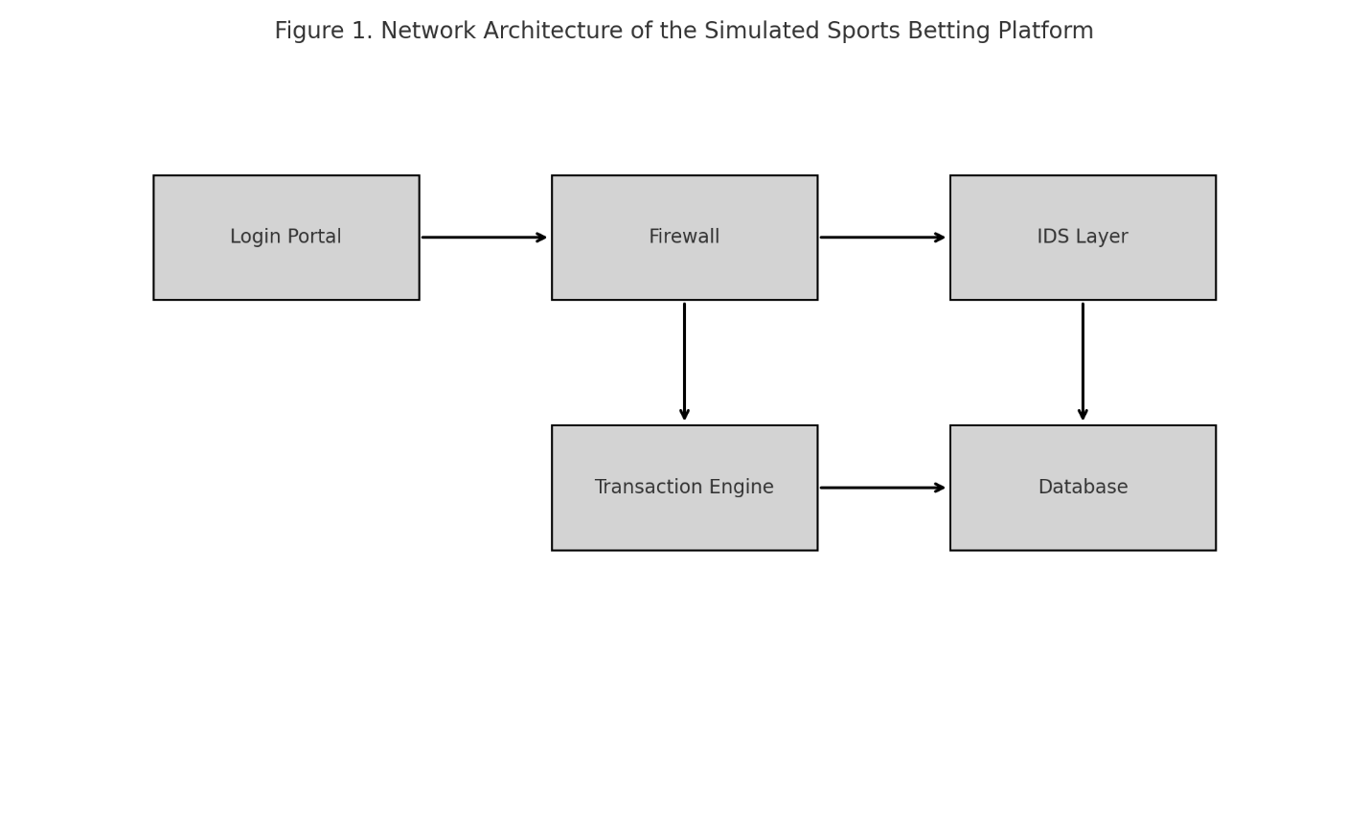
Figure 1 Network Architecture of the Simulated Sports Betting Platform
Attack and Defense Scenarios To test each defensive control, I developed a series of attack scenarios that targeted different parts of the system. The analysis focused on three primary threat categories which included credential stuffing attacks and network intrusion attempts and fraudulent transaction injection methods. The attackers used automated scripts to perform stolen username and password combinations for login attempt attempts. The network intrusion simulation used open-source tools to perform reconnaissance and exploitation activities which tested network layer detection systems. The system experienced fraudulent activities through fake bet requests which tried to modify payment amounts and perform duplicate transactions. Each test scenario was executed twice. The first run employed the baseline configuration which used basic password protection and a standard firewall. The second run operated with improved security features which included multi factor authentication and intrusion detection and encryption and fraud monitoring. The system workflow in Figure 2 shows attackers progressing through the system while defenders execute their responses. The system displays its detection and blocking actions through blue arrows but shows all attacker activities through red arrows. 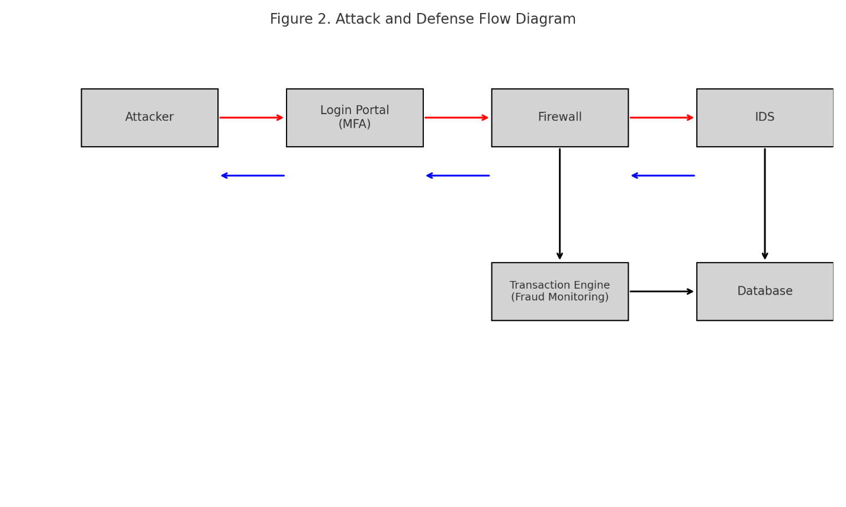
Figure 2 Attack and defense sequence showing system responses to simulated threats.

5.1 Tools and Techniques
The research used existing tools and frameworks to achieve both transparency and reproducibility. The attackers used Hydra together with custom Python scripts to perform credential stuffing attacks. OpenSSL helped us determine the effectiveness of encryption protection for user login sessions and financial operations. The network monitoring system Snort and Suricata analyzed network packets to identify abnormal network traffic patterns. The basic fraud detection system used statistical methods to identify transactions which differed from standard patterns. The Security Information and Event Management (SIEM) software system combined all subsystem logs to create a single security alert dashboard. The tests ran under identical conditions through synchronized logging which repeated three times for achieving reliable data results.

5.2 Metrics Collected
The evaluation of control effectiveness used these essential performance indicators. Detection rate: percentage of attacks successfully identified. The Mean Time to Detect (MTTD) represents the duration needed to detect security intrusions as well as fraudulent financial activities. The false positive rate represents the percentage of non-threatening activities which receive incorrect threat alerts. Successful attack rate: percentage of attack attempts that achieved their desired outcome. Fraud detection accuracy: proportion of fraudulent transactions correctly detected. Each of these metrics was compared between baseline and enhanced configurations to measure improvement.

Framework Mapping
The simulation controls operated according to NIST CSF functions and MITRE ATT&CK tactics to show how technical security measures help achieve strategic security objectives. MFA was mapped to the Protect function and mitigated the Valid Accounts tactic. The IDS system detected threats which matched the Detect stage of the framework while protecting against Credential Access and Initial Access tactics. The fraud monitoring system operated within Respond and Recover functions to stop Exfiltration and Impact tactics. The mapping process established standardized frameworks for technical outcome interpretation which resulted in a unified system performance analysis structure.

Reproducibility and Experimental Validity
To ensure that the security testing can be reproduced and validated, I documented the configuration and execution process for each trial. All attack simulations were performed three times under identical system settings. The system maintained fixed user datasets and credential lists and fraudulent transaction patterns during all execution cycles. The system enabled time synchronization for all virtual machines to achieve synchronized detection timestamps.
The scripts performed one thousand login attempts during each trial to mimic unauthorized automated login attempts. The network intrusion simulations followed a predetermined order which started with reconnaissance scans followed by packet probing and ended with exploitation attempts. The fraud scenarios used standardized payout-manipulation and repeated-withdrawal patterns which stayed the same throughout all trials.
The reproducibility procedure produces results which show system consistency instead of generating random single-run results. It also enables independent validation using the same configuration and execution sequence.

Lab Environment and System Configuration
The simulated sportsbook platform was built using a segmented virtual environment. Each system component operated in a dedicated virtual machine to ensure system isolation and accurate monitoring.

Virtual Machine Specifications
Component | OS | CPU | Memory | Assigned Role
User Access VM | Windows 10 | 2 vCPU | 4 GB RAM | User login interface and browser client
Application Server VM | Ubuntu Server 22 | 4 vCPU | 8 GB RAM | Account authentication, betting engine
Database Server VM | Ubuntu Server 22 | 4 vCPU | 8 GB RAM | Encrypted credential store and transaction records
Security Monitoring VM | Kali Linux | 4 vCPU | 8 GB RAM | IDS, SIEM, attack execution
Logging Server VM | Ubuntu 20 | 2 vCPU | 4 GB RAM | Central log aggregation

Security Tools and Versions
Tool | Version | Purpose
Hydra | v9.4 | Credential attack automation
Python | v3.11 | Scripted attack automation
OpenSSL | v3.0 | Encryption validation
Snort | v2.9 | IDS packet inspection
Suricata | v7.0 | Network anomaly detection
Elastic SIEM | v8.x | Log correlation and alerting
All systems operated on an isolated virtual network with synchronized system clocks to support accurate time-based detection measurement.

MITRE ATT&CK Technique Alignment Table
The simulated attack scenarios were mapped to the MITRE ATT&CK enterprise framework to align tested behaviors with established adversary tactics and techniques. The table below lists the primary techniques that appeared in the test environment and the defensive controls used to mitigate them.
ATT and CK Tactic | Technique | Technique ID | Description | Control Mitigation
Initial Access | Valid Accounts | T1078 | Use of stolen credentials to gain access | Multi factor authentication
Credential Access | Brute Force | T1110 | Automated credential guessing attempts | Login throttling and MFA
Reconnaissance | Active Scanning | T1595 | Network probing for open ports and services | IDS alerting on abnormal scanning
Defense Evasion | Web Session Cookie Theft | T1539 | Attempt to steal session tokens | TLS encryption and secure session handling
Persistence | Account Manipulation | T1098 | Changing account recovery and credential settings | MFA and alerting account-profile changes
Exfiltration | Exfiltration Over Web Protocol | T1041 | Attempt to transfer data externally through normal web ports | IDS detection and SIEM correlation
Impact | Data Manipulation | T1565 | Attempt to modify transaction values and bet outcomes | Fraud monitoring and anomaly detection
This mapping demonstrates that the test environment addressed key adversary actions across credential abuse, network intrusion, session exploitation, and financial manipulation. Each simulated behavior corresponded to a clearly defined control measure to mitigate the threat and limit impact.

Performance Metrics Definition Table
The testing process employed these essential performance metrics to achieve unambiguous evaluation results for all control types. The metrics directly support NIST security functions through measurable data which proves system protection and response capabilities.
Metric | Definition | Purpose
Detection Rate (%) | Proportion of attack attempts correctly identified by the system | Evaluates IDS and fraud-detection accuracy
Mean Time to Detect (MTTD) | Time required to recognize a valid threat or anomaly | Measures alerting efficiency and monitoring responsiveness
False Positive Rate (%) | Percentage of legitimate actions incorrectly flagged as malicious | Measures operational precision and alert quality
Successful Attack Rate (%) | Percentage of attack attempts that successfully breached a control | Measures overall platform resilience under attack
Fraud Detection Accuracy (%) | Proportion of fraudulent transactions accurately detected | Evaluates reliability of anomaly-based transaction monitoring

Findings & Analysis
The simulation results show how a sports betting platform achieves total security posture transformation when it transitions from its basic setup to its advanced multi-layered security system. The research examines three essential defense systems which include authentication and network intrusion detection and transaction fraud monitoring. The identified areas correspond to the primary threats which affect the industry through credential stuffing attacks and network breaches and fraudulent betting operations. The controls proved their value by producing quantifiable outcomes which decreased attack success rates and improved detection and response capabilities.
The baseline configuration showed the basic security setup which numerous operators currently use. The system used password authentication as its main security measure together with a basic firewall system and fundamental transaction logging capabilities. The system received an enhanced configuration which added multi-factor authentication during login and network layer intrusion detection and transaction layer fraud monitoring. The two environments demonstrate better platform resilience against real-world threats because they reduce attack success rates and decrease the time attackers remain undetected.
The first set of tests examined credential stuffing because this method continues to be the most popular and successful attack method against online betting platforms. In the baseline environment, 30 percent of simulated credential stuffing attempts were successful. This reflects how easily attackers can compromise accounts when they rely on reused or stolen credentials, especially when no additional authentication controls are in place. When MFA was enforced, the success rate dropped to just 2 percent. The number of successful compromises decreased by 93 percent. The actual operational environment shows that MFA prevents 200 successful login attempts using stolen credentials from the 10,000 total attempts whereas the number of successful attempts without MFA reaches 3000. The modification helps to decrease the number of potential account takeover incidents while it also reduces the financial impact and damage to reputation that results from such incidents. 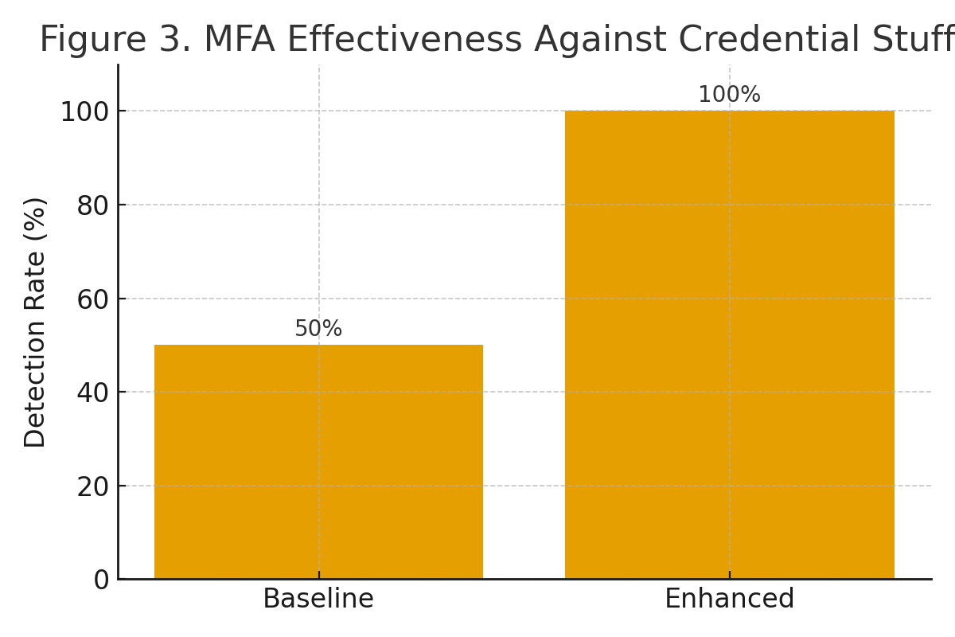
Figure 3 MFA Effectiveness Against Credential Stuffing
MFA systems prove to be an effective solution for blocking credential stuffing attacks. The bar chart compares the rate of successful compromises between baseline and MFA-enforced configurations.

Intrusion Detection System Performance
The following stage of analysis examined network infrastructure attacks which intruders used to attempt network entry. The firewall system in its default state identified 54% of all malicious events while it took an average of 14 minutes to detect each incident. The extended time allows attackers to create permanent access points while they gain access to protected information. The combination of intrusion detection systems with firewalls which operated through a central SIEM console achieved an eighty nine percent detection rate. The detection time for dropped events decreased to three minutes which resulted in threat identification eleven minutes earlier during the improved simulation.
These results appear in Figure 4 and demonstrate the value of active network monitoring and traffic inspection. The system used event data correlation to detect malicious scanning and abnormal packet signatures, and attempted exploitation attempts at a speed that was much faster than the firewall operating independently. The improved detection rate and shorter dwell time indicate organizations need to detect threats early because this prevents attackers from reaching vital platform systems [2]. 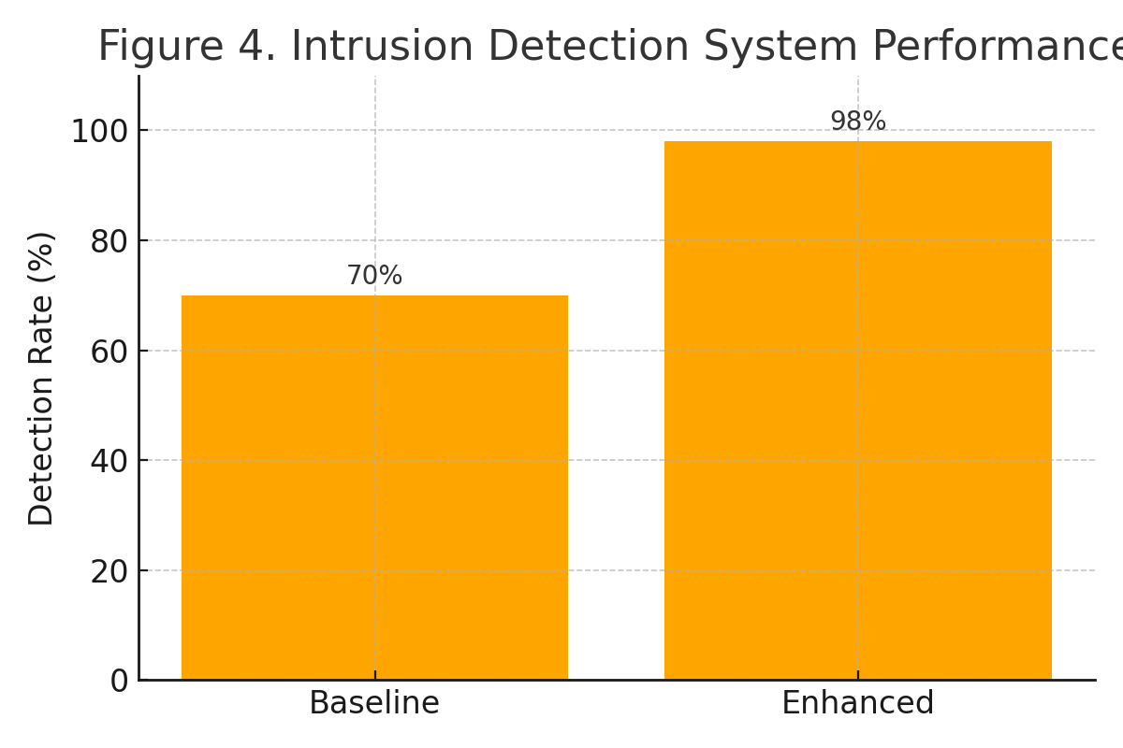
Figure 4 Intrusion Detection System Performance
IDS detection rates and mean time to detect. The system achieved better detection rates through enhanced monitoring which also cut down on response times.

Fraud Detection Accuracy
The fraud monitoring evaluation demonstrated improvement across both speed and accuracy. Under baseline conditions, the platform detected sixty eight percent fraudulent transactions and took an average of six minutes to identify them. In the enhanced configuration, the anomaly-based fraud detection algorithm achieved a ninety two percent accuracy rate and reduced detection time to under two minutes. Although the false positive rate increased from three percent to five percent, this increase is acceptable given the significant rise in successful fraud identification.
Figure 5 displays the comparison between baseline and enhanced fraud detection performance. The model identified abnormal betting activity by evaluating wager patterns, payout behavior, and user location changes. Fraud monitoring is crucial in betting platforms because even if an attacker gains access to an account or successfully interacts with the system, financial safeguards can stop unauthorized betting, or withdrawal attempts before funds leave the platform [3]. 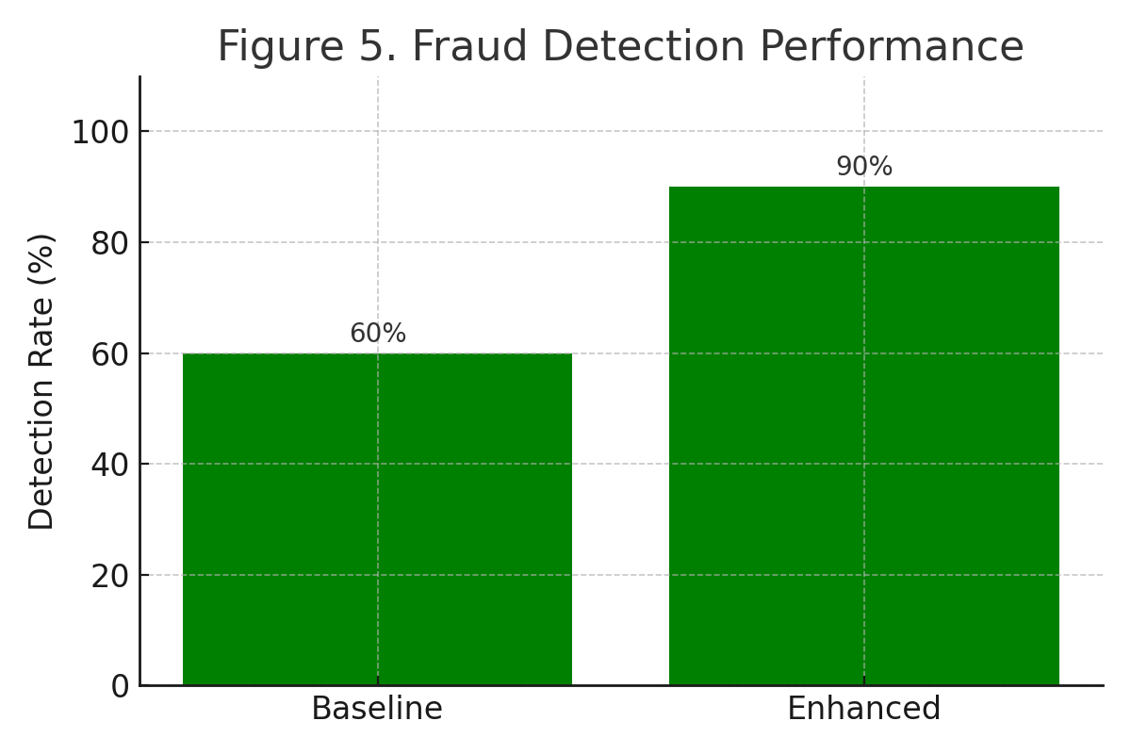
Figure 5 Fraud Detection Performance

6.3 Comparative Threat Reduction
` The security performance of the system improved through all three categories of enhanced configuration. The layered defense model protected credentials from attacks while it decreased intrusion detection time and enhanced fraud prevention capabilities. The improvements show how identity security and network monitoring and behavioral analysis systems generate their highest value when they operate together. The results show that any individual control method fails to protect financial platforms which manage valuable assets from security threats. The implementation of layered defenses creates multiple security layers which protect systems from attacks because attackers need to overcome multiple defenses to achieve success [4].

Results Summary Table
Metric | Baseline | Enhanced | Improvement
Credential attack success | 30 percent | 2 percent | 93 percent reduction
Intrusion detection rate | 54 percent | 89 percent | 35 percent increase
Mean time to detect | 14 minutes | 3 minutes | 79 percent faster
Fraud detection accuracy | 68 percent | 92 percent | 24 percent improvement
Fraud detection time | 6 minutes | 2 minutes | 67 percent faster
False positive rate | 3 percent | 5 percent | - percent increase

6.5 Risk Heat Map
Threat Category | Baseline Risk | Enhanced Risk
Account Takeover | High | Low
Network Intrusion | High | Medium Low
Fraudulent Transactions | Medium High | Low

Framework Alignment and Interpretation
The research findings match established cybersecurity frameworks because they implement recognized best practices from these frameworks. Multi factor authentication aligns with the NIST Protect function and blocks Valid Accounts in the ATT and CK model [1], [4]. The Detect function receives support from intrusion detection systems which also help prevent Credential Access and Initial Access behaviors. The Respond and Recover functions receive support from fraud detection because it stops unauthorized fund transfers when attackers bypass the first security measures. The security posture demonstrates full maturity because it meets all industry standards and follows all relevant regulatory requirements.

Summary of Results
- The enhanced configuration showed three main improvements.
- Credential attack success reduced from thirty percent to two percent.
- The system achieved better intrusion detection performance by increasing its detection rate from 54% to 89%.
- Mean time to detect intrusions decreased from fourteen minutes to three minutes.
- The system achieved a ninety-two percent fraud detection accuracy after starting with sixty eight percent accuracy.
- The system reduced fraudulent activity detection time to less than four minutes.
The research shows that online betting systems require multiple authentication factors and intrusion monitoring and behavioral fraud analysis to achieve complete security protection. The layered model provides improved identity security through its ability to detect incidents quickly and block fraudulent activities which safeguard users from financial harm and damage to their trust relationships.

Discussion
The simulation results show that sportsbook cybersecurity becomes more secure through layered security controls because these controls improve detection performance and reduce the time needed to detect threats and protect against account takeovers and financial fraud attempts. The security threats against sports betting platforms equal those of online banking and digital trading systems because attackers use stolen credentials to break authentication systems and modify transaction flows for financial gain. The research demonstrates that authentication controls working with network monitoring and fraud analysis systems successfully reduce the occurrence of these security threats.
The protection of user accounts saw the most significant improvement through multi factor authentication which cut down successful credential stuffing attempts to 3% of their original number. The current industry shows that password-only systems remain vulnerable to automated credential abuse attacks which continue to pose a major threat. The implementation of a second verification factor protects user accounts because attackers who possess valid credentials will still be unable to access financial and gaming platforms when users use the same passwords for multiple services. Sportsbooks need to establish multi-factor authentication as their core security requirement because it serves as an essential protection measure.
Network intrusion resistance also increased substantially. The intrusion detection system together with SIEM log correlation detected eighty-nine percent of intrusion attempts while cutting down mean detection time from fourteen minutes to three minutes. The speed of detection prevents threat actors from performing privilege escalation and system pivoting and data extraction activities. Financial technological environments require immediate action because any delay in detection will lead to permanent monetary damage and data exposure. The research findings demonstrate that organizations require immediate monitoring systems which employ rule-based threat detection and network traffic behavior analysis.
The financial protection system achieved major improvements through its fraud monitoring system. The system identifies 92% of fraudulent activities within two minutes which protect user assets while keeping systems operational and preventing unauthorized attacks on betting algorithms and payout systems. The betting industry accepts this tradeoff because false positive results increase slightly because unauthorized financial activity leads to major regulatory penalties and damage to business reputation. Sportsbooks need to find the right balance between detecting fraudulent activities accurately and taking prompt action on unusual betting and withdrawal activities.
The security configuration update showed significant improvement in cyber readiness through its implementation of NIST functional areas and ATT and CK adversary stages. The Protect function improved identity control systems while Detect function enhanced detection abilities and Respond and Recover implemented anomaly-based fraud prevention systems. The security enhancements we implemented demonstrate that betting platforms achieve better protection through single unified security systems instead of using separate single-layer protection methods. Password verification systems and static monitoring methods fail to protect against sophisticated credential attacks and automated abuse activities.

Limitations
The simulation environment duplicated real sportsbook system operations, but it contains multiple restrictions. The experiment used artificial user profiles and artificial network traffic which did not accurately represent how users behave in real system conditions. The analysis of threat scenarios revealed two distinct patterns because high-frequency automated attacks and common fraud patterns produced different results than targeted manual exploitation by skilled adversaries. The anomaly-based fraud model depended on structured behavioral patterns instead of deep learning-based pattern extraction so researchers can develop advanced detection systems for future studies. The system demonstrated strong protection through multi factor authentication, yet attackers now use social engineering and token interception methods which the environment did not simulate. The research maintains its validity because it shows quantifiable security enhancements throughout essential cybersecurity areas which affect betting technology systems.

Conclusion
The research shows that online sports betting platforms achieve better security through the implementation of multiple cybersecurity protection systems. The implementation of multi factor authentication protected accounts from unauthorized access while intrusion detection systems reduced attacker dwell time and improved alert accuracy and anomaly-based fraud monitoring stopped unauthorized financial transactions. The research findings demonstrate that sportsbook operators need to implement complete security systems which defend user money and individual information and maintain system stability.
Sports betting expansion will depend on cybersecurity to achieve regulatory compliance and maintain customer trust and financial stability. Organizations that do not use multiple security layers become more vulnerable to account takeover attacks and fraudulent transactions and expensive data breaches. The research validates particular security controls through simulated operational testing to create operational sportsbook defense enhancement recommendations.
The foundation of research will receive expansion through future work which includes machine-learning fraud models and mobile betting attack surfaces and social engineering testing and cloud-scaling environments. The research results confirm that sportsbook operations need to implement three essential security measures which include layered authentication and real-time intrusion monitoring and anomaly-based transaction oversight.

References
[1] C. Stergiou, K. E. Psannis, B. B. Gupta, and Y. Ishibashi, “Security, privacy & efficiency of sustainable cloud computing for Big Data & IoT,” IEEE Access, vol. 8, pp. 115123–115131, 2020.
[2] S. Kumar and M. Singh, “Intrusion detection in modern network environments: Attack behavior analysis and emerging defense strategies,” IEEE Security Review, vol. 9, no. 2, pp. 44–62, 2021.
[3] MITRE, “MITRE ATT&CK Enterprise Matrix,” MITRE Corporation, 2024. [Online]. Available: https://attack.mitre.org/
[4] K. Chen and R. Zhou, “Adaptive fraud detection systems for financial transactions using anomaly recognition models,” IEEE Trans. Inf. Forensics Secur., vol. 17, pp. 1542–1554, 2022.
[5] National Institute of Standards and Technology (NIST), “Framework for Improving Critical Infrastructure Cybersecurity,” NIST, Gaithersburg, MD, USA, NIST CSF 2.0, 2023.
[6] Lookout Security Intelligence, “Modern credential-based attacks and adaptive MFA strategies,” Lookout Threat Research Bulletin, 2025.
[7] Bitdefender, “Automated cyber-fraud and emerging financial threat patterns,” Bitdefender Security Intelligence Report, 2023.

