MHD Omar Kabbani

000389376

2021/11/07

**Q1**

#include <stdio.h>

int gcd(int num1, int num2){

int gcdt;

if (num1 == 0 && num2 == 0){

return -1;

}

if (num1 < 0){

num1 = -num1;

}

if (num2 < 0){

num2 = -num2;

}

int i;

for (i = 1; i <= num1 && i <= num2; i++){

if (num1 % i == 0 && num2 % i == 0){

gcdt = i;

}

}

return gcdt;

}

int main()

{

int num1, num2, gcdnum=0;

printf("Enter two integers: ");

scanf("%d %d",&num1 ,&num2);

if (gcdnum == -1){

printf("At least one number must be nonzero \n");

}

gcdnum = gcd(num1, num2);

printf ("GCD of %d and %d is %d \n",num1 , num2, gcdnum);

return 0;

}

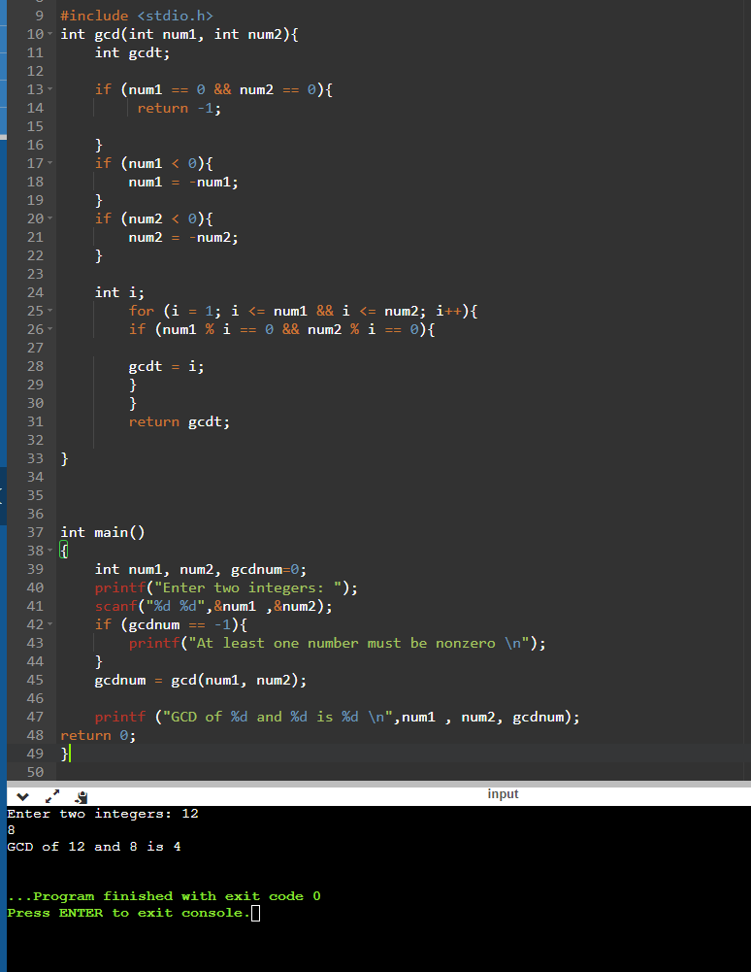

**Q2**

#include <stdio.h>

float pay_rate(char pay_char);

float total_pay(float hours, float rate);

float pay_rate(char pay_char){

float rate= 0;

if(pay_char == 'A'){

rate= 12.5;

}

else if(pay_char == 'B'){

rate= 15;

}

else if(pay_char == 'C'){

rate= 20;

}

else if(pay_char == 'D'){

rate= 25;

}

else {

rate= 0;

}

return rate;

}

float total_pay(float hours, float rate){

float pay = 0;

if (hours < 40){

pay = hours * rate;

}

else if (hours <= 44 && hours >= 40){

pay = (40*rate) + (rate*1.5*(hours - 40));

}

else{

pay = (40*rate) + (1.5*4*rate) + (2*(hours - 44)*rate);

}

return pay;

}

int main()

{

float hours, rate, pay;

char pay_char;

printf("Enter the pay category A , B, C, D : ");

scanf("%c", &pay_char);

printf("Enter the total hours worked: ");

scanf("%f", &hours);

rate = pay_rate(pay_char);

if (rate == 0){

printf("rate entery is wrong \n");

}

printf("the rate is: %.2f \n",rate);

printf("the total pay is %.2f",total_pay(hours, rate));

return 0;

}

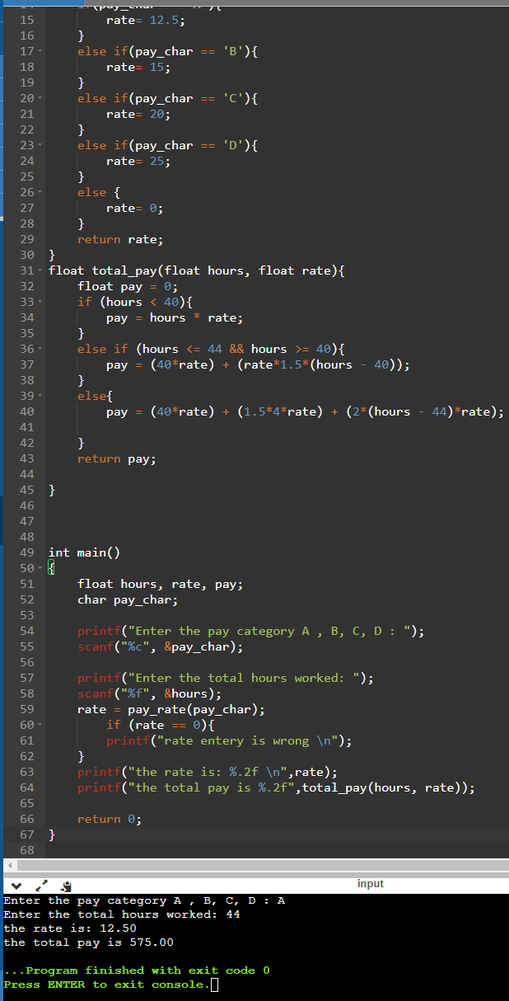

**Q3**

#include <stdio.h>

int main()

{

int i;

int array1[10], sort = 0 ,temp;

printf("Enter 1 for ascending order and 2 for descending order: ");

while (sort != 2 && sort != 1){

scanf("%d", &sort);

if (sort > 2 || sort < 1){

printf("wrong selection, try again \n");

}

}

printf("Enter 10 intergals: ");

for(i = 0 ; i < 10 ; i++){

scanf("%d", &array1[i]);

}

if (sort == 1){

for (int i = 0; i <= 9 ; i++){

for (int j = i + 1 ; j <= 9 ; j++ ){

if (array1[i] > array1[j]){

temp = array1[j];

array1[j] = array1[i];

array1[i] = temp;}

}

printf("\n%d",array1[i]);

}

}

else if(sort == 2){

for (int i = 0; i <= 9 ; i++){

for (int j = i + 1 ; j <= 9 ; j++ ){

if (array1[i] < array1[j]){

temp = array1[j];

array1[j] = array1[i];

array1[i] = temp;

}

}

printf("\n%d",array1[i]);

}

}

return 0;

}

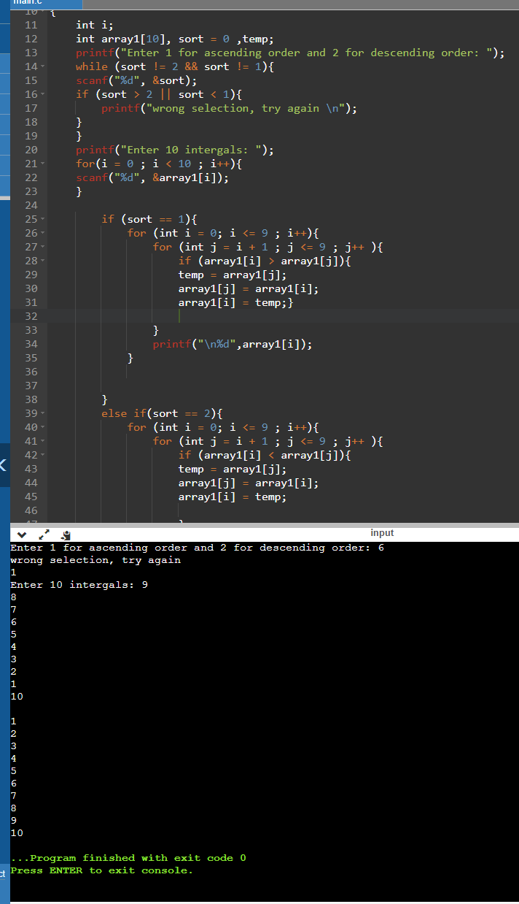

**Q4**

#include <stdio.h>

int main()

{

float gpa[30], gpasum=0, gpa_avg = 0;

char cont = '\0';

int x=0, count= 0;

printf("Enter up to 30 GPAs to calculate the average. \n");

while(count < 30 && cont != 'y' && cont != 'Y'){

printf("Enter GPA: \n");

scanf("%f",&gpa[count]);

if (gpa[count] <= 4 && gpa[count] >= 0){

}

else{

printf("number should be between 0 and 4\n");

printf("Enter GPA: \n");

scanf("%f",&gpa[count]);

}

printf("do you want to calculate the GPA (Y or N)\n");

scanf(" %c",&cont);

count++;

}

for (x = 0; x <= count; x++){

gpasum += gpa[x];

}

gpa_avg = gpasum / count;

printf("the average GPA is: %f ",gpa_avg);

return 0;

}

