RT-E Specifications

Image Here

# System Description

The RT-E is a low cost high accuracy fuel flow monitoring and data logging system.   
This system is compatible with most industry standard flow meters and offers temperature compensation and calibration to meet the needs of even the toughest sub 1% accuracy requirements.

* Two dedicated flow monitoring inputs with temperature compensation.
* Wide input voltage range and filtering to support 12V or 24V systems including automotive.
* Offers true sub 1% accuracy readout thanks to temperature compensation of fuel density.
* Backlit LCD screen to allow monitoring of fuel flow and temperature.
* Industry standard SD card to log data to in an Excel compatible format.
* Real Time Clock for accurate data logging with timestamps.
* Optional GPS for location and speed logging.
* Custom add-on interface to support customer specific modifications and additional sensor input.
* USB PC interface.

# Block Diagram

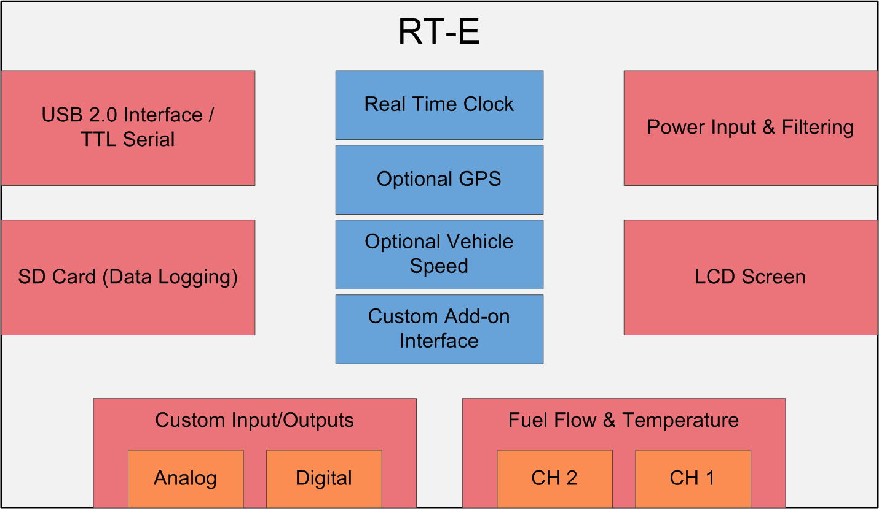

# System Operational Specifications

## Recommended Parameters

Voltage Input: 9V-24V  
Current Input: 0.2A **[2]**   
Operating Temperature: -10°C – 70°C  
Thermistor Type: 10K@25°C - Software Adjustable Beta

## Max Parameters

Voltage Input: 8.5V-28V   
Current Input: 0.2A [2]   
Operating Temperature [1]: -20°C – 80°C  
Thermistor Type: 10K@25°C - Software Adjustable Beta

## Performance over Recommended Conditions

## Fuel Flow Rate:

Instantaneous Accuracy **[3]**: <± TBD?   
Accumulated Accuracy **[3]**: > 99.99%

## Temperature:

Temperature Measurement Error **[4]**: <±2.5%

## Real-time Clock:

1 Year time accuracy: ±310 Seconds  
Clock life without power: >5 Years

## Data Logging:

Capacity [5]: >2 million samples or 2000 hours.

**[1]** Temperatures outside of recommended range may cause inaccuracy in real time clock as well as temperature compensation. For low temperature operation a micro heater can be installed to maintain temperature within the recommended specifications. **[2]** Tested with maximum LCD backlight with VIN= 12V. Recommended inline fuse of 0.5A.  
**[3]** Accuracy is also dependent on the physical flow meter used with the RT-E. This measurement assumes 0% error of the flow meter, which in practice is not typical. Accumulated accuracy is the measure of pulses received. Being a digital device, there is no error here. Instantaneous accuracy depends on many factors such as pulses per second, meter resolution, the moving average filter size etc.  
**[4]** Error shown with no calibration, using custom firmware calibration <±1% is possible.  
**[5]** Based on 1GB SD card with FAT filesystem and logging of all standard sensors at an interval of 1 second.

# Method of Flow Data Collection and Computation

In order to provide a more statistically accurate fuel flow, multiple flow rates are collected and averaged. This is due to the non-uniformity of the flow sensor, it is a “pulse” based device and the period between any two pulses does not signify identical fuel flow. Only over multiple pulses can an accurate measurement be achieved.

The equations below signify the method used to calculate the fuel flow and then perform temperature compensation (TC). Typically $N_{avg}$ is 5, this essentially introduces a 5 point moving average filter. For temperature compensation a base temperature of 60°F (15.55°C) is used and the thermal volumetric expansion coefficient is 7.831x10-4 /°C. Finally note $ppg$ is pulses per gallon of flow, and $dt$ is the delta time from the last flow rate update not the last pulse. $C_{time}=3600$ Is the conversion from flow per second to flow per hour.

$$Flow\left[\frac{gal}{hr}\right]=C_{time}{\left[\sum_{n=0}^{N_AVG}{pulses[n]/(ppg*dt[n])}\right]}/{N_{avg}}$$

$$Flow_{tc}\left[\frac{gal}{hr}\right]=Flow*\left[1+7.831x{10}^{-4}*(15.55℃-T)\right]$$

## Example Calculation

A sample calculation was performed, as well as the difference between compensated and non-temperature compensated measurements is shown.

$ppg=2000$

$N_{avg}=2$

$T_{fuel}=34℃$

* Volumetric Expansion per Degree is defined as: $α=7.831x{10}^{-4}$
* $dt=5sec$ (Anything from 5.00-5.2 could be expected due to software jitter.)
* The system is receiving ~ 60 pulses per update period ($dt$)

$$Flow\left[\frac{gal}{hr}\right]=C_{time}{\left[\frac{62}{ppg*5.12}+\frac{58}{ppg*5.02}\right]}/{N_{avg}→}{\left[21.8+20.8\right]}/{2=21.30}\left[\frac{gal}{hr}\right]$$

Then to apply temperature compensation we use the above 21.3gal/hr. and place it into the 2nd formula.

$$Flow_{tc}\left[\frac{gal}{hr}\right]=21.3*\left[1+ α*\left(15.55℃-34℃\right)\right]=20.99\left[\frac{gal}{hr}\right]$$

This example also illustrates the large difference that temperature compensation can make. The original measurement would have an error of 1.5% based on the expansion of fuel in different temperatures. So this proves that while some commercial flow monitors will advertise accuracies of 1%, without temperature compensation, that accuracy can only be guaranteed if the fuel is the same temperature it was during calibration (most likely 20°C) and this is often not the case in practice.

$$diff\left[\%\right]=\frac{20.99-21.30}{21.30}*100=-1.5\%$$

# Data Logging

Data Logging is performed at a customizable interval, typically once per second. The data is logged into a comma separated file that is saved to the SD card on the device. The logged data contains by default what is listed below but can be modified to include any custom sensor or format.

* Timestamp
* Fuel Flow (TC and non TC)
* Fuel Temperature
* Raw Flow Meter Pulses

Examples of additional information that has been included for customers with custom firmware or sensors:

* GPS latitude and longitude
* Analog voltage measurements
* Digital IO states
* Vehicle speed and heading
* Altitude and air pressure

# Custom Add-on Card Interface

Reicon understands customers often need more than just fuel measured, as well as the convenience to have all data measured in one system. For that exact reason the RT-E was designed with a custom add-on card port. We can create interface cards for almost any industrial or custom sensor you have. We can then monitor and log that information alongside the fuel flow. Some examples of the types of interfaces we have worked with are:

* Serial/I2C/CAN – Used for a lot of embedded sensors such as altitude, pressure, acceleration sensors etc.
* Digital IO – Be it open collector, push pull totem pole or anything else exotic. We can detect and monitor it up to 1MHz. Some examples of these sensors are low voltage digital IO, PWM, or even high voltage PLC logic.
* Analog IO – Analog transducers can be a pain to log with traditional generic logging hardware. Since we are already making a custom interface board, we can design in any amplification or filtering needed to make high accuracy measurements without loading the analog transducer.

# Physical Packaging

Available in multiple enclosures ranging from rack mountable lab design to IP67 rated in vehicle enclosure with optional remote LCD for ease of viewing and electrical connections.

**Put size / cad drawing here???**

Image Here

Image Here