LinearEquation UML

by
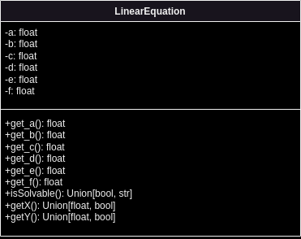
Paul Estephan

- a, b, c, d, e, and f are private attributes, whom value are set by the user while calling the LinearEquation object.
- get_a(), get_b(), get_c(), get_d(), get_e(), and get_f() are getter methods that provide access (by reatreiving the value of private variables) to the private datafields a, b, c, d, e, and f.
- isSolvable() is a method that check if a*d – b*c = 0. If the result of the equation are not 0 (!=) it returns true, else it returns a string stating that the equation has no solution.
- getX() and getY() are 2 methods that calculate the value of x and y by checking if the output of isSolvable() method. If isSolvable() is true, getX() and getY() return the value of x and y respectivly by using the needed caculations. Else they return a false statement.

