# **HORSES**

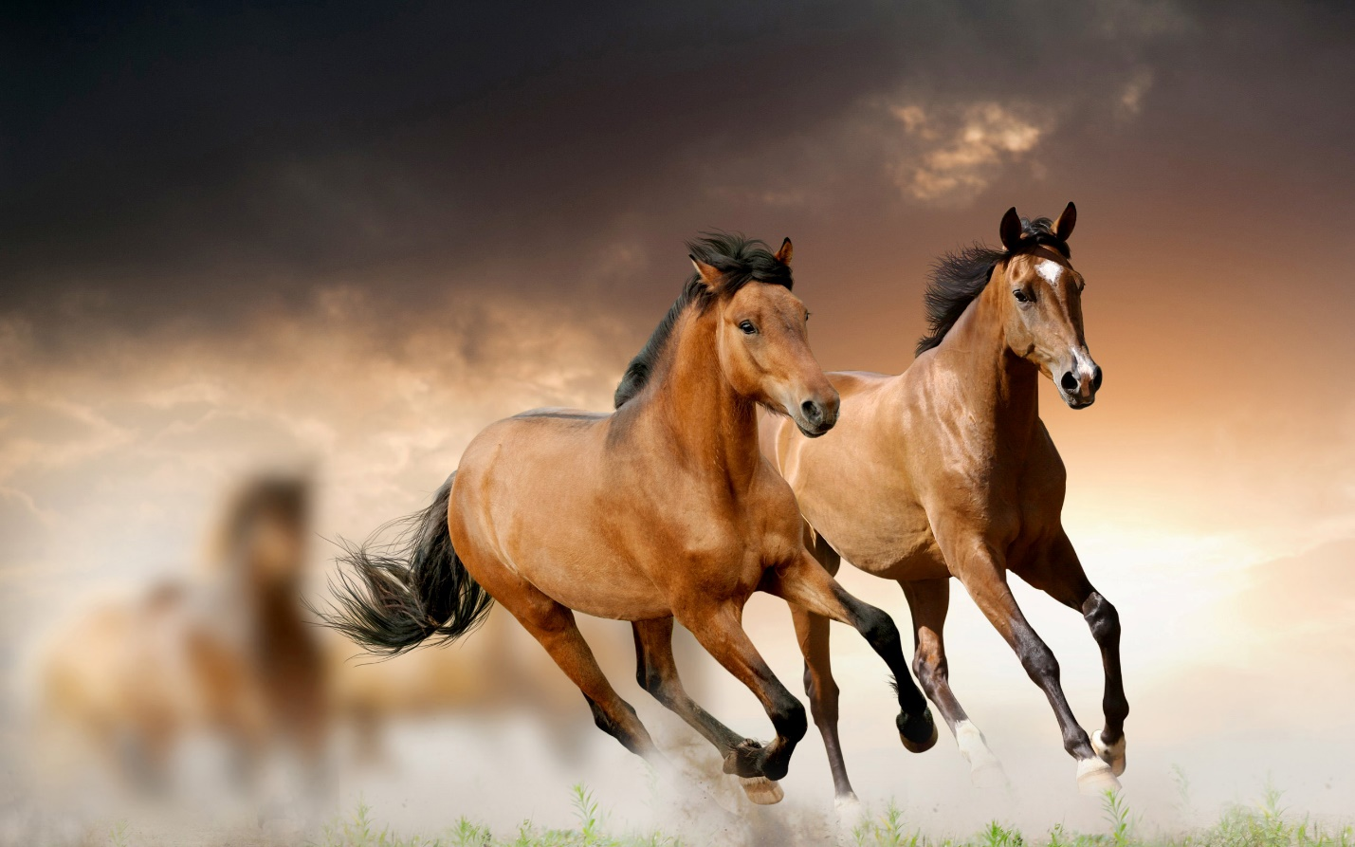

**Heel Ropes** (*pecharie*).

If possible, horses should be left loose, which generally can be done in India, as most of the stables are loose boxes. Sometimes it is necessary to fasten them up, such as when picketed out at night in the hot weather or on the march. There are several plans of picketing, each having its advantages and disadvantages; but as these generally apply to military animals, I will merely mention those commonly used in private stables. The most common plan is to fasten the horse up with head and heel ropes, to wooden pegs driven into the ground. Heel ropes (pecharie) consist of either two ropes about twelve feet long, ending in a single one, so as to be Y-shaped, the single one being fastened to a wooden peg (make) driven into the ground, and the two arms to the horse’s hind fetlocks by means of leather straps, called “muzzumas.” These straps are loops of rope covered with leather, to[Pg 70] one end of which the heel rope is tied, and into which the hind foot is slipped, being secured by a flat leather thong wound round the middle of it behind the fetlock joint to prevent its slipping off. The strap is then of a fig. 8, or hour-glass shape, the heel rope being tied in one loop, the foot placed in the other, the thong forming the neck or constriction. These, I think, are the best form of leather foot strap; but in buying them care should be taken that the stitching of the leather is on the outside, as if it is on the inside, where natives often put it, it is very likely to rub the skin and cause a bad cracked heel. Another form of “muzzuma” is made out of stiff flat leather lined with felt. This has a slip loop going round it, with a buckle on one side and a strap on the other, that runs along the centre. The heel rope is tied to one end, the foot put into the other, and when the strap is buckled tightly, the running loop is drawn close up to the heel, so as to keep the whole arrangement in its place. This form of “muzzuma” is the usual kind sold; but it is objectionable, as the edges get stiff and hard, and are likely to cut the heel, which the round ones do not. Both sorts of leather “muzzumas” require to be kept soft and pliable with dubbing (momrogan), which “syces”[Pg 71] never think necessary. I, however, prefer those made out of plaited hemp or tow. They are merely a band of loosely plaited tow, about eighteen inches long, the heel rope being fastened to one end, and secured by a string or tape just behind the fetlock; they are much softer than the leather ones, and quite as strong. The disadvantage, however, is that they soon wear out, but they are very cheap; in fact, the “syces” can make them themselves out of the raw hemp or tow (sun). They are used by many of the native cavalry regiments in India in preference to the leather ones. The heel ropes can be made out of one long rope doubled, a “muzzuma” fastened to each free end, and the doubled portion to a tent-peg. When heel ropes are used, one should be put on each hind leg; it is dangerous to only put on one, and I have seen more than one fractured thigh caused by this. If the heel ropes are on both hind legs, and the horse kicks, he has to do so straight into the air, as there is equal restraint on both; but if there is only one, the unequal check of the single rope is likely to cause a fracture. If allowed, “syces” will always pull the heel ropes so tight as to stretch the horse out; they should be loose enough to allow him to stand in a natural position.

 [Pg 72]

**Head Ropes** (*aghari*).

Head ropes should be fastened to the ring on the head collar (nukta) under the chin. There should either be two separate ropes, one end of each fastened to the ring, or one long one doubled in the middle, the central portion fastened to the ring, and the two ends to two wooden pegs driven into the ground about three or four feet on each side of the horse’s head. If only a single rope is used, it must, naturally, be fastened to a peg straight in front, and, to allow the horse to move his head up and down, must be loose. When fastened in this way he is exceedingly likely to get his fore leg over the rope and get hung up in it, a nasty wound in the heel or at the back of the knee being the result, if nothing worse; whereas, if the ropes are pegged out on each side, he can move about freely, and it would be difficult for him to get his leg over them. Both head and heel ropes should be made of hemp; the cotton rope used in India for most purposes is not strong enough, and soon breaks and wears out. In Peshawur and along the north-west frontier, a rope is made of goat hair that is very strong, and is excellent for this purpose. It is somewhat more expensive than ordinary rope, but with care will last[Pg 73] a long time, and will amply repay itself. Both head and heel ropes should be tied to the pegs in a slipknot, so that with a single pull horses can be set free when necessary. “Syces” will usually tie them in a jam-knot, and horses struggling to get loose when frightened very often badly injure themselves before they can be set free.

**Fetlock Picketing.**

A method of picketing horses was introduced into the Indian army some years ago, by dispensing with head ropes and using a short chain shackle about three feet long, buckled round one of the fore fetlocks, and fastened to a peg driven into the ground. This was chiefly done with the object of reducing the weight carried, and with animals used for military purposes, doubtless fulfilled the purpose, but in a private stable I fail to see its advantages over the other plan.

**Picketing Posts.**

When horses are picketed outside the stable, and there is space enough, picketing posts are the most preferable method, as they allow greater freedom than any other. A stout smooth post, about five or[Pg 74] six inches in diameter, is driven several feet into the ground, so that it is five or six feet above the surface, a strong iron ring is slipped over it, and to this the head rope is made fast; no heel ropes are used, and the horse can move round it as he pleases. The post must be smooth, so that there is nothing for the ring to catch in, and when put into the ground the point should be put into the fire and charred, or covered with kerosene oil, to keep off the white ants. It will also have to be examined occasionally to see that it is not damaged or rotten. The only drawback to this plan is that, if there are several horses, a considerable space is necessary, as they must be far enough apart to prevent their kicking at each other.

**Ringing.**

In South Africa and the colonies horses are picketed by the method known as “ringing,” the head rope of one being fastened to the head collar of the next, and so on, till the head rope of the last is in its turn fastened to the head collar of the first, their heads forming a ring looking inwards. Colonial horses will stand like this for hours together; but they are very quiet, and behave in a different way to the Indian country-bred. I have seen the same[Pg 75] plan used in a cavalry regiment of the Italian army on the march near Milan.

**Rheims.**

In South Africa head ropes are made of prepared raw hide called “rheims.” They are prepared by the Kaffir women out of raw ox hide, and are very strong and supple, and are excellent for the purpose.

**Knee-haltering.**

Knee-haltering is also a South African plan of securing horses when turned out to graze. The fore leg is lifted up, so that the forearm from the elbow to the knee is parallel to the ground. The head rope, or “rheim,” is then fastened above the knee, the head being pulled a little downwards. The horse is then turned out to graze on the veldt, and when his head is down feeding he can use his limbs and walk about as he likes, but as soon as he puts up his head to trot or gallop the fore leg is pulled up, and he has only three to go on, and can easily be caught.

**Shackles** (*bheri*).

The natives of India use iron shackles, much like handcuffs, to fasten with a key round both fore fetlocks of horses when turned out loose; but[Pg 76] they are not a desirable invention, and in young animals are very likely to cause ringbones. But this, I think, is on account of their clumsy shape and being constantly worn, as I believe shackles made out of round iron that shut with a spring were used by the Canadian mounted police at one time when turning their horses out, and they found they did not chafe and rub so much as leather ones did. It was found that even moving through the wet grass the steel hobbles were polished, kept bright, and required no attention, whereas the leather ones perished and became hard, and gave constant trouble unless carefully looked after. I have never tried this plan myself, for I have found the Cape system of knee-haltering when turning animals out to graze the best I have yet come across.

**Picketing-pegs** (*make*).

Picketing-pegs should be made out of hard wood about eighteen inches to two feet long; iron ones are dangerous. They should be driven into the ground in a slanting direction, the point towards and the head away from the animal, to resist the strain on it. If there are no tent-pegs, or the ground is so soft that there is no holding for them, a hole a couple of feet deep can be dug, and a bundle[Pg 77] of straw or a couple of tent-pegs tied crossways buried in it, the earth trodden down, and the rope brought out at the surface. This will give ample holding, and may be practically tested, for although a vertical pull will easily bring it up, the strongest man will fail to move it if the strain is horizontal.

**Leading-ropes** (*bagh durie*).

Leading-ropes are things that ruin half the horses’ mouths in India, and I never let such a thing into the stable. If they are used as they were originally intended to be, that is, buckled into the ring of the snaffle or watering bridle to lead the horse with, they do no harm; but it is impossible to prevent “syces” from passing them over the head and then back through both rings, so as to form a gag, and this they hang on to. I always make them use a leading-chain, which is a leather strap with about a foot of chain and a snap-hook at the end of it. The hook fastens into the ring of the snaffle, and they cannot well pass the strap over the head to turn it into a gag. It seems impossible to teach a “syce” how to lead a horse in a watering bridle, and I find these chains the best compromise.

 [Pg 78]

**Brushes and Gear.**

The grooming utensils required in an Indian stable are very simple: a horse-brush, curry-comb, bucket, some dusters, and a hoof-picker, being the sum total; but only one of these last is required among five or six horses. It is best to get English bristle brushes, they last out two of the native fibre ones, and are very little more expensive. Good horse-brushes are made by several firms in Cawnpore, and, of course, when a large number are used, the saving is considerable if the country-made article is bought, but where only a small number are required, this is a false economy.

**Curry-combs.**

These an Indian “syce” cannot get on without, and although he only uses it to wear out the brush, still, after all, it does not do so very much harm; but a bad, lazy man, if he is not prevented, will use it to scrape the dirt off the horse with. Country-breds are generally very thin-skinned, and feel the comb very much if scarified with it, as the “syce” is very fond of doing; and I am positive that this practice in many cases has to account for much of the proverbial bad temper of these animals. The curry-comb should never be put on[Pg 79] the horse’s body at all, and in reality it is useless. If it can be managed, it is best not to give the “syces” such things, the only use of them being to clean the brush with, and this can be done just as well with the palm of the left hand, and the brush does not wear out so quickly; but it is the custom to use the comb, and it is hard to prevent it.

**Buckets** (*balti*).

Buckets can be bought anywhere. Zinc ones are better than tin, although perhaps a little more expensive; one should be provided for each horse.

REF: https://www.gutenberg.org/cache/epub/32376/pg32376-images.html#GROOMING