f

**Benha University**

**Faculty of Computers &**



**Artificial Intelligence**

**Digital Clock**

**In**

Logic design

**by**

Student’s Full Name (Student Section Number)

|  |  |
| --- | --- |
| Osama mahmoud abdelkhalek (Section 3) | Ahmed Saeed Mohamed (Section 2) |
| Ahmed abdelaal abohadeed(Section 2) | Mohammed Abdel Karim okasha  (Section 17) |
| Ahmed Sayed Ahmed  (Section 2) | Mohamed sobhi aish  (Section 16) |

**Table of Contents**

1. Introduction 1

2. Content 1

*2.1* *Snapshots* 2

*2.2* *Truth tables* 7

3. Conclusion 8

# Introduction

This project is the Digital clock, it is a useful project that show seconds ,minutes and hours, we take this project because we are interested in it, it is very useful to help us with improvements in the technology the digital clock is very important to every one to do his work in the right time so we would continue in this field in more project like this , ther was some problems faced us like which circuits should we use to make this project ? and How we use it in the right place ?. We made this project to run in seconds to minutes to hours , it works on 24 hour system, it starts from 1 second when it rech 59 seconds the second after it will make seconds zeros and minutes start with one to reach 59 minute and the minute after it make minutes zeros and hours start with one hor to reach 23 hour and the hour after it make the hours zeros.

# Content

The project has been made with some circuits and components it works in efficient way. The components are : 555 Timer, 6 Counters, 6 Seven segments, And gate, Resistors and Capacitors.

The timer 555 (clock ) gives pulses to the counter , the counter begin to count from zero to nine and output this number as binary number to the decoder which transform this binary to decimal number and display it in the 7 segment

## Snapshots

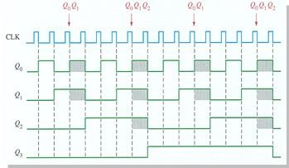

The timer 555 (clock ) gives pulses to the counter , the counter begin to count from zero to nine and output this number as binary number to the decoder which transform this binary to decimal number and display it in the 7 segment

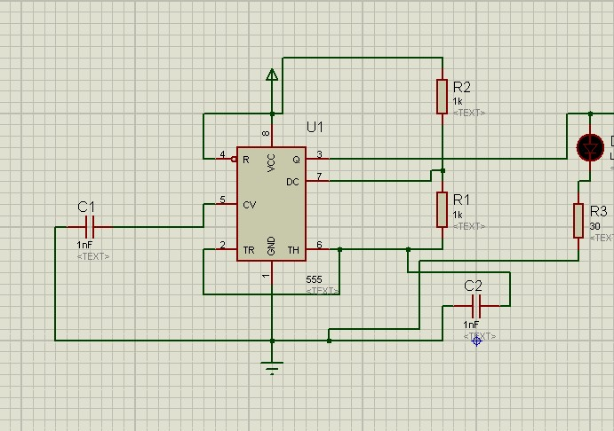

The timer gives pulses every f which f is the frequency of the wave From this equation :

**F=1.44/(R1+2R2)C1**

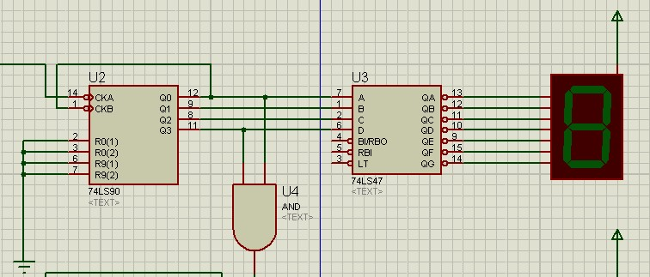

The counter receive the pulses from the timer and begin to output the binary number to the decoder which transform it to decimal and display it at the 7segment.

When the counter Reach the number 9 it enable the next counter to count 1

When the 2nd counter of seconds reach the number 9, it enable the next counter of minutes to count 1 and count to nine, the 2nd  counter of minutes count from 1 to 5 and enable the next counter of hours to count 1 and count to nine , the 2nd  counter of hours count from 1 to 2 and when the hour reach to 23 the next hour will be zeros.

Set the counter to zero

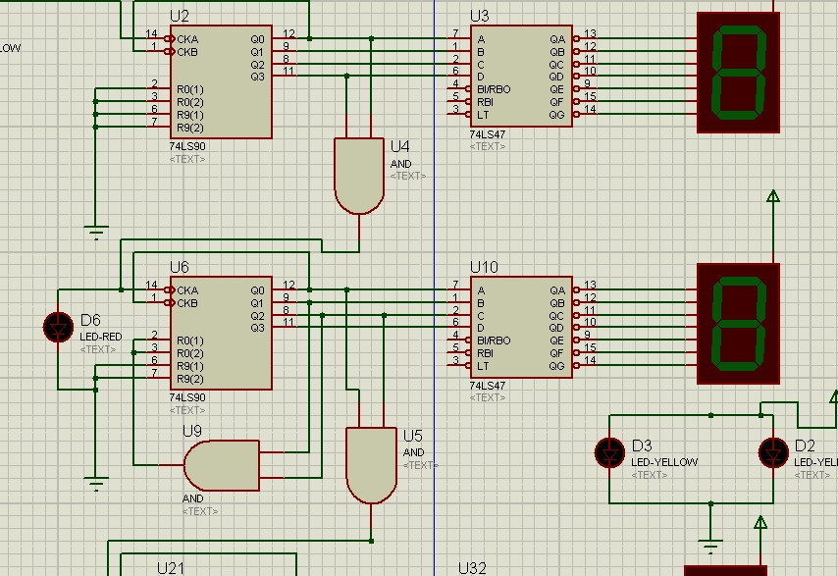

This is for seconds

the first counter count from 1 to 9 and the decoder display it at 7 segment when the first counter reach 10(glitch) it enable the next counter to count from 1 to 5, the decoder display it at 7 segment and when the counter reach 6(glitch) it enable the next counter

......etc

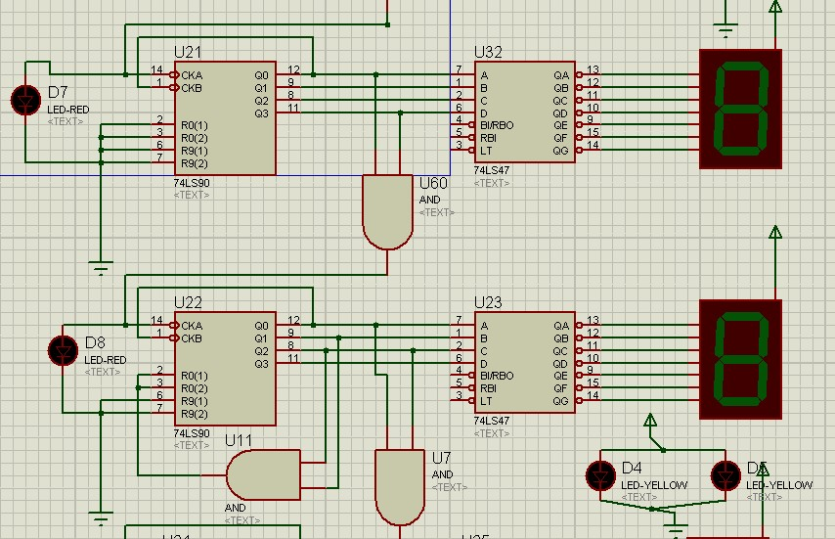

Set the counter to zero when reach 6. This is for minutes, it work like the second counters.

It count 24 hours and begin again .

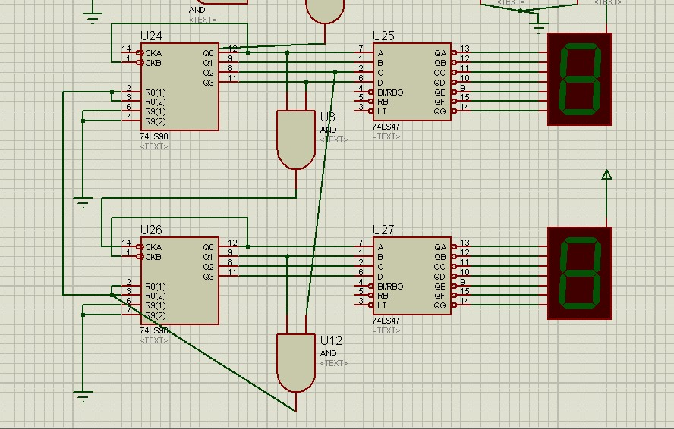

When the 2nd counter reach at 2 and the first counter reach 4 this and set the two counter to zero to count again.

## Truth Tables

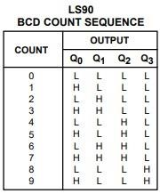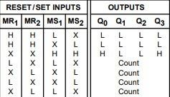

# Conclusion

Digital clock is a useful project that shows seconds ,minutes and hours, This project works as follows, The timer 555 (clock ) gives pulses to the counter , the counter begin to count from zero to nine and output this number as binary number to the decoder which transform this binary to decimal number and display it in the 7 segment. When the 2nd counter of seconds reach the number 9, it enable the next counter of minutes to count 1 and count to nine, the 2nd  counter of minutes count from 1 to 5 and enable the next counter of hours to count 1 and count to nine , the 2nd  counter of hours count from 1 to 2 and when the hour reach to 23 the next hour will be zeros.