1. Using a timer clock source of 8 MHz, calculate PSC and ARR values to get a 60 Hz interrupt. • This is tricky because precisely 60 Hz is impossible with our system; instead, think about the process and minimize the error. Many combinations of PSC and ARR values work—not just one!

The PSC and ARR value combinations that I found to work for a ~60Hz interrupt is 7999 for the PSC and 17 for the ARR (16.666… in reality)

1. Look through the Table 13 "STM32F072x8/xB pin definitions" in the chip datasheet and list all pins that can have the timer 3 capture/compare channel 1 alternate function. • If the pin is included on the LQFP64 package that we are using, list the alternate function number that you would use to select it.

* PE3
* PA6 (GPIOA->AFR[1])
* PC6 (GPIOC->AFR[0])
* PB4 (GPIOB->AFR[1])

1. List your measured value of the timer UEV interrupt period from first experiment.

~83.326 ms (12 Hz; this microcontroller strangely appears to use the 24MHz clock by default rather than the 8MHz clock.)

1. Describe what happened to the measured duty-cycle as the CCRx value increased in PWM mode 1

Before: (value is 25)

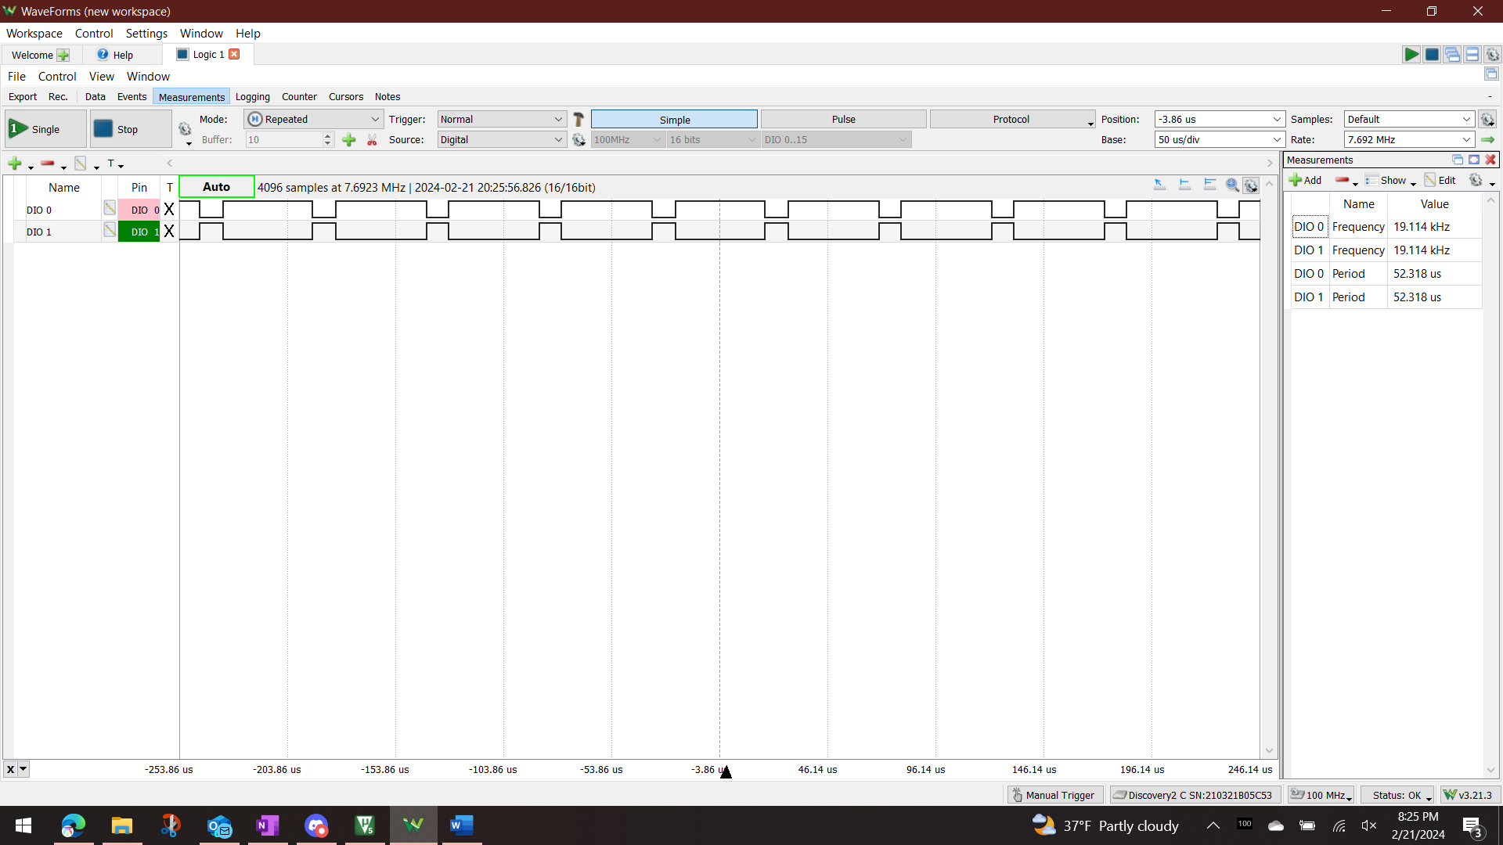

After: (value is 100)

The “on” period of the waveform very visibly lengthened.

1. Describe what happened to the measured duty-cycle as the CCRx value increased in PWM mode 2

The “off” period of the waveform visibly lengthened.

1. Include at least one logic analyzer screenshot of a PWM capture.
2. What PWM mode is shown in figure 3.6 of the lab manual (PWM mode 1 or 2)?

PWM mode 1; it is edge-aligned.