TASK1: AI App Hunter.

Shazam:

The name of the application is Shazam and you can find it in iOS and Android.
Shazam uses algorithms that can be considered a form of artificial intelligence, specifically for identifying musical patterns and creating acoustic fingerprints of songs, allowing it to recognize and compare them with its vast database to find matches.
You can easily identify songs you hear on the radio or in a place where you can’t look up the name or don’t know it.
I think this application don’t have an important risk for people.

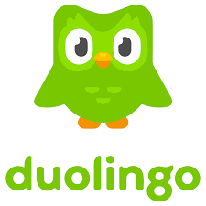Duolingo:
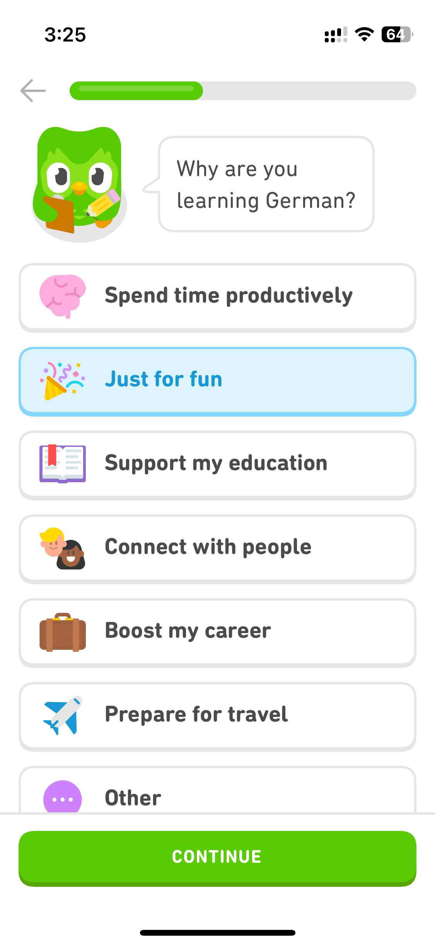
The name of the application is Duolingo. This app is very useful is you want to learn another language whit your mobile phone. You can find it in Android, iOS, in the Microsoft Store for your PC and in their web page.
This app uses de AI to adapt to each student level and progress. Duolingo it’s able to predict which exercises you might struggle whit and reinforce those areas. In other part, generate personalized practice using language models and provide automatic feedback on pronunciation and grammar.
I think Duolingo don’t have a lot of risk for the people but, it could make a dependence whit people to maintain the streak of everyday. And this app cannot replace a traditional teacher, Duolingo can be a complement to your teaching.

DALL·E:
The name of this application is DALL·E. With this app you can generate photos from a sentence. You can introduce a sentence describing something and de IA generate an image with that description, then you can do changes or edit the photo. You can find it in the OpenAI.
This IA uses neuronal network trained on millions of images and descriptions. DALL·E interprets the text, understand the concepts and combines them visually. It can create, modify or enhance images by following instructions. You can do custom styles like realistic, cartoon, 3D, painting, photography, Disney or your favourite anime, …
You can find many risks like copyright. This app doesn’t do exactly copies, but can inspire in other examples. The quality could be variable, some images aren’t realistic and could generate bugs or errors.

