Introduction to ITWS

Quiz 2: November 10, 2025
Create a Fork of your repo, tagged Quiz2, and do all work in this repo.
DO NOT Merge this into main or you will receive a 0 for this quiz.
DO NOT link this quiz to your personal website
Create a folder in your repo named: ITWS1100-F25-Quiz2
Save this document as ITWS1100-F25-Quiz2-yourname-yourRCSID.docx
Any submission other than a Word file will receive 0 credit.
Enter your answers directly into your copy of this document (with the exception of #1)
All answers should be in be in Your Own Words, and use proper grammar
Make sure your answers use an alternative font and/or color – (not black or red)
Place your name on the top of this document in the header
When finished with the quiz, zip your repo including all related files.

- Technology (coding): (35 points, 30 minutes)
  - Given the Quiz2.html, .css, and .js files, make the following modifications;
In the HTML;
- Change whatever is necessary to ensure the file(s) adhere to html5 syntax.
- Connect your html file to jQuery either locally or via CDN
- Add your name in an h4 tag below the h1 tag
  - Add additional tagging (your choice) that may be used to identify when your last name is selected (eg clicked)
- Add a button at the bottom of the page with an id of your choosing that is labeled ‘Go’ on the page.

In the JavaScript file:
- Show an alert that the page is about to load
- Add a function that will execute when the document is finished loading to the browser and will (HINT: You will need the jQuery ready function)
  - Set the title of the page to “Intro to ITWS - Quiz 2” to act as the default
  - Using JavaScript with or without jQuery :
    - When ‘Go’ is clicked and the title is set to the default
      - Change the title of the page to ‘yourname – Quiz 2’
    - When ‘Go” is clicked and the title is other than the default
      - Change the title back to the default
    - When the user hovers the mouse over your last name
      - Add a class of makeItPurple to your last name
      - Remove it when the user is no longer hovering over your last name

In the CSS;
- Add the CSS necessary to change the properties of something with a class of ‘makeItPurple’ show in purple, italic and in small caps.
- Make the content of the h1 and h4 tags centered

Your webpage (and the alert – which I moved for clarity) should look similar to the following before and after the button is clicked, and while the name is being hovered over;

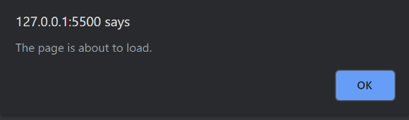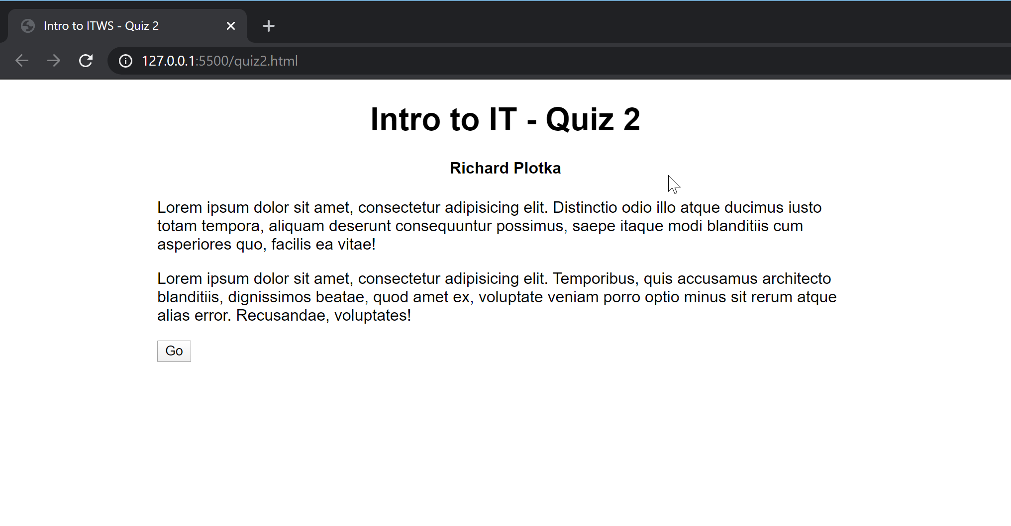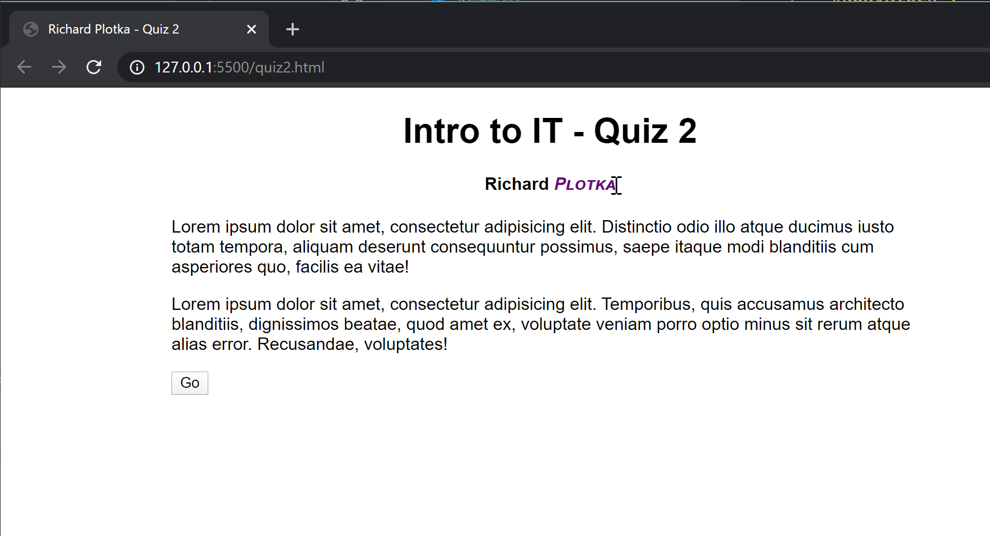
- Technology (description) (25 points, 20 minutes): Web Development
  - Based on the discussions in class, what is the three-way handshake and how does it relate to the OSI Model? Why do we need/use it? (Make sure to provide definitions in your answer) (10 points)

The three-way handshake is is the primary way 2 devices establish 2-way communication over a TCP/IP network, named for the 3 primary steps it entails.
- The initiating device sends a Synchronize Sequence Number (SYN) packet to the responding device, alerting the target it is going to start communicating with it, and with what SYN the initiating device will start/sign it’s segments with.
- The responding device will send the initiating device a SYN+ACK packet, or in other words a packet containing it’s own Synchronize Sequence Number and an ACKnowledgement that it received the initiator’s SYN packet.
- Finally, the initiating device will complete the handshake with an ACK packet of it’s own, confirming that it, too, now has it’s partner’s SYN.

  - We have learned the jQuery function in class. Explain what the ‘$’ does as it pertains to jQuery. Also explain what we would do if another API set is already using the $ (5 points)
The ‘$’ symbol in jQuery is a namespace identifier that communicates that the following code is jQuery and should reference the jQuery js file. If another API set is already using the ‘$’ symbol, then we can instead use the namespace identifier ‘jQuery’.
Ex:
$(document).ready(function () {});
Becomes
jQuery(document).ready(function(){});

  - What is a JavaScript object? (Provide 3 examples in your answer and describe them) (5 points)
A JavaScript object is a variable in JavaScript that can hold multiple variables. Objects are made up of key-value pairs, Each key string referring to another JS data type or function.
Ex:
const car = {year:”2014”, model:”Malibu”, make:”Chevy”};
Or
const book = new Object({
title: “The Jewish-Japanese Sex and Cookbook and How to Raise Wolves”
Author: “Jack Douglas”
Isbn: “1979761205”
ShelfLoc: nonfiction
Shelve: function(loc) {
shelfLoc = loc;
}
});
Or
const book = {};
book.title = “The Anarchist Handbook;
book.author = “Michael Malice”;
book.blurb = “Anarchism has been both a vision of a peaceful, cooperative society--and an ideology of revolutionary terror. Since the term itself--anarchism--is a negation, there is a great deal of disagreement on what the positive alternative would look like…”;
Or
const war = {startDate:2026, endDate:2030, aggressor:”France”, victor:”Anglo-Canadia”}

  - Recalling the HCI discussion in class, what is a paper computer and what is a prototype and what purpose do they serve? Explain in your own words, and give an example as it pertained to your projects. (5 points)
A paper computer is a model of a computer created using only pen and paper. It, along with paper prototyping -- the practice of modeling software or other parts of a computer with, similarly, only pen and paper, provide useful strategies for understanding computers and software and testing out ideas before attempting to implement them. Balsamiq, for instance, is a software that uses computers to accomplish paper prototyping, allowing it’s users to prototype app and web designs with a much smoother user interface then clunkily-specific html and css.

- “Guest Lectures” Discussion (20 points, 20 minutes)

  - Product Management? What is the difference between a Project Manager, Product Manager, and a Program Manager. Be specific to the lecture, but feel free to be as detailed as you like. (15 points)

Project managers work on the smallest and most technical scale. They are given a specific project to oversee and it’s their job to figure out the project’s objectives and make sure they are accomplished on time and with efficient resource use.
Program managers oversee multiple projects, managing the projects’ interdependencies and helping them coordinate to create the company’s product.
Product managers, identify what that product is. They own the product vision, identify customer needs, usually have some hand in marketing, and define project requirements.

  - As Ms. Poon mentioned in her lecture, what were some of the challenges that she and her colleagues faced with? (5 points)

- “Method” Case and “Google” Case: (20 points, 20 minutes)
  - As discussed in class, during the Method case; what is SaaS? What are IaaS, PaaS, and XaaS – how are the similar/different? (10 points)

SaaS is Software as a Service, a cloud service model that provides a software product, alleviating the consumers from the responsibility of improving, maintaining, or hosting the software.

IaaS is Infrastructure as a Service. This cloud service model provides hosting, networking, and storing to the consumer, but leaves the software and data to be hosted up to the users. Commonly used by providers of SaaS.

PaaS is Platform as a Service. This cloud service model works similarly to IaaS, but leaves control of the software tools necessary to make effective use of the provided infrastructure to the provider, letting the consumer focus solely on their product. Also commonly used by providers of SaaS.

XaaS is Everything or Anything as a Service. This is an umbrella term that can be used to describe almost any outsourcing of hardware and software to others, including the acronyms defined above. Recently, -aaS acronyms have become very popular product descriptors and there are dozens of acronyms used to describe variations of these subscription-based models.

  - How did Google handle the protests? Was anybody completely in the right? If so, how, and if not how? Be specific and justify your answers (10 points)

Google held strong in the face of it’s employees protests, pointing to the protests’ disruptiveness, and it’s contractual obligations to Israel in lieu of it’s supposed ‘culture of openness.’ Over 50 employees were fired in the wake of them trying to make themselves heard, and Google did not budge an inch, not even to prevent similar contracts from being made in the future, with Google actually excepting Israel from their usual policies against causing harm. Multiple lawyers and consultants within Google recommended against the deal years even before the protests happened. For all these reasons Google is specifically and entirely in the wrong, and it’s protestors nearly entirely in the right, with their acts of protest being fairly harmless as far as protests on such vital topics go.

