# ER DIAGRAM: WinnaleahEssentialOilsCo

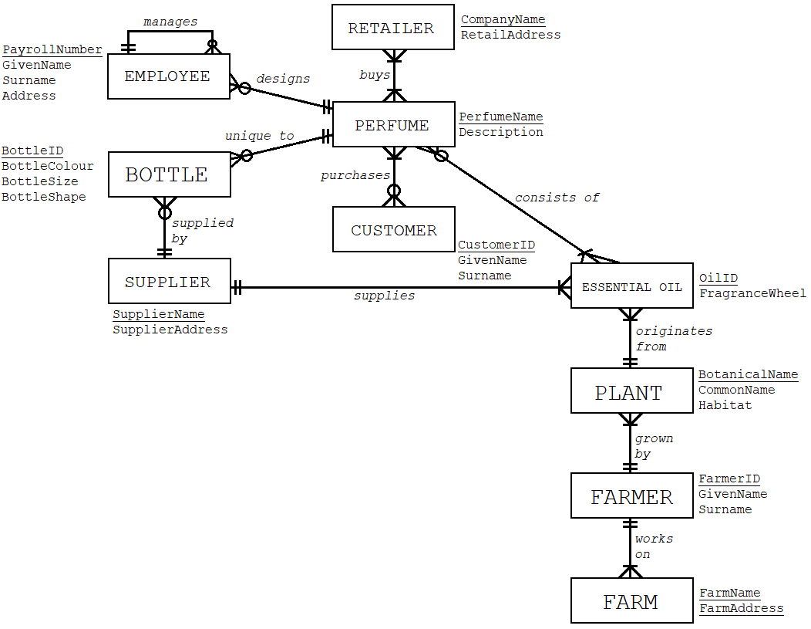RELATIONAL SCHEMA CONVERSION

**Step 1: Each entity becomes a relation**

EMPLOYEE(PayrollNumber, [pk] GivenName, Surname, Address)

RETAILER(CompanyName, [pk] RetailAddress)

PERFUME(PerfumeName, [pk] Description)

BOTTLE(BottleID, [pk] BottleColour, BottleSize, BottleShape)

CUSTOMER(CustomerID, [pk] GivenName, Surname)

SUPPLIER(SupplierName, [pk] SupplierAddress)

ESSENTIAL_OIL(OilID, [pk] FragranceWheel)

PLANT(BotanicalName, [pk] CommonName, Habitat)

FARMER(FarmerID, [pk] GivenName, Surname)

FARM(FarmName, FarmAddress, [pk])

**Step 2: Each many-to-many relationship becomes a relation**

BUYS(*CompanyName* [fk1], *PerfumeName* [fk2], [pk])

PURCHASES(*CustomerID* [fk1], *PerfumeName* [fk2], [pk])

CONSISTS_OF(*PerfumeName* [fk1], *OilID* [fk2], [pk])

**Step 3: Each one-to-many relationship is represented by a foreign key**

ESSENTIAL_OIL(OilID, [pk] FragranceWheel, *BotanicalName* [fk1], *SupplierName* [fk2])

PLANT(BotanicalName, [pk] CommonName, Habitat, *FarmerID* [fk])

FARM(FarmName, FarmAddress, [pk] *FarmerID* [fk])

BOTTLE(BottleID, [pk] BottleColour, BottleSize, BottleShape, *SupplierName* [fk1], *PerfumeName* [fk2])

EMPLOYEE(PayrollNumber, [pk] GivenName, Surname, Address, *PayrollNumber* [fk1], *PerfumeName* [fk2])

**Step 4: Write out the final relational schema (Logical Model)**

WinnaleahEssentialOilsCo

**Perfume**(PerfumeName, [pk] Description)

**Farmer**(FarmerID, [pk] GivenName, Surname)

**Supplier**(SupplierName, [pk] SupplierAddress)

**Retailer**(CompanyName, [pk] RetailAddress)

**Customer**(CustomerID, [pk] GivenName, Surname)

**Employee**(PayrollNumber, [pk] GivenName, Surname, Address, *PayrollNumber* [fk1], *PerfumeName* [fk2])

**Farm**(FarmName, FarmAddress, [pk] *FarmerID* [fk])

**Plant**(BotanicalName, [pk] CommonName, Habitat, *FarmerID* [fk])

**EssentialOil**(OilID, [pk] FragranceWheel, *BotanicalName* [fk1], *SupplierName* [fk2])

**Bottle**(BottleID, [pk] BottleColour, BottleSize, BottleShape, *SupplierName* [fk1], *PerfumeName* [fk2])

**CustomerPerfume**(*CustomerID*[fk1], *PerfumeName* [fk2], [pk])

**RetailerPerfume**(*CompanyName* [fk1], *PerfumeName* [fk2], [pk])

**PerfumeOil**(*PerfumeName* [fk1], *OilID* [fk2], [pk])