# CLI VERSION

Pic 1:

* Showing intro screen
* has/2, case 1 – correct key word and value –-> print correct message
* has/2, case 2 – wrong key word -> support messages
* has/2, case 3 – right keyword, wrong value -> print incorrect message
* 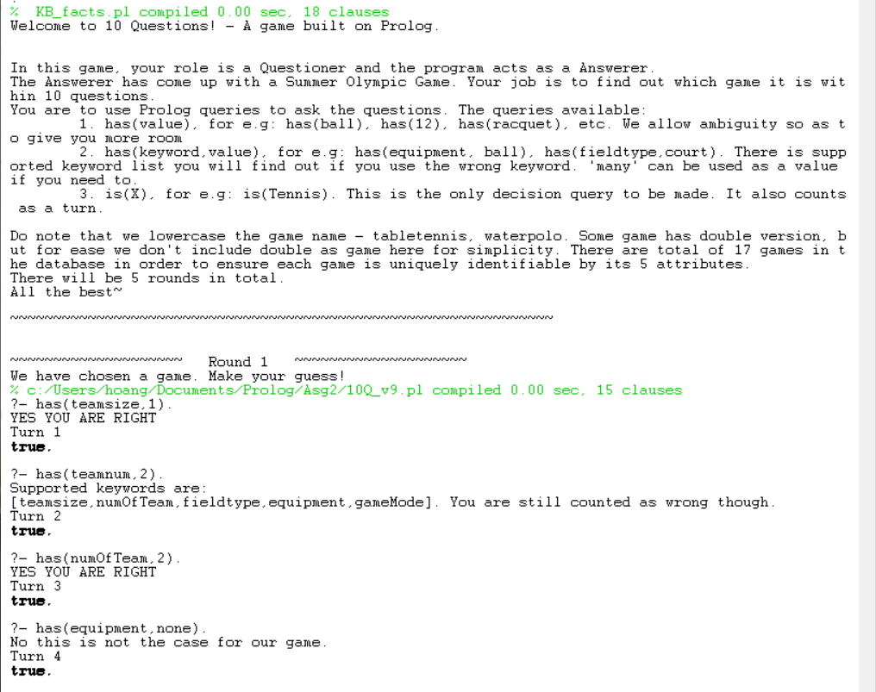turn increment

Pic 2:

* has/1 – fail case
* is/1 – fail case
* Failing a round by reaching N == 10 – print message and chosen game
* Round increment
* Choosing new game

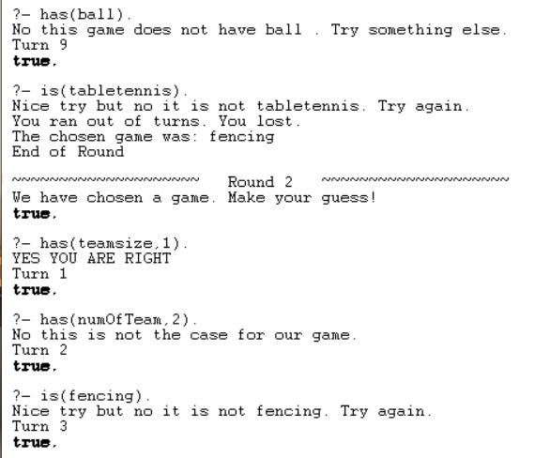

Pic 3:

* has/1 - success case
* is/1 - success case
* Winning a round as it reaches turn 10 (boundary case)

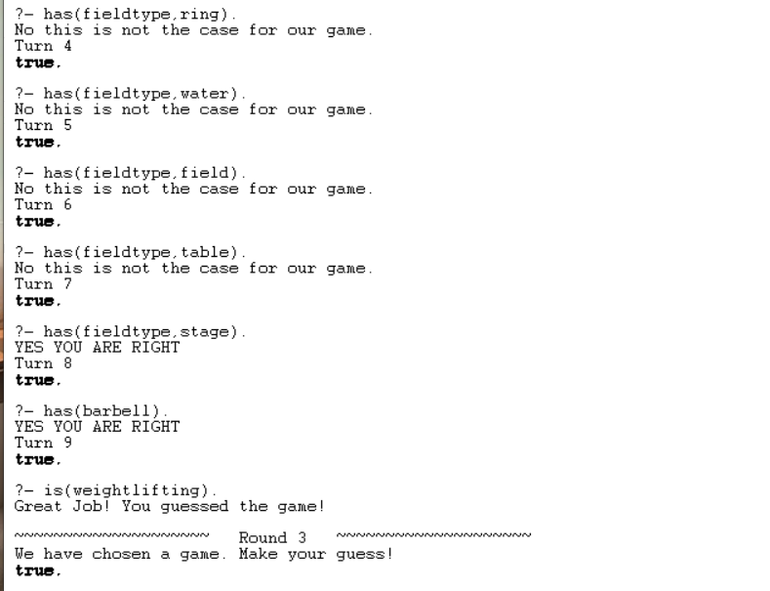

Pic 4:

* Showing termination of case
* Winning at turn < 10 case
* End of Game screen
* Restart command

