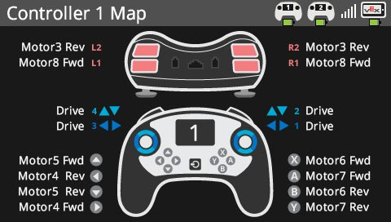

Intake In

Intake Down

Catapult Down

Catapult Up

Catapult Normal Velocity

Catapult Match Load Velocity

