# CONDA De-Installation of Anaconda Python

Purpose of this document: When you de-install Anaconda on Windows 7 (as a prep step to re-installing a damaged environment), it leaves behind “residue” that can conflict with your re-installation. This document outlines simple steps you can take (if your machine is like mine) to ensure you clean the residue off before re-installation. This process has now been successfully used on:

* Conda 4.1 installation of Python 3.5 (default) with a 2.7 environment added to it
* Conda 4.2 Installation of Python 2.7 (default) with a 3.6 environment added to it

**Ghosts in the Start menu (Recently Used Programs:**

* To avoid confusion, remove icons created in your recently accessed programs list of the start menu. On Windows 7 it should look something like this:

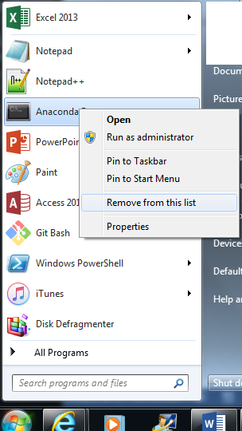

* Each icon from your Anaconda installation (that you used recently) will show in this hot list and can be removed with “remove from this list” right-click menu.

**Remove Anaconda Installation:**

On Windows7: Start 🡪 Control Panel 🡪 Programs 🡪 Remove Programs

It will look something like this:



As part of this process, you need to restart / re-boot your PC

After reboot check the Programs list on Control panel again. If it is still there, try to uninstall again and you will get an option to remove it from the list:

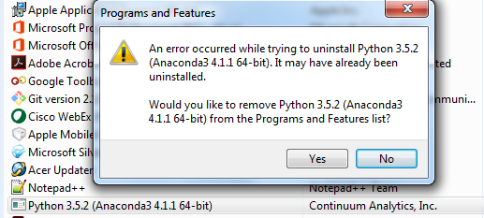

After completion of this step, you should no longer see it here.

**Ghosts in the Start menu (Program Icons):**

Icons may still be in your start menu. Before you delete them, if you don’t remember where Anaconda is installed, you can right click on an icon and check properties to remind yourself where you installed Anaconda. You will need this path for file clean up steps in this document.

Look for them and delete if still there:

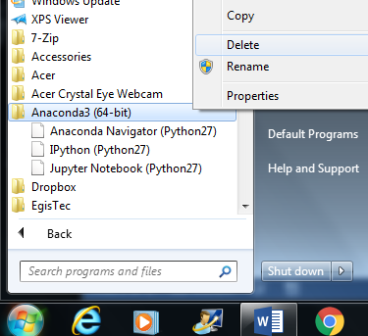

**Files and Folders Left Behind:**

First go to your Anaconda install path and make sure the whole folder is truly gone. It should be, but if not, delete it.

Next, in an explorer window, type: %AppData%

This will take you to the folder where Application Data is stored by default.

Look for a “Jupyter” folder and delete it. You may also have a “Jedi” folder or other folders that match known packages in your installation. Check date-time matches date of your installation and you can delete these as well.

Finally, in explorer, type: %HOMEDRIVE%%HOMEPATH%

This should take you to a path that is something like: C:\users\<MyUserProfile>

In here are a series of folders that are used by your conda installation (your list may vary depending on what you actually used and initialized with your installation). They should be removed or emptied out so your new installation can create them fresh:

* .anaconda
* .conda
* .continuum
* .iPython
* .jupyter
* .spyder2-py3

.spyder-py … should end with 2 or 3 depending on what version you installed

You may also see a .matplotlib folder and/or other folders for python libraries you recognize. It is a judgement call whether to clean these out or not (I did).

I also checked %PATH% to ensure no paths to Python still existed. My %PATH% was clean of python / Anaconda paths after de-installing it.

In your Anaconda root path, there should be an “uninstall-anaconda.exe.” Oddly – though this made the de-install process more graphical, it took all the same steps to clean all traces off the system as above. No real benefit seems to be gained by using it.