This topic was researched on a laptop with MS Office 2013 running on Windows 7 – 64bit. For older versions of Office and/or versions running on different versions of MS Windows/Office, it may be necessary to research how these menu options and popups differ on your system.

In this document:

* Developer Only Password Challenge:
* Settings Before Rolling the DB Out to Users
* To Re-enable Developer access to Ribbon, Design hot menus, and hidden objects

**Developer Only Password Challenge:**

To prevent casual users from clicking on “Developer Only” features, a password challenge is presented when clicking on the button for the “Developers Only” dashboard:

* This password can be seen in clear text in this VB code module: “Form_Switchboard” (the VB for the actual Switchboard form)
* Change this password before taking any DB you create from these files live
* Security through obfuscation is not security. The VB project can be locked (on the copy rolled out to the public) with a password to protect this further, but note that if real security is desired, additional measures may need to be designed.

**Settings Before Rolling the DB Out to Users:**

These settings are found as shown here under MS Access 2013. They may be arranged a little differently in MS Access 2007 or more current versions of Access. Note: different paths to these options present depending on what you have open in the DB – the following options can get you to the required features:

File 🡪 Privacy 🡪 Database Tab

File 🡪 Options 🡪 Database Tab

Screenshots begin on the next page

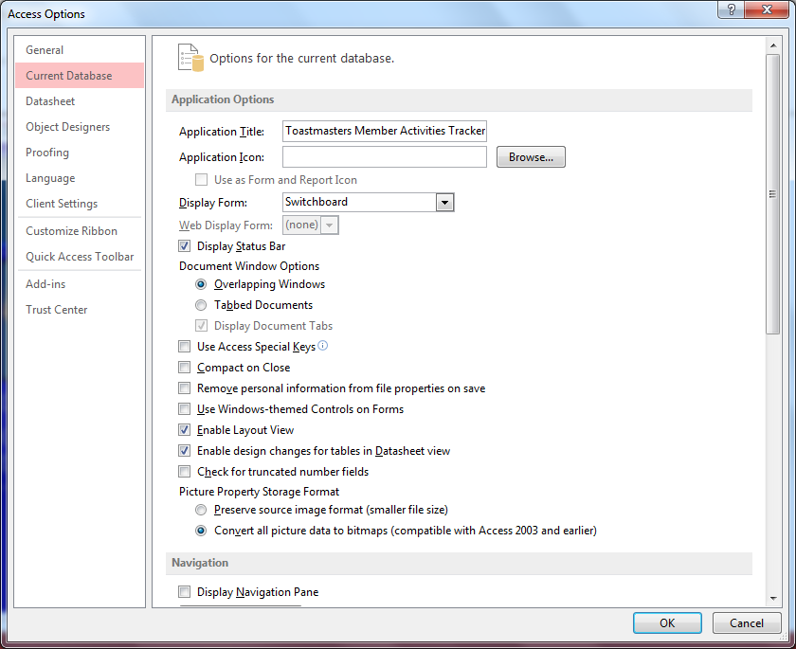

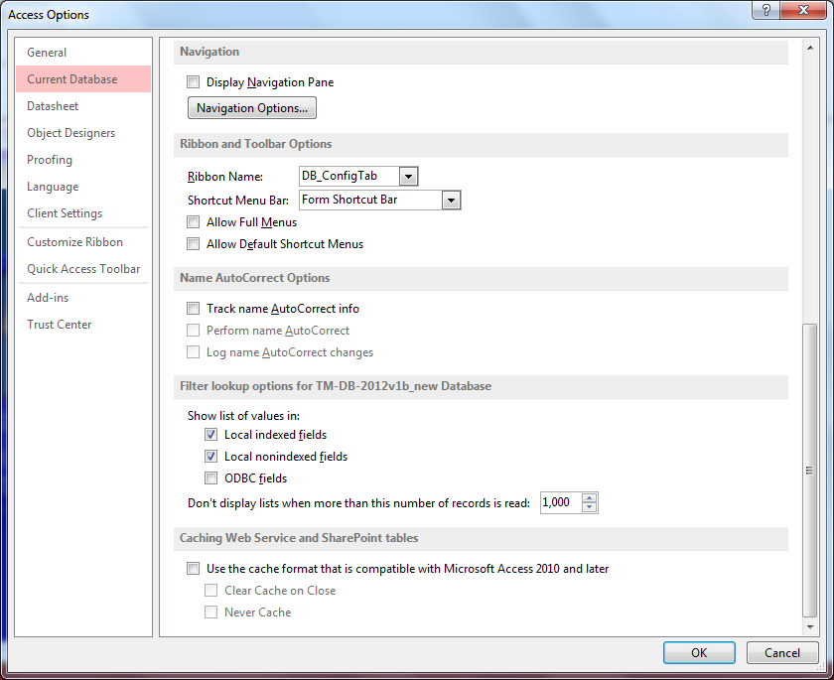

You will also want to click the “Navigation Options” button shown above and make sure hidden objects is unchecked. This will hide certain “developer only” objects from users and database admins.

**To Re-enable Developer access to Ribbon, Design hot menus, and hidden objects:**

If you do the above on your working file, you lose the ability to access design and other developer features. These steps will put the database “right” again so you can work on the code.

Note that a simpler approach is to make all your changes to a file that has all this stuff visible and “open”, then copy the file and follow steps above to prep the copy for roll-out.

File 🡪 Privacy 🡪 Database Tab

File 🡪 Options 🡪 Database Tab

Then make sure to check these boxes shown in image below:

* Display Navigation
* Allow Full Menus
* Allow Default Shortcut Menus

To work on hidden objects:

* Click Navigations button shown below and check “show hidden objects”
* Then go back into this setting and uncheck it before rolling out the DB to users

