**Warning!** Each topic in this document comes with a trade-off. You are turning off security features that can protect you from hackers in order to get the VBA automation code between Excel and Access to run. Please consult Microsoft help documentation and proceed at your own risk. All who work in Office VBA are familiar with this trade off, and unfortunately, the code does not present much in the way of options to get it to work without doing some of this.

This topic was researched on a laptop with MS Office 2013 running on Windows 7 – 64bit. For older versions of Office and/or versions running on different versions of MS Windows/Office, it may be necessary to research how these menu options and popups differ on your system:

Setting up Trust for the Excel Macros file so it will work:

Excel 🡪 Options 🡪 Trust Center 🡪 Trusted Center Settings (button) 🡪

Trusted Locations 🡪 Add New Location 🡪

Then fill out as shown in these images:

Excel 🡪 Options 🡪 Trust Center 🡪

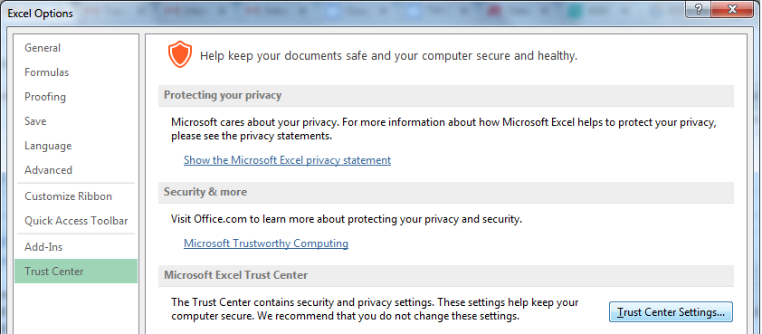

Trusted Center Settings (button) 🡪Trusted Locations 🡪 Add New Location 🡪

(image on next page)

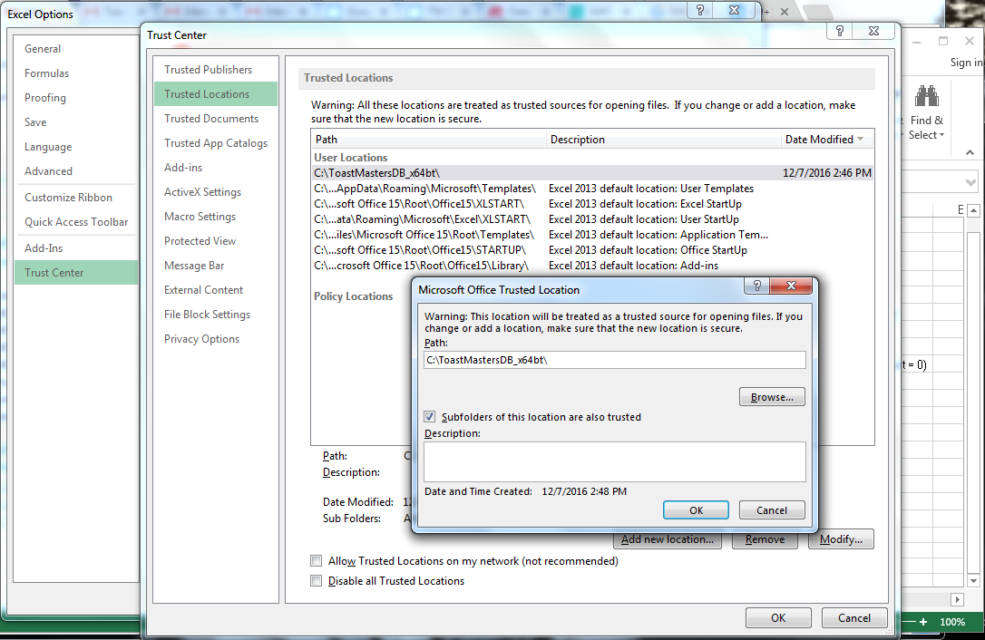

If problems still occur you may need to also explore configuring the “Macros Settings” options as well as shown below.

