Getting Started

# Configuring the DB for Your Club

The company name, club number and district number displayed on all navigational dashboards of the database can easily be configured to match your club.



To do this:

1. Click the **Goto Admin Features** button on Main
2. Click the **Edit Toastmasters Group Dashboard Text 1** button and edit the text that pops up in the window.
3. Do the same thing from the **Edit Toastmasters Group Dashboard Text 2** button.
4. Refresh the dashboard by clicking a button to go to another dashboard screen and then returning to Main.

Figure 1: Configurable Information

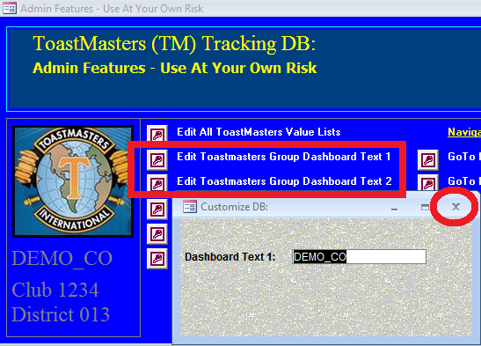

Figure 2: Example Image - Step 2

After entering a value, use the “x” in the corner to complete the operation. You won’t actually see the effect of the change until you click on a navigation button to go to another dashboard screen (so the screen can refresh).

Note: If you click [Enter] by mistake, the field will appear to empty, but the value you put in it will still take effect. Simply exit the screen and the change will take effect after you click a navigation button to refresh the Dashboard.

Important! – Unless you install the DB using the exact same paths provided in documentation for the code version you are using, you will need to relink all data tables to point to your file system setup. See this debugging topic before you begin for how to do this:

3.1 TM-DB-Config.accdb or TM-DB-Data.accdb Not Found

# Database Basics – Getting Started Using It

The database was originally designed to store information about members and guests, and to manage what activities they participate in. Specifically, speeches they give, roles they take, and other things they can do like volunteering to take a table topic. Over time, it has been expanded to store other club information as well.

## Member Records – Start Here!

### Always Begin With Member Records

You always need to enter Member Records first (when someone new joins or participates as a guest), and then you can add activities for that member (or guest). Though all persons entered into the database get a record on the “Members” form, the **Member Type** then defines who is actually a member of the club versus guests and other defined types. To enter a guest in the database, set the Member Record field named **Member Type** to “Guest”.

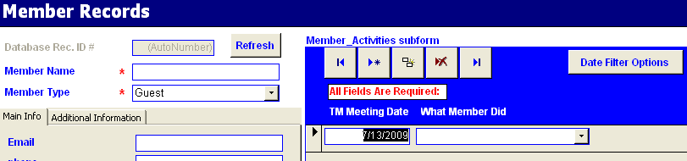

Figure 3: Required Fields - Member Records Form

In the above image:

* + **Member Name** and **Member** **Type** are required (note the **red** asterisk by them).
  + Current Officers are flagged as such by their **Member Type**. To keep a history of past officers, explore the buttons off of the blue Main button form.
  + On the Member Activities panel – all fields are required to enter an activity, but you can have a Member with no activities if they haven’t done anything yet.

On other screens of the database, **Member Name** drop-downs are populated automatically from the names you entered for Members through the Member Records form. Note that these drop-downs will be blank until you get some Members in the Database.

### Additional Guidance – Optional Fields on the Member Records Form

Fields were proposed by the officer team of July 2008 for the DTCC club. While every effort was made to make fields self-explanatory, some might bear some explaining. Note that you do not have to fill out any of these optional fields for reporting to work:

1. **Certifications** – single text field. Enter a member’s multiple certifications as a comma separated list such as CC, CL, etc.
2. **On the Additional Information Tab** – are fields for entering: the Toastmasters International Website ID, tracking status of whether the member record is up-to-date with both the International site and your club’s site (should you have one), and a notes field where you can put in comments of any sort you want.
3. **Enter # of Speeches – Not in DB** – was requested specifically by aforementioned officer team. Like all optional fields, you don’t have to use this feature if you don’t want to. DTCC’s club has members and guests who speak at other clubs. For simplicity, we only want activities and speeches from our club stored in the database. But this can throw off the speech total since the member may be on speech 8 of their CC and yet the database may only have records for 5 of them. To fix this, find out how many speeches were given as other clubs and enter this manually. You will see this number get added to the count of speeches that are in the DB when you click the Member Summary Dashboard button on the Member Records form. Member speaks again at your club, and this total will still be right. But if the member speaks outside your club again, you may need to update this manually again (on occasion).

## Entering Speeches, Roles, and Other Activities

Activities (what members did like speeches, roles, etc.) can be entered by member from the Member Records form or by Activity date from the Activities Form. On the Member Records form, you can input more than one activity / meeting date for a given member:

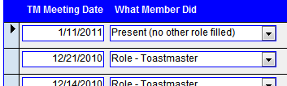

The Activities Form presents more like filling out a duty roster and makes it easy to enter everything that happened on a given day. Experiment with the buttons on Main and you will quickly see how easy these different options make it.

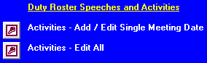

Regarding the fields on Activities Forms and Sub-forms:

1. **TM Meeting Date** – Access permit using the control-semicolon key combination to pick up today’s date. Otherwise, type the date in using a 4-digit year as in 2009. Example: 7/7/2009.
2. **What Member Did** – Start typing until you get what you want (Access attempt to complete the value for you by looking for matches on the first characters typed). Note that this one drop-down involves speeches, roles, etc. – and even though you can add your own values to it through the Admin button form, it requires certain categories as prefixes. This means that to enter a speech, you need to start with “Speech – “, to enter a role, start with “Role – “ and you probably want to take a look at the drop down and familiarize yourself with the values so you know what to type. Contest roles and activities (as in contest judge, or contest table topic volunteer) have the word Contest in them.
3. **Member Name** – is only presented on the form to enter Activities by date. If you enter an activity through the Member Records form, it gets the Member Name off of that form automatically (yet another reason that a Member must have a record in the database before you enter activities for that Member). Note that guests who perform actions at your club can be managed in the database by entering “Guest” for their **Member Type** field.

## Member Dashboard Buttons

Dashboard buttons on the Member Records form, pop up what look like spreadsheets of information. This is no coincidence.

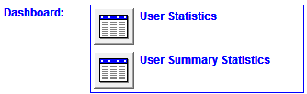

If right-clicking the top corner of these pop-up screens does not present a hot-menu with a copy option, then do the following if you wish to copy this information into Excel:

1. Click the upper right corner of the report to select all records

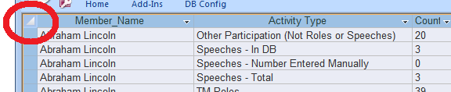

1. press Control-C to copy this information
2. Now open Excel and you can paste the information
3. In Excel you can reformat, print and edit as you wish – this is a convenient way to prep information to send to someone via email.

## Reporting Features

Reporting uses an Excel template to format the final results. Try all of the different reporting buttons and you should be able to figure them out. The “Main” Report contains a menu page with buttons to jump to each tab and an explanation on the menu page of what each tab is.

A few things to note:

1. Read pop-up messages at start and end of each report button
2. Under Windows 7, Excel may load minimized, so even if you opt to keep the report open after it runs, look at the bottom of the screen for a minimized Excel option to open it.
3. For reports that have names and email addresses on them, you can take advantage of a hidden feature to auto-generate email lists from the report:

* Click Alt-F8 to access email list generation macros:

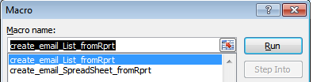

One creates a spreadsheet, the other creates a list in a single field that you can copy and paste into emails to email everyone on the report. Both can be used in combination with Excel sheet-filtering features to generate lists of just the email addresses desired.

This code is also available for use in the following file:

/excel_macros/email_list_converter.xls

## Reporting Dashboard Buttons

Reporting Dashboard buttons are designed to export reports directly into Excel. Before you use reporting buttons for the first time, make sure to consult this document to enable the excel macros the MS Access database communicates with:

TMDB-Enabling-ExcelAutomationInDB.docx

You should also note that the VB code to exit Excel after creating a report leaves a process running on Windows in the task manager. This can build up as you click multiple reporting buttons until your task manager looks like this:

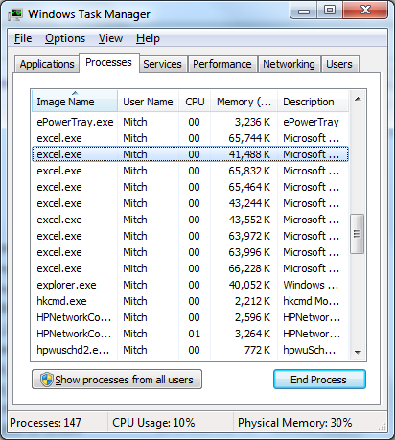

On Windows 7, right-click the status bar, goto “Task Manager”, then the “Processes” tab and select and “end process” on all of these with no documents open in Excel. This will clear out the memory used up by all of these instances and help head off some symptoms you may encounter in Excel.

## Quick Notes About Admin Features Button Forms

This form, near its title, warns you to “use at your own risk” for a reason. Before using the features from this form (or other forms you may access from buttons on this form), you should always make a backup copy of the database. That way, if you make any mistakes, you can use the copy to go back to what you had before.

Drop-downs throughout the database other than for the **Member Name** field can be edited from the Admin button form. Read all notes on all screens carefully before you begin to make changes to things.

# DB Troubleshooting Help

## TM-DB-Config.accdb or TM-DB-Data.accdb Not Found

A likely cause for this error is that somehow, the links to data tables that reside in 2 backend db files separate from the design (under \data) have somehow broken and need to be relinked. A feature exists in the DB to help with this. FYI – this feature can also be used to take the entire ToastmastersDB or ToastmastersDemoDB folder tree and move it off the route of your computer. After moving, you would also perform this process to fix broken links.

Here’s what to do:

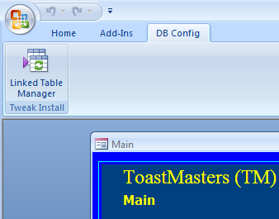

1. Goto “DBConfig” tab in the Database Ribbon (you may need to click or double-click the tab to open it so you see the icon shown above).
2. Click the “Linked Table Manager” icon
3. Select the boxes for the two table paths that end in “TM-DB-Config.accdb” and also the one for “Always prompt for new location” and click OK

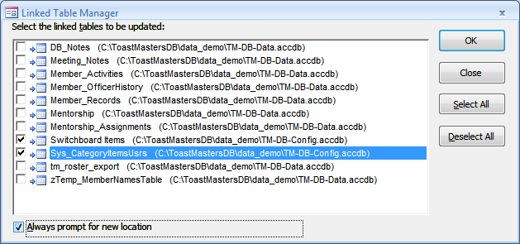

1. Navigate to the “data” subdirectory where you have stored the file “TM-DB-Config.accdb” on your system and click OK to all prompts
2. Repeat above process but this time, select just the boxes which have table paths ending in TM-DB-Data.accdb and this time, you will navigate to the TM-DB-Data.accdb file instead to link up the rest of the tables. (This will be all of the boxes except for the two you selected in the previous steps for the config file.)
3. Save the DB so you don’t lose these changes

## Reporting Buttons initiate the Process, but then Hang Up And Fail To Complete

See this document: TMDB-Enabling-ExcelAutomationInDB.docx

Update Log:

* This document last tested on Feb. 13, 2011 – 12:03 am.
* Troubleshooting section added Aug. 8, 2013
* Minor edits performed 12/11/2016 while testing, editing, and preparing this project for inclusion on Github