

Hardware Implementation of ASCON
Hardware Security Project Report
Prepared by: Mohamad Ali Khalil 20220728

Contents
Summary 3
1. Project Objectives 3
2. Tools and Environment 3
3. Project Folder Organization 4
4. Hardware RTL Setup 5
5. Software Implementation 7
6. RTL Compatibility Fixes 8
7. Quartus Hardware Synthesis 9
8. Area Utilization Results 10
9. Timing Result 12
10. Power Consumption Results 13
11. Hardware Security Discussion 13
12. Verification Summary 14
13. GitHub Repository 14
14. Conclusion 14

Summary
This project implements and evaluates an ASCON lightweight cryptographic core using SystemVerilog RTL and Intel Quartus Prime Lite. A Python software reference model was also prepared to generate encryption, decryption, and hash test vectors. The hardware design was synthesized successfully on a Cyclone IV E target device, and Quartus was used to collect area, timing, and power results.
The final implementation required small RTL compatibility fixes because Quartus rejected unsized SystemVerilog enum literals. These fixes made the state and mode encodings explicit without changing the intended behavior of the design.

1. Project Objectives
- Understand the ASCON algorithm at the level needed to implement encryption, decryption, and hashing.
- Prepare a hardware ASCON core using RTL design files.
- Use Python software as a reference model to generate and verify test vectors.
- Synthesize the hardware design in Quartus and collect area, timing, and power results.
- Organize the final deliverables as source files, test vectors, screenshots, report files, and a public GitHub repository.

2. Tools and Environment
Item | Value
Operating system | Ubuntu Linux
Python version | Python 3.12.3
Git version | 2.43.0
HDL simulator checked | Icarus Verilog 12.0
Synthesis tool | Intel Quartus Prime Lite 24.1std Build 1077
HDL language | SystemVerilog
Top-level entity | ascon_core
Target FPGA family | Cyclone IV E
Target FPGA device | EP4CE115F29C7

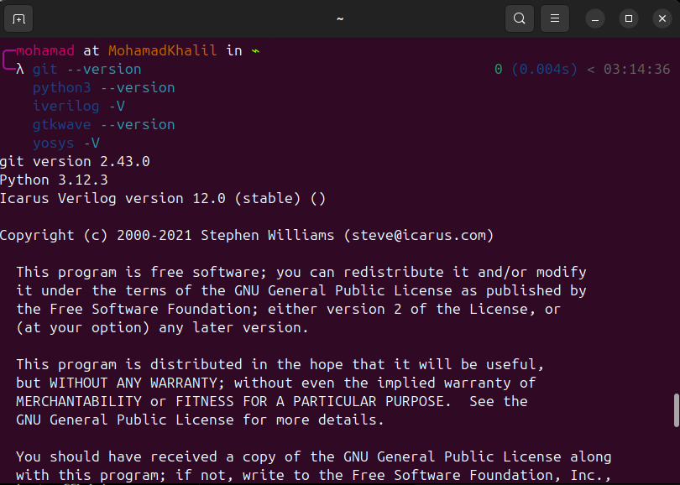
Figure 1: Toolchain versions used in the project environment.

3. Project Folder Organization
The project was organized into separate folders for hardware RTL, Quartus files, software scripts, generated test vectors, screenshots, and the final report. This structure keeps the implementation files and evidence files clear for review.
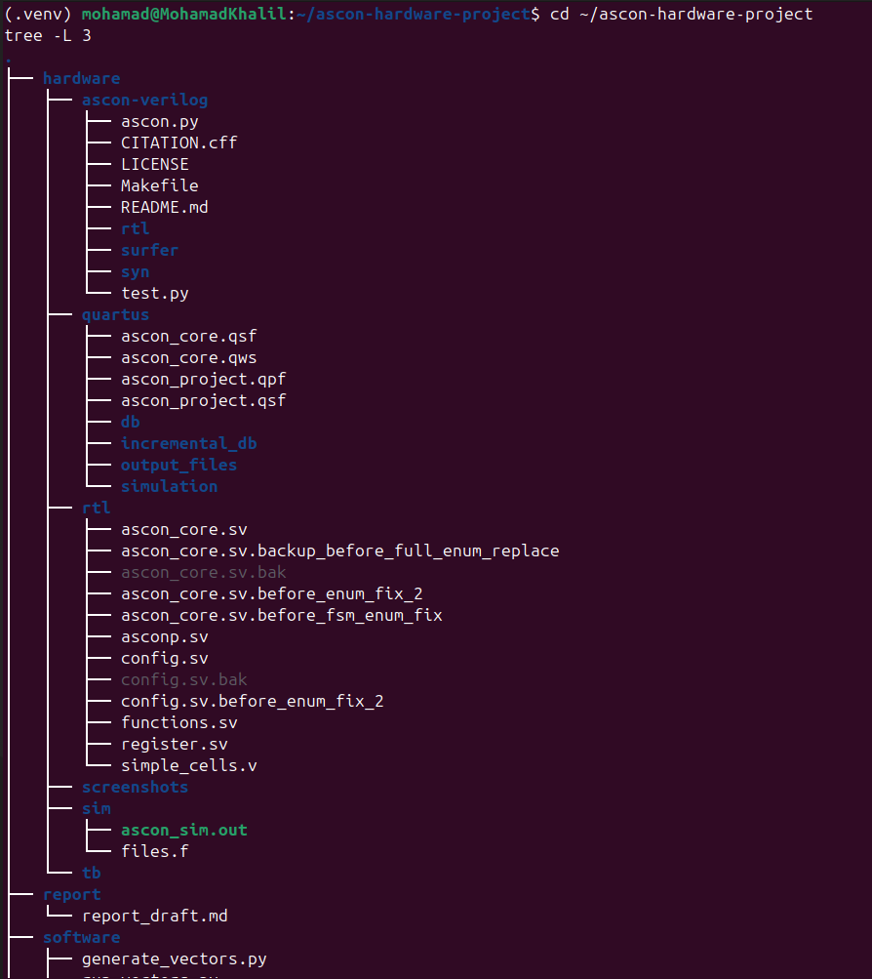
Figure 2: Final project directory tree.

4. Hardware RTL Setup
The ASCON-Verilog hardware repository was cloned and the RTL files were copied into the project hardware/rtl directory. The files used for Quartus synthesis were config.sv, functions.sv, register.sv, simple_cells.v, asconp.sv, and ascon_core.sv.
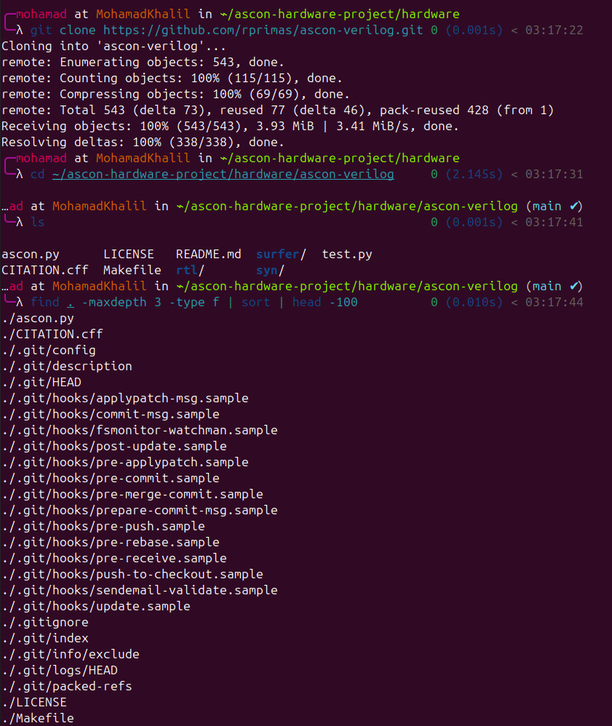
Figure 3: Downloaded ASCON-Verilog repository and listed its files.
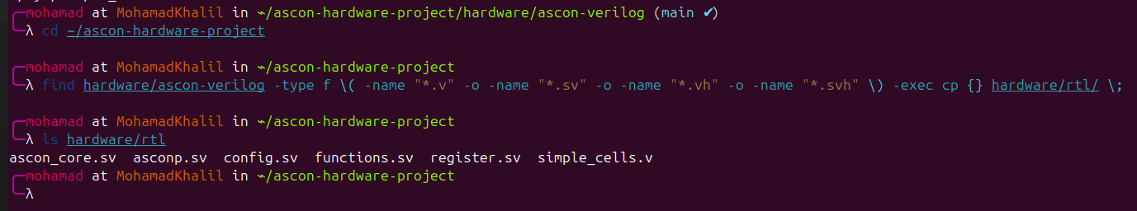
Figure 4: RTL files copied into the local project hardware directory.

5. Software Implementation
The software side was written in Python and used as the reference model. The script generate_vectors.py creates test vectors containing key, nonce, associated data, plaintext, ciphertext with authentication tag, and hash output. The script run_vectors.py reloads the generated vectors and verifies encryption, decryption, and hashing.
The generated vectors were saved as text, CSV, and HEX-style files. These files make it easier to reuse the same input/output pairs for documentation and future hardware testbench verification.
File | Purpose
software/generate_vectors.py | Generates ASCON reference vectors and saves them to the test_vectors folder.
software/run_vectors.py | Recomputes the outputs and checks that all saved vectors still pass.
test_vectors/test_vectors.txt | Human-readable input/output test vector document.
test_vectors/test_vectors.csv | Structured test vector file for easier processing.
test_vectors/test_vectors_for_tb.hex | Hardware-testbench-friendly vector file.

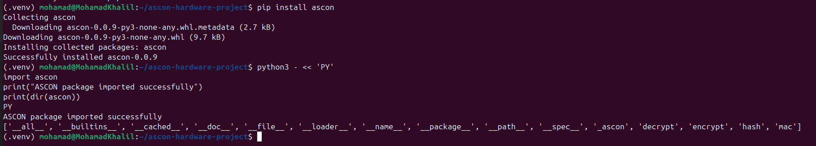
Figure 5: Python ASCON package installed and imported successfully.
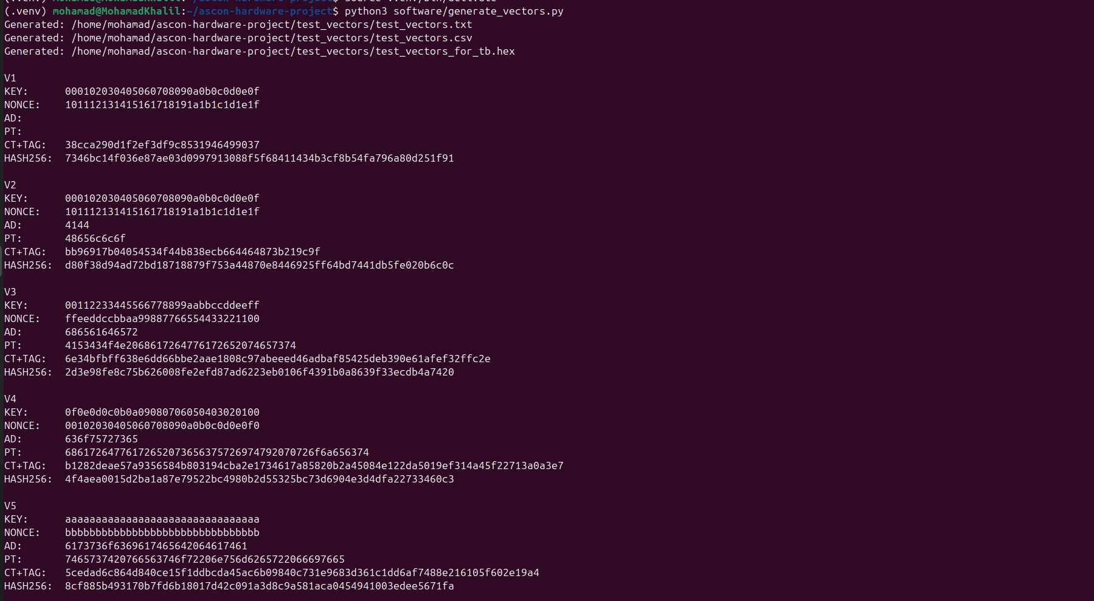
Figure 6: Python software generated ASCON test vectors.
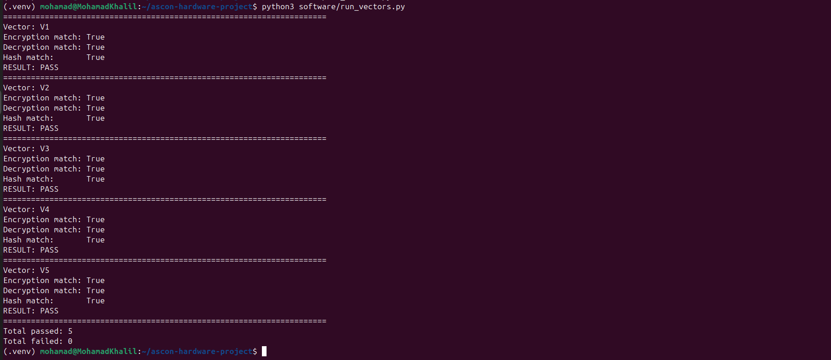
Figure 7: Python verification confirmed all encryption, decryption, and hash checks passed.
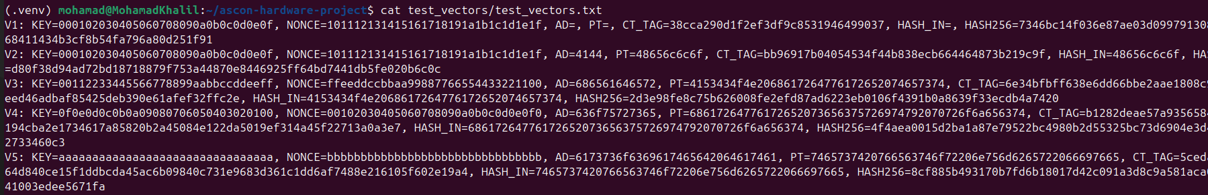
Figure 8: Generated test vector file containing input/output pairs.

6. RTL Compatibility Fixes
The original RTL did not compile immediately in Quartus because several enum values were written as unsized literals. Quartus treated these as 32-bit values, while the enum base types were 4-bit or 5-bit fields. This caused elaboration errors before synthesis could continue.
The fix was to make the enum widths explicit. The mode and data type enums in config.sv were changed to use 4-bit literals such as 4'd0 and 4'd1. The finite-state-machine enum in ascon_core.sv was changed to use 5-bit literals such as 5'd0 and 5'd1. This is a syntax compatibility correction and does not change the design function.
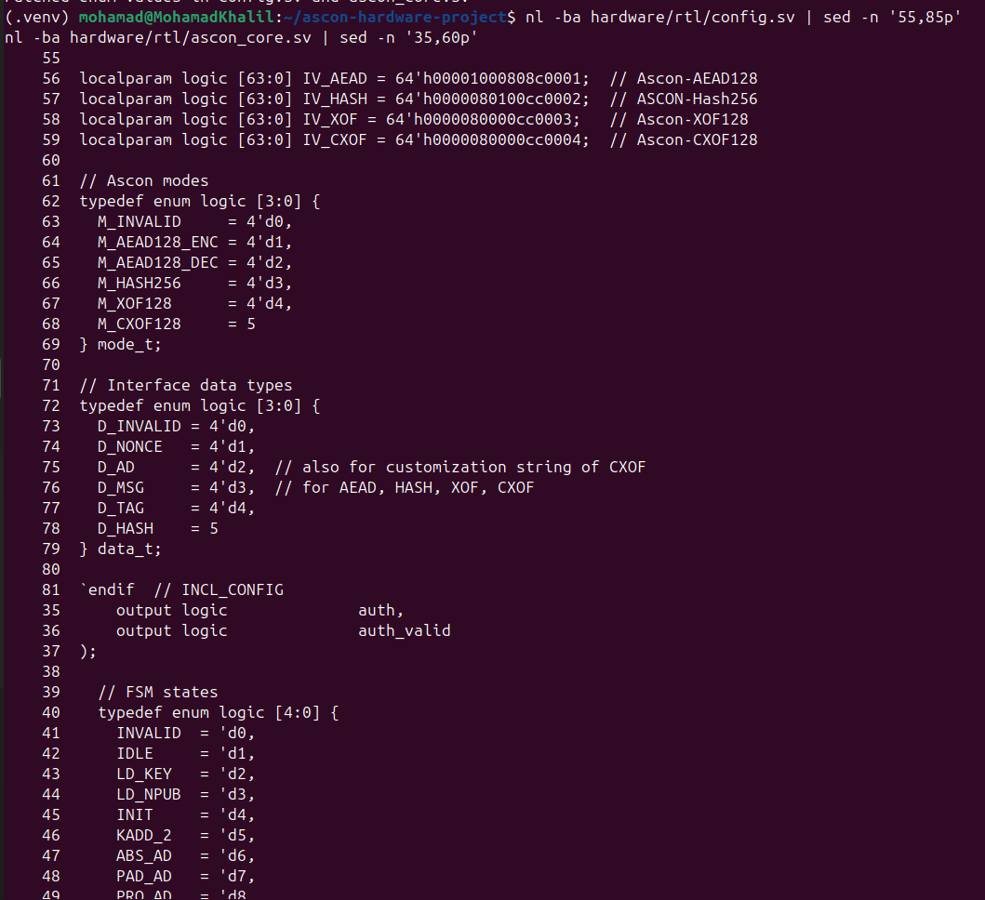
Figure 9: Quartus compilation error before correcting enum literal widths.
After the enum literals were corrected and Quartus cache folders were cleared, the full compilation completed successfully.

7. Quartus Hardware Synthesis
The project was compiled in Intel Quartus Prime Lite using ascon_core as the top-level entity. The target device selected was EP4CE115F29C7 from the Cyclone IV E family. Compilation completed successfully with zero errors.
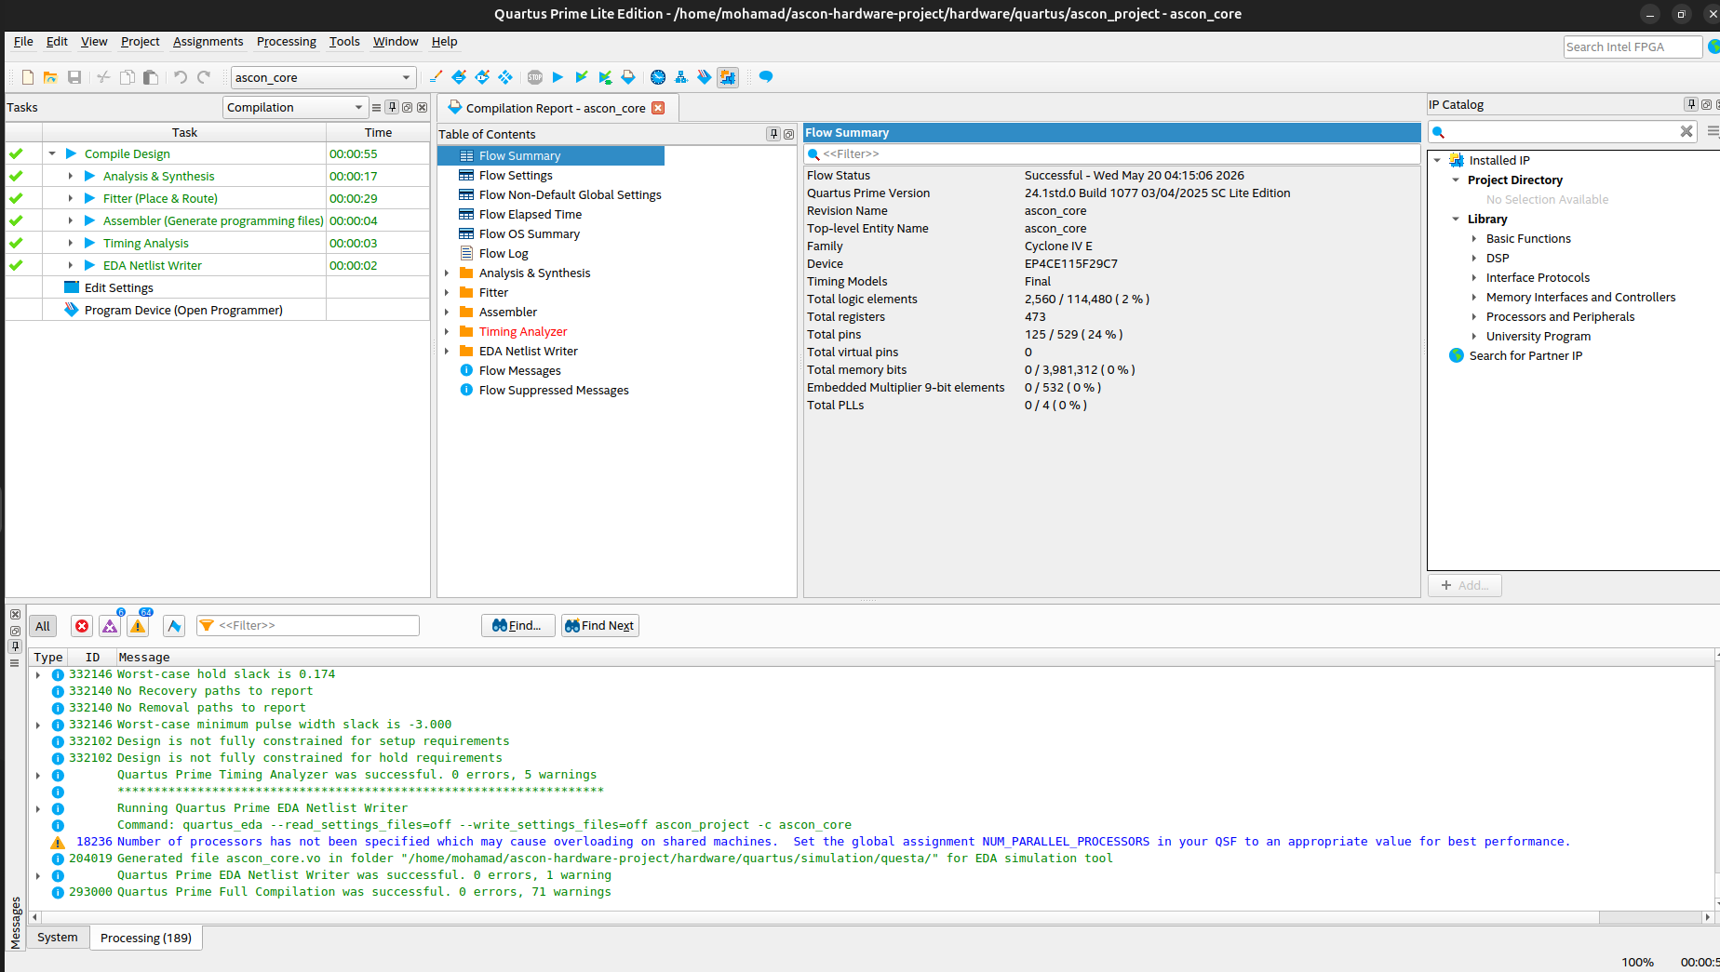
Figure 10: Successful Quartus full compilation after RTL compatibility fixes.
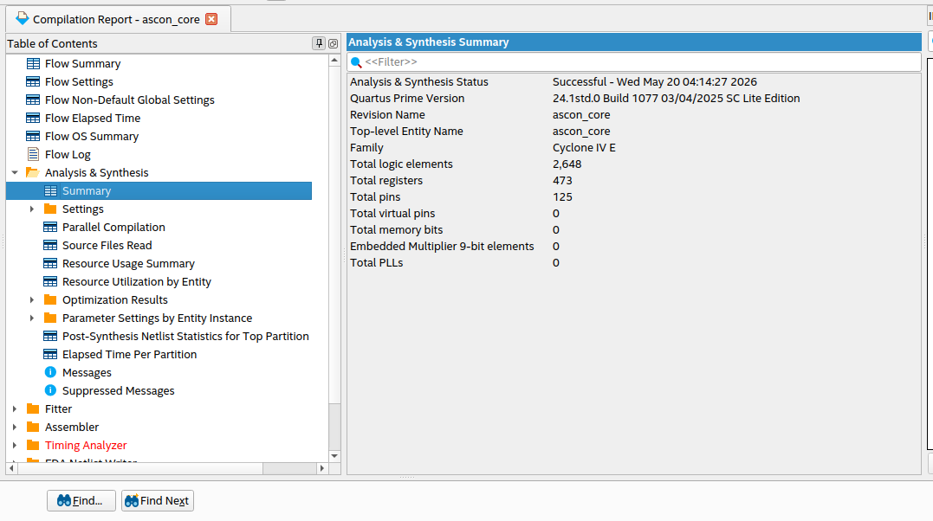
Figure 11: Analysis and Synthesis summary for the ASCON core.

8. Area Utilization Results
The final fitter results show that the design uses a small portion of the selected FPGA. The main area usage is from combinational logic and registers inside the ASCON permutation and state registers.
Area Metric | Quartus Result
Device | EP4CE115F29C7
Family | Cyclone IV E
Top-level entity | ascon_core
Total logic elements | 2,560 / 114,480 (2%)
Total registers | 473
Total pins | 125 / 529 (24%)
Total virtual pins | 0
Total memory bits | 0 / 3,981,312 (0%)
Embedded multiplier 9-bit elements | 0 / 532 (0%)
Total PLLs | 0 / 4 (0%)

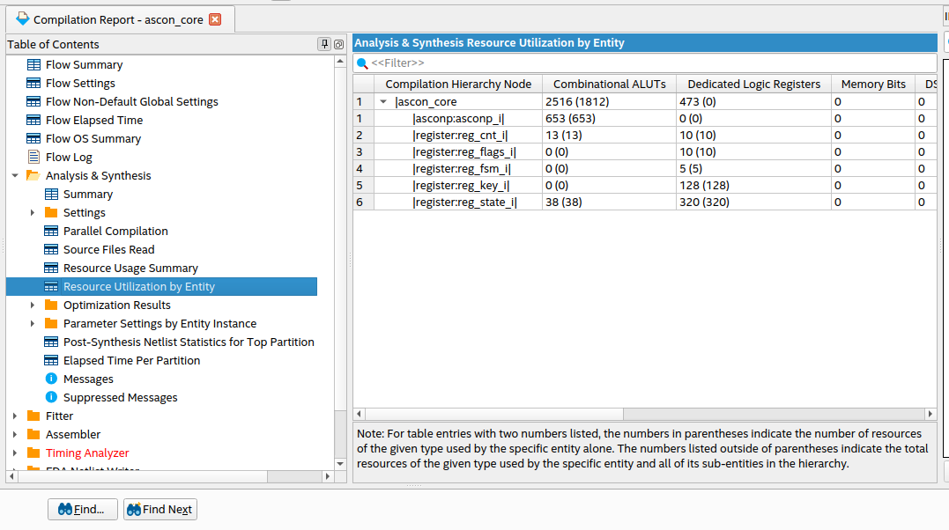
Figure 12: Resource utilization by entity.
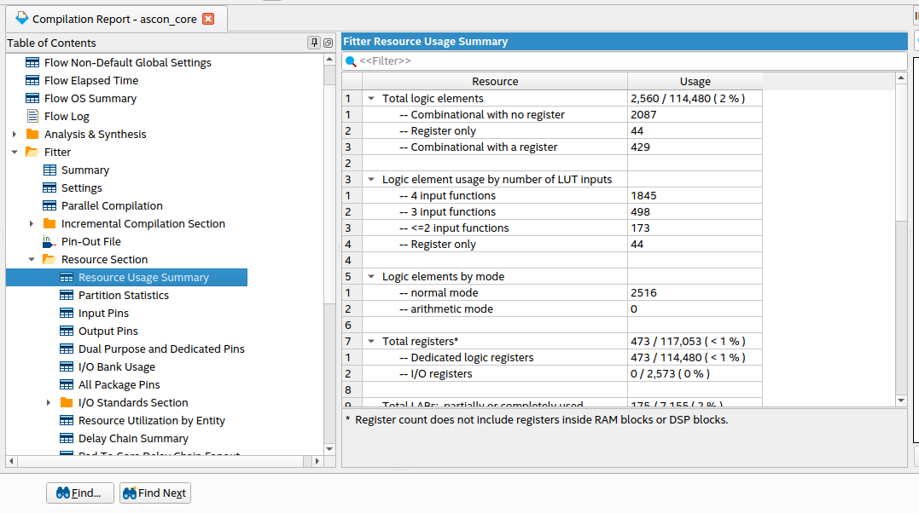
Figure 13: Fitter resource usage summary.
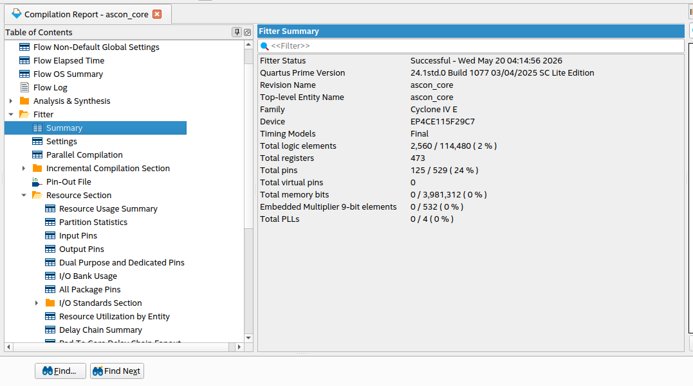
Figure 14: Fitter summary showing final device utilization.

9. Timing Result
The Timing Analyzer reported an estimated maximum clock frequency of 100.69 MHz for the clk signal. This value is useful as an initial synthesis result for the selected FPGA device.
Timing Metric | Value
Clock name | clk
Fmax | 100.69 MHz
Restricted Fmax | 100.69 MHz

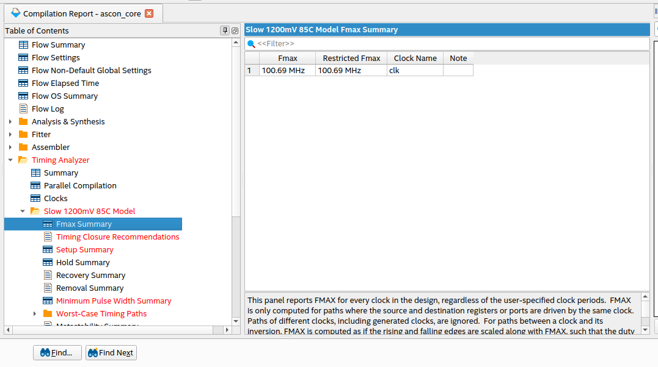
Figure 15: Timing Analyzer Fmax summary.

10. Power Consumption Results
Quartus Power Analyzer was used to estimate the design power. The report used vectorless/default activity estimation because no simulation activity file was provided. Quartus marked the confidence as low due to insufficient toggle-rate data, so the values should be treated as initial estimates rather than final measured power.
Power Metric | Quartus Result
Total thermal power dissipation | 174.29 mW
Core dynamic thermal power dissipation | 0.00 mW
Core static thermal power dissipation | 98.81 mW
I/O thermal power dissipation | 75.47 mW
Power estimation confidence | Low - insufficient toggle-rate data

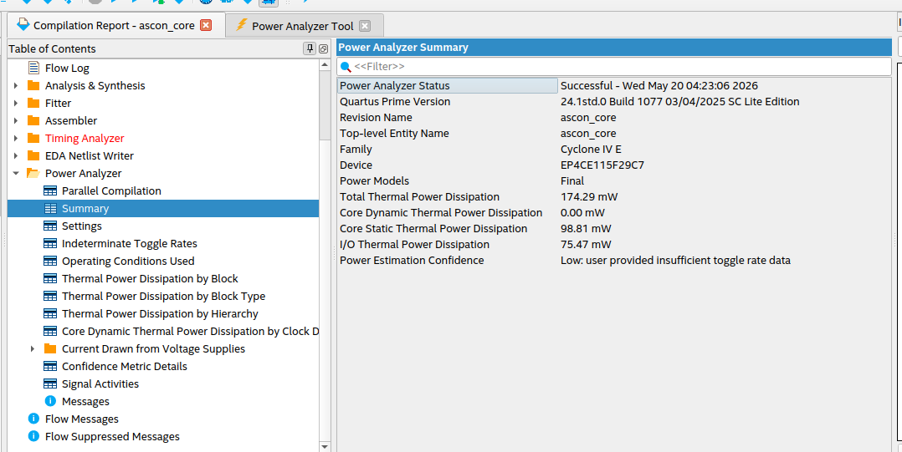
Figure 16: Power Analyzer summary.

11. Hardware Security Discussion
ASCON is used in constrained devices where area and power matter. In hardware, the main practical security concerns are side-channel leakage and fault injection. Side-channel attacks can use power, timing, or electromagnetic leakage to infer secret data. Fault attacks can disturb the circuit using clock or voltage glitches.
The current RTL was reviewed as a functional ASCON implementation. It uses a synchronous structure with a finite-state-machine controller, state registers, and a permutation datapath. No explicit masking, redundancy, parity check, or fault-detection logic was confirmed in the available synthesis evidence. Therefore, this implementation should be described as functionally synthesized and suitable for basic evaluation, but not as a fully protected hardware-security implementation against advanced physical attacks.

12. Verification Summary
The software reference verification passed for all five generated vectors. Each vector checked encryption, decryption, and hashing. The hardware side was successfully synthesized in Quartus, proving that the ASCON core can be compiled for the selected FPGA device.
Verification Item | Status
Python vector generation | Completed
Python encryption/decryption/hash verification | Passed for 5 vectors
Quartus Analysis and Synthesis | Successful
Quartus Fitter | Successful
Timing result | Fmax = 100.69 MHz
Power estimation | Completed using vectorless/default activity

The same generated vectors are the reference data for testbench-based hardware verification. They provide the expected outputs that should be compared against the RTL outputs when running simulation.

13. GitHub Repository
The project files should be submitted through a public GitHub repository. The expected repository link is:
https://github.com/TheMohammadKhalil/ascon-hardware-project
The repository should include the RTL files, Quartus project, Python source files, test vectors, and this final report.

14. Conclusion
The ASCON hardware project was completed through a full software and hardware preparation flow. Python was used to generate and verify ASCON reference vectors. The hardware RTL was prepared, corrected for Quartus enum-width compatibility, and synthesized successfully on a Cyclone IV E FPGA target. Quartus reports show 2,560 logic elements, 473 registers, 125 pins, an estimated Fmax of 100.69 MHz, and estimated total thermal power of 174.29 mW.

