**Princess Sumaya University for Technology King Abdullah II Faculty of Engineering**

**Electrical Engineering Department**



**EMBEDDED SYSTEMS**

**FINAL PROJECT REPORT**

**EcoGrow: Autonomous Greenhouse Control**

***Authors: Supervisor:***

**Maryam Abualia 20210937 Computer Engineering Dr Belal Sababha**

**Joud Quteifan 20221073 Computer Engineering**

**Mohammad Khalil 20220728 Computer Engineering**

***May 27,2025***

***Abstract***

*The project presents an automated greenhouse control system operated by pic16F877A microcontroller. The system integrates real-time soil moisture sensing, temperature-operated ventilation and ultrasonic-based water level monitoring. It automatically does important greenhouse functions such as important greenhouse functions such as water, temperature control and water management, reducing manual labor and improving plant growth stability. The testing confirmed the precise sensor reactions and reliable actuator operations, highlighting the efficiency of the system and potential scalability. This project displays a practical step in permanent agricultural technology, benefiting from farming efficiency and crop yield.*

**TABLE OF CONTENTS**

1 INTRODUCTION 2

1.1 THEORY 2

1.2 OBJECTIVE 2

2 Design 3

2.1 HARDWARE DESIGN 3

2.2 SOFTWARE DESIGN 4

3 RESULTS 6

4 PROBLEMS AND RECOMMENDATIONS 7

5 CONCLUSION 7

6 REFERENCES 8

# INTRODUCTION

Integration of embedded systems in agriculture has changed traditional greenhouse management by automating significant environmental controls, reducing dependence on manual labor, and adaptation of resource efficiency. The project presents an automatic greenhouse control system using pic16F877A microcontroller to increase crop growth through real -time monitoring and adjustment. The system appoints soil moisture sensor for accurate irrigation, temperature sensor for climate regulation, an all-run ventilation system and ultrasonic sensor for efficient water level monitoring. By managing these parameters wisely, the system reduces human intervention, preservation of resources, and ensures the ideal growing conditions-recalling the ability of embedded technologies to carry forward torrent and high yielding agriculture.

## THEORY

This automated greenhouse system combines embedded control and sensor technologies to optimize growing conditions for the plants. The PIC16F877A microcontroller processes real-time readings from soil moisture sensors, temperature sensors, and ultrasonic water-level detectors through closed-loop control to sustain optimal parameters. The system triggers appropriate responses if readings differ from setpoints, for example, auto-irrigation, fan-controlled ventilation adjustments, or water supply warning. By replacing hand observation with this feedback-driven approach, the design uses precise environmental regulation at a cost of resources, showing how microcontroller automation can rationalize farm productivity with targeted, data-informed interventions.

## OBJECTIVE

1. **Automated Irrigation Control:** Develop a system that monitors soil moisture in real-time and activates a water pump when dryness is detected, ensuring efficient and consistent irrigation.
2. **Ventilation via Timed Servo Control:** Implement a servo-controlled vent that opens and closes periodically based on a timer, allowing passive airflow to support greenhouse ventilation.
3. **Water Level Monitoring**: Utilize an ultrasonic sensor to detect low water levels in the reservoir and activate an LED indicator, preventing system failure due to water shortage.
4. **Integrated Embedded System Design**: Ensure seamless hardware integration of the PIC16F877A microcontroller with all sensors and actuators for reliable and synchronized operation.

# Design

## HARDWARE DESIGN

The hardware design of the automated greenhouse system integrates multiple components to monitor environmental conditions and control essential functions efficiently:

* Microcontroller (PIC16F877A):

Acts as the central controller, processing inputs from sensors and managing outputs such as the water pump, fan, servo motor, and LED indicators.

* Soil Moisture Sensor:

Provides a digital signal indicating soil dryness. When dry conditions are detected, the microcontroller activates the water pump for irrigation.

* Temperature Sensor (LM35):

Measures ambient temperature and sends analog data to the microcontroller, which activates the fan if cooling is needed.

* Servo Motor (Ventilation):

Operates a vent flap that opens and closes at timed intervals, allowing passive airflow regardless of temperature readings.

* Ultrasonic Sensor (HC-SR04):

Monitors the water reservoir level. If the level drops below a set point, the microcontroller lights up an LED to signal low water availability.

* Fan:

Automatically turns on when the temperature exceeds a defined threshold to maintain suitable conditions inside the greenhouse.

* Water Pump:

Engages only when the soil is dry, as indicated by the moisture sensor, to ensure efficient water use.

* Power Supply (12V Battery):

A 12V rechargeable battery powers the entire system, supplying consistent energy to all components through appropriate voltage regulations.

* LED Indicators:

Provide visual feedback, such as low water alerts or sensor activity, helping monitor the system's status immediately.

This hardware configuration supports autonomous greenhouse management, reducing manual labor and improving consistency in plant care.

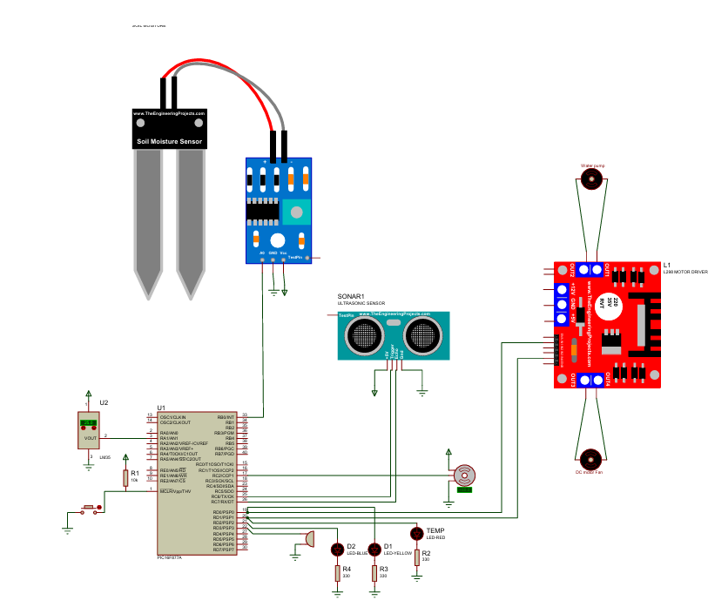

*Figure 1 EcoGrow Proteus design.*

## SOFTWARE DESIGN

The software for the automated greenhouse system is written in embedded C and used on the PIC16F877A microcontroller. Its main function is to continuously monitor sensor inputs and control actuators based on predefined logic, creating a responsive and autonomous greenhouse environment.

Sensor data acquisition is handled through both analog and digital inputs. The soil moisture sensor provides a digital signal to indicate dryness, while the LM35 temperature sensor sends analog voltage values that are converted to temperature readings using the ADC module. The ultrasonic sensor operates by sending a pulse via the trigger pin and measuring the time it takes for the echo to return, allowing the system to estimate water levels in the water tank.

The main control logic is structured around real-time decision-making. When dry soil is detected, the microcontroller turns on the water pump until adequate moisture is restored. If the temperature exceeds a certain threshold, the fan is turned on to help cool the environment. The servo controlled vent opens or closes based on a timer, providing passive ventilation. Additionally, when the ultrasonic sensor detects a low water level, an LED is triggered to alert the user.

Pulse-width modulation (PWM) is used to control the servo motor responsible for opening and closing the vent. Timers are configured to maintain accurate delays and signal generation, ensuring consistent motor control and proper functioning of the ultrasonic sensor. All components operate within an infinite loop, allowing the system to maintain continuous monitoring and actuation without requiring manual resets or input.

The software is designed to be efficient, modular, and easily expandable. It prioritizes stable performance and low power consumption, making the system suitable for long-term use in a standalone greenhouse setup.

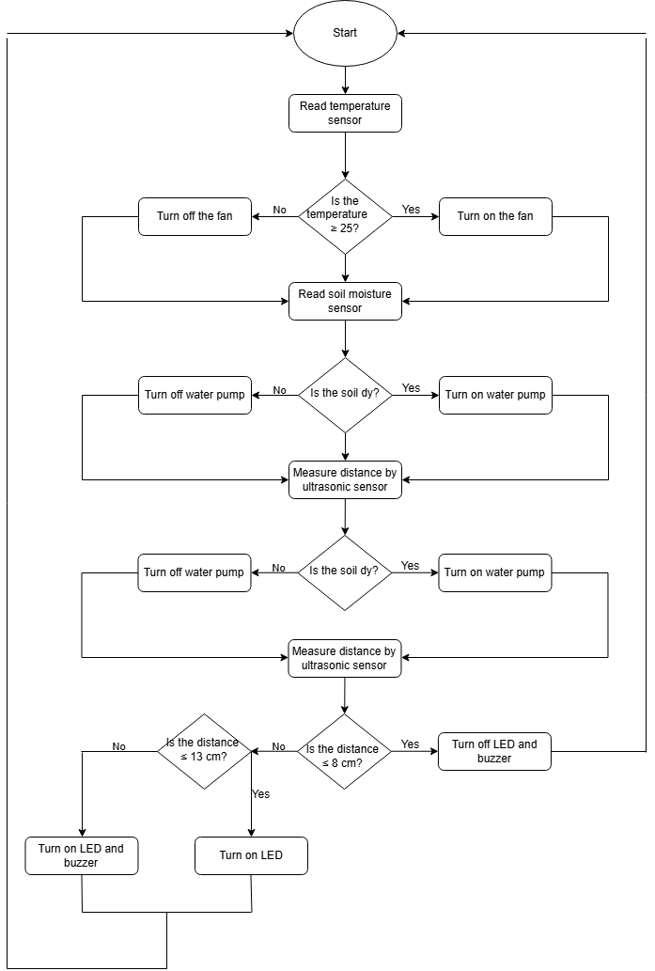

*Figure 2 EcoGrow flow diagram.*

# RESULTS

The automated greenhouse system functioned as intended during testing, responding accurately to various environmental conditions. When the soil moisture sensor detected dryness, the microcontroller activated the water pump to irrigate the soil efficiently. The temperature sensor reliably triggered the fan when the ambient temperature rose above the threshold, helping to regulate internal conditions. The servo-controlled vent operated on a timed basis, opening and closing periodically to allow airflow. Additionally, the ultrasonic sensor successfully monitored the water reservoir level and lit an LED when the water level was too low. These coordinated operations confirmed the system's ability to maintain a stable growing environment with minimal human intervention.

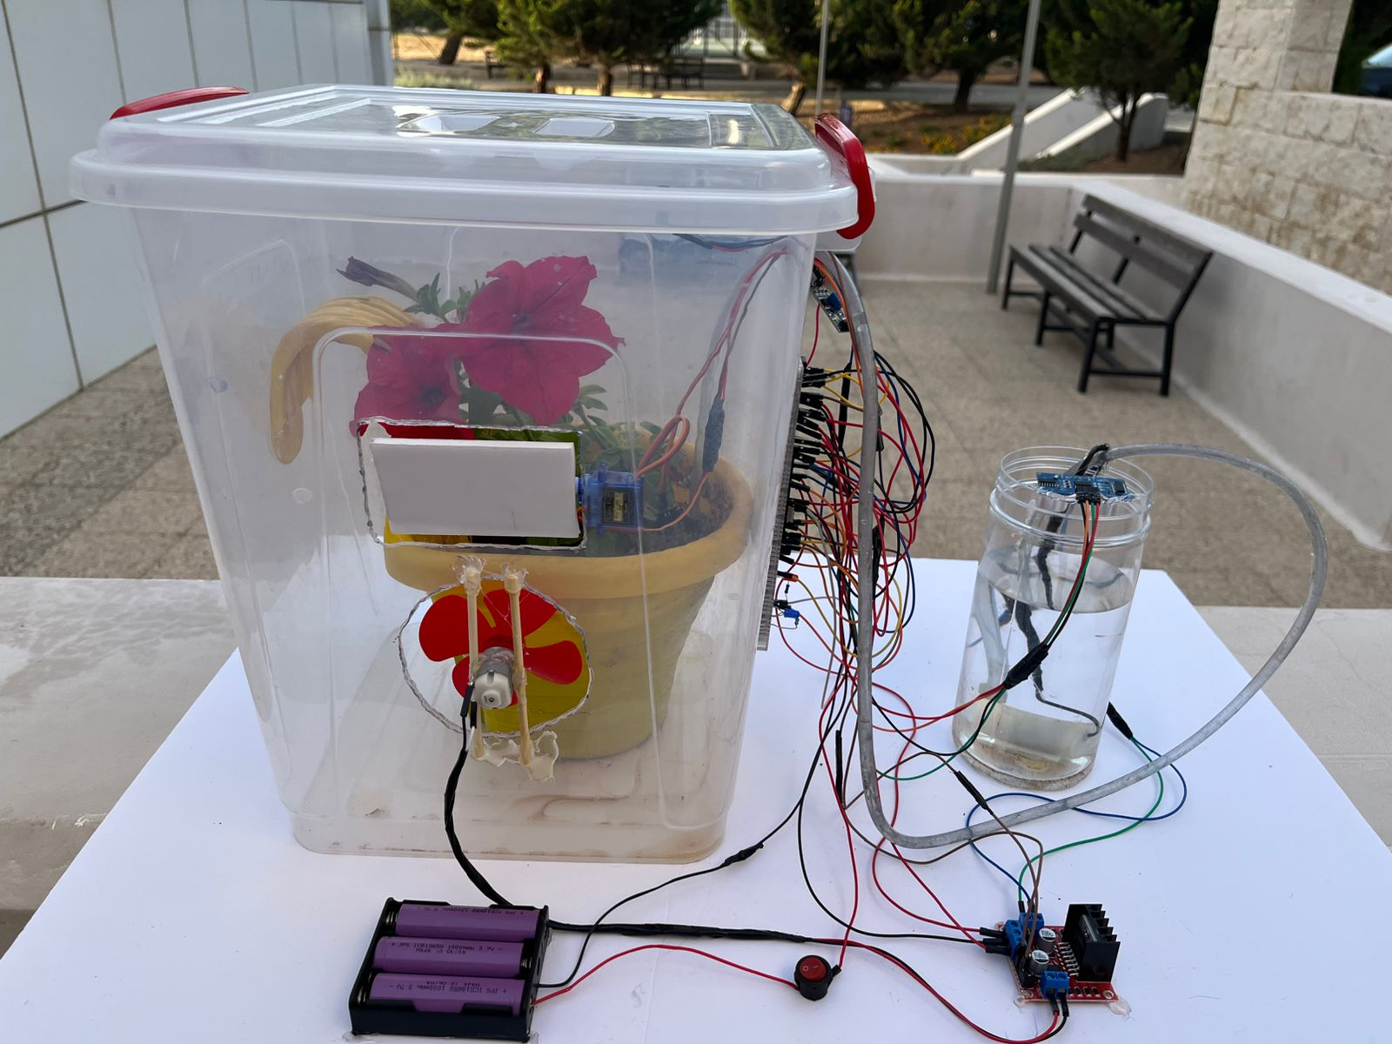

*Figure 3 EcoGrow Final Design*

# PROBLEMS AND RECOMMENDATIONS

**Servo and DC Fan Activation Conflict**Issue: When the servo motor and DC fan were powered together, one or both devices sometimes did not work properly. This was probably because power supply stress was resulting from the combined current consumption of both devices.  
 Recommendation: We made sure the servo and fan were not powered simultaneously. Their activities were sequenced in code to prevent simultaneous power consumption, and thus we achieved a stable performance in both components.

**LM35 Sensor Instability**Issue: The LM35 temperature sensor was difficult to work with and tended to produce unstable readings, especially due to slight current or voltage fluctuations. Recommendation: We suggest the implementation of software-based smoothing mechanisms to improve stability.

# CONCLUSION

# The automated greenhouse system successfully demonstrated how embedded technology can be used to simplify and enhance agricultural processes. By integrating soil moisture detection, temperature monitoring, timed ventilation, and water level sensing, the system maintained key environmental conditions with minimal human input. Despite some challenges, particularly with LM35 sensor stability and power fluctuations, the system performed reliably in testing and proved effective for small-scale greenhouse automation. Moving forward, improvements such as better power regulation, optimized timing control, and enhanced sensor filtering could further increase the system’s reliability and scalability. This project provides a solid foundation for future development in sustainable and intelligent farming solutions.

# REFERENCES

**Research Paper – PIC16F877A Microcontroller in Greenhouse Automation**  
A scholarly article detailing the use of the PIC16F877A in greenhouse monitoring and control systems.  
<https://www.researchgate.net/publication/377890336_PIC16F877A_Microcontroller_Using_Automatic_Green_House_Monitoring_and_Controlling_System>

**HC-SR04 Ultrasonic Sensor Datasheet**  
Complete datasheet and specifications for the ultrasonic sensor used to detect water levels.  
<https://cdn.sparkfun.com/datasheets/Sensors/Proximity/HCSR04.pdf>

**LM35 Temperature Sensor Datasheet – Texas Instruments**  
Technical details of the LM35 analog temperature sensor used in your project.  
 <https://www.ti.com/lit/ds/symlink/lm35.pdf>

**PIC16F877A Microcontroller Datasheet – Microchip**  
Official datasheet providing electrical specs, pin configurations, and peripheral information for programming and circuit design.  
 https://ww1.microchip.com/downloads/en/DeviceDoc/39582b.pdf