**Princess Sumaya University for Technology King Abdullah II Faculty of Engineering**

**Electrical Engineering Department**



**EMBEDDED SYSTEMS**

**FINAL PROJECT REPORT**

**EcoGrow: Autonomous Greenhouse Control**

***Authors: Supervisor:***

**Maryam Abualia 20210937 Computer Engineering Dr Belal Sababha**

**Joud Quteifan 20221073 Computer Engineering**

**Mohammad Khalil 20220728 Computer Engineering**

***May 25,2025***

***Abstract***

*This project presents an automated greenhouse control system powered by the PIC16F877A microcontroller. The system integrates real-time soil moisture sensing, temperature-driven ventilation, and ultrasonic-based water level monitoring. It automates critical greenhouse functions such as watering, temperature control, and water management, significantly reducing manual labor and improving plant growth consistency. Testing confirmed accurate sensor responses and reliable actuator operations, highlighting the system's efficiency and potential scalability. This work demonstrates a practical step forward in sustainable agricultural technology, benefiting farming efficiency and crop yield.*

**TABLE OF CONTENTS**

1 INTRODUCTION 2

1.1 THEORY 2

1.2 OBJECTIVE 2

2 DESIGN 3

2.1 HARDWARE DESIGN: 3

2.2 SOFTWARE DESIGN: 4

3 RESULTS 6

4 PROBLEMS AND RECOMMENDATIONS 7

5 CONCLUSION 7

6 REFERENCES 7

# INTRODUCTION

The integration of embedded systems into agriculture has transformed traditional greenhouse management by automating critical environmental controls, reducing reliance on manual labor, and optimizing resource efficiency. This project presents an automated greenhouse control system using the PIC16F877A microcontroller to enhance crop growth through real-time monitoring and adjustments. The system employs soil moisture sensors for precision irrigation, temperature sensors for climate regulation, a servo-driven ventilation system, and ultrasonic sensors for efficient water-level monitoring. By intelligently managing these parameters, the system minimizes human intervention, conserves resources, and ensures ideal growing conditions—demonstrating the potential of embedded technologies to advance sustainable and high-yield agriculture.

## THEORY

This automated greenhouse system combines embedded control and sensor technologies to optimize plant growth conditions. The PIC16F877A microcontroller processes real-time data from soil moisture sensors (using resistive/capacitive measurement), temperature sensors, and ultrasonic water-level detectors, implementing closed-loop control to maintain ideal parameters. When readings deviate from setpoints, the system triggers appropriate responses: automated irrigation, servo-driven ventilation adjustments, or water supply alerts. By replacing manual monitoring with this feedback-driven approach, the design achieves precise environmental regulation while conserving resources—demonstrating how microcontroller-based automation can enhance agricultural efficiency through targeted, data-driven interventions.

## OBJECTIVE

1. **Automated Irrigation Control:** Develop a system that monitors soil moisture in real-time and activates a water pump when dryness is detected, ensuring efficient and consistent irrigation.
2. **Ventilation via Timed Servo Control:** Implement a servo-controlled vent that opens and closes periodically based on a timer, allowing passive airflow to support greenhouse ventilation.
3. **Water Level Monitoring**: Utilize an ultrasonic sensor to detect low water levels in the reservoir and activate an LED indicator, preventing system failure due to water shortage.
4. **Integrated Embedded System Design**: Ensure seamless hardware integration of the PIC16F877A microcontroller with all sensors and actuators for reliable and synchronized operation.

DESIGN

## HARDWARE DESIGN

The hardware design of the automated greenhouse system integrates multiple components to monitor environmental conditions and control essential functions efficiently:

* Microcontroller (PIC16F877A):

Acts as the central controller, processing inputs from sensors and managing outputs such as the water pump, fan, servo motor, and LED indicators.

* Soil Moisture Sensor:

Provides a digital signal indicating soil dryness. When dry conditions are detected, the microcontroller activates the water pump for irrigation.

* Temperature Sensor (LM35):

Measures ambient temperature and sends analog data to the microcontroller, which activates the fan if cooling is needed.

* Servo Motor (Ventilation):

Operates a vent flap that opens and closes at timed intervals, allowing passive airflow regardless of temperature readings.

* Ultrasonic Sensor (HC-SR04):

Monitors the water reservoir level. If the level drops below a set point, the microcontroller lights up an LED to signal low water availability.

* Fan:

Automatically turns on when the temperature exceeds a defined threshold to maintain suitable conditions inside the greenhouse.

* Water Pump:

Engages only when the soil is dry, as indicated by the moisture sensor, to ensure efficient water use.

* Power Supply (12V Battery):

A 12V rechargeable battery powers the entire system, supplying consistent energy to all components through appropriate voltage regulations.

* LED Indicators:

Provide visual feedback, such as low water alerts or sensor activity, helping monitor the system's status immediately.

This hardware configuration supports autonomous greenhouse management, reducing manual labor and improving consistency in plant care.

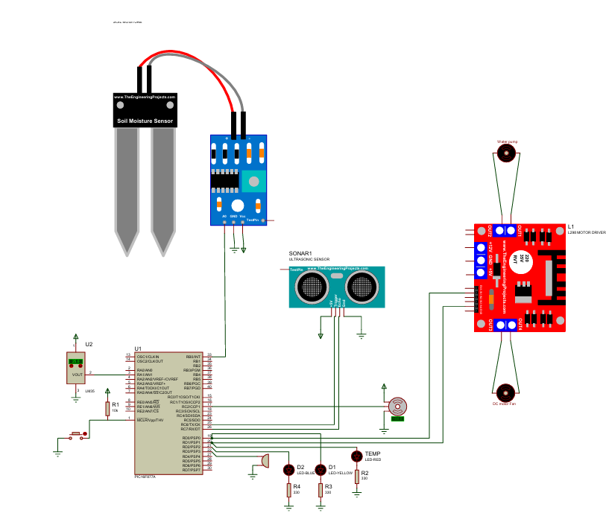

*Figure 1 EcoGrow Proteus design.*

## SOFTWARE DESIGN

The software for the automated greenhouse system is written in embedded C and deployed on the PIC16F877A microcontroller. Its core function is to continuously monitor sensor inputs and control actuators based on predefined logic, creating a responsive and autonomous greenhouse environment.

Sensor data acquisition is handled through both analog and digital inputs. The soil moisture sensor provides a digital signal to indicate dryness, while the LM35 temperature sensor sends analog voltage values that are converted to temperature readings using the ADC module. The ultrasonic sensor operates by sending a pulse via the trigger pin and measuring the time it takes for the echo to return, allowing the system to estimate water levels in the reservoir.

The main control logic is structured around real-time decision-making. When dry soil is detected, the microcontroller activates the water pump until adequate moisture is restored. If the temperature exceeds a certain threshold, the fan is turned on to help cool the environment. The vent is operated independently of temperature and opens or closes based on a timer, providing passive ventilation. Additionally, when the ultrasonic sensor detects a low water level, an LED is triggered to alert the user.

Pulse-width modulation (PWM) is used to control the servo motor responsible for opening and closing the vent. Timers are configured to maintain accurate delays and signal generation, ensuring consistent motor control and proper functioning of the ultrasonic sensor. All components operate within an infinite loop, allowing the system to maintain continuous monitoring and actuation without requiring manual resets or input.

The software is designed to be efficient, modular, and easily expandable. It prioritizes stable performance and low power consumption, making the system suitable for long-term deployment in a standalone greenhouse setup.

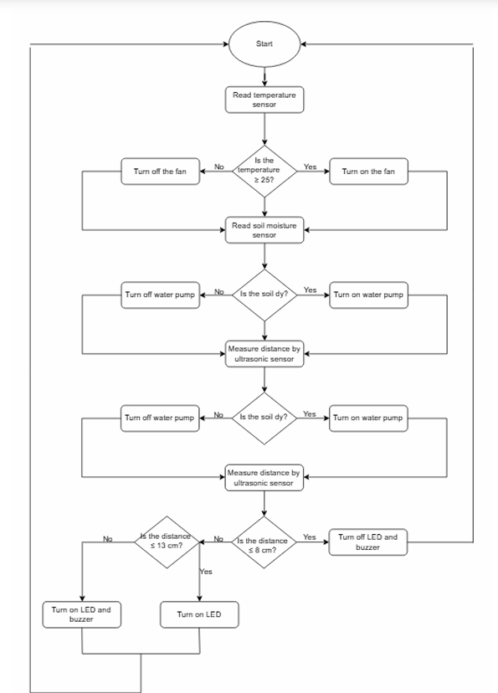

*Figure 2 EcoGrow flow diagram.*

# RESULTS

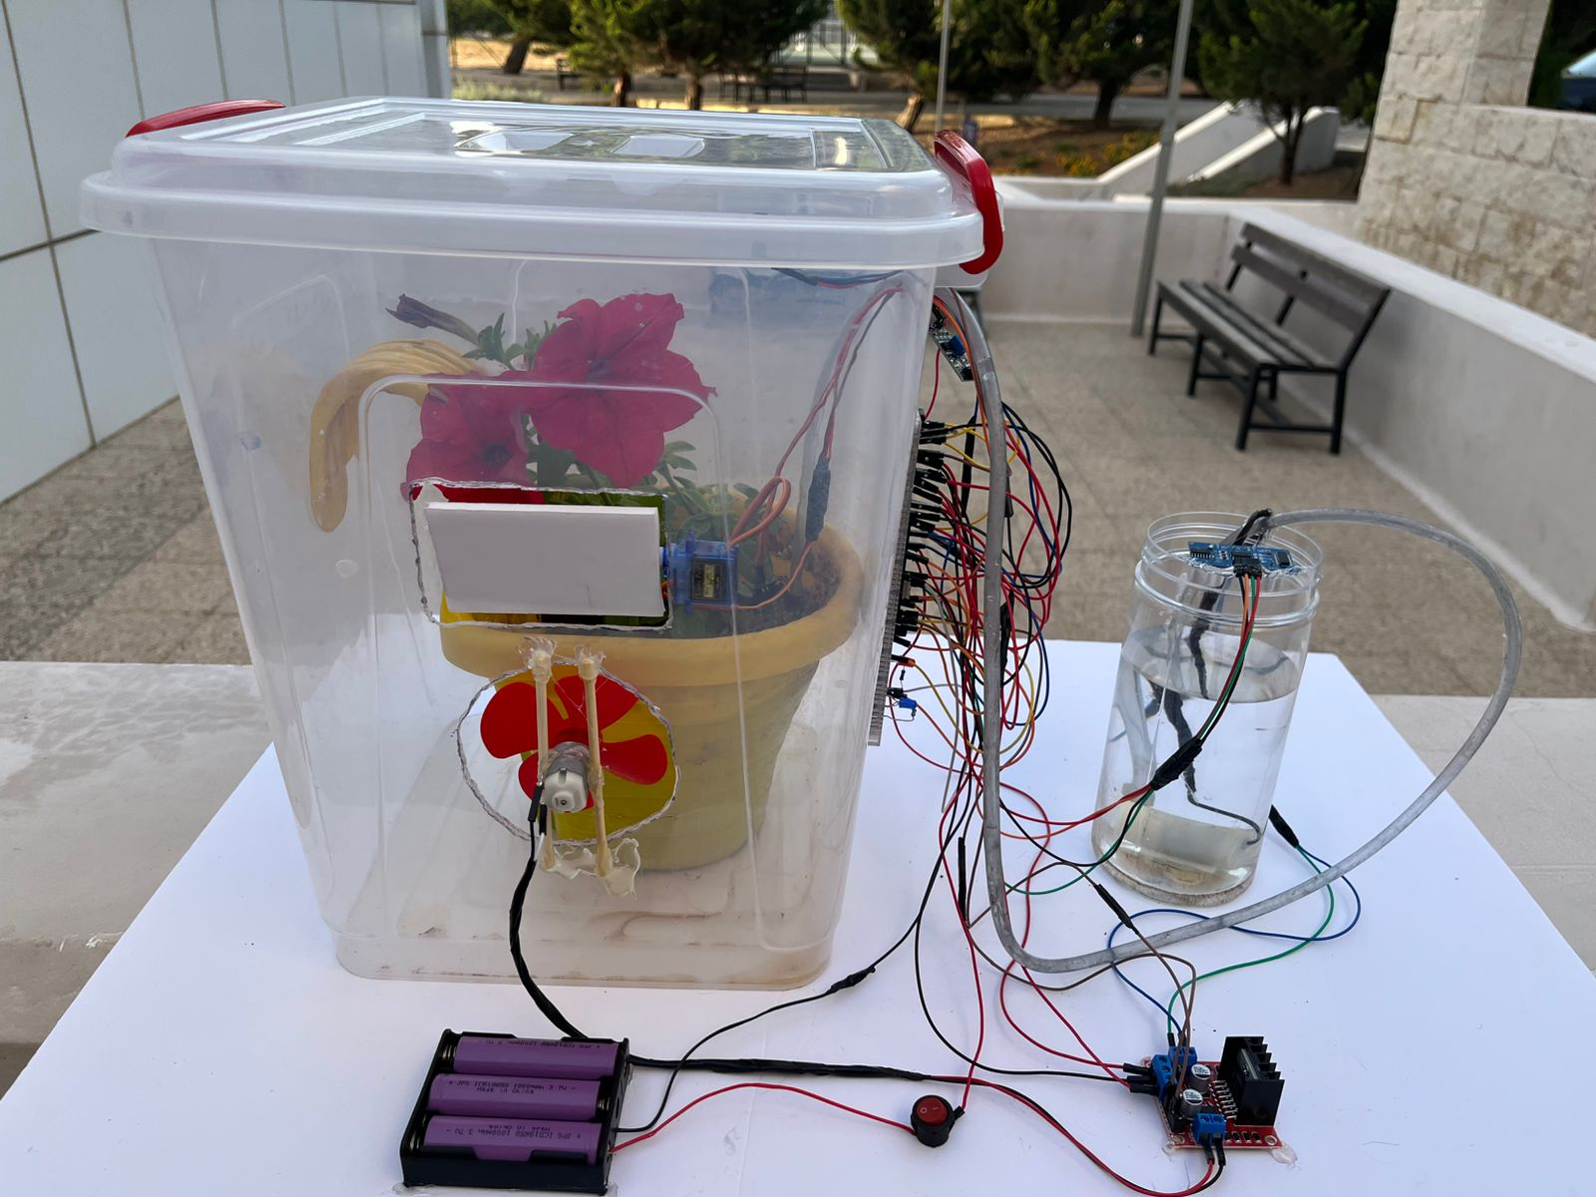The automated greenhouse system functioned as intended during testing, responding accurately to various environmental conditions. When the soil moisture sensor detected dryness, the microcontroller activated the water pump to irrigate the soil efficiently. The temperature sensor reliably triggered the fan when the ambient temperature rose above the threshold, helping to regulate internal conditions. The servo-controlled vent operated on a timed basis, opening and closing periodically to allow airflow. Additionally, the ultrasonic sensor successfully monitored the water reservoir level and lit an LED when the water level was too low. These coordinated operations confirmed the system's ability to maintain a stable growing environment with minimal human intervention.

*Figure 3 EcoGrow Final Design*

# PROBLEMS AND RECOMMENDATIONS

**Servo Motor Timing Conflicts**Issue: The timed operation of the servo motor occasionally interfered with other time-based tasks, particularly ultrasonic readings.  
 Recommendation: Use independent timers or restructure the code to allow non-blocking operations, ensuring stable multitasking.

**Unstable Ultrasonic Readings**

Issue: The ultrasonic sensor sometimes produced inconsistent results due to noise and signal timing issues.  
Recommendation: Implement a simple averaging algorithm to smooth readings and filter out noise for more reliable water level detection.

**LM35 Sensor Instability**Issue: The LM35 temperature sensor was difficult to manage and often produced unstable readings, especially due to slight current or voltage fluctuations.  
Recommendation: Add filtering capacitors and ensure stable power supply to improve accuracy, and implement software-based smoothing techniques to stabilize output.

# CONCLUSION

# The automated greenhouse system successfully demonstrated how embedded technology can be used to simplify and enhance agricultural processes. By integrating soil moisture detection, temperature monitoring, timed ventilation, and water level sensing, the system maintained key environmental conditions with minimal human input. Despite some challenges—particularly with LM35 sensor stability and power fluctuations—the system performed reliably in testing and proved effective for small-scale greenhouse automation. Moving forward, improvements such as better power regulation, optimized timing control, and enhanced sensor filtering could further increase the system’s reliability and scalability. This project provides a solid foundation for future development in sustainable and intelligent farming solutions.

# REFERENCES

**Research Paper – PIC16F877A Microcontroller in Greenhouse Automation**  
A scholarly article detailing the use of the PIC16F877A in greenhouse monitoring and control systems.  
<https://www.researchgate.net/publication/377890336_PIC16F877A_Microcontroller_Using_Automatic_Green_House_Monitoring_and_Controlling_System>

**HC-SR04 Ultrasonic Sensor Datasheet**  
Complete datasheet and specifications for the ultrasonic sensor used to detect water levels.  
<https://cdn.sparkfun.com/datasheets/Sensors/Proximity/HCSR04.pdf>

**LM35 Temperature Sensor Datasheet – Texas Instruments**  
Technical details of the LM35 analog temperature sensor used in your project.  
 <https://www.ti.com/lit/ds/symlink/lm35.pdf>

**PIC16F877A Microcontroller Datasheet – Microchip**  
Official datasheet providing electrical specs, pin configurations, and peripheral information for programming and circuit design.  
 https://ww1.microchip.com/downloads/en/DeviceDoc/39582b.pdf