**Build jar file**

**mvn clean package**

**Jar file created:**



**Make docker image**

**docker build -t saumya11031998/assignment .**

**docker login**

**give dockerhub username and it’s password**

**docker push saumya11031998/assignment**

**docker images**

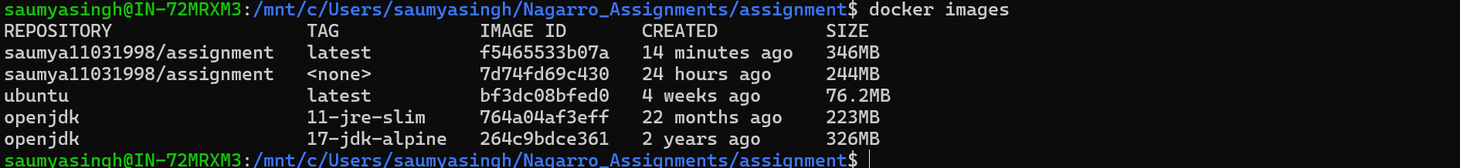

**docker run -p 9090:9090 saumya11031998/assignment**

**Api running**

