TRANSPORT AND TELECOMMUNICATION INSTITUTE


ENGINEERING FACULTY

Final report

Course: Software Engineering - I

Student: Ruvims Ungeitis
St. code: 84951
Group: 4301BNA

Riga
2026
Contents
Introduction 4
Project Goals 5
Architecture 6
Flow 6
Frontend 7
Backend 7
Command Pattern 8
Persistence Architecture 8
External Services 8
Deployment Architecture 9
Features 17
Authentication 17
Food Search 17
Barcode Lookup 17
AI Meal Analysis 17
The AI result includes: 17
Daily Nutrition Log 17
Dashboard 18
Weekly Calorie Chart 18
Delete Logged Foods 18
Demo Persistence 18
Error Handling 18
Engineering Decisions 19
React Native And TypeScript 19
FastAPI Backend 19
PocketBase For Development 19
localStorage For Deployed Demo 19
Command Pattern 19
External APIs 19
Defensive Data Handling 19
Demo Data Bypass 20
Knowledge Base 21
Testing 22
Frontend Testing 22
Backend Testing 22
Manual Testing 22
Testing Result 23
Deployment 24
Backend Deployment 24
Frontend Deployment 24
Deployment Limitations 24
Challenges 26
Connecting Multiple Parts 26
PocketBase Deployment 26
Food Data Inconsistency 26
PocketBase Number Validation 26
API And Deployment URLs 26
AI API Limitations 26
Keeping The MVP Simple 26
Lessons Learned 27
Limitations 28
Future Improvements 29
Conclusion 30

Introduction
In this project, I created an iOS and web application called Smart Nutrition & Fitness Tracker. It is an AI-powered nutrition tracking application designed to help users log food, monitor daily nutrition, and view simple progress information through an easy-to-use interface. The main goal of the application is to make food tracking faster and less complicated than traditional fitness apps. Users can search for food, view nutrition values such as calories, protein, carbohydrates, and fats, and track their daily intake through a dashboard and weekly calorie chart. The application was developed in Visual Studio Code. The frontend was built with React Native and TypeScript, while the backend was built with Python and FastAPI. During development, PocketBase was used for authentication and nutrition record persistence. For the deployed web demo, the app uses browser localStorage instead of a deployed PocketBase database. This allows users to register, stay signed in after refreshing the page, and save demo nutrition records directly in the browser. The original PocketBase-based authentication and persistence architecture remains in the project, but localStorage is used for the free web deployment. The application also includes AI-based meal analysis through an external AI API. However, because the API key used during development does not have paid access, the AI analysis feature may return an error in the deployed demo. This is documented as a project limitation.

Deployed frontend: https://smart-nutrition-fitness-tracker.onrender.com
Backend API: https://smart-nutrition-fitness-tracker-backend.onrender.com
GitHub repository: https://github.com/TheMozii/Smart-Nutrition-Fitness-Tracker

Project Goals
The main goal of this project was to build a working MVP of an AI-powered nutrition and fitness tracking application. The application was designed to help users log food, understand their daily nutrition intake, and view simple progress information.
- The specific project goals were:
- Create a simple and user-friendly food tracking application.
- Allow users to register and sign in.
- Allow users to search for food by name.
- Support barcode-based food lookup using Open Food Facts.
- Add AI-based text meal analysis for natural food descriptions.
- Display nutrition information, including calories, protein, carbohydrates, and fats.
- Allow users to add foods to a daily nutrition log.
- Calculate daily nutrition totals automatically.
- Show a dashboard with daily calories and macronutrients.
- Add an editable calorie goal.
- Display weekly calorie progress using a 7-day chart.
- Save user and nutrition data during development using PocketBase.
- Support a deployed web demo using browser localStorage instead of a deployed database.
- Keep the architecture simple, modular, and maintainable.
- Separate frontend, backend, database, and external API responsibilities.
- Use AI as an approximate estimation tool, not as medically accurate advice.
- Add basic tests for important frontend and backend logic.
- Deploy the application to the web for final demonstration.

Architecture
The Smart Nutrition & Fitness Tracker uses a layered full-stack architecture. The system is separated into frontend, backend, persistence, and external services. This separation makes the application easier to understand, maintain, and extend. The frontend is built with React Native and TypeScript. It handles the user interface, user input, dashboard, food logging screen, authentication screen, and progress visualization. The backend is built with Python and FastAPI. It handles API routes, food search, barcode lookup, and AI-based meal analysis. During development, PocketBase was used for authentication and nutrition record persistence. For the deployed web demo, browser localStorage is used instead of a deployed database. This allows users to register, stay signed in after refreshing the page, and save demo nutrition records directly in the browser. The system also connects to external services. Open Food Facts is used for food search and barcode data, while the OpenAI API is used for text-based AI meal analysis. AI nutrition values are treated as approximate estimates and are not intended to be medically accurate.
The system contains the following main parts:
- Frontend: React Native Expo application written in TypeScript.
- Backend: FastAPI application written in Python.
- Development database/authentication: PocketBase.
- Deployed demo persistence: browser localStorage.
- External food data: Open Food Facts API.
- AI service: OpenAI API.
- Deployment platform: Render.
The frontend communicates with the backend through HTTP API requests. The backend then communicates with external APIs when food or AI nutrition data is needed.

Flow
User
↓
React Native Expo Frontend
↓
Food Logging Module
↓
Reducer and Command Pattern
↓
Frontend Service Layer
↓
FastAPI Backend
↓
Food Service and Mapper
↓
Open Food Facts API / OpenAI API
This flow keeps the user interface separate from business logic and external API communication.

Frontend
The frontend is organized around feature modules. The most important module is the Food Logging feature. This module contains the logic for searching foods, analyzing meals, saving foods, loading saved foods, deleting records, and calculating nutrition totals.
Important frontend files include:
- frontend/src/app/index.tsx
- frontend/src/app/auth.tsx
- frontend/src/app/food-logging.tsx
- frontend/src/features/auth/
- frontend/src/features/food-logging/
- frontend/src/services/api.ts
The frontend separates responsibilities into:
- UI screens
- reducer logic
- hooks
- service functions
- types
- demo storage logic
This makes the code easier to test and update.

Backend
The backend is built with FastAPI. It exposes API endpoints for health checks, food search, barcode lookup, and AI text-based meal analysis.
Important backend files include:
- backend/app/main.py
- backend/app/api/routes/health.py
- backend/app/api/routes/food.py
- backend/app/services/food_service.py
- backend/app/domain/food/mapper.py
- backend/app/core/env.py
The backend separates route handling from service logic. Route files receive requests and return responses, while service files handle communication with external APIs and nutrition data processing. The mapper is used to normalize food data before it is sent back to the frontend.

Command Pattern
The Food Logging module uses the Command pattern. This means user actions are represented as commands before side effects happen.
Examples of commands include:
- FETCH_FOOD_BY_NAME
- FETCH_FOOD_BY_BARCODE
- ANALYZE_MEAL_TEXT
- SAVE_FOOD_TO_POCKETBASE
- LOAD_SAVED_FOODS_FROM_POCKETBASE
- LOAD_WEEKLY_TOTALS_FROM_POCKETBASE
- DELETE_FOOD_FROM_POCKETBASE
This pattern helps separate pure state changes from side effects such as API calls. The reducer updates the application state, while commands tell the service layer what external action should happen next.
This makes the food logging feature more maintainable because UI actions, state updates, and API calls are not mixed together.

Persistence Architecture
During development, PocketBase was used for authentication and nutrition persistence. PocketBase provided a simple way to create users, sign in, and save nutrition records without building a custom authentication backend.
For the deployed web demo, browser localStorage is used instead. This decision was made to keep the deployment free and avoid deploying a separate database service. In demo mode, users can register through the normal authentication form, stay signed in after refreshing the page, and save nutrition records in the browser.
The real PocketBase-based architecture remains in the project. The localStorage implementation is used only for the deployed demo.

External Services
The application uses two external services:
- Open Food Facts API
- OpenAI API
Open Food Facts is used to search for food by name and barcode. This allows the app to return nutrition information such as calories, protein, carbohydrates, and fats.
The OpenAI API is used for AI text-based meal analysis. Users can describe a meal in natural language, and the backend asks the AI service to estimate nutrition values. These values are approximate and should not be treated as medical or professional nutrition advice.

Deployment Architecture
The application was deployed using Render.
The backend is deployed as a Render Web Service. It runs the FastAPI server and exposes API endpoints for the frontend.
The frontend is deployed as a Render Static Site. It runs the exported Expo web application.
Render Static Site
Frontend Web App
↓
Render Web Service
FastAPI Backend
↓
External APIs
Open Food Facts / OpenAI
For the deployed demo, browser localStorage is used for user accounts and nutrition records. This allows the main functionality to work without deploying PocketBase.

Figures and Screenshots
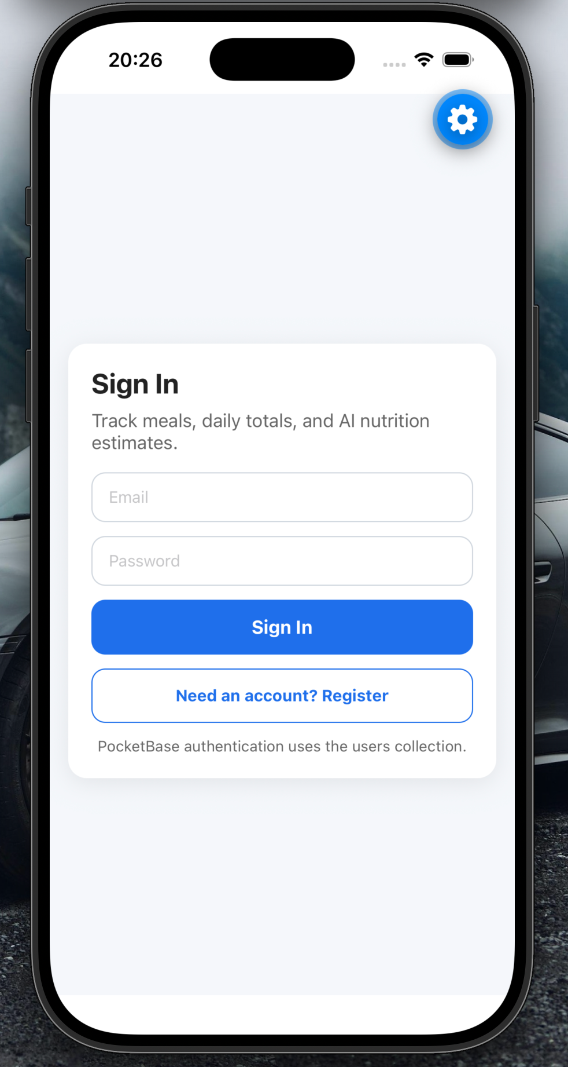
Pic 1 Sign In page
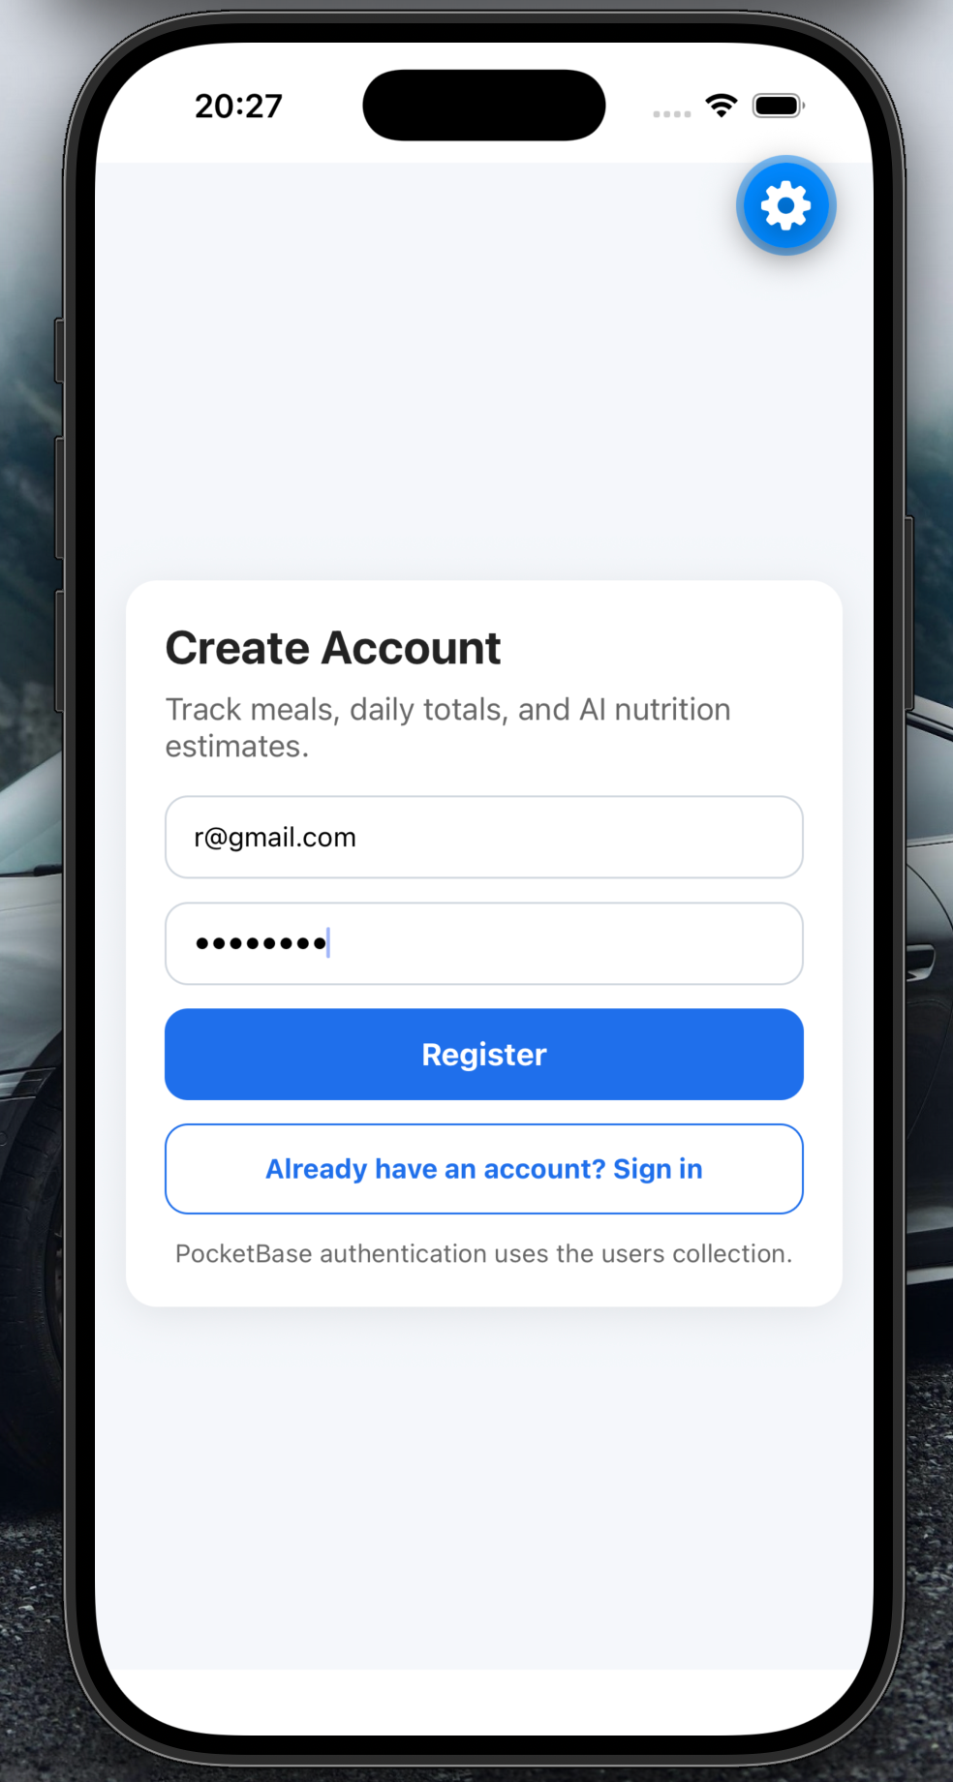
Pic 2 Create account page
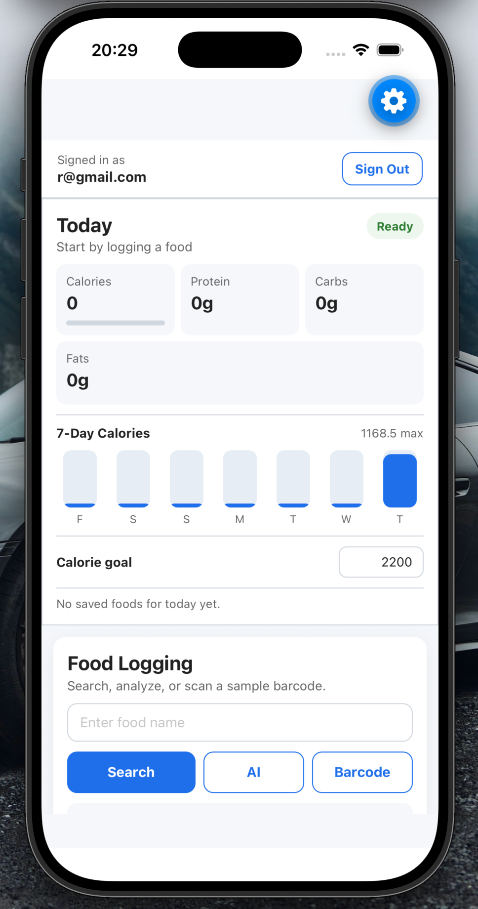
Pic 3 Top view of the app
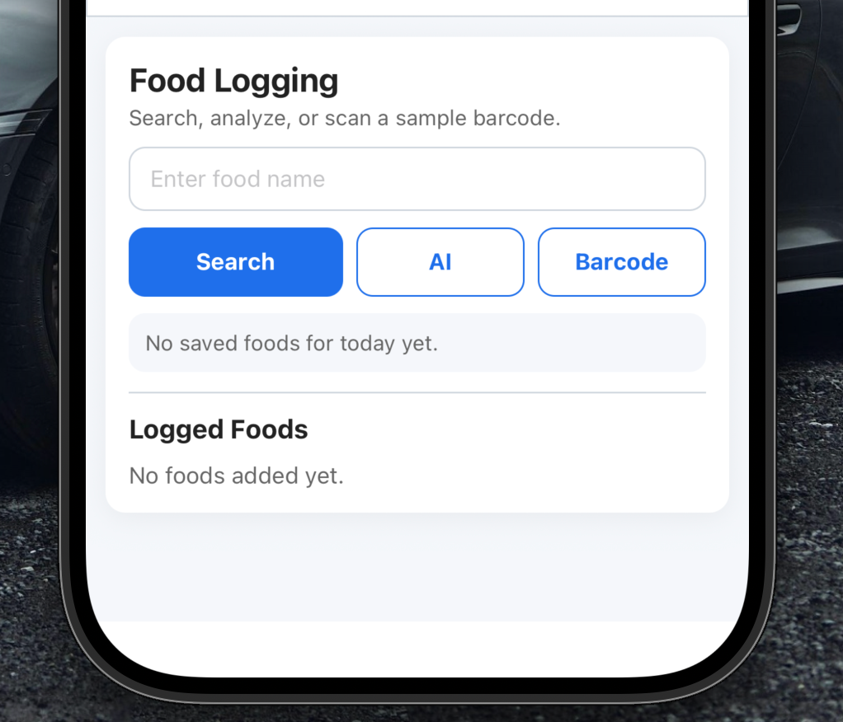
Pic 4 Bottom view of the app
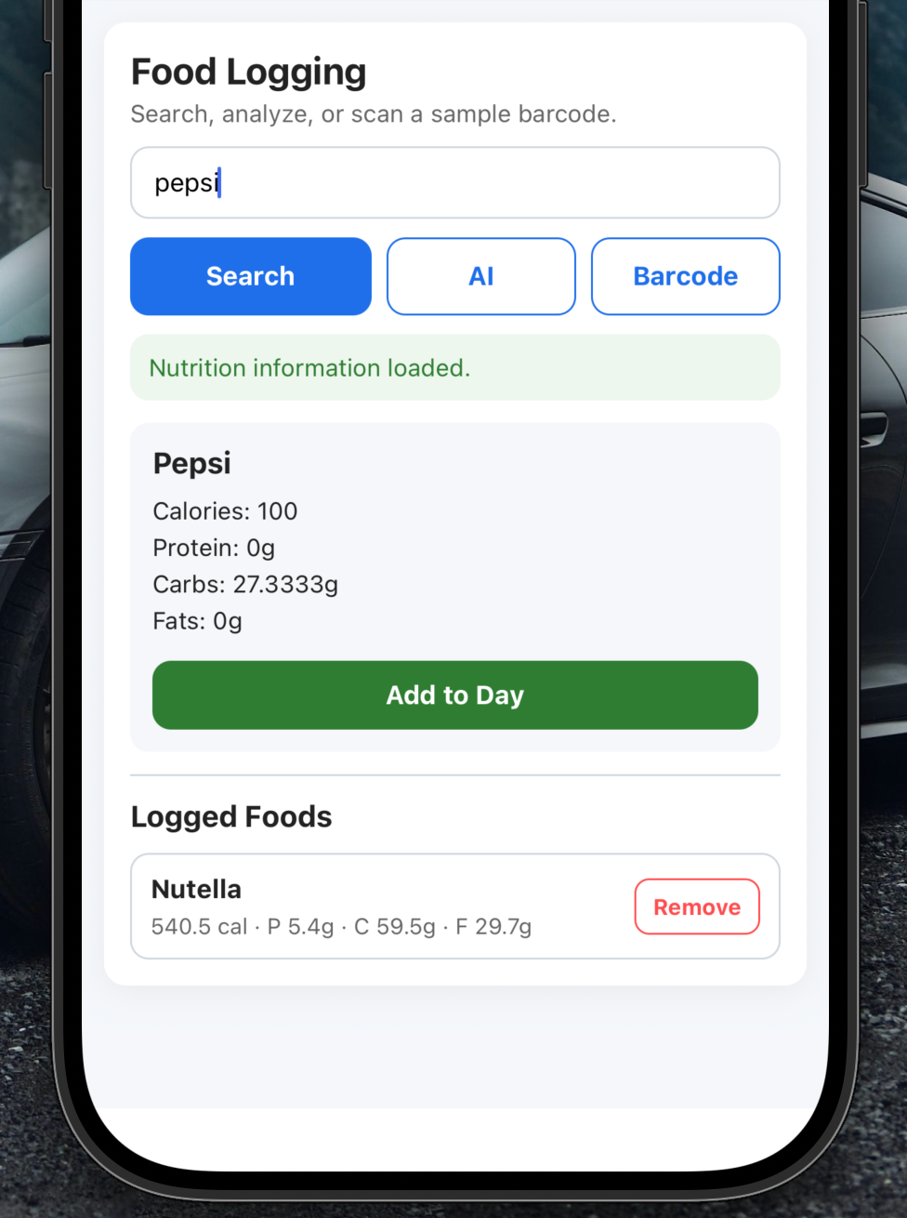
Pic 5 Searching for food by name
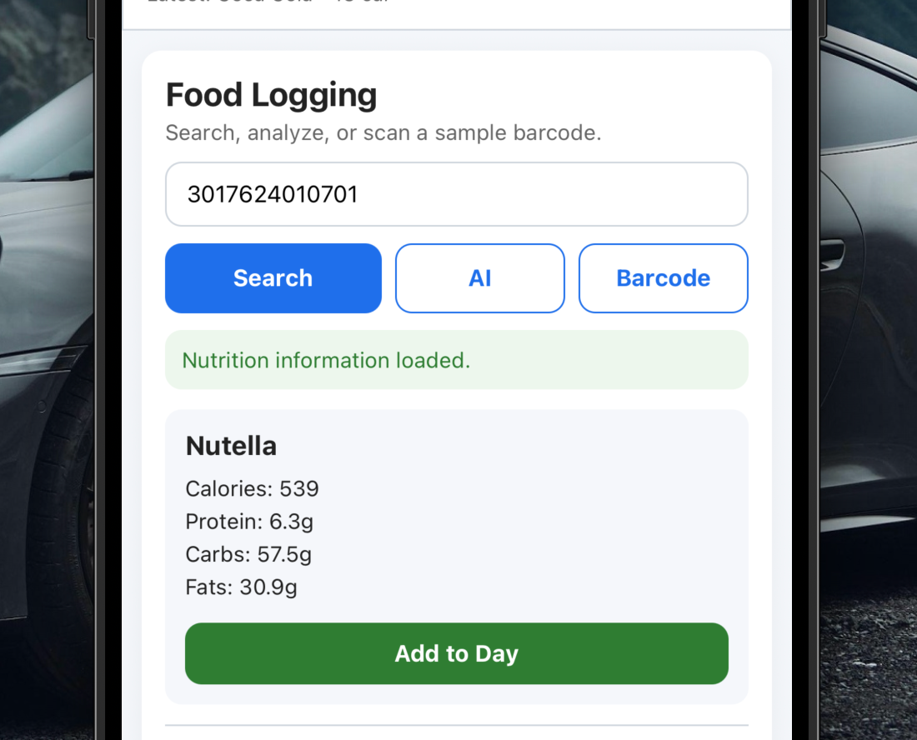
Pic 6 Searching for food by barcode
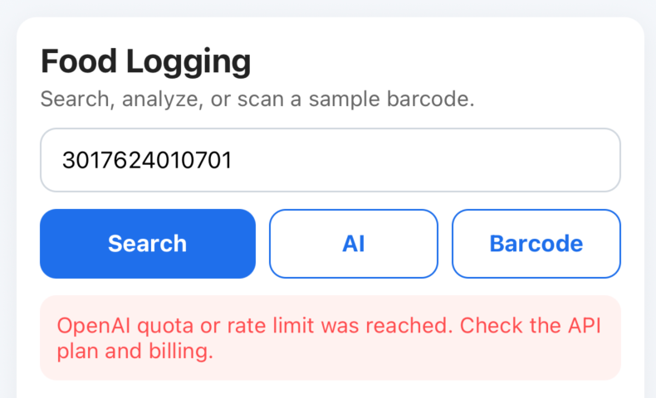
Pic 7 Trying to analyze with AI
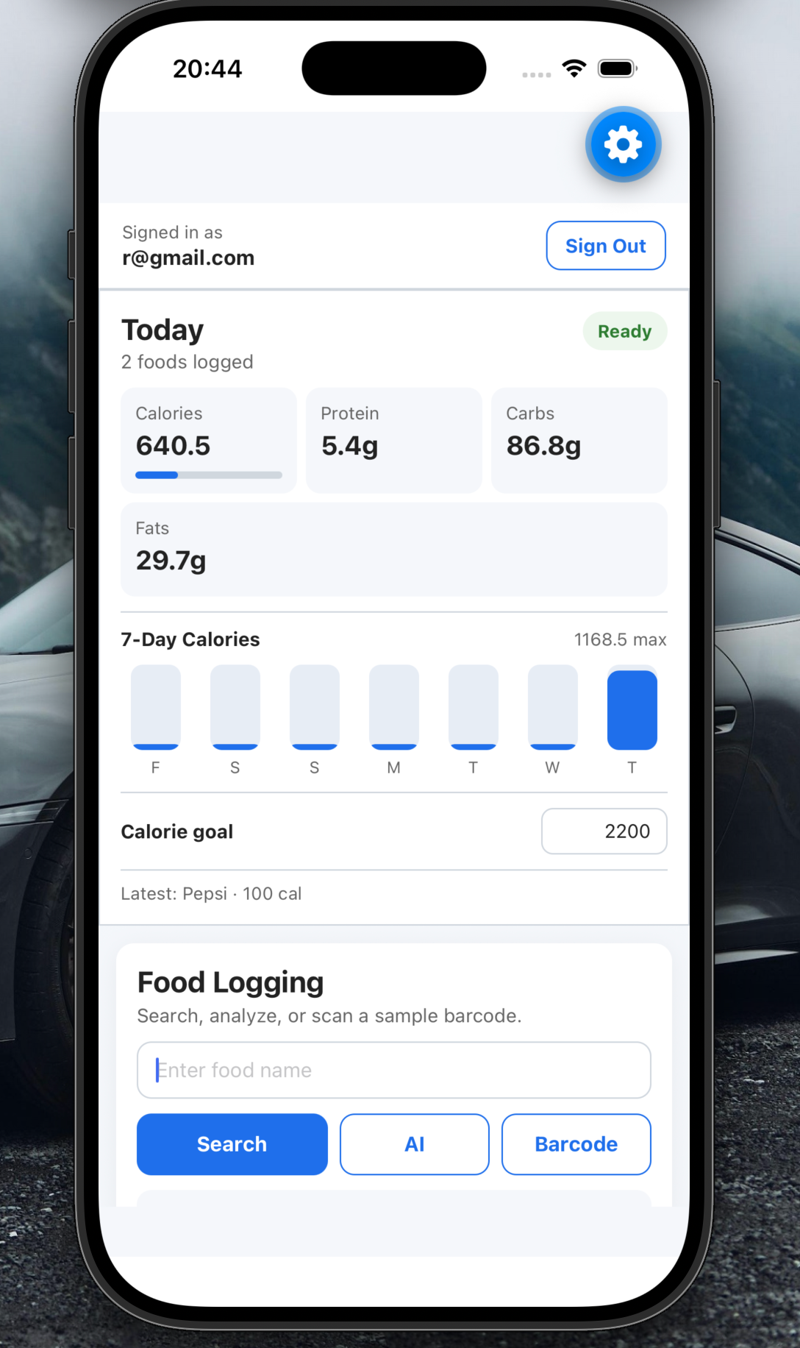
Pic 8 Changes in Table after logging food
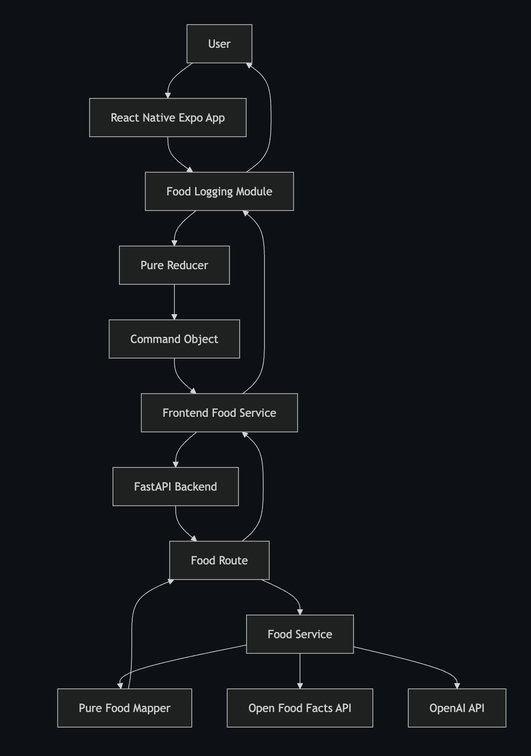
Pic 9 Architecture diagram
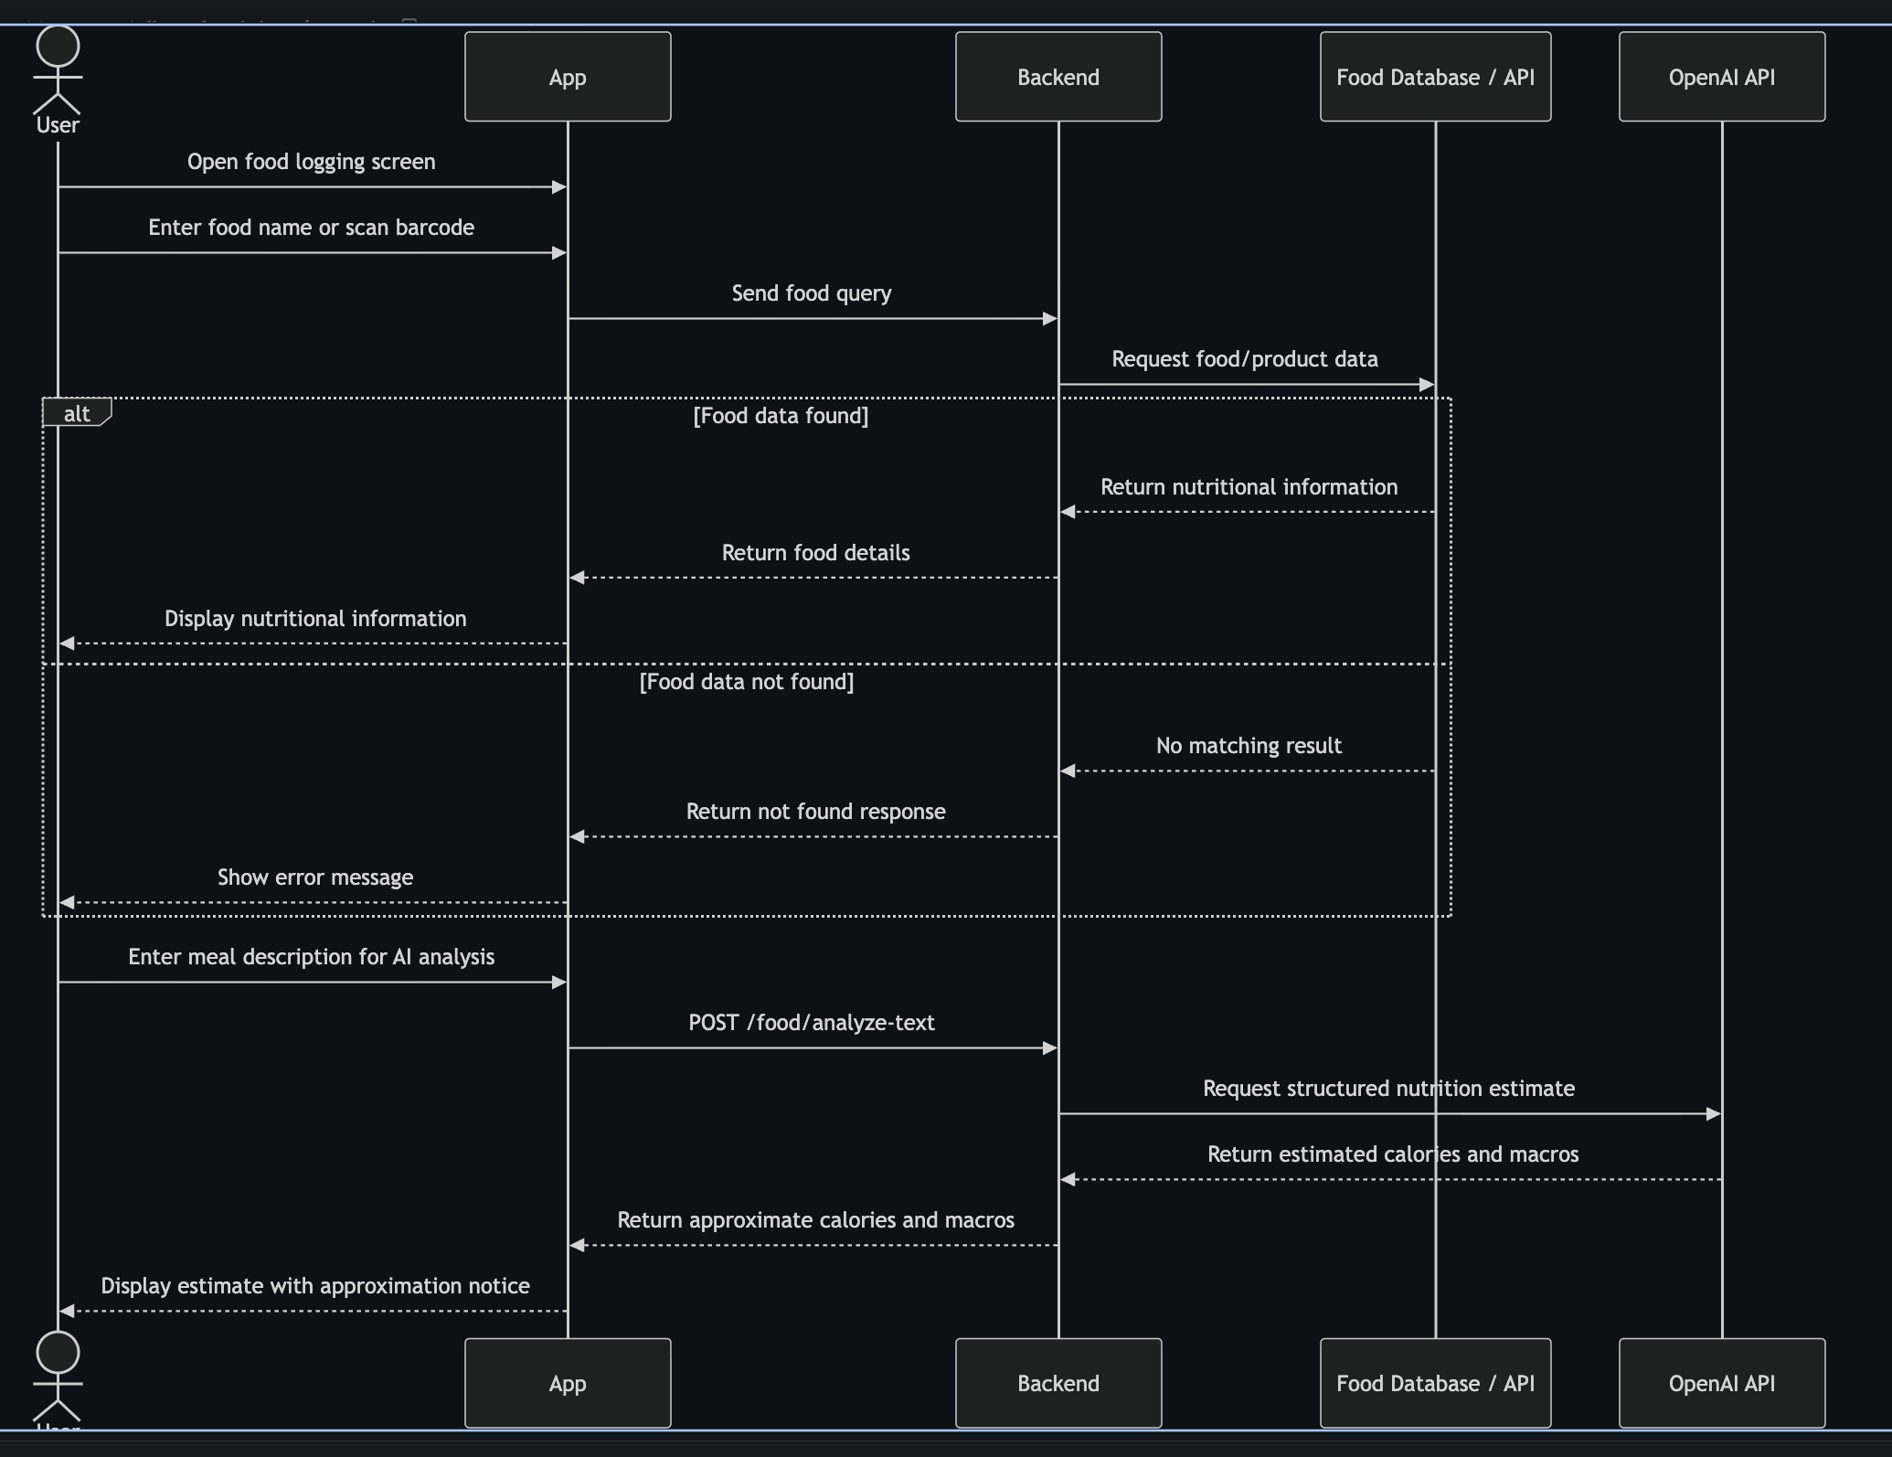
Pic 10 Food Logging Flow diagram

Features
The Smart Nutrition & Fitness Tracker MVP includes the core features needed for basic nutrition tracking and progress monitoring.

Authentication
The application includes a registration and sign-in screen. During development, authentication was handled with PocketBase. For the deployed web demo, browser localStorage is used instead, allowing users to register, stay signed in after refreshing the page, and test the app without a deployed database.

Food Search
Users can search for food by name. The frontend sends the search request to the FastAPI backend, which uses the Open Food Facts API to find nutrition data. The result shows calories, protein, carbohydrates, and fats.
For the deployed demo, some common foods are also available as local demo data if the external API does not return a result.

Barcode Lookup
The app includes a sample barcode lookup feature. This allows the user to test barcode-based food lookup using Open Food Facts product data.

AI Meal Analysis
Users can enter a natural meal description and request AI-based nutrition analysis. The backend sends the meal description to the OpenAI API and returns estimated nutrition values.
The AI result includes:
- calories
- protein
- carbohydrates
- fats
These values are approximate and should not be treated as medical advice.

Daily Nutrition Log
Users can add searched or AI-analyzed foods to their daily nutrition log. The app automatically calculates daily totals for calories and macronutrients.
After a food is added to the daily summary, the search field is cleared so the user can quickly enter another food.

Dashboard
The dashboard gives users a quick overview of their daily nutrition progress. It shows daily calories, protein, carbohydrates, and fats.
The dashboard also includes an editable calorie goal, allowing users to compare their current calorie intake against a target.

Weekly Calorie Chart
The app includes a 7-day calorie chart. This helps users see simple weekly progress and understand their calorie intake over time.

Delete Logged Foods
Users can remove foods from the daily nutrition log. When a food is removed, the daily totals and weekly chart are updated automatically.

Demo Persistence
For the deployed web version, user accounts, sign-in state, and nutrition records are stored in browser localStorage. This allows the main app functionality to work without deploying a separate PocketBase database.

Error Handling
The application displays clear error messages when something goes wrong, such as:
- backend unavailable
- food not found
- PocketBase unavailable
- OpenAI API key missing or invalid
This makes the app easier to test and understand during development and deployment.

Engineering Decisions
In this project, several engineering decisions were made to keep the application simple, maintainable, and suitable for an MVP.

React Native And TypeScript
React Native was used because it allows the app to work on both mobile and web. TypeScript was used to make the frontend code more reliable by adding type checking for components, services, reducers, and nutrition data.

FastAPI Backend
FastAPI was chosen for the backend because it is lightweight, simple to use, and works well for API-based applications. It allowed the project to expose clear endpoints for food search, barcode lookup, health checks, and AI meal analysis.

PocketBase For Development
PocketBase was used during development for authentication and nutrition record persistence. It provided a simple way to create users, sign in, and save nutrition records without building a custom database and authentication system from scratch.

localStorage For Deployed Demo
For the deployed web demo, browser localStorage was used instead of deploying PocketBase. This decision was made to keep the deployment free and simple. Users can register, stay signed in after refresh, and save demo nutrition records in the browser.

Command Pattern
The food logging module uses the Command pattern. User actions create commands, and those commands trigger side effects such as API calls or persistence actions. This keeps state updates separate from external operations and makes the feature easier to maintain.

External APIs
Open Food Facts was used for food and barcode nutrition data. The OpenAI API was used for AI meal analysis. AI values are treated as approximate estimates, not medical advice.

Defensive Data Handling
Some foods do not include complete nutrition data. Because of this, missing calories or macro values are safely handled instead of blocking the user. This improves the reliability of the food logging flow.

Demo Data Bypass
During development, the application used PocketBase for authentication and saving nutrition records. However, deploying PocketBase separately would add extra deployment complexity and could require paid or persistent hosting.
To keep the final web deployment simple and free, I added a demo persistence bypass using browser localStorage.
This bypass allows the deployed web version to work without a deployed PocketBase database.
The localStorage bypass handles:
- demo user registration
- demo sign-in
- keeping the user signed in after page refresh
- saving daily nutrition records
- loading saved nutrition records
- deleting logged foods
- updating the daily summary
- updating the weekly calorie chart
This means the deployed demo can still show the main MVP functionality even without a live database service.
The bypass does not remove the original PocketBase architecture. The real PocketBase authentication and persistence flow remains in the codebase and was used during local development.
The localStorage implementation is only used to make the deployed demo easier to run and test.
This decision helped keep the deployment free while still allowing users and evaluators to test the core application flow.
The main limitation is that localStorage is browser-based. Data is saved only on the user’s current browser and device. It is not shared across devices and should not be used as a production database.

Knowledge Base
A separate knowledge base was used during the project to document the engineering journey and important development decisions. The knowledge base helped track what was implemented, why decisions were made, what problems appeared, and what was learned during the project.
The knowledge base followed a structured format with separate areas for:
- inbox
- beliefs
- decisions
- experiments
- resources
- Synthesis
This structure made it easier to separate raw ideas, assumptions, final decisions, and implementation experiments.
During the project, knowledge base entries were created for several important steps, including:
- AI text-based food analysis
- PocketBase authentication
- PocketBase nutrition persistence
- loading saved nutrition records
- deleting saved nutrition records
- dashboard implementation
- weekly calorie chart
- core tests
- MVP stabilization
- food logging stabilization
The knowledge base was useful because it kept a record of the reasoning behind the project, not only the final code. For example, it documented why PocketBase was used during development, why browser localStorage was used for the deployed demo, and why missing nutrition values needed to be handled safely.
Using a knowledge base also helped with the final report because the report could be based on the actual development process, including completed experiments, trade-offs, limitations, and lessons learned.
Knowledge base repository: https://github.com/TheMozii/Knowledge-Base

Testing
Testing was added to make sure the main MVP features work correctly and to reduce the chance of breaking the food logging flow during changes.

Frontend Testing
The frontend tests focus on the food logging reducer. This reducer is important because it controls the main state changes for searching, saving, deleting, and calculating nutrition totals.
The frontend tests check that:
- Empty searches show a validation error.
- Searching by food name creates the correct command.
- Adding food creates a save command.
- Saved foods update the daily nutrition totals.
- Deleting food updates the daily totals.
- Weekly totals are stored correctly.
- The search field is cleared after food is added to the daily summary.
Frontend test command:
- cd frontend
- npm run test

Backend Testing
The backend tests focus on food mapping, service behavior, and API routes.
The backend tests check that:
- Food data is mapped correctly.
- Missing nutrition values default safely.
- Food not found responses are handled.
- AI text analysis validates missing input.
- Missing OpenAI API key returns a clear error.
- Health route works correctly.
- API error responses are mapped correctly.
Backend test command:
- cd backend
- python3 -m unittest discover -s tests

Manual Testing
Manual testing was also used to verify the full user flow:
- Register a user.
- Sign in.
- Search for food.
- Add food to the daily summary.
- Confirm the search field clears after adding.
- Confirm daily totals update.
- Remove a logged food.
- Confirm totals update again.
- Refresh the page.
- Confirm the demo user session persists.
- Confirm saved demo foods remain available.

Testing Result
Both frontend and backend tests passed successfully.
- Frontend tests: passed
- Backend tests: passed
- Manual MVP flow: tested

Deployment
The application was deployed to the web using Render. Render was used because it allows both frontend and backend deployment and provides a free option suitable for an MVP demo.
The project was deployed as two services:
- Frontend: Render Static Site
- Backend: Render Web Service

Backend Deployment
The backend was deployed as a Render Web Service. It runs the FastAPI application and provides API endpoints for food search, barcode lookup, AI meal analysis, and health checks.
Backend settings:
- Root Directory: backend
- Build Command: pip install -r requirements.txt
- Start Command: python3 -m uvicorn app.main:app --host 0.0.0.0 --port $PORT
The backend exposes routes such as:
- /health
- /food/search
- /food/barcode/{barcode}
- /food/analyze-text

Frontend Deployment
The frontend was deployed as a Render Static Site. The Expo React Native web version was exported and hosted as a static web application.
Frontend settings:
- Root Directory: frontend
- Build Command: npm install && npx expo export --platform web
- Publish Directory: dist
Frontend environment variable:
EXPO_PUBLIC_API_URL=https://smart-nutrition-fitness-tracker-backend.onrender.com
Demo Persistence In Deployment
PocketBase was not deployed separately for the final web demo. Instead, the deployed version uses browser localStorage for user accounts, sign-in state, and nutrition records.
This allowed the project to stay free to deploy while still showing the main MVP functionality.

Deployment Limitations
There are some limitations in the deployed version:
- Render free backend services may sleep after inactivity.
- The first backend request may be slow while the service wakes up.
- localStorage data only exists in the current browser.
- PocketBase is not used in the deployed demo.
- The OpenAI feature may fail if the API key is missing, invalid, or unpaid.
- AI nutrition estimates are approximate and not medically accurate.

Challenges
Several challenges appeared during the development and deployment of the project.

Connecting Multiple Parts
The application has a frontend, backend, database, and external APIs. Making these parts work together required careful handling of API URLs, environment variables, and data formats.

PocketBase Deployment
PocketBase worked well during local development, but deploying it separately would add more complexity. To keep the final deployment free and simple, browser localStorage was used for the deployed demo.

Food Data Inconsistency
Some foods from external APIs do not include complete nutrition data. For example, some products may have missing protein, carbohydrates, or fats. This caused issues when saving records, so the app was updated to safely handle missing values.

PocketBase Number Validation
PocketBase required number fields can reject zero values. This caused errors when foods had 0 or missing macro values. To fix this, a migration was added so nutrition number fields could be optional.

API And Deployment URLs
During deployment, the frontend API URL had to be configured correctly. A trailing slash in the backend URL caused double-slash API requests, so URL normalization was added.

AI API Limitations
The AI meal analysis feature depends on an OpenAI API key. If the key is missing, invalid, or unpaid, the feature returns an error. This was documented as a limitation of the deployed demo.

Keeping The MVP Simple
There were many possible features to add, such as image recognition, advanced charts, and full production database hosting. The challenge was keeping the project focused on the MVP scope and avoiding unnecessary complexity.

Lessons Learned
This project helped me understand how to build a full-stack application that connects a frontend, backend, database, and external APIs.
One important lesson was the value of separating responsibilities. The frontend handles the user interface, state, and user interactions, while the backend handles API routes, food lookup, barcode lookup, and AI meal analysis. This made the system easier to understand and maintain.
I also learned that external nutrition data is not always complete. Some food records may be missing values such as protein, carbohydrates, or fats. Because of this, the application needs to handle missing data safely instead of blocking the user.
Another lesson was that deployment can affect engineering decisions. PocketBase worked well during local development, but deploying it separately would make the final demo more complex. Using browser localStorage for the deployed version allowed the main features to work while keeping deployment free.
I learned that environment variables are important for deployed applications. The frontend needs the correct backend API URL, and the backend needs API keys for services such as OpenAI.
Testing was also important. Frontend reducer tests and backend tests helped confirm that food logging, nutrition totals, and API behavior continued to work after changes.
Finally, I learned that AI features must be presented carefully. AI nutrition estimates can make food logging faster, but they are approximate and should not be treated as medical advice.

Limitations
Although the project implements the main MVP functionality, it still has several limitations.
The AI meal analysis feature depends on an external OpenAI API key. If the key is missing, invalid, or unpaid, the AI feature may return an error in the deployed demo.
AI-generated nutrition values are only approximate. They should not be treated as medically accurate or used as professional nutrition advice.
The deployed web version uses browser localStorage instead of a real deployed database. This means user accounts and nutrition records are stored only in the current browser and device. Data is not shared across devices and can be lost if browser storage is cleared.
PocketBase was used during development, but it was not deployed as part of the final web demo. A production version would need a real hosted database and authentication system.
Food search depends on the Open Food Facts API. Some foods may not be found, and some products may have incomplete nutrition data.
The barcode feature uses a sample barcode flow. It is useful for testing, but it is not a full camera-based barcode scanner in the deployed web version.
The application is an MVP, so it does not include advanced features such as image-based food recognition, detailed meal history, advanced analytics, mobile app store deployment, or integration with fitness devices.
The Render free backend may sleep after inactivity, so the first request can be slow while the backend wakes up.

Future Improvements
In the future, the application could be improved by replacing the deployed localStorage demo persistence with a real hosted database. This would allow user accounts and nutrition records to be stored permanently and accessed across different devices.
PocketBase could be deployed with persistent storage, or the project could be migrated to Supabase as originally planned. This would make authentication and nutrition tracking more suitable for production use.
The food logging feature could also be improved with a full camera-based barcode scanner. This would make barcode lookup faster and more realistic on mobile devices.
Another improvement would be image-based food recognition. Users could take a photo of a meal, and the app could estimate nutrition values from the image. This feature was not included in the MVP because it would add more complexity.
The dashboard could be expanded with more detailed analytics, such as weekly macronutrient charts, meal history, calorie trends, and goal progress over longer periods.
The app could also include editable user goals, such as calorie targets, protein goals, weight goals, and fitness objectives.
Testing could be improved by adding end-to-end tests that simulate the full user flow in the browser, including registration, food logging, saving, deleting, and refreshing the page.
Finally, the application could be prepared for real mobile deployment through iOS and Android builds, allowing users to install it as a mobile app instead of only using the web demo.

Conclusion
The Smart Nutrition & Fitness Tracker project successfully demonstrates a working MVP of an AI-powered nutrition tracking application. The app allows users to register, search for foods, analyze meals with AI, add foods to a daily summary, view nutrition totals, and track weekly calorie progress. The project combines several technologies, including React Native, TypeScript, FastAPI, PocketBase, browser localStorage, Open Food Facts, OpenAI API, and Render deployment. Together, these technologies helped create a full-stack application with both frontend and backend functionality. During development, I learned how to structure a full-stack project, connect a frontend to a backend API, use external services, handle incomplete nutrition data, and deploy an application to the web. I also learned how important error handling, testing, and clear architecture are when building a maintainable application. The deployed version uses browser localStorage instead of a deployed PocketBase database to keep the demo free and simple. This allowed the core functionality to remain testable while keeping the original PocketBase architecture in the project for future improvement. Artificial intelligence was also used during the development and reporting process. AI tools were also used to support debugging, documentation, and report writing, while final decisions and implementation were reviewed and adapted by me. However, the final project decisions, testing, and implementation were reviewed and adapted to fit the project requirements.
Overall, the project meets the assignment goal by bringing the application into a usable web demo and documenting the engineering journey from architecture and implementation to testing and deployment.

