**Complex Engineering Activity**

**Design of Machine Elements and CAD/CAM (MCT 311L)**



**Design and Modelling of Product Sorting Conveyor**

**Submitted by:**

Hurraira Adrees Roll No: 2021-MC-01

Muhammad Saad Yaseen Roll No: 2021-MC-37

Muhammad Rafay Roll No: 2021-MC-39

**Submitted to:**

Miss Amina Younis

**Department of Mechatronics & Control Engineering**

**University of Engineering & Technology, Lahore.**

January 2024

Table of Contents

Abstract: 2

Introduction: 2

Project Description: 2

Research Done: 2

Important Features: 3

Figure: 3

Views of Parts: 4

Methodology: 5

Assumptions: 5

Conveyor Belt Parameters: 5

Power Drive System: 6

Power Transmission System: 6

SolidWorks Static Simulation: 8

Complete System Simulation: 9

Future Recommendations: 9

Problems Faced: 9

References: 10

Contribution Table: 10

# 

# Belt Conveyor System, Automatic Product Sorting

# Abstract:

The following complex engineering exercise offers students a chance to demonstrate their ability to create solutions for real-world industrial applications. The students were instructed to select an industrial conveyor system and then design the power transmission system for it using the lab and theory skills they had learned in Design of Machine Elements classes, considering the application requirements.

A conveyor belt is the carrying medium of a belt conveyor system. A belt conveyor system is one of many types of conveyor systems. A belt conveyor system consists of two or more pulleys, with a closed loop of carrying medium, the conveyor belt rotates about them.

# Introduction:

## Project Description:

We have chosen **Automatic Product Sorting**, which, in an industry, uses conveyors to send packages of different sizes or weights to another conveyor using sensors. These boxes specify Chips and Snacks industry that have different snacks in different prices and different carton sizes. We selected this industrial application because in the industry, various conveyors receive packages of different sizes, and sorting them manually is not an easy task. Therefore, to reduce manual effort, automate processes, and save time, we opted for this application. These packages will further proceed to be assembled in the inventory, making it easier to deliver them later. We utilized a motor in this setup and connected it with a belt-pulley system so that it can effectively drive our conveyor. Additionally, we constructed three separate conveyors to ensure that each size of the package can smoothly shift to its designated conveyor, maintaining its original size.

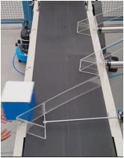

Figure . Industrial Example o Product Sorting conveyor

## Research Done:

The product that was selected for the conveyor system has three boxes at a time at conveyor.

**Box 1:**

Weight= 720gram = 1.5873 lb

Dimension (L x W x H) = 24x20x20 inches3

**Box 2:**

Weight= 1080gram = 2.3809 lb

Dimension (L x W x H) = 24x12x10 inches3

**Box 3:**

Weight= 960gram = 2.1164 lb

Dimension (L x W x H) = 17x14x7 inches3

Total weight in lb = 6.3492 lb

Total weight in grams= 2760gram



Figure . Box Package.

## Important Features:

Some of the important features needed to be taken into consideration of the design are as follows:

* No of boxes on the belt at the time must be known i.e. 3.
* Linear speed of the belt is adjustable.
* Weight of the belt and boxes is incorporated.
* Electric Motor is used as the power drive system.
* Belt-Pulley are used as the power transmission system.

## Figure:

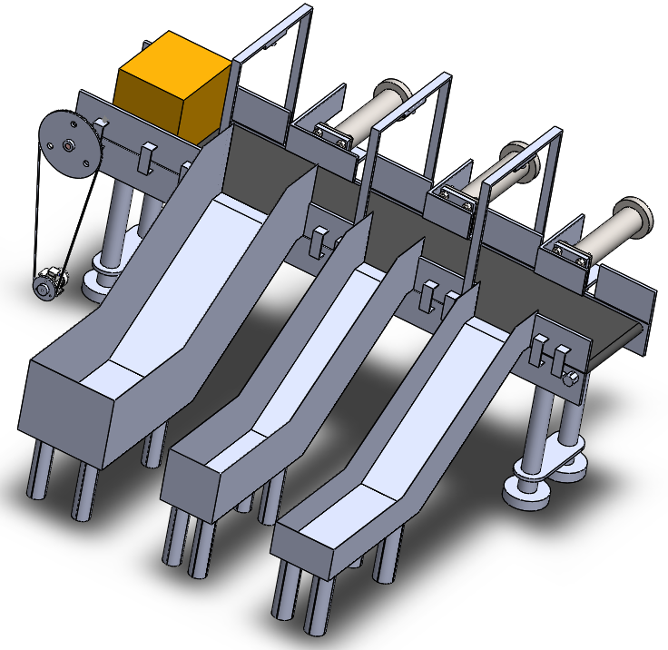

Figure : Product Sorting Conveyor

## Views of Parts:

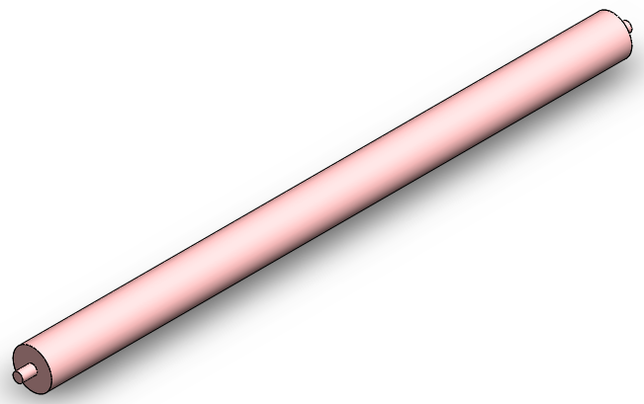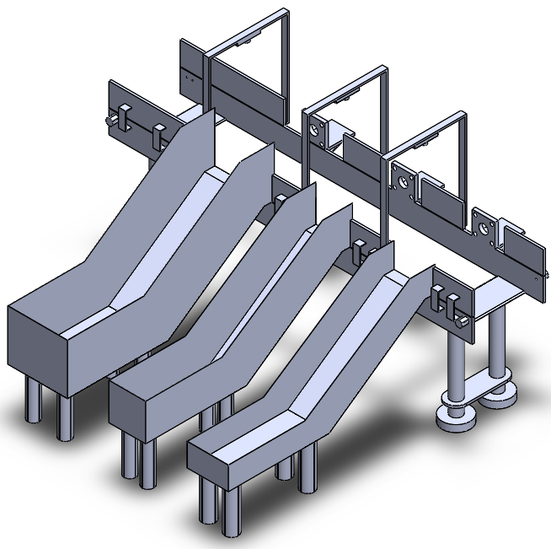

Figure : Conveyor

## 

Figure 5: Roller

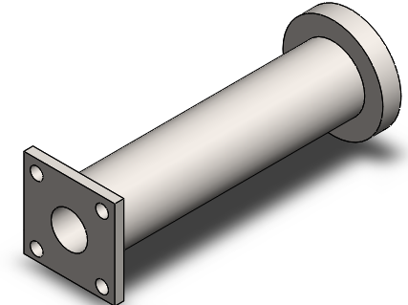

Figure 7: Actuator

## 

Figure 6: Belt

## 

Figure 8: Motor

## 

Figure 9: Plunger

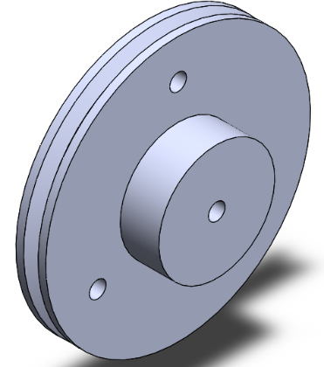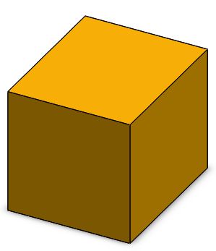

Figure 10: Box

# Methodology:

Figure 11: Sprocket

## Assumptions:

* Box 1 Dimensions: 24 x 20 x 20 inches3

• Box 2 Dimensions: 24 x 12 x 10 inches3

• Box 3 Dimensions: 17 x 14 x 7 inches3

• Total Weight: 6.3492 lb.

• Capacity: Maximum 5 boxes

• Belt Width: 30 inches

• Belt Thickness: 0.08 inches

• Minimum Roller Diameter: 2 inches

• Length of Conveyor: 158 inches

• Belt speed: 65 fpm (100 rpm)

• Motor Speed: 290 rpm (151.8 fpm)

• Torque of Conveyor: 95.445 lb.in

• Torque of Motor = 82.55 lb.in

• Material: Nitrile Rubber (Density: 0.08115635 lb/ft3)

## Conveyor Belt Parameters:

The Box has longer dimension of 24inches, so the width of conveyor is 30 inches. According to Standard Belt Conveyor M1950-ED, conveyor has length of 4000mm = 157.48 inches = 158 inches . The belt speed linear speed was found using motor speed. Made up of Nitrile Rubber of density 0.08115635 lb/ft3 The specifications of the belt are given as follows:

)

## Power Drive System:

The calculations for the selection of motor are given as follows:

Thus, the selected motor have the following ratings. It has Rated speed of 290 rpm. Rated power is 1.1kW as we need 0.456 hp only. So, it is well within the required range.

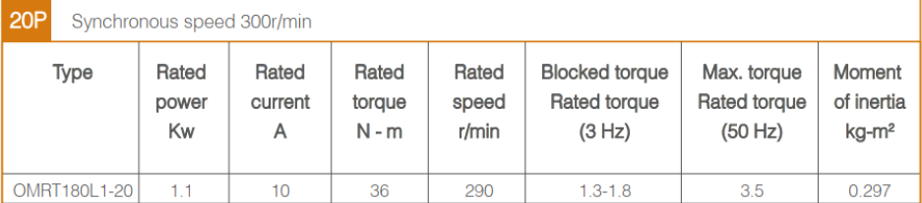

Figure 12: Motor Selection

## Power Transmission System:

The design steps and calculations are taken from the Book “Machine Elements in Mechanical Design”, 6th Edition written by Robert L. Mott. A V-Belt with Pulley system is incorporated and attached with the motor that further drives the conveyor belt and rolls on the rollers. The calculations of the V-Belt drives are given as follows:

As the conveyor is light, and works for 15 hours, so it has a Service factor of 1.2 only.

From Figure 7-13, the belt drive selected is **3V** belt.

For driving Sheave, let Vb = 1000 ft/min.

The trial sizes are calculated for input sheave and compute the actual ratio and output speed.

|  |  |  |  |
| --- | --- | --- | --- |
| Standard D1 | Approximate D2( 2.9*D1) | Nearest Standard D2 | Actual Output Speed |
| 13.95 | 40.45 | 33.45 | 120 rpm |
| 10.55 | 30.59 | 33.45 | 91.21 rpm |
| 7.95 | 23.05 | 24.95 | 92.4 rpm |
| **6.85** | **19.865** | **18.95** | **104.82 rpm** |

Corrected Belt Speed =

For Rated Power, check the line of 870rpm in figure 7-14 and interpolate for 290rpm.

From Figure 7-17, add the power 0.33hp that is interpolated at 2.9 V.R.

Center Distance Range:

Nearest Standard Length for 3V Belt = L = 132 in

For Actual CD,

Angle of Wrap,

From figure 7-18,

From figure 7-19

For number of Belts in V-Belt Drive,

So, We can use only one V-Belt Drive for this system.

**Summary:**

Input: Electric motor, 1.4745 hp at 290 rpm

Service factor: 1.2

Design power: 1.8 hp

Belt: 3V cross section, 132-in length, 1 belt

Sheaves: Driver, 6.85-in pitch diameter, 3V. Driven, 18.95-in pitch diameter, 3V

Actual output speed: 104.82 rpm

Center distance: 45.34 in

# SOLIDWORKS Static Simulation:

A Static Simulation of Power Transmission System is shown as:

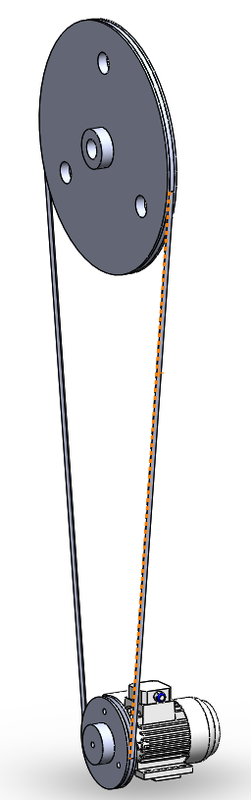

Figure 13: Belt Pulley System

# Complete System Simulation:

The final 3D model of the product sorting conveyer system is shown below:

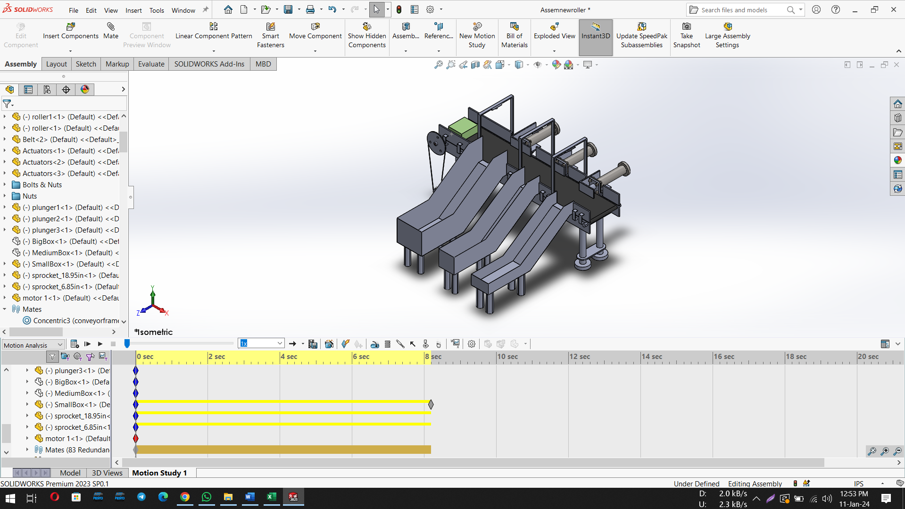

Figure 14: Final 3D Model

# Future Recommendations:

* Gears with different modules and design requirements can be used as power transmission systems to further improve the conveyor system speed.
* Chain drives can also be explored in terms of learning aspects.
* The contacts and gravity feature can be explored for a more complex motion analysis.
* Teach more tools that are used in Semester Projects for more clarity.
* A standardized electrical system and transmission system could be used to further automate the conveyor system.

# Problems Faced:

* Making a belt conveyor was a new task so had to take help from YouTube tutorials.
* Incorporating motor drive system and shafts for which online research helped.
* Exploring standard sizes of components used so we can be as close as possible to the practical application.
* Complex designs and then its assembly and motion analysis was difficult to make.
* SolidWorks is a tool requiring high specifications of a device because increasing the features would slow the computer and important files will crash.

[1-8]

# References:

1. *Conveyor Belt*. 2024 31-10-2023 [cited 2024 10-01-2024]; Available from: <https://en.wikipedia.org/wiki/Conveyor_belt>.

2. Fun, S. *Solidworks tutorial: Simple Belt Conveyor Design Assembly and Motion Study*. 2024 [cited 2024 10-01-2024]; Available from: <https://www.youtube.com/watch?v=yPrzRc3g_xc&t=416ss>.

3. DESIGN, M.M. *MASTER || Belt Conveyor Design | PART 02 | How To Design Belt Conveyor in Solidworks*. 2024 [cited 2024 10-01-2024]; Available from: <https://www.youtube.com/watch?v=oLRZr5a5Bdk>.

4. TUTORIALS, C.C.C. *SOLIDWORKS TUTORIAL #23 || Design a V belt and pulley assembly with motion analysis in solidworks.* 2024 [cited 2024 10-01-2024]; Available from: <https://www.youtube.com/watch?v=p3YAdqpPxxI&t=153s>.

5. Design, M.M. *Mastering Belt Conveyor Motor Selection and Calculation: Ultimate Guide*. 2024 [cited 2024 10-01-2024]; Available from: <https://www.youtube.com/watch?v=p4qzQi-DQlY>.

6. Fun, S. *Product sorting conveyor design using proximity sensor in solidworks*. 2024 [cited 2024 10-01-2024]; Available from: <https://www.youtube.com/watch?v=Bk8mNvNQ6T4&list=PL8pFbI7LGu70N6OaVx0FXEH5Q386ilHuP&index=28>.

7. *Conveyors & Automated Handling Solutions*. 2024 [cited 2024 10-01-2024]; Available from: <https://www.monk-conveyors.com/>.

8. *CATALOGO OMRT ROLLER TABLE*. 2024 [cited 2024 10-01-2024]; Available from: <https://www.omemotors.com/media/catalogo/en/CATALOGO%20OMRT%20ROLLER%20TABLE.pdf>.

# Contribution Table:

|  |  |  |  |
| --- | --- | --- | --- |
| **Registration no** | **Mathematical Design** | **Simulations** | **Project Report Writing** |
| 2021-MC-01 | 35% | 35% | 25% |
| 2021-MC-37 | 35% | 30% | 30% |
| 2021-MC-39 | 30% | 35% | 45% |