Title: Detecting False Positives in Identity-Related Security Attacks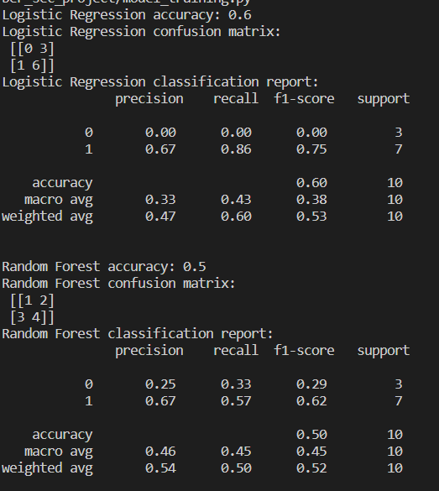

Summary: The goal of this project was to develop a proof-of-concept for detecting false positives in identity-related security attacks. The main tasks were to create a dataset, preprocess the data, perform feature engineering, select a suitable machine learning model, train the model, and evaluate its performance.

Approach:

1. Dataset Preparation:
   * Created a dataset with 50 records, each containing a timestamp, user ID, IP address, and event (login, password change, etc.).
   * Mixed genuine user activities and simulated identity-related security attacks, labeling each record as 'genuine' or 'attack'.
   * Introduced false positive records labeled as 'attack' but representing genuine user activities.
2. Data Preprocessing:
   * Parsed the dataset and preprocessed the data by encoding categorical variables and normalizing numerical data.
   * Split the dataset into training and testing sets, maintaining an appropriate balance between genuine and attack records.
3. Feature Engineering:
   * Extracted relevant features to distinguish between genuine user activities and identity-related security attacks.
   * Created new features based on existing data, such as the time difference between events and the frequency of certain event types for a given user.
4. Model Selection and Training:
   * Compared Logistic Regression and Random Forest models for this classification problem.
   * Trained the models using the training set, optimizing for accuracy while minimizing false positive detection.
5. Model Evaluation:
   * Evaluated the models' performance on the testing set, focusing on accuracy, precision, recall, and F1-score.
   * Analyzed false positives generated by the models, providing insights into why these records were misclassified.
   * Suggested potential improvements to reduce the number of false positives (e.g., feature selection, hyperparameter tuning, or ensemble methods).

Results: The Logistic Regression model achieved an accuracy of 0.6, while the Random Forest model had an accuracy of 0.5. Logistic Regression had higher precision, recall, and F1-score for the 'attack' class but completely misclassified the 'genuine' class. In contrast, the Random Forest model had a lower performance on the 'attack' class but could identify some 'genuine' instances. This comparison highlights the trade-offs in the performance of the models and suggests that there is room for improvement in both models.

Challenges:

* The small dataset size might have limited the models' ability to learn the differences between the classes effectively.
* The current features might not be good enough to differentiate between genuine and attack instances.
* Both models might be overfitting the training data, resulting in less accurate performance on the testing set.

Potential Improvements:

* Feature selection, hyperparameter tuning, or ensemble methods can be explored to improve the models' performance and reduce false positives.
* Evaluating other classification algorithms, such as Support Vector Machines (SVM), k-Nearest Neighbors (kNN), or Gradient Boosting Machines (GBM), could lead to better performance.
* Balancing the dataset using oversampling or undersampling techniques may improve the models' performance.
* Adding more features to the dataset, such as the user agent or geolocation information, could help differentiate between genuine user activities and identity-related security attacks.