**Task 1: Requirement elicitation**

**1.1:**

- The context of the project: Urban waste management has already been of the most notable problems faced by the majority of countries in the world, particularly the developing ones. In these countries, the cost of solid waste management is usually exorbitant and ineffective , which in turn can hinder their prospect of development and economic growth. In an attempt to solve this problem and achieve Sustainable Development Goal (SDG) 11: sustainable cities and communities and SDG 6: clean water and sanitation, improvement on waste collection and management must be made to create positive influence on cities, societies and environments.

- The relevant stakeholders in this project include the back officers, the coordinate front collectors and the janitors. Their current needs are that they require an information management system through which they can communicate and coordinate with one another.

- The benefits that UWC 2.0 offers for each of the stakeholder are as follows:

- To the back officers: it provides them with the capability to create calendar, coordinate front collectors and janitors and assign tasks among them. This system also assists them in vehicle planning activity.

- To the janitors : it provides them with the information about the location of MCP ( Major Collecting Points), to which they can deliver their garbage to after collecting.

- To the collectors: it provides them with the information of all MCP they have to drive through as well as the predetermined route.

**1.2:**

**- Functional requirements:**

- Task Management module should allow:

- Back officers to:

1. Have an overview of janitors and collectors, their work calendar

2. Have an overview of vehicles and their technical details (weight, capacity, fuel consumptions, etc)

3. Have an overview of all MCPs and information about their capacity. Information should be updated from MCPs every 15 minutes with the availability of at least 95% of their operating time.

4. Assign vehicles to janitors and collectors

5. Assign janitors and collectors to MCPs (task)

6. Create a route for each collector. Assigned route is optimized in term of fuel consumption and travel distance.

7. Be able to send message to collectors and janitors.

- Collectors and janitors to:

1. Have an overview of their work calendar

2. Have a detail view of their task on a daily and weekly basic. All important information should be displayed in one view (without scrolling down).

3. Be able to communicate with collectors, other janitors and back officers. The messages should be communicated in a real-time manner with delay less than 1 second.

4. Check in / check out task every day 5. Be notified about the MCPs if they are fully loaded

- **Non-functional requirements:**

**-** UWC 2.0 is expected to import and to use the existing data from UWC 1.0

- UWC 2.0 must be inter-operable with the UWC 1.0 as much as possible.

- The system should be able to handle real-time data from at least 1000 MCPs at the moment and 10.000 MCPs in five years.

- UWC 2.0 system interfaces should be in Vietnamese, with an opportunity to switch to English in the future.

**- System use-case diagram:**

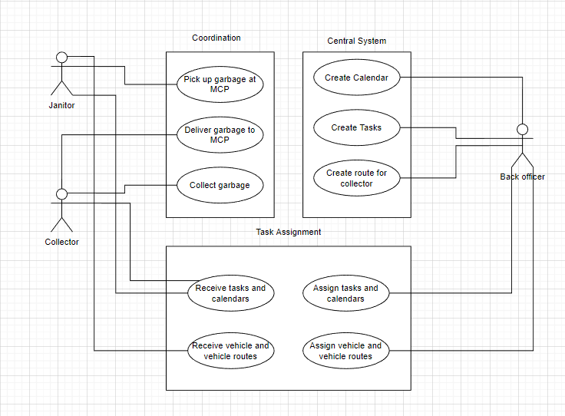

**1.3:**

**- Task assignment modules use-case diagram:**

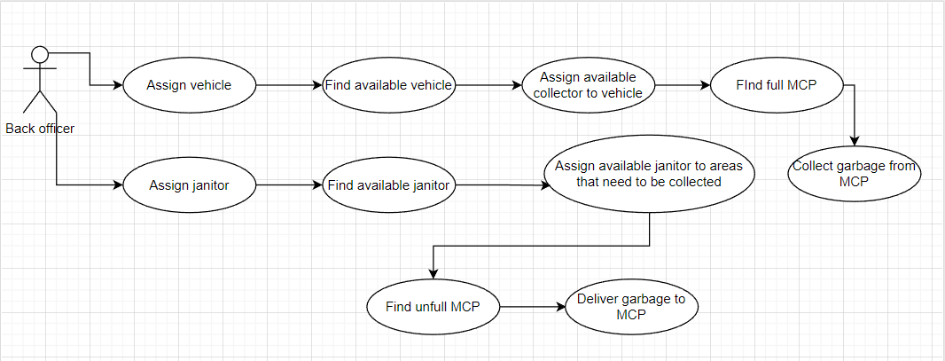

**- Describe the use-case using a table format:**

|  |  |
| --- | --- |
| **Use case** | **Description** |
| Name | Task Assignment |
| Actors | Back officer , collector, janitor |
| Pre-condition | Collector, janitor, vehicle must be available |
| Post-condition | All MCPs’ garbage is collected |
| Basic path | 1. This use case starts when the back officer assign vehicle to the collector and assign janitor to areas which need garbage-collecting .  2. Find MCPs.  3. All MCPs’ garbage is collected by the collector. |
| Alternative path | At step 2 of the basic path, if the MCP is full , assign collector to collect garbage. |
| Exceptional path | At step 2 of the basic path, if the MCP is unfull , assign janitor to deliver garbage to that MCP. |