Student ID: |  |  | Student Name:
Subject code & Name | : | ITUE301 - AWDF | Practical | : | 10 | Academic Year | : | 2025-26

Task - 10: Asynchronous Processing with Event-Driven Architecture
Aim
To implement non-blocking background processing using Node.js native EventEmitter without external message queues, decoupling notifications from the synchronous HTTP request-response cycle.
Code
(Paste your GitHub Repository Link – Practical Wise)
GitHub Repository Link (Main): https://github.com/TheNameIsVishvesh/AWDF_PRACTICALS
Practical 10 Direct Folder Link: https://github.com/TheNameIsVishvesh/AWDF_PRACTICALS/tree/main/Practical-10
Output
10.1 Stored Task Collection Managed by Express Controller:
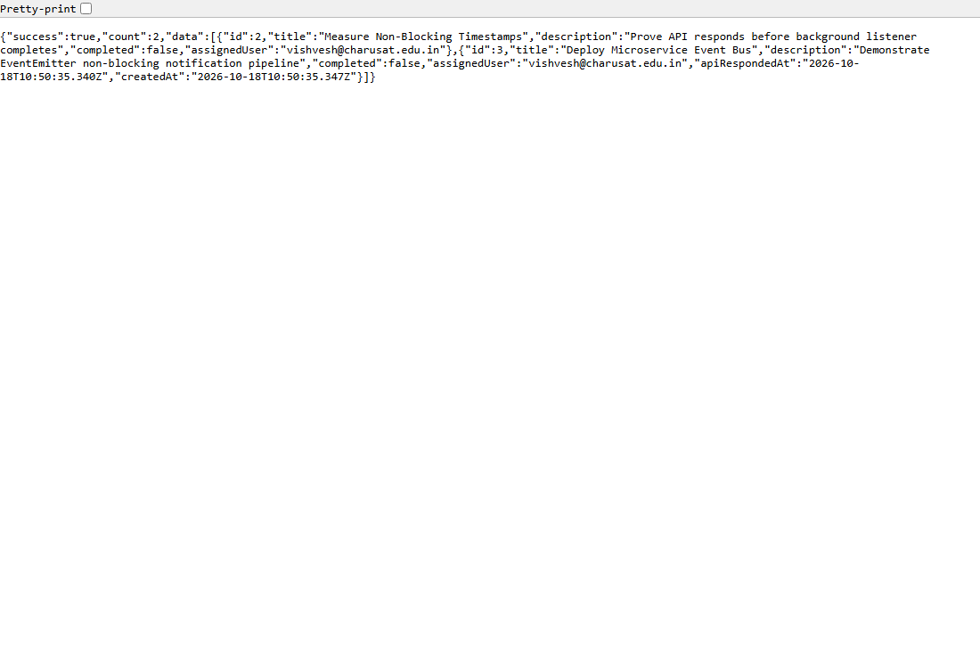
10.2 Asynchronous Event Execution Order & Non-Blocking Timestamps Audit:
