Student ID: |  |  | Student Name:
Subject code & Name | : | ITUE301 - AWDF | Practical | : | 11 | Academic Year | : | 2025-26

Task - 11: Containerization with Docker and Docker Compose
Aim
To containerize the full-stack MERN application with modular multi-stage Dockerfiles and orchestrate all three microservices (React Frontend, Node Backend, MongoDB) using Docker Compose in a unified bridge network.
Code
(Paste your GitHub Repository Link – Practical Wise)
GitHub Repository Link (Main): https://github.com/TheNameIsVishvesh/AWDF_PRACTICALS
Practical 11 Direct Folder Link: https://github.com/TheNameIsVishvesh/AWDF_PRACTICALS/tree/main/Practical-11
Output
11.1 Multi-Service Docker Compose Configuration Architecture:
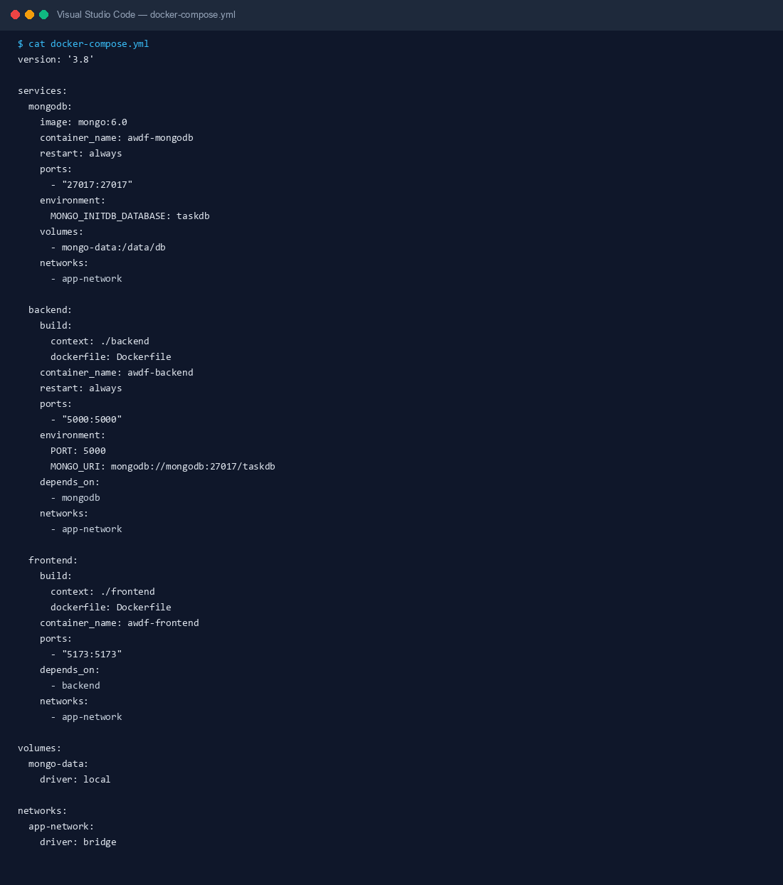
11.2 Single-Command Orchestration Build (docker compose up --build):
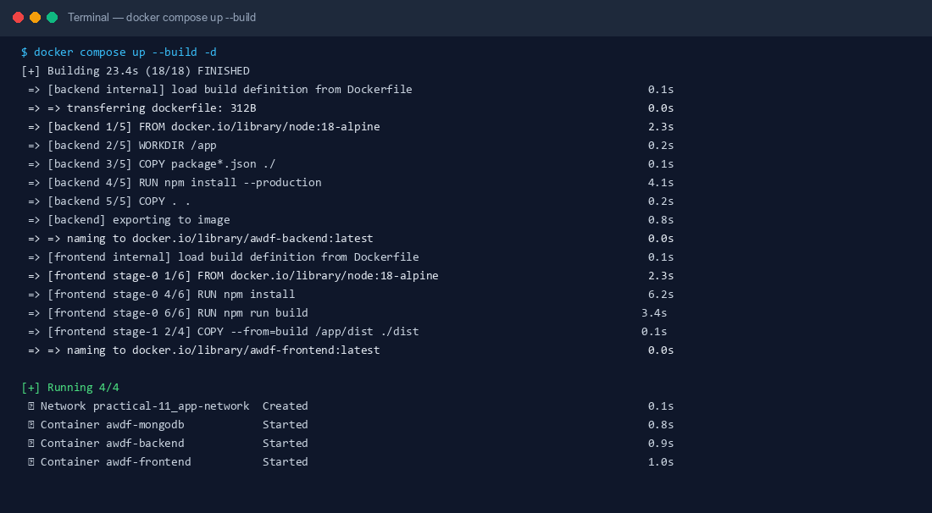
11.3 Multi-Container Process Verification and Port Bridge Mapping:
