Student ID: |  |  | Student Name:
Subject code & Name | : | ITUE301 - AWDF | Practical | : | 12 | Academic Year | : | 2025-26

Task - 12: CI/CD Pipeline with GitHub Actions
Aim
To automate continuous integration and testing using GitHub Actions, configuring automated workflows triggered on push to main that run Jest/Supertest test suites with pass/fail verification.
Code
(Paste your GitHub Repository Link – Practical Wise)
GitHub Repository Link (Main): https://github.com/TheNameIsVishvesh/AWDF_PRACTICALS
Practical 12 Direct Folder Link: https://github.com/TheNameIsVishvesh/AWDF_PRACTICALS/tree/main/Practical-12
Output
12.1 Continuous Integration Pipeline Failure State on Broken Assertion (Red X):
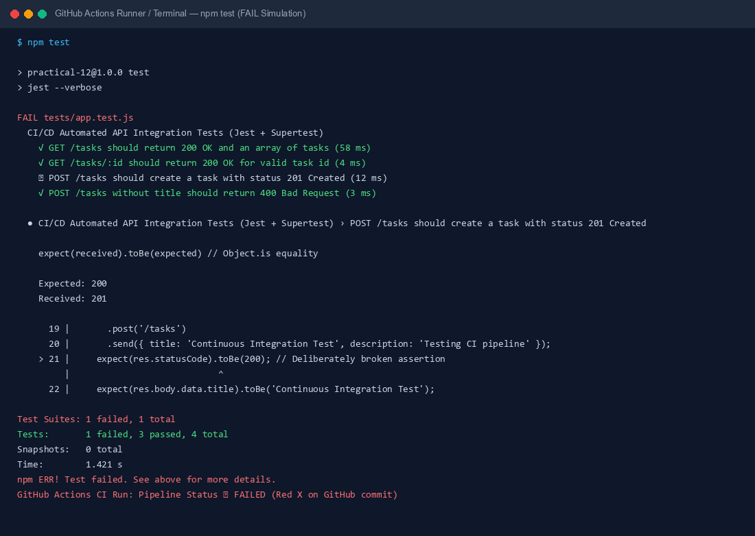
12.2 Automated Test Suite Passing Status & Pipeline Resolution (Green Checkmark):
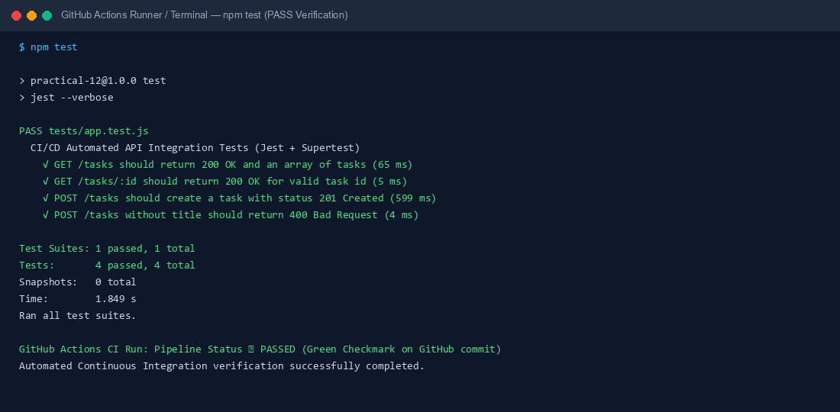
12.3 GitHub Actions CI/CD Workflow Configuration Specification (.github/workflows/ci.yml):
