Student ID: |  |  | Student Name:
Subject code & Name | : | ITUE301 - AWDF | Practical | : | 13 | Academic Year | : | 2025-26

Task - 13: AI API Integration into a Web Application
Aim
To securely integrate a third-party AI service (OpenAI / Gemini) via backend proxy architecture, implementing graceful degradation on service outage, rate-limiting, and responsible AI user disclaimers.
Code
(Paste your GitHub Repository Link – Practical Wise)
GitHub Repository Link (Main): https://github.com/TheNameIsVishvesh/AWDF_PRACTICALS
Practical 13 Direct Folder Link: https://github.com/TheNameIsVishvesh/AWDF_PRACTICALS/tree/main/Practical-13
Output
13.1 AI-Generated Task Description & Priority Suggestion (Happy Path):
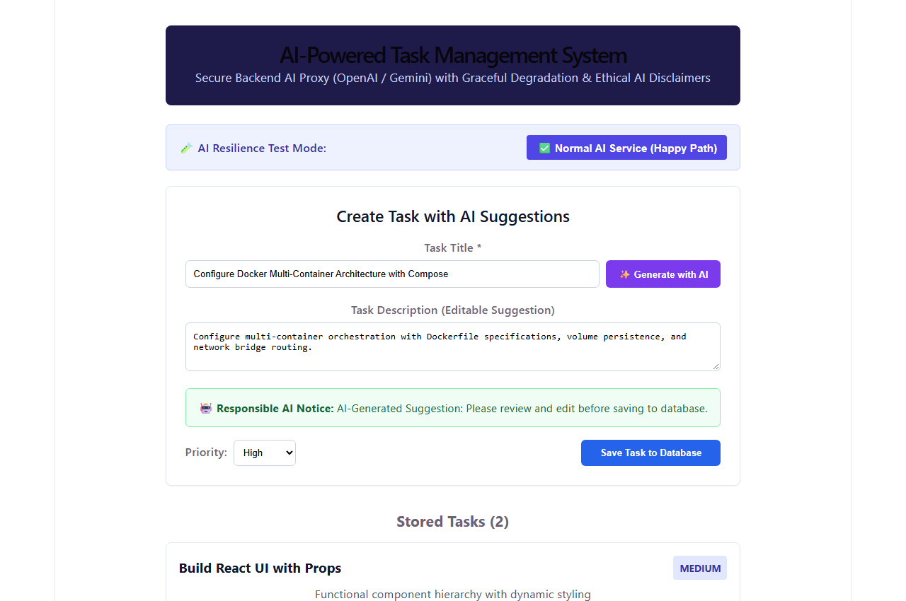
13.2 Graceful Degradation & Fallback Handling on AI Service Outage:
