Student ID: |  |  | Student Name:
Subject code & Name | : | ITUE301 - AWDF | Practical | : | 9 | Academic Year | : | 2025-26

Task - 9: In-Memory Caching and Query Optimization
Aim
To implement server-side caching using node-cache, enforce strict cache invalidation on write operations (POST, PUT, DELETE), and empirically measure its performance impact on API response latency.
Code
(Paste your GitHub Repository Link – Practical Wise)
GitHub Repository Link (Main): https://github.com/TheNameIsVishvesh/AWDF_PRACTICALS
Practical 9 Direct Folder Link: https://github.com/TheNameIsVishvesh/AWDF_PRACTICALS/tree/main/Practical-9
Output
9.1 Uncached Database Query Latency Benchmark (Baseline):
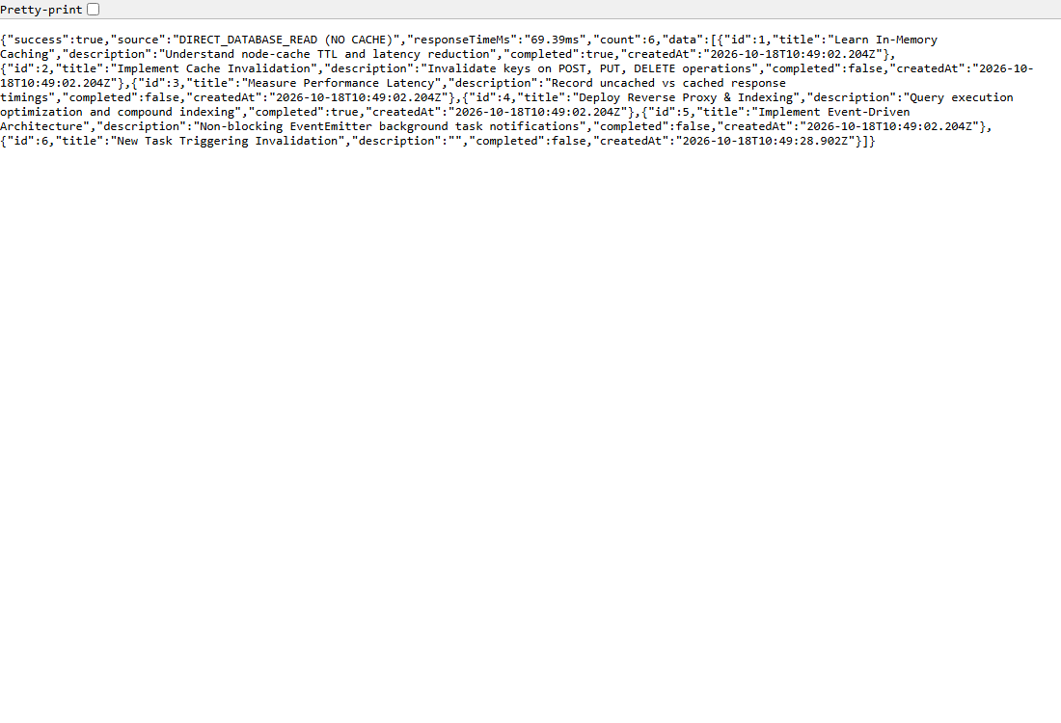
9.2 In-Memory Cache Hit Sub-Millisecond Response Speed:
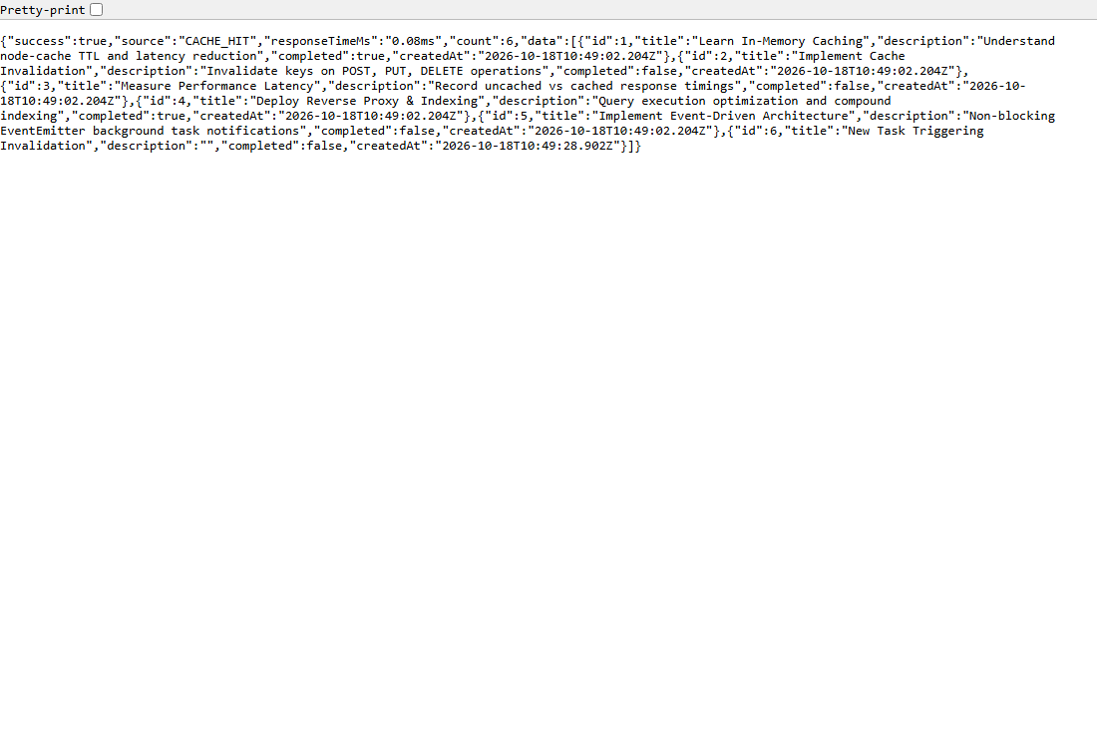
9.3 Server-Side Cache Metrics & Hit/Miss Debug Monitor:
