Student ID: |  |  | Student Name:
Subject code & Name | : | ITUE301 - AWDF | Practical | : | 1 | Academic Year | : | 2025-26

Task - 1: Introduction to React and Component Architecture
Aim
To set up a React development environment using Vite and build a static UI using independently structured, reusable components (Header, About, Skills, Projects, Footer) and props data flow.
Code
(Paste your GitHub Repository Link – Practical Wise)
GitHub Repository Link (Main): https://github.com/TheNameIsVishvesh/AWDF_PRACTICALS
Practical 1 Direct Folder Link: https://github.com/TheNameIsVishvesh/AWDF_PRACTICALS/tree/main/Practical-1
Output
1.1 Full Application View with Modular Component Hierarchy:
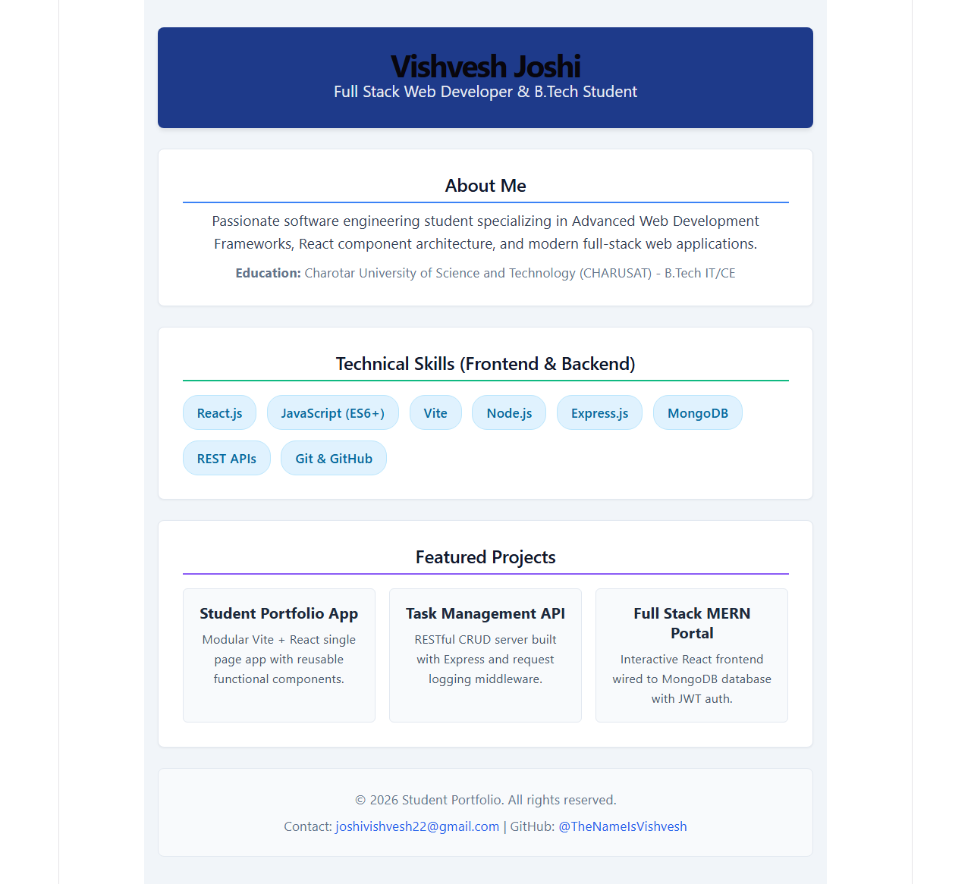
1.2 Header & About Components with Props Data Flow:
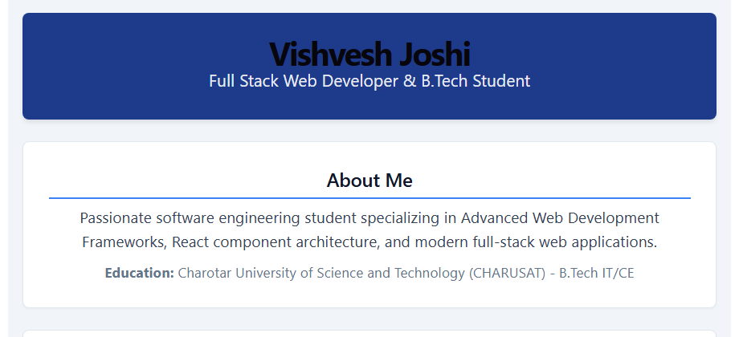
1.3 Skills & Projects Reusable Components List Mapping:
