Student ID: |  |  | Student Name:
Subject code & Name | : | ITUE301 - AWDF | Practical | : | 2 | Academic Year | : | 2025-26

Task - 2: State Management and Routing in React
Aim
To implement reactive state management using useState and multi-page client-side navigation using React Router v6 (BrowserRouter, Routes, Route, NavLink) in the student portfolio application.
Code
(Paste your GitHub Repository Link – Practical Wise)
GitHub Repository Link (Main): https://github.com/TheNameIsVishvesh/AWDF_PRACTICALS
Practical 2 Direct Folder Link: https://github.com/TheNameIsVishvesh/AWDF_PRACTICALS/tree/main/Practical-2
Output
2.1 Home Route with Reactive useState Toggle Display:
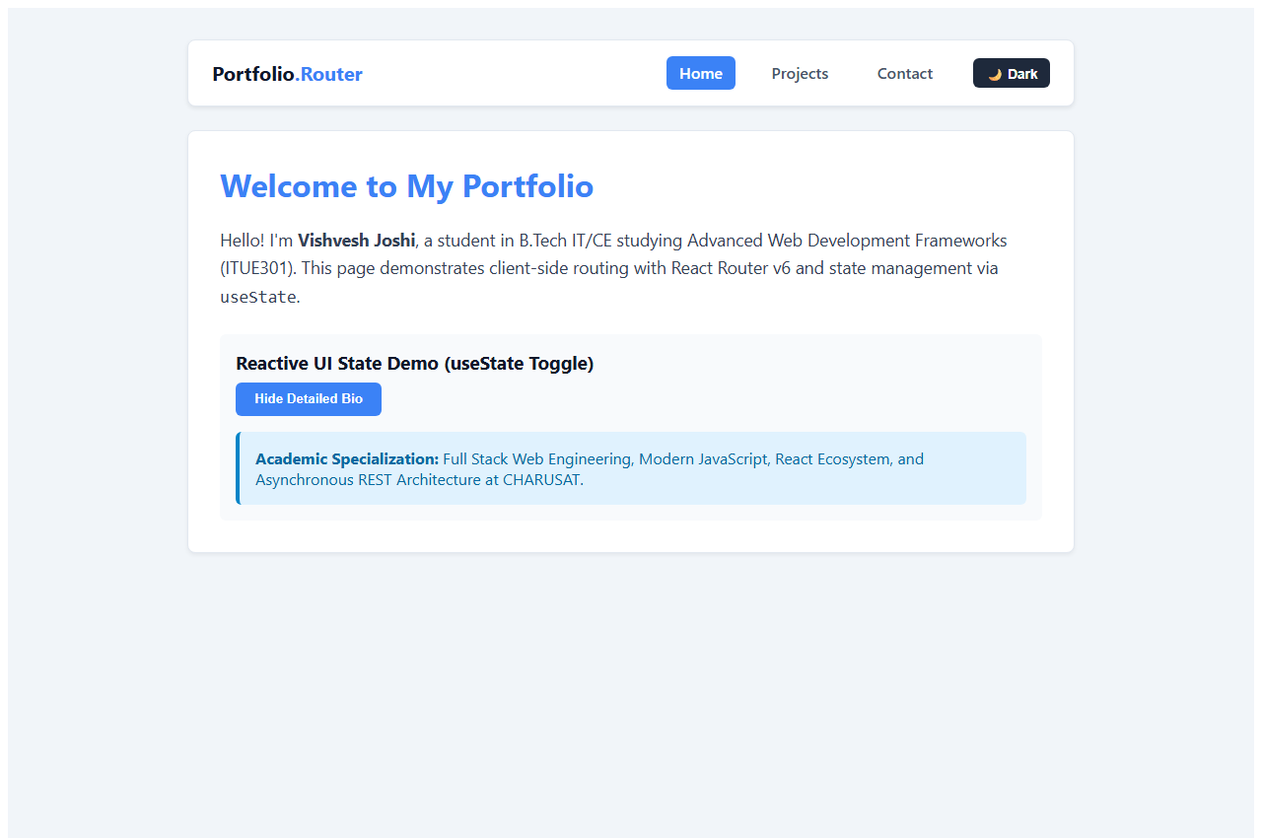
2.2 Projects Route Rendered via Client-Side Routing:
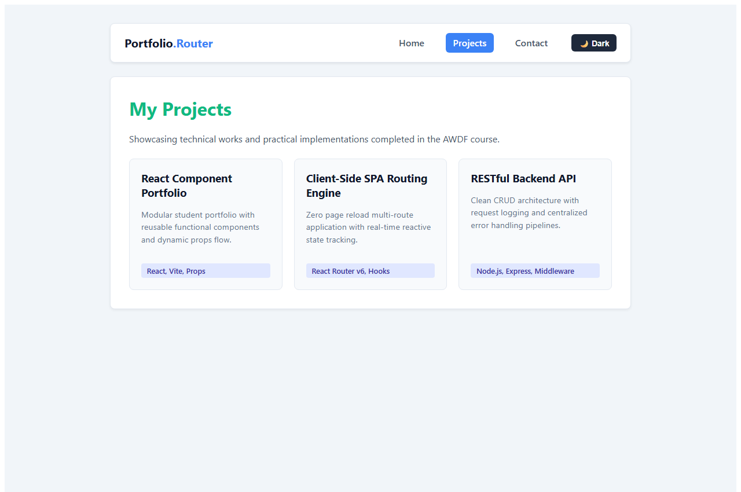
2.3 Contact Route with Controlled Form Inputs Tied to State:
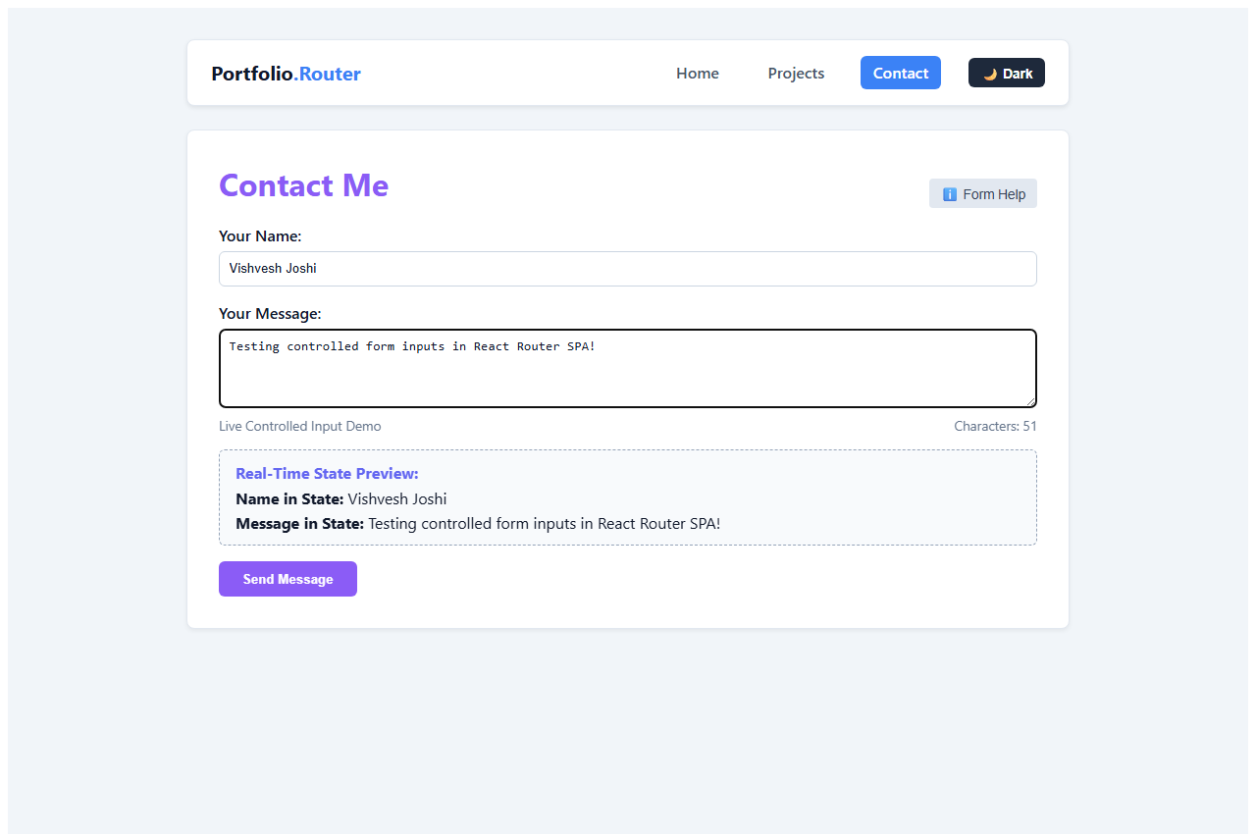
2.4 Dynamic Dark/Light Mode Theme Toggle State:
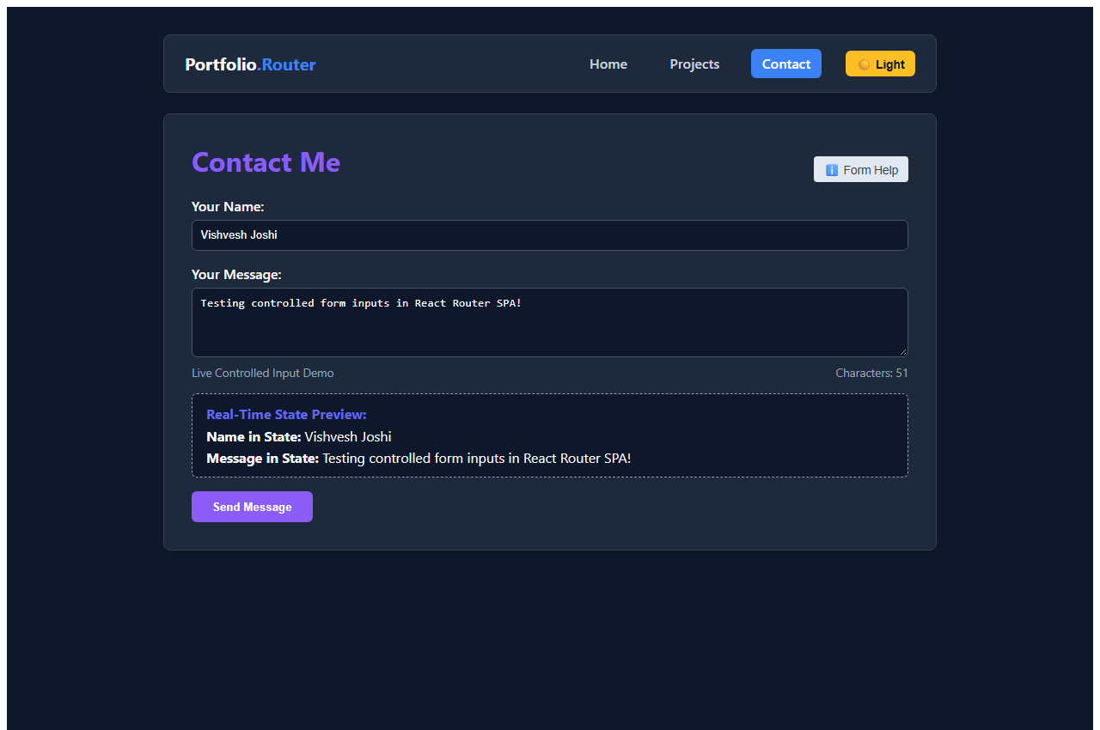
2.5 Custom 404 Not Found Fallback Route:
