Student ID: |  |  | Student Name:
Subject code & Name | : | ITUE301 - AWDF | Practical | : | 3 | Academic Year | : | 2025-26

Task - 3: API Integration and Data Rendering in React
Aim
To consume a REST API in React using useEffect, manage asynchronous data fetching with loading and error states, and conditionally render the UI based on network response.
Code
(Paste your GitHub Repository Link – Practical Wise)
GitHub Repository Link (Main): https://github.com/TheNameIsVishvesh/AWDF_PRACTICALS
Practical 3 Direct Folder Link: https://github.com/TheNameIsVishvesh/AWDF_PRACTICALS/tree/main/Practical-3
Output
3.1 Successful REST API Integration (Happy Path Data Render):
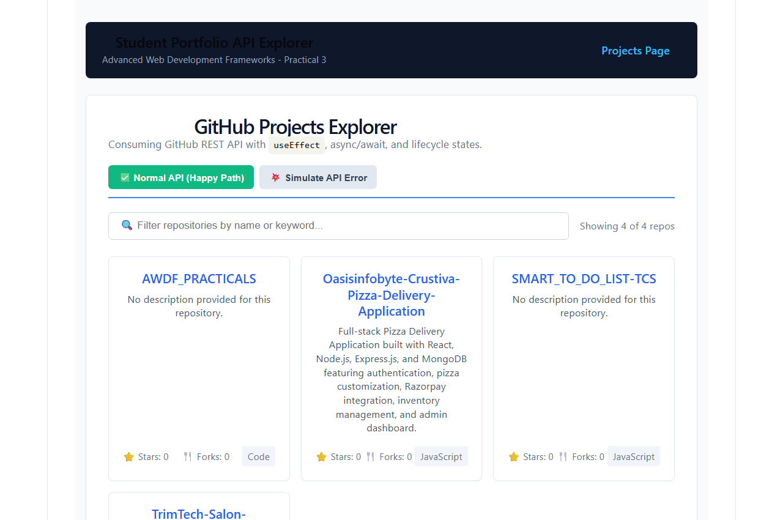
3.2 Real-time Search and Filter on Asynchronous Data:
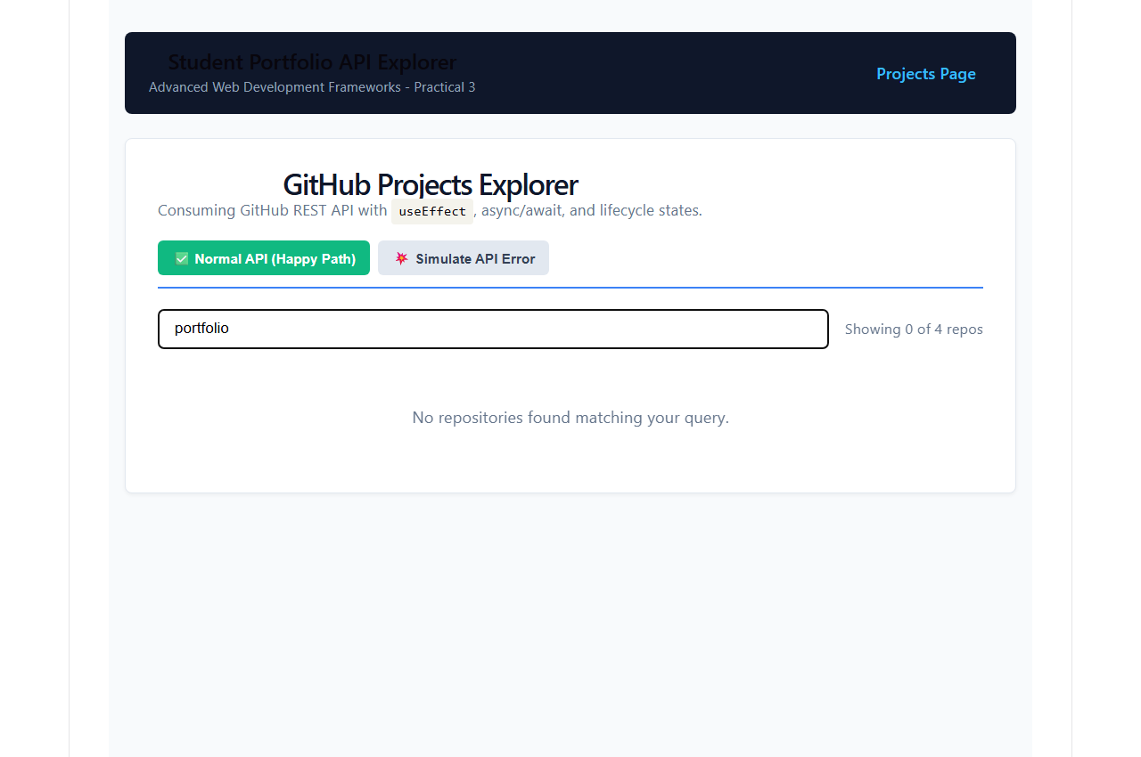
3.3 Error Boundary and Network Failure UI Handling:
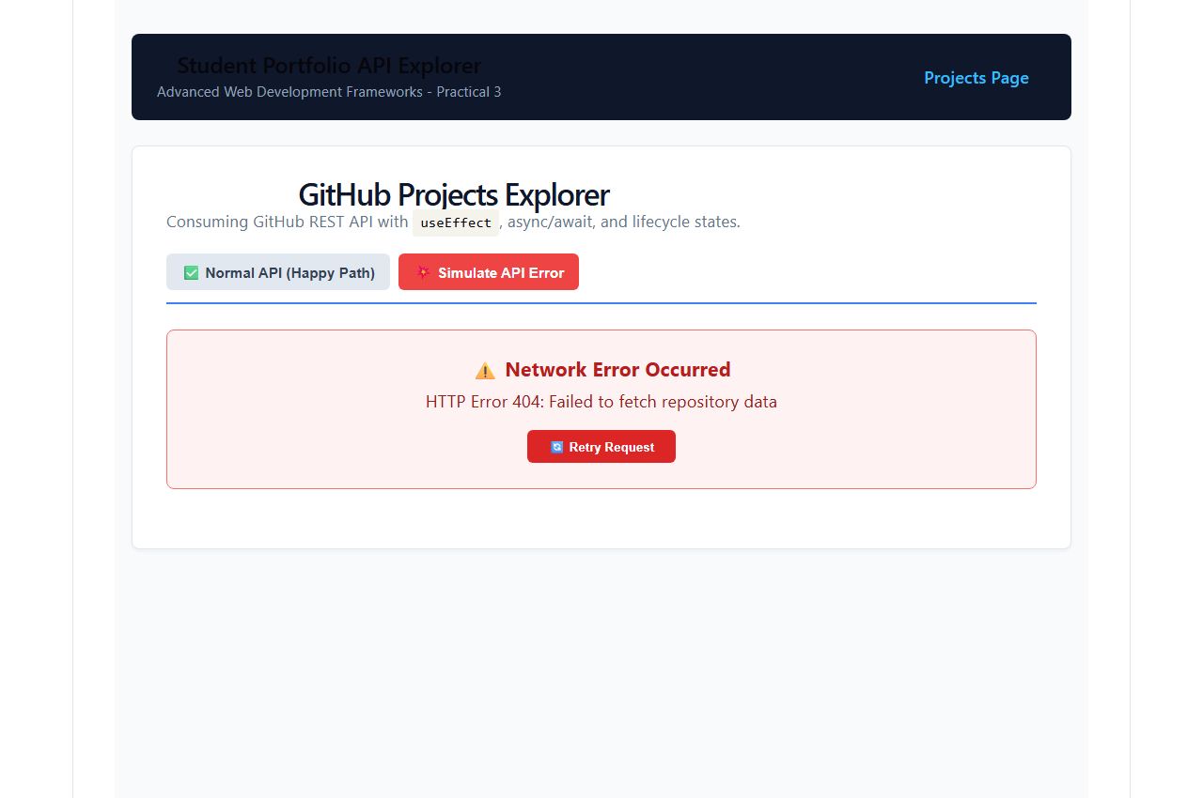
3.4 API Retry Mechanism Restoring Fetched Data:
