Student ID: |  |  | Student Name:
Subject code & Name | : | ITUE301 - AWDF | Practical | : | 4 | Academic Year | : | 2025-26

Task - 4: Building a RESTful API with Node.js and Express
Aim
To design and implement a RESTful backend server with complete CRUD endpoints using Express, custom request logging middleware, Content-Type validation, and centralized global error handling.
Code
(Paste your GitHub Repository Link – Practical Wise)
GitHub Repository Link (Main): https://github.com/TheNameIsVishvesh/AWDF_PRACTICALS
Practical 4 Direct Folder Link: https://github.com/TheNameIsVishvesh/AWDF_PRACTICALS/tree/main/Practical-4
Output
4.1 GET /tasks - Retrieve All Tasks with Status 200 OK:
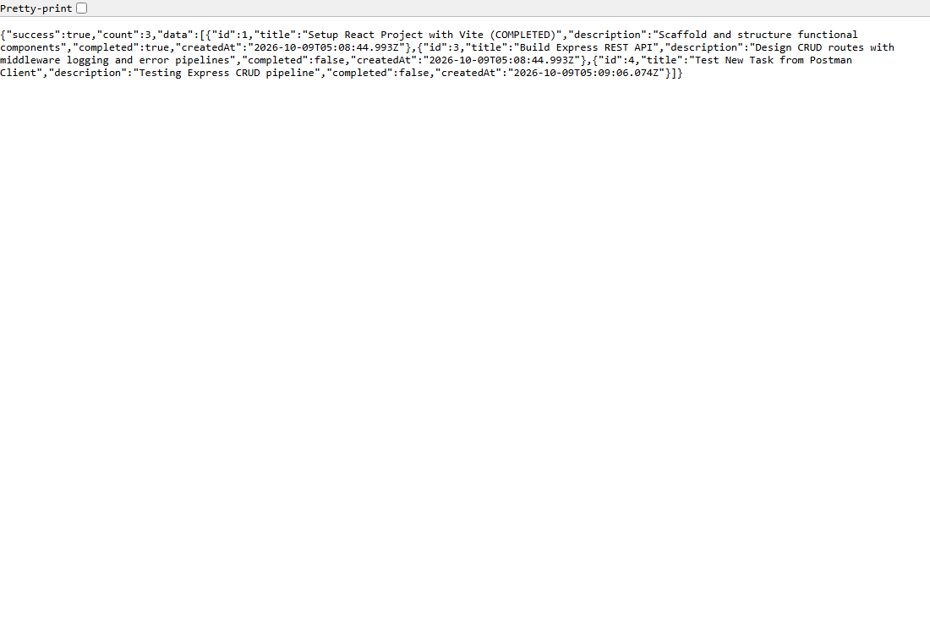
4.2 GET /tasks/:id - Retrieve Specific Task with Parameter Parsing:
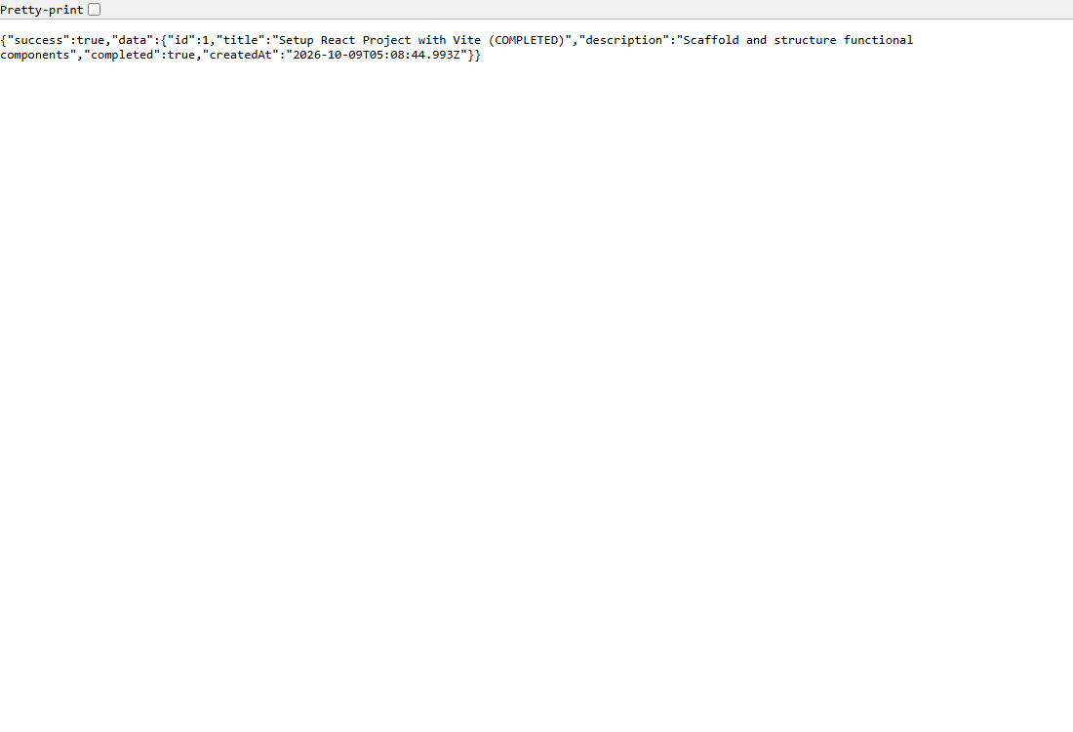
4.3 Undefined Route 404 Structured JSON Handler:
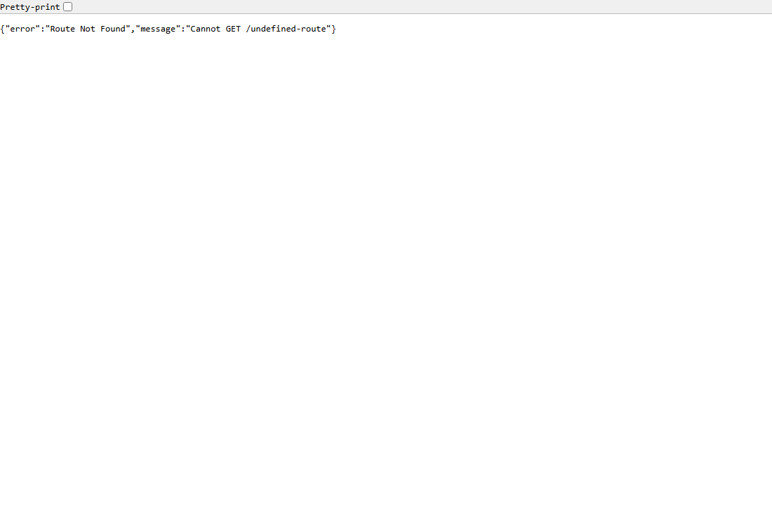
4.4 Global Error Handling Middleware Pipeline Execution (500):
