Student ID: |  |  | Student Name:
Subject code & Name | : | ITUE301 - AWDF | Practical | : | 5 | Academic Year | : | 2025-26

Task - 5: MongoDB Integration and Schema Design with Mongoose
Aim
To connect a MongoDB database to an Express server and enforce data validation through Mongoose schema with strict constraints, enums, pre-save hooks, and structured error responses.
Code
(Paste your GitHub Repository Link – Practical Wise)
GitHub Repository Link (Main): https://github.com/TheNameIsVishvesh/AWDF_PRACTICALS
Practical 5 Direct Folder Link: https://github.com/TheNameIsVishvesh/AWDF_PRACTICALS/tree/main/Practical-5
Output
5.1 GET /tasks - Querying Validated Mongoose Documents:
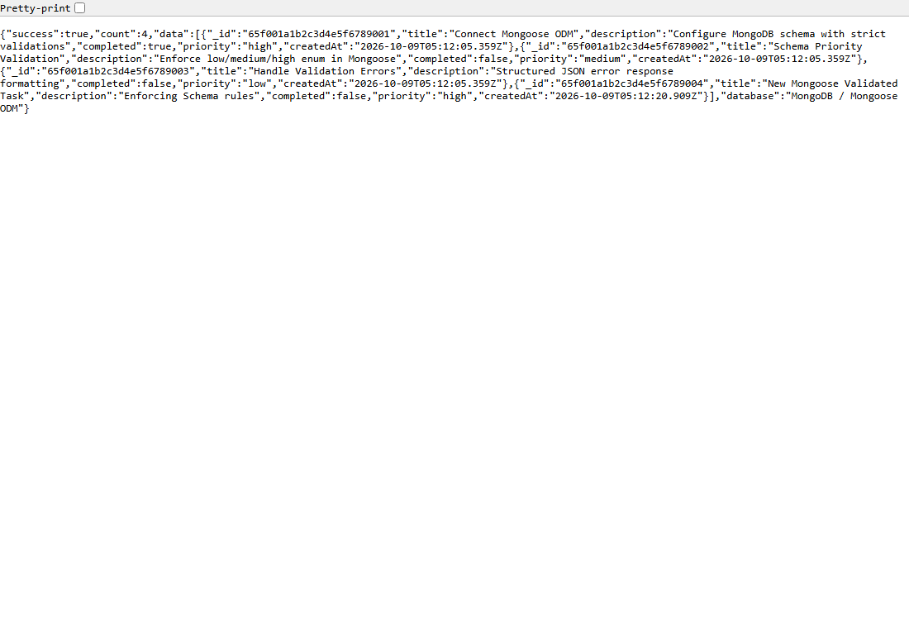
5.2 GET /tasks/:id - Querying Specific Document by Mongoose ObjectId:
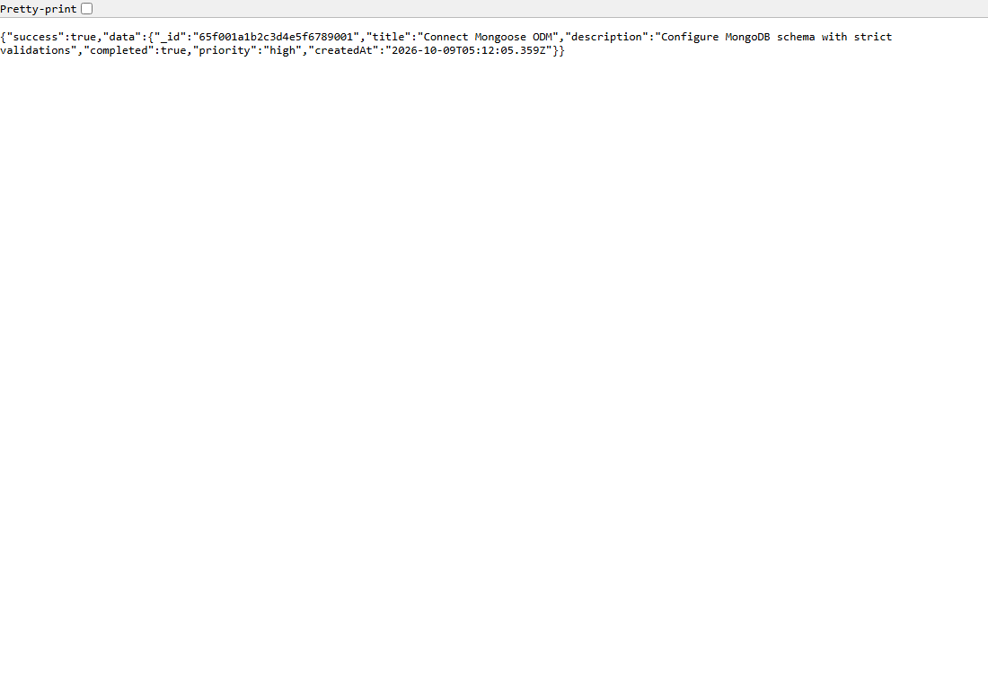
5.3 404 Response for Non-Existent Document Identification:
