Student ID: |  |  | Student Name:
Subject code & Name | : | ITUE301 - AWDF | Practical | : | 6 | Academic Year | : | 2025-26

Task - 6: Full Stack Integration React + Node + MongoDB
Aim
To wire the React frontend to the Node/Express/MongoDB backend into a fully functional full-stack application with CORS configuration, complete CRUD operations, and persistent state synchronization.
Code
(Paste your GitHub Repository Link – Practical Wise)
GitHub Repository Link (Main): https://github.com/TheNameIsVishvesh/AWDF_PRACTICALS
Practical 6 Direct Folder Link: https://github.com/TheNameIsVishvesh/AWDF_PRACTICALS/tree/main/Practical-6
Output
6.1 End-to-End Full Stack Dashboard with Live Backend Tasks:
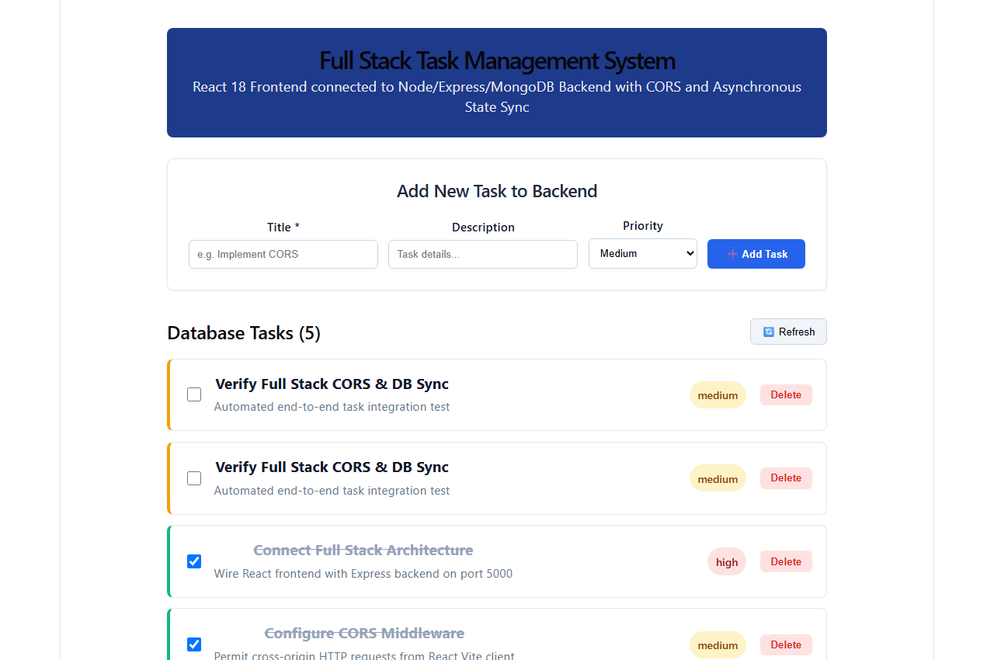
6.2 Creating Task from React UI and Database Persistence with Toast:
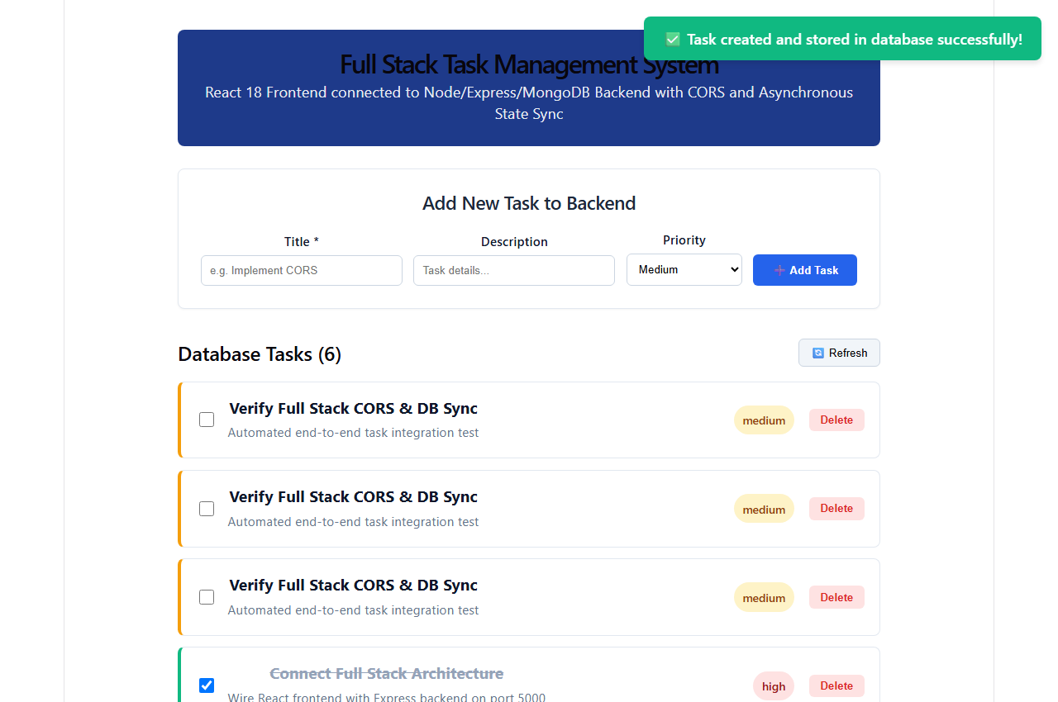
6.3 Asynchronous PUT Status Toggle Synchronized with Server:
