Student ID: |  |  | Student Name:
Subject code & Name | : | ITUE301 - AWDF | Practical | : | 7 | Academic Year | : | 2025-26

Task - 7: Authentication and Middleware Pipeline
Aim
To implement JWT-based user authentication, secure bcrypt password hashing, token verification middleware, and server-side input validation on protected Express routes.
Code
(Paste your GitHub Repository Link – Practical Wise)
GitHub Repository Link (Main): https://github.com/TheNameIsVishvesh/AWDF_PRACTICALS
Practical 7 Direct Folder Link: https://github.com/TheNameIsVishvesh/AWDF_PRACTICALS/tree/main/Practical-7
Output
7.1 Access Denied 401 Unauthorized on Protected Route without Token:
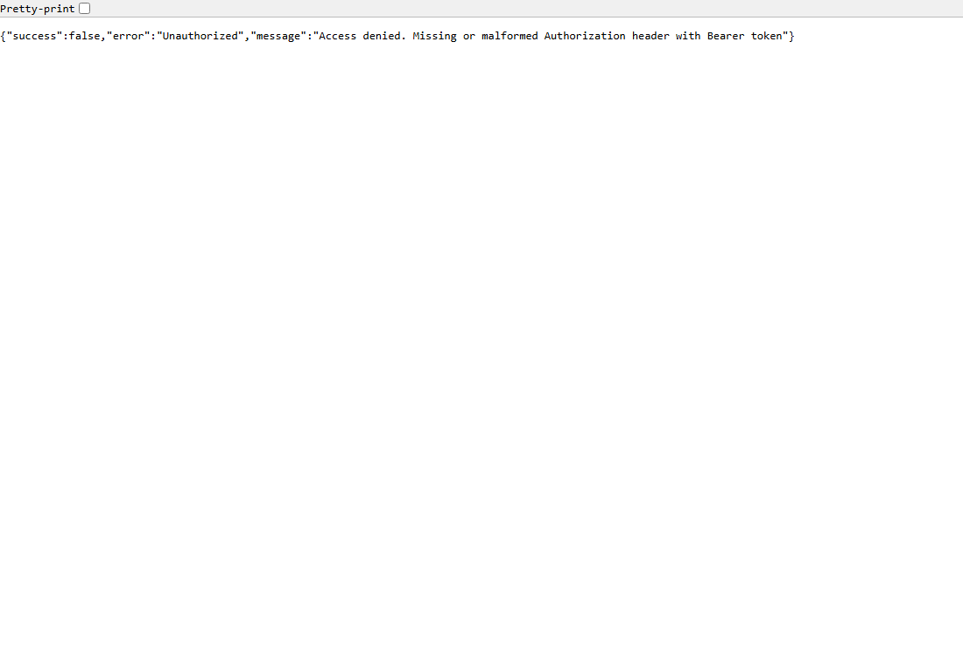
7.2 Authorized Access to Protected Task Endpoints with Bearer JWT:
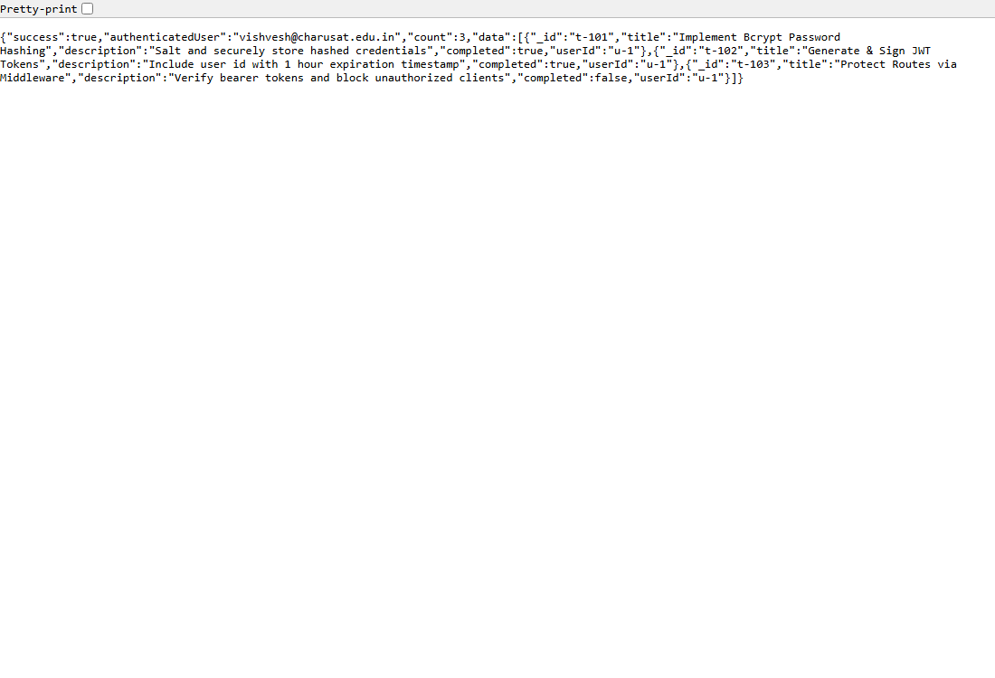
7.3 User Profile Endpoint /me Verifying Decoded JWT Token Payload:
